4 BA Mock - Case study
Assignment 1: BRD for Dairy (Ice-Cream & Milk) Inventory + Quickest Delivery
BRD (Business Requirements Document)
Project Title
Integrated Inventory and Logistics Management System for Ice-Cream and Dairy Products Manufacturer
Executive Summary
This project aims to digitalize and centralize inventory and distribution operations at multiple manufacturing plants and warehouses, ensuring real-time inventory control and efficient customer delivery. The transformation from manual management to automated, data-driven processes will minimize errors, cost, and delivery times, thereby boosting profitability and customer satisfaction.
Project Overview
The company manufactures and distributes ice-cream and milk products through plants and warehouses across the country. The organization intends to build a centralized software system to Manage inventory across plants, warehouses, and distribution points.
Ensure quickest delivery of products to customers by optimizing order allocation and route planning.
1.Business Goals:
- Fast, efficient tracking and resolution of customer/service tickets.
- Reduce response times.
- Improve customer satisfaction.
2. Objectives
- Real-time visibility of stock levels.
- Automated inventory replenishment alerts.
- Smart order allocation from nearest warehouse/plant.
- Route optimization for fastest delivery.
- Improved customer satisfaction and reduced wastage.
3. Key Stakeholders
- Client Sponsor: CEO / Director of Operations
- Business Users: Plant managers, Warehouse managers, Delivery managers
- IT Team: Developers, Testers, Database admins
- End Users: Customers placing orders
4. Key Features / Requirements
- Centralized dashboard for inventory monitoring.
- Stock movement tracking (Plant → Warehouse → Customer).
- Order fulfillment system with location-based delivery logic.
- Integration with transport/logistics partners.
- Mobile app for delivery staff.
- Reporting & analytics (stock, sales, wastage, delivery times).
5. Constraints & Assumptions
- System should support both web and mobile platforms.
- Peak seasonal demand should be handled without downtime.
- Compliance with food safety regulations.
6. KPIs (Key Performance Indicators)
- Inventory Accuracy ≥ 98%
- Delivery SLA ≤ 30 minutes (urban), ≤ 2 hours (rural)
- Wastage Reduction ≥ 15% in 6 months
- Customer Satisfaction ≥ 90% positive feedback
Development & Resource Plan
1. Methodology
- Agile Scrum – 2-week sprints, incremental delivery.
2. Team Structure
- Business Analyst (1) – Requirement gathering, documentation
- Project Manager (1) – Planning, tracking
- Developers (4) – Backend, frontend, mobile app
- UI/UX Designer (1) – User-friendly design
- QA/Testers (2) – Functional & performance testing
- DevOps Engineer (1) – Deployment, monitoring
3. Timeline (High-level)
- Requirement Gathering & BRD: 2 weeks
- Design (UI/UX + Architecture): 2 weeks
- Development: 10–12 weeks
- Testing: 3 weeks
- Deployment & Training: 2 weeks
- Go-live: ~20 weeks total

Process flow diagram :
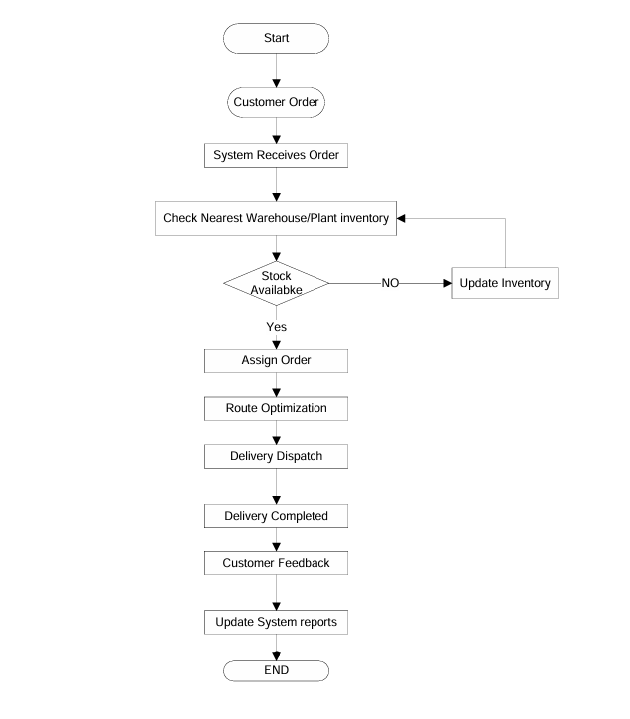
Introduction Letter
Subject: Introduction – Business Analyst for Upcoming Project
Dear Coepd,
I am Likhitha, the Business Analyst assigned to work with you and your team for the upcoming project. My role will be to bridge the gap between your business needs and the technical team, ensuring that the solution we build aligns with your goals.
Over the coming weeks, I will collaborate closely with your stakeholders to gather requirements, document processes, and create structured specifications for development. I look forward to understanding your vision and translating it into a successful solution.

Best Regards,
Likhitha
Business Analyst

Brief BRD (Online Store Example)
- Project Overview
Develop an E-commerce platform to allow customers to browse, select, and purchase products online with seamless checkout and order tracking.
- Objectives
- Easy product search & filtering
- Secure payment options
- Real-time order tracking
- Personalized recommendations
- Stakeholders
- Business Owners
- Customers
- Admin/Support Team
- IT Development Team
SRS (Online Store Example)
- Functional Requirements
- User Registration & Login
- Product Catalog (search, filter, sort)
- Shopping Cart & Checkout
- Payment Integration (UPI, Card, Wallets)
- Order Tracking & Notifications
- Admin Panel for product & order management

- Non-Functional Requirements
- Performance: <3s response time
- Security: Data encryption, secure payment gateway
- Scalability: Support high traffic during sales
ERD of creating a support ticket
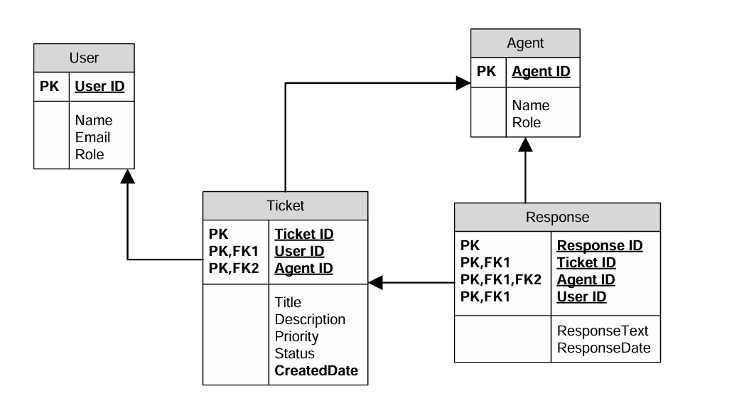

User story of shopping from ecommerce
Sprint 1 – User Account & Product Discovery (Foundations)
User story No : US001 | Task: 1 |  | Priority : Highest
As a New User

I WANT TO register with my email/phone

SO THAT I can create an account and start shopping.
BV : 300 |  | CP : 02
ACCEPTANCE CRITERIA

- User can sign up with email/phone
- Password must be encrypted and validated
- Confirmation email/SMS sent after registration

User story No : US002 | Task: 2 |  | Priority : Highest
As a Registered User

I WANT TO log in securely

SO THAT I can access my account safely.
BV : 300 |  | CP : 05
ACCEPTANCE CRITERIA
- User can log in using email/phone + password
- Incorrect credentials show error message
- Session auto logout after inactivity

User story No : US003 | Task: 3 |  | Priority : Highest
As a Customer

I WANT TO browse all available products

SO THAT I can see what the store offers.
BV : 200 |  | CP : 04
ACCEPTANCE CRITERIA

- Products displayed with name, price, image
- Pagination or scrolling available

User story No : US004 | Task: 4 |  | Priority : Highest
As a Customer

I WANT TO search for products by keyword

SO THAT I can quickly find what I need.
BV : 300 |  | CP : 05
ACCEPTANCE CRITERIA

- Search box available on homepage
- Results displayed within 3 seconds

User story No : US005 | Task: 5 |  | Priority : Highest
As a Customer

I WANT TO filter/sort products

SO THAT I can narrow my choices.
BV : 250 |  | CP : 05
ACCEPTANCE CRITERIA

- Filter by category, brand, price
- Sort by price/popularity

Sprint 2 – Cart & Checkout

User story No : US006 | Task: 1 |  | Priority : Highest
As a Customer

I WANT TO view product details

SO THAT I can make informed decisions.
BV : 250 |  | CP : 05
ACCEPTANCE CRITERIA

- Show description, reviews, availability
- Variant/size selection available

User story No : US007 | Task: 2 |  | Priority : Highest
As a Customer

I WANT TO add products to cart

SO THAT I can purchase later.
BV : 300 |  | CP : 05
ACCEPTANCE CRITERIA

- Item added with correct price & quantity
- Cart icon updates in real time

User story No : US008 | Task: 3 |  | Priority : Highest
As a Customer

I WANT TO modify cart items

SO THAT I can adjust my order.
BV : 250 |  | CP : 05
ACCEPTANCE CRITERIA

- Quantity update reflected in total
- Remove items updates cart

User story No : US009 | Task: 4 |  | Priority : Medium
As a Customer

I WANT TO save items for later

SO THAT I don’t lose track.
BV : 200 |  | CP : 04
ACCEPTANCE CRITERIA
- Wishlist in account
- Move item from wishlist to cart

User story No : US010 | Task: 5 |  | Priority : High
As a Customer

I WANT TO checkout smoothly

SO THAT I can complete my purchase.
BV : 300 |  | CP : 05
ACCEPTANCE CRITERIA

- Multi-step checkout (Address→Payment→Review)
- Guest checkout supported

Sprint 3 – Payments & Order Management
User story No : US011 | Task: 1 |  | Priority : High
As a Customer

I WANT TO save multiple addresses

SO THAT I can choose easily during checkout
BV : 200 |  | CP : 04
ACCEPTANCE CRITERIA
- Add/edit/delete addresses
- Set default address

User story No : US012 | Task: 2 |  | Priority : High
As a Customer

I WANT TO pay securely with multiple methods

SO THAT I can complete purchase safely.
BV : 300 |  | CP : 05
ACCEPTANCE CRITERIA

- Card, UPI, wallet options available
- Transactions encrypted & confirmed

User story No : US013 | Task: 3 |  | Priority : High
As a Customer

I WANT TO receive order confirmation

SO THAT I know my purchase is successful.
BV : 300 |  | CP : 05
ACCEPTANCE CRITERIA

- Email/SMS confirmation sent
- Order summary in My Orders

User story No : US014 | Task: 4 |  | Priority : High
As a Customer

I WANT TO track my order status

SO THAT I know when it will arrive.
BV : 300 |  | CP : 05
ACCEPTANCE CRITERIA

- Statuses: Placed→Shipped→Delivered
- Tracking number available

User story No : US015 | Task: 5 |  | Priority : Medium
As a Customer

I WANT TO cancel my order before shipping

SO THAT I can avoid unwanted purchases.
BV : 200 |  | CP : 04
ACCEPTANCE CRITERIA

- Cancel allowed only in Placed status
- Refund auto-initiated for prepaid

Sprint 4 – Enhancements & Support
User story No : US016 | Task: 1 |  | Priority : Medium
As a Customer

I WANT TO leave reviews

SO THAT I can share my experience.
BV : 200 |  | CP : 04
ACCEPTANCE CRITERIA

- Only verified buyers can review
- Rating & comments allowed

User story No : US017 | Task: 2 |  | Priority : Low
As a Customer

I WANT TO see personalized recommendations

SO THAT I can discover products easily.
BV : 100 |  | CP : 03
ACCEPTANCE CRITERIA

- Recommendations based on history
- Shown on homepage/product page

User story No : US018 | Task: 3 |  | Priority : Medium
As a Customer

I WANT TO get notifications

SO THAT I stay informed about offers/orders.
BV : 200 |  | CP : 04
ACCEPTANCE CRITERIA

- Email/SMS/Push supported
- Order updates real-time

User story No : US019 | Task: 4 |  | Priority : Highest
As a Customer

I WANT TO raise support tickets

SO THAT I can get help when needed.
BV : 300 |  | CP : 05
ACCEPTANCE CRITERIA

- Support chat/ticket form available
- Ticket ID generated for tracking

User story No : US020 | Task: 5 |  | Priority : Highest
As a Customer

I WANT TO return products

SO THAT I can get refund/replacement
BV : 300 |  | CP : 05
ACCEPTANCE CRITERIA

- Return request within policy window
- Refund/replacement after pickup

