Online Agriculture Product- Capstone Prep 1 Part 3
Question 1 – Functional Requirements
Actually, Software testing has two types functional and non-functional requirements. Its validating functional and non-functional requirements in a end user point of view.
Functional requirement:
Functional requirements define the features and functionalities and behaviour of the software application or system work as expected according to the requirements. If mainly focuses on what the system actually does to do (features, functions). Verifies that the system works according to the specified functional requirements. To ensure the system meets business needs and functions correctly. It must perform to achieve its objectives. Ensure the system meets business needs and works correctly.
Examples (Online Agriculture Store)
- Farmer can register/login
- Manufacturer can upload products
- Farmer can search for seeds
- Order confirmation email is sent
Non-Functional Requirement:
Define how the system should work – the quality attributes and constraints. Focus on the compatibility, performance, usability, reliability, security of the system. Ensure the system is efficient, reliable, and user-friendly under real-world conditions.
Examples
- Page load time < 2 seconds
- System supports 10,000 users
- Secure payment with encryption
- Available 24/7 with 99.9% uptime
Req ID | Req Name | Req Description
FR0001 | Farmer Registration | Farmers shall be able to register a new account by providing their email and a password.
FR0002 | Farmer Login | Farmers shall be able to securely log in to their account using their email and password.
FR0003
  Farmer Search for Products
  Farmers should be able to search for available products in fertilizers, seeds, pesticides
FR0004 |  | Manufacturers should be able to upload product details (name, type, price, description, image)
  Upload Products
FR0005 | Product Browsing | Farmers shall be able to browse products by category (e.g., fertilizers, seeds, pesticides).
FR0006 | Farmer Profile Management | Farmers shall be able to view and update their profile details, including name, contact information, and delivery address.
FR0007 | Product Search | Farmers shall be able to search for products (fertilizers, seeds, pesticides) using keywords.
FR0008 | View Product Details | Farmers shall be able to view detailed information for each product, including price, description, and manufacturer.
FR0009 | Add to Cart | Farmers shall be able to add selected products to a shopping cart.
FR0010 | View Shopping Cart | Farmers shall be able to view, modify, or remove items from their shopping cart before checkout.
FR0011 | Place an Order | Farmers shall be able to complete the purchase process by placing an order for items in their cart.
FR0012 | Multiple Payment Options | Farmers shall be able to choose from different payment options, including Cash on Delivery (COD), UPI, and Credit/Debit cards.
FR0013 | Order History | Farmers shall be able to view a list of their past and present orders.
FR0014 | Order Status Tracking | Farmers shall be able to track the current status and location of their placed orders.
08-10-2025FR0015 | Order Cancellation | Farmers shall be able to cancel an order within a specified time frame.
FR0016 | Password Reset | Farmers shall be able to reset their password if they forget it.
FR0017 | Login with Verification Code (OTP) | The system shall allow users (Farmers and Manufacturers) to login using a One-Time Password (OTP) sent to their registered email address or mobile number. After entering their username (email/phone), the system should generate an OTP and send it to the registered channel.
FR0018 | Order Status Update | Manufacturers shall be able to update the status of an order (e.g., "Shipped," "Delivered").
FR0019 | Product Review & Rating
  Farmers should be able to provide reviews/ratings for purchased products
FR0020 | Order Monitoring | The administrator shall be able to view and monitor all orders placed through the platform.

QUESTION 2 - Minimum 5-page designs

Make wireframe and prototypes.

Sign Up
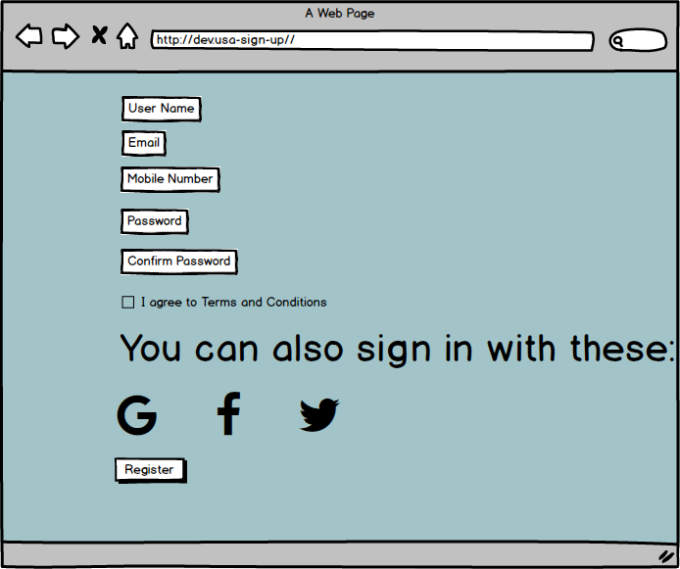

Login Page
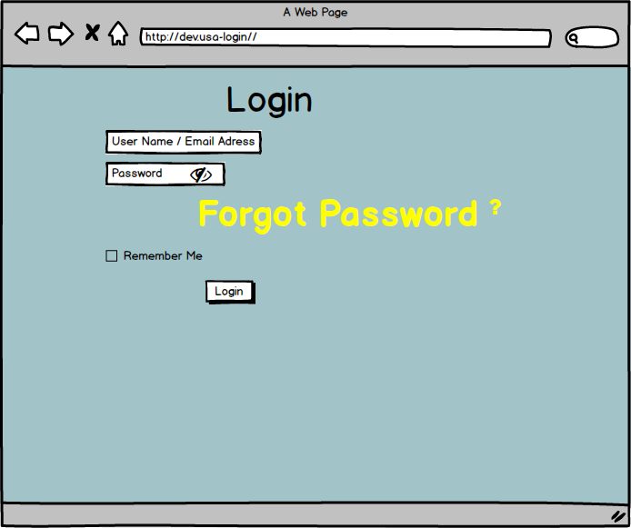
Search Product
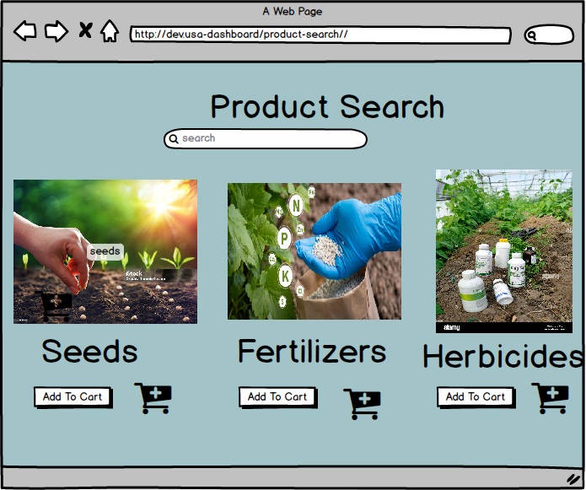

Cart Page
Payment Page
Axure Diagrams

Question 3 – Tools (Visio, Balsamiq )
Make a note of the Tools, which you are using for above concepts.
The tools, which are used in the above concepts, are:
- MS Visio – A diagramming and vector graphics application used to create diagrams, flowcharts, and other visual representations of complex information such as UML diagrams and activity diagrams.
Microsoft Visio is a diagramming and visualization tool used to create flowcharts, data flow diagrams (DFDs), network diagrams, UML diagrams, Activity Diagrams
Purpose
- Visually represent complex information, processes, or systems in an easy-to-understand format.
- Help Business Analysts, Project Managers, and Engineers document and communicate ideas, workflows, and system designs effectively.
- Serve as a blueprint for system development and process improvement.

- Balsamic – A rapid wire framing tool used to create mock-ups and prototypes of user interfaces. It is ideal for designing wireframes for websites, web applications, and desktop software. It allows stakeholders to visualize ideas and concepts quickly through a simple drag-and-drop interface.
It is more focus on creating static wire frames and mock-ups. It is used to create web and mobile based application user interface design tool for creating wireframes (drag and drop feature).
Main purpose of the balsamic wire framing helps the stakeholders to explain their requirements efficiently of the system.
More focused on creating static images and exporting them in formats such as PNG and PDF.
Clarify Requirements: Help clients visualize requirements before development.
A Business Analyst uses Balsamic to design:
- Login Page
- Signup Page
- Product Listing Page
- Payment Page
- Dashboard
These wireframes guide developers and testers during project implementation.

Axure – An advanced prototyping tool used to create high-fidelity interactive prototypes and wireframes for web, desktop and mobile applications. It helps in building interactive, clickable buttons, inputs, outputs and designs that simulate real user experiences.
It allows the business stakeholders to get the feel of the future software application or system and you can capture their feedback during the session. It is more powerful, and more advanced and have advanced prototyping features.
Supporting a wide range of of output formats, including HTML , CSS and JS (Java Script)
Purpose:
- Create interactive prototypes that simulate real system behaviour.
- Validate requirements early by showing how the system will work.
- Help stakeholders understand workflows and UI interactions clearly.

Question 4 – RTM
Definition:
RTM means, It Is mapping the business requirements to corresponding test scenarios and corresponding test cases is called an requirements traceability matrix.
Requirements Traceability Matrix (RTM) to address the stakeholders' questions and demonstrate the project's status. The RTM is a document that links requirements to test cases, development tasks, and other project artifacts. It helps track a requirement's throughout the project life cycle, from its origin to its implementation and verification, ensuring that all requirements are met and nothing is missed.
Advantages of RTM:-
- To determine the % percentage of test coverage.
- As we are able to trace a group of test cases belongs to a group of particular requirement, test execution will become easy.
- As we are able to trace test scenarios and test cases belongs to a specific requirement, change request process can be easily implemented.

Req ID | Req Name | Req Description | Design | Code Development |  | Unit Testing (White Box Testing) |  | System Testing(SI) | SIT(System Integration Testing | UAT(User Acceptance Testing)
FR0001 | FR0001 | Farmer Registration | DONE | Complete |  | Complete |  | Complete | Complete | In Progress
FR0002 | Farmer Search for Products | Farmers should be able to search for available products in fertilizers, seeds, pesticides. | DONE |  | Complete |  | Complete | Complete | Complete | Pass
FR0003 | Upload Products | Manufacturers should be able to upload product details | DONE |  | Complete |  | Complete | Complete | Complete | In Progress
FR0004 | Browse Product Catalog | Farmers should be able to browse through product categories | DONE |  | Complete |  | Complete | Complete | Complete | In Progress
FR0005 | Add to Cart | Farmers should be able to add products into cart before placing orders | DONE |  | Complete |  | Complete | Complete | Complete | In Progress
FR0006 | Place Order | Farmers should be able to place an order after selecting products. | DONE |  | Complete |  | Complete | Complete | Complete | In Progress
FR0007 | Payment Options | Farmers should be able to make payments via COD, UPI, Debit/Credit Card. | DONE |  | Complete |  | Complete | Complete | Fail | In Progress
FR0008 | Delivery Tracking | Farmers should be able to track the delivery status of their order. | DONE |  | Complete |  | Complete | Test In Progress | In Complete | In Progress

Question
5 – 10 Test Case Documents
A Test Case Document is a formal document that outlines a set of conditions or actions used to verify a specific functionality of a software application. It serves as a blueprint for testers, detailing the steps, data, and expected outcomes to determine if a feature works correctly and meets its requirements.
Test case is a brief description of what to test and how to test. In other words, a test case is a set of (test procedure) test steps and test data and expected behaviour planned to validate a functionalities in the system.
Note: For future reference only we are writing test scenarios and test cases.
- Password Reset
Test case ID | TC001 | Test case Name | Password Reset
Project ID | P001 | Project Name | Online Agriculture Products Store
PM ID | PM001 | PM Name | Mr Vandanam
Test strategy ID | TS001 | Tester ID | T002
Test plan ID | TP001 | Tester Name | Ms. Alekya
Test schedule ID | SCH001 | Date of Test | 09-04-2025
Scenario | A user requests a password reset link.
Link to that page | Forgot PWD Page
Input Data | Registered Email Address
Expected behaviour | A password reset link is sent to the provided email, and a confirmation message is displayed on the page.
Actual behaviour
Comments
Result (Pass/Fail)

- Farmer Registration

Test case ID | TC002 | Test case Name | Farmer Registration
Project ID | P001 | Project Name | Online Agriculture Products Store
PM ID | PM001 | PM Name | Mr Vandanam
Test strategy ID | TS002 | Tester ID | T001
Test plan ID | TP001 | Tester Name | Mr. Jason
Test schedule ID | SCH001 | Date of Test | 09-04-2025
Scenario | Register a new farmer with valid, unique credentials.
Link to that page | Registration Page
Input Data | Name: [Unique Name], Email: [Unique Email], Password: [Strong Password]
Expected behaviour | Farmer account created successfully. User is redirected to login or home page.
Actual behaviour
Comments
Result (Pass/Fail)
- Search Product (Valid)
Test case ID | TC003 | Test case Name | Search Product (Valid)
Project ID | P001 | Project Name | Online Agriculture Products Store
PM ID | PM001 | PM Name | Mr Vandanam
Test strategy ID | TS003 | Tester ID | T001
Test plan ID | TP001 | Tester Name | Mr. Jason
Test schedule ID | SCH001 | Date of Test | 09-04-2025
Scenario | Search for fertilizer
Link to that page | Search Page
Input Data | Keyword: Fertilizer
Expected behaviour | System displays relevant fertilizer products.
Actual behaviour
Comments
Result (Pass/Fail)

- Add to Cart
Test case ID | TC004 | Test case Name | Add to Cart
Project ID | P001 | Project Name | Online Agriculture Products Store
PM ID | PM001 | PM Name | Mr Vandanam
Test strategy ID | TS004 | Tester ID | T002
Test plan ID | TP001 | Tester Name | Ms. Alekya
Test schedule ID | SCH001 | Date of Test | 09-04-2025
Scenario | Add a selected Herbicide to cart.
Link to that page | Product Page
Input Data | Product ID: p01 (Herbicide)
Expected behaviour | Product is successfully added to the cart, and the cart icon updates.
Actual behaviour
Comments
Result (Pass/Fail)

- Buy Now
Test case ID | TC005 | Test case Name | Buy Now
Project ID | P001 | Project Name | Online Agriculture Products Store
PM ID | PM001 | PM Name | Mr Vandanam
Test strategy ID | TS005 | Tester ID | T002
Test plan ID | TP001 | Tester Name | Ms. Alekya
Test schedule ID | SCH001 | Date of Test | 09-04-2025
Scenario | Place an order for seeds.
Link to that page | Checkout Page
Input Data | Seed ID: S201
Expected behaviour | Order placed successfully, and a confirmation page is displayed.
Actual behaviour
Comments
Result (Pass/Fail)

- Payment - COD
Test case ID | TC006 | Test case Name | Payment - COD
Project ID | P001 | Project Name | Online Agriculture Products Store
PM ID | PM001 | PM Name | Mr Vandanam
Test strategy ID | TS006 | Tester ID | T001
Test plan ID | TP001 | Tester Name | Mr. Jason
Test schedule ID | SCH001 | Date of Test | 09-04-2025
Scenario | Make a payment using Cash on Delivery.
Link to that page | Payment Page
Input Data | Select COD option.
Expected behaviour | Order is confirmed with COD selected as the payment method.
Actual behaviour
Comments
Result (Pass/Fail)

- Payment - Card
Test case ID | TC007 | Test case Name | Payment - Card
Project ID | P001 | Project Name | Online Agriculture Products Store
PM ID | PM001 | PM Name | Mr Vandanam
Test strategy ID | TS007 | Tester ID | T001
Test plan ID | TP001 | Tester Name | Mr. Jason
Test schedule ID | SCH001 | Date of Test | 09-04-2025
Scenario | Make a payment using a Credit/Debit card.
Link to that page | Payment Page.
Input Data | Valid Card Number , Expiry , CVV.
Expected behaviour | Payment is successfully processed, and an order confirmation is displayed.
Actual behaviour
Comments
Result (Pass/Fail)

- Payment - UPI
Test case ID | TC008 | Test case Name | Payment - UPI
Project ID | P001 | Project Name | Online Agriculture Products Store
PM ID | PM001 | PM Name | Mr Vandanam
Test strategy ID | TS008 | Tester ID | T001
Test plan ID | TP001 | Tester Name | Mr. Jason
Test schedule ID | SCH001 | Date of Test | 09-04-2025
Scenario | Make a payment using a UPI ID.
Link to that page | Payment Page.
Input Data | Valid UPI ID.
Expected behaviour | Payment is successfully processed, and an order confirmation is displayed.
Actual behaviour
Comments
Result (Pass/Fail)

- Order Tracking
Test case ID | TC009 | Test case Name | Order Tracking
Project ID | P001 | Project Name | Online Agriculture Products Store
PM ID | PM001 | PM Name | Mr Vandanam
Test strategy ID | TS009 | Tester ID | T001
Test plan ID | TP001 | Tester Name | Mr. Jason
Test schedule ID | SCH001 | Date of Test | 09-04-2025
Scenario | Track a recently placed order.
Link to that page | Order Tracking Page
Input Data | Order ID: 123
Expected behaviour | The page displays the order's correct, real-time status and location.
Actual behaviour
Comments
Result (Pass/Fail)

- Email Confirmation
Test case ID | TC010 | Test case Name | Email Confirmation
Project ID | P001 | Project Name | Online Agriculture Products Store
PM ID | PM001 | PM Name | Mr Vandanam
Test strategy ID | TS010 | Tester ID | T001
Test plan ID | TP001 | Tester Name | Mr. Jason
Test schedule ID | SCH001 | Date of Test | 09-04-2025
Scenario | Receive an email after an order is successfully placed.
Link to that page | Email Inbox
Input Data | Order placed successfully
Expected behaviour | An email confirmation with order details is received at the farmer's registered email address.
Actual behaviour
Comments
Result (Pass/Fail)

Question 6:
DB Design
DB Schema is a blueprint that outlines the structure of a database, including its tables, fields, relationships, constraints and other characteristics.
It defines how data is organized, how different tables are related, and what constraints or rules apply to the data.
Components of DB Schema:
A schema usually includes:
- Tables (entities, e.g., Customers, Orders, Products)
- Fields (columns) with their data types (e.g., CustomerName – VARCHAR(100))
- Primary Keys (unique identifiers for each record)
- Foreign Keys (to define relationships between tables)
- Constraints (rules like NOT NULL, UNIQUE, CHECK)
- Relationships (like one-to-many or many-to-many)
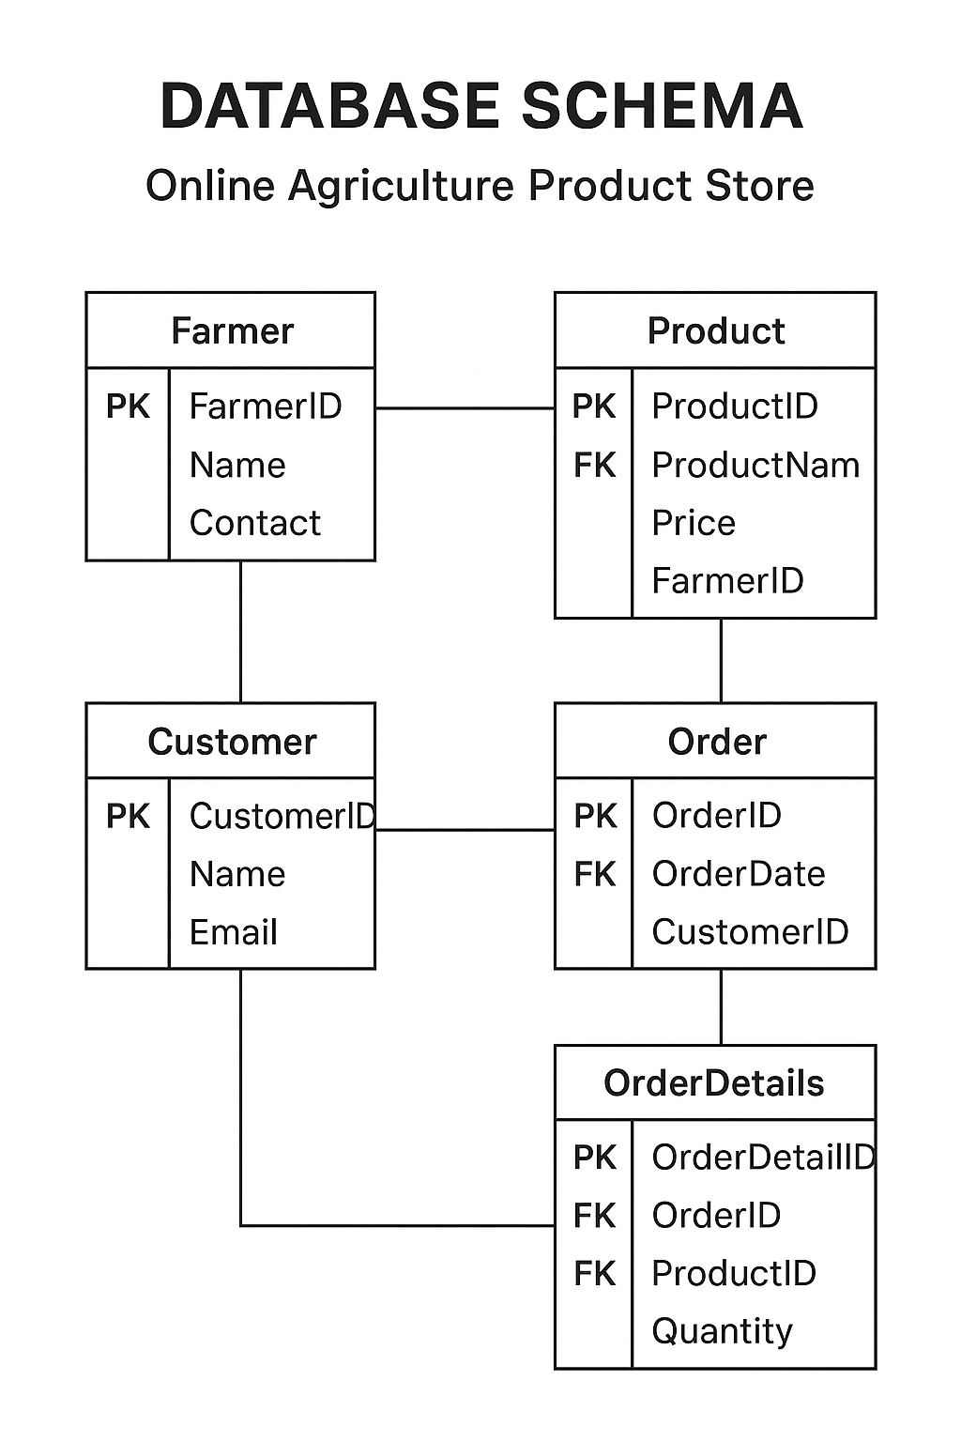

An Entity-Relationship Diagram is a visual representation of the relationships between entities in a database. It depicts the entities (such as tables), attributes (properties or fields) and relationships between them.

Entity Relationship Diagram – Online Agriculture Product Store
This document represents the Entity Relationship Diagram (ERD) for the Online Agriculture Product Store project. The ERD outlines the main database entities, their attributes, and the relationships between them.
An Entity Relationship (ER) represents the logical structure of data — it shows how entities (things or objects) in a system are related to each other.
In database design, this is often visualized using an Entity Relationship Diagram (ERD), which helps plan and understand how data flows and connects across the system.

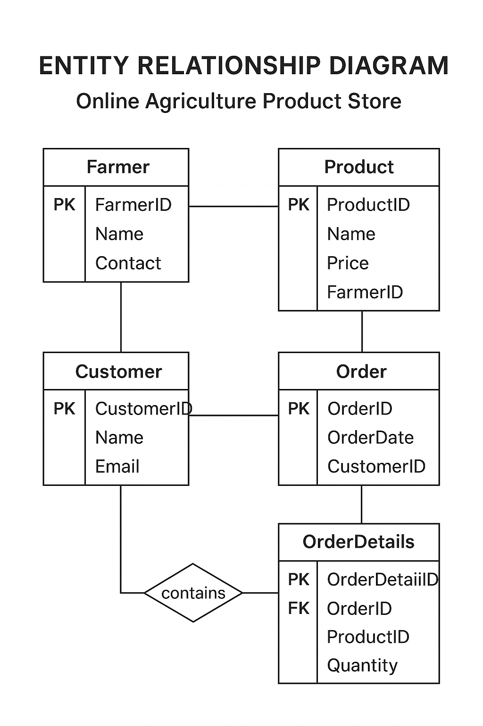

Question 7 – Data Flow Diagram

Data Flow Diagram (DFD) is a graphical / visual representation of how information flows through a system. It shows the movement of data from its source to its destination, highlighting the processes that transform the data along the way.
It helps to analyst and designers to understand the flow of data within a software application / system, identify the inefficiencies and communicate system requirements to stakeholders.

As shown in Fig. First user needs to login its account so that user can easily get access of agriculture application. If the user is not register details before login first needs to register a details about user then user has its own account to access.

After the login user will be able to view and select the item by a choice from a given menu. Menu contains plants, seeds, pots, fertilizers. After selection of an item user need to buy that item by clicking buy option or add that item to cart. Make a payment by cash on delivery method after receiving item by confirm the order

Question 8 – Change Request
How do you handle change requests in a project?
Here's how I would handle a change request in a project, specifically the one regarding a change in the government's taxation structure.

Document the Change Request
First, I'd formally document the change request from the stakeholders. This involves capturing all the necessary details, such as:
- Requestor: Mr. Pandu (Financial Head) and/or Mr. Dooku (Project Coordinator).
- Reason for Change: New Government Taxation structure.
- Description of the Change: A detailed explanation of the new tax rates, calculations, and which products or services they apply to.
- Impact: I would note that this change will affect product pricing, payment gateway integration, and financial reporting.
Performance Impact Analysis:
Next, I would analyse how this change affects the entire project. This is a crucial step to understand the full scope of the request. My analysis would cover:
- Scope: How does this change affect the original project scope? Does it add new functionality or just modify existing ones? In this case, it's a modification, but it's a significant one.
- Cost: What resources are needed to implement this? Will it require more developer hours? This could impact the budget, possibly requiring a new cost estimate.
- Time: How much time will it take to implement the new tax structure? This could affect the project's timeline and potentially delay the launch.
- Resources: What project team members are needed? This would likely involve developers (Ms. Juhi, Mr. Teyson, etc.), a tester (Mr. Jason, Ms. Alekya), and possibly the DB Admin (Mr. John) if the database schema needs to change.

Plan and Implement the Change:
If the CCB approves the change request, I would update the project documents, including:
- Requirements Traceability Matrix (RTM): I would add a new requirement for the tax change and link it to the relevant test cases and design documents.
- Functional Requirements: I would update the FRs to reflect the new tax calculations.
Technical Specifications: I would communicate the changes to the development team (Mr. Vandanam, Ms. Juhi, and others) so they can update the code. Development team modifies the business logic or system code.
- Test Plan: I would inform the testing team (Mr. Jason, Ms. Alekya) about the new test cases needed to verify the tax calculations are correct. Testers validate updated tax calculation in all scenarios.
Communicate the Change:
Inform stakeholders and end-users of changes (new tax structure applied in invoices/payments).
I would communicate the approved change to all relevant stakeholders and team members. This ensures everyone is aware of the new plan and any adjustments to the project's timeline or scope. This process ensures that changes are managed effectively, transparently, and with full awareness of their impact on the project.
Close the Change Request:
After implementation and UAT sign-off, mark CR as completed and update Change Log.

Question 9: Change Request vs Enhancement

Ben and Kevin requested:
- Farmers should be able to sell their crop yields through the application.
- Introduce an Auction system for crop yields.
My Response and Analysis as a BA:
- The original scope included only farmer registration, searching for products, and purchasing inputs (fertilizers, seeds, pesticides).
- Selling crops and adding an Auction system was not part of the original requirements.
- These requests do not alter existing tax or business rules but rather add new features and extend system functionality.
- Record these as New Enhancement Requests.
- Conduct feasibility and impact analysis (time, cost, scope).
- Discuss with stakeholders (Mr. Henry, project sponsor) to decide if these enhancements can be included in the current release or scheduled for future phases.

Based on the new requests from Ben and Kevin, my response would be that these are enhancements, not a simple change requests.
This is classified as an Enhancement, not a Change Request, because:
- A Change Request modifies existing functionality due to regulatory, compliance, or error fixes (e.g., tax structure change).
- A formal request to modify existing functionality due to errors, compliance, or business rule changes.
- Example: Updating the tax calculation as per new government taxation policy.
- BA Action: Perform impact analysis → update existing requirements, design, test cases.
Change Request: A change request typically involves a minor modification or adjustment to an existing feature. For example, changing the tax rate on a product, as discussed in the previous question, or updating a page layout would be a change request. It falls within the existing scope and architecture of the project.
- An Enhancement introduces new capabilities that improve or extend the application (e.g., selling crops, auctions).
- A request to add new features or improve the system beyond initial scope.
- Example : Allowing farmers to sell their crops and introducing an auction system.
- Treat as new requirement → feasibility study, add to backlog/future phase.
Enhancement: An enhancement introduces a new feature or a significant change in functionality that was not part of the original project plan. This requires new design, development, and testing efforts. The request for farmers to sell their own products and introduce an auction system fits this definition because it requires building entirely new modules for.
Conclusion:
- Change Request: Modifies existing features (e.g., Government Tax update).
- Enhancement: Adds new features (e.g., Crop Selling & Auction system).

Question -10 Come up with estimations – How many Manhours required?
Man-hours are the required efforts of the resources to complete a project. Based on standard classification:
- Small Project: Up to 500 hours
- Medium Project: Up to 1000 hours
- Large Project: Up to 1500 hours

Cost Estimation (Validation)
To validate the man-hour estimate, I can do a quick back-of-the-envelope calculation based on the project budget of 2 Crores INR.
- Project Duration: 18 months
- Team Size: 15–20 members (Developers, Testers, BA, DB Admin, Network Admin, etc.)
- Nature of Work: Web/Mobile application with Registration, Login, Product Catalog, Cart, Payments, Order Tracking.
- Resources: Skilled resources available; no trainers required.
- Infrastructure: Already available; no additional infra required.
Considering the scope, duration, and team size, this project falls under the Medium Project category with an estimated effort of ~1000 Man-hours.
This estimation aligns with the budget and timelines shared by the stakeholders (18 months, 2 Crores INR under CSR initiative).
Estimation Analysis:
Factor | Value | Calculation | Total Manhours

Team Size (average) | 18 members

Monthly Work Hours | 160 hrs per resource (8 hrs × 20 days)

Duration | 18 months | 18 × 160 = 2880 hrs per resource

Total Effort | 18 × 2880 hrs |  | 51,840 hrs

Question 11 – UAT
The project has successfully completed all phases (requirements, design, development, testing). Now, the Business Analyst plays a key role in ensuring User Acceptance Testing (UAT) and project closure.
UAT Initiation:
- Plan UAT: Prepare UAT strategy, scope, test cases, and acceptance criteria aligned with requirements.
- Client Communication: Contact Mr. Henry and Peter (stakeholders) to schedule UAT sessions.
- Environment Setup: Ensure UAT environment is stable, with correct data and user roles.
- Facilitate Execution: Support stakeholders while they execute test cases and scenarios.
- Capture Feedback: Record issues, defects, and suggestions during UAT.

UAT Acceptance Criteria Checklist:-
Make sure to cover 100% of business and functional requirements are tested and validated.
All critical and high-severity defects are fixed and retested successfully.
Only minor/low-priority issues remain with documented workarounds.
End-to-end business workflows (e.g., Registration → Search → Purchase → Payment) verified.
Application performance is stable (page load within 2 seconds, no crashes).
User interface is intuitive and matches design expectations.

Legal, compliance, and updated Taxation structure requirements are met.

Stakeholder Sign-Off: Client (e.g., Mr. Henry and team) formally signs the UAT acceptance document, confirming the system is fit for production. Once stakeholders confirm the system meets expectations, they provide a formal sign-off document.
Client stakeholders (Mr. Henry & team) provide formal sign-off on UAT completion. UAT completion report is documented and approved before production push.
Approval: This confirms the product is ready for production use.

Question 12 – Project Closure Document:
A Project Closure Document is a formal report prepared at the end of a project to confirm that all project objectives have been achieved, deliverables have been completed, and the client has accepted the final product. It serves as the official declaration that the project is closed and no further work will be carried out unless a new project is initiated.
Key Sections of a Project Closure Document
- Project Information – Project name, ID, start and end dates, project manager, stakeholders.
- Objectives Achieved – Summary of whether project goals were met.
- Deliverables – List of completed deliverables and client acceptance.
- UAT Sign-off – Confirmation that User Acceptance Testing (UAT) is completed and approved.
- Change Requests – Document any approved/rejected change requests during the project.
- Lessons Learned – Challenges faced, risks encountered, and recommendations for future projects.
- Team Performance – Acknowledgement of contributions from team members.
- Handover Details – Transfer of ownership, documents, and system access to client.
- Closure Approval – Formal sign-off by the client and project manager.
Purpose:
- To provide transparency and accountability.
- To officially release resources (team, budget, infrastructure).
- To document success and areas of improvement for future projects.
In short, the project closure document acts as the final handshake between client and project team, ensuring clarity, acceptance, and formal closure.
Project Closure Document – Summary:
Project Name: Online Agriculture Products Store
Project Manager: Mr. Vandanam
Stakeholders: Mr. Henry, Mr. Peter, Mr. Kevin, Mr. Ben
Duration: 18 months (March 2024 – Sept 2025)
Key Points:
- Objectives Achieved
  - Farmer Registration & Login
  - Product Search & Purchase
  - Cart & Checkout
  - Multiple Payment Modes (COD, UPI, Card)
  - Order Tracking & Email Notifications
  - Taxation compliance & Accessibility standards
- UAT Sign-off
  - UAT completed with stakeholders
  - All critical defects resolved
  - Client sign-off received
- Change Requests/Enhancements
  - Taxation structure updated
  - Auction system added for crop yields
- Lessons Learned
- Early stakeholder involvement reduces risks
- RTM helped track requirements
- Prototypes improved communication
- Handover
  - Source code & documents delivered
  - Training & admin access provided
- Approval
  - Project formally closed with client & PM sign-off

