Document 6- Please prepare a use case diagram, activity diagram and a use case specification document
1. Use case Name:- Customer onboarding & account opening
2. Use case Description:- This use case covers the end-to-end process of onboarding a new customer including collecting KYC details, verifying identity, opening an account, capturing signatures and confirming activation.
3. Primary Actors Secondary actors:-
- Primary Actor:
New Customer.
Bank officer (Admin)
- Secondary Actor:
KYC verification system
Document management system
Signature capture device
4. Basic Flow:-
- Customer visits branch or accesses online portal for onboarding.
- Bank officer initiates customer onboarding.
- The customer provides KYC documents and personal details.
- The system validates documents using KYC verification system.
- Upon successful verification, an account is created in the Core Banking System.
- Signatures are digitally captured and stored.
- Account opening confirmation is sent to the customer.
5. ALTERNATE FLOW:-
A1: Online Onboarding Flow
- Customer accesses self-service portal.
- Uploads documents and fills in details.
- The system performs OCR & document verification.
- Account is created upon backend approval.
A2: Assisted Onboarding (Senior Citizens or disabled)
- Bank officer uses assisted process for data entry.
- Signature is captured manually and scanned.

6. Exceptional flows:-
E1: KYC Verification Fails
- System notifies Bank Officer.
- Officer requests re-submission or alternate documents.
E2: Signature Device Fails
- Signatures are captured manually.
- Scanned copy uploaded to the system later.
E3: Duplicate Customer
- The system identifies existing customers.
- The onboarding process is halted or merged with existing records.

7. Pre- Conditions:-
- Customers must have valid identity and address proof.
- The system should be online and integrated with KYC and banking systems.
8. post-conditions:-
- The customers accounts are created and activated.
- Signature is stored and linked with account.
- All uploaded documents are stored and linked with account.
9. Assumptions:-
- The customer consents to data processing.
- Systems are integrated and functioning (KYC, core banking, signature).
10. Constraints:-
- KYC must comply with Cyprus national banking regulations.
- The signature must meet biometric authentication standards.
- The maximum onboarding duration.
11. Dependencies
- Integration with the national KYC database.
- Core banking system readiness.
- Working signature/biometric device.

12. Inputs and Outputs:-
Inputs | Outputs
Customer details | Account number
KYC documents | Welcome email/SMS
Signature | Digital account activation confirmation
Proof of address | Account dashboard access

13. Business Rules:-
- Mandatory KYC check before account creation.
- No duplicate accounts for same ID number.
- Digital signature must match physical identity proof.
- Account must be activated only after all checks are successful.
14.Miscellaneous Information:-
- GDPR compliance for personal data.
- Option for customers to download signed onboarding PDF.
- Language options available: Greek, English.
Use Case Diagram:
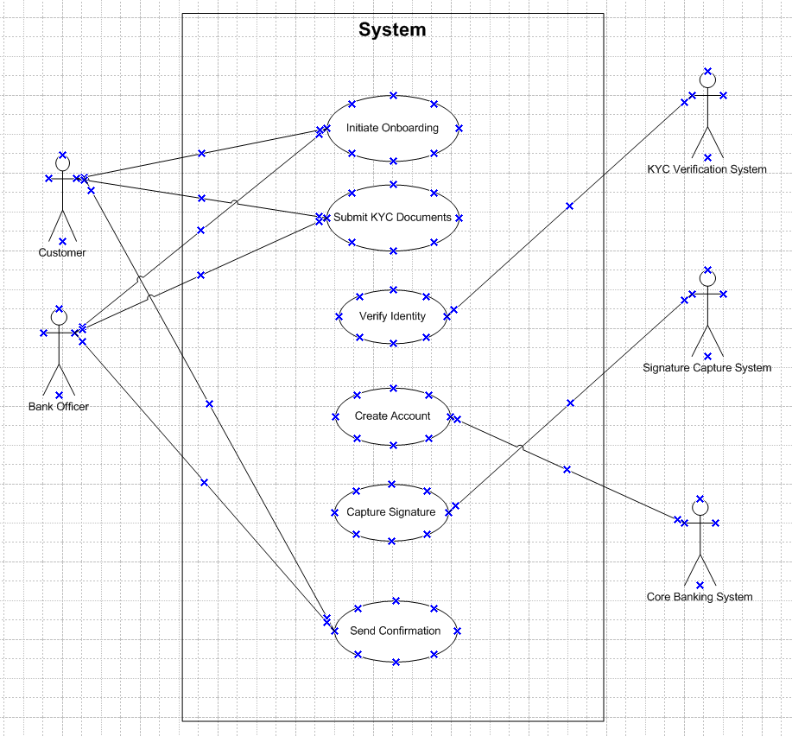
Activity Diagram:
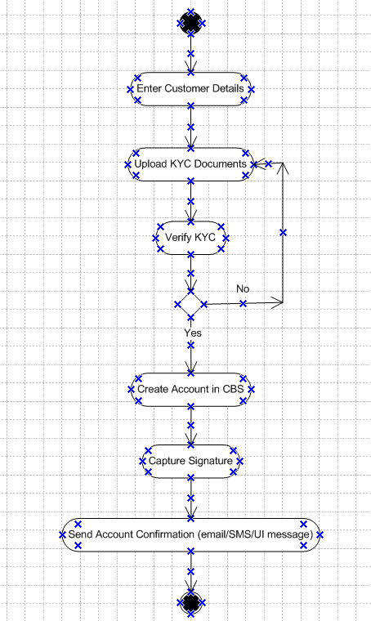

Document 7- Screens and pages Please follow the following steps to create the mock-ups.
Home Screen: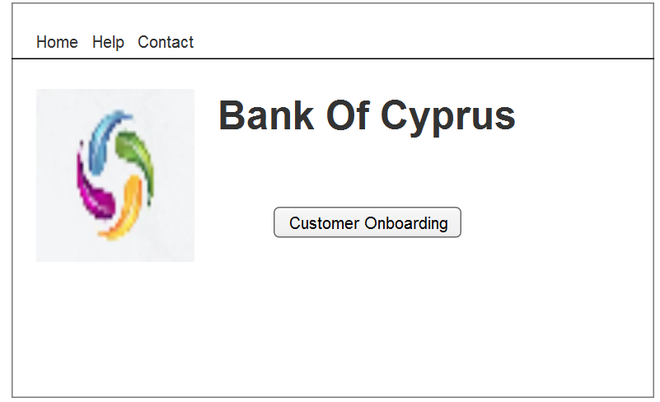
Login Screen:
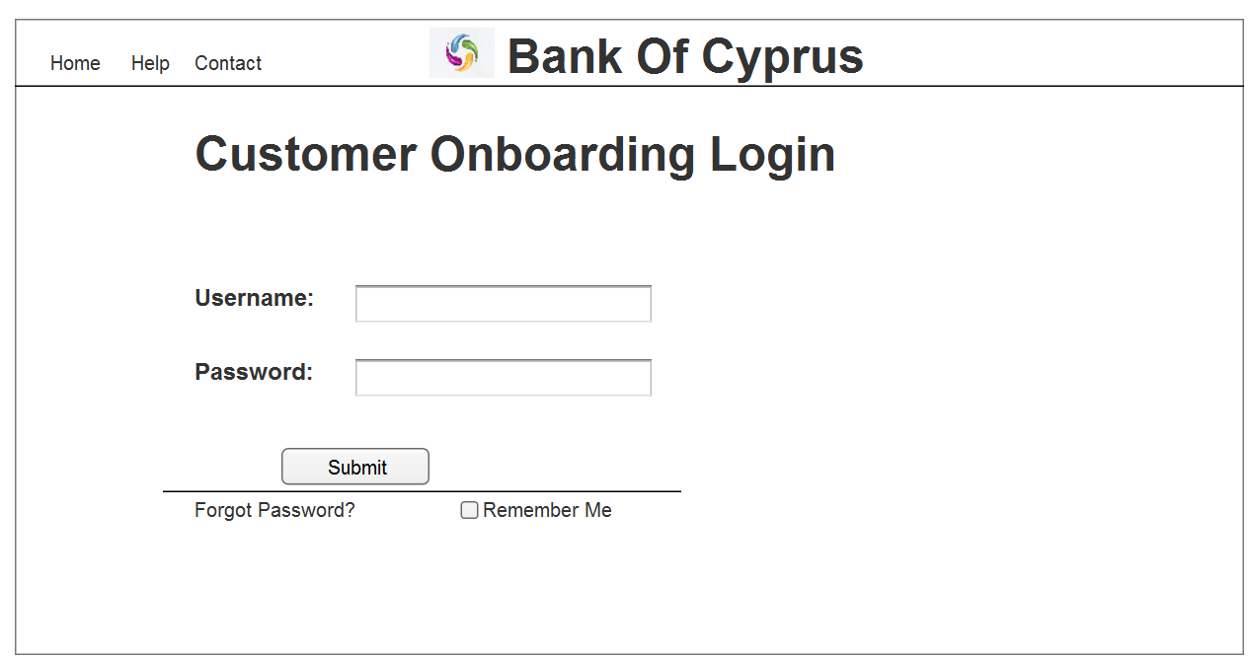

Personal Form Screen: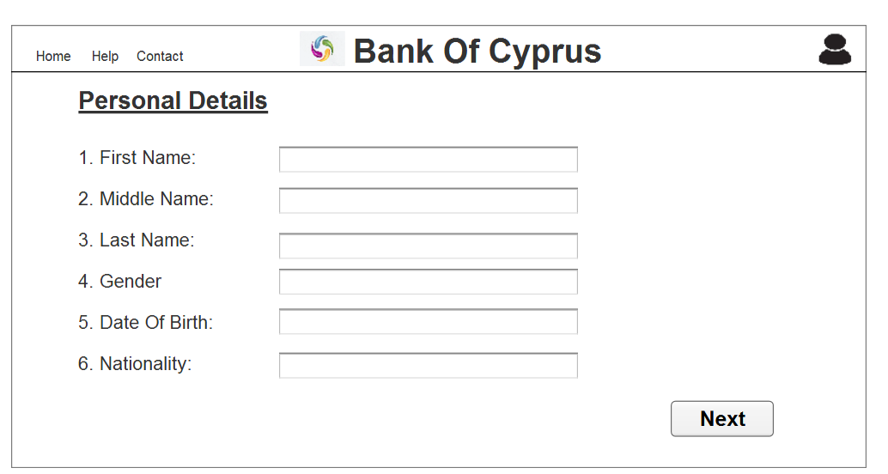
Contact & Address Form Screen:
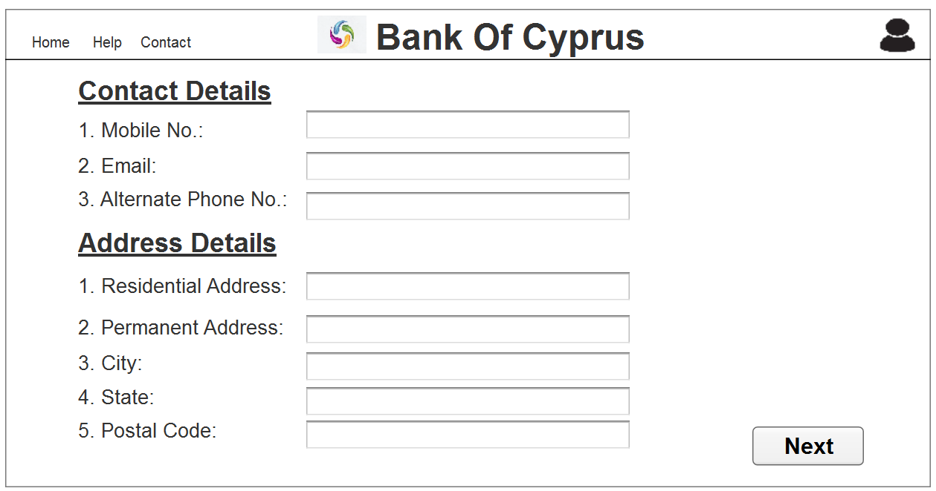

Upload Document Screen:
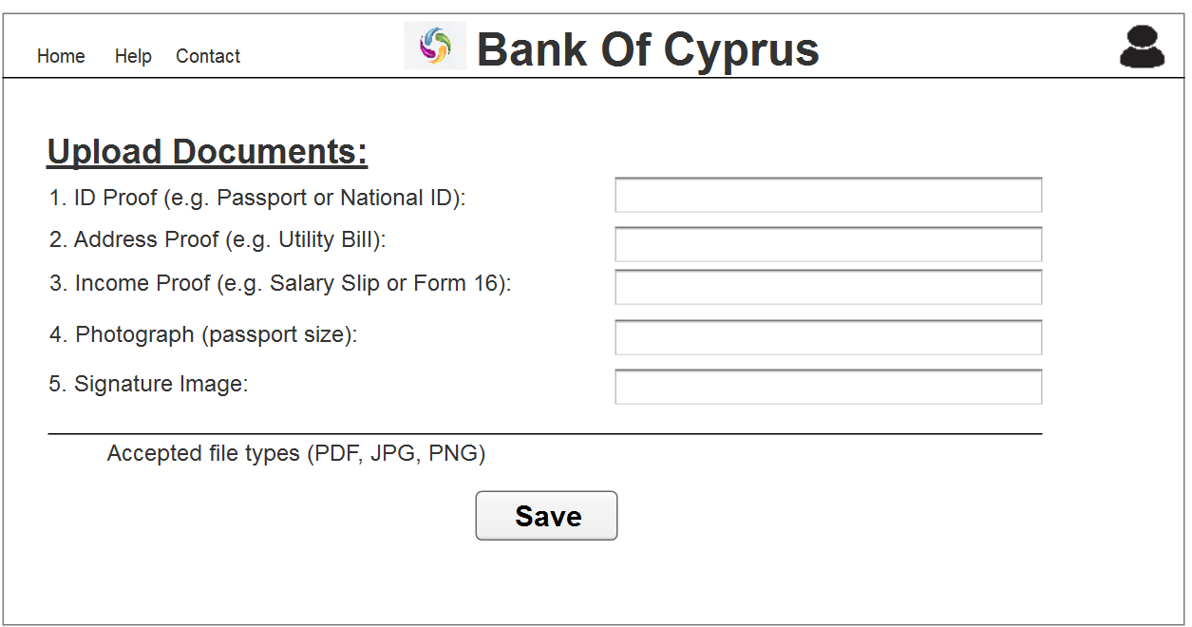
Final Screen:
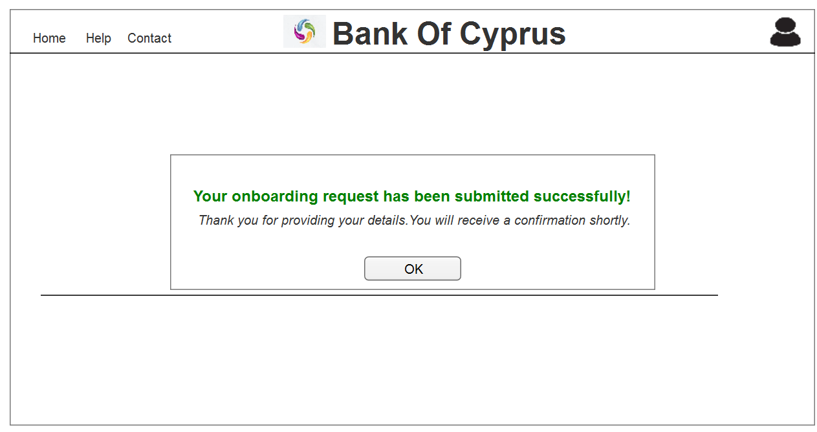

Document 8- Tools-Visio and Axure Write a paragraph on your experience using Visio and Axure for the project.
- For the Bank of Cyprus onboarding project, both Vision and Axure proved highly effective in visualizing and validating the system design.
- Visio was particularly useful for creating clear and structured diagrams, such as the use case and activity diagrams, which helped communicate complex workflows in a simplified manner to stakeholders.
- Its drag-and-drop interface made it easy to represent actors, processes, and data flow. On the other hand, Axure was instrumental in developing interactive wireframes and mock-ups.
- It allowed for rapid prototyping of user interfaces with clickable elements, enabling early testing of user journeys such as customer onboarding, identity verification, and account creation.
- Overall, using Visio and Axure together streamlined the documentation process and improved clarity and feedback during review sessions.

Document 9- BA experience My experience as BA in following phases: 1. Requirement gathering: 2. Requirement Analysis: 3. Design: 4. Development: 5. Testing: 6. Deployment:
- Requirement Gathering:-
- In this phase I actively engaged with stakeholders including business users, technical teams and compliance units to understand the goals and expectations of the system.
- I conducted interviews, workshops and used observations techniques to capture both functional and non-functional requirements.
- I also created stakeholders requirement lists, documented pain points in the existing onboarding process and ensure alignment with regulatory standards.
- Requirement Analysis:-
- After gathering the requirements, I analyzed them to identify gaps, ambiguities and conflicts.
- I created use cases, process flows and user stories to break down complex scenarios into actionable items.
- I collaborated with technical teams to assess feasibility and with business teams to prioritize based on impact and value.
- Tools like MoSCoW and FURPS helped in organizing and validating requirements.
- Design:-
- During the design phase I worked closely with the UI/UX team and system architects to ensure the solution aligned with the user needs and system capabilities.
- I created wireframes using Axure and contributed to mock-ups showing the complete onboarding journey.
- I reviewed screens flows, forms and validation logic to ensure they supported a smooth and intuitive customer experience.
- Development:-
- While not directly involved in coding I acted as a bridge between developers and stakeholders.
- I clarified business rules, provided additional details when needed and ensured development aligned with approved specifications.
- I updated documentation and handled change requests effectively during sprint reviews or change control meetings.
- Testing:-
- I participated in UAT (User Acceptance Testing) by creating test scenarios and validating them against business requirements.
- I supported QA teams by ensuring test cases covered all business rules and exceptional flows.
- I documented defects and worked with developers to resolve issues promptly.
- My involvement ensured that the final solution met both functional and regulatory expectations.
- Deployment:-
- For deployment, I assisted in preparing user guides, training materials, and transition documents.
- I worked with the release management team to confirm that all configurations and data were production ready.
- I also supported post-deployment activities, collected user feedback, and helped with process stabilization and continuous improvements.

