Capstone Project 1 – Part 2/3 – Answers
Project: Online Agriculture Products Store
Q.1 Quarterly Audits are planned Q1, Q2, Q3, and Q4 for this Project what is your knowledge on how these Audits will happen for a BA?

Audit: Inspection of work for quality and for progress stds.
As a BA we are responsible to update the progress of the project to the responsible stakeholder
Concerning document need to be shared based on audit requirement.
Audit can be Internal means same company doing the audit some time External it can be by client or third party
Stage | Quarter 1 Audit Report  (Requirement gathering phase)
Completed | 10 weeks (Week 1 to Week 10)
Checklist | BRD template prepared for Online Agriculture Products Store  Elicitation results documented from stakeholders (Mr. Henry, Peter, Kevin, Ben)  Duplicate requirements identified and resolved  Grouping of functionalities/features with client signoff (e.g., product catalog, search, login, payment)  Email communication tracked (To, CC, BCC)

Stage | Quarter 2 Audit Report  (Requirement analysis phase)
Completed | 7 weeks (Week 16 to Week 23)
Checklist | UML diagrams created (Use Case, Activity) for product search, login, order, and payment processes  Business to functional requirements mapping completed  Client signoff on requirement documents (including BR001–BR002 and others)  RTM (Requirements Traceability Matrix) document version control maintained  Email communication recorded (To, CC, BCC)

Stage | Quarter 3 Audit Report  (Design Phase)
Completed | 7 weeks (Week 30 to Week 37)
Checklist | Utilization of tools for UI/UX design and database schema design  Documented evidence on client communication for approval of wireframes and screen mock-ups  Stakeholder MOM (Minutes of Meeting) for design finalization  Email communication maintained (To, CC, BCC)

Stage | Quarter 4 Audit Report  (Development Phase)
Completed | 20 weeks (Week 40 to Week 60)
Checklist | JAD (Joint Application Development) session reports for integration of modules (login, catalog, search, payment, delivery tracking)  End-user manual preparation document initiated  BA and developer MOM for sprint updates  Email communication tracked (To, CC, BCC)

Stage | Quarter 5 Audit Report  (Testing Phase)
Completed | 20 weeks (Week 58 to Week 78)
Checklist | Test case summary for functional and UAT testing  Training report to end-users (farmers and manufacturers)  Lessons learned document prepared  Email communication recorded (To, CC, BCC)

Question 2 – BA Approach Strategy - 6 Marks
Before the Project is going to Kick Start, The Committee asked Mr Karthik to submit BA Approach
Strategy Write BA Approach strategy (As a business analyst, what are the steps that you would need to follow to complete a project – What Elicitation Techniques to apply, how to do Stakeholder Analysis RACI/ILS, What Documents to Write, What process to follow to Sign off on the Documents, How to take Approvals from the Client, What Communication Channels to establish n implement, How to Handle Change Requests, How to update the progress of the project to the Stakeholders, How to take signoff on the UAT- Client Project Acceptance Form )
Your Team Project Manager - Mr Vandanam Senior
Java Developer - Ms. Juhi
Java Developers - Mr Teyson, Ms Lucie, Mr Tucker, Mr Bravo
Network Admin - Mr Mike
DB Admin - Mr John.

Business Analyst (BA) Approach Strategy

1. Understanding the Project Scope
- Review project charter and CSR initiative details (Budget: ₹2 Cr, Duration: 18 months).
- Understand high-level goals:
  - Connect farmers with manufacturers of fertilizers, seeds, pesticides.
  - Enable product search, ordering, payment, and delivery tracking via web/mobile app.

2. Elicitation Techniques to Apply
- Document Analysis – Study existing product catalogs, farmer order processes.
- Stakeholder Interviews – Meet Mr. Henry, Peter, Kevin, Ben, and the technical team.
- Workshops / JAD Sessions – Collaborate with developers, testers, and client committee.
- Prototyping – Create wireframes for login, search, product upload, payment pages.
- Brainstorming – Generate feature ideas with client and dev team.

3. Stakeholder Analysis

Stakeholder | Role | Interest | Influence
Mr. Henry | Project Sponsor | CSR initiative success | High
Mr. Pandu, Mr. Dooku | Client-side Committee | Budget & scope control | High
Peter, Kevin, Ben | Farmer Representatives | Easy access to products | Medium
APT Dev Team | Development | Build product as per BRD | High

4. RACI Matrix
Task | R (Responsible) | A (Accountable) | C (Consulted) | I (Informed)
Requirements Gathering | BA | PM | Stakeholders | Dev & Test teams
BRD Signoff | BA | Client Committee | PM | Dev & Test teams
UAT Signoff | Client Stakeholders | Sponsor | BA, PM | Dev Team

5. Documents to Prepare
- Business Requirement Document (BRD)
- Functional Requirement Specification (FRS)
- Requirements Traceability Matrix (RTM)
- Use Case Specifications & UML diagrams
- Meeting Minutes (MOM)
- Change Request Log
- UAT Signoff Form

6. Document Sign-off Process
- Prepare draft document.
- Share with stakeholders for review.
- Incorporate feedback.
- Final review meeting.
- Obtain written/email signoff.
- Store approved version in project repository.

7. Client Approval Process
- All major deliverables (BRD, FRS, design wireframes, UAT results) to be sent to the client committee.
- Approvals via email or digitally signed documents.

8. Communication Channels
- Primary: Email, Project Management Tool (Jira / Trello)
- Meetings: Weekly status calls, bi-weekly sprint review meetings, monthly steering committee review
- Documentation: Shared on secure cloud repository

9. Change Request Handling
- Receive CR from stakeholder.
- Log into Change Request Log.
- Impact analysis with dev, test, PM.
- Client approval on scope/budget/timeline impact.
- Update RTM and relevant documents.

10. Progress Updates
- Weekly status report to PM and client.
- Sprint demos for client review.
- Monthly milestone reports for committee.

11. UAT & Client Project Acceptance
- Prepare UAT plan and test cases.
- Conduct UAT with farmers & manufacturers.
- Capture defects, retest fixes.
- Obtain final UAT signoff on Client Project Acceptance Form.

Question 3 – 3-Tier Architecture

IT application can be viewed in 3 layers
1. Application layer /Presentation Layer (UI) – Interface for farmers and manufacturers. (We have Screens, pages, Validation on page, company specific logic, Functionality)

2. Business Logic Layer – Processes requests and applies rules.
All Re-usable components, Frequently changing components, Goerning Body Rules & Regulations, Compliances ...
Example : Printer, Payment gateways, Mail Servers
RBI rules for Banks, IRDA rules for insurance
3. Data Layer – Stores and retrieves data.
Data base components connecting to the databases.
it is not the database it is the database components that connects to database
Ex : Front end application .net and backend is SQL server
here in the screen not database server SQl it is the .net that connects to sql server

Question 4 – BA Approach Strategy for Framing Questions

Apply 5W & 1H Technique
Before asking a question, ensure it covers the key aspects:
- What – What feature or process is being discussed?
Example: "What product categories should be available in the catalog?"
- Why – Why is this feature needed?
Example: "Why do we need both COD and UPI payment options?"
- Who – Who will use the feature? (Farmer, Manufacturer, Admin)
Example: "Who will approve product listings uploaded by manufacturers?"
- Where – Where will the functionality be accessed? (Web, Mobile)
Example: "Where will farmers track their delivery status — in the app, email, or both?"
- When – When should this process occur? (Trigger events)
Example: "When should the order confirmation email be sent?"
- How – How should the process work step-by-step?
Example: "How will the delivery tracking system be updated in real time?"

2. Ensure Questions Follow SMART Principles
- Specific – Clear and focused ("Which payment gateway do you prefer: Razorpay or PayU?")
- Measurable – Can be validated ("How many product categories should be visible on the home page?")
- Achievable – Realistic for the project timeline/budget ("Can we launch with 3 payment methods and add more later?")
- Relevant – Linked to business goals ("Do we need offline order support for low-internet regions?")
- Time-bound – Include deadlines ("When do you expect the manufacturer portal to be ready?")

3. Keep RACI Roles in Mind
- Know who to ask for what type of question:
  - Responsible (Dev/Test team) – Technical feasibility questions.
  - Accountable (PM, Sponsor) – Scope, budget, timeline questions.
  - Consulted (Stakeholders like farmers, manufacturers) – User experience & needs.
  - Informed (Others in team) – Share answers for awareness.

4. Relate Questions to 3-Tier Architecture
- Presentation Layer – "How should the search page look for farmers?"
- Business Logic Layer – "What rules should apply for free delivery eligibility?"
- Data Layer – "What product details must be stored in the database?"

5. Link to Use Cases & Specs
- Ask questions that clarify actors, preconditions, and flows.
Example: "If a farmer forgets their password, should they reset via OTP, email, or both?"

6. Relate to Activity Diagrams
- Ask about decision points and process flow.
Example: "After payment is made, should the order go directly to the manufacturer or pass through admin approval?"

Connect with Models & Page Designs
Models are visual representations of requirements, processes, or data that help everyone understand the system without ambiguity.
Ex: Use case diagram, Activity diagram, data model
Page designs (also called wireframes or UI mockups) are visual layouts of how screens will appear to the end-user.
Ask UI/UX-focused questions.
Ex: Log in page (Email Id, Password fields, “Create Account” link, and Forgot password option.)
Product catalog page,( Product images, names, price, “Add to Cart” button, filters) etc..

Question 5 – Elicitation Techniques

Common elicitation techniques a BA can use include (BDRFOWJIPQU):
1. Brainstorming
2. Document Analysis
3. Reverse Engineering
4. Focus Groups
5. Observation
6. Workshops
7. JAD (Joint Application Development)
8. Interviews
9. Prototyping
10. Questionnaires/Surveys
11. Use case Spec

Question 6 – This Project Elicitation Techniques
Prototyping: To visualize system features before actual development.
Since Mr. Henry and the farmers may not be familiar with technical documents, prototypes (wireframes/mock-ups) help them understand how the Register page, log in , payment page, and wish list / cart tracking
Use Case Specifications: To document user interactions with the system in detail.
Farmers and manufacturers have different system roles. Use case specs ensure all actor interactions are clearly captured (e.g., “Farmer logs in, searches for product, adds to cart, makes payment, and receives confirmation email”). This helps developers build exactly what’s required.

Document Analysis: To understand existing processes and product information.
Reviewing existing manufacturer product catalogs, current sales records, and delivery workflows ensures that the new system can integrate necessary product details like fertilizer types, seed varieties, pesticide brands. Example: Analyzing current order forms to decide database fields.

Brainstorming: To generate ideas and features collaboratively.
Involving Mr. Henry, farmer representatives (Peter, Kevin, Ben), and technical team in brainstorming helps refine features (e.g., including “Buy Later” option, delivery tracking updates, multiple payment modes). This ensures user-friendly and innovative solutions.

Identified Business Requirements (BR) – Online Agriculture Product Store

Req ID | Business Requirement
BR001 | Farmers should be able to search for available products in fertilizers, seeds, pesticides.
BR002 | Manufacturers should be able to upload and display their products in the application.
BR003 | Farmers should be able to browse the product
BR004 | Farmers should be able to log in using email ID and password.
BR005 | New farmers should be able to create an account with email ID and secure password.
BR006 | Farmers should be able to add products to a "Buy Later" list.
BR007 | The system should provide an easy-to-use payment gateway with COD, credit/debit card, and UPI options.
BR008 | Farmers should receive an email confirmation after placing an order.
BR009 | Farmers should be able to track the delivery status of their orders.
BR010 | The system should allow manufacturers to manage their listed products and update details.

Question 7 – 10 Business Requirements

BR001 – Farmers should be able to search for products (fertilizers, seeds, pesticides).
BR002 – Manufacturers should upload and display their products.
BR003 – Farmers can create a new account and log in.
BR004 – Secure payment gateway with COD, Credit/Debit, and UPI.
BR005 – Email confirmation for orders.
BR006 – Delivery tracking feature.
BR007 – Product catalog with category-wise browsing.
BR008 – Wishlist / Buy Later functionality.
BR009 – Mobile-responsive interface.
BR010 – Role-based access control (Farmer, Manufacturer, Admin).

Question 8 – Assumptions

All farmers and manufacturers have internet access.
Farmers have basic knowledge of using mobile or web apps.
Payment gateways are already approved for integration.
Delivery partners are available for remote locations.
Manufacturers will provide accurate product details and images.

Question 9 – Requirements Priority

Req ID | Req Name | Req Description | Priority
BR001 | Farmer Search | Farmers search for products in fertilizers, seeds, pesticides | 8
BR002 | Manufacturers Upload | Manufacturers upload and display products | 8
BR003 | Account Management | Create new account and login | 9
BR004 | Payment Gateway | Multiple payment options | 10
BR005 | Email Confirmation | Order status email notifications | 7
BR006 | Delivery Tracking | Track order location/status | 9
BR007 | Product Catalog | Category-wise browsing | 8
BR008 | Wishlist | Add items to buy later | 6
BR009 | Responsive UI | Mobile-friendly interface | 7
BR010 | Role-based Access | Different access for users | 7

Question 10: Use Case Diagram

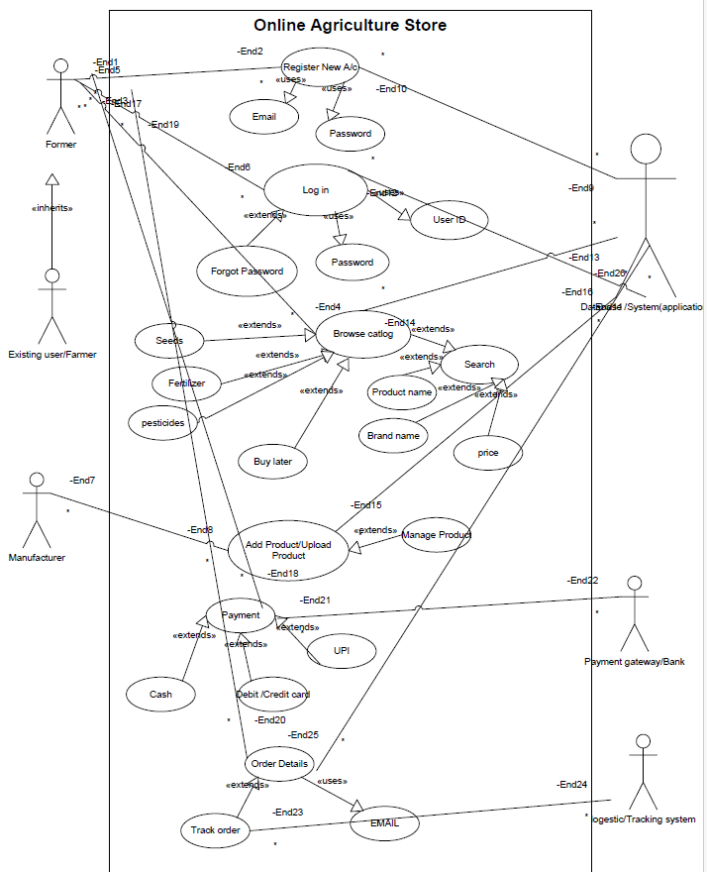

Mock-ups

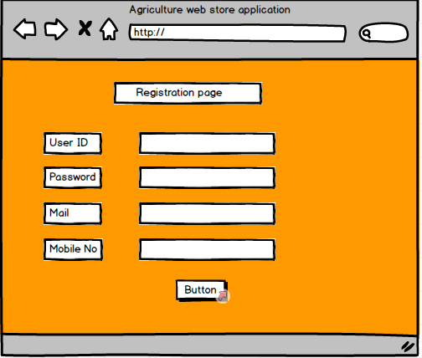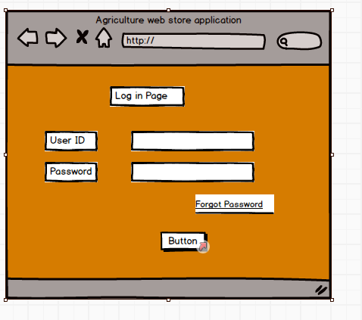

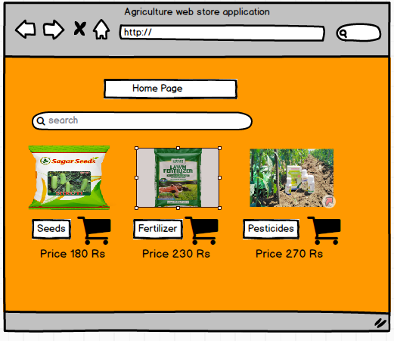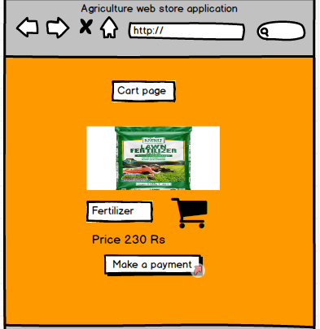

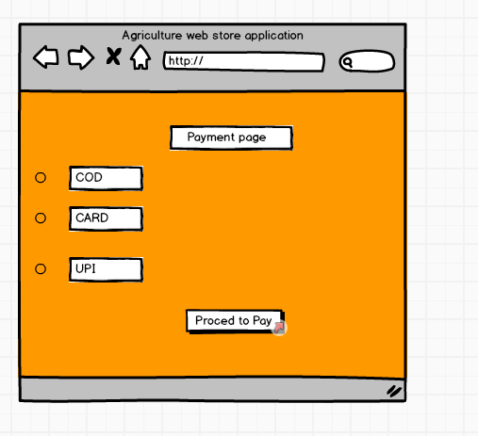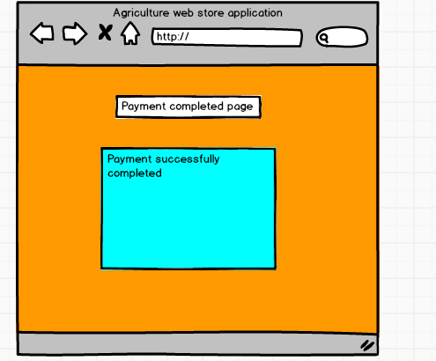

Question 11 – Use Case Specs

Use Case ID | UC5
Use Case Name | Create Account
Use Case Description | Farmer creates a new account
Actor | Farmer
Pre-Conditions | Farmer has not registered earlier
Basic Flow | 1. Farmer clicks 'Sign Up'  2. Farmer provides email ID and password  3. System validates inputs and creates account
Alternative Flow
Exceptional Flow | If email already exists, show error
Post-Conditions | New account is created
Key Scenarios | Successful account creation, duplicate account
Special Requirements | Unique email validation

Use Case ID | UC4
Use Case Name | Login
Use Case Description | Farmer logs into the system
Actor | Farmer
Pre-Conditions | Farmer has registered an account
Basic Flow | 1. Farmer enters email ID and password  2. System validates credentials  3. System grants access to dashboard
Alternative Flow | Forgot password option for recovery
Exceptional Flow | Invalid credentials show error message
Post-Conditions | Farmer is logged in successfully
Key Scenarios | Valid login, invalid login
Special Requirements | Secure password validation

Use Case ID | UC1
Use Case Name | Search Products
Use Case Description | Farmer searches products by keyword
Actor | Farmer
Pre-Conditions | Farmer is on the application home page
Basic Flow | 1. Farmer enters search keyword  2. System displays matching products
Alternative Flow
Exceptional Flow | If no products found, system shows 'No results found' message
Post-Conditions | Relevant product results are displayed
Key Scenarios | Search for fertilizers, seeds, pesticides
Special Requirements | Search should be fast and support partial matches

Use Case ID | UC6
Use Case Name | Add to 'Buy Later'
Created By
References
Use Case Description | Farmer adds a product to 'Buy Later' list.
Actor (Primary & Secondary) | Farmer
Pre-Conditions | Farmer is logged in.
Basic Flow | 1. Farmer selects a product  2. Farmer clicks 'Add to Buy Later'  3. System saves product in list
Alternative Flow | -
Exceptional Flow | -
Post-Conditions | Product saved in 'Buy Later' list.
Key Scenarios | -
Special Requirements | -

Use Case ID | UC7
Use Case Name | Make Payment
Created By
References
Use Case Description | Farmer makes payment for items in cart.
Actor (Primary & Secondary) | Farmer, Payment Gateway
Pre-Conditions | Farmer has items in the cart.
Basic Flow | 1. Farmer proceeds to checkout  2. Selects payment method  3. System processes payment  4. Confirmation received
Alternative Flow | Retry if payment fails.
Exceptional Flow | Payment gateway error.
Post-Conditions | Payment completed, order confirmed.
Key Scenarios | -
Special Requirements | -

Question 12 – Activity Diagrams
Activity Diagram For user Registration & Login
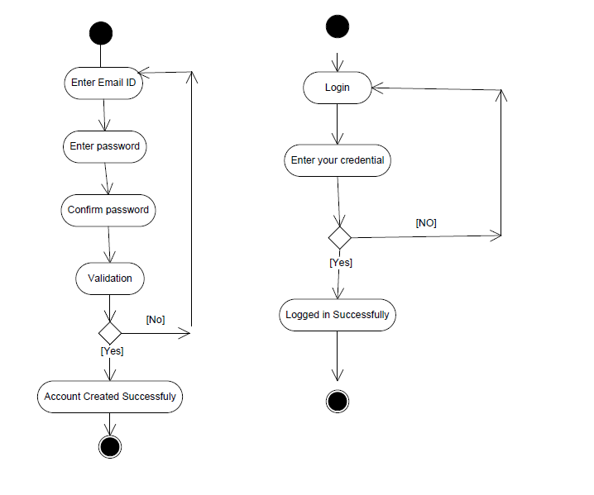

2. Browse Catalogue

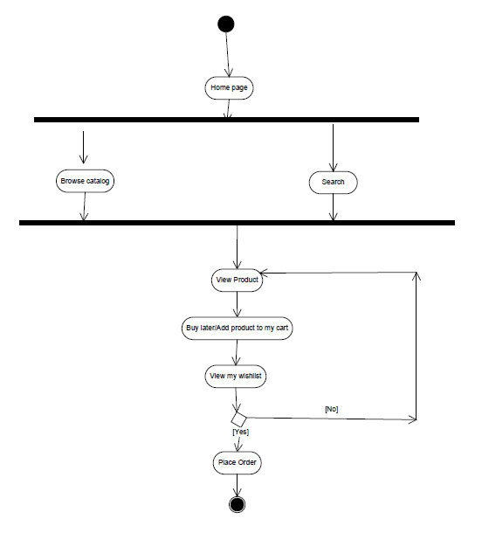

3. Search
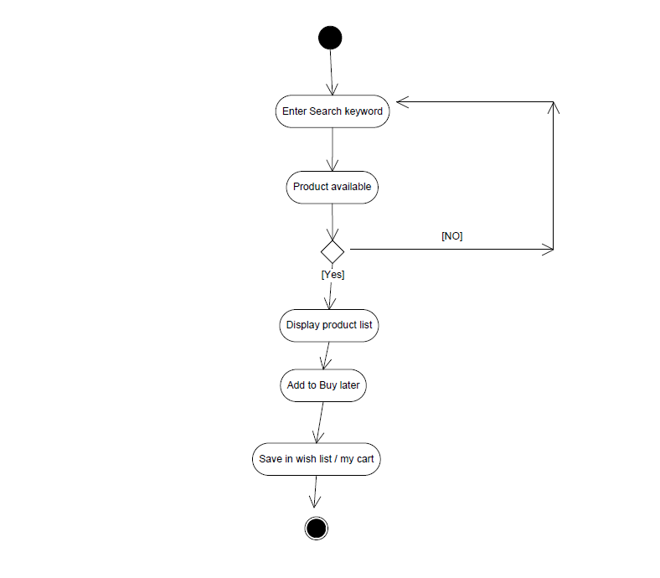

4. Payment

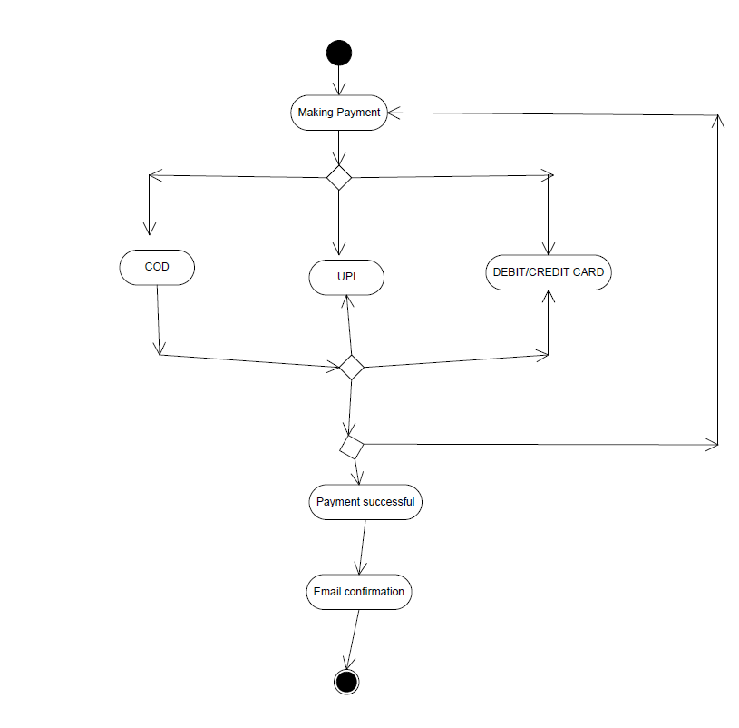
- Track order
