Requesting For Tools Installation
I Sudhakar Jenilesh A, enrolled for Business Analyst Training with COEPD, hereby voluntarily declare that, I completed BA Workshop sessions. I request COEPD to support me in installing the tools in my system. I understood that,
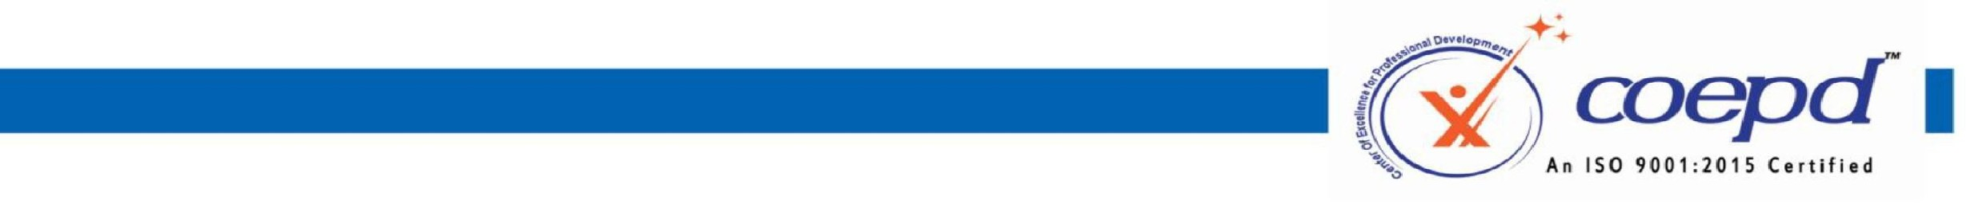

MAC, Linux etc.,
1.
Tools
Installation
will
done
only
one
time
through
Coepd
portal.
In
case
of
losing
application
from
system,
Coepd
is
not
responsible
for
re-installation.
2.
Tools
installation
support
is
complementary
to
the
training
3.
COEPD
is
not
liable
for
any
damages
caused
during
the
installation
process
4.
These
Tools
are
Trail
Versions
and
works
during
the
trial
period
only.
5.
COEPD
will
install
the
tools
only
in
the
OS
supported
by
Microsoft,
and
will
not
be
responsible
for
the
other
OS
’
s
like
6.
Aspirant
should
buy
the
actual
license
after
the
expiry
of
trail
period.
Signature of the student:Jenilesh
Name of the Student:Sudhakar Jenilesh A
Batch Start date: June 7th 2025
Request Date:July 8th 2025

3rd Floor, Sahiti Arcade, Beside S.R. Nagar Police Station, S.R. Nagar, Hyderabad - 500038
www.coepd.cominfo@coepd.com

