Nurturing Process - Capstone Project2 –Agile-Scrum
Question 1: Write Agile Manifesto?
Answer: It is a foundational document for agile software development. It was created by a group of software developers and thought leaders to provide guiding principles and values that prioritize collaboration, adaptability and delivering high quality software. The Agile Manifesto reflects a shift from traditional, rigid project management approaches to more flexible and iterative development.
The 4 core values:
Agile values item on left more than those on right:
- Individuals and interaction over processes and tools.
- Working software over Comprehensive Documentation
- Customer collaboration over Contract Negotiation
- Responding to change over following a plan

The Agile Manifesto is supported by 12 Principles:
- Satisfy the customer through early and continuous delivery of valuable software.
- Welcome changing requirement even late in development. Agile process harness change for customer’s competitive advantage.
- Delivery working software frequently, from a couple of weeks to a couple of months with preference to the shorter timescale.
- Business people and developers must work together daily throughout the project.
- Build project around motivated individuals. Give them environment and support they need and trust them to get the job done.
- The most effective and efficient method of conveying information to and within a development team is face to face conversation.
- Working software is the primary measure of progress.
- Agile process promote sustainable development. The sponsors, developers and user should be able to maintain a constant pace indefinitely.
- Continuous attention to technical excellence and good design enhance agility.
- Simplicity- the art of maximising the amount of work not done is essential.
- The best Architect and designs emerge from self-organising team.
- At regular intervals, the team reflect on how to become more effective then tunes and adjust its behaviour accordingly.

Question 2: Write minimum 40 user stories and their Acceptance Criteria along with their BV and CP?
Answer:
User Story No: 1 | Tasks: 2 |  | Priority: HIGHEST
AS A DELIVERY BOY
I WANT TO REGISTER IN SCRUM FOOD
SO THAT I CAN DELIVER ORDER
BV: 500 |  | CP: 02
ACCEPTANCE CRITERIA:
Registration Screen
Text Boxes for Username, Password, Nation ID, Mobile Number, Email, Address, Phone Number
Click on Registration button
Send Registration successful message to the User

User Story No: 2 | Tasks: 2 |  | Priority: HIGHEST
AS A RESTAURANT OWNER
I WANT TO VIEW ORDERS
SO THAT I CAN DELIVER ORDER
BV: 500 |  | CP: 02
ACCEPTANCE CRITERIA:
View order, Display lists of Orders in tabular form

User Story No: 3 | Tasks:2 |  | Priority: HIGHEST
AS A CUSTOMER
I WANT TO ADD THE ADDRESS
SO THAT I CAN GET THE ORDER TO MY ADDRESS
BV: 500 |  | CP: 02
ACCEPTANCE CRITERIA:
Text Box to enter
Business Rule: within the radius of 10 km

User Story No: 4 | Tasks:2 |  | Priority: HIGHEST
AS A CUSTOMER
I WANT TO SELECT PAYMENT MODE
SO THAT I CAN MAKE PAYMENT OF MY CHOICE
BV: 500 |  | CP: 03
ACCEPTANCE CRITERIA:
Display payment mode, Radio buttons to select payment modes, payments button.
Business Rule : can select only one payment mode

User Story No: 5 | Tasks: 2 |  | Priority: HIGHEST
AS AN ADMIN
I WANT TO VIEW THE RESTAURANTS
SO THAT I CAN APPROVE THE REGISTRATION
BV: 500 |  | CP: 02
ACCEPTANCE CRITERIA:
Lists of Restaurants, select Restaurants, verify Restaurant Details, approve button, Reject button, notification to the restaurant

User Story No: 6 | Tasks: 2 |  | Priority: LOW
AS A CUSTOMER
I WANT TO VIEW THE RESTAURANT
SO THAT I CAN ORDER THE FOOD
BV: 50 |  | CP: 01
ACCEPTANCE CRITERIA:
Display price in the lists of Menu item

User Story No: 7 | Tasks: 2 |  | Priority: LOW
AS A CUSTOMER
I WANT TO VIEW THE CONTACT NUMBER OF DELIVERY BOY
SO THAT I CAN CONTACT DELIVERY BOY FOR THE STATUS OF DELIVERY
BV: 50 |  | CP: 01
ACCEPTANCE CRITERIA:
Display delivery boy mobile number
Display delivery boy name in tracking field

User Story No: 8 | Tasks: 2 |  | Priority: MEDIUM
AS A RESTAURANT OWNER
I WANT TO PROVIDE TIME SLOTS
SO THAT CUSTOMER CAN CHECK OPENING AND CLOSING HOURS
BV: 100 |  | CP: 02
ACCEPTANCE CRITERIA:
Click on restaurant dashboard
Add from time to time
Click on submit
Display updated successfully

User Story No: 9 | Tasks: 2 |  | Priority: HIGH
AS A BUSINESS OWNER
I WANT TO VIEW RESTAURANT REVENUE REPORT
SO THAT I CAN VIEW RESTAURANTS REVENUE
BV:200 |  | CP: 03
ACCEPTANCE CRITERIA:
Select reports
Select revenue reports
Select to and from date
Select region (can select all)
Generate report
Download report in Excel

User Story No: 10 | Tasks: 3 |  | Priority: HIGHEST
AS A REGISTERED ADMIN
I WANT TO MANAGE REGIONAL RESTAURANT
SO THAT I CAN TRACK THE PERFORMANCE OF REGIONAL RESTAURANT
BV: 200 |  | CP: 03
ACCEPTANCE CRITERIA:
Click on performance of restaurants
Select from date to date
Click on generate report which include Restaurants ID, Name, Revenue
Click on download report which should be in excel

User Story No: 11 | Tasks: 2 |  | Priority: HIGHEST
AS A RESTAURANT OWNER
I WANT TO VIEW ORDERS
SO THAT I CAN VIEW THE LIST OF ORDERS IN TABULAR FORM
BV: 500 |  | CP: 02
ACCEPTANCE CRITERIA:
View orders, Display lists of orders in the tabular form

User Story No: 12 | Tasks: 2 |  | Priority: HIGH
AS A CUSTOMER
I WANT TO CHAT WITH REG ADMIN
SO THAT I CAN REQUEST FOR REFUND
BV:200 |  | CP: 02
ACCEPTANCE CRITERIA:
BR all mandatory
Text box field
Display order ID
Text box for description
Submit button generate issue ID
Display successful

User Story No: 13 | Tasks:2 |  | Priority: MEDIUM
AS AN ADMIN
I WANT TO SEE REGIONAL REVENUE REPORTS
SO THAT I CAN VIEW THE REGIONAL PERFORMANCE
BV: 500 |  | CP: 02
ACCEPTANCE CRITERIA:
View orders, display lists of orders in the tabular form

User Story No: 14 | Tasks: 2 |  | Priority: HIGHEST
AS A CUSTOMER
I WANT TO REGISTER IN SCRUM FOOD
SO THAT I CAN LOGIN IN SCRUM FOOD APPLICATIONS
BV: 200 |  | CP: 04
ACCEPTANCE CRITERIA:
Registration screen
Text boxes for username, Password, Mobile number, Email ID, Address, Click on Register button
Send successfully registered notification to the user

User Story No: 15 | Tasks:2 |  | Priority: HIGHEST
AS A CUSTOMER
I WANT TO LOGIN IN SCRUM FOODS
SO THAT I CAN USE THE SCRUM FOOD APPLICATION
BV: 200 |  | CP: 04
ACCEPTANCE CRITERIA:
Login screen
Text boxes for username, Password, click on Login Button

User Story No: 16 | Tasks: 2 |  | Priority: HIGHEST
AS A CUSTOMER
I WANT A SEARCH OPTION IN SCRUM FOOD APPLICATION
SO THAT I CAN SEARCH RESTAURANTS TO ORDER FOOD
BV:200 |  | CP: 04
ACCEPTANCE CRITERIA:
Text boxes for Search menu, show restaurant details
Enable Search option to display list of restaurants to order food

User Story No: 17 | Tasks: 2 |  | Priority: HIGHEST
AS A CUSTOMER
I WANT TO VIEW RESTAURANT MENU IN THE SCRUM FOOD APPLICATION
SO THAT I CAN ORDER FOOD FROM RESPECTIVE RESTAURANT
BV: 500 |  | CP: 02
ACCEPTANCE CRITERIA:
View the list of restaurants and Menu cards in tabular form
Show available menu list of the restaurants

User Story No :18 | Tasks:2 |  | Priority: HIGHEST
AS A CUSTOMER
I WANT TO ORDER FOOD FROM RESTAURANT LISTED IN SCRUM FOOD APPLICATION
SO THAT I CAN ORDER FOOD FROM RESPECTIVE RESTAURANT
BV: 200 |  | CP: 04
ACCEPTANCE CRITERIA:
Login, show the list of available restaurants
Display menu cards, Enable the customer to select item and place order in application

User Story No: 19 | Tasks:3 |  | Priority: HIGHEST
AS A CUSTOMER
I WANT TO MAKE ONLINE PAYMENT
SO THAT I CAN PAY ONLINE ADVANCE PAYMENT
BV: 500 |  | CP:05
ACCEPTANCE CRITERIA:
Login, Show payment options Net Banking, UPI payments, Credit card
Enable customer to select mode of payment and proceed with the payment option

User Story No: 20 | Tasks:3 |  | Priority: HIGHEST
AS A CUSTOMER
I WANT TO HAVE MY TRACKING ORDER
SO THAT I CAN TRACK MY ORDER ONLINE
BV:500 |  | CP: 05
ACCEPTANCE CRITERIA:
Show status of delivery with the location detail, and expected time of delivery.
Enable the customer to track the delivery of the placed order and expected time of delivery

User Story No: 21 | Tasks: 3 |  | Priority: HIGHEST
AS A CUSTOMER
I WANT THE CANCEL OPTION
SO THAT I CAN CANCEL THE ORDER IN CASE OF A REAS0N
BV: 500 |  | CP: 04
ACCEPTANCE CRITERIA:
Text box for cancel option, order can be cancelled mentioning the reason for cancellation
Display the status as cancelled and process for refund to customer

User Story No: 22 | Tasks: 2 |  | Priority: HIGHEST
AS A CUSTOMER
I WANT FEEDBACK OPTION
SO THAT I CAN ACCEPT THE ORDER AND DELIVERY
BV: 500 |  | CP: 05
ACCEPTANCE CRITERIA:
Text box for feedback option, option to rate the delivery agent

User Story No: 23 | Tasks:3 |  | Priority: HIGHEST
AS A DELIVERY BOY
I WANT TO REGISTER
SO THAT I CAN ACCEPT THE ORDER AND DELIVERY
BV: 500 |  | CP: 05
ACCEPTANCE CRITERIA:
Text Boxes for Username, Password, Mobile Number, Email, Address, Phone Number
Click on Registration button
Send Registration successful message to the User

User Story No: 24 | Tasks: 3 |  | Priority: HIGHEST
AS A DELIVERY BOY
I WANT TO LOGIN THE SCRUM FOOD APPLICTION
SO THAT I CAN VIEW AND ACCEPT THE ORDER FOR DELIVERY
BV: 500 |  | CP: 05
ACCEPTANCE CRITERIA:
Text Boxes for Username, Password, Mobile Number, Email, Address, Phone Number
Click on Login button
Send successful message to the User

User Story No: 25 | Tasks:3 |  | Priority: Highest
AS A DELIVERY BOY
I WANT TO UPDATE THE ORDER STATUS
SO THAT I CAN VIEW AND UPDATE THE DELIVERY STATUS
BV: 500 |  | CP: 02
ACCEPTANCE CRITERIA:
Text box for updating of delivery status and feedback

User Story No: 26 | Tasks: 3 |  | Priority: HIGHEST
AS A DELIVERY BOY
I WANT TO UPDATE PAYMENT STATUS
SO THAT I CAN VIEW AND UPDATE THE PAYMENT STATUS FOR COD
BV:500 |  | CP: 05
ACCEPTANCE CRITERIA:
Text box for updating payment status and feedback

User Story No: 27 | Tasks: 3 |  | Priority: HIGHEST
AS A DELIVERY BOY
I WANT TO LOGIN
SO THAT I CAN VIEW THE FEEDBACK FOR MY DELIVERY
BV: 500 |  | CP:05
ACCEPTANCE CRITERIA:
Text Boxes for Username, Password, Mobile Number, Email, Address, Phone Number
Click on Login button
Send successful message to the User and access to delivery boy

User Story No: 28 | Tasks: 2 |  | Priority: HIGHEST
AS A RESTAURANT OWNER
I WANT TO VIEW DETAILS
SO THAT I CAN VIEW THE LISTS OF ORDERS AND RELATED FEEDBACK FROM CUSTOMER
BV: 500 |  | CP: 05
ACCEPTANCE CRITERIA:
Text Boxes for Username, Password, Mobile Number, Email, Address, Phone Number
Click on Login button
Send successful message to the User and access to restaurant owner

User Story No: 29 | Tasks: 3 |  | Priority: HIGHEST
AS A CUSTOMER
I WANT TO PAYMENT
SO THAT ICAN VIEW MY ORDERS AND PAYMENT RECEIPT
BV: 500 |  | CP: 05
ACCEPTANCE CRITERIA:
Text boxes for reports of placed orders and payments

User Story No: 30 | Tasks: 2 |  | Priority: HIGHEST
AS A BUSINESS OWNER
I WANT TO REGISTER
SO THAT I CAN LOGIN IN SCRUM FOOD APPLICATION
BV: 500 |  | CP: 05
ACCEPTANCE CRITERIA:
Text Boxes for Username, Password, Mobile Number, Email, Address, Phone Number
Click on Registration button
Send Registration successful message to the User

User Story No: 31 | Tasks: 2 |  | Priority: HIGHEST
AS A BUSINESS OWNER
I WANT TO LOGIN
SO THAT I CAN UPDATE VIEW ORDERS, THE PAYMENTS AND OTHER FOR DETAILS OF RESTAURANT
BV: 500 |  | CP: 05
ACCEPTANCE CRITERIA:
Text Boxes for Username, Password, Mobile Number, Email, Address, Phone Number
Click on Login button
Send successful message to the User

User Story No: 32 | Tasks: 2 |  | Priority: HIGHEST
AS AN ADMIN
I WANT TO LOGIN
SO THAT I CAN VIEW THE RESTAURANTS
BV: 500 |  | CP: 05
ACCEPTANCE CRITERIA:
Text Boxes for Username, Password, Mobile Number, Email, Address, Phone Number
Click on Login button
Send successful message to the User

User Story No: 33 | Tasks: 2 |  | Priority: HIGHEST
AS AN ADMIN
I WANT TO VIEW REPORTS
SO THAT I CAN VIEW THE REGINAL REVENUES
BV:500 |  | CP: 05
ACCEPTANCE CRITERIA:
Generate the reports of orders and payment and calculate the revenue

User Story No: 34 | Tasks:2 |  | Priority: HIGHEST
AS A CUSTOMER
I WANT TO RAISE ISSUE
SO THAT I CAN UPDATE THE COMPLAINTS OF DELIVERY AGENTS OR RESTAURANTS
BV: 500 |  | CP: 02
ACCEPTANCE CRITERIA:
Enable to add comments for customer regarding the ratings or any complaints regarding the delivery boys or restaurants

User Story No: 35 | Tasks: 2 |  | Priority: HIGHEST
AS A DELIVERY BOY
I WANT TO LOGIN
SO THAT I CAN VIEW DELIVERY REPORT AND REVENUE GENERATED
BV: 500 |  | CP: 05
ACCEPTANCE CRITERIA:
Reports generated and view delivery report and view revenue generated

User Story No :36 | Tasks: 2 |  | Priority: HIGHEST
AS A RESTAURANT OWNER
I WANT TO LOGIN
SO THAT I CAN UPDATE THE LIST OF FOODS AND AVAILIBILITY
BV:500 |  | CP: 02
ACCEPTANCE CRITERIA:
Text Boxes for Username, Password, Mobile Number, Email, Address, Phone Number
Click on Login button
Send successful message to the User and update the available food and status of availability

User Story No: 37 | Tasks: 2 |  | HIGHEST
AS A CUSTOMER
I WANT TO UPDATE THE ADDRESS
SO THAT I CAN UPDATE THE NEW ADDRESS AS CURRENT ADDRESS
BV: 500 |  | CP:02
ACCEPTANCE CRITERIA:
Modify the address and set as current location

User Story No: 38 | Tasks: 2 |  | Priority: HIGHEST
AS A ADMIN
I WANT TO ACCESS THE FOOD APPLICATION
SO THAT I CAN ADD OR DELETE THE DELIVERY BOY
BV:500 |  | CP: 02
ACCEPTANCE CRITERIA:
Text box to update the addition or deletion of delivery boys

User Story No: 39 | Tasks:2 |  | Priority: HIGHEST
AS A REGIONAL ADMIN
I WANT TOVIEW REPORTS
SO THAT I CAN VIEW REGIONAL REVENUE
BV:500 |  | CP: 02
ACCEPTANCE CRITERIA:
Generate reports region wise and view reports

User Story No: 40 | Tasks: 2 |  | Priority: MEDIUM
AS A CUSTOMER
I WANT TO VIEW THE ORDER LIST
SO THAT I CAN REORDER LAST ORDER
BV:500 |  | CP: 02
ACCEPTANCE CRITERIA:
Display order list and enable user to reorder if order is in the stock

Question 3: What is epic? Write 2 epics
In Agile, an Epic is a large user story that cannot be completed in a single sprint.
It represents a broad business goal or feature that is too big or complex, so it's broken down into smaller user stories for easier planning, development, and delivery
- Epic = Big picture / broad functionality
- User Stories = Smaller pieces of that functionality
Customer Order Management
This epic focuses on all activities a customer performs to place, track, and manage food orders
Restaurant Partner Management
This epic deals with features that help restaurant partners manage their operations on the app
Question 4: What is the difference between BV and CP
Answer:
Aspect | BV (Business Value) | CP (Complexity Points)
What it is | Measures how valuable a feature or user story is to the business or customer | Estimates how complex or time-consuming a task is for the development team
Why it's used | Helps prioritize work based on what delivers the most impact or benefit | Helps the team plan their capacity during a sprint
Who decides it | Usually the Product Owner or stakeholders | Development team during sprint planning
Example | A feature allowing customers to pay online might have high BV (e.g., 1000) as it boosts conversion & convenience | A feature requiring heavy backend integration might have high CP (e.g., 8) due to technical difficulty

Question 5: Explain about Sprint
Section | Details
Definition | A short, focused cycle (1–4 weeks) where the team works on a defined set of tasks or goals. While most common in Agile software projects, it can be applied to many types of work.
Main Characteristics | Fixed Timeframe: Pre-decided duration of 1–4 weeks.  Clear Objective: Each sprint has a Sprint Goal.  Incremental Progress: Delivers a working product increment.  Time-Bound Commitment: Unfinished work is returned to the backlog.
Sprint Activities | Sprint Planning: Choose backlog items, define Sprint Goal, break tasks down.  Daily Scrum: Short update meeting on progress and blockers.  Sprint Execution: Collaborative work to complete planned tasks.  Sprint Review: Present work to stakeholders for feedback.  Sprint Retrospective: Reflect on successes, challenges, and improvements.
Sprint Artifacts | Sprint Backlog: Selected backlog items and tasks for the sprint.  Product Increment: Usable, potentially shippable version of the product.
Benefits | Focused Effort: Targets short-term goals.  Adaptability: Allows quick adjustments to changing needs.  Transparency: Keeps stakeholders updated through reviews.  Continuous Improvement: Retrospectives enhance processes and teamwork.

PBI (Product Backlog Item) | TASKS | WIP | DONE
Registration | 3 | 2 | 1
Loin | 2 | 2 | 0
Add restaurants | 3 | 2 | 1
Order food | 3 | 0 | 3
Make payment | 3 | 3 | 0
Track delivery | 3 | 3 | 0
Customer feedback | 3 | 3 | 0

Question 6: Explain Sprint Backlog and Product Backlog?
Answer: Product Backlog: It is the key artefacts in the scrum framework, representing a prioritised list of work items that the scrum team needs to complete to deliver a product or project. It serves as a single source of truth for all features, enhancement, bug fixes, technical requirements, and other deliverables required to achieve the project goal.
Key characteristics
Dynamic and Evolving: The Product backlog is not static; it evolves over time based on changing requirement, market needs or feedback from stakeholders
Prioritized: Items are ordered by priority, with the most important and valuable items placed at the top. These usually addresses first in Sprint
Refined: items in the backlog are regularly refined or “groomed” to ensure they are ready for future sprints.
Owned by Product Owner: The product owner is responsible for maintaining the Backlog, ensure it align with the product vision and stakeholders need.
Detailed as needed: Items near the top (high priority) are more detailed while those further down can remain less defined until they approach implementation.
Benefits:
Clarity and Focus: provides a clear roadmap of work to be done.
Transparency: keeps the team and stakeholder aligned on priority.
Flexibility: Adapts to changing requirement or feedback.
Facilitates Planning: helps team plan sprint effectively by pulling items from the top.
Sprint backlog: the sprint backlog is the key artefact in the scrum framework that presents the subset of product backlog items selected for a specific sprint, along with the plan to deliver them. It is the Teams working-to-do list during the sprint and includes all the tasks required to meet the Sprint Goal.
Key characteristics
- Subset of Product Backlog: The sprint backlog is derived from the product backlog during sprint planning. It contains only the items team commits to completing during the current sprint.
- Owned by the Development Team: the development team is responsible for managing and updating the sprint backlog throughout the sprint.
- Detailed and clear: Each backlog item is broken into smaller tasks with sufficient detail for the team to understand and work on them.
- Dynamic but Stable: the sprint backlog may evolve slightly as tasks are refined, but the scope of sprint goal should not change.
- Linked to the sprint goal: Every item in the sprint backlog contributes directly to achieve sprint goal.
Benefits:
- Focus: provide team with clear and actionable plan for the sprint.
- Transparency: Helps everyone understand what the team is working on and the progress being made.
- Adaptability: allows the team to manage their work dynamically while maintain alignment with the Sprint Goal.
- Accountability: Ensure teams take ownership of their commitments and progress.
Question 7 – What is impediments log? write 2 impediments
An Impediments Log is a document or tracking system used by the Scrum team to record and monitor any issues, obstacles, or blockers that prevent team members from completing their tasks efficiently during a sprint
These impediments are usually identified during Daily Scrum meetings, and it's the Scrum Master's responsibility to help remove or resolve them quickly
Purpose of Impediments Log:
- Track and document all challenges faced by the team
- Ensure transparency and accountability
- Help the Scrum Master take action to resolve issues early
- Prevent delays in delivery
Impediments Log:
No | Impediment Description | Date Logged | Impact | Status | Resolved By
1 | API not responding for payment gateway integration | 24-Jul-25 | Delaying backend progress | In Progress | Scrum Master
2 | Login page design not finalized by UI/UX team | 25-Jul-25 | Blocking frontend tasks | Pending | Product Owner/UX Team

Question 8: Explain Velocity of the Team?
Answer: Team velocity is a measure of the amount of work a team can take during a single sprint and is the key metric in scrum. When you complete a sprint, you will total the points for all fully completed user stories and over time find the average number of points you complete per sprint.
So, velocity means how many Complexity points (CP) is covered in this sprint and if team has covered 8 CPs hence Velocity of team is 8.
Question 9 – Draw Sprint Burn Charts and Product Burn Down Charts
Answer: Sprint Burn Charts – It is visual tool used in Agile project management to track the progress within a sprint. It helps teams understand how much work remains and whether they are on track to meet their sprint goal.
Types of Sprint Burn charts-
- Sprint Burn charts- Tracks the remaining work overtime during a sprint. Shows a download slope as tasks are complete. Key goal is to ensure the team is completing tasks at a pace to finish the sprint on time.
- Sprint Burn up Chart- Tracks the completed work overtime during a sprint. Shows an upward slope as more tasks are completed. Key goal is to monitor progress towards the sprints total scope.
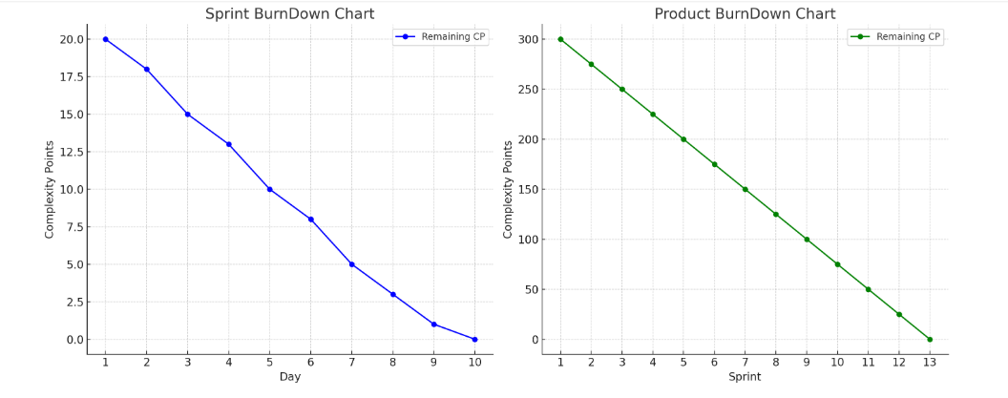

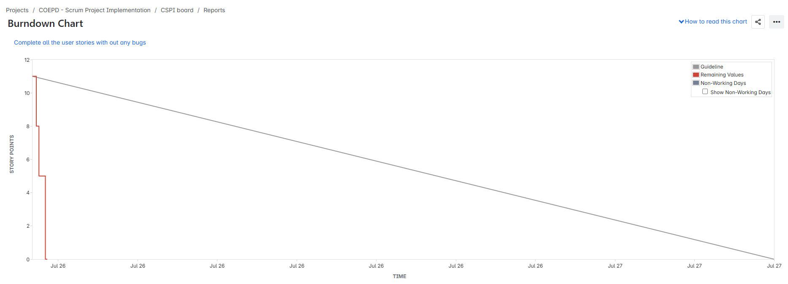
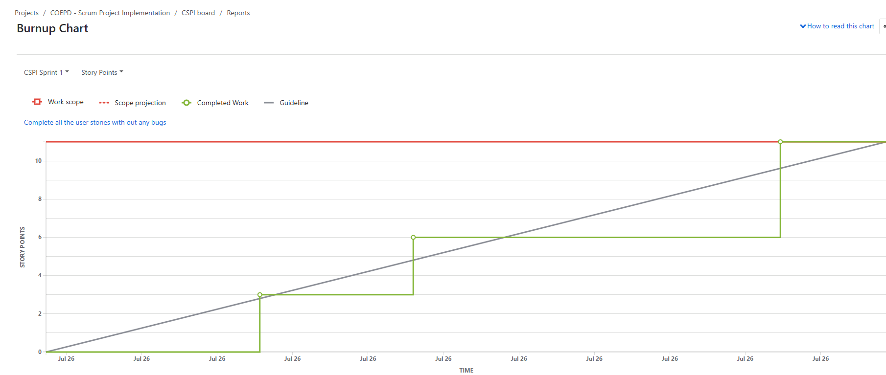
Product Burn down Chart- it is a visual tool used in agile management to track the progress of a project towards completing all works (usually in the form of user stories or tasks) in the product backlog. It helps team and stakeholders monitor the remaining work overtime, providing a clear picture of whether the project is on track to meet its deadline and goals.

Question 10: Explain about Product Grooming?
Answer: Product grooming also known as Backlog refinement is a collaborative agile practice aimed at preparing and prioritising the product backlog to ensure that it is well organised, up-to-date, ad ready for upcoming sprints.
The goal includes Clarify Requirement, prioritize work, Estimate Efforts, Remove obsolete Items, and break down large items.
Benefits include: Improved clarity, Smoother Sprint planning, increase productivity, Focus on value.
Question 11: Explain the roles of Scrum Master and Product Owner?
Answer: Scrum Master: He will monitor the performance of the Team within the Sprint. Team will raise all their issues to the Scrum Master and he will run to look for Answers. This role can be played by any person in team normally BA’s play this role
Product Owner: He will decide what needs to be in the product and will be responsible for how the product has to be. He will regularly interact with customers and BA’s. This role may be played by the BA or any person who worked for end users for a long time or customer himself.

Question 12: Explain all Meetings Conducted in Scrum Project?
Answer: In a Scrum project, there are four key meetings designed to keep the team aligned, inspect progress, and adapt plans. These meetings are time-boxed and serve specific purposes to help teams deliver value in an iterative, collaborative way.
Sprint Planning:
Purpose: Plan the work to be completed during the upcoming sprint.
Attendees:
Product Owner
Scrum Master
Development Team
Key Activities:
Select Sprint Goal
Choose backlog items to work on
Break stories into tasks
Team commits to what they can deliver
Time-box:
Up to 8 hours for a 1-month sprint
Usually 2–4 hours for a 2-week sprint
Daily Scrum (Stand-Up)
Purpose: A daily check-in for the team to synchronize and identify blockers.
Attendees: Development Team (PO and Scrum Master may listen but don’t lead)
Typical Questions:
What did I do yesterday?
What will I do today?
Are there any blockers?
Time-box:
15 minutes, same time and place daily
Sprint Review
Purpose: Demonstrate the work completed during the sprint and gather feedback.
Attendees:
Development Team
Product Owner
Scrum Master
Stakeholders
Key Activities:
Show working product increment
Discuss what was done vs. planned
Collect feedback for future planning
Time-box:
Up to 4 hours for a 1-month sprint
Shorter for shorter sprints
Sprint Retrospective
Purpose: Reflect on the sprint and identify ways to improve team processes.
Attendees:
Development Team
Scrum Master
Product Owner (optional, but encouraged)
Key Questions:
What went well?
What didn’t go well?
What can we improve?
Time-box:
Up to 3 hours for a 1-month sprint
Usually 1–1.5 hours for a 2-week sprint
Summary Table:
Scrum Meeting | Purpose | Time-box | Participants
Sprint Planning | Define sprint goal & work scope | Up to 8 hours | PO, Scrum Master, Team
Daily Scrum | Daily team sync-up | Up to 15 minutes | Development Team
Sprint Review | Demo and gather feedback | Up to 4 hours | Scrum Team, Stakeholders
Sprint Retrospective | Reflect & improve processes | Up to 3 hours | Scrum Team

Question 13: Explain Sprint Size and Scrum Size?
Answer: Sprint Size: Sprint size refers to amount of work that a scrum team commits to completing during a single sprint. It is typically measured in terms of:
- Story Points: A relative measure of complexity, effort, or size for backing items.
- Hours: the estimated time required to complete task.
- Number of tasks/User stories: A count of items that the team plans to complete.
Scrum Size: scrum size refers to composition and capacity of the scrum team, encompassing the number of team members, their role, and their collective ability to deliver work within a sprint. While there is no strict rule for scrum team size, certain guidelines exist to ensure efficiency and collaboration.
Question 14 – Explain DOR and DOD
DOR – Definition of Ready
DOR is a checklist of conditions that must be met before a user story or task can be picked up by the development team
It ensures that the work is clear, well-understood, and actionable
When is a user story “Ready”
- Be clearly defined and understood by the team
- Have acceptance criteria written
- Be estimated with CP (Complexity Points)
- Be prioritized in the Product Backlog
- Have all necessary dependencies resolved
- Be testable
DOD – Definition of Done
DOD is a checklist of criteria that must be fulfilled for a user story or task to be considered completed and shippable
When is a user story “Done”?
- Be fully developed
- Code is reviewed
- Pass all functional and non-functional testing
- Be integrated and deployed in test/staging environment
- Be accepted by the Product Owner
- Be ready for release (if required)

Question 15: Explain Prioritization Techniques and MVP?
- Prioritization Techniques:
- “MOSCOW” Technique: MOSCOW is a prioritizing technique which is used in business analysis and software development to reach a common understanding with stakeholders on the importance of each requirement
- Other Techniques are: 100 Dollars Test
- Top 10 requirements
- Numerical Assignment- Mandatory, very important, rather important, Not Important, does not matter
Minimum Viable Product:
- Definition: It is the simplest version of a product that delivers enough value to:Solve the core problem
- Be usable by early adopters
Allow you to gather feedback for improvement
- Use MVP: Reduce risk by testing ideas early
- Save time and cost - avoid overbuilding
- Accelerate learning through real user feedback
- Validate product-market fit
- MVP Is Not a:
- A prototype or wireframe (it's functional)
- The full product with all features
- A shortcut for low quality
- MVP Example:
Full App Idea: A food delivery app with chat, GPS tracking, and loyalty programs
MVP: A web-based app that lets users order food from nearby restaurants with basic delivery options
Question 16: Differentiate between Business Analysts and Product Owner?
Answer: Business Analysts is a professional who plays a key role in building bridge between business needs and technology solutions. They work closely with stakeholders including business leaders, project manager, developers and other team members, to understand the organisation need and translate them into technical requirement for product development or process improvement. The Bas primary goal is to ensure that the business requirement are clearly defined, understood and met through effective solutions.
Product Owner: PO is a key role in Agile framework especially in Scrum, responsible for defining and prioritizing the features, functionalities and deliverables of a product. The Product Owner act as a primary Liaison between stakeholder (such as customers, Business team and executives) and the Scrum team (which include developers, testers and scrum masters).

