WATERFALL DELIVERABLES 2

DOCUMENT – 6
Please prepare use case diagram , activity diagram and use case specification document
USE CASE DIAGRAM
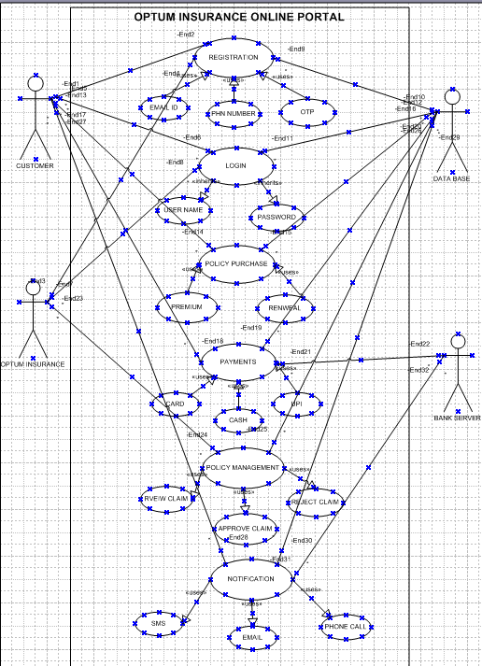
ACTIVITY DIAGRAMS

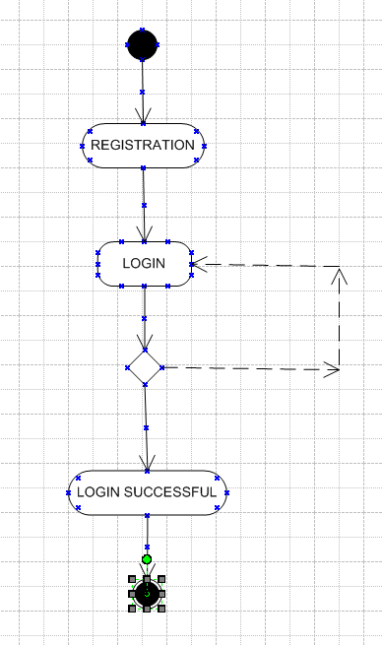

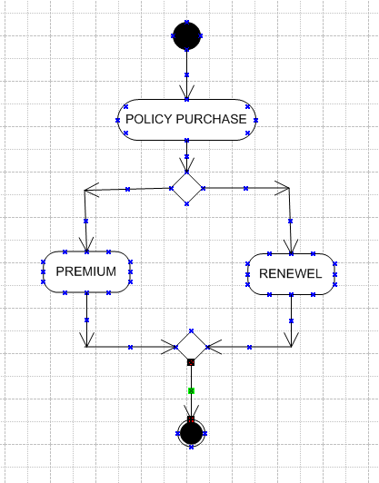
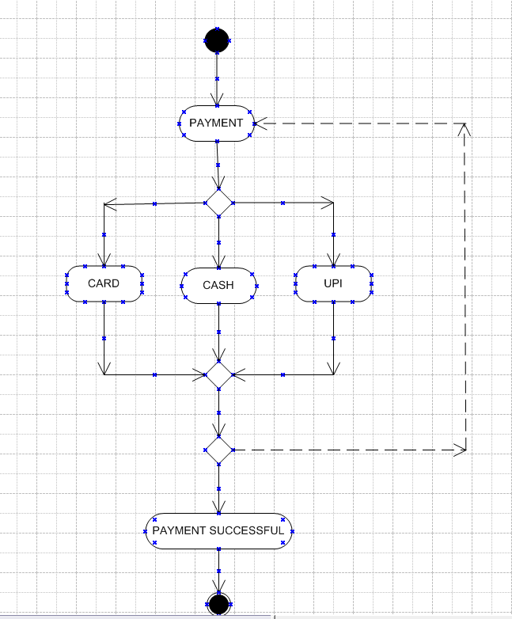

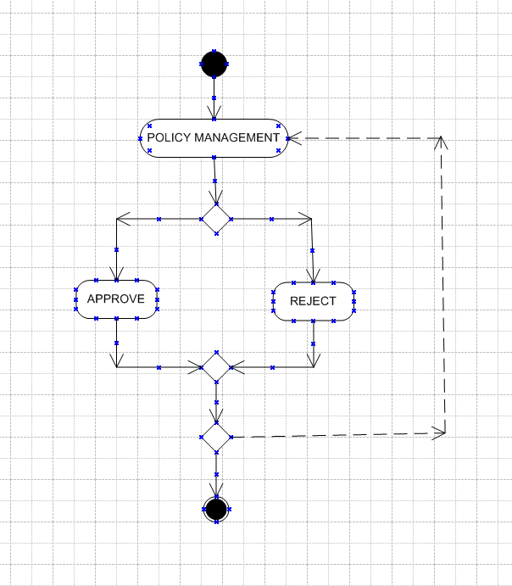

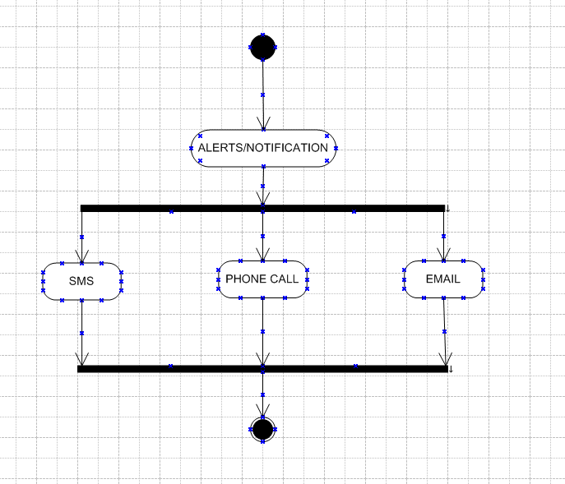

Use case specification

USE CASE NAME – Registration
USE CASE DESCRIPTION – The new customer can register the optum insurance online portal by the accurate personal identification
- ACTORS
PRIMARY ACTORS – customers, optum insurance firm
SECONDARY ACTORS – Data server

BASIC FLOW-
The customer can onboard the application by registering in application
The customer navigates to register page and the customer should enter valid email, mobile number or through OTP to get register in the application
ALTERNATE FLOW –
If the user enters the wrong email which is already existing they will prompted to login instead
If the user enters wrong OTP it ask for the enter valid OTP.
EXCEPTIONAL FLOWS
If the user can’t able to build strong password it asks to build a password with given characters
If the user internet connection is weak it might stop the process and leads to stop the registration process
PRE-CONDITIONS
The user should have good internet connection , the system must be online and the user must have access to registration page
POST CONDITIONS
The user had registration is successful to application and he has an account and he has access to login screen.
ASSUMPTION
The user provides the valid identification information and has valid email address and Adhar linked mobile number.
CONSTRAINTS
The user should have the strong password and the limited number of characters for user name.
DEPENDENCES
The process may depend on the data base server and the email service to send email conformation
INPUTS –
The details provided by the customers like mobile number, pan number, OTP
OUTPUTS –
Successful notification or declined notification ,like user account got registered
BUSINESS RULES
The user must be s provide personal email id and phone number
The user should verify the email before submitting
MISCELLANEOUS INFORMATION
Shows the message with good design like you have successfully registered

USE CASE NAME – Login
USE CASE DESCRIPTION
The user who got registered with providing the personal information can login the application
ACTORS
Primary actor – customer , optum internal.
Secondary actor – DB server
BASIC FLOW
Customer navigates to login screen
Customer should enter user name and password
Customer navigates to the main screen of the application
ALTERNATE FLOW
If customer enters wrong user name or wrong password it shows enter correct credentials
If customer enters invalid credentials it leads to user case failure

EXCEPTIONAL FLOW
The DB server is busy user cant able to login , and it shows the server busy on the screen
PRE-CONDITIONS
User should and must have the user name and password to login.
POST CONDITIONS
The user login is successful
Customer navigates to the policy purchase screen
ASSUMPTIONS
User should have existing account
The user should have the valid user name and password and he should
CONSTRAINTS
User can do 5 attempts for entering credentials and login
More than 5 attempts leads to account block
DEPENDENCES
Verification of username and password on DB server
INPUTS
User name and password
OUTPUT
Navigating to the policy purchase screen
BUSNISS RULES
User must be change their password for every 3months.
MISCELLANEOUS INFORMATION
It shows the welcome to Optum insurance company on screen.

USE CASE NAME – Policy purchase
USE CASE DESCRIPTION –
User can purchase the policy and renewal the policy according to their wish and by the premium
ACTORES
Primary actors- customers
Secondary – DB server
BASIC FLOW –
The customer can select weather purchase policy or renewal
If purchase he should select the premium
If renewal he should select the renewal and continue the policy
ALTERNATIVE FLOW-
User buy one policy the sytem shows and additional policy with discount
Customer renewal before the date expires it shows policy not expired
EXCEPTIONAL FLOW
Customer request for unknown policy
Customer age limit crossed for the policy and renewal request id cancelled
PRE-CONDITIONS
Portal must have available policy options that must satify the customer criteria
POST CONDITIONS
User can access the new purchased policy through their account
User can continue their policy as renewal is done
ASSUMPTIONS
User must meet the eligibility before the policy purchase like age, health condition

CONSTRAINTS
User should not have serious health issue and health condition , illness for the policy purchase.
DEPENDENCES
Verification and terms and conditions are on the DB server and staff
INPUTS
Selecting the policy of insurance
Selecting Renewal of the same policy
OUTPUTS
Benefits of the purchased policy
Continuing on the same policy
BUSINESS RULES
Customer should provide correct health conditions reports and eligibility reports for the policy purchase
MISCELLANEOUS INFORMATION
Customer can see the date of expiry of the policy and will show notification alerts before the expiry

USECASE NAME – PAYMENT
USE CASE DESCRIPTION
User can make payment by the card cash and UPI transaction as it is their optional they should simply select the option and make the payment
ACTORS
Primary Actors- customers
Secondary Actors – DB server, Bank server

BASIC FLOW
Customers can make payment by selecting payment option
Customer should chose the payment mode and make the payment
ALTERNATIVE FLOW
CUSTOMER ENTERED WRONG DETAILS OF BANK IT WILL DECLINE AND NAVIGATES TO MAKE PAYMENT SCREEN
EXCEPTIONAL FLOW
CUSTOMER MAY GET ERROR OPTION WHEN BANK SERVER IS BUSY
PRE-CONDITIONS
CUSTOMER SHOULD HAVE ENOUGH BALANCE TO MAKE PAYMENT
CUSTOMER SHOULD HAVE KNOWLEDGE ON MAKING PAYMENT THROUGH ONLINE
POST CONDITIONS
PAYMENT SUCESSFUL CUATOMER CAN RECIVE RECEIPT AND CONTINUE THE POLICY
ASSUMPTIONS
User should have the limit in card transaction limit in the card for purchasing the policy
User should have enough balance to purchase the policy
CONSTRAINTS
Payment should be done after authentication and credentials should be done in correct way
Bank mandatory fields should be accurate
DEPENDENCIES
Payment conformation well depend on the bank servers
Bank should conform verify the details and give conformation
Depend on various server for notification
INPUTS
Physical cash , digital cash
OUTPUT
Payment done notification , receipt
BUSINESS RULES
Payment should done in secured way
Wrong transaction cant be encouraged
MISCELLANEOUS INFORMATION
Payment successful on display, showing the time and date of the payment

USE CASE NAME – policy management
USE CASE DESCRIPTION
The policy management shows where the claim and the policy is been to take
ACTORS
Primary Actors – customers, optum staff
Secondary actors – DB server
BASIC FLOW-
Staff review the claims submitted by the customers
Staff analyize the claim they approve or reject accordingly
ALTERNATIVE FLOW
Customer submitting the incorrect claim may navigates to submit document screen
EXCEPTIONAL FLOW
The system automatically checks the policy of the customers
The approver administration will validates approve or rejects the claim
PRE- CONDITIONS
The optum staff should be trained for the policy management
The approval administration should know about the policy management

POST CONDITIONS
If approved customer can start the purchased policy
If rejected the customer should follow the eligibility criteria
ASSUMPTIONS
Customer should eligible for the policy submitted
Customer should resubmit the claim with correct information in the case of rejection
CONSTRAINTS
Customer should have to accept the terms and conditions of the insurance company
There are limited advantage for the policy holders
DEPENDENCES
Status of approval or reject depends on the approval administration team
INPUTS
Digital claim , prof documentation
OUTPUT
Claim status like approve or reject
BUSINESS RULES
Submitting the fraud documentation is may block the customer ID
Eligible customers are only approved
MISCELLANEOUS INFORMATION
Approve notification and congratulation emoji
If in case reject sad emoji with reject on display

USE CASE NAME – Notification/ Alerts
USE CASE DESCRIPTION –
The portal send the notification ti inform the customer about the policy which they have purchased
ACTORS
Primary Actor- customers
Secondary- DB server, bank server
BASIC FLOW
Once the policy got approved or reject customer gets the notification about the policy purchase
Once the payment is done the bank sends the notification to the customer
ALTERNATIVE FLOW
If the policy process is in waiting list it shows under process on the screen
If the payment got declined it shows payment decline due to incorrect pin and gets alert notification
EXCEPTIONAL FLOW
If the bank server is busy the payment screen shows in process do swipe back while processing
PRE-CONDITIONS
Customer should be online in mobile ,email and he should able to answer the phone call .
POST CONDITIONS
Customer gets notification about the approval or reject status in by the email ,sms and call
Customer receive the bank alters after the amount deducted from the bank
ASSUMPTIONS
Customer should have to submit the accurate mobile number to get the notification
User have register eith accurate email
The user should select the communication channels

CONSTRAINTS
Email and sms delivery times my very but are generally quick
Character limits for SMS is usually 180 characters and the format of email content
DEPENDENCIES
Notification speed depends on the email servers and the respective sim servers
INPUTS
Accurate email id , mobile number, Bank registered number
OUTPUTS
Alert sms, status sms
BUSINESS RULES
Make sure that email id and mobile number are clear and specific for customer
Sending notifications in the appropriate time
MISCELLANEOUS INFORMATION
Displaying the policy conformed on the dash board after the notification send
Display the bank alert with alert picture and it shows successful right mark on screen

DOCUMENT-7
SCREENS AND PAGES
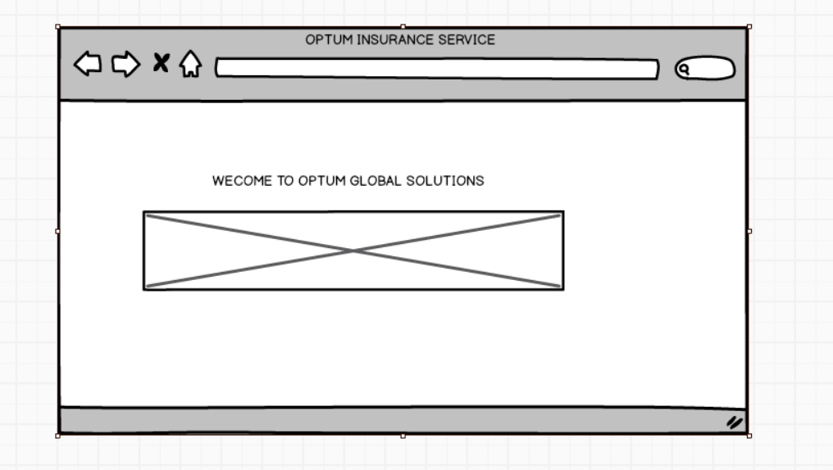
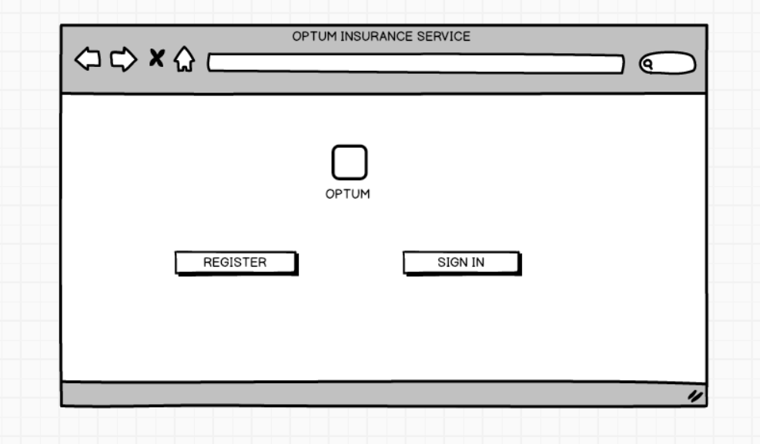
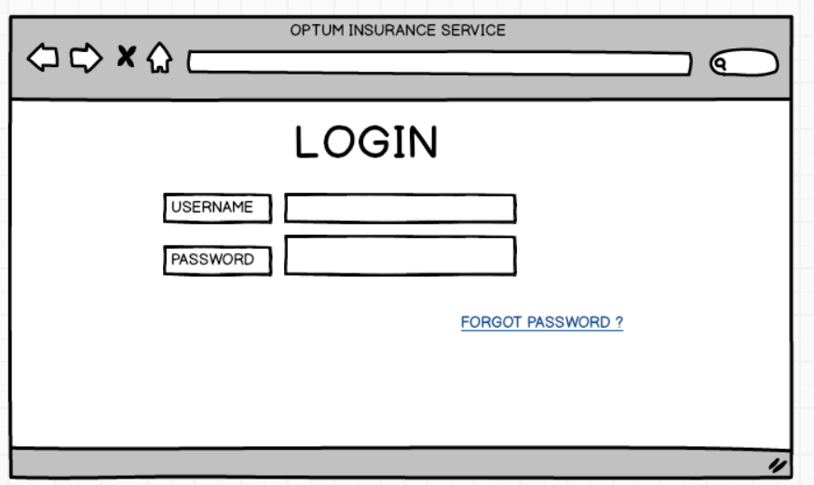

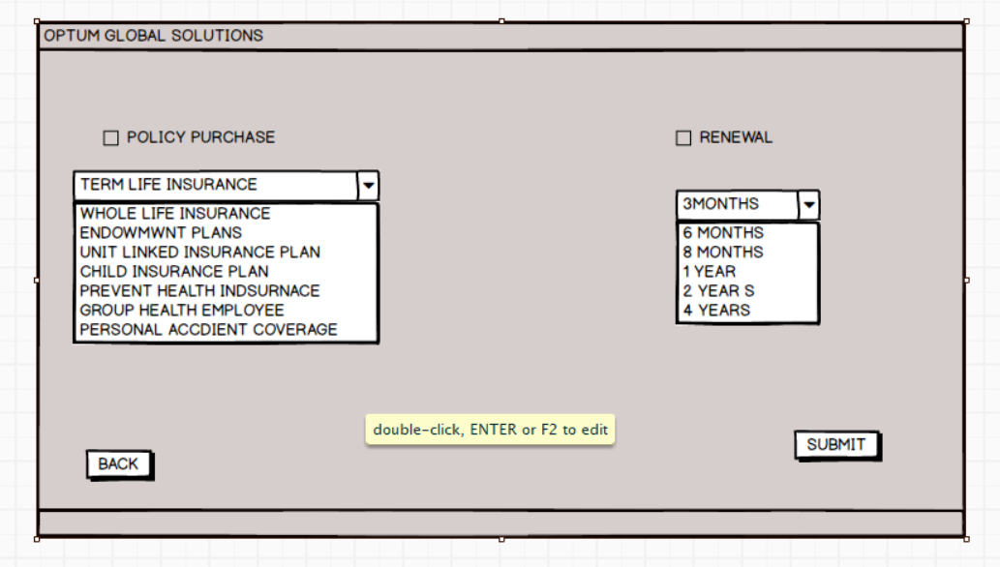
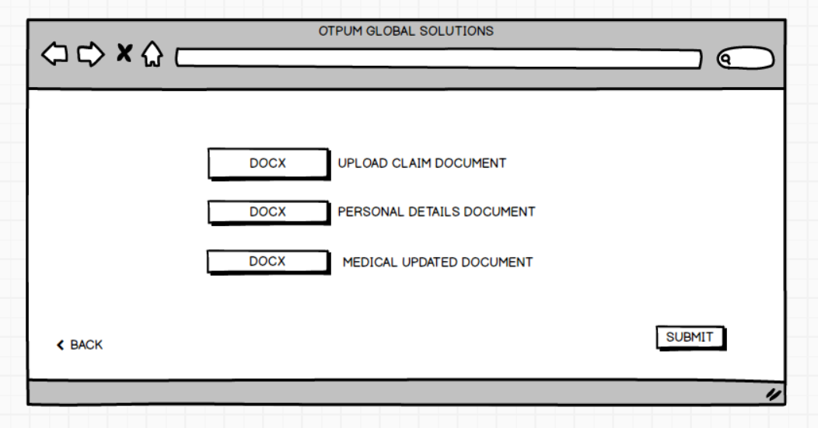

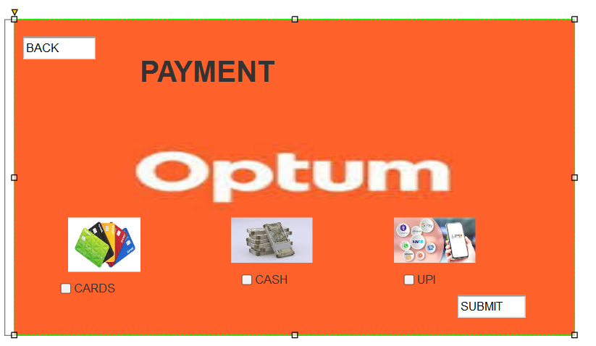
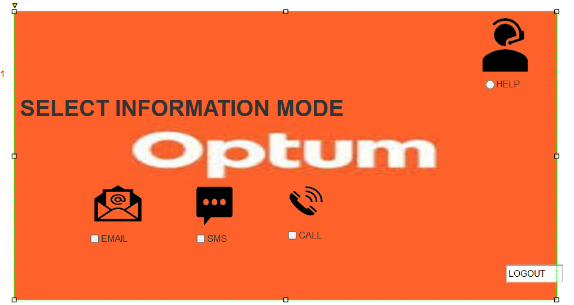

DOCUMENT -8
MS VISIO
For this online insurance project , I had used Microsoft visio to design and document key process flows and system interactions , the visio was especially valuable in mapping out the end to end customer journey from quote generation policy purchase claim submission ,
I created detailed flowcharts , data flow diagram to visually represent user interaction , backend process and integration with the third party services like payment gateways and identify verification tools
These visual document plays the important role in aligning the business stakeholders and the development team , ensuring everyone had a clear understanding of the system requirements and dependencies , Visio’s flexibility and professionals output significantly improved communication and supported efficient decision making throughout the project lifecycle

AXURE-
In this optum online portal insurance project I have used Axure to create interactive wireframes and high-fidelity prototypes that brought the user interface designs of life
Axure was particularly useful for simulating real user interactions across key workflows such obtaining quotes , comparing plans , submitting applications and managing policy details
By incorporating dynamic panels , form validation and conditional logic , I was able to model the behaviour of the actual system and gather early feedback from the stakeholders and users
This helped in identifying usability issues and refine design decisions before development begin
Axure’s ability to generate clickable prototypes greatly improved communications with both the product team and developers ensuring a shared understanding of functionality and user expectations .

DOCUMENT – 9
MY EXPERIENCE AS A BA FOLLOWINFG PHASES
As I have done with the stakeholders analysis and identified the stakeholders and then I have gathered the business requirements from stakeholders using the elicitation techniques
I had used the MOSCOW technique used to prioritization method to decide the importance of requirements in the project it stands for
MUST have the essential requirements without which the portal does not function is like user registration , login , claim submission
SHOULD have important but not critical like policy purchase, payment integration, renewal reminders
COULD have is nice to have features such as customizable insurance plan customer service , tracking claim
WOULD have features not included in current version like dicounts, coupons, policy offers , different localization

CLIENT ABSENCE
When the primary client was unavailable , I proactively identified and engaged alternate points of contact from the client side to avoid delays
I will contact my team member and ensure that who might have direct contact with the client side or if I have contact details for other members of the client team I will try as much as I can to meet the client as it should not get delay I will prepare the document and keep it ready as soon as client meet as we show the requirement information to make work faster. This ensured continues information flow and minimal disruption to the requirement gathering timeline

I will validate the requirements using FURPS technique
Functionality I ensure that user should able to get registered and login easily and allow user to compare different insurance plans , get quotes , purchase plans and file claim online
Usability – the user interface should be intuitive and easy to navigate the screen as user friendly and allow users to quick find information and complete their tasks
Reliability- the online portal should be stable and available consistently ensuring user can access services any time without interruptions
Performance- the system should respond very quickly to user actions in login , registration claim process and over all in policy management with fast loading time and efficient processing of requests
Supportability- As it is new to customers to use the portal should provide helpful customers support options including FAQQs , live chat and easy way to contact support staff.

As there are many requirements which are duplicated or repeated we need to remove as I am a BA I will conduct a session with stakeholders and I will review the the requirement with the stakeholders conduct workshops and review on them in this sessions with stake holder I will discuss and validated and identified and removed redundant or overlapping requirements early in the process , improving documentation clarity and reducing the risk of scope creep during later phases

As the payment integration is important the I have used prototyping is used to give more specification requirement I want to show the client of payment prototype
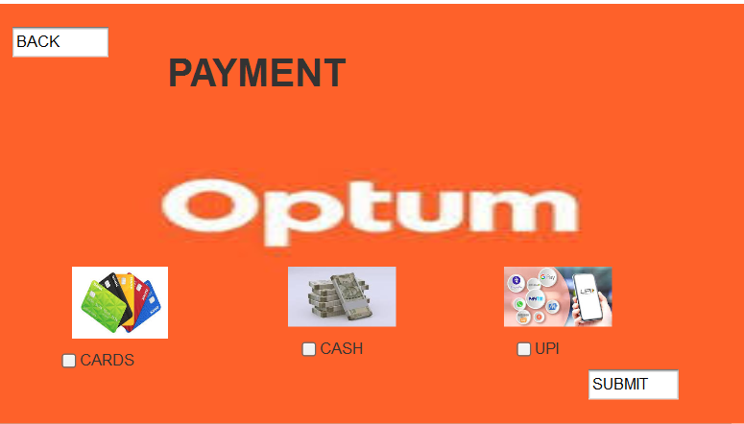
I had satisfied the customer by the protype which is clear to choose the option on payment model .
I developed and used interactive prototypes to facilitate clearer communication of system expectations particularly for online insurance portal payment gateways .
This approach helped stakeholders visualize the end product and provide more specific and actionable feedback.

REQUIREMENT ANALYSIS
I had drawn the UML diagram to visually describe the requirements
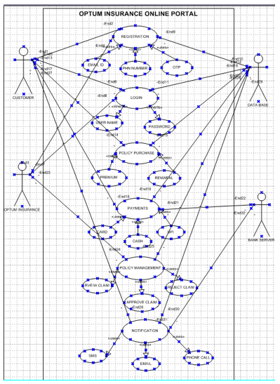

I had drawn the activity diagram to describe the process flow
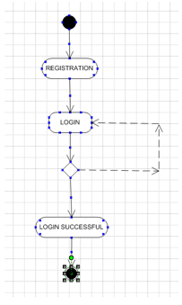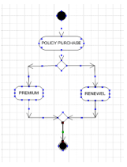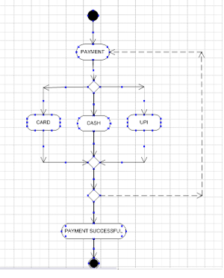

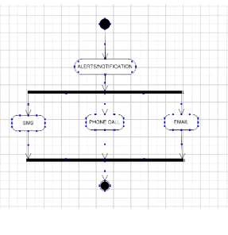

- I have been communicated the UML diagrams and the process floe diagrams with the team some of the team member have not not agreed with that so I have consider the points and noticed and made an note for the modification

Prepare BRS and SRS

BUSINESS REQUIREMENT SPECIFICATION

Project tittle : OPTUM online insurance service
Prepared by : R Pradeep chary
Date : 27-07-2025

Business overview –
The object is to develop the online platform for the optum insurance company to allow user to purchase the claim insurance policies , the systems aims to automate processes, improve customer experience and reduce manual workload
Business Objectives
Provide customers with a seamlines online platform for insurance services
Enable policy generation , policy purchase , renewal and claims processing in digitally
Improve customers service and reduce response time
Ensure secure handling and sensitive data
Scope-
User registration and login
Viewing policy purchase
Policy renewal
Payment integration
Claims submission
Out scope
Physical branch operations
Integration with third party agencies.
Stakeholders-
Customers
Insurance agents
Admin staff
Underwriters
Processing. Customer support staff
IT team , Developers.

Business Requirements
REQ- ID | REQUIREMENTS DESCRIPTION
BR001 | The system should allow users to register and login securely
BR002 | The user should able to renewal and purchase the premium
BR003 | The user should able to make payment in different models
BR004 | User should able to submit claims in digitally
BR005 | User should able to have account dashboard for browsing
BR006 | Admin user should able to maintain all policy and claim data
BR007 | User should able to have customer services
BR008 | User should have alerts notifications of claims

Thank you

SOFTWARE REQUIREMENT SPECIFICATION (SRS)
Project tittle- OPTUM online insurance service
Prepared by – R Pradeep chary
Date - 27-07-2025

Introduction –
The onine application for optum global solutions is to working automation integration and the application should be helping in designing by the business requirements given.
User have better experience and process in real time will have quick with technology
Product scope
The system will allow users to manage their insurance needs via a secure and user-friendly web portal.
Features include policy browsing, purchasing, renewal, claims submission, and an administrative backend.
This SRS defines the functional and Non functional requirements for optum online insurance system

Intended Audience
- Development team
- QA team
- Business stakeholders
- Project managers
Definition
Insurance product offered to customers
Request made by a policy holder for compensation .

Over all Description
- Product perspective
This system is a web-based application that supports online insurance operations.
- User classes and characteristics
Customers - Registers, purchases ,manages policies ,and submits claims.
Admin- Manages system users, policies, and claims
Insurance Agent- Assists customers, reviews claims

Assumptions and Dependencies
Internet connectivity required
Application use resources required
Payment gateway integration
Wating for multiple servers returns.

FUNCTIONAL REQUIREMENTS
REQUIREMENT ID | REQUIREMENT NAME | REQUIREMENT DESCRIPTION
FR001 | Registration | User should able to register the application easily.
FR002 | Login | User should able to login with email id and password
FR003 | Claim submission | User should able to submit the soft copy claim in the application
FR004 | Policy search | User should able to search the insurance policies
FR005 | Payment integration | User should have multiple options for the making payment
FR006 | Customer management | The portal shoud allow the company view and mange customer profiles
FR007 | Document management | The portal should allow the company to upload, store the data of customer in the portal q
FR008 | Contact details | Portal should have contact details of the customers and insurance company
FR009 | Get details | User should able to get the details of each policy on portal
FR010 | Track claim | User should able to track the claim process

Non – Functional requirements
NR001 | Performance | This application must be load in 4 sec
NR002 | Usability | The application must be user friendly
NR003 | SECURITY | The application should ensure user authentication
NR004 | Response time | The application must be respond to input in 2 within 2 sec
NR005 | Reliability | The portal should able to handle and recover error with incorrect data

System model References
- UML diagrams
- Activity diagrams
- BRD

Thank you

DESIGN-
Based on the usecase diagram I had discussed with the client on each requirement and identified all possible test scenarios .
Each use case is decomposed into detailed positive and negative test cases
The goal is to validate each flow main and alternate described in the use case documentation

- Client communication on design and solution documents
Shared all Use case diagrams
Activity diagrams
Systems flow diagrams
UI wireframes
Confirm that the solution aligns with business goals and regulatory needs
Collect the client feedback and make iterative updates before locking the design

Writing the Negative and positive test cases
For the each functionality I have created the positive and negative test cases
So that it ensures the system is secure and user friendly

TEST SCENARIO | POSTIVE CASE | NEGATIVE CASE
Registration | Valid email id , phone number | Invalid email  Existing email , land line number
Login | Valid user id  Valid password | Invalid user id  Invalid password
Purchase policy | Payment successful | Invalid card details  Invalid transaction
Claim upload | All required documents | Missing and wrong file format
Policy management | Analysing accurately | Error process
Alerts notification | Register mobile number Sent to correct mobile number | Error in sms forward

I have not Missing even one edge case could lead to functional gaps , customer dissatisfaction or regulatory non compliance in the SDLC
Cross reference all test cases with requirements and use cases to ensure full coverage

TEST DATA-
As a BA I have collaborated with QA and developers teams to define realistic and comprehensive test data, which covers
New user profiles
Existing policy holders
Different insurance types policies
Valid and invalid payment and document scenarios

RTM( REQUIREMENT TRACEABILITY MATRIX FOR EACH REQUIREMENTS ) FOR ALL FUNCTIONAL AND NON FUNCTIONAL REQUIREMENTS
Req id | Req name | Req description | Design | CODE | DEV 1 | TEST CASE ID | TEST | STATUS
FR001 | REGISTRATION | User should able to register to the application | DONE | DONE | DONE | TC001 | DONE | pending
FR002 | Login | User should able to login with email id and password | DONE | DONE | ND | TC002 | ND | Pending
FR003 | Claim submission | User should able to submit the soft copy claim in the application | DONE | DONE | ND | TC003 | ND | Pending
FR004 | Payment integration | User should have multiple options for the making payment | DONE | DONE | ND | TC004 | pending | Pending
FR005 | POLICY SEARCH | User should able to search the insurance policies | DONE | DONE | DONE | TC005 | DONE | Pending
FR006 | Customer management | The portal should allow the company view and mange customer profiles | DONE | DONE | ND | TC006 | ND | Pending
FR007 | Document management | The portal should allow the company to upload, store the data of customer in the portal | DONE | ND | ND | TC007 | ND | Pending
FR008 | Contact details | Portal should have contact details of the customers and insurance company | DONE | DONE | ND | TC008 | ND | Pending
FR009 | Get details | User should able to get the details of each policy on portal | DONE | DONE | DONE | TC009 | ND | Pending
FR010 | Track claim | User should able to track the claim process | DONE | DONE | DONE | TC010 | DONE | Pending
NR001 | Performance | This application must be load in 4 sec | DONE | DONE | ND | TC011 | ND | PENDING
NR002 | Usability | The application must be user friendly | DONE | ND | ND | TC012 | ND | Pending
NR003 | SECURITY | The application should ensure user authentication | DONE | DONE | DONE | TC013 | ND | PENDING
NR004 | Response time | The application must be respond to input in 2 within 2 sec | DONE | DONE | ND | TC014 | ND | PENDING

DEVELOPMENT –
As my responsibility during the development phase which I can use for documentation , performances reviews , project status updates and internal communication
I had organised JAD session (joint application development )
I had facilitated it in structured way involving developers , testers and stakeholders
Ensured that technical team fully understood about the requirements and system workflows
Used visual aids such as UML diagrams , activity flows to support discussions
Clarified queries of technical team during coding as a bridge between the business and technical team
Quick responded to developers ‘ queries to avoid delays
Referred back to BRS,SRS and design diagram to clarify functionality , data handling and workflow logic.
I will Handle Conflicts and Resistance during JAD sessions
I will Addressed situations where some team members disagreed with the approach or were uncooperative
Then I will Conduct one on one discussions to understand their concerns and explain the impact of delayed collaboration on project timelines.
And I will Created a positive and respectful team environment that promoted open communication and mutual understanding

I Refer Diagrams to Support Development is
- Use case diagrams
- Activity diagrams
- Process flow diagrams

I will conduct the regular Team meeting and Client Meeting
I will manage recurring meetings with both technical teams and the client for progress updates and clarifications.
I will Acknowledged the challenge of inconsistent availability from team members.
I will manage absence and communication gaps by
- Record all important meetings and shared recordings with those who could not attend.
- Conduct individual follow-up discussions to ensure no one missed critical updates or decisions.
- Document and share meeting minutes for traceability.

TESTING –
I had prepared testcase for each of the use case
TEST SCENARIO | POSTIVE CASE | NEGATIVE CASE
Registration | Valid email id , phone number | Invalid email  Existing email , land line number
Login | Valid user id  Valid password | Invalid user id  Invalid password
Purchase policy | Payment successful | Invalid card details  Invalid transaction
Claim upload | All required documents | Missing and wrong file format
Policy management | Analysing accurately | Error process
Alerts notification | Register mobile number Sent to correct mobile number | Error in sms forward

I have collaborated with the testing team and high level of testing to
- Validate that workflows align with business processes
- Ensure functional completeness and logical consistency
- Identify any gaps between expected and actual behaviour before handing over to QA

In the test data coordination I have requested realistic test data from client for UAT and pre- production scenarios
Ensured that the data included
- Different users roles like customers agent and admin
- Policy type like life, health etc
- Valid and invalid claim conditions and payment scenarios
And I am aware that data should validated and sanitized before use to comply with data privacy policies .
I updated RTM
FUNCTIONAL AND NON FUNCTIONAL REQUIREMENTS
Req id | Req name | Req description | Design | CODE | DEV 1 | TEST CASE ID | TEST | STATUS
FR001 | REGISTRATION | User should able to register to the application | DONE | DONE | DONE | TC001 | DONE | pending
FR002 | Login | User should able to login with email id and password | DONE | DONE | DONE | TC002 | DONE | Pending
FR003 | Claim submission | User should able to submit the soft copy claim in the application | DONE | DONE | DONE | TC003 | DONE | Pending
FR004 | Payment integration | User should have multiple options for the making payment | DONE | DONE | DONE | TC004 | DONE | Pending
FR005 | POLICY SEARCH | User should able to search the insurance policies | DONE | DONE | DONE | TC005 | DONE | Pending
FR006 | Customer management | The portal should allow the company view and mange customer profiles | DONE | DONE | ND | TC006 | ND | Pending
FR007 | Document management | The portal should allow the company to upload, store the data of customer in the portal | DONE | DONE | DONE | TC007 | DONE | Pending
FR008 | Contact details | Portal should have contact details of the customers and insurance company | DONE | DONE | DONE | TC008 | DONE | Pending
FR009 | Get details | User should able to get the details of each policy on portal | DONE | DONE | DONE | TC009 | DONE | Pending
FR010 | Track claim | User should able to track the claim process | DONE | DONE | DONE | TC010 | DONE | Pending
NR001 | Performance | This application must be load in 4 sec | DONE | DONE | DONE | TC011 | DONE | PENDING
NR002 | Usability | The application must be user friendly | DONE | DONE | DONE | TC012 | DONE | Pending
NR003 | SECURITY | The application should ensure user authentication | DONE | DONE | DONE | TC013 | DONE | PENDING
NR004 | Response time | The application must be respond to input in 2 within 2 sec | DONE | DONE | DONE | TC014 | DONE | PENDING

After I should take sign off from client for testing
I have presented test results , RTM status and open issue log to the client
Collected formal sign off from the client on completion of testing phase ‘
Confirmation that requirements were implemented as expected
Approval with proceed with UAT

I have prepared client for User Acceptance testing
- I had scheduled and facilitated UAT sessions with the client by providing
A walkthrough of the system and its functionalities
Access credentials and environment instructions
Supported the client during execution and captured feedback
I have ensured a smooth UAT process and handled clarifications promptly

DEPLOYMENT –

In the deployment stage I have shared the updated and final requirement traceability matrix with the client
Ensured that it was included with the project closure document
Here is the both RTM and project closure document
Req id | Req name | Req description | Design | CODE | DEV 1 | TEST CASE ID | TEST | STATUS
FR001 | REGISTRATION | User should able to register to the application | DONE | DONE | DONE | TC001 | DONE | Done
FR002 | Login | User should able to login with email id and password | DONE | DONE | DONE | TC002 | Done | Done
FR003 | Claim submission | User should able to submit the soft copy claim in the application | DONE | DONE | DONE | TC003 | DONE | Done
FR004 | Payment integration | User should have multiple options for the making payment | DONE | DONE | DONE | TC004 | DONE | Done
FR005 | POLICY SEARCH | User should able to search the insurance policies | DONE | DONE | DONE | TC005 | DONE | Done
FR006 | Customer management | The portal should allow the company view and mange customer profiles | DONE | DONE | ND | TC006 | ND | Done
FR007 | Document management | The portal should allow the company to upload, store the data of customer in the portal | DONE | DONE | DONE | TC007 | DONE | Done
FR008 | Contact details | Portal should have contact details of the customers and insurance company | DONE | DONE | DONE | TC008 | DONE | Done
FR009 | Get details | User should able to get the details of each policy on portal | DONE | DONE | DONE | TC009 | DONE | Done
FR010 | Track claim | User should able to track the claim process | DONE | DONE | DONE | TC010 | DONE | Done
NR001 | Performance | This application must be load in 4 sec | DONE | DONE | DONE | TC011 | DONE | Done
NR002 | Usability | The application must be user friendly | DONE | DONE | DONE | TC012 | DONE | Done
NR003 | SECURITY | The application should ensure user authentication | DONE | DONE | DONE | TC013 | DONE | Done

Project closure document
S.NO | POINS TO INCLUDE | DETAILS | REFERENCES LINK
1 | Did the client sign- off UAT testing | YES | Businesscase04.docx
2 | Date of sign off | 27-07-2025
3 | Name of resource | Desktop
4 | User friendly | Archived
5 | Customer satisfaction | ROI in 4 years
6 | Software installed | Yes
7 | Secure payment processing | Archived
8 | Amount approval | 44lakhs
I had coordinated completion and sharing of End User manuals
I had collaborated with the documentation team and QA to create end user manuals for the customers and internal users , admin, agents operating guides
I reviewed manuals to ensure language was clear and non technical and screenshots and process steps were up to date , instructions reflected actual deployed functionality
And I have delivered final versions with both PDF and Editable format.

I planned and organized in training sessions
I created and shared a training plan and agenda with client team
Sessions were designed for different user groups like
Customers | Self service portal
Admins | Back end tools and SOPs
Agents and underwriters | Policy handling , claims reviews

I have been provided supporting material like SOP. PPT slides ,FAQs and system demos

I had Ensured Full attendance in training session
By sending meeting invites well in advance to all relevant users
I will send remainders a day before for each sessions
I will ensure attendance by
- Tracking participate
- Recording sessions for absences
- Following up with one on one sessions if anyone missed group training
I will ensure all users are confident and prepared to use the system post deployment

