Question No 1:

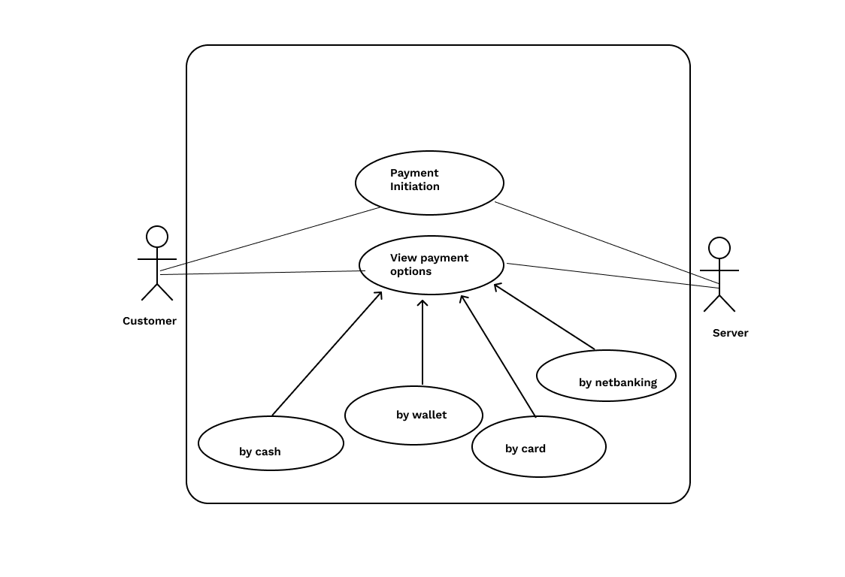
Question No. 2 –

Boundary Class-used to handle interactions between the system and external actors

Ex: PaymentOption Boundary Card Payment Boundary

Controller Class act as intermediaries between boundary and entity classes.

Ex: PaymentinitiatedController, Card PaymentController

Entity Class represent the core data and business logic of the application.

Ex: Customer Payment
Question No 3 –

User Layer –
PaymentMethodSelectionBoundary
CardPaymentBoundary
CashPaymentBoundary
WalletPaymentBoundary
NetbankingPaymentBoundary

Business Layer
PaymentInitiatedController
CardPaymentController
CashPaymentController
WalletPaymentController
NetbankingPaymentController

Data Layer
Customer (Entity Class)
Payment (Entity Class)

Question No 4 –
A domain model is a conceptual representation that defines structure, relationships and behaviours of entities within a specific problem domain.
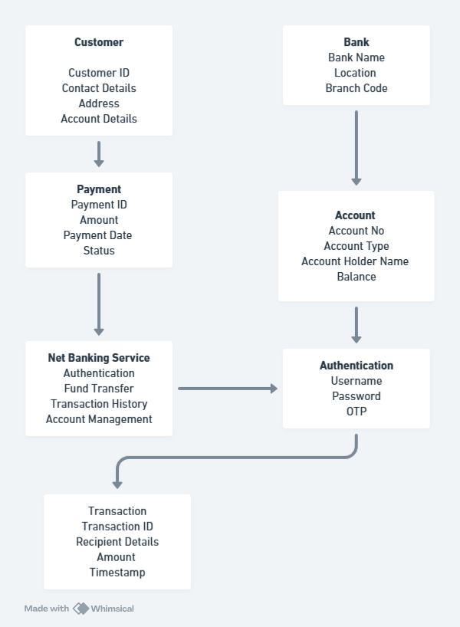

Question No 5 –
A sequence diagram is a type of interaction diagram used in software engineering and systems design to illustrate how processes operate with one another and in what order.

BANK
NET BANKING SYSTEM
CUSTOMER

Initiate payment request Authenticate Customer details

Validate payment details
Deduction of Amount

Process payment to reciepient bank
Payment Confirmation

Receives payment confirmation

Question No 6 -

A conceptual model is a high-level representation of a system that helps in understanding, visualizing, and communicating the essential aspects of a domain.

Its Provides a clear and simplified view of the domain, making it easier to understand.

Key Elements of a Conceptual Model:

1. Entities

Customer, Product, Order & Payment

2. Attributes - customerId, name, email, phoneNumber.

3. Relationships - For example, a Customer places an Order.

Question No 7 –

MVC Architecture (Model–View–Controller)

MVC is a software design pattern that separates an application into three interconnected components — Model, View, and Controller. This structure helps in managing complex systems by dividing responsibilities, making the application easier to maintain, test, and scale.

The Model represents the data and business logic of the application. It defines how the data is stored, manipulated, and retrieved. For example, in an online agriculture product store, classes like Product, Farmer, Order, and Payment belong to the model layer because they deal directly with the core data.

The View is responsible for the user interface. It displays data to the user and sends user actions (such as button clicks or form submissions) to the controller. Examples include web pages such as ProductList, LoginPage, or OrderSummary.

The Controller acts as a bridge between the View and the Model. It handles user input from the View, processes it (by applying business logic or validations), communicates with the Model to update or fetch data, and then updates the View accordingly. For example, ProductController or OrderController would handle actions like adding a product to the cart or placing an order.

The MVC workflow proceeds as follows: the user interacts with the View, the Controller receives and processes the input, the Model updates or retrieves the required data, and finally, the View is updated to reflect the changes.

Rules to Derive Classes from Use Case Diagram

When deriving classes from a use case diagram, the first step is to read the use case description carefully. Every important noun in the description can become a potential class. For instance, in a use case like “Customer places an Order,” Customer and Order are nouns and can be modeled as classes.

Next, identify verbs or actions in the use case, as these often represent methods or operations of a class. For example, the use case “Place Order” may lead to methods such as addItem(), calculateTotal(), or confirmOrder().

After that, identify relationships among classes. These can be associations (like a customer places an order), aggregations (an order contains multiple products), or inheritance (for example, OnlineCustomer could inherit from Customer).

For every use case, define a controller class to handle its flow and logic. For instance, “Manage Product” can result in a ProductController.

Also, separate the classes into entity, boundary, and control categories. Entity classes represent data (such as Product, Customer, Order), boundary classes manage the interaction with users (such as LoginPage or ProductForm), and control classes handle logic and coordination (such as OrderManager or PaymentProcessor).

Guidelines to Place Classes in 3-Tier Architecture

Once classes are identified, they are organized into the three tiers of application architecture.

The presentation tier (or user interface layer) contains all the boundary classes. This layer is responsible for displaying information to the user and receiving user inputs. Examples include web forms, mobile screens, or HTML pages.

The business logic tier (or application layer) contains control or controller classes. These classes contain the actual logic of the system, such as validating inputs, processing requests, and coordinating between the presentation and data layers. Controllers like ProductController or OrderManager are placed in this layer.

The data access tier (or persistence layer) includes all the entity classes and database interaction logic. These classes represent business objects and are responsible for storing and retrieving data from the database. Classes like Product, Customer, Order, and Payment belong here.

Mapping MVC to 3-Tier Architecture

In the MVC pattern, the Model aligns with the data access tier, the View aligns with the presentation tier, and the Controller aligns with the business logic tier. This mapping ensures that each layer performs a distinct function and can be modified independently without affecting others.

For example, in an online agriculture product store, the Product, Order, and Payment classes would be part of the Model or data layer, the ProductController or OrderController would belong to the Controller or business logic layer, and the ProductListPage or CheckoutPage would form the View or presentation layer.

Question No 8 –

Waterfall Model Overview
The Waterfall Model is a sequential software development approach where each phase flows down to the next like a waterfall.
The typical stages are:
- Requirement Gathering & Analysis
- System Design
- Implementation (Coding)
- Testing
- Deployment
- Maintenance
A Business Analyst (BA) plays a critical role especially in the early and transitional phases — ensuring business needs are understood, documented, and met throughout the lifecycle.

1. Requirement Gathering & Analysis Phase
BA Contributions:
- Elicit Requirements:
Conduct interviews, workshops, surveys, and observations with stakeholders to gather business requirements.
- Analyze Requirements:
Identify gaps, conflicts, dependencies, and priorities in requirements.
- Document Requirements:
Prepare documents like Business Requirement Document (BRD), Functional Requirement Specification (FRS), and Use Case Diagrams.
- Validate Requirements:
Get stakeholder sign-off to confirm clarity and completeness.
- Define Scope:
Clearly define what is in-scope and out-of-scope for the project.
Deliverables:
- BRD / FRS
- Requirement Traceability Matrix (RTM)
- Use Case Models
- Approved Requirement Baseline

2. System Design Phase
BA Contributions:
- Support Design Team:
Clarify business rules and data flow to system architects and designers.
- Review Design Documents:
Ensure system design aligns with business requirements.
- Participate in Data Modeling:
Help define entities, attributes, and relationships (ER Diagrams).
- Ensure Usability:
Provide input on UI/UX mockups and ensure user needs are addressed.
Deliverables:
- Reviewed & Approved System Design Document (SDD)
- Data Dictionary
- Updated RTM (linking design to requirements)

3. Implementation (Coding) Phase
BA Contributions:
- Requirement Clarifications:
Act as a bridge between developers and business users for any requirement doubts.
- Change Management:
If any changes arise, document and assess their impact on scope, timeline, and cost.
- Review Development Progress:
Verify that development aligns with business rules.
Deliverables:
- Clarification Logs
- Change Request Documents
- Updated RTM
4. Testing Phase
BA Contributions:
- Prepare Test Scenarios:
Help QA team derive test cases from business requirements.
- Validate Test Results:
Ensure the system output matches business expectations.
- User Acceptance Testing (UAT) Support:
Coordinate UAT, create test scripts, collect feedback, and ensure acceptance criteria are met.
- Defect Triage:
Prioritize defects based on business impact.
Deliverables:
- UAT Plan & Test Cases
- Defect Reports with Business Impact
- UAT Sign-off Document

5. Deployment Phase

BA Contributions:
- Release Readiness:
Confirm all business requirements are fulfilled before go-live.
- Support Go-Live Activities:
Participate in training sessions for end-users.
- Business Communication:
Communicate go-live schedule and expected outcomes to stakeholders.
- Verify Transition:
Ensure smooth transition from development to production.
Deliverables:
- Training Materials / User Manuals
- Deployment Checklist
- Go-Live Sign-Off

- Maintenance Phase
BA Contributions:
- Monitor System Performance:
Gather feedback and track if the system meets business goals.
- Handle Change Requests:
Elicit and analyze new requirements or enhancements.
- Impact Analysis:
Assess how proposed changes affect existing system functionality.
- Support Continuous Improvement:
Suggest process or feature improvements.
Deliverables:
- Change Request Forms
- Impact Analysis Reports
- Updated Documentation

Question No 9 –
1. What is Conflict Management?
Conflict Management is the process of identifying and handling conflicts in a sensible, fair, and efficient manner.
Conflicts arise when there are differences in opinions, goals, interests, or values among individuals or teams.
Goal of Conflict Management
- Minimize negative impact of conflict
- Enhance collaboration and understanding
- Ensure project objectives are met smoothly
A Business Analyst (BA), Project Manager, or Team Leader must be skilled at managing conflicts — especially in requirement discussions, prioritization meetings, and stakeholder communication.

2. Thomas–Kilmann Conflict Management Technique
Developed by Kenneth Thomas and Ralph Kilmann, this model explains five styles of handling conflict, based on two dimensions:
Dimension | Meaning
Assertiveness | The extent to which a person tries to satisfy their own concerns
Cooperativeness | The extent to which a person tries to satisfy others’ concerns
Each combination leads to a specific conflict-handling style:

3. The Five Conflict-Handling Styles
Competing (High Assertiveness, Low Cooperativeness)
Also known as: Forcing or Dominating
- One person pursues their own concerns at the expense of others.
- Suitable when quick, decisive action is needed (e.g., emergencies or deadlines).
- Focus is on winning the conflict.
Example:
A project manager decides to meet the delivery date even if additional testing time is reduced.
BA Use Case:
When enforcing compliance or regulatory requirements that cannot be negotiated.

Collaborating (High Assertiveness, High Cooperativeness)
Also known as: Problem-Solving or Win-Win
- Both parties work together to find a mutually beneficial solution.
- Focus is on understanding root causes and satisfying all interests.
- Requires open communication and time.
Example:
A BA and a developer discuss a feature implementation to meet both performance and usability needs.
Best Used When:
Building relationships, solving complex issues, or ensuring full stakeholder buy-in.

Compromising (Moderate Assertiveness, Moderate Cooperativeness)
Also known as: Give and Take
- Each party gives up something to reach a middle ground.
- Often used when time is limited or when both parties have equal power.
Example:
A BA agrees to postpone a low-priority feature to the next release so that high-priority items can be delivered now.
Best Used When:
Quick resolution is needed and both sides can accept partial satisfaction.

Avoiding (Low Assertiveness, Low Cooperativeness)
Also known as: Withdrawing or Ignoring
- The person does not immediately pursue their own or others’ concerns.
- Used when the issue is minor, emotionally charged, or when more information is needed.
Example:
A BA postpones discussion of a minor UI issue until after core functionality is finalized.
Best Used When:
Issue is trivial or there’s no chance of resolution in current situation.

Accommodating (Low Assertiveness, High Cooperativeness)
Also known as: Smoothing or Yielding
- One person gives in to others’ needs or requests.
- Used to maintain harmony and relationships.
Example:
A BA agrees to a stakeholder’s preferred reporting format to avoid unnecessary delay.
Best Used When:
Maintaining goodwill is more important than winning the argument.

Question No 10 –

Reasons for Project Failure
A project fails when it does not meet its objectives — such as not delivering on time, exceeding budget, or not satisfying user requirements.
Below are the main reasons why projects commonly fail

1. Poor Requirement Gathering
- Incomplete, unclear, or misunderstood requirements.
- Frequent changes without proper impact analysis.
- Lack of stakeholder involvement during requirement elicitation.
Result: The final product doesn’t meet business needs.

2. Lack of Clear Objectives and Scope
- Undefined or constantly changing project goals.
- Absence of a clear project scope statement.
Result: Scope creep and uncontrolled changes.

3. Inadequate Planning
- Poor estimation of time, cost, or resources.
- Missing risk management plan or schedule baseline.
Result: Project delays and budget overruns.

4. Weak Project Management
- No proper monitoring or control mechanisms.
- Lack of coordination among teams.
- Ignoring early warning signs of project deviation.
Result: Project gets off-track and fails to recover.

5. Insufficient Stakeholder Engagement
- Key stakeholders not identified or consulted.
- Lack of communication and feedback loops.
Result: Misalignment between business expectations and project outcomes.

6. Ineffective Communication
- Information not shared timely or clearly among team members.
- Misunderstanding between business users and technical team.
Result: Confusion, duplication of work, and errors.

7. Lack of Skilled Resources
- Team members not adequately trained or experienced.
- High turnover leading to knowledge gaps.
Result: Poor quality deliverables and missed deadlines.

8. Unrealistic Deadlines or Budgets
- Over-commitment without proper feasibility study.
- Management pressure to deliver faster than possible.
Result: Compromised quality or incomplete deliverables.

9. Poor Risk Management
- Risks not identified or mitigated early.
- Ignoring contingency planning.
Result: Unexpected issues cause project delays or failure.

10. Inadequate Testing and Quality Control
- Insufficient time for testing due to schedule pressure.
- Ignoring user acceptance testing (UAT).
Result: Product defects and user dissatisfaction after release.

11. Lack of Executive Support
- No strong project sponsor to provide direction or funding.
- Poor decision-making due to lack of authority.
Result: Project loses momentum or gets cancelled mid-way.

12. Resistance to Change
- Users unwilling to adopt new processes or systems.
- Poor change management or training support.
Result: Low user acceptance and project benefits not realized.

Question No 11 –

Challenges Faced by a Business Analyst (BA) in Projects
A Business Analyst (BA) plays a key role in bridging the gap between business stakeholders and the technical team.
However, during project execution, BAs often face multiple challenges at different stages.

1. Unclear or Changing Requirements
- Stakeholders may not clearly express what they need.
- Requirements keep changing during the project (scope creep).
Impact: Confusion, rework, and delays.
BA’s Action: Conduct proper requirement elicitation and maintain a Requirement Traceability Matrix (RTM).

2. Stakeholder Conflicts
- Different stakeholders have conflicting interests or priorities.
- Difficult to achieve consensus among business users, sponsors, and developers.
Impact: Delayed approvals and unclear direction.
BA’s Action: Use conflict management techniques (like Thomas–Kilmann model) and facilitate discussions diplomatically.
3. Communication Gaps
- Miscommunication between business and technical teams.
- Jargon or lack of documentation causes misunderstandings.
Impact: Misinterpreted requirements or incorrect system design.
BA’s Action: Use clear, standardized documentation (BRD, FRS) and conduct frequent review meetings.

4. Limited Stakeholder Availability
- Key stakeholders may be too busy or not available for discussions or feedback.
Impact: Delays in requirement sign-off and decision-making.
BA’s Action: Schedule meetings in advance and send summaries for confirmation.

5. Resistance to Change
- End users often resist adopting new systems or processes.
Impact: Poor user acceptance and failed implementation.
BA’s Action: Conduct change management sessions and provide user training and demos.

6. Lack of Domain Knowledge
- BA may not have deep understanding of the business domain initially.
Impact: Missing critical requirements or wrong assumptions.
BA’s Action: Spend time studying business processes, terminology, and industry standards.

7. Unrealistic Timelines
- Management may set tight deadlines for analysis and documentation.
Impact: Incomplete requirements and quality issues.
BA’s Action: Negotiate realistic schedules and prioritize critical requirements first.

8. Scope Creep
- Continuous addition of new requirements after sign-off.
Impact: Increased workload, delayed delivery, and cost overrun.
BA’s Action: Use change control process to evaluate and approve changes formally.

9. Technical Constraints
- System limitations or legacy systems may restrict requirement implementation.
Impact: Some business needs cannot be fully met.
BA’s Action: Collaborate with technical team to find feasible alternatives.

10. Poorly Defined Acceptance Criteria
- If success criteria are unclear, UAT becomes subjective.
Impact: Disagreements during testing and sign-off.
BA’s Action: Define clear, measurable acceptance criteria during the requirement phase.

11. Inadequate Tools and Resources
- Lack of proper BA tools for modeling, documentation, or analysis.
Impact: Inefficient work and manual errors.
BA’s Action: Suggest appropriate tools (e.g., JIRA, Confluence, MS Visio, Balsamiq).

12. Balancing Multiple Stakeholders
- Managing expectations of sponsors, users, developers, and testers simultaneously.
Impact: Conflicting priorities and workload pressure.
BA’s Action: Prioritize requirements based on business value and maintain transparency.

Question No 12 –

Document Naming Standards
Document Naming Standards are a set of predefined rules used to assign names to project documents in a consistent and systematic manner. These standards ensure that all documents are easily identifiable, traceable, and manageable throughout the project lifecycle.
The main objective of following document naming standards is to maintain uniformity, clarity, and organization across all project-related files. It helps team members and stakeholders quickly locate the correct document version without confusion or duplication.
Purpose of Document Naming Standards
- To ensure consistency in naming documents across the project.
- To make it easier to identify the purpose and version of a document.
- To avoid duplication and maintain version control.
- To support better organization, communication, and collaboration.
Key Components of a Document Name
A standard document name generally includes:
- Project Name or Code – Identifies the project to which the document belongs.
- Document Type – Specifies the nature of the document (e.g., BRD, SRS, RTM).
- Module or Feature – Indicates which part or function of the project it relates to.
- Version Number – Shows the revision level of the document.
- Status – States whether the document is in draft, review, or final stage.
- Date – Used to show when the document was created or updated.

Question No 13 –

Category | Do’s | Don’ts
Communication | Communicate clearly and effectively with all stakeholders. | Don’t make assumptions without confirming with stakeholders.
Requirements Gathering | Ask detailed questions to fully understand business needs. | Don’t document vague or incomplete requirements.
Documentation | Maintain accurate, updated, and well-structured documents. | Don’t skip version control or neglect documentation updates.
Stakeholder Management | Build strong relationships and actively listen to feedback. | Don’t ignore stakeholder concerns or feedback.
Analysis & Problem Solving | Analyze requirements critically and validate them against business goals. | Don’t rush into solutions without understanding the root problem.
Change Management | Manage changes through a formal process and impact analysis. | Don’t accept changes without proper evaluation or approval.
Testing & Validation | Participate in testing to ensure requirements are met. | Don’t assume the development team will catch all issues.
Professional Conduct | Be objective, ethical, and transparent in your work. | Don’t show bias or manipulate data to please stakeholders.
Collaboration | Work closely with developers, testers, and project managers. | Don’t work in isolation or withhold information.
Continuous Improvement | Keep learning tools, techniques, and domain knowledge. | Don’t rely solely on outdated methods or past experience.

Question No 14 –
Aspect | Packages | Sub-systems
Definition | A package is a logical grouping of related classes, interfaces, or components. | A sub-system is a larger functional unit consisting of multiple packages or modules that perform a major function within a system.
Scope | Smaller in scope — focuses on grouping related elements. | Broader in scope — represents a complete functional area.
Purpose | Used mainly for organizing and managing the structure of a model or code. | Used to divide a complex system into manageable parts for development and maintenance.
Dependency | Packages may depend on other packages for certain functionalities. | Sub-systems may interact with other sub-systems but are more independent and self-contained.

Question No 15 –
Camel-casing is a naming convention used in programming where multiple words are joined together without spaces, and each new word starts with a capital letter (like a camel’s humps ).
It helps make variable names, methods, or identifiers readable even when spaces aren’t allowed.

Where Camel Casing is used-
Area | Example | Explanation
Programming Languages | Java, C#, JavaScript | Used to name variables, classes, and methods.
Database Fields | customerId, accountNumber | Makes field names readable and consistent.
APIs and JSON | "paymentDate", "userEmail" | Keeps keys clear and structured.
UML / Object Models | CustomerDetails, makePayment() | For naming entities and operations consistently.

What is a Development Server?
A Development Server is a dedicated environment where developers build, test, and modify the software before it is released to other environments (like testing, staging, or production).
It acts as a sandbox for programmers to write and test code without affecting the live system.

Purpose of Development Server
- To develop and integrate new features.
- To test functionality during development.
- To debug and fix errors early.
- To provide a safe workspace before the product is deployed to production.

Typical Software Environments
Environment | Purpose
Development (Dev) | For developers to build and test features.
Testing (QA) | For testers to verify features and find bugs.
Staging (UAT) | Final pre-production testing by business users.
Production (Live) | The live environment used by real customers.

Accesses a Business Analyst (BA) Has on Development Server
A Business Analyst (BA) does not develop code, but they need limited access for validation and coordination.
Access Type | Description | Purpose for BA
Read-only Access | BA can view screens, forms, and data but cannot modify code. | To verify if business requirements are implemented correctly.
Test / Demo Access | BA can execute test cases, input sample data, and view outputs. | To validate functionality before moving to QA/UAT.
Log Access (limited) | BA can view logs or error messages. | To understand issue reports and coordinate fixes with developers.
Requirement Mapping Access | BA can check mapping of requirements to modules or functionalities. | Ensures traceability between requirements and implementation.
Restricted Admin Access (rare) | Some BAs may get higher privileges (under supervision). | To perform configuration or parameter testing (e.g., settings, workflows).

Question No 16 –
A Development Server is an environment where the software or application is built, developed, and tested before it is moved to other environments (like testing, staging, or production).
It is mainly used by the development team to write, debug, and test the initial code.

It provides a platform for developers and testers to build, test and debug applications before they are deployed to a production environment.

As a BA we have a limited access only.

Question No 17 –

Data Mapping is the process of matching fields or data elements from one source to another — usually between two different systems, databases, or file formats.
It's like creating a guide or map that shows how data in one place corresponds to data in another place.
This is especially important when you're moving data between different systems or databases to ensure that the data stays consistent and accurate.

Question No 18 –

An API, or Application Programming Interface is a set of rules and tolls that allows different software applications to communicate with each other.
It defines the methods and data formats that applications can use to request and exchange information.
In online payments, APIs are commonly used between your application (merchant site) and the payment gateway (e.g., PayPal, Razorpay, Stripe).

Example: Customer Making Payment Online
Let’s say Online Agriculture Product Store (India) integrates with a Payment Gateway (US-based) for processing customer payments.

Step-by-Step API Integration Flow
Step | Description | Example
1. Customer Action | Customer selects products and clicks “Pay Now” on your website. | Customer buys seeds worth ₹1000
2. API Request Sent | Your application sends payment details to the Payment Gateway API (in the US). | JSON sent:  {"amount": 1000, "currency": "INR", "paymentDate": "10-11-2025"}
3. Payment Gateway Receives Data | Payment gateway expects the date format as mm-dd-yyyy, but your system sends dd-mm-yyyy. | Misinterpretation risk: 10-11-2025 = Oct 11, 2025 (not 10 Nov 2025)
4. Conversion Logic in Integration | You add a date conversion step before sending data to the API. | Convert 10-11-2025 → 11-10-2025 (mm-dd-yyyy)
5. Payment Gateway Processes Transaction | The payment is validated and completed.
6. API Response Returned | Payment gateway sends response back with payment status and transaction date in its own format (mm-dd-yyyy). | Response:  {"status": "Success", "transactionDate": "11-10-2025"}
7. Your System Converts Response | Before saving to your database, you convert date format back to dd-mm-yyyy.

