Waterfall 3 Answer Sheet

Document 6- Please prepare a use case diagram, activity diagram and a use case specification document.
Ans: Actors:
- Primary: Warehouse Employee, Inventory Manager
- Secondary: System (automated processes), ERP System
Use Cases Included:
- Track Inventory
- Scan Items (Barcode)
- Get Stock Alerts
- Access Inventory Reports
- Reconcile Inventory
- Manage Users
- Upload/View Documents
- Access Mobile App
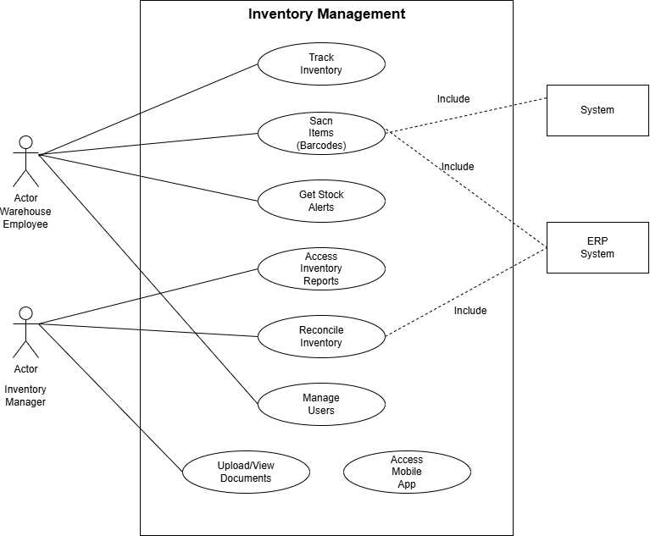
Activity Diagram

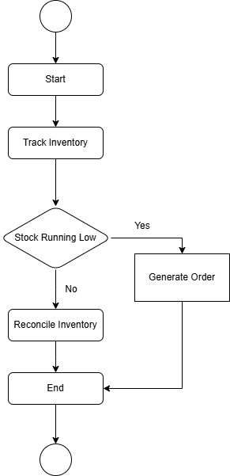

Use Case Specification Document

Use Case 1
Use Case Name | Scan and Update Inventory
Use Case Description | Warehouse staff scan item barcodes to update inventory quantities in real time.
Actors | - Primary: Warehouse Employee  - Secondary: System (automated update), ERP System
Basic Flow | - Employee logs in.  - Employee scans item barcode.  - System fetches item details.  - System updates inventory count.  - System stores updated data.
Alternate Flow | - Manual item code entry if scanner unavailable.
Exceptional Flows | - Barcode not recognized → Display error message.
Pre-Conditions | - Employee authenticated.  - Barcode scanner connected.  - Item exists in database.
Post Conditions | - Inventory updated.
Business Rules | - Barcode must be unique.  - All updates logged with user and timestamp.
Dependencies | - Barcode scanner hardware.  - Reliable network connection.
Input Output | - Input: Barcode scan, manual item code  - Output: Updated inventory, alerts, log entry

Use Case 2
Use Case Name | Inventory Threshold Monitoring and Alerts
Use Case Description | The system checks stock levels after updates. If inventory falls below threshold, it triggers alerts.
Actors | - Primary: System  - Secondary: Warehouse Supervisor (receives alerts)
Basic Flow | - System checks threshold after inventory update.  - If stock is below threshold, system generates alert.  - Alert is sent to supervisor or inventory manager.
Exceptional Flows | - None (handled automatically).
Pre-Conditions | - Threshold levels are configured.
Post Conditions | - Stock alerts generated if necessary.
Business Rules | - Alerts mandatory for low stock.  - Notifications logged.
Dependencies | - ERP integration for threshold data.

Use Case 3
Use Case Name | Manual Item Entry and New Item Request
Use Case Description | Employees manually enter item codes or request addition of new items if not found in the system.
Actors | - Primary: Warehouse Employee  - Secondary: Support Staff
Basic Flow | - Employee attempts to scan item.  - If scanner fails, manual entry is used.  - If item not found, employee raises support ticket or new item request.
Exceptional Flows | - System downtime → Manual logging of updates for later entry.
Pre-Conditions | - Employee authenticated.  - Item not found in system.
Post Conditions | - Ticket raised or item added to system.
Business Rules | - New items require approval before addition.
Dependencies | - Support team availability.

Use Case 4
Use Case Name | Audit and Exception Handling
Use Case Description | Handles stock mismatches, system errors, and audit trail maintenance.
Actors | - Primary: System  - Secondary: Inventory Auditor, Warehouse Employee
Basic Flow | - System detects stock mismatch.  - System flags entry for audit.  - Auditor reviews flagged transactions.
Exceptional Flows | - System down → Manual update submitted later.
Pre-Conditions | - Inventory update failure or mismatch detected.
Post Conditions | - Audit log created and resolved.
Business Rules | - All exceptions logged for auditing.  - Auditor responsible for closing audit flags.
Dependencies | - Reliable logging infrastructure.

Document 7- Screens and pages
Ans:
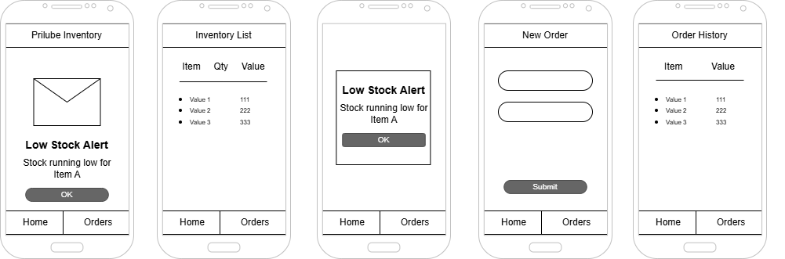

Document 8- Tools-Visio and Axure
Ans:
Microsoft Visio is a powerful diagramming tool widely used for designing and visualizing complex systems. It supports the creation of various diagrams such as use case diagrams, activity diagrams, sequence diagrams, flowcharts, and more. Visio offers a rich set of inbuilt templates and standardized symbols, making it easy to represent system processes, workflows, and architectures clearly and professionally.
Balsamiq is a user-friendly wireframing tool designed for creating low-fidelity mockups of user interfaces. It allows designers to sketch out the structure and layout of applications quickly, focusing on functionality rather than visual design. Wireframes created in Balsamiq act as blueprints for the actual application, helping stakeholders understand and review the design early in the development process.
Axure is an advanced prototyping tool that goes beyond wireframing to create fully interactive and functional prototypes. It enables users to design detailed user flows and simulate real user interactions by linking pages, setting conditions, and applying logic. This makes it especially useful for demonstrating the behavior of an application before any code is written, allowing for thorough user testing and feedback.

Document 9 : BA experience
Ans:

1. Requirement Gathering:
- Interacted with company stakeholders and supervisors to understand existing inventory processes and business goals.
- Collected data on how inventory was being tracked manually and identified common bottlenecks, such as stock mismanagement, delays in procurement, and lack of real-time tracking.
- Documented user needs for features like stock alerts, vendor management, and reporting capabilities.

2. Requirement Analysis:
- Analyzed the gathered information to categorize requirements into functional and non-functional types.
- Identified key actors such as Store Manager, Purchase Manager, and Admin, and defined their roles and responsibilities in the system.
- Developed a Software Requirements Specification (SRS) document outlining the detailed scope, features, and performance criteria of the system.
- Created detailed use cases to understand system interactions from a user's perspective.

3. Design:
- Designed the Use Case Diagram and Activity Diagram using Microsoft Visio to visually represent system functionality and user interactions.
- Created a 5-page wireframe using Balsamiq to present the user interface layout and navigation flow, including screens for Login, Dashboard, Inventory Entry, Vendor Management, and Reports.
- Used Axure to build interactive prototypes with linked screens, simulating the user experience by enabling page transitions based on actions (e.g., clicking buttons or selecting options).

4. Development :
- Followed the Waterfall model for project planning, dividing the process into linear, sequential phases.
- Outlined key modules and their functions, such as:
  - Inventory Dashboard: Shows current stock levels and alerts.
  - Add/Update Stock: Allows users to enter new stock or modify existing records.
  - Vendor Management: Stores vendor details and tracks purchase history.
  - Reports Generation: Provides inventory movement and reorder analysis.

5. Testing:
- Conducted manual walkthrough testing of each module using the wireframes and diagrams as a reference.
- Validated system behavior against the original requirements to ensure accuracy.
- Reported any logical issues, missing functionalities, or interface inconsistencies, and iterated on design as needed.

6. Deployment :
- Built a clickable prototype using Axure, which was presented to the project guide and stakeholders.
- Demonstrated working UI flows, data input screens, and navigational logic without coding.
- Provided comprehensive documentation, including the SRS, diagrams, and wireframes, to support future development and implementation.

