Capstone Project – 1
Part – 3
Requirements  ID | Requirement Name | Description
FR001 | Registration | The user must register the application to use application
FR002 | Login | The user needs to login into application to seen the products
FR003 | Search | The user can use search option to view products
FR004 | Upload | The manufacture companies need to upload all products in the application.
FR005 | Display | User can see offers and discounts on the application
FR006 | Add to cart | The user can add to cart products to buy later
FR007 | Get details | The user can see products details and price in the application
FR008 | Payment | The users should pay by all payment methods like UPI, CARDS, BANK TRANAFER AND CASH ON DELIVERY.
FR009 | Email confirmations | The users should get order confirmation through Email and SMS and Phone call.
FR010 | Track Delivery | The users can see order track on the application
Q1. Functional Requirements
A.

* Non – Functional Requirements.
Requirement  ID | Requirement Name | Description
NFR001 | Application Performance | The application must load in a 4 to 5 Seconds
NFR002 | Usability | This application like a user friendly
NFR003 | Security | The application should ensure the user authentication
NFR004 | Compatibility | This application must be compatible with the Chrome, UC Browser and Edge etc
NFR005 | Response Time | This application must response to inputs with in a 1 to 2 seconds
NFR006 | Scalability | This application must have scalability to 5000 to 10000 people to use at a time.
NFR007 | Maintains | The mean time to restore the application must not be more than the 10 mints
NFR008 | Portability | This application must be able to use in mobile, Laptops, and Operation systems.
NFR009 | Reliability | The system should able to handle and recover errors without incorrect data and the data loss.
NFR010 | Localization | The application needs to handle all languages like Telugu, Hindi and English etc.

Q2. Make Wireframes and Prototypes:
A.
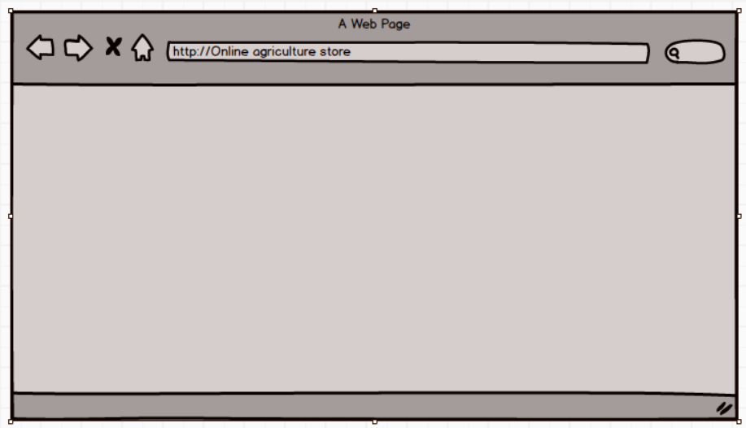
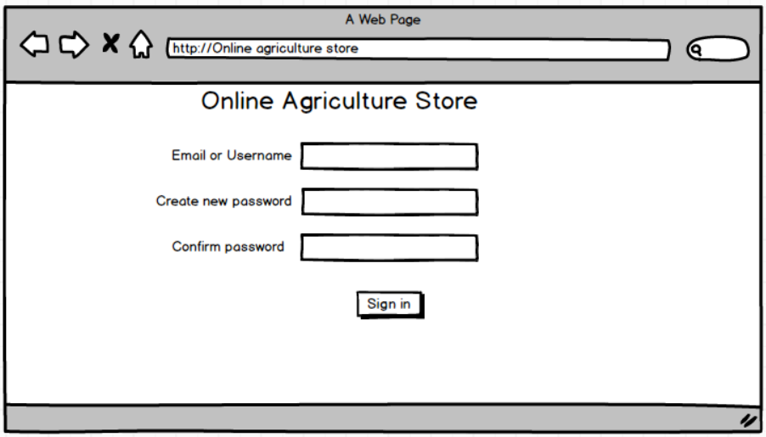
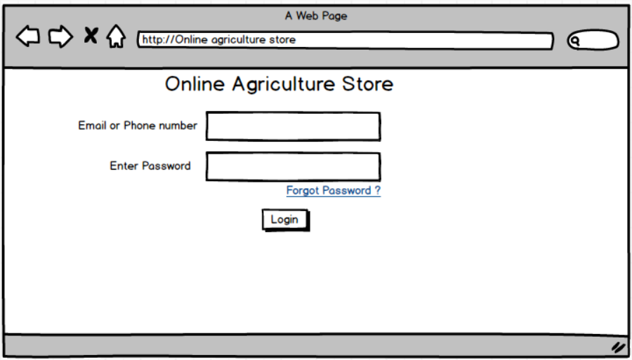
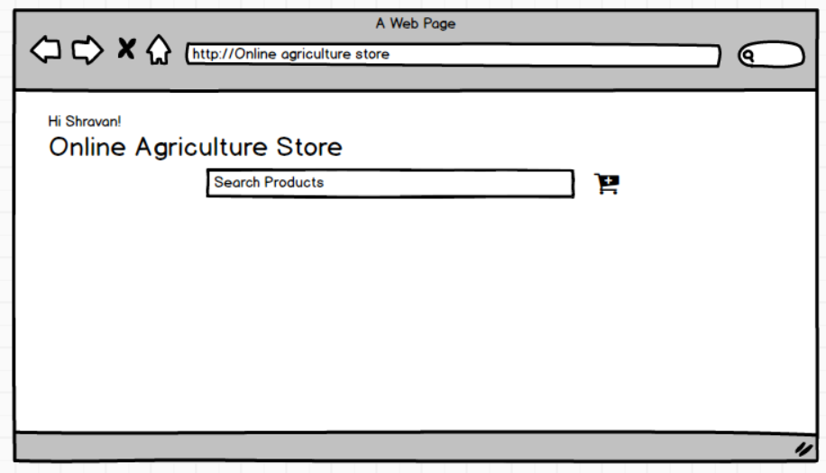
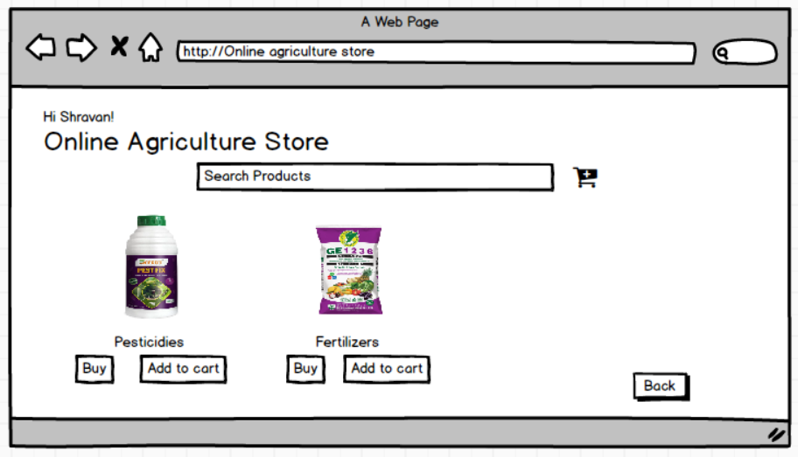
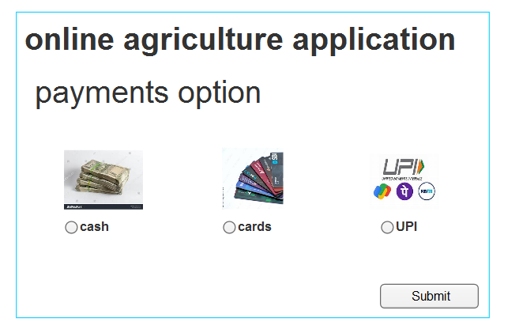

Q3. Tools (Visio and Balsamiq)
A.
Microsoft Visio:
The Microsoft Visio is a diagramming tool made by the Microsoft. And we can use it to create the flowcharts and system diagrams, network maps, organizational charts and more on this Microsoft Visio.
* Flowcharts – To show how a process works like a step-by-step workflow.
* System Diagrams – To plan software system or IT networks.
* Organization charts – Visio facilitates the creation of organization structure diagrams showing relationship and team structure.
* Network Diagrams – Users can create visual representation of computer network including devices connections.
* UML Diagrams – For software design like class diagrams, sequence diagrams.
* Data Visualization – Visio allows users to connect to data source such or share point and visualize data in various diagrams format.
* Collaboration – Visio enables users to share and collaborate on diagrams with others facilitating communication and team work
Balsamiq:
Balsamiq is low fidelity wire framing tool used by user interface designers, business analyst and developers to sketch user interface mock ups quickly
The purpose of Balsamiq is to create wire frames for website, apps and software interface,
It helps in brainstorming collaboration and early feedback and it is ideal for visualizing and communication layout and functionality during the plaining phase of development.
Key features:
Drag and drop interface:
It is easy for anyone regardless of design experience to create wire frames.
* Multiples styles:
Balsamiq offers different styles like draft, sketch, presentation to suit various stages of the design process from rough ideation to more refined presentation.
* Reusable Symbol:
Users can create and customers reusable UI elements or symbols to save time and repetitive task.
* Prebuilt UI components:
It offers a rich library of pre made UI control, icons and templates (Ex-buttons, text fields, forms, images, chats etc)
Axure RP:
The Axure RP a leading UX prototyping and wireframing tool it is a powerful and comprehensive designed application for UX (user experience) professional to create highly interactive prototypes, wire frames and specification for website and application. It allows designers to visualize and test their concepts before the development phase effectively mimicking the behaviour of a live application.
Key Features:
Interactive prototyping:
Drag and drop interface –
Easily place, resize and format widgets (Button, text fields, images etc) for building layouts
Conditional logic and dynamic content -
Create complex interaction such as displaying or high elements, showing different stages of a panel or performing calculation based on user input.
Event triggers, conditions and actions -
Define how elements respond to user action like clicks, hovers, swipes or key board inputs along with specific conditions that must be met for an interaction to occur.
As I used the Axure RP for the online agriculture application in this project this tools is very great to use it enables creation of high-fidelity, function prototypes that closely resemble the final product leading to more accurate user testing and feedback.
Q4
A.
REQ  ID | Requirement Name | Description | D1 | T1 | T4 | UAT
FR001 | Registration | The user must register the application to use application | Complete | Complete | Complete | Complete
FR002 | Login | The user needs to login into application to seen the products | Complete | Complete | Complete | Complete
FR003 | Search | The user can use search option to view products | Complete | Complete | Complete | Complete
FR004 | Upload | The manufacture companies need to upload all products in the application. | Complete | Complete | Complete | Complete
FR005 | Display | User can see offers and discounts on the application | Incomplete | Incomplete | Incomplete | Incomplete
FR006 | Add to cart | The user can add to cart products to buy later | Incomplete | Incomplete | Incomplete | Incomplete
FR007 | Get details | The user can see products details and price in the application | Complete | Complete | Complete | Complete
FR008 | Payment | The users should pay by all payment methods like UPI, CARDS, BANK TRANAFER AND CASH ON DELIVERY. | Complete | Complete | Complete | Complete
FR009 | Email confirmations | The users should get order confirmation through Email and SMS and Phone call. | Complete | Complete | Complete | Complete
FR010 | Track Delivery | The users can see order track on the application | Complete | Complete | Complete | Complete

Requirement  ID | Requirement Name | Description | D1 | T1 | T4 | UAT
NFR001 | Application Performance | The application must load in a 4 to 5 Seconds | Complete | Complete | Complete | Complete
NFR002 | Usability | This application like a user friendly | Complete | Complete | Complete | Complete
NFR003 | Security | The application should ensure the user authentication | Complete | Complete | Complete | Complete
NFR004 | Compatibility | This application must be compatible with the Chrome, UC Browser and Edge etc | Complete | Complete | Complete | Complete
NFR005 | Response Time | This application must response to inputs with in a 1 to 2 seconds | Complete | Complete | Complete | Complete
NFR006 | Scalability | This application must have scalability to 5000 to 10000 people to use at a time. | Incomplete | Incomplete | Incomplete | Incomplete
NFR007 | Maintainability | The mean time to restore the application must not be more than the 10 mints | Incomplete | Incomplete | Incomplete | Incomplete
NFR008 | Portability | This application must be able to use in mobile, Laptops, and Operation systems. | Complete | Complete | Complete | Complete
NFR009 | Reliability | The system should able to handle and recover errors without incorrect data and the data loss. | Complete | Complete | Complete | Complete
NFR010 | Localization | The application needs to handle all languages like Telugu, Hindi and English etc. | Complete | Complete | Complete | Complete

5Q. Test Case Documents
A. Test Case Specification for Login

Test Case ID |  | TC001 |  | Test Case Name | Login - 1
Project ID |  | P01 |  | Project Name | AGRI-1
PM ID |  | P001 |  | PM Name | MR VANDANAM
Test Strategy |  | ST001 |  | Tester ID | J004
Test Plan ID |  | TP001 |  | Tester Name | MR JASON
Test Schedule ID |  | TS001 |  | Date of Test | 29-10-2025
Scenario: Login to online agriculture store app
Procedure: 1. Click on login button 2. Verify email and password
Link to that Page: www.agriculturstore.com
Input Data | Mail ID: sattushravan7@gmail.com  Password: Sattu@1999 |  | Email ID: Prem5@  Password:APK119 | Email: Sai@101  Password: Sai@19 |  | Email: Mahesh123  Password:MK@14
Expected Behaviour | User able to login |  | System user able to see home page | Error displayed user redirect to login page |  | User change password, gets OTP, password changed
Actual Behaviour | As expected, |  | As expected, | As expected, |  | As expected,
Comments | Admin should keep screen on before it logged out
Results Pass/Fail | Pass |  | Pass | Pass |  | Pass

2.
Test Case ID |  | TC002 |  | Test Case Name | SEARECH
Project ID |  | P01 |  | Project Name | AGRI-1
PM ID |  | P001 |  | PM Name | MR VANDANAM
Test Strategy |  | ST001 |  | Tester ID | J004
Test Plan ID |  | TP002 |  | Tester Name | MR JASON
Test Schedule ID |  | TS002 |  | Date of Test | 29-10-2025
Scenario: By entering in option search, it should show the products
Procedure: Admin should click on search
Link to that Page: www.agriculturestore.com
Input Data | Pesticides |  | seeds | Crops |  | Motors
Expected Behaviour | Shows all products by searching
Actual Behaviour | As expected, |  | As expected, | As expected, |  | As expected,
Comments | Shows particular products admin search for products
Results Pass/Fail | Pass |  | Pass | Pass |  | Pass

3.
Test Case ID |  | TC003 |  | Test Case Name | Register
Project ID |  | P01 |  | Project Name | AGRI-1
PM ID |  | P001 |  | PM Name | MR VANDANAM
Test Strategy |  | ST001 |  | Tester ID | J004
Test Plan ID |  | TP003 |  | Tester Name | MR JASON
Test Schedule ID |  | TS003 |  | Date of Test | 29-10-2025
Scenario: To Register
Procedure: Click on register and enter fields
Link to that Page: www.agriculturestore.com
Input Data | Mail ID: sattushravan7@gmail.com  Password: Sattu@1999  Contact: 9515392569 |  | Email ID: Prem5@  Password:APK119  Contact: 6300190063 | Email: Sai@101  Password: Sai@19  Contact: 9550008299 |  | Email: Mahesh123  Password:MK@14  Contact: 9515766829
Expected Behaviour | All Require fields are filled |  | All require fields are filled | Error displayed |  | User change password users get OTP
Actual Behaviour | As expected, |  | As expected, | As expected, |  | As expected,
Comments | Admin should be eligible to register
Results Pass/Fail | Pass |  | Pass | Pass |  | Pass

4.
Test Case ID |  | TC002 |  | Test Case Name | Add to Cart
Project ID |  | P01 |  | Project Name | AGRI-1
PM ID |  | P001 |  | PM Name | MR VANDANAM
Test Strategy |  | ST001 |  | Tester ID | J004
Test Plan ID |  | TP004 |  | Tester Name | MR JASON
Test Schedule ID |  | TS004 |  | Date of Test | 29-10-2025
Scenario: To Add item to cart
Procedure: Click on item and click on add to cart
Link to that Page: www.agriculturestore.com
Input Data | Item name seeds item ID S04 item cost 10$ |  | Item name pests item ID S05 item cost 10$ | Item name crops item ID C04 item cost 10$
Expected Behaviour | User Able to add items to cart |  | User cab able to check count of item | User able to check items
Actual Behaviour | As expected, |  | As expected, | As expected,
Comments | Admin should click on add to cart
Results Pass/Fail | Pass |  | Pass | Pass |  | Pass

Q6.
Draw the data base schema diagram and ER diagram
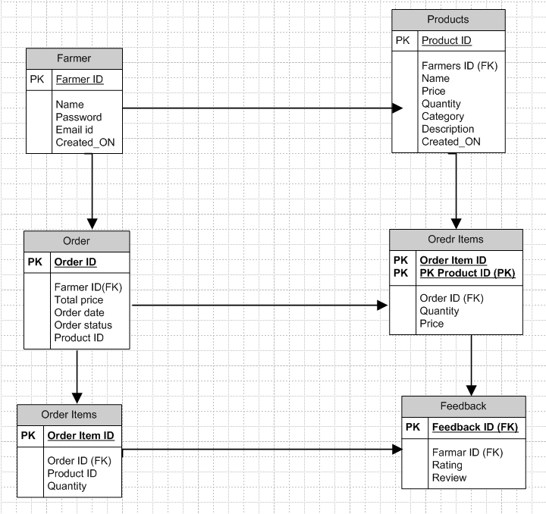

ER Diagram
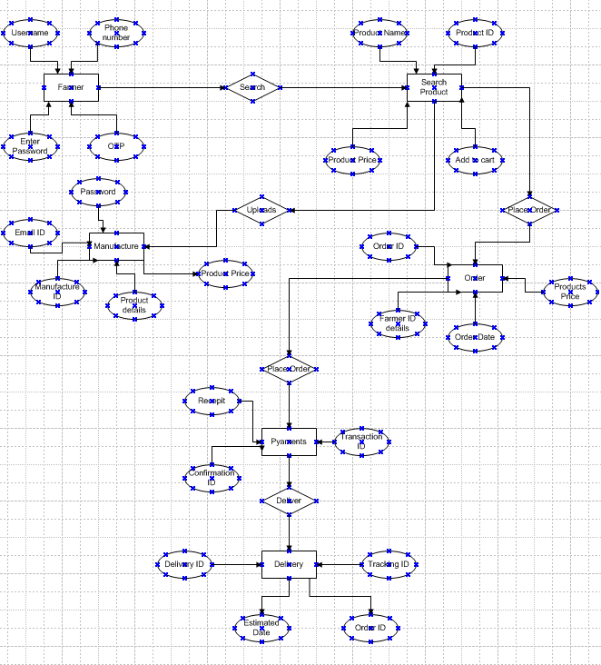
Q7. Data flow Diagram.
A. The data flow diagram is a visual representation that show the clear picture about how data moves through a system or process using symbols like arrows, rectangles, circles and text labels to depict data flow and transformation. Some of the key elements are,
Processes (Circles or Rectangles)
It represent actions or transformation that data under goes.
Data flows (Arrows)
It shows the movement of data between processes, Inputs, Outputs and stores
Data stores (Rectangles with open sides)
It represent places where data is stored such as data bases or files
External entities (Rectangles)
It represent sources or destinations of data outside the system which is being model
Text Labels
Used to describe the data, Processes and stores.
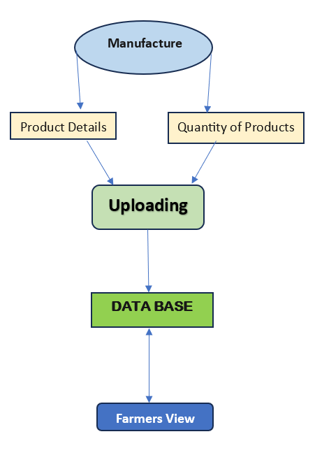

Q8. Change Request.
A.
How to handle change request in the project.
A change request is a format proposal for an alternation to a product system or project often which is initiated by the client or team member and requiring a structured process for evaluation and approval.
Definition
The change request is a format document that outline a proposed modification to a project, system and product.
Purpose
It serves as a mechanism to manage the change during a project life cycle and ensuring that any alternation is documented assed for impact and it is approved before implementation
Key elements:
Project Name – It clearly identifies the project to which that change request applies
Request Number – An identification for the change request
Requester – The individual or a team who initiating the change request
Description for change – A detailed explanation for the proposed change
Reason for change – Justification for why change is been needed
Impact of the change – Assessment of the potential effects of the change on the project scope, schedule, budget and quality
Proposed Action – The specification or actions required to implement the change
Business Priority – The important of the change is been related to the overall project goal
CHANGE REQUEST PROCESS
Collect Information – Gathering the all necessary and information related to the proposed change
Evaluate Impact – Asses the potential impact by the change request in the project
Prioritize – Determines the priority of the change request based on the importance and urgency and by this verify the impact assessment and seeing the risk analysis.
Approve or Reject – Review and either approve or rejects the change request
Plan Implementation – If the approval is done then plan the implementation of the change
Types of the Change Request:
Standard Changes: Pre-authorized, low-risk changes that follow a well know procedure.
Emergency Changes: Changes that must be implement immediately to resolve a major incident.
Normal Changes: All other change which is not standard changes and emergency changes are the normal changes.

Q9. Change request VS An Enhancement.
A.
The Both the change request and the enhancement involve in the modification some difference we have is enhancement are improving the existing functionality or features and in change request are broader proposal for alternate the project, product or the system, potentially including the enhancements new features or fixes.
Change Request:
Focus – Any modification to a project, system, including enhancement, new features or fixtures.
Purpose – To address change in requirement, scope, or deliverables.
Example – A change request might involve in adding new report of software application changing the way a button is positioned or fixing a bug that prevent a specific function working correctly.
Nature – Can be critical for project’s success as they address changes in requirements or address defects.
Process – Change request typically goes through a formal process of review, approval and implementation.
Enhancement:
Focus – It improves existing functionality and make it more efficient and powerful.
Purpose – It improve efficiency and capability of the project or system.
Example – As our project is online agriculture store farmers want to sell the crops in this app so this app is useful for buying and selling transactions.
Nature – Often considered nice to have improvement not necessarily critical for the project’s core functionality.
As the project is in process, Ben and Kevin have contacted you. The reason is to inform you that they want the Farmers to sell their crop yields through this application i.e. Farmers should be able to add their crop yields or products and display to general public and should be able to sell them. They also want to introduce Auction system for their Crop yields. As a BA, what will be your response? Is this a change request or an enhancement?
Yes, both these statements are enhancements.
Enhancement:
Purpose – It improve efficiency and capability of the project or system
Origin – Can come from users, customers or internet teams
Examples:
* Adding new feature to a website.
* Improve performance of software application.
Process – Enhancement request is typically reviewed and prioritized by development team.
Impact – Enhancement can improve user satisfaction, increase product value and enhance the overall user experience.

Q10. Estimations
A.
To estimations the man hours required for an online agriculture store, we need to consider various stages of software development life cycle (SDLC) from the planning to deployment as we are in online agriculture store project. It should be gathering requirement from the rural areas as it should be user friendly to the user in rural area.
Man, hours are the required efforts of the resources to complete a project as there are three types of projects,
PHASE | JUSTIFICATON | ESTIMATED MAN HOURS
Requirement Gathering | First, we need to gather requirement from stakeholder and we need to use elicitation techniques | 120-160 Hours
UI/UX Design | We should do the frame works, prototyping and responsive design | 150-200 Hours
Code/Testing | Writing code design and testing in system mobiles | 140-160 Hours
Payment Integration | UPI, Cards, Razor pay, Paytm, etc all payments Integration | 100-120 Hours
* Small projects up to 1000
* Medium project up to 1500
* Large project up to 2000
As it has 18 months of the duration this is a large project

Q11. UAT.
A. User acceptance testing (UAT) is a crucial phase in software development where real users test software to ensure it meets the needs and expectations in real world scenarios.
PUROSE
Early issues detection: UAT helps identify potential and discrepancies before software is released.
Reduce post-release issues: It can reduce the issues that arise after the software is released.
Key Steps.
Plaining: Determine the scope of UAT and select representative group of end-users or stakeholders to participate. Develop a plan that analysis the objectives test case and outcomes of the project.
Test Case Development: Create test cases based on user requirement and business needs and prioritize them based their importance and impact on user experience.
Execution and Reporting: Conduct UAT and execute the create text cases record the defects identified during UAT and prioritize the defects based on their severity and impact on user experience.
Defect Resolution and Re-Testing: Address and fix the defects identified and retest the software to ensure the defects are solved.
Sign-off and Release: After all the defects are solved obtain signoff from the users or stakeholders to proceed and release the software.
Benefits:
* UAT improves the software quality.
* As we identify the issues before releasing the software. It saves time and cost of the user.
After successful User Acceptance Testing (UAT), Project closure involves obtaining signing off documenting test results addressing remaining issues and preparing for final release.
Closure Process After UAT:
Obtaining Sign off
* Document tester approval: The most important step after UAT is to document the tester’s approval signifying that system the system meets all the requirement of users and is ready to release.
* Sign off methods: Consider using email approvals or physical signature.
* Communicate next steps: Explain next steps of the project to testers to address any concerns.
Document Test Result and Finalise Reports:
* Create Report: Group all the reports including defect reports bug verification
* Sign-off on the report: Ensure that all the stakeholders sign-off on the report confirming that all test are conducted and issues are addressed.
Addressing Issues and Prepare for Release:
* Prioritize and Resolve Bugs: Resolve the high priority defects identified during UAT.
* User Training and Documents: Arrange for user training and ensure that all the request documents are finalized and available.
* Prepare for post Release Support: Plan for post release support that includes feedback.
Project Closure:
* Finalize project documents: Ensure that all documents related to project like test plans test cases and final reports are accessible.
* Release the Project: Deploy the product to production along with the finalized release plan.

Q12. Project Closure Document
A.
Explain Project Closure Document
A project closure document is a formal document that summarises that final outcome of a project and documents the lesson learned for future project.
Purpose:
* Formal Project completion: It officially signals the end of project
* Performance Evaluation: It provides the review of the project and helps to improve in future project
* Stakeholder Communication: It communicates the final project result and lessons learned to stakeholders.
* Resource Release: Its facilities the release of project resources and transition of project deliverables to the operation team.
* Lessons learned: It captures key insights and best practices from the project that can helps in improvement for future project.
* Contract Closure: It ensure whether all the agreement related to project are properly closed.
Key Elements:
* Project Goals and Objectives: It provides a summary of initial goals of the project and helps to verify whether they were achieved.
* Deliverables and Acceptance: A list of final deliverables and conformation of client acceptance.
* Outstanding issues: A list any outstanding issues or takes that need to be addressed after project closure.
* Stakeholder Feedback: It includes feedback the stakeholder involved in project.
* Resource Release: A plan for releasing resource and transferring ownership of deliverables.
* Financial Reconciliation: It gives confirmation that all project related financial obligations have been met.
* Contract Closure: It ensures whether all the agreements related to project are properly
S.NO | Points to include | Details | Reference Link
1 | Did the client sign-off UAT testing | Yes | Business.docx
2 | Date of sign-off | 20th June 2025
3 | Name of resource
4 | Objective of project
5 | User friendly | Achieved
6 | Customer satisfaction | ROI in 6 months
7 | More categories | Achieved
8 | Functionality to worked on
9 | Secure payment processing | Achieved
10 | Categories | Achieved
11 | Infrastructure
12 | Software installed | Achieved
13 | Laptops purchased | Achieved
14 | Funding
15 | Amount approval | 2 crores | Financialbreakdown.docx
16 | Amount used | 1.4 lakhs
17 | Overall project info
18 | Escalations
19 | Customer satisfaction | 50
20 | Value to the company
21 | Positive/negative |  | 90% company gained edge over others, trained employees, increased clients, new project in pipeline

