Q1. Draw a Use Case Diagram on

Q2. Derive Boundary Classes, Controller classes, Entity Classes.
Boundary Class – Used to handle interactions between the system and external actors.
Example: Payment Option Boundary
Card Payment Boundary , user interface screen
Controller classes
It acts as intermediate between Boundary Class and Entity Class. manage the flow and logic of a specific use case, coordinating between the boundary and entity classes.
Example: Paymentintiated Controller , Card Payment Controller
Entity Class:
Represents the core data and business logic of the application. represent the data that persists in the system, often corresponding to nouns in the use case description.
Example:
Customer , Payment

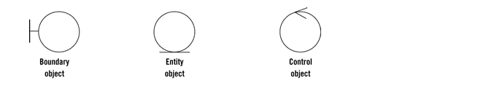
Question 3. Place these classes on a three tier Architecture.
Application Layer: Top most layer of the architecture – also known as presentation layer – It handles UI components such as screen , pages.
Ex:- E-Commerce Website.
Business Logic Layer: Middle Layer of the architecture – acts as an intermediary between the presentation layer and the data storage layer – layer contains the core logic of the application.
Ex:- Printer, Payment Gateway
Database Layer – bottom – most layer of the architecture – responsible for storing and retrieving data.
Ex: MySQL , Oracle Database.
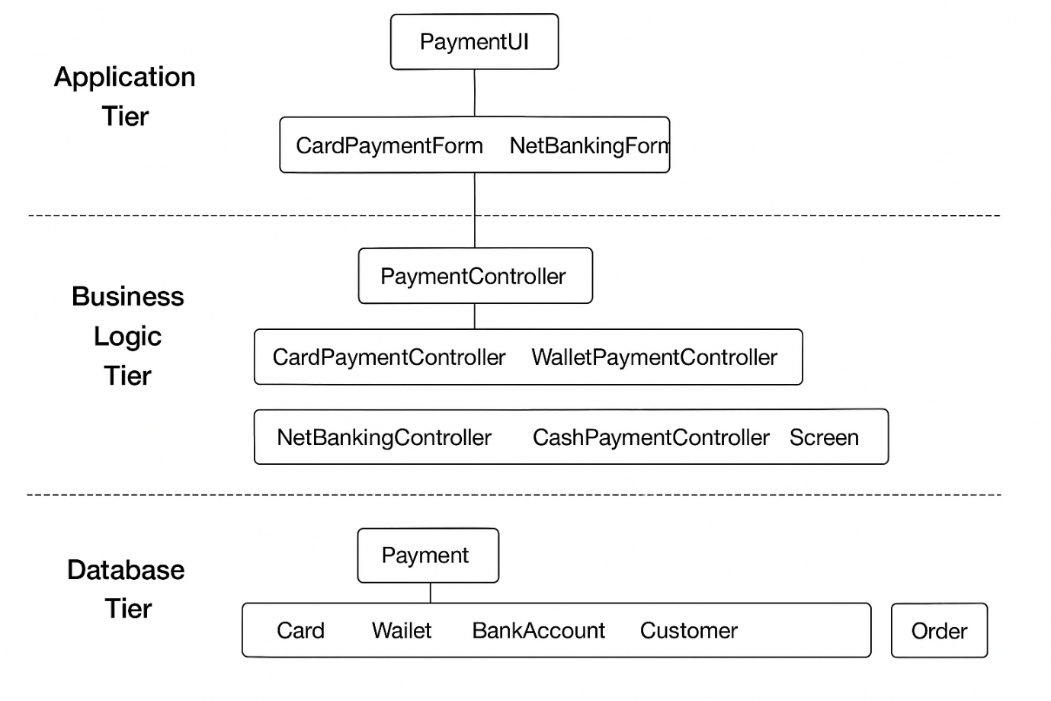
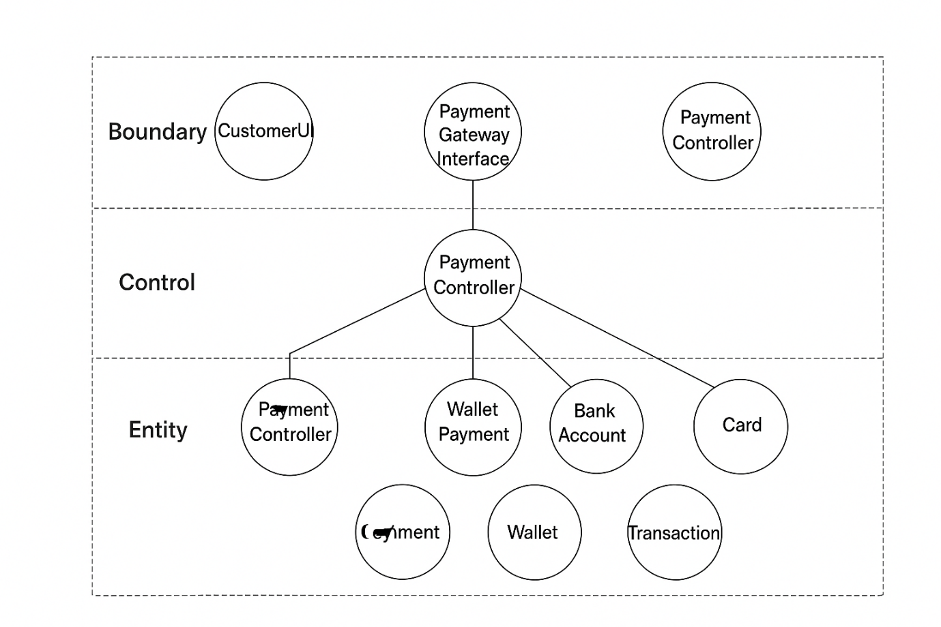
Q4. Explain Domain Model for Customer making payment through Net Banking
A Domain Model is a conceptual representation that defines the structure, relationship and behaviours of entities with a specific problem domain.
It shows the conceptual structure of the system — mainly objects (entities), attributes, and relationships between them.
Entities and Relationships
- Customer
- Attributes: CustomerID, Name, Email, Phone
- Relationship: Initiates the payment.
- Payment
  - Attributes: PaymentID, Amount, Date, Status, PaymentType
  - Relationship: Associated with a Customer and linked to NetBankingDetails.
- NetBankingDetails
  - Attributes: BankName, AccountNumber, IFSCCode, LoginID
  - Relationship: Used by Payment to process Net Banking.
- Bank
  - Attributes: BankID, BankName, Branch
  - Relationship: Hosts the NetBankingDetails.
- Transaction
  - Attributes: TransactionID, TransactionDate, TransactionStatus
  - Relationship: Generated from Payment.
- Order
  - Attributes: OrderID, OrderDate, TotalAmount
  - Relationship: Linked to Payment.
Summary of Relationship
- A Customer makes a Payment.
- Payment is processed via NetBankingDetails.
- NetBankingDetails belong to a Bank.
- Each Payment generates a Transaction.
- Each Payment corresponds to an Order.
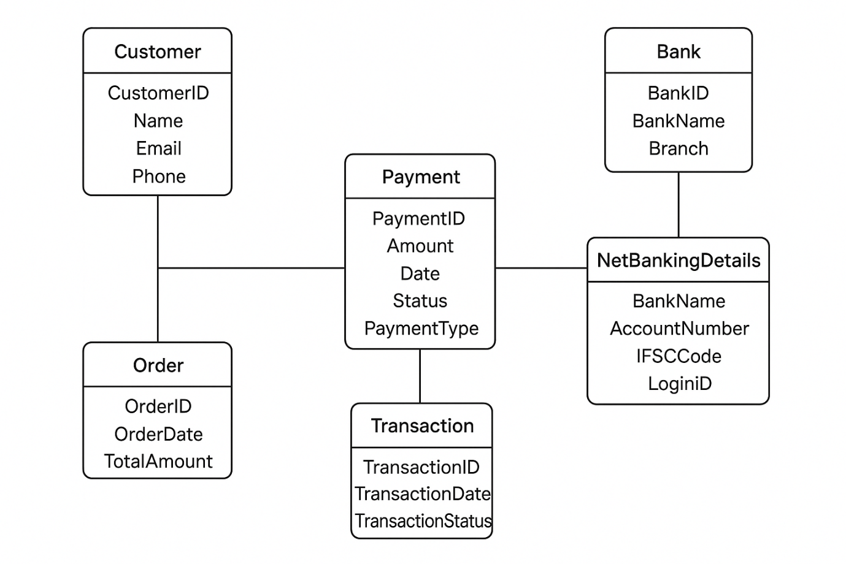

Q5. Draw a sequence diagram for payment done by Customer Net Banking
A sequence diagram is a type of interaction diagram used in software engineering and system design to illustrate how processes operate with one another and in what order.

Q6. Explain Conceptual Model for this Case
A conceptual model is high-level representation of s system that helps in understanding, visualizing and communicating the essential aspects of a domain. The Conceptual Model represents the high-level view of the system showing the key entities and their relationships involved in the payment process through Net Banking. It focuses on what data is required and how entities are related, without going into technical details.
It provides a clear and simplified view of the domain, making it easier to understand.
Key Elements of a Conceptual Model:
- Entities: Customer, Product, Order & Payment
- Attributes – CustomerId, name, email and Mobile Number
- Relationsships :
- Customer makes Payment.
- Payment is processed through Bank.
- Bank Account belongs to Customer.
- Payment is made to Merchant.
- Payment generates Receipt.
Summary:
The conceptual model shows the main entities and their logical relationships involved in the Net Banking payment process. It helps in understanding the overall system structure before moving to detailed design like ERD or database schema.

Q7. What is MVC architecture? Explain MVC rules to derive classes from use case diagram and guidelines to place classes in 3-tier architecture
The Model-View-Controller(MVC) framework is an architecture pattern that separates an application inti three main logical components Model, View and Controller. This separation helps in organizing code, improving maintainability, and supporting parallel development.
Components of MVC:
View:
Represents the user interface elements that display data to the user and accept input.
Ex: PaymentUI, NetBankingForm, ReceiptScreen
Model:
Represents the data and business logic of the system. It defines how data is stored, processed, and validated.
Ex: Classes like Customer, Payment, BankAccount, Transaction
Controller:
Acts as a mediator between View and Model. It processes user input, invokes model operations, and updates the view.
Ex: PaymentController, NetBankingController
Rules to Derive Classes from Use Case Diagram
- Identify Boundary Classes (View):
  - Derived from actors and user interactions in the use case diagram.
  - Represent UI screens or forms.
  - Example: PaymentUI, NetBankingForm, ReceiptScreen.
- Identify Control Classes (Controller):
  - Derived from use cases themselves.
  - Manage the flow of operations and coordinate between View and Model.
  - Example: PaymentController, TransactionController.
- Identify Entity Classes (Model):
  - Derived from nouns and data elements in use cases and scenarios.
  - Represent business objects and persist data.
  - Example: Customer, BankAccount, Payment, Receipt.
Guidelines to Place Classes in 3-Tier Architecture:
Tier | Contains | Example Classes | Purpose
Presentation Tier (UI Layer) | View / Boundary classes | Payment UI, Net Banking Form, Receipt Screen | Interact with users and display output
Application Tier (Business Logic Layer) | Controller / Control classes | Payment Controller, Transaction Controller | Handle processing, coordination, and logic flow
Data Tier (Database Layer) | Model / Entity classes | Customer, Bank Account, Payment, Receipt | Manage data storage, retrieval, and relationships
Summary
- MVC architecture divides the system into Model, View, and Controller for better modularity.
- Classes derived from use case diagram are categorized as boundary (View), control (Controller), and entity (Model).
- In 3-tier architecture,
  - Boundary classes → Presentation Tier,
  - Control classes → Application Tier,
  - Entity classes → Data Tier.
This ensures clear separation of concerns, easy maintenance, and scalable system design.

Q8. Explain BA contributions in project (Waterfall Model – all Stages)
The Waterfall Model is a sequential software development process where each phase must be completed before the next begins. The Business Analyst (BA) plays a key role at every stage of this model to ensure that the business requirements are correctly understood, documented, and implemented.

Stage | Activities | Artifacts & Resources
Pre Project | - Understand business need and problem statement  - Conduct feasibility and impact analysis  - Support in business case preparation | Business Case, Feasibility Report
Planning | - Define project scope and objectives  - Identify stakeholders and gather initial requirements  - Assist in project plan creation | Project Charter, Scope Document, Stakeholder Register
Project Initiation | - Conduct stakeholder meetings  - Finalize scope and timelines  - Define requirement elicitation plan | Requirement Management Plan, Communication Plan
Requirements Gathering | - Conduct workshops, interviews, and brainstorming sessions  - Elicit and document functional & non-functional requirements | BRD (Business Requirements Document), Use Cases, User Stories
Requirements Analysis | - Analyze and validate requirements  - Ensure requirements traceability  - Resolve conflicts and prioritize features | Requirement Traceability Matrix (RTM), Process Flow Diagrams
Design | - Support solution and system design discussions  - Review UI/UX wireframes and prototypes  - Validate design alignment with requirements | System Design Document, Wireframes, Data Flow Diagrams
Development | - Clarify requirements to developers  - Participate in sprint or build reviews  - Update documentation for any scope changes | Updated BRD/SRS, Change Request Document
Testing | - Review test plans and test cases  - Perform UAT preparation and support  - Validate test results against requirements | Test Plan, Test Cases, Defect Log, RTM
UAT | - Coordinate UAT with business users  - Capture feedback and confirm acceptance  - Get sign-off for deployment | UAT Sign-off Document, Release Notes

Conclusion:
The Business Analyst acts as a bridge between business stakeholders and the technical team throughout all Waterfall stages. Their contributions ensure that the final system meets business objectives, minimizes rework, and delivers value effectively.
Q9. What is conflict management? Explain using Thomas – Kilmann technique
Conflict management is the process of resolving conflicts or disagreements between individuals or groups in a constructive manner.
Conflict Management is the process of identifying, addressing, and resolving disagreements between individuals or teams in a constructive way.
The goal is to maintain healthy working relationships while achieving project objectives effectively.
Conflicts may arise due to differences in opinions, priorities, communication gaps, or resource allocation during a project.

Thomas – Kilmann technique is a widely used too for conflict resolutions style & guiding individuals in selecting appropriate strategies to manage conflicts.
The Thomas–Kilmann Conflict Mode Instrument (TKI) identifies five different styles of handling conflict based on two dimensions:
- Assertiveness – The extent to which you try to satisfy your own concerns.
- Cooperativeness – The extent to which you try to satisfy others’ concerns.
Style | Description | When to Use
1. Competing (High Assertive, Low Cooperative) | You pursue your own concerns at the expense of others. | Quick, decisive actions are needed; emergencies.
2. Collaborating (High Assertive, High Cooperative) | You work together to find a win–win solution. | When both parties’ interests are important.
3. Compromising (Moderate Assertive, Moderate Cooperative) | Each party gives up something to reach an acceptable solution. | When time is limited, and both sides have equal power.
4. Avoiding (Low Assertive, Low Cooperative) | You ignore or postpone dealing with the conflict. | When the issue is minor or emotions are high.
5. Accommodating (Low Assertive, High Cooperative) | You put others’ needs before your own. | When maintaining harmony is more important than winning.

Steps in Effective Conflict Management:
- Identify the source of conflict.
- Analyse the situation and discuss the issue openly.
- Explore possible solutions collaboratively.
- Select the most suitable resolution approach.
- Implement and monitor the solution to prevent recurrence.
Summary:
- Conflict management ensures effective teamwork and communication.
- The Thomas–Kilmann model provides five strategies: Competing, Collaborating, Compromising, Avoiding, and Accommodating.
- The right style depends on the situation, urgency, and relationship importance.
Q10. List down the reasons for project failure
A project is considered a failure when it does not meet its objectives in terms of time, cost, quality, or scope. There are several key reasons why projects fail:
A project fails mainly due to poor planning, weak communication, and lack of control.
Effective requirement management, leadership, and monitoring can prevent most failures.
Poor Requirement Gathering and Analysis
- Incomplete, unclear, or changing requirements.
- Lack of involvement of end users or stakeholders.
Impact: Leads to rework and product not meeting user needs.
Lack of Proper Planning
- No detailed project plan, unclear milestones or deadlines.
- Underestimating time, cost, and resources.
Impact: Causes schedule slippages and cost overruns.
Ineffective Communication
- Miscommunication between team members, clients, or departments.
- Missing updates and unclear roles/responsibilities.
Impact: Leads to confusion, conflict, and delays.
Inadequate Risk Management
- Ignoring potential risks or not preparing mitigation plans.
Impact: Unexpected problems halt project progress.
Poor Project Leadership
- Weak project manager with lack of decision-making or control.
- No coordination among cross-functional teams.
Impact: Results in low team morale and poor direction.
Scope Creep (Uncontrolled Change Requests)
- Adding new features or changes without proper approval.
Impact: Increases workload, time, and cost, reducing project quality.

Q11. List the Challenges faced in projects for BA
A Business Analyst (BA) acts as a bridge between business stakeholders and the technical team.
During a project, the BA faces several challenges related to requirements, communication, and stakeholder management.
A Business Analyst faces challenges mainly in requirement clarity, stakeholder management, and communication.
To overcome these, a BA must use effective elicitation techniques, maintain clear documentation, and ensure continuous stakeholder engagement.
Unclear or Changing Requirements
- Stakeholders often provide incomplete, vague, or frequently changing requirements.
Impact: Leads to confusion and scope creep.
Communication Gaps
- Miscommunication between business users, developers, and testers.
- Different stakeholders may interpret requirements differently.
Impact: Causes misunderstanding and rework.
Managing Multiple Stakeholders
- Conflicting interests or priorities among stakeholders.
- Difficulty in getting approvals and consensus.
Impact: Delays in decision-making.
Limited Domain Knowledge
- BA may lack in-depth understanding of the business domain or processes.
Impact: Incorrect requirement interpretation or solution mismatch.
Times Constraints and Tight Deadlines
- Insufficient time for requirement elicitation and documentation. Impact: Poor quality analysis and missed requirements.
Resistance to Change
- End users or stakeholders may resist adopting new systems or processes.
Impact: Impacts project acceptance and user adoption.
Q12. Write about Document Naming Standards
A document naming standard is a systematic approach used to assign unique and meaningful identifiers to project documents.
It ensures consistency, easy tracking, and version control throughout the project lifecycle.

Document Naming Standards are guidelines used to name project documents in a consistent and organized way.
They ensure that all team members can easily identify, locate, and manage documents throughout the project lifecycle.
Purpose:
- To maintain consistency across all project files.
- To enable quick identification of document type, version, and purpose.
- To avoid duplication or confusion.
- To support traceability and audit of project documents.
Example:
Suppose we have a project with the ID “PROJ567”, and we are working on a Business Requirements Document (BRD).
Project ID: PROJ567
Document Type: BRD
Version: 1.0
Date: 2025-11-02
->Document Identifier could be:
PROJ567-BRD-1.0-2025-11-02
Where:
- ProjectName → Identifies the project (e.g., ECommerceApp)
- DocumentType → Type of document (e.g., BRD, SRS, TestPlan)
- Version → Version control (e.g., V1.0, V2.1)
- Date/Author → Optional field to track updates
Document naming standards help maintain clarity, uniformity, and traceability across all project files, making collaboration and document management more efficient.
Q13. What are the Do’s and Don’ts of a Business analyst
A Business Analyst (BA) plays a crucial role in bridging the gap between business stakeholders and the technical team.
To perform effectively, a BA must follow certain best practices (Do’s) and avoid common mistakes (Don’ts).
Do’s | Explanation
1. Understand Business Objectives | Clearly identify business goals before gathering requirements.
2. Communicate Effectively | Maintain open, transparent communication with all stakeholders.
3. Document Requirements Clearly | Use standard templates and maintain traceability.
4. Involve Stakeholders Early | Engage users and sponsors throughout the project to avoid rework.
5. Validate and Verify Requirements | Ensure the documented requirements meet business needs.
6. Keep Learning and Adapting | Stay updated with business trends, tools, and techniques.

Don’ts | Explanation
1. Don’t Assume Requirements | Always confirm details; never make assumptions.
2. Don’t Ignore End Users | User input is critical for accurate requirement gathering.
3. Don’t Use Technical Jargon with Business Stakeholders | Communicate in business-friendly language.
4. Don’t Skip Reviews or Approvals | Always get stakeholder sign-off before proceeding.
5. Don’t Resist Change | Adapt positively to change requests or feedback.
6. Don’t Work in Isolation | Collaborate closely with the project team and management.
Summary:
- Do’s: Communicate well, document clearly, validate requirements, and stay business-focused.
- Don’ts: Avoid assumptions, jargon, and ignoring stakeholder input.
A successful BA must balance analytical thinking, communication, and collaboration to ensure project success.
Q14. Write the difference between packages and sub-systems
Packages:
A package is a collection of components or modules that are not reusable in nature.
These are usually developed for specific client requirements or custom applications.

A logical grouping of related classes, interfaces, or components within a system. It helps organize the model to make it more manageable and modular.
Example: Application development companies typically work on packages.
Sub-systems:
A sub-system is a collection of components or modules that are reusable in nature.
They are usually part of product-based development where modules can be reused across multiple products.
A self-contained, independent unit of the system that performs a specific set of related functions. It can contain multiple packages.
Example: Product development companies generally work on sub-systems.
Basis | Package | Sub-system
Meaning | Logical grouping of related elements like classes or use cases. | A larger, functional part of the system that performs a major business process.
Scope | Smaller unit within a system. | Higher-level component that may include multiple packages.
Purpose | Organize and simplify the system model. | Divide the system into manageable, independent modules.
Example | Payment Package,  Customer Package | Billing System,  Inventory System

Q15. What is camel-casing and explain where it will be used
- Camel-casing is a naming convention used in computer programming.
- It is mainly used for naming variables, functions, classes, and identifiers in a readable manner.
Example:
- Camel Case: camelCaseExample
In camel casing, the first word starts with a lowercase letter and each subsequent word begins with an uppercase letter, making the name easy to read and understand.

Usage Area | Description / Example
Variable Names | Used in most programming languages for readability. → totalAmount, userName
Method / Function Names | Used to name methods that perform actions. → calculateTotal(), getCustomerData()
Class or Object Names | Usually in Pascal Case form. → CustomerDetails, PaymentController
Attribute Names in Models or Documents | For maintaining consistency in data or UML diagrams.
Advantages:
- Improves readability and consistency.
- Makes code easier to understand for developers.
- Helps maintain naming standards across the project.
Camel-casing is a widely used naming convention in programming and documentation.
It ensures clarity, uniformity, and professionalism in naming variables, methods, and classes across all project documents and codebases.

Q16. Illustrate Development server and what are the accesses does business analyst has?
A development server refers to a dedicated environment used during the software development process for building, testing, and debugging applications.
It serves as a platform for developers and testers to verify application functionality before deployment to staging or production environments.
As a Business Analyst (BA), access is limited — typically restricted to:
- Viewing or validating application behavior.
- Performing basic testing or review of functionalities.
- Reporting issues or providing feedback to the development team.

A Development Server is a dedicated environment where developers and project teams build, integrate, and test new features or applications before moving them to testing or production environments.
It acts as a sandbox for trying out code, configurations, and updates without affecting live (production) data.
Purpose of Development Server:
- To allow coding, unit testing, and integration of new features.
- To validate functionality before release.
- To maintain separation between development, testing, and production environments.
- To ensure system stability by isolating experimental changes.
Development Server → Testing (QA) Server → UAT Server → Production Server
A Business Analyst (BA) does not usually perform coding,
but they are given limited and controlled access to the development server for analysis and validation purposes.
A Development Server is mainly used for coding and integration, while the Business Analyst uses it to validate requirements, check system behaviour, and ensure traceability — all without changing the system configuration or data.
This ensures safe, structured, and collaborative development within the project lifecycle.
Q17. What is Data Mapping
Data mapping is the process of connecting or linking data from one source to another.
It involves creating a guide or map that shows how data in one system corresponds to data in another system.
Data mapping is crucial when transferring or integrating data between different databases, systems, or applications to maintain data consistency, accuracy, and integrity.

Data Mapping is the process of connecting or linking data fields from one source to corresponding data fields in another destination (target) system.
It defines how data will be transferred, transformed, and stored when moving between systems, databases, or formats.

Purpose:
- To ensure data consistency and accuracy during migration or integration.
- To support ETL (Extract, Transform, Load) processes in data warehousing.
- To standardize data formats between different systems.
- To help BAs and developers understand how data flows across systems.
Examples:
Customer Data Migration
In a CRM to Billing System migration, the field Customer_Name from the CRM maps to FullName in the Billing System, Contact_No maps to PhoneNumber (with a +91 country code added), and Email_ID maps directly to EmailAddress without any change.
Employee Data Integration
When integrating the HR Portal with the Payroll System, Emp_ID in the HR system maps to EmployeeCode in payroll, Joining_Date maps to DateOfJoining after formatting into YYYY-MM-DD, and Basic_Salary maps to BasePay after converting it into a numeric format.
Product Catalog Transfer
During the transfer of data from an Inventory Database to an E-Commerce Portal, the Prod_ID field is mapped to ProductID, Prod_Description is mapped to ProductDetails (after trimming extra spaces), and Price is mapped to ProductPrice rounded to two decimal places.
Student Data Migration
In a College Admission to Examination System migration, Student_Name from the admission system maps to FullName in the exam system, DOB is mapped to DateOfBirth with a format conversion from DD/MM/YYYY to YYYY-MM-DD, and Course_Code maps to ProgramID through a lookup table.
Sales Data Reporting
When transferring sales data from the Sales Database to a Data Warehouse, Order_ID is mapped to TransactionID, Total_Amount is mapped to SalesValue after converting it into a floating-point number, and Order_Date is mapped to SaleDate using the ISO date format YYYY-MM-DD.
Each example shows how data mapping defines relationships between source and target fields, including data transformation rules to ensure consistency and accuracy during system integration or migration.

Q18. What is API. Explain how you would use API integration in the case of your application Date format is dd-mm-yyyy and it is accepting some data from Other Application from US whose Date Format is mm-dd-yyyy

An API (Application Programming Interface) is a set of rules and tools that allow different software applications to communicate and interact with each other.
It defines the methods, protocols, and data formats that applications can use to request and exchange information efficiently.
An API (Application Programming Interface) is a set of rules, protocols, and tools that allows two different software applications to communicate and share data with each other.
It acts as a bridge between systems, enabling them to exchange information securely and efficiently without manual data entry.
Purpose:
API Integration connects two or more systems so that they can share and update data automatically.
It ensures real-time communication, data consistency, and process automation between multiple applications.
Examples:
-> Payment Application connecting with a Bank’s Server via API to verify transaction details.
-> In this case, your application accepts data in dd-mm-yyyy format, but the US-based external application sends date data in mm-dd-yyyy format through an API.
How API Integration Works in This Case:
- Step 1: API Request Received
  - The external (US) application sends data (e.g., 05-10-2025) via an API in mm-dd-yyyy format.
  - Example data: { "DateOfPayment": "05-10-2025" }
- Step 2: Data Parsing and Validation
  - Your system receives the API request and validates the data format.
  - The API identifies that the incoming date format is US style (month-day-year).
- Step 3: Data Transformation / Conversion
  - The API layer converts the format from mm-dd-yyyy → dd-mm-yyyy using a transformation rule.
  - Example conversion: 05-10-2025 (US) → 10-05-2025 (India)
- Step 4: Store in Application Database
  - After conversion, the correctly formatted date is stored in the local database.
  - This ensures that all internal reports and screens follow the Indian format.
- Step 5: Response Sent Back
  - The API sends a success response (e.g., 200 OK) back to the US system confirming that data was received and stored properly.
API Integration Techniques Used:
- Middleware or Integration Layer: Handles transformation of date and data formats.
- Data Mapping: Defines how incoming API fields map to your internal data model.
- Validation Rules: Check if the data is complete and in the expected range.
- Logging & Error Handling: Records format errors or invalid inputs for troubleshooting.
In this case, API Integration ensures smooth and accurate data exchange between your local application and the US application.
By implementing data transformation logic, especially for date formats, the systems can communicate effectively without data mismatch or confusion.

