Q1. Draw a Use Case Diagram – 4 Marks
Actors: Customer
Use Cases:
- Make Payment
- Choose Payment Method (Card, Wallet, Cash, Net Banking)
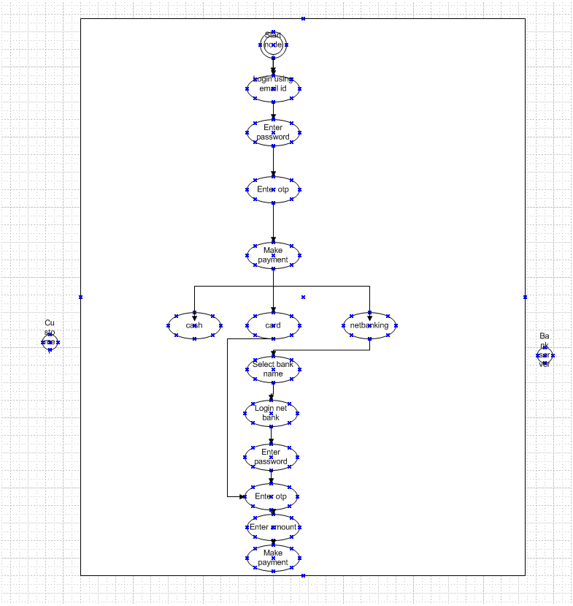
Q2. Derive Boundary Classes, Controller Classes, Entity Classes – 4 Marks
- Boundary Classes: is a class that is boundary of the system and other stem or user ( which is actor in the use case diagram)
- Features are as follows
- This class is easy to change than entity and control class
- The attribute of the class and screen layer are defined at the basic design
- In the class diagram there are stereotype (boundary) added
- Class diagram is shown by icon
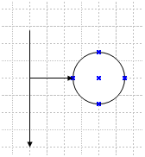

- Controller Classes:feature of control class

- This has few attributes

- There are stereotype (control) is added

- Class achieve use case in the use case diagram

- Entity Classes:

It is the class that has data the E of ER diagram means Entity
Feature of entity
The class is related to data oriented approach
The class diagram there are cases that the stereotype entity is added
  - Customer
  - Payment
  - Transaction
  - BankDetails
  - WalletAccount
  - 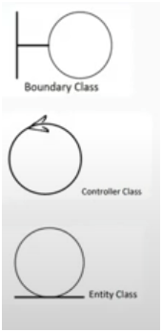

Q3. Place These Classes in a 3-Tier Architecture – 4 Marks
- Presentation Tier (UI Layer)
  - PaymentScreen, CardPaymentUI, WalletPaymentUI, CashPaymentUI, NetBankingUI
- Business Logic Tier (Application Layer)
  - PaymentController, TransactionProcessor
- Data Tier (Persistence Layer)
  - Customer, Payment, Transaction, BankDetails, WalletAccount
  - 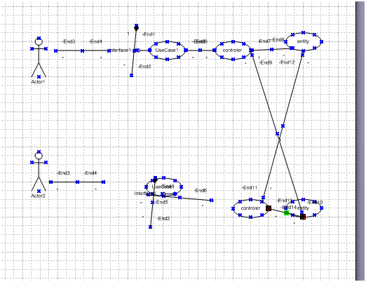

Q4. Explain Domain Model for Customer Making Payment Through Net Banking – 4 Marks
- 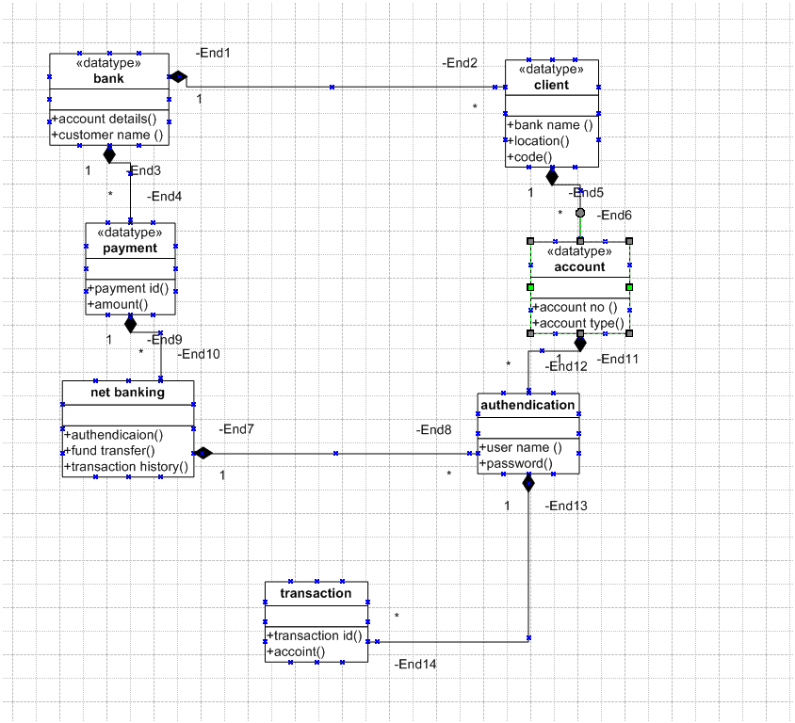 Domain Model represents entities and their relationships.
- In Net Banking payment, entities are:
  - Customer: Initiates the payment
  - Payment: Stores amount, date, and method
  - BankDetails: Stores bank account info
  - Transaction: Contains status, ID, time
Relationships:
- A Customer initiates a Payment.
- A Payment uses BankDetails for Net Banking.
- A Transaction is generated upon payment processing.

Q5. Draw a Sequence Diagram for Payment by Net Banking – 4 Marks
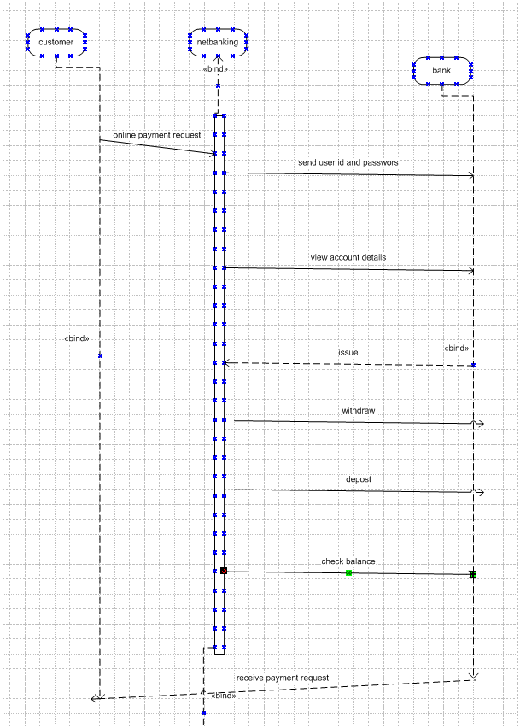

Q6. Explain Conceptual Model for This Case – 4 Marks
- A Conceptual Model shows high-level relationships between business entities.( ER diagram )
- Interaction between actor and object
- Entities:
  - Customer, Payment, Payment Method, Transaction, Bank
Concepts:
- A Customer performs a Payment
- A Payment is done using a Payment Method
- A Payment leads to a Transaction
- For Net Banking, Bank validates and authorizes payment

Q7. What is MVC Architecture? Explain MVC rules to derive classes and 3-Tier Guidelines – 8 Marks
MVC (Model-View-Controller):
- Model: Data & Business Logic
- View: UI / Screens
- Controller: Handles user input & business coordination
Rules to Derive Classes:
- Use case diagram actions → Controller Classes
- System actors/UI screens → Boundary Classes
- Business objects/data → Entity Classes
3-Tier Guidelines:
- Presentation Layer: View & Boundary Classes
- Application Layer: Controller Classes
- Data Layer: Entity Classes
MVC stands for Model-View-Controller. It is a software architectural pattern that separates an application into three main logical components:
Component | Responsibility
Model | Manages data, business logic, and rules of the application
View | Responsible for presenting data (UI) to the user
Controller | Handles user input, manipulates model, and updates view
This separation helps organize code, promote reusability, and support parallel development.

2. Components Explained
Model
- Represents business data and logic.
- Examples: Customer, Order, Invoice, Payment, etc.
- Responsible for interacting with the database and managing the state of the application.
View
- Represents the user interface elements.
- Examples: Forms, Web pages, Mobile app screens.
- It displays the data from the model and sends user actions to the controller.
Controller
- Acts as a mediator between view and model.
- Accepts inputs from the view, processes it (via model), and sends output back to the view.
- Examples: LoginController, PaymentController

3. Rules to Derive Classes from Use Case Diagram (UCD)
When analyzing a Use Case Diagram, the following rules are used to derive relevant classes based on MVC:
🔹 Boundary Classes (View Layer)
- Represent interfaces between the system and actors (users, external systems).
- Derived from interactions between the actor and use case.
- Typically corresponds to screens/forms/pages.
Examples:
- LoginScreen, PaymentForm, UserDashboard
🔹 Controller Classes (Application Logic Layer)
- Handle the communication between boundary and entity classes.
- Derived from use cases — each use case generally maps to one controller.
- Controls the flow of the application.
Examples:
- PaymentController, OrderController
🔹 Entity Classes (Data Layer)
- Represent persistent data and domain logic.
- Derived from nouns in the use case description or business rules.

Q8. BA Contributions in Waterfall Model – 8 Marks
The Waterfall Model is a sequential software development methodology, where each phase must be completed before moving on to the next. A Business Analyst (BA) plays a critical role in each phase to ensure that the solution meets business goals, aligns with stakeholder needs, and supports smooth delivery.

- Requirement Gathering: Define and document detailed BRD, SRS
- Analysis: Validate requirements with stakeholders
- Design Phase: Assist in translating requirements into technical specs
- Development Phase: Support dev team with clarifications
- Testing Phase: Validate test cases, participate in UAT
- Deployment: Ensure smooth handover
- Maintenance: Monitor performance, gather feedback
Waterfall Phase | BA Contribution
Requirement Gathering | Elicit, document, validate, trace requirements
Design | Translate business logic, review design
Development | Clarify scope, ensure alignment
Testing | Review test cases, UAT support
Deployment | User training, transition support
Maintenance | Feedback, change request analysis
The Business Analyst is involved throughout the Waterfall lifecycle, though most active during requirement gathering and validation. The BA ensures that the solution meets business goals, helps minimize rework, and plays a key role in achieving project success.

Q9. Conflict Management – Thomas-Kilmann Technique – 6 Marks
Conflit management us the process of resolving the conflit or disagreements between individuals or groups
5 steps
Identify the conflit
Discuss the details
Agree with root problem
Check for every possible
Negotiate for solution
Conflicts can arise in a project due to differences in:
- Opinions or expectations
- Priorities
- Roles and responsibilities
- Communication gaps
- Resource constraints

Technique Dimensions:
- Competing – Assertive, uncooperative
- Collaborating – Assertive and cooperative
- Compromising – Mid-level both
- Avoiding – Unassertive, uncooperative
- Accommodating – Cooperative, unassertive
Usage: BA identifies conflict type and applies the best style to maintain team harmony and project flow.
The Thomas-Kilmann Conflict Mode Instrument (TKI) is a popular model used to understand and manage conflict. It is based on two dimensions:
- Assertiveness – the extent to which an individual tries to satisfy their own concerns
- Cooperativeness – the extent to which an individual tries to satisfy the concerns of others

Q10. Reasons for Project Failure – 6 Marks
Poor planning
Project failure can occur at any stage of the software development lifecycle and can be caused by a variety of factors. Understanding these reasons is essential for Business Analysts and Project Managers to proactively prevent failure and ensure successful delivery.
Below are key reasons why projects fail:

- Unclear requirements and objectives
- Technique challenge
- Scope creep
- Poor communication
- Lack of stakeholder involvement
- Unrealistic timelines
- Inadequate risk management
Project failure is often the result of multiple issues combined, rather than a single cause. A proactive Business Analyst plays a crucial role in avoiding these pitfalls by:
Ensuring proper requirement gathering and validation
Supporting change and risk management
Facilitating clear stakeholder communication
Tracking requirements throughout the project
By doing so, the BA helps in minimizing risks and maximizing project success.

Q11. Challenges Faced by BA – 6 Marks
Business Analysts (BAs) play a central role in bridging business needs and technical implementation. However, during a project lifecycle, BAs face multiple challenges that can impact requirements, timelines, and stakeholder satisfaction.
Here are the key challenges faced by BAs in projects:

1. Changing Requirements
- Requirements may evolve due to changing business priorities, new regulations, or competitor actions.
- Stakeholders might change their expectations mid-project.
Impact: Leads to scope creep, delays, and frequent rework.
Mitigation: Use change control processes and maintain an updated Requirement Traceability Matrix (RTM).
2. Lack of Stakeholder Engagement
- Stakeholders may be unavailable or unwilling to participate in discussions.
- Inconsistent feedback or delays in approvals.
Impact: Incomplete requirements, missed expectations.
Mitigation: Early stakeholder identification, active communication, and scheduling regular meetings.
3. Communication Gaps
- Misunderstandings between technical teams and business users.
- Use of unclear language or excessive jargon.
Impact: Incorrect implementation of requirements, project delays.
Mitigation: Use clear documentation (SRS/BRD), visual models, and facilitate discussions.

4. Conflicting Stakeholder Interests
- Different departments or user groups may have competing goals.
- Internal politics or power struggles may arise.
Impact: Decision-making delays and conflicts in requirement prioritization.
Mitigation: Facilitate conflict resolution using techniques like Thomas–Kilmann model or prioritization frameworks (MoSCoW, etc.).

5. Limited Domain Knowledge
- BA may not be familiar with industry-specific processes or technical aspects.
Impact: Misinterpretation of requirements, poor documentation.
Mitigation: Conduct domain research, attend KT sessions, and involve SMEs (Subject Matter Experts).

6. Tight Timelines and Resource Constraints
- High pressure to deliver quickly with limited BA team support.
- Insufficient time for detailed analysis or requirement validation.
Impact: Quality trade-offs, missed requirements.
Mitigation: Timeboxing, prioritization of features, and proactive planning.

7. Tool or Technology Limitations
- Lack of access to required tools like JIRA, Visio, or UML modeling tools.
- BA may also face restrictions in accessing development or test environments.
Impact: Incomplete documentation or tracking.
Mitigation: Raise tool access requirements early, work closely with IT support.

Conclusion:
A Business Analyst must possess not only analytical skills but also adaptability, communication skills, and domain awareness to overcome these challenges. Being proactive, empathetic, and process-driven enables a BA to reduce risks and contribute effectively to project success.

Q12. Document Naming Standards – 4 Marks
- Ensure consistency and clarity
- Example:
  - BRD_ProjectName_Version_Date
  - SRS_ClientName_Module_V1.0
- Avoid spaces and special characters
- Use CamelCase or underscore format
What are Document Naming Standards?
Document Naming Standards refer to a predefined, consistent way of naming project documents to ensure:
- Clarity
- Easy identification
- Version tracking
- Uniformity across the organization or team
Naming standards are a critical part of document management and help avoid confusion, duplication, or loss of important files.

2. Importance of Naming Standards
- Helps in easy retrieval and search
- Supports version control and audit trail
- Clearly indicates the document type, purpose, version, and owner/project
- Enhances collaboration and reduces miscommunication

3. Common Naming Convention Structure
Most naming conventions follow this basic structure:
php-template
CopyEdit
<DocumentType>_<ProjectName/Module>_<Version>_<Date>

4. Examples of Document Naming Standards
Document Type | Example File Name
Business Requirement Document | BRD_ECommercePortal_V1.0_15-07-2025.docx
Software Requirement Specification | SRS_BankingApp_Module1_V2.1_10-07-2025.docx
Use Case Document | UseCase_InventoryModule_V1.2_01-06-2025.docx
Test Case Document | TC_PaymentGateway_V1.0_20-07-2025.xlsx
Meeting Minutes | MoM_SprintPlanning_12-07-2025.docx

5. Best Practices
- Use CamelCase or Underscore to separate words (avoid spaces).
- Avoid special characters (e.g., / \ : * ? " < > |).
- Always include version number (e.g., V1.0, V2.3).
- Include date in dd-mm-yyyy format for clarity.
- Prefix with document type (e.g., BRD, SRS, MoM, RTM).

6. Benefits in Real Projects
- A new team member or auditor can easily understand the document’s context.
- Reduces back-and-forth among teams about “which document is the latest?”
- Facilitates version control and smoother handovers.

Conclusion:
Document Naming Standards are a small but essential aspect of project documentation governance. A well-defined naming strategy increases document traceability, saves time, and supports team collaboration.

Q13. Do’s and Don’ts of a Business Analyst – 6 Marks
A Business Analyst (BA) plays a vital role in bridging the gap between business needs and technical solutions. To perform effectively, a BA must follow certain professional practices (Do's) and avoid actions that could disrupt project success (Don’ts).

Do’s of a Business Analyst:
- Listen Actively:
  - Understand stakeholder concerns before responding. Pay attention to verbal and non-verbal cues.
- Document Clearly and Accurately:
  - Create precise BRDs, SRS, use cases, and models. Clarity prevents miscommunication.
- Ask the Right Questions:
  - Use open-ended questions to gather complete requirements. Follow the 5Ws & 1H (What, Why, Who, Where, When, How).
- Maintain Stakeholder Engagement:
  - Involve users and stakeholders regularly for feedback and validation.
- Be Proactive:
  - Anticipate potential issues and propose mitigation strategies before they escalate.
- Stay Professional and Neutral:
  - Manage conflicts diplomatically. Focus on facts, not emotions.
- Follow Standards and Methodologies:
  - Adhere to frameworks like BABOK, Agile, Waterfall, and company-specific processes.

Don’ts of a Business Analyst:
- Do Not Assume Requirements:
  - Avoid making assumptions without stakeholder confirmation.
- Avoid Using Technical Jargon with Non-Technical Stakeholders:
  - This can lead to confusion and misunderstandings.
- Do Not Ignore Change Requests:
  - Every change must be analyzed for impact and properly documented.
- Don’t Work in Isolation:
  - BAs must collaborate with stakeholders, developers, testers, and SMEs throughout the project.
- Avoid Scope Creep:
  - Don’t accept new requirements without following the change control process.
- Do Not Overlook Documentation:
  - Skipping documentation can cause issues in traceability, testing, and knowledge transfer.

Summary:
To succeed, a Business Analyst must balance strong communication, analysis, documentation, and stakeholder management skills while avoiding assumptions, isolation, and poor documentation practices.

Q14. Difference between Packages and Subsystems – 4 Marks
- Package: Logical grouping of classes/interfaces. Small units in single module
- Subsystem: Larger unit consisting of multiple packages/modules; provides a specific service. Collection of components which are reusable
Example:
- UI_Package vs. PaymentSubsystem
Packages and sub-systems are both used in modeling systems, particularly in UML (Unified Modeling Language), to organize and manage complexity. However, they differ in scope, structure, and purpose.

 |  |  | Aspect | Package | Sub-system
 |  |  | Definition | A package is a grouping mechanism used to organize related elements like classes, interfaces, or components. | A sub-system is a self-contained unit of a system that can perform a set of related functions.
 |  |  | Purpose | Used to provide logical grouping and structure to UML models for better organization. | Represents a functional partitioning of the system; can be independently developed and deployed.
 |  |  | Scope | Limited in scope – only groups model elements together for modularization. | Broader in scope – includes internal architecture and external interfaces.
 |  |  | Dependency | Elements within a package can be loosely related. | Sub-systems often have clearly defined interfaces and dependencies.
 |  |  | UML Representation | Represented by a folder icon in UML. | Represented by a package icon with a 'subsystem' stereotype in UML.
 |  |  | Use in Architecture | Common in logical view or class diagrams. | Common in deployment or component diagrams.

Example:
- A Package might contain all classes related to "Payment".
- A Sub-system could be an entire "Payment Processing System", containing packages like "Card Payment", "Wallet Integration", etc., and defining how they interact with other sub-systems.

Summary:
- Packages = Logical grouping for organization.
- Sub-systems = Functional unit with defined behavior and boundaries.

Q15. What is Camel-Casing? Where is it used? – 6 Marks
Camel-casing is a naming convention used in programming and documentation where multiple words are written together without spaces, and each word after the first starts with a capital letter. The first letter may or may not be capitalized, depending on the convention used.
There are two common types:
- lowerCamelCase – First word starts with a lowercase letter.
Example: customerName, paymentStatus
- UpperCamelCase (also known as PascalCase) – All words start with capital letters.
Example: CustomerName, PaymentStatus

🔹 Why is it called "Camel" Case?
It is called "camel" case because the capital letters in the middle of the word resemble the humps of a camel.

🔹 Where is Camel-Casing Used?
- Programming / Coding:
  - For naming variables, functions, and objects.
    - Example: calculateTotalAmount(), userId
- Class Names (PascalCase):
  - Often used in OOP for class names.
    - Example: CustomerDetails, PaymentGateway
- Database Field Naming:
  - Often used in NoSQL databases or when consistency across frontend-backend is required.
    - Example: productList, orderDate
- UI and API Specifications:
  - Used in JSON/XML structures or API parameters to maintain readability and consistency.
    - Example:
json
CopyEdit
{
"userName": "john_doe",
"accountBalance": 1000
}

🔹 Benefits of Using Camel-Casing:
- Increases readability.
- Avoids spaces or underscores (which can be problematic in some languages).
- Ensures consistency in naming across the codebase.

Summary:
Camel-casing is a widely used naming convention that enhances code readability and consistency. It is primarily used in programming, API design, and data modeling to clearly define names of variables, classes, methods, and data attributes.
Q16. Development Server & BA Access – 6 Marks
Development Server:
- Environment where code is built and tested
BA Access:
- Read-only access to test data
- Access to UI for validation
- No access to code deployment
- Permission to raise bugs via tools (JIRA, etc.)
What is a Development Server?
A Development Server is an environment where developers build and test the application before it's moved to testing or production. It mimics the production environment but is isolated to allow:
- Code integration
- Early bug detection
- Unit testing
- Feature validation
It is the first layer in the deployment pipeline, followed by QA/UAT and Production environments.

Purpose of Development Server:
- To write and test new code
- To validate functionality at an early stage
- To integrate modules and APIs
- To collaborate between developers and business analysts

Accesses a Business Analyst Has on Development Server:
A Business Analyst (BA) typically does not have full development privileges, but they have read-only or limited access to:
- Application Preview Access:
  - To verify functionalities based on requirements
  - To check if business rules and UI elements are implemented correctly
- Database Access (Read-Only):
  - To verify data entries, table structures, and validate data flows
  - Helps in creating or validating data mappings and logic
- Logs & Error Reports:
  - BA may view logs or debug reports to understand issues raised during testing
- Requirement Traceability Checks:
  - BA checks whether the developed features align with the SRS, BRD, or User Stories
- Testing Support:
  - BA helps QA teams during functional testing or SIT by providing requirement clarifications
- UI/UX Feedback:
  - Reviews the look and feel of the UI/UX and ensures it aligns with wireframes and mockups

Activities BA Typically Performs on Dev Server:
Activity | Description
Requirement Validation | Verifying if the implemented features match documented needs
Support to QA | Helping testers understand the intended functionality
Raising Defects or Suggestions | If gaps or mismatches are observed in development
Observing Workflows | Reviewing process flows or business logic visually

Summary:
The development server is a technical space for building and testing the application. A Business Analyst’s access is typically limited to observation and validation tasks, such as checking functionalities, reviewing UI, and supporting QA, without the ability to modify code or configurations.

Q17. What is Data Mapping – 6 Marks
- Aligning data fields from source to target system
- Used in integrations and migrations
- Helps ensure accurate transformation and consistency
- Example: CustomerID (CRM) → ClientID (ERP)
Definition of Data Mapping:
Data Mapping is the process of creating a link between source data fields and target data fields to ensure that data flows accurately from one system, format, or database to another.
It defines how data elements from one data model (source) correspond to data elements in another model (target).

Purpose of Data Mapping:
- To ensure data integrity during migration or integration.
- To enable data transformation when source and target systems have different structures.
- To support ETL processes (Extract, Transform, Load) in data warehousing.
- To align systems during application integration (like APIs, third-party tools).

Where Data Mapping is Used:
- Data Migration:
  - Moving data from a legacy system to a new system.
  - Example: Migrating customer data from Oracle DB to Salesforce.
- Data Integration:
  - Integrating two applications or systems using API or middleware.
  - Example: Mapping ERP data to CRM software.
- Reporting and BI Tools:
  - Mapping raw data fields to report labels or dashboard indicators.
- API Integration:
  - Ensuring that request and response fields between systems match expected formats.

Example of Data Mapping Table:
Source Field (CRM) | Target Field (ERP) | Transformation Rule
Customer_Name | ClientFullName | No change
DOB | BirthDate | Format change: MM-DD-YYYY
Phone | ContactNumber | Remove country code prefix

Benefits of Data Mapping:
- Ensures data consistency and quality
- Supports automation of data flows
- Helps BAs and developers in understanding data relationships
- Facilitates faster integration and clean data migration

Summary:
Data Mapping is a critical BA activity that ensures the right data is moved, transformed, or interpreted correctly between systems. It plays a key role in projects involving system integration, data migration, and API connectivity, helping maintain data consistency and process accuracy

Q18. What is API? Explain API Integration with Date Format Scenario – 10 Marks
API (Application Programming Interface) is a set of protocols and rules that allows different software applications to communicate and exchange data.
- It acts as a bridge between two applications.
- Enables data access, integration, and function reuse without exposing internal code.

🔹 Types of APIs:
- REST API (most common, uses HTTP methods like GET, POST)
- SOAP API (uses XML)
- GraphQL API
- Webhooks

How API Integration Works:
API integration allows systems to:
- Send and receive data
- Call functions in another application
- Stay synchronized across platforms

Business Scenario:
Your application uses the date format dd-mm-yyyy, but it receives data via API from a US-based application using the format mm-dd-yyyy.

Challenges:
- Date Format Mismatch
- Data Consistency Risk
- Validation & Parsing Errors

4. Validation
- Ensure that incorrect formats trigger error handling or are flagged for review.
5. Testing
- Perform end-to-end testing with test API data to verify proper conversion and system compatibility.

🔹 Business Analyst Role in API Integration:
Responsibility | BA's Task
Requirement Gathering | Define the expected format in the internal system
Communication with Tech Teams | Ensure the format mismatch is identified and documented
Coordinate with API Providers | Confirm the format from US system and validate API specs
Write User Stories / Use Cases | Include transformation logic, edge cases, and validation rules
Support Testing | Help testers validate correct date conversion

Summary:
An API enables systems to interact and share data. When integrating with systems that use different date formats, the BA must ensure that transformation logic (e.g., from mm-dd-yyyy to dd-mm-yyyy) is defined, developed, and tested to maintain data accuracy, system compatibility, and user satisfaction.

