Water fall document -2:

- Use case name: Employee empower hub

2 use case description:
For the Employee Empower Hub is a centralized platform designed to empower employees by providing access to essential HR, payroll, and development services.
3.Actors:
* primary Actor: employee
* Secondary Actor: system administration
4 basic follows:
An employee empower hub application is initiates the process in:
- Employee login: The employee accesses the portal securely.
- Open Employee Empower Hub application.
- Enter employee id or password.
- System validates credentials.
- Dashboard loads with employee-specific options in attendance, payroll, leaves and logout.

5. Alternative follows:
Login | : Wrong credentials, locked account, reset password
Profile: Invalid input, restricted fields, rejected update

Leave | : No balance, overlap, approval escalation, cancellation

Attendance: Missed punch, device error, location issues.
Payroll: Payslip delay, salary mismatch, tax document alert.

6. Exceptional flow:
- Incorrect information:
If an employee provides in correct information during employee empower hub application is process, may ask them to try again or offer further assistance.
- Suspicious Activity:
If detects suspicious employee empower hub application request, it it may delay the process or required additional verification steps.

7. Pre-condition:
- An employee has a employee empower hub
- An employee has previously provided recovery information (employee ID, and password).
8. Post Condition:
* An employee successfully regains access to their employee empower hub account.
* An employee account is secure and protected.

9.Assumptions:
- The system is primarily used by internal employees, HR staff, team leads, and managers.
- All users have basic digital literacy and access to the internet.
- Each employee has a unique user ID (usually tied to employee code/email).

10. Constraints:
An employee empowerment hub application, when operating under constraints, requires careful consideration of how to provide employees with autonomy, resources, and support while managing limitations.
- Resource Allocation:

Determine how resources (e.g., information, tools, budget) will be allocated and accessed within the hub. Prioritize resources for tasks that directly contribute to the organization's goals while ensuring equitable distribution.

- Access to Information:
Provide employees with timely and relevant information to make informed decisions. This might involve streamlining information access through the hub or providing targeted training on how to utilize resources effectively
- Skill Development:
Identify areas where employees need additional skills to operate effectively within the hub. Provide targeted training programs or mentorship opportunities to enhance their capabilities and confidence.

11 Dependencies:
Employee empowerment hub application information:
This includes an employee id and password , associated phone numbers.
- Security questions: there are personalized questions you set while creating an account.
- Two step verification:
If enabled, you all needs to use a code sent to your phone or another device to verify the user identity.

12. Input and output:
Input in this protect primarily consist of information provided by an employee to verify the identify and regain access.
- Employee empower hub Account information:
This includes the original employee id and password associated with an employee empowerment application account.

- Previous login information:
The system might request information about the devices and locations where an employees logged in previously.
Output in this protect is mainly about successful to employee hub application account.

- Employee empowerment application hub application Access;
An employee is granted access to their hub application account and its associated services as well.

- Passwords reset:
The system will provide instructions for employee’s passwords to ensure secure further access.
- Confirmation and successful.

13 Business rule:
In an employee empowerment hub application, business rules are sets of conditions and actions that automate and manage various HR processes, ensuring consistency, accuracy, and efficiency. These rules can govern data validation, workflow triggers, field visibility, and more, based on specific criteria and events within the system

14 Miscellaneous information:
Miscellaneous Expenses:

- Any minor, non- securing and may not be easily budget for.
- While individually small, that they can accumulate and input the overall project budget.
Miscellaneous refers to items or information that don’t nearly fit into project categories or cost.
This can include various expenses, files or tasks, that aren’t directly related to core project activities.

Activity diagram:

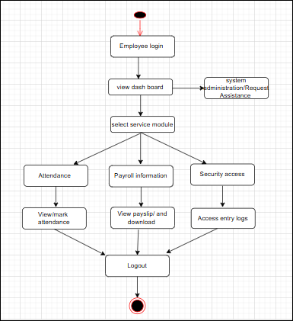

Use case diagram:

.

Use case diagram:

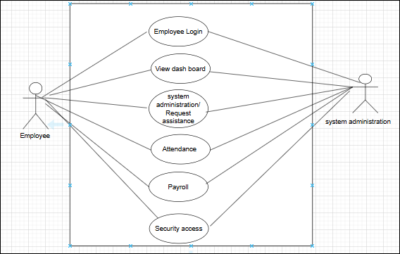

7 Screens and pages:

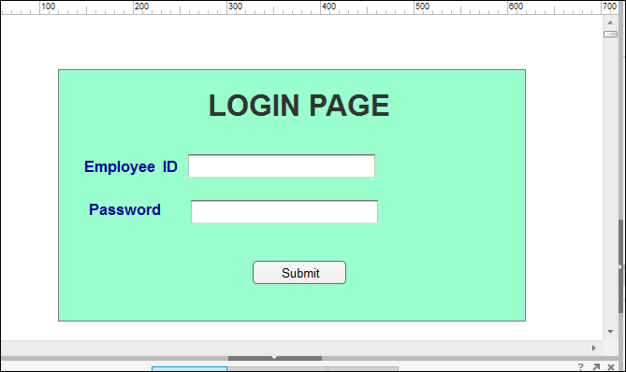
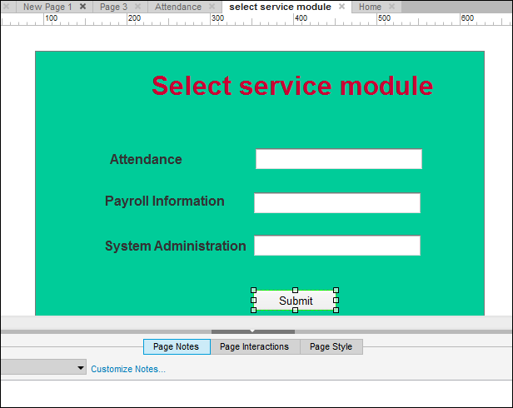
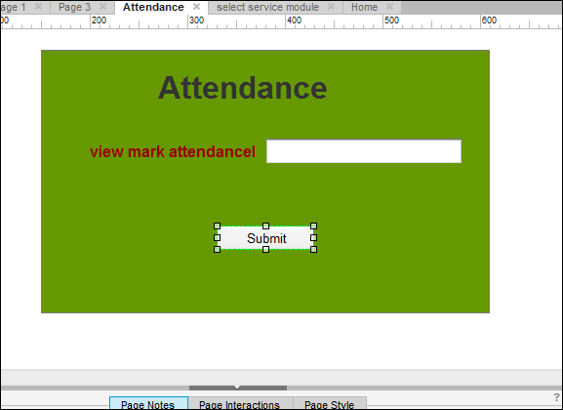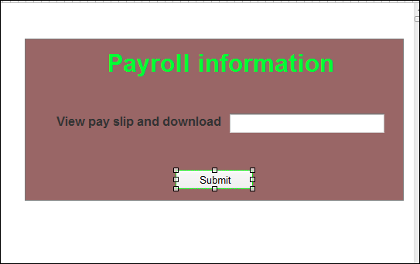

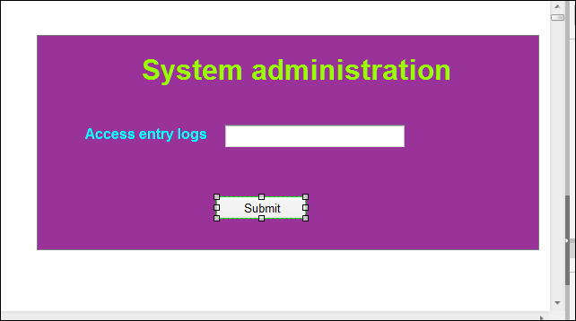

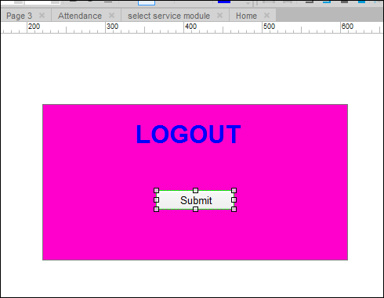

Document 8
MS Visio: MS Visio is used for mainly creating diagrams and flowcharts. it is drawing tool which made the account recovery flowchart a visual understanding of the process flow. Also Ms Visio i have visual representation of complex information in this application users can the customized shapes with in text, images, to create unique detailed design.
AXURE:
It is an advanced prototyping tool used creates high interactive wireframes of proto types project. In the wire frames te basic outline of project design for understand what is the recovery up gradation
Used and hour is the visual representation will be in more simple words it is a skeleton outline of the design giving an idea prototyping more interactive more visual representation of the design which allows the user to interact with the user face and experience it is functionality Balsamic is a rapid wire framing tool used to create mock-ups and prototyping user for interface in the project using Balsamic i have created a visual representation of how does the recovery of employee empowerment hub application account happens if any uses lost access.

Document 9

1 Requirement Gathering:
I have initially understood the project, identified the stakeholders, the business problem, opportunities, documentation, business needs, requirement elicitation etc.
In this project i have mainly used. Brainstorming technique in the requirement elicitation process.
- To prioritize requirement for the development process i have used Moscow technique. Also removed repeated and duplicate document.

Requirement Analysis:

In the requirement analysis as a BA draw UMLB diagram (use case) and activity diagram also prepared functional such as password reset options also prepared SRS document t (software specification) document) which is a comprehensive document that outlines. The functionality feature and performance criteria of the software that is being development technical requirement also prepared BRS (BUSINESS REQUIREMENT SPECIFICATON). Which outline the business goals objectives and project requirements?
Requirement traceability matrix to track the requirements throughout the project life cycle ensuring that they are met and requirement once looked.
The UML diagrams are communication to stakeholders as well as to the team and also consider their input if required made necessary corrections.

3 DESIGNS:
The design phase in Employee empowerment hub project focus on creating a user friendly and secure system for the users to regain access to their accounts. This phase involves during the flow, determining the methods and planning the interface for the process.
By using MS Visio, balsamic as a BA i have create use case diagrams and test case and communicated them with the client on the design and solution documents, also updated the status to the client and make them understand how the solution would look like as a BA i have also prepared the end user manuals and updated RTM made sure that all the requirements are met.

4 DEVELOPMENTS:

AS a BA in the development stage i have organized JAD session (joint application development) which can efficiently gather comprehensive and accurate system requirement in this stage as BA i have taken responsibility and clarifying quarries of technical team during coding. Here i have also updated the end user manuals with any changes made by the developers and also updated the RTM. Here as the project in the development states meetings are conducted with technical team and the client also encouraging the client for participated in UAT.

5 TESTING;
In the stage i have prepared test case from user case and also assist test manages also high level testing in conducted. Also involve the client in the testing phase and test data is request from the client, if any changes the end user manual the updated and also updated RTM also in this stage a signoff from the client is taken on client project acceptance form.

6. DEPLOYMENT:
In the project closure document, the updated RTM is also attached. User manual is shared to the client and also trainings are conducted for the end users. In this sessions it is made sure that all the candidate is involved and attending the meeting.

