CAPSTONE PROJECT – SIMILAR CASE STUDY
(Prep 1 – Part 2)

Q. no 1:
4 Quarterly Audits are planned Q1, Q2, Q3, Q4 for this Project What is your
knowledge on how these Audits will happen for a BA?

Answers: -
Requirement gathering phase

Stage | Quarter 1 – Audit report
Completed | 10 weeks (week 1 – week 10)
Checklist | BRD template
Checklist | Elicitation reports
Checklist | Grouping all the functional and non-functional requirements
Checklist | Client signoff
Checklist | Email and meeting

Requirement Analysis phase
Stage | Quarter 2 – Audit report
Completed | 8 weeks (week 15 - week 23)
Checklist | UML Design
Checklist | Business to functional requirements mapping
Checklist | RTM documents
Checklist | Client signoff

Design Phase
Stage | Quarter 3 – Audit report
Completed | 7 Weeks (week 30 – week 37)
Checklist | Usage of Tools
Checklist | Gathering all requirements to verify
Checklist | Design the architecture / model
Checklist | Stakeholders MoM
Checklist | Signoff

Development phase
Stage | Quarter 4 – Audit report
Completed | 20 Weeks (week 40 – week 60)
Checklist | JAD sessions report
Checklist | Prepare user manual
Checklist | BA and developer interactions

Testing phase
Stage | Quarter 5 – Audit report
Completed | 20 Weeks (week 58 – week 78)
Checklist | Test cases
Checklist | Training report send to end users
Checklist | E-mail communications

Q. no 2:
Before the Project is going to Kick Start, The Committee asked Mr. Karthik to submit BA Approach
Strategy
Write BA Approach strategy (As a business analyst, what are the steps that you would need to
follow to complete a project – What Elicitation Techniques to apply, how to do Stakeholder Analysis
RACI/ILS, What Documents to Write, what process to follow to Sign off on the Documents, how to
take Approvals from the Client, What Communication Channels to establish n implement, how to
Handle Change Requests, how to update the progress of the project to the Stakeholders, how to
take signoff on the UAT- Client Project Acceptance Form)

Your Team
Project Manager – Mr. Vandanam Senior
Java Developer - Ms. Juhi
Java Developers – Mr. Tyson, Ms. Lucie, Mr. Tucker, Mr. Bravo
Network Admin - Mr. Mike
DB Admin - Mr. John.
Testers - Mr. Jason and Ms. Alekya
BA – You
Technical Team have assembled to discuss on the Project approach and have finalized to follow 3-tier
architecture for this project.
Answers: -
- What are Elicitation techniques to apply in our project?

According to me, we can apply below elicitation techniques:
- Workshop: - It is a structure meeting where stakeholders and experts work together.
- Surveys: - We can use this to collect data from a group of farmers and manufactures about requirements.
- Brainstorming: - It is technique used to generate ideas, solutions and requirements of a project.

- How to do stakeholder Analysis RACI/ILS?

The RACI matrix can help clarify roles and responsibilities that ensure stakeholders needs are addressed in the project correctly.
- Responsible: - Individuals performs the tasks.
- Accountable: - Individuals are answerable for the tasks.
- Consulted: - Stakeholder’s opinions are taken.
- Informed: - Stakeholders are to be updated.

- What Documents to write?

We can write below documents:
- Business Required Document: - A high-level document that outlines the business needs and goals of a project. It’s created at the beginning of a project.
- Functional Required Document: - It outlines how to fulfil the business needs of a project.
- Non – Functional Requirements: - It is to identify the requirements related to performance, security and usability.
- Use case Document: - A document that describes how a user interacts with a system or product.
- Test Case Documentation: - A document that includes test strategies, test cases, bugs etc. It minimizes the time and cost of software development.
- Risk Management plan: - It identifies the potential risk of the project.

- What process to follow to sign off on the documents?

It is a formal process that acknowledges the completion of a project and the delivery of its deliverables.
- Preparing sign-off document.
- Organizing a sign-off meeting.
- Presenting sign-off document.
- Discussing feedback.
- Asking for sign-off.
- Documenting approvals.
- Communicate sign-off to all stakeholders.

- How to take Approvals from the clients?
Establish a formal meeting with the client to keep them informed and get continuous feedback. Once feedback is received, we can send an email to ask for an approval to sign-off project. After the approval is received, we can forward it to all stakeholders and document it.
- What communication channels to establish and implement?
We can establish communication through
- Face to face meeting
- E-mail
- Telephonic communication
- Online messaging apps

- How to Handle Change Request?
- Receive request in Change request form.
- Acknowledge change request.
- Analysing the change request.
- Approve/ Reject request.
- Communicating request
- Implementing the change request.
- Document the status of change request.
- How to update the progress of the project to the stakeholders?

We can organize weekly or daily meeting and can keep document in progress in this meeting. We can also organize a monthly review meeting to track the progress of project and discuss upcoming process.

- How to take signoff on the UAT – Client Project Acceptance Form?

- Prepare UAT form.
- Conducts UAT process.
- Record all feedbacks.
- Fix issues.
- Prepare acceptance form.
- Review the form.
- Approve the form.
- Document the form.
- Sign-off

Q. no 3:
Explain and illustrate 3-tier architecture?
Answers: -
Three tier architecture is a software application architecture that organizes applications into three logical tiers - Application tier, Business logic tier, Database Layer.
- Presentation Layer - Topmost layer of the architecture. It handles user interface components such as screens, pages.
Ex: E-commerce Website.
- Business Logic Layer - Middle layer of the architecture acts as an intermediary between the presentation layer and the data storage layer. This layer contains the core logic of the application.
Ex: Printer, payment gateways.
- Database Layer – Bottom most layer of the architecture, responsible for storing and retrieving data.
Ex: MySQL, Oracle database.

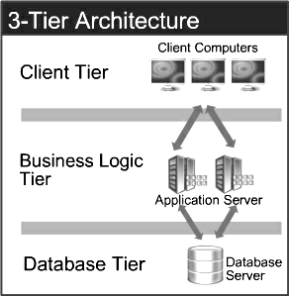
Q. no 4:
Business Analyst should keep What points in his/her mind before he frames a Question to ask to
the Stakeholder
(5W 1H – SMART – RACI – 3 Tier Architecture – Use Cases, Use case Specs, Activity
Diagrams, Models, Page designs)
Answers: -
- 5W1H Framework – This framework helps analyse the project by addressing the below questions.

Question | Answer
Who? | Farmers, manufactures, delivery teams, stakeholders, APT IT solutions.
What? | An online platform for farmers to purchase agriculture products.
When? | 18 months with a budget of 2 Crores INR.
Where? | Remote area where farmers face difficulties.
Why? | To simplify access to products
How? | Through mobile application that connects farmers and manufactures directly.

- SMART Goals – Specific, Measurable, Achievable, Relevant and Time-bound for project

Criteria | Details
Specific | Develop a platform for farmers
Measurable | Place order successfully during UAT with 90 %
Achievable | Use existing technology with skilled persons within budget and timeframe.
Relevant | Aligns with goals of company and addresses farmers challenges.
Time-bound | Deliver the solution within 18 months.

- RACI Matrix –

Responsible : Individuals performs the tasks.

Accountable : Individuals answerable for task.

Consulted : Stakeholders for opinions.

Informed : Update stakeholders.

- 3 Tier Architecture –
Three tier architecture is a software application architecture that organizes applications into three logical tiers - Application tier, Business logic tier, Database Layer.
- Presentation layer:

- How would be First page of application?
- How the filter is listed?
- Was store available in web and mobile for farmers?
- How was data protected?

- Application layer:

- How the process work after order placed?
- Were the products listed with “in stock” and “out stock”?
- How will we get confirmation details when order placed successfully?
- Database layer:

- What are the details stored?
- How user information is stored?
- How will we manage products availability?
- What are the payment options?

- UML –
Unified Modelling Language (UML), is a standardized way of diagramming and modelling software systems to aid in design, development, and communication between team members.
- Use case: It refers how farmers and manufactures interacts with system to achieve goals.
- Activity diagram: It is also a UML diagram, which refers to workflow of system.

Q. no 5:
As a Business Analyst, What Elicitation Techniques you are aware of? (BDRFOWJIPQU)
Answers: -
- Brainstorming:
Brainstorming is a collaborative technique where a group of stakeholders (including the project team, users, and clients) come together to generate a wide range of ideas, solutions, or requirements in a short amount of time. goal is to come with as many ideas as possible.
- Document Analysis:

It is done through reading a document and understanding the product, process and project. This technique is useful for understanding current situation, regulations, goals etc.

- Reverse engineering:
The processes of extracting knowledge or design information from anything man made and reproducing it involves disassembling something and analysing its components and workings in detail.
- Focus Groups:
It means to elicit ideas and attitudes about a specific product, service or opportunity in an interactive group environment.
- Observation:
Observing, shadowing users or doing a part of their job, can provide information of existing processes, inputs and outputs.
- Workshops:
Workshop is a structured approach to capture requirements. Which is used to scope, discover, define, prioritize and reach closure on requirements for the target system.
- Joint Application Development (JAD):
JAD is a highly structured, facilitated session where business users, staff and stakeholders together to discuss requirements.

- Interview:
Interviews are one – on -one discussions with stakeholders to gather detailed about their needs, problems, expectations. It can be structured (pre-defined questions) or unstructured (In detail exploration).
- Prototype:
Prototyping involves building an early, simplified version of system that stakeholders can interact with. Feedback from stakeholders is used to refine the prototype, and this iterative process helps clarify and define requirements.
- Questionnaire:
Questionaries or surveys are written tools used to collect information from a large group of stakeholders. These can be used to gather opinions about needs, priorities, and current challenges in a scalable way.
- Use case:
Use case describe how users will interact with system to achieve goal. Creating use cases with stakeholders helps to define functional requirements in a structured way by detailing system actions, user interactions and outcome.
Q. no 6:
Which Elicitation Techniques can be used in this Project and Justify your selection of Elicitation Techniques?
Prototyping
Use case Specs
Document Analysis
Brainstorming
Fertilizers, seeds, pesticides details from the manufacturers and should be able to display them to the
Farmers.
To gather the business requirements from the client, you went to SOONY and met Mr. Henry. When Mr.
Henry was asked about the project and what are they expecting from the project, Mr. Henry stated that he is
expecting to have a login for all its users (fertilizers, seeds, pesticides manufacturers and Farmers), a product
catalog of fertilizers, seeds, pesticides, a search option to search for products, payment process, and delivery
tracking.
After doing the stakeholder analysis, you have found out that Peter, Kevin, Ben are the key stakeholders and
you have scheduled an appointment to meet them. After meeting with them and trying to gather the
stakeholder requirements, Kevin said that, a Farmer should be able to browse through the products catalog
once they visit the website and need to have a search option so that they can search for any product they
need. Peter said that, if a farmer wants to buy any product or add them to buy-later list, they need to login first using their email id and password. If it is a new user, then they can create a new account by submitting
their email ID and creating a secure password. Ben added saying that, Farmers needs to have an easy-to-use
payment gateway which should include cash-on-delivery (COD), Credit/Debit card and UPI options so that the
user’s experience should be better. Kevin mentioned that, a user gets an email confirmation regarding their
order status. A delivery tracker to track the whereabouts of their order.
Identify Business Requirements (which includes Stakeholder Requirements)
BR001 – Farmers should be able to search for available products in fertilizers, seeds, pesticides
BR002 – Manufacturers should be able to upload and display their products in the application
Answers: -
These techniques can provide a comprehensive and adaptable approach to gathering requirements for project. Each technique has its strengths depending on the stage and requirements.
- Prototyping:
  - Shows the look and feel of the website before building it.
  - Helps stakeholders understand how things like login, search, and payment will work.
  - Finds mistakes early, so you can fix things before actual development starts.
  - Saves time and effort, by avoiding rework and improving communication.
  - Involves users, so they can give feedback and feel connected to the project.

- Use Case Spec:
  - Explains how the system works step-by-step from the user’s point of view (like logging in, searching for products, making payments).
  - Makes requirements easy to understand by showing how each type of user interacts with the system.
  - Helps developers and testers know exactly what to build and test.
  - Avoids confusion by making sure all stakeholders are on the same page about what each feature does.
  - Improves planning because it clearly defines inputs, actions, and expected results.
- Document Analysis:

  - Helps gather product data from existing documents like catalogs, labels, and specs provided by manufacturers (fertilizers, seeds, pesticides).
  - Saves time by using already available information instead of asking for everything from scratch.
  - Improves accuracy because the data comes straight from official sources and includes details like product descriptions, quantities, and pricing.
  - Reveals rules or standards that may need to be followed—like packaging norms, safety guidelines, or dosage instructions.
  - Supports requirement validation by comparing stakeholder expectations with documented facts.

- Brainstorming:

  - Generates fresh ideas by encouraging open discussion between stakeholders (e.g., new features like “buy-later list” or smart filters).
  - Explores different perspectives, helping include farmer needs, manufacturer suggestions, and business goals in one session.
  - Encourages creative solutions—like bundling fertilizers with seeds or suggesting eco-friendly packaging.
  - Builds team collaboration, making stakeholders feel heard and involved from early stages.
  - Helps refine requirements, especially when key users aren’t sure exactly what they need until they start discussing possibilities.

Q. no 7:
Make suitable Assumptions and identify at least 10 Business Requirements.
Answers: -
BR001 – Farmers should be able to search for available products in fertilizers, seeds, pesticides.
BR002 – Manufacturers should be able to upload and display their products in the application.

Req ID | Requirement Name | Description
BR001 | Accessibility | If the application would be accessible through both web and mobile.
BR002 | Ease of use | The application should be easy to use for all the farmers.
BR003 | Language | The application should have multiple languages as per the users understanding.
BR004 | Search and Filter | The user should be able to search all options and add filter to it.
BR005 | Data update | The manufacturers should be able to update all the details.
BR006 | System update | The system should always be updated with availability of products (in-stock/out-of-stock).
BR007 | Privacy | It should be able to protect all the personal data and keep them secure.
BR008 | Tracking | This application should track the products order and have delivery details.
BR009 | Feedback | There should be always continuous feedback to monitor the effectiveness of the application.
BR010 | Notification and Alert | This application should be able to send notification and updates with pop up messages.

Q. no 8:
List your assumptions?
Answers: -
An assumption is something that you assume to be the case, even without proof.
Assumptions:
- A user can login with Google or Facebook.
- The stakeholders would have all idea about business requirements.
- They will attend all the meetings scheduled on time.
- All users have basic knowledge of application usage.
- All the data would be available for team to prepare design and development stages.
- The resources should be available for all the users. (Mobile, Internet).
- All stakeholders would co-ordinate properly at each stage of project.
- Delivery should be available in all locations of the users.
- The designers have designs to display in the application. The need for the application is ever growing.
- The customers have online accounts for secured payment processing.

Q. no 9:
Give Priority 1 to 10 numbers (1 being low priority – 10 being high priority) to these Requirements
after discussions with the stakeholders
Answers: -
MoSCoW (Must-Have, Should-Have, Could-Have, Won’t- Have) will prioritize the list of top 10 business requirements.

Req ID | Requirement Name | Description | Priority
BR001 | Accessibility | If the application would be accessible through both web and mobile. | 1
BR002 | Ease of use | The application should be easy to use for all the farmers. | 2
BR003 | Language | The application should have multiple languages as per the users understanding. | 3
BR004 | Search and Filter | The user should be able to search all options and add filter to it. | 4
BR005 | Data update | The manufacturers should be able to update all the details. | 7
BR006 | System update | The system should always be updated with availability of products (in-stock/out-of-stock). | 6
BR007 | Privacy | It should be able to protect all the personal data and keep them secure. | 5
BR008 | Tracking | This application should track the products order and have delivery details. | 8
BR009 | Feedback | There should be always continuous feedback to monitor the effectiveness of the application. | 10
BR010 | Notification and Alert | This application should be able to send notification and updates with pop up messages. | 9
Q. no 10:
Draw use case diagram.
Answers: -
Use case:
A Use Case Diagram in Unified Modelling Language (UML) is a visual representation that illustrates the interactions between users (actors) and a system.
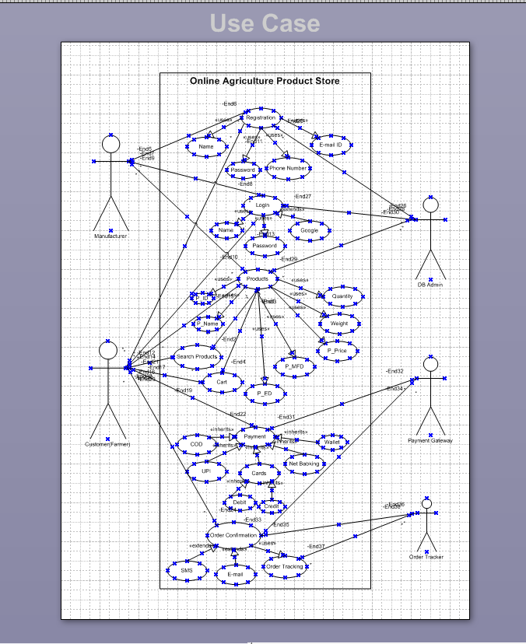
Q. no 11:
Prepare use case specs for all use cases.
Answers: -
Use case specification:
A use case specification is a detailed textual description that outlines the interactions between an actor (user or external system) and a system to achieve a specific goal.
- Use Case Document for “Login”
Use case Id | UC001
Use case name | User Login
Created By | Mrs. Architha | Last Updated by | March 1st, 2025
Data Created | November 11th, 2024 | Last Revision Date | March 15th, 2025
Actor | Farmer, Manufacturer, Admin
Description | This use case describes how user can login.
Pre-condition | - The user must have the internet connectivity.  - The users must have a registered account to login to the application.
Post condition | - The user must successfully logged in and should go back to dashboard.
Normal Flow | - The user navigates to the login page of the online agriculture store.  - The login page should ask user name/phone number/ email and password.  - The users enter credentials and click on login.  - The system verifies credentials and redirects to user’s dashboard.
Alternative Flow | - In case the user fails to login successfully, the system will show an error message for “invalid credentials”.  - The system will then provide an option for “Forget user ID/Password”.  - The user is asked to re-enter their credentials.
Exceptions | - If the user forgets their password.  - Internet issue  - Technical issue
Frequency of Use | High
Assumptions | - It is assumed that the user has registered on the application.  - It is assumed that the user knows the credentials correctly.

- Use Case Document for “Searching products”
Use case Id | UC002
Use case name | Search Products
Created By | Mrs. Architha | Last Updated by | March 1st, 2025
Data Created | November 11th, 2024 | Last Revision Date | March 15th, 2025
Actor | Farmer
Description | This use case describes how the farmers would search for products.
Pre-condition | - The user must login.  - Data must be uploaded by manufactures.
Post condition | - Farmers are able to search desired products.
Normal Flow | - User clicked on search bar on the dashboard.  - Enter seed and click on search.  - Complete list of similar/related products.  - By clicking on products, users can see complete details like price, quantity ...  - The filter option will sort all the list as per brand, price, etc..
Alternative Flow | - If no product match will redirect to page showing “no product found”.  - User can try and search with different keywords.
Exceptions | - Internet issue.  - Technical issue.
Frequency of Use | High
Assumptions | - The product database matches with keyword search by user.  - The user has knowledge to use search option and apply filter to the searched list of products.
- Use case Document for “Adding products in the cart”.
Use case Id | UC003
Use case name | Add product in the cart
Created By | Mrs. Architha | Last Updated By | March 1st, 2025
Data Created | November 11th, 2024 | Last Revision Date | March 15th, 2025
Actor | Farmer
Description | This use case describes how the farmers would add the product in the cart.
Pre-condition | - The user must login.  - The application should have details of products.
Post condition | - The farmers have successfully added the products in the cart.
Normal Flow | - The user searches the desired product on the search option.  - It shows a list of similar/related products.  - User searches for the product they want to purchase.  - It should display complete details.  - The user should click on “add to cart” button.  - The system displays the message that products are added to cart.
Alternative Flow | - The user wants to change the product after item is added to cart.  - Quantity of the item wants to be changed after adding to the cart.
Exceptions | - Product out of stock.  - Technical issue in application.
Frequency of Use | High
Assumptions | - The user should know to add product in the cart.  - Product details are updated and show “in stock” and “out of stock”

- Use Case Document for “Making payment”.
Use case Id | UC004
Use case name | Making payment
Created By | Mrs. Architha | Last Updated by | March 1st, 2025
Data Created | November 11th, 2024 | Last Revision Date | March 15th, 2025
Actor | Farmer
Description | This use case describes how farmers would make payment for the products available in the cart.
Pre-condition | - Login to application.  - User must add some products to cart.  - Secure option for payment.
Post condition | - Farmers has successfully made payment for the products.
Normal Flow | - The user searched and added products to cart.  - System displays total amount to be paid for the products added to cart.  - Click on proceed to pay option.  - Different methods to make payments:  - UPI  - Credit /debit card  - Wallet  - Cash on delivery  - User now click on pay button.  - Once payment was done, the payment gateway confirms the transaction and sends response to system.  - System displays a confirmation message “payment successful! Your order was placed.”  - Order confirmation was sent with receipt via email/SMS.
Alternative Flow | - If user wants payment option need to be changed, then application should go back to previous page.  - User want to add discount available on product.
Exceptions | - If payment fails then it should ask for” Retry payment”  - Payment is interrupted due to technical issue.  - Sufficient balance is not available in chosen payment method.
Frequency of Use | High
Assumptions | - The user has knowledge on different payment methods.  - Sufficient amount in their bank account for payment.

- Use case Document for “Product Delivery”.

Use case Id | UC005
Use case name | Product delivery
Created By | Mrs. Architha | Last Updated by | March 1st, 2025
Data Created | November 11th, 2024 | Last Revision Date | March 15th, 2025
Actor | Farmers, Manufacturers and delivery partner.
Description | This use case describes the process of delivering purchased products to user’s address after order placed successfully in system.
Pre-condition | - User has successfully placed an order and complete payment.  - A valid delivery address is to be provided.  - Products are available in stock and ready for dispatch.
Post condition | Products are delivered successfully to customer address and order status is updated to “Delivered.”
Normal Flow | - After order placed payment is confirmed, unique order id is generated.  - The system assigns a delivery partner.  - The staff prepares shipment products with security.  - Delivery partner collects the package and updates shipment status.  - A notification was sent to user.  - Once the delivery person delivers the product to user’s specified address.  - Upon successful delivery, the system updates the order status to “Delivered” and notifies the user.
Alternative Flow | - In case user wants to change address of product delivery.  - Delivery delayed due to some reasons.
Exceptions | - If delivery fails due to incorrect address or user unavailability, the system notifies user and provides rescheduling /cancellation.  - In case user receives any damaged or mismatch of products, user reports issue to customer and system initiates a replacement/refund process.
Frequency of Use | High
Assumptions | - Customer provides an accurate delivery address/contact detail.  - In-time delivery services by delivery partners.  - The products are dispatched within given timeline at time of order placing.

Q. no 12:
Activity diagrams.
Answers: -
Activity Diagram:
Activity diagrams are an essential part of the Unified Modelling Language (UML) that help visualize workflows, processes, or activities within a system. They depict how different actions are connected and how a system moves from one state to another.

- User Login

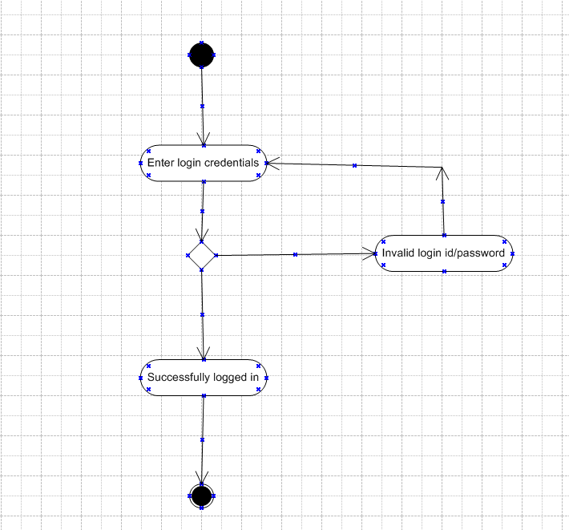

- Search Product

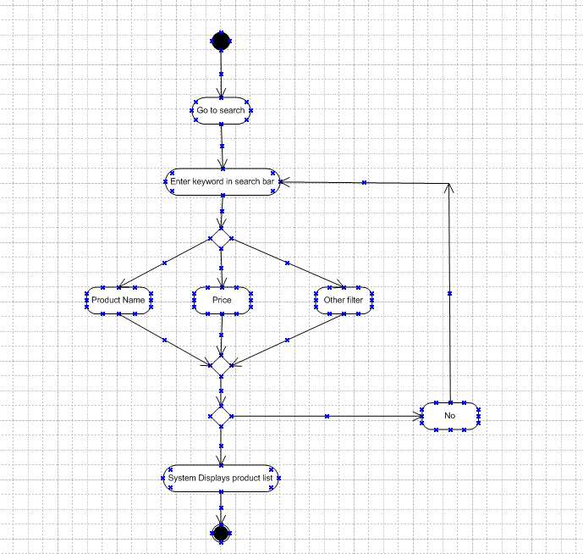

- Add product to cart

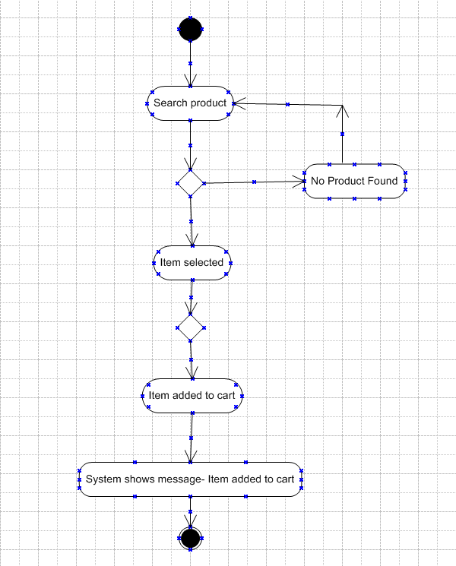

- Make Payment for product

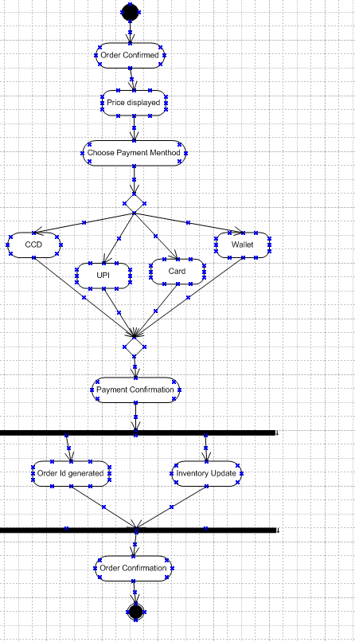

- Order delivered

