AGILE DOCUMENTS-

Document – 1
Definition of Done

The Definition of Done is the technique where the team got agreed on and the prominently displayed a list of criteria met before the a backlog item is considered done
It is shared understanding of what it means for work to be complete and we can say it is 100% done and potentially shippable
The DOD document now relates specifically to new online insurance portal , I have prepared a tailored version that integrates the DOD check list for an online insurance portal making it more relevant and actionable for stakeholders.

Purpose – To define when backlog item like user story and feature for the online insurance portal can be considered done by the agile team

A team defined checklist that confirms a user story or deliverable
- Meets agreed functional and quality standards
- It is ready for production or the next delivery phase
- Has been reviewed and accepted by the relevant stakeholders
And the team
- Well defined
- Unambiguous
- Measurable
- Shared and visible
Agreed and shared Definition of done between the all team members
The acceptance criteria is done for the satisfaction of the customer requirement for the product
And the quality criteria is done to showed for satisfy quality requirement of the product .

Check list for Definition of Done-
S.NO | CRITERIA | Specific note | Done/Not done
1 | Produced code for functionality | Its like login, premium calculator and policy generation | Done
2 | Assumptions of User Story met | User story assumptions validated , confirmed against insurance product rules | Done
3 | Project builds without errors | Application build without any error . clean builds across all modules like claims, policy, payment etc | Done
4 | Unit tests written and passing | It includes edge cases for policy rules age limits etc | Done
5 | Project deployed on the test environment identical to production platform | It includes third party integration like KYC , payment gateways | Done
6 | Tests on devices/browsers listed in the project assumptions passed | Works on chrome, edge, UC browser mobile responsiveness verified | Done
7 | Feature ok-ed by UX designer | Approved and consistent with design for customer onboarding and claim submission | Done
8 | QA performed & issues resolved | Functional and regression testing completed | Done
9 | Feature is tested against acceptance criteria | It is like quote generation within 4 seconds | Done
10 | Feature ok-ed by Product Owner | Approved and confirmed that business needs are met | Done
11 | Refactoring completed | Clean, maintainable modular codebase | Done
12 | Any configuration or build changes documented | Especially for server settings, API keys and compliance logs | Done
13 | Documentation updated | It includes technical specs , process flows and user guides | Done
14 | Peer Code Review performed | Completed and took sign from senior developer | Done

DOCUMENT -2
Product vision
Scrum project name: | Optum online insurance solutions
Venue: | Triple four towers | Hitech city, Hyderabad-50444
Date: 04-08-2024 | Start time – 10:00 am | End time – 02:00pm | Duration- 4hours
Stakeholder list: | Business owner | Administration | Operation head
 | Processor head | Customer
 | Scrum team
Scrum master: | Mujeeb ali khaja
Product owner: | R. pradeep chary
Scrum developer 1: | Naveen
Scrum developer 2: | Srikanth
Scrum developer 3: | Shiva
Scrum developer 4: | Akhil
Scrum developer 5: | Venkat

Vision : our product aim to create a user friendly user friendly , secure online portal that simplifies the insurance process to the customers our vision is to empower users easily compare purchase and manage their insurance policies from any device by providing personalised recommendation , transparent policy details and efficient claims processing we aim to enhance the customers satisfaction and trust in their insurance provider
Online insurance solutions is our target segment  Users and customers  People who want to get insured and people who work for the organization | Reducing the manual effort and delay in process  Customer can purchase insurance policies without any confusion and agents has accurate data to verify. | Digitalized insurance portal will be on mobile, tablets, desktops applications  Real time tracking and giving 24/7 customer services  Product feasibility can be complex and require attention in every aspect | By more revenue stream, direct customer collaboration without any queries  Providing digitalized platform for insurance policies in the country.  Digitally connecting insurers agents and policy holders enabling policy management

DOCUMENT – 3
User Story NO: 1 | Tasks: 1 |  | Priority: high
AS A CUSTOMER
I WANT TO RESGISTER TO ACCOUNT WITH EMAIL ID AND MOBILE NUMBER
SO THAT I CAN LOGIN INTO APPLICATION
BV: 500 |  | CP: 40
Acceptance Criteria :
Registration screen
Text box of email id and password
Submit button
Display Registration successful on screen.

User Story NO: 1 | Tasks: 1 |  | Priority: high
AS A CUSTOMER
I WANT TO LOGIN TO APPLICATION BY USER NAME AND PASSWORD
SO THAT I CAN USE APPLICATION.
BV:500 |  | CP:40
ACCEPTENCE CRITERIA-
Display login screen
Text column for user name and password
Display Login successful

User Story NO: 1 | Tasks: 1 |  | Priority: high
AS A CUSTOMER
I WANT TO SEARCH THE POLICIES
SO THAT I CAN FIND WHAT KIND OF POLICY IAM LOOKING FOR
BV:500 |  | CP:20
Acceptance Criteria :
Search option
User should able to see the policies
Select option for policies

User Story NO: 1 | Tasks: 1 |  | Priority: high
AS A CUSTOMER
I WANT TO RENEWAL OPTION
SO THAT I CONTINUE MY INSURANCE POLICY
BV:400 |  | CP:10
Acceptance Criteria :
Renewal option on screen
Select option to renewal
Display renewal terms and conditions

User Story NO: 1 | Tasks: 1 |  | Priority: high
AS A CUSTOMER
I WANT TO SELECT A PAYMENT MODE
SO THAT I CAN MAKE PAYMENT BY CHOICE
BV:500 |  | CP:40
Acceptance Criteria :
Display payment mode
Radio button for payment modes
Payment submit button , payment successful notification
Business rule: Can only select one payment mode

User Story NO: 1 | Tasks: 1 |  | Priority: high
AS A CUSTOMER
I WANT TO BE ABLE TO FILE AND TRACK MY INSURANCE CLAIMS ONLINE
SO THAT I CAN HANDLE THE PROCESS QUICKLY AND CONVENIENTLY
BV: 400 |  | CP: 30
Acceptance Criteria :
Display track claim option
Select button for tracking claim
Show the claim status

User story No-1 | Tasks: 1 |  | Priority: high
AS A CUSTOMER
I WANT TO RECIVE PERSONALIZED INSURANCE QUOTES BASED ON MY PROFILE
SO THAT I CAN FIND AFFORDABLE PLAIN THAT MEETS MY REQUIREMENTS
BV:300 |  | CP:20
Acceptance Criteria :
Personal Notification option
Show insurance quotes
Select option on quote and submit option

User Story NO: 1 | Tasks: |  | Priority: high
AS A CUSTOMER
I WANT TO COMPARE DIFFERENT INSURANCE PLANS EASILY
SO THAT I CAN CHOOSE BEST COVERAGE FOR MY NEEDS
BV:500 |  | CP:40
Acceptance Criteria :
Insurance plans option
Show new insurance plans
Select option and submit button

User Story NO: 1 | Tasks: |  | Priority: high
AS A INSURANCE COMPANY ADMINISTRATOR
I WANT TO PROVIDE PLATFORM WHERE CUSTOMERS CAN VIEW AND MANAGE THEIR INSURANCE POLICIES
SO THAT THEY CAN UPDATE THEIR INFORMATION AND FILE CLAIMS
BV:500 |  | CP:40
Acceptance Criteria :
Display insurance policy
Select option on policies
Accept terms and conditions button
Submit button

User Story NO: 1 | Tasks: |  | Priority: high
AS A SERVICE MANAGER
I WANT TO SEND AUTOMATED REMINDERS TO CUSTOMERS TO RENEWAL POLICIES
SO THAT CUSTOMER CAN RENEW THEIR POLICIES
BV:500 |  | CP:40
Acceptance Criteria :
Show date of start and end of policies fo customers
Alerts notifications
Display Customer communication details of customer

User Story NO: 1 | Tasks: |  | Priority: high
AS A INSURANCE COMPANY REPRESENTATIVE
I WANT TO PROVIDE AN ONLINE TOOL FOR GENERATING QUOTES
SO THAT POTENTIAL CUSTOMERS CAN EASILY UNDERSTAND ABOUR PREMIUM
BV:500 |  | CP:40
Acceptance Criteria :
Automated generating quote
Text option about quotes
Release option

User Story NO: 1 | Tasks: |  | Priority: high
AS A PRODUCT MANAGER
I WANT TO COLLECT FEEDBACK FROM CUSTOMER ABOUT ONLINE PORTAL
SO THAT WE CAN DO IMPROVEMENT AND ENHANCE CUSTOMER SATISFACTION
BV:500 |  | CP:40
Acceptance Criteria :
Customer feedback option
Text box to enter by customer
Display feedback
Business rule : can enter 400 characteristics

User Story NO: 1 | Tasks: |  | Priority: high
AS A INSURANCE COMPANY SERVICE MANAGER
I WANT TO ENABLE CUSTOMERS TO CHOOSE PREFERED COMMUNICATION CHANNELS
SO THAT I CAN PROVIDE TIMELY AND PERSONALIZED COMMUNICATION
BV:500 |  | CP:40
Acceptance Criteria :
Show selected communication channels
Select option
Text box to enter
Submit button

User Story NO: 1 | Tasks: |  | Priority: high
AS A BUSINESS OWNER
I WANT TO VIEW SALES REPORTS
SO THAT I CAN IMPROVE THE BUSINESS BY ENHANCING
BV:500 |  | CP:40
Acceptance Criteria :
Click option on reports
Select From date – To date
Download option

User Story NO: 1 | Tasks: |  | Priority: high
AS A MARKETING AGENT
I WANT TO VIEW THE POLICY HOLDERS INSURED LIST
SO THAT I CAN IMPROVE MARKETING
BV:300 |  | CP:10
Acceptance Criteria :
Policy holders list
Select option
Download option

User Story NO: 1 | Tasks: |  | Priority: high
AS A SYSTEM OPERATOR
I WANT TO KNOW ABOUT THE PAYMENT CONFORMATION
SO THAT I CAN APPROVE THE POLICY AND CONTINUE THE POLICY
BV:500 |  | CP:40
Acceptance Criteria :
Display payment done (or) payment pending
Approve (or) Reject option
Select and submit button

Document – 4
I am assuming as a product owner I had a vision of the product keeping the domain that’s insurance sector experience and the market need
Following are the responsibilities of mine in the project
- Market analysis
Firstly I have went with understanding the market situation and target of the market and then I went with understanding that who are the customers types of customers what is there goal what are the needs and what would be the demand.
So I came to known that the people who are health conscious and who are getting old and who are already suffering with health issues and people who wants to be safe side in future.
The need is getting the work done very easily . claiming the insured amount very quick and collaboration with the insured company in digitalized way
The demand is for offering the new policies plan with less amount and by coupons, discounts and transaction should be organized in online system.
There are similar insurance companies which are offering the good policies with more customer collaboration through online system by 24/7 services.
- Enterprise analysis-
By the enterprise analysis I have understood the business need and got solution scope were that can feasibly be implemented buy the business, I evaluated an organizations structure , processes goals and environment , the goal is to identify an enhancement opportunity to the insurance company.by the help of Gap analysis, SWOT analysis and feasibility study root cause analysis.
- Due diligence on the market opportunity
The Due diligence on the market opportunity is a critical component of business planning especially when evaluating the new ventures, acquisitions or product launches , it helps all the stakeholders understand the viability , size and risks of a business opportunity.
This is how I structured a Due Diligence report on the market opportunity
- Market overview
Industry description –
optum global solutions, the scope is to get digitalized with new insurance policies and better services
Market size –
Addressable in 14 county’s in united states of America
Historical trends- No growth in past 4 years
Forecasts- expected market growth 3-4 years forward

- Customer Analysis
Target segments- health conscious, health illness, old age ,pre planed
Need & pain points – no collaboration between company and customers need collaboration to solve queries
- Competitive landscape
Key competitors- southern land health insurance , UHG etc
Barriers to entry – Capital requirement and investments
- Regulation and legal environment
Industry regulations- like licensing , compliance , environmental , data etc
Political and economic factors – tax policies , trade restrictions and economic stability
- Distribution and market strategy
Sales channels with online and retail B2B , distributors
- SWOT Analysis
Strengths- every individual should get insured in united states
Weakness – no online collaboration and transaction may done manually
Opportunity- can make digitalized platform and less manual process
Threats – customer cant able to handle online portal without knowledge may mislead.
- Risk Assessment
The market risks like saturations, price wars , customer concentration
The operation risks may be supply chain and staffing .

The product vision and road map for the new insurance portal by this methodology this structure the specifically around the insurance industry pain points user needs and iterative nature of agile scrum.

Product vision-
To create a unified , user centric insurance portal that simplifies policy management, enhances the customer experience and automates backends workflows for faster more transparent insurance services
- Vision anchored in Need analysis :
Customer pain points :
- Difficult to navigate portals
- Lack of real time updates on claims/ policies
- Low transparency on coverage
- Long turnaround times for quotes/ claims
Business challenges :
- High customer service load
- Disjointed legacy systems
- Poor data flow between departments
- Regulatory compliance overhead ‘
Opportunity identified:
- Digitalized and centralized policy management
- Offer self service for quotes and claims
- Use automation for faster processing
- Improve analytics for risk and compliance

Product Road map in High Level.
It is based on scrum divided into major releases by quarters and epics with sprints
- Customer portal foundation time line Q1 (Months 1-3)
The goal is to build and launch a basic functional self service portal for policy holders
Epics-
- User Authentication: secure login
- Dashboard: over view of active policies , recent claims
- Policy viewing: view coverage and download documents
- Request quote module: basic data input for new policy quote
- Customer support integration : chatbot, support tickets
In this the sprint planning would be 5 sprints 2 weeks each.

2 claims management and automation Time line Q2(months 4-6)
The goal is streamline the claims process and add back end support
Epics-
- Submit claim: uploads documents, incident details
- Claims status tracking: Real time updates email alerts
- Workflow Automation: Auto assign claims to adjusters and processors
- Backend Admin panel: claim review dashboards for staff
Continues backlog grooming based on MVP feedback

3 Advance policy management and integrations time line Q3 (months 7-9)
The goal is to give users full control over policy changes and integrate with key systems
Epics-
- Policy endorsement: update contact info , add or remove coverage
- Renewal reminders : notifications and renewal workflows
- Payment gateways integration: online premium payment and auto pay
- Role based access control: granular user permission like broker, admin,users
Sprint planning would be 4 sprints 2 weeks each sprint .

After that I should manage the product features
- Managing the stakeholders expectations
The key stakeholders like customers like end users and corporate clients
The internal teams like sales marketing , customer support , compliance
Insurance providers and partners etc .
The best way to manage stakeholders expectation
STRATEGY | DESCRIPTION
Regular communication | Hosting and keeping regular meeting that syncs or sprints with stakeholders
Transparent Road mapping | Maintain a shared product road map a backlog that is accessible
Expectation framing | Clearly explain trade offs and capacity limits , use data to show why some features are delayed
Prioritization workshops | Collaborate with stakeholders during prioritization to gain alignment
Feedback loop | Use surveys analytics and support tickets to validate stakeholders assumptions

And for this project the prioritization is based on criticality ROI can be predicatable but hope for the best it all depends on the user impact on us.
For the prioritization on EPIC stores and feature I use the MOSCOW technique
MOSCOW priority | Feature | Justification
Must have | User registration, login | Core entry point , essential for product function
Should have | Policy management , search for policy | Important to run the activities in application
Could have | Payment modes , communication service | For the solving the queries and approving the policies
Wont have | AL based, advanced policy management | No so important right now

And I will also Weighted Scoring for Epics Business Value and Complexity points for the prioritizing the epic

- For managing the product backlog
I will prioritization of user stories by the MOSCOW technique I will use this by
- Must have : core functionalities
- Should have : Enhancements
- Could have : not essential but valued
- Wont have : low priority

I will do reprioritization based on the stake holders needs
As the product backlogs are living documents that evolve the market shifts , feedback and stakeholders priorities

- The action I take is regular grooming sessions weekly or sprint based backlog grooming with stake holders and product team
- Feedback integration by using real time feedback like supports tickets, sales inputs to adjust backlog
- Change control this will define a clear process for evaluating the impact of new requested item

Epic planning
As the epic represent larger features sets or the business objectives that are broken into smaller user stories ifor our project it is like claims managements the features would be online file claiming , document uploading , status tracking and notification etc and the the user stories prepared
From my perspective I will do epic planning by
- Align epics with business goal
- Use roadmaps alignment
- Balance big bets vs quicks wind
Managing overall iteration progress for this process in structured way by covering
- Sprint progress review
In this th goal is to ensure the sprint stays in track , aligned with the goal and delivers value by the end of the iteration
The key sprint progress review activities are
Daily stand ups- track team progress and adjust tasks keep it focused and timeboxed
Sprint burndown chart- monitor remaining work daily helps to predict whether the sprint goal met
Mid sprint review – optional check in with stakeholders and as a BA should validate progress and get feedback

Indicators of sprint risks are-
Multiple stories stuck in “In progress”
Burndown chart flattening or rising
Team velocity dropping
Frequent scope creep or unclear requirements
- Reprioritization of sprints and Epics (if needed)
Despite the best planning , changes happen , reprioritization must be agile , data – driven and collaborative
When the reprioritize a sprint or Epic :
- A critical bug or regulatory change arises
- A stakeholders may demand a last minute feature shift
- Sprint items are blocked by external dependencies
- Market opportunity or risks requires realignment
To reprioritize effectively:
STEP | ACTION
Assess Impact | To check how the change affect goals , dependencies and timelines
Engage Stakeholders | To include Bas, Product owner and tech lead to evaluate trade offs
Adjust sprint scope | To move lower priority stories out and adjust story points accordingly
Update Jira | Reflect changes clearly in backlog and board
Document rationale | To keep track of why changes were made for transparency

- Sprint Retrospective with business analyst
The retrospective ensures continues improvements , involving the BA bridges the gap between business expectations and delivery reality
The retrospective format:
Question | Purpose
What went well today ? | I can identify successful practices or process improvements
What did not go well ? | I can find blockers , communication gaps or issues in the planning
What can we improve ? | I can suggest actionable process or workflow changes
What is unclear from the business side ? | BA can clarifies business logic , priorities or ambiguous requirements

As a BA my role in the retrospective is
- To provide feedback on how well the delivered stories met business needs
- Clarify misinterpreted requirements
- Suggest refinements for upcoming sprints
- Recommend documentation or communication improvements .

From this project I have learned how to handle sprint meetings such as
- Sprint planning meetings
In this project I learned how effectively participate in and contribute to sprint planning meetings , this includes settings clear sprint goals , estimating efforts required of each task , prioritizing backlog item and ensuring that the team has a shared understanding of the work done and I also gained experience in breaking down user stories into actionable tasks and allocating them based on team capacity and skill sets.
- Daily scrum meetings
Through this project I learned the importance of daily scrum meetings in maintaining team alignment and transparency. I gained experience in providing concise updates on what was completed and what I planned to work on next, and any blockers I was facing.
These meetings helped improve team communication, identify issues early and keep the sprint on track.

- Sprint review meeting
During this project I have learned how to effectively participate in sprint review meetings by presenting completed work to stakeholders and gathering their feed back.
This meeting helped me understand the importance of demonstrating deliverables validating that sprint goals were met and incorporating stakeholder input to improve future iterations. It also emphasized transparency and collaboration between the development team and stakeholders.

- Sprint Retrospective meeting
By this project I had learned how to contribute constructively to sprint retrospective meetings by reflecting on what went well, what could have been improved, and how the team could work more effectively in future sprints.
This meeting emphasized continuous improvement, team collaboration, and open communication. It provided a valuable opportunity to identify process enhancements and strengthen team dynamics.
- Backlog Refinement Meeting
By doing this project I had gained experience participating in backlog refinement meetings where the team reviewed and updated the product backlog. I have learned how to clarify user stories, break down large tasks into manageable items, prioritize work based on business value, and estimate effort using techniques like story points.
This meeting helped ensure that backlog items were well-defined and ready for upcoming sprints, improving the overall efficiency of sprint planning.

I also learned how to create effective user stories and understand the key components that should be included in each story. This process ensures clarity, alignment with business goals, and ease of implementation. The key elements I focused on include:
- Story Number
A unique identifier used to track and reference the user story throughout the sprint and project lifecycle.
- Priority
Indicates the importance of the story relative to others in the backlog.

- Acceptance criteria
The Clear, testable conditions that must be met for the story to be considered complete.
- Tasks
which are smaller actionable units of work that help the development team execute the story efficiently.
Each task is specific clear and contributes directly to fulfilling the user story.
- Business value
This represents the value a particular user story or feature delivers to the business or customer. And represents how important the features to the business this is estimated by scrum currency notes like 20,50,100,500,1000
This estimations is done by the stake holders that is clients, where a higher value indicates greater impact or importance. Understanding BV helped me prioritize tasks that contribute most to business goals.
- Complexity points
These are used to measure the relative complexity, effort, and risk associated with implementing a user story or task. Instead of using time, story points reflect how challenging a task is based on factors like technical difficulty, amount of work required
Cp is estimated by the scrum developers and in this we provide poker cards with the values 1,2,3,5,8,13,20,40,100 and big .

And in this project as a product owner I should act as a liaison between multiple areas of an organization like clients and technical team by the collaboration in closely with the scrum team to keep all areas of the business informed on the project development.
As a product owner a vision of a product function and operation, which in turn allows this Scrum team member to define product features and break those features into product backlog item.
So as a Product Owner I ensure that the team is always working on the most valuable tasks that align with business goals.

Document -5
Product and sprint backlog and product and sprint burndown chart .

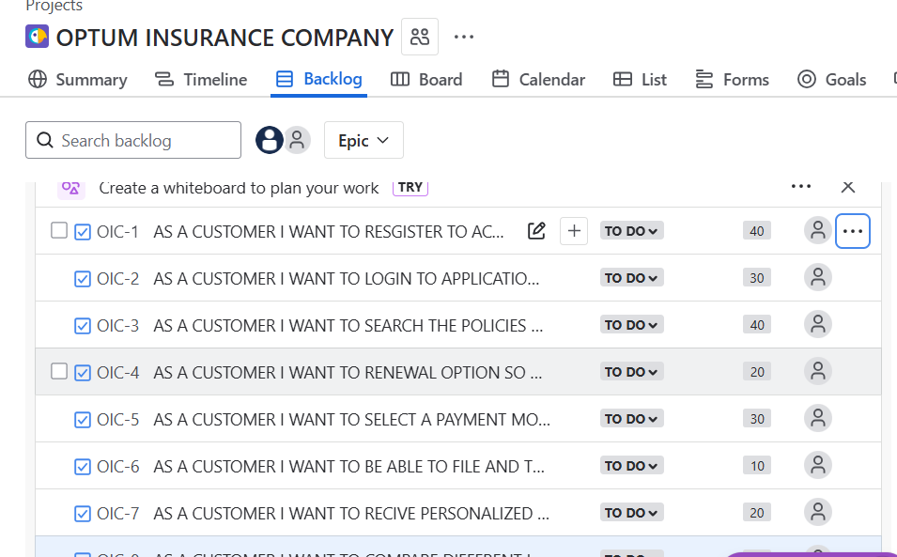

Sprint backlog –

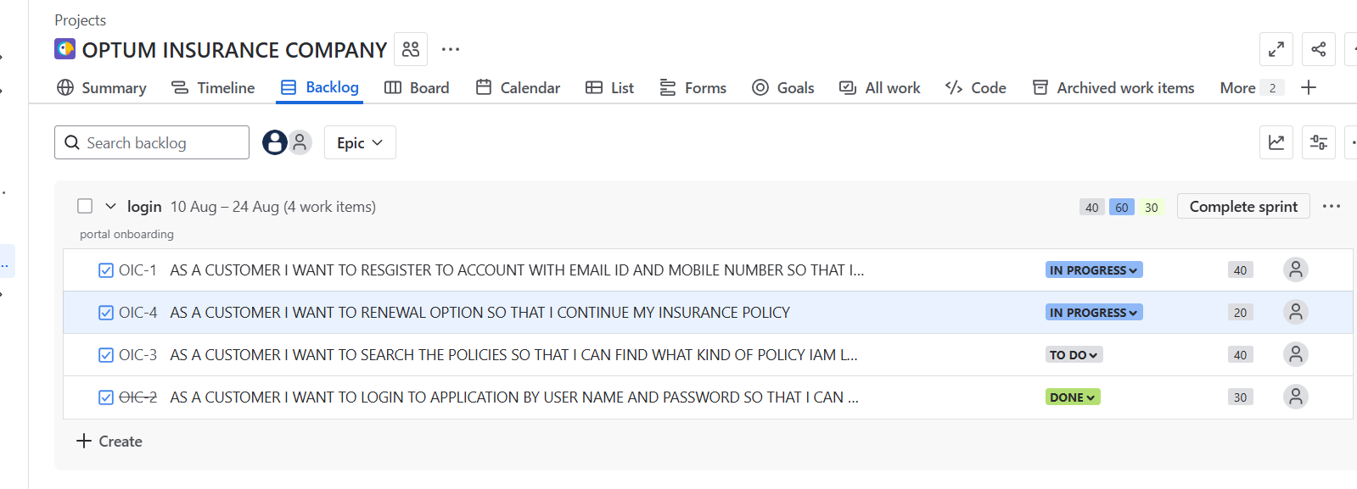
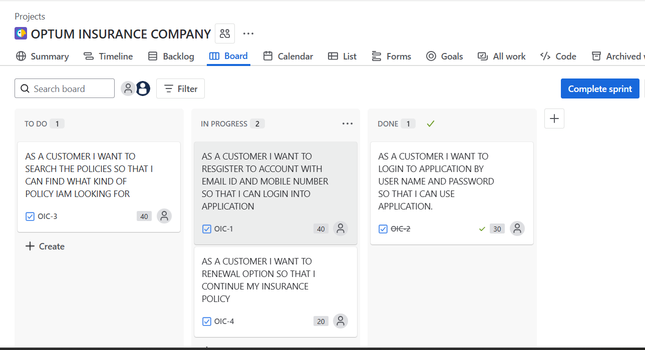

The status over view of project
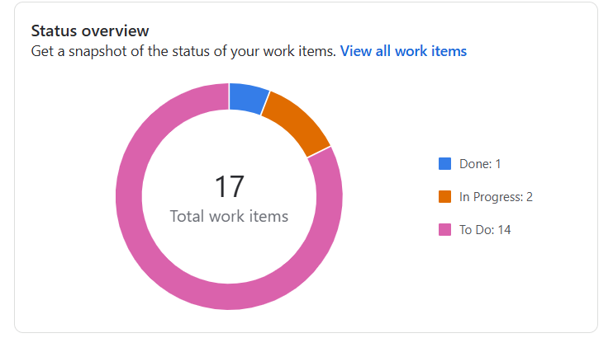

sprint burndown chart
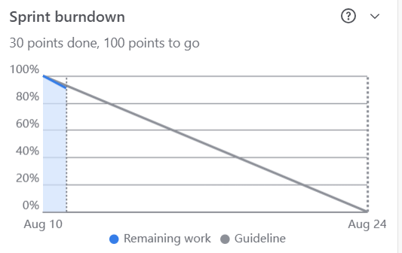

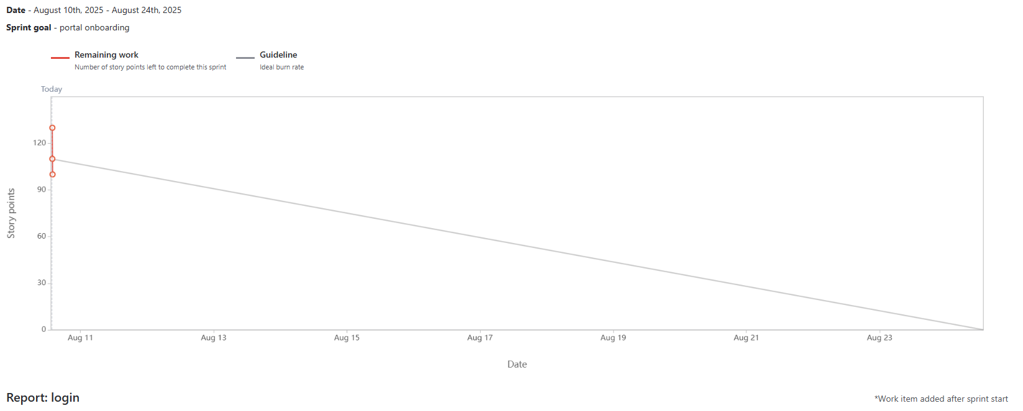
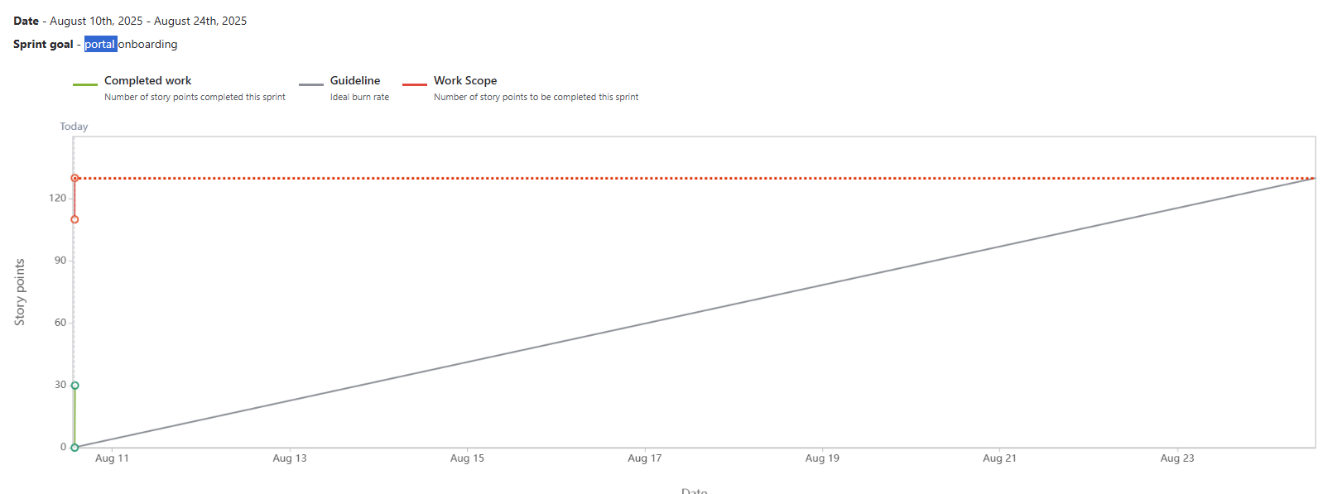

Document – 6
Sprint meetings
Meeting type 1 – sprint planning meeting
Date | 04-08-2025
Time | 11.00 AM
Location | Triple four towers conference hall - 4
Prepared by | Pradeep chary
Attendees | Product owner, scrum master , developers , business analyst

Agenda Topics
Topic | Presenter | Time Allotted
Welcome and objectives | Scrum master | 5mins
Present draft sprint goal | Product owner | 10 min
Review top priority backlogs items | Product owner | 20 min
Clarify requirements and acceptance criteria | Business analyst and QA | 15min
Estimation ( Story points ) | Development team | 15min
Sprint capacity and commitment | Scrum master | 10min
Task breakdown ( if time allows ) | Development team | 15min
Questions and final adjustments | ALL | 10min

Other information-
Observers | Stakeholders, Product owner, scrum master, development team , marketing , customer support reps
Resources | Jira board – www.jira.com  Product backlog in jira  Sprint goal (draft) : launch MVP quote and apply floe or individual health insurance users  Poker cards  API documentation
Special notes | This sprint will focus on MVP quote and apply journey including form input validation, basic eligibility logic , API integration with insurance data provider .  Ensure all stories have clear acceptance criteria .  QA to flag any regulatory testing requirements  Dependencies : awaiting conformation of provider API sandbox access

- Sprint review meeting
Date | 07-08-2025
Time | 12:00 am
Location | Triple four towers conference room 4
Prepared by | pradeep chary
Attendees | Product owner , scrum master , development team, QA, stakeholders,  BA

Sprint status | Things to Demo | Quick updates | What next
Sprint – onboarding  Sprint goal – deliver a working registration and login screens.  Velocity : 3 story points in 2 weeks  Completed work: API integration  Not completed: screen real time prototype | Quote form like mobile or desktop by frontend developer it include field validations  QA test report summary by QA engineer it is highest test coverage and key bugs | QA- All critical bugs resolved 95% test coverage  Developer- Awaiting access to production environment  Me – received initial feedback from pilot users  UX/UI- final designs for payment flow ready | Plan for sprint -2  Integrate payment gateway  Being work on user dash board and policy management  Schedule stakeholder feedback session  Address API rate limit concerns  Conform security review timeline

- Sprint Retrospective meeting-
Date | 08-08-2025
Time | 12:00 am
Location | Triple four towers conference room 4
Prepared by | Pradeep chary
Attendees | Development team , scrum master, product owner.

Agenda | What went well | What did not go well | Questions | References
Welcoming and purpose of retrospective | Successful API integration with stable , met expected response time | Last minute story additions which caused overload and some scope slipped | Can we better define Done for backend features | www.jira.com
Team Reflection | UI delivered on time by matched design specs | Incomplete acceptance criteria which led to confusion during development | Should we timebox story pointing to avoid overruns | Retrospective notes
Action Items and improvements | Good collaboration across team | Limited stakeholders availability | How do you handle mid sprint change request going forward | Sprint report docxx.
Summary and closing | Daily standups helped to clarify blockers | Slow feedback cycle | Can we make better view of the application | Burndown charts

- 4 Daily stand up meeting –
Team – optum online insurance portal project
Date range from 04-08-2025 to 10-08-2025
Question | Name/ role | Monday | Tuesday | Wednesday | Thursday | Friday |  | sunday
What did you do yesterday | Developer  1.Rishi  Developer  2.Govthami  Developer  3.Akhil | Finalized API authentication logic  Built quote form layout  Reviewed story estimates | Integrated quote API endpoints  Implemented form validation  Helped with backend testing | Handled API errors and response mapping  Connected form to backend  Added logging & monitoring hooks | Wrote unit tests for quote module  Fixed UI bugs on mobile  Worked on apply flow | Refactored middleware code  Completed UI for summary screen  Deployed test build to QA
What will you do today ? | Developer  1.Rishi  Developer  2.Govthami  Developer  3.Akhil | Start integration with eligibility service  Start styling apply screen  Review PRs | Review test results from QA  Tweak accessibility issues  Assist with API load testing | Prepare for security audit  Work on responsive layout  Update documentation | Address QA feedback  Conduct cross-browser testing  Coordinate with BA on edge cases | Sync with DevOps for CI/CD  Prep for sprint demo  Finalize backend checklist
What Is blocking your progress? | Developer  1.Rishi  Developer  2.Govthami  Developer  3.Akhil | Waiting for API keys from provider  None  Lack of clarity on eligibility edge cases | Still no production access  Minor delay with design assets  Still unclear requirements for family policy flow | Limited test data from partner  Awaiting review on style guide changes  None | None  None  None | None  None  None

