COEPD
Capstone Project 2- Online Agriculture Products Store

Submitted by – Annu Singh

Question 1 – Audits - 5 Marks
5 Quarterly Audits are planned for Q1, Q2, Q3, Q4, and Q5 for this Project What is your knowledge of how these Audits will happen for a BA?
Answer -
An audit is carried out in projects to check the overall working of the project, it helps to minimize the loop in the project if any.
Internal and External Audits are the two types of audits companies carried out in a year, Company itself carried out the intern audits and clients may ask for external audits to perform, the checklist & parameters of the audit may vary and be dependent on the current stage of the project. As per my understanding auditor may tend to ask the below queries during the audit.
- Auditor may ask for the BRD document which we have created at the time of information gathering
- Mail communication happened with a client regarding confirmation of various requirements
- During the information gathering stage we have created the timesheet auditor may ask the same
- Invitation sends to various stakeholders for workshop and their confirmation.
- Answers received from the attendees in a survey conducted for elicitation technique
- SRS (Software Requirement Specification) document signed by the client auditor may ask to check that all requirements are attended to by BA
- RTM prepared by the respective team member may ask for inspection purpose
- Various user case tests are followed in the project during the testing phase
- Completion of the document while deploying the project to a client.

Question 2– BA Approach Strategy
Before the Project is going to Kick Start, The Committee asked Mr. Karthik to submit a BA Approach Strategy Write BA Approach strategy (As a business analyst, what are the steps that you would need to follow to complete a project – What Elicitation Techniques to apply, how to do Stakeholder Analysis RACI/ILS, What Documents to Write, What process to follow to Sign off on the Documents, How to take Approvals from the Client, What Communication Channels to establish n implement, How to Handle Change Requests, How to update the progress of the project to the Stakeholders, How to take signoff on the UAT- Client Project Acceptance Form )
Your Team
Project Manager – Mr Vandanam Senior
Java Developer – Ms. Juhi
Java Developers - Mr Teyson, Ms Lucie, Mr Tucker, Mr Bravo
Network Admin - Mr Mike
DB Admin - Mr John.
Testers - Mr Jason and Ms Alekya
BA – You
Technical Team have assembled to discuss on the Project approach and have finalised to follow 3-tier architecture for this project.

what are the steps that you would need to follow to complete a project? Ans -
Step 1: Identify and meet with stakeholders.
Step 2: Set and prioritize goals.
Step 3: Define deliverables.
Step 4: Create the project schedule.
Step 5: Identify issues and complete a risk assessment. Step 6: Present the project plan to stakeholders.

What Elicitation Techniques to apply? Ans -
According to me brainstorming is the best suitable elicitation technique, in this case, presently there is no set
process/application for purchasing fertilizers, Seeds, and Pesticides important stakeholders are less in number hence brainstorming can easily be done for gathering requirements.

how to do Stakeholder Analysis RACI/ILS? Ans -
Identify the individuals or groups that are likely to affect or be affected by a proposed action, and sort them according to
their impact on the action and the impact the action will have on them. RACI categorization will be used for clarifying what stakeholders’ roles and responsibilities are in a context of a specific taskor process.
Responsibility charting in a RACI matrix is straightforward:

- -Identify all the activities involved and list them on the left-hand side of the matrix
- -Identify all the roles involved and list them along the top of the matrix
- -Complete the cells of the matrix: identify who has the R, A, C, and I responsibility for each activity.

What process to follow to Sign off on the Documents? Ans –

- Organize the project documents.
- Prepare the final report.
- Distribute the sign-off sheet.
- Review your lessons learned.

How to take Approvals from the Client, What Communication Channels to establish n implement, How to Handle Change Requests, how to update the progress of the project to the Stakeholders, and How to take signoff on the UAT- Client Project Acceptance Form.
Ans -
Finalize the requirement from stakeholder through stakeholder, communicate the requirement to the technical team through UCD and activity diagram, the graphical design will be done by the architecture, and then testing will be done once the coding is finished, & UAT will be done at client server

Question 3 – 3-Tier Architecture
Explain and illustrate 3-tier architecture? Answer -
3 Tier Architecture is basically a software application working process, 3 tier architecture is divided into 3 layers
A) Application Layer, 2) Business Logic Layer, 3) Data Layer
- Application Layer: -Application Layer means the end user interface or communication with the application or system throw screen and pages, the main purpose of the application layer is to display the information and collect the information from the end user.
- Business Logic Layer: - All the reusable components, governing body rules, changing components, Compliance, rules and regulation are
included in the Business logic layer
- Data Layer: -In database layer information processed by the application is stored and managed. The database component connecting to the database will be the data layer.

APPLICATION LAYER | All user interfaces will be visible in the application layer Ex. Application name, Members Login, Product List, New user registration, new arrivals.
BUSINESS LAYER | Reusable components/changing rules and regulations are included in the business logic layer Ex GST Various payment options, Card, Cash, UPI
DB LAYER | Storage place for all the information related to all products for Ex. Product price, Quality, Quantity Database all product-related information

Question 4 – BA Approach Strategy for Framing Questions
Business Analyst should keep What points in his/her mind before he frames a Question to ask to the Stakeholder (5W 1H – SMART – RACI – 3 Tier Architecture – Use Cases, Use case Specs, Activity Diagrams, Models, Page designs)
Answer -
BA should keep in mind to use the Below technique
SMART
  - Specific: explaining to the team exactly what outcome is expected [ a properly working application user friendly
  - measurable: the requirement can be measured /tested to determine whether it's been met
  - attainable: checking if the requirement is achievable
  - realistic: if the requirement is relevant and realistic
  - traceable/ time-bound: having a clearly defined time frame

RACI: responsible, accountable, consulted, informed which is used to clarify and define role and responsibilities
5W1H: why, what, who, where, when, and how

What should be the timeline to complete the project? What payment options should be available?
Why there is a need for an online application store?
Where Application should be available for use on Android or desktop? How will the application help farmers and manufacturers?
How much is the budget?
How many users can use the application at a time?
An activity diagram is drawn to model how the system should function to Achieve business logic, business functionality, and business objectives

3-Tier architecture:
it's a software application that organizes applications in 3 logical and physical tiers:
- presentation tier: it’s the user interface
- application tiers: data is being processed in this phase
- data tier: data associated with the application is stored and managed Use case: use case diagrams are designed to explain how
As an external user is interacting with the system it is helpful to identify the requirement

Use case specification: use case name, use case description, actors, primary actors, secondary actors , basic flow , alternate flow ,exceptional flows , pre- conditions ,post- conditions , assumptions ,constraints , dependencies ,inputs and outputs business rules ,miscellaneous information

Models: data model, data flow diagram, ER diagram Page design: interface design

Question 5– Elicitation Techniques - 6 Marks
As a Business Analyst, What Elicitation Techniques you are aware of? ( BDRFOWJIPQU) Answer -
As a Business Analyst below is the best elicitation technique
- Brainstorming: -Brainstorming can be done individually or in a group, in this technique we collect the user ideas, and those ideas are reviewed and analyzed and checked whether given ideas are relevant to include within the system requirement, and user or stakeholders come up with innovative ideas to define their requirement. Brainstorming is effective with a group of 8 to 12 people it helps to get a good number of an idea from users and stakeholders also use to find all possible solution to the problem and understand the new opportunities
- Document Analysis: - Document Analysis technique is used where the current system is in place and documents of older systems are used to transfer into new system creation, inputs are taken from an old system to develop a new system, it includes interface details, user manual, and software vendor manuals. Document analysis evaluates the document to know the AS-IS process and performs the GAP analysis to migrate the system
- Reverse Engineering: - in the situation where existing software is old and outdated and to know how the system work, usually reverse engineering is used to examine software or software component to figure out how they are processing business rules and
How do they take a decision? How does the software support to the business?
- Focus Group: -A focus group is a group of persons of 6-12 attendees and from this attendee elicit ideas and attitude about a specific product, The participant shares their ideas, preferences, and need about the software. Open-ended questions are asked to the group or participant to encourage responding and interacting freely with other group members.
- Observation: -User of the system can provide information about the existing process input and outputs of a system. it helps to improve a process or remove unnecessary activity from the new system. There are two approaches are used in this technique passive and Active.
- Workshop: -Workshop technique is used to identify the requirement of a user or stakeholder, in this method 6-10 or more users or stakeholders attend the session for a defined duration, it is a structured way to capture the requirement, it is used for scope, discover, define, prioritize, and reach closure on the requirement.
- JAD Workshop: - A software development approach that engages the end user or stakeholder to design and develop the system, this technique provides a large amount of high-quality information in a short period to develop the system
- Interview: -An interview is the systematic approach to elicit information from a person or group of persons withformal or informal communication, interviewer ask the attendees relevant question and document the responses, in this technique required less planning.
- Prototyping: -Prototyping means Mockup. Generally, mean a representation of a computer screen and examples of how the user will interact with the application to accomplish a task to solve business problems, it is a process of creating a working model to test various aspects of a design, and it helps to reduce the project risk and cost. Prototyping has also been proposed as a technique for obtaining the software requirement from the stakeholders.
- Questioner: -Questioner is used to elicit information about customer products, work practices, and attitudes from a group of people in a structured way and a relatively short period, A questioner is used to present a set of the questioner to the stakeholder whose response collected and analyzed to understand the subject matter. There are two types of questionnaires used in the technique Open Ended and Close Ended.

Question 6 – This project Elicitation Techniques
Which Elicitation Techniques can be used in this Project and Justify your selection of Elicitation Techniques?

Prototyping
Use case Specs
Document Analysis
Brainstorming

Fertilizers, seeds, pesticides details from the manufacturers and should be able to display them to the Farmers. To gather the business requirements from the client, you went to SOONY and met Mr. Henry. When Mr. Henry was asked about the project and what are they expecting from the project, Mr. Henry stated that he is expecting to have a login for all its users (fertilizers, seeds, pesticides manufacturers and Farmers) , a product catalog of fertilizers, seeds, pesticides, a search option to search for products, payment process, and delivery tracking. After doing the stakeholder analysis, you have found out that Peter, Kevin, Ben are the key stakeholders and you have scheduled an appointment to meet them. After meeting with them and trying to gather the stakeholder requirements, Kevin said that, a Farmer should be able to browse through the products catalog once they visit the website and need to have a search option so that they can search for any product they need. Peter said that, if a farmer wants to buy any product or add them to buy-later list, they need to login first using their email id and password. If it is a new user, then they can create a new account by submitting their email ID and creating a secure password. Ben added saying that, Farmers needs to have an easy-to-use payment gateway which should include cash-on-delivery (COD), Credit/Debit card and UPI options so that the user’s experience should be better. Kevin mentioned that, a user gets an email confirmation regarding their order status. A delivery tracker to track the whereabouts of their order.

Identify Business Requirements (which includes Stakeholder Requirements)

BR001 – Farmers should be able to search for available products in fertilizers, seeds, pesticides
BR002 – Manufacturers should be able to upload and display their products in the application
Answer -
According to me brainstorming is the best suitable elicitation technique, in this case, presently there is no set process/application for purchasing fertilizers, Seeds, and Pesticides important stakeholders are less in number hence brainstorming can easily be done for gathering requirements.

Question 7 – 10 Business Requirements
Make suitable Assumptions and identify at least 10 Business Requirements. Answer -
- All users (manufacturers and Farmers) should be able to log in to the application using their Email id and password.
- Farmer should be able to browse through the products catalog once they visit the website.
- Farmers should be able to add products to the buy-later list.
- Farmers need to have an easy-to-use payment gateway that should include cash-on-delivery (COD), Credit/Debit card, and UPI options so that the user’s experience should be better.
- A user should get an email confirmation regarding their order status.
- Farmers should get a delivery tracker to track the whereabouts of their orders.
- User should be able to reset the password if forgot or wrongly inputted it more than 3 times.
- Users should have a search option to search for different products.
- A new user should be able to create a new account using email and password.
- Manufacturers should be able to list their products easily.
- User Interface should be easy to user friendly and easy to use.
- Application should also be available in local languages.

Question 8 –Assumptions List
Answer -
- All users/Farmers have a valid email ID.
- Users have android/apple mobile if they are not using a computer or laptop.
- Availability of internet connection while using the application
- Availability of Printing and stationery material with the manufacturer.
- Transportation system available for delivery of products.
- Sufficient manpower availability

Question 9 – This project Requirements Priority
Give Priority 1 to 10 numbers (1 being low priority – 10 being high priority) to these Requirements after discussions with the stakeholders
Answer –

Req ID | Req Name | Req Description | Priority
BR001 | Login credentials | All users (manufacturers and Farmers) should be able to log in to the application using their Email id and password. | 10
BR002 | Manufacturers upload their Products | Manufacturers should be able to upload and display their products in the application | 10
BR003 | Farmer Search for Products | Farmers should be able to search for available products in fertilizers, seeds, pesticides | 9
BR004 | Wishlist | Farmers should be able to add products to the buy-later list. | 7
BR005 | Payment gateway | Farmers need to have an easy-to-use payment gateway that should include cash-on-delivery (COD), Credit/Debit card, and UPI options so that the user’s experience should be better. | 9
BR006 | Order confirmation | A user should get an email confirmation regarding their order status. | 5
BR007 | Delivery Tracking | Farmers should get a delivery tracker to track the whereabouts of their orders. | 4
BR008 | Login credentials reset | User should be able to reset the password if forgot or wrongly inputted it more than 3 times. | 9
BR009 | Search option | Users should have a search option to search for different products. | 5
BR0010 | New account | A new user should be able to create a new account using email and password. | 6
BR011 | Product listing | Manufacturers should be able to list their products easily. | 7
BR012 | User Interface | User Interface should be easy to user friendly and easy to use. | 5
BR013 | Language | Application should also be available in local languages. | 8

Question 10 – Use Case Diagram Draw use case diagram
Answer –
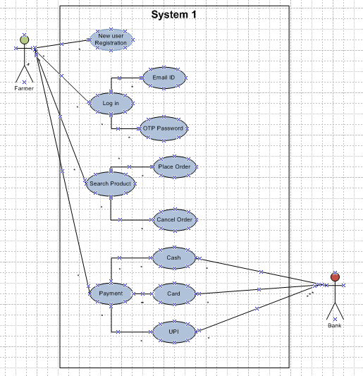
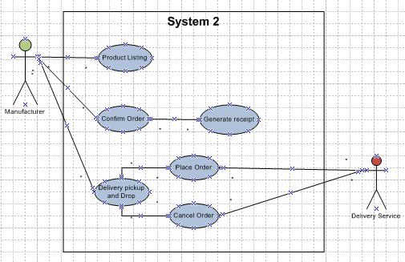
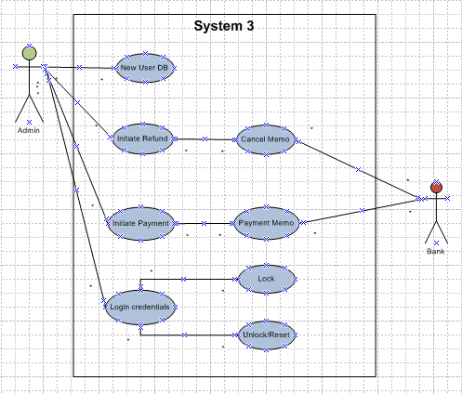

Question 11 – (minimum 5) Use Case Specs Prepare use case specs for all use cases Answer –

USE CASE NAME | Login
USE CASE DESCRIPTION | 1. Users will be able to log in to the application using their registered email and password or registered mobile number and OTP.
USE CASE DESCRIPTION | 2. User will be able to reset the user id/password using forgot user id/password option.
ACTOR | Farmer
PRE-CONDITION | 1. Active Network available.
PRE-CONDITION | 2. Users have valid email id
POST CONDITION | The user logged in successfully
BASIC FLOW | 1. Farmer trying to login into the application by inputting valid email id / registered mobile number and password / OTP.
BASIC FLOW | 2. Farmer will be able to go to the next page if entered user id and password or mobile number and OTP matches with the database.
BASIC FLOW | 3. Farmer can reset the user id/password using forgot option for user id/password.
ALTERNATE FLOW | If the User id is correct and password is incorrect / user id is incorrect and password is correct/ both user id and password are incorrect the system will pop up the error message 'Invalid User Id / Password '

USE CASE NAME | New user registration
USE CASE DESCRIPTION | 1) New user will be able to register to the application using there register Email and Password or register mobile  number and OTP,
USE CASE DESCRIPTION | 2) New user will fill up the required information in the application
USE CASE DESCRIPTION | 3) New user should be receiving the OTP on Email and register mobile number
USE CASE DESCRIPTION | 4) New user should be able to authenticate the received OTP on register email and mobile number
ACTORS | Farmer
PRE CONDITION | 1)Active network available,
PRE CONDITION | 2)New user have valid Email id availability of android mobile is the application must be used on mobile

 | 3) New user should know the registration option in the application
POST CONDITION | Successful registration done
BASIC FLOW | 1)New user lodging to the application and click on registration tab in application.
BASIC FLOW | 2)By inputting valid Email id / Register Mobile no and Password/OTP, user register himself in application
BASIC FLOW | 2)New user will be go to the next page filled up the required information which asked in application,
BASIC FLOW | 3)New user should be input the OTP once registration done and pop up will appear,
BASIC FLOW | 4)New user should set the password in given format
BASIC FLOW | 5) New user will successfully get register
ALTERNATE FLOW | 1) New user should register himself with valid email id
ALTERNATE FLOW | 2) New user should receive the otp on register email id or mobile number
ALTERNATE FLOW | 3) New user should have information which need to filled while registering on application

USE CASE NAME | Place Order
USE CASE DESCRIPTION | 1.Farmer will be able to select the product from available product catalogue.
USE CASE DESCRIPTION | 2.The selected product will get added to cart
USE CASE DESCRIPTION | 3.Farmers will be able to place order
ACTORS | Farmer
PRE-CONDITION | 1.Farmers have sufficient balance available for purchasing the product
PRE-CONDITION | 2.Stock availability with the manufacturer.
PRE-CONDITION | 3.Farmers are ready to wait for the delivery of the product as per TAT.
POST CONDITION | Farmers placing order successfully.
BASIC FLOW | 1. Farmer will choose the product from available product catalogue.
BASIC FLOW | 2. The chosen product will get added to the cart and farmer place order.
ALTERNATE FLOW | 1. Same product will not get selected in cart if already selected by the farmer. Pop up error message 'Invalid User Id / Password'

USE CASE NAME | Make Payment
USE CASE DESCRIPTION | 1) Farmer will be able to view the payment option once product is select from the cart list.
USE CASE DESCRIPTION | 2) Farmer should be select payment type from various payment option
USE CASE DESCRIPTION | 3) Farmer should be able to make the payment from various available options
ACTORS | Farmer
PRE CONDITION | 1) Farmers should have the facility to make a payment from the various payment options.
PRE CONDITION | 2)Farmers should have knowledge that how to pay the payment though various options
POST CONDITION | Farmers make payment successfully
BASIC FLOW | 1)Farmers will choose the product from available product catalogue.
BASIC FLOW | 2) farmer will view the payment option in payment option.
BASIC FLOW | 3)Farmers choose the payment options as per there convince.
BASIC FLOW | 4) Farmer make the payment
BASIC FLOW | 5) Farmers will receive the confirmation of the payment done
ALTERNATE FLOW | 1)Farmer should be able to view the payment option.
ALTERNATE FLOW | 2)No response from bank server
ALTERNATE FLOW | 3)Fund should be available in farmer account

USE CASE NAME | Cancel the order
USE CASE DESCRIPTION | 1) Farmer will be able to cancel the order once booked and if they are not required.
USE CASE DESCRIPTION | 2)Farmer should be able cancel the order under return policy
USE CASE DESCRIPTION | 3) Farmer should cancel the product within TAT
USE CASE DESCRIPTION | 4) Once order is cancelled farmer should receive the refund amount in provided bank account.
ACTORS | Farmer
PRE-CONDITION | 1)Order should be cancel within TAT.
PRE-CONDITION | 2)Farmer should not open the product if want to return and not required
PRE-CONDITION | 3) Farmer should have the bank account for received the refund amount in their account.
POST CONDITION | Farmers cancel the product successfully
BASIC FLOW | 1)Farmers should visit the application and view the order cancelation option.
BASIC FLOW | 2) Farmer should be able to select the product which they want to cancel.
BASIC FLOW | 3)Farmer should select the product and cancel the product
BASIC FLOW | 4)Farmer should receive pop up before submitting the cancelation request
BASIC FLOW | 5)Product cancel and repayment should be processed to the farmers account
BASIC FLOW | 5) Farmers should receive the fund in their account
ALTERNATE FLOW | 1)Farmer will not be able to cancel the order if TAT is over.
ALTERNATE FLOW | 2)cancelation option is disabled
ALTERNATE FLOW | 3)could not be able to process the repayment option
ALTERNATE FLOW | 4)farmer does not receive the fund in their account.

Question 12 – (minimum 5) Activity Diagrams Activity diagrams
Answer –
- Activity Diagram 1 - Login
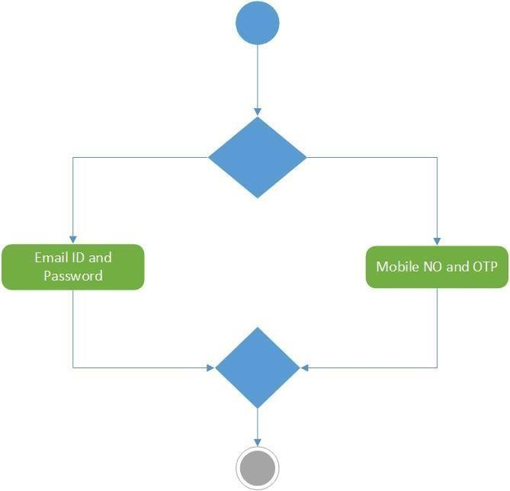

- Activity Diagram 1 – New User Registration
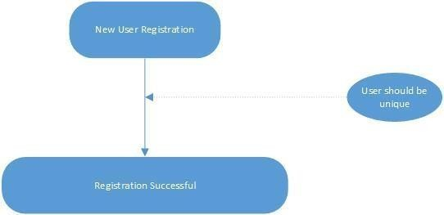

- Activity Diagram 3 – Payment Mode
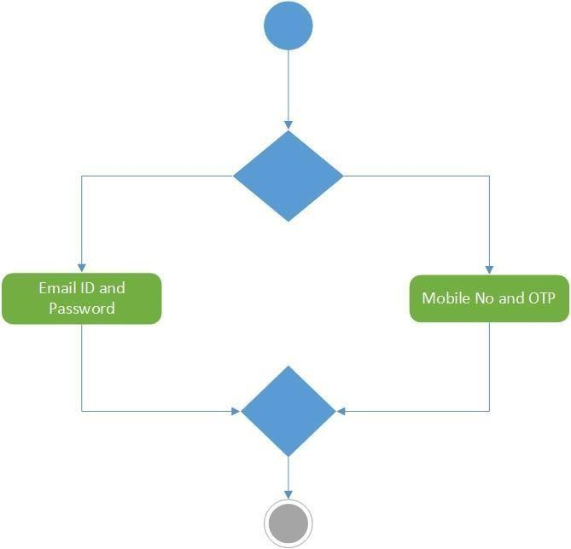

- Activity Diagram 4 – Cancel order
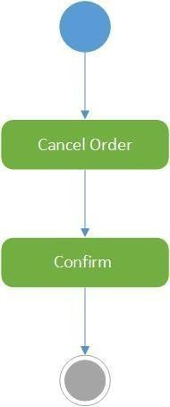

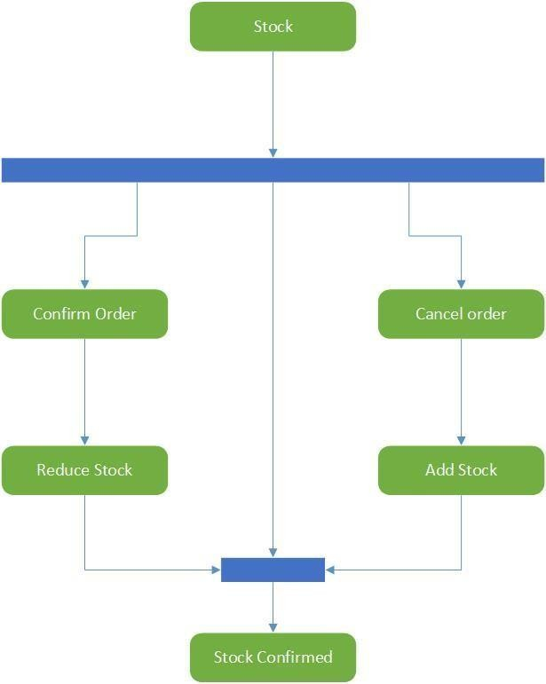
- Activity Diagram 5 – Stock Confirmation

