Capstone Project – Online Agriculture Products Store
Prepared by: Business Analyst

Question 1 – Functional Requirements
Below are the identified functional and non-functional requirements for the Online Agriculture Products Store:
- FR001: Farmers should be able to register with the application.
- FR002: Farmers should be able to login/logout securely.
- FR003: Manufacturers should be able to register and login.
- FR004: Farmers should be able to search for products (fertilizers, seeds, pesticides).
- FR005: Farmers should be able to view product catalog.
- FR006: Farmers should be able to add products to cart.
- FR007: Farmers should be able to place orders.
- FR008: Farmers should be able to track delivery status of orders.
- FR009: Payment gateway should support COD, Credit/Debit cards, and UPI.
- FR010: Farmers should receive email confirmation of orders.
- FR011: Farmers should be able to reset their password using email verification.
- FR012: Manufacturers should be able to upload their products with details (price, stock, description).
- FR013: Farmers should be able to save items in a wishlist (buy-later list).
- FR014: Farmers should be able to cancel orders before shipping.
- FR015: Admin should be able to manage users and products.
- FR016: Admin should be able to generate reports of sales and inventory.
- FR017: System should send notifications to users on order updates.
- FR018: Delivery partner should be able to update delivery status.
- FR019: Farmers should be able to rate and review products.
- FR020: System should log all user activities for auditing.

Non-Functional Requirements
- NFR001: Each page should load within 2 seconds.
- NFR002: System must meet WCAG 2.1 accessibility guidelines.
- NFR003: The application should support both web and mobile platforms.
- NFR004: The system should handle at least 10,000 concurrent users.
- NFR005: Data must be encrypted (SSL/TLS) for secure communication.
- NFR006: Passwords should be stored using hashing techniques.
- NFR007: System uptime should be 99.9%.
- NFR008: Application should provide multilingual support (English + local language).
- NFR009: System must be scalable to accommodate future growth.
- NFR010: Backup and recovery should be done daily.

Question 2 – Wireframes and Page Designs
Five key wireframe designs are proposed for the Online Agriculture Products Store:
1. Home Page – Contains navigation bar, product categories, and featured products.
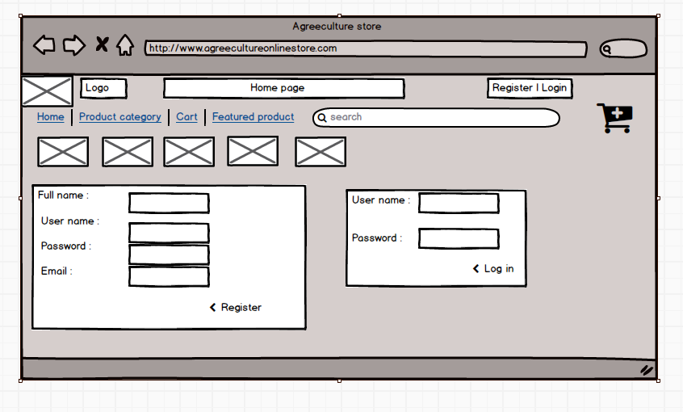
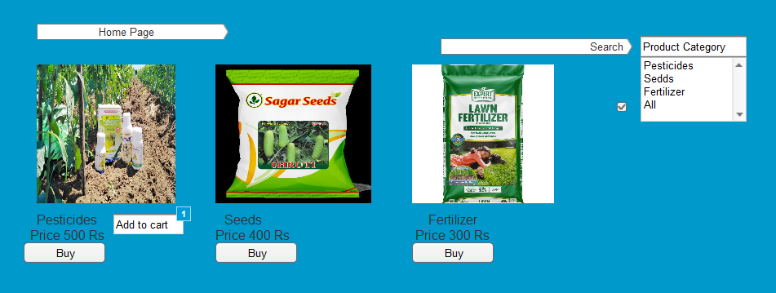
2. Login / Registration Page – Allows Farmers and Manufacturers to create accounts and login.
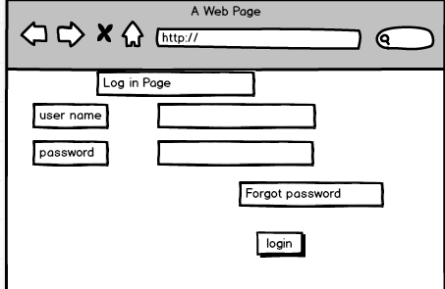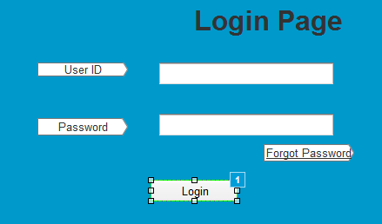
3. Product Catalog Page – Displays fertilizers, seeds, pesticides with filters and search option.
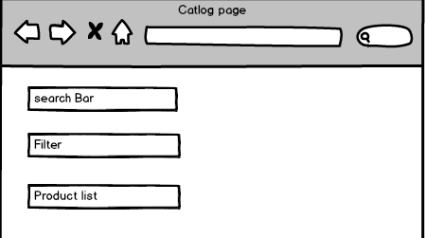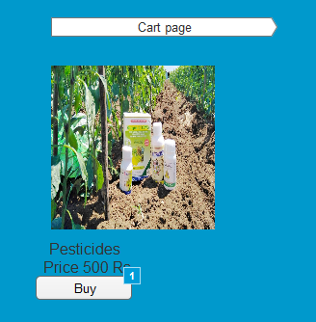
4. Cart and Checkout Page – Shows selected items, payment options (COD, UPI, Card).
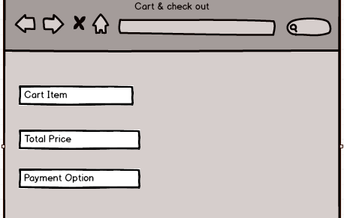
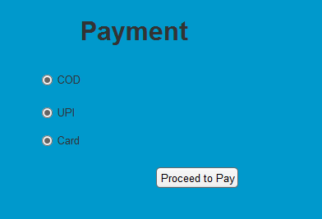

5. Order Tracking Page – Allows farmers to track the status of placed orders.

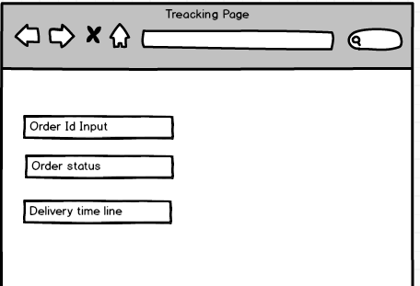
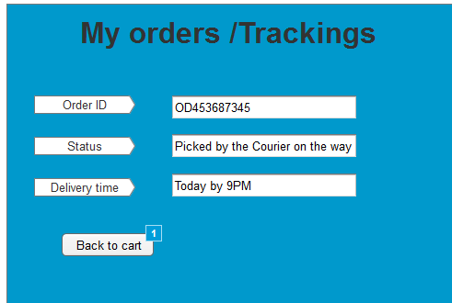
Note: Wireframes| Design can be prepared using tools such as Balsamiq, Ausre

Question 3 – Tools

The following tools are recommended for this project:
- Microsoft Visio: Tool for creating UML diagram Use Case, Activity, Diagrams.
- Balsamiq / Figma: For creating wireframes and screen mock-ups.
Asure - Powerfull design tool for creating Hightly interactive prototype for web and mobile application with screen navigation
-

Question 4 – Requirement Traceability Matrix (RTM)

What is RTM?
RTM stands for Requirement Traceability Matrix. It is a simple document that helps track all the requirements of a project throughout its lifecycle. The main purpose of RTM is to make sure that no requirement is missed, and every requirement is covered in design, coding, and testing phases. In short, it acts like a checklist to see whether each requirement is implemented and tested properly.
Req ID | Req Name | Req Description | Design | Code | Unit Testing | Component Testing | System Testing | UAT
FR001 | Farmer Registration | Farmers should be able to register with the application | CMPLT | CMPLT | CMPLT | CMPLT | CMPLT | INCMPLT
FR002 | Search Products | Farmers should be able to search for available products | CMPLT | CMPLT | CMPLT | CMPLT | INCMPLT | INCMPLT
FR003 | Product Upload | Manufacturers should be able to upload and display their products | CMPLT | CMPLT | CMPLT | CMPLT | INCMPLT | INCMPLT
FR004 | Add to Cart | Farmers should be able to add products to the cart | CMPLT | CMPLT | CMPLT | CMPLT | INCMPLT | INCMPLT
FR005 | Place Order | Farmers should be able to buy products | CMPLT | CMPLT | CMPLT | CMPLT | INCMPLT | INCMPLT
FR006 | Payment Gateway | Farmers should be able to make payments via UPI, Cards, COD | CMPLT | CMPLT | CMPLT | INCMPLT | INCMPLT | INCMPLT
FR007 | Delivery Tracking | Farmers should be able to track the delivery status of their products | CMPLT | CMPLT | CMPLT | INCMPLT | INCMPLT | INCMPLT
NFR001 | Page Load Time | Each page should load within 2 seconds | CMPLT | CMPLT | CMPLT | INCMPLT | INCMPLT | INCMPLT
NFR002 | Accessibility (WCAG) | System should comply with WCAG 2.1 guidelines | CMPLT | CMPLT | CMPLT | INCMPLT | INCMPLT | INCMPLT

Question 5 – Test Case Documents
Test Case: TC001 - User Registration
Test case ID | TC001
Test case Name | User Registration
Scenario | User registers with valid details
Input Data | Name, Email, Password
Expected Behaviour | Account created successfully, confirmation mail sent
Actual Behaviour / Result | To be tested / Pass or Fail
Test Case: TC002 - User Login
Test case ID | TC002
Test case Name | User Login
Scenario | User logs in with valid credentials
Input Data | Registered Email + Password
Expected Behaviour | User redirected to homepage
Actual Behaviour / Result | To be tested / Pass or Fail
Test Case: TC003 InvalidLogin
Test case ID | TC003
Test case Name | Invalid Login
Scenario | User enters wrong password
Input Data | Correct Email + Wrong Password
Expected Behaviour | Error message shown 'Invalid Login'
Actual Behaviour / Result | To be tested / Pass or Fail
Test Case: TC004 - Search Product
Test case ID | TC004
Test case Name | Search Product
Scenario | Farmer searches for a product
Input Data | Search keyword: Fertilizer
Expected Behaviour | All fertilizer products displayed
Actual Behaviour / Result | To be tested / Pass or Fail
Test Case: TC005 - View Product Details
Test case ID | TC005
Test case Name | View Product Details
Scenario | User clicks a product from catalog
Input Data | Select 'Pesticide X'
Expected Behaviour | Product details page opens with description, price, seller info
Actual Behaviour / Result | To be tested / Pass or Fail
Test Case: TC006 - Add Cart
Test case ID | TC006
Test case Name | Add to Cart
Scenario | Add a product to cart
Input Data | Select 'Seed Pack A' → Add to Cart
Expected Behaviour | Product added, cart count updated
Actual Behaviour / Result | To be tested / Pass or Fail
Test Case: TC007 - Place Order
Test case ID | TC007
Test case Name | Place Order
Scenario | User places an order successfully
Input Data | Cart items + Address + Payment Info
Expected Behaviour | Order confirmation displayed with Order ID
Actual Behaviour / Result | To be tested / Pass or Fail
Test Case: TC008 - Payment – UPI
Test case ID | TC008
Test case Name | Payment – UPI
Scenario | Pay using UPI
Input Data | UPI ID (xyz@upi)
Expected Behaviour | Payment success, receipt generated
Actual Behaviour / Result | To be tested / Pass or Fail
Test Case: TC009 - Delivery Tracking
Test case ID | TC009
Test case Name | Delivery Tracking
Scenario | User tracks delivery status
Input Data | Order ID
Expected Behaviour | Status displayed: 'Shipped / Out for delivery / Delivered'
Actual Behaviour / Result | To be tested / Pass or Fail
Test Case: TC010 - Page Load Performance
Test case ID | TC010
Test case Name | Page Load Performance
Scenario | Page load time
Input Data | Open homepage
Expected Behaviour | Page should load within 2 seconds
Actual Behaviour / Result | To be tested / Pass or Fail

Question 6 – Database Design

The database schema consists of the following entities:
- Users (UserID, Name, Email, Password, Role)
- Products (ProductID, Name, Category, Price, Stock, ManufacturerID)
- Orders (OrderID, UserID, OrderDate, Status, PaymentID)
- Payments (PaymentID, OrderID, PaymentType, Amount, Status)
- Delivery (DeliveryID, OrderID, Status, ExpectedDate)
- Manufacturers (ManufacturerID, Name, Contact, Address)
Relationships:
- Users ↔ Orders (1:M)
- Orders ↔ Payments (1:1)
- Orders ↔ Delivery (1:1)
- Manufacturers ↔ Products (1:M)
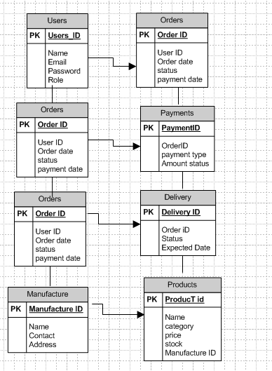

Question 7 – Data Flow Diagram
A Data Flow Diagram (DFD) represents the flow of data when a Farmer places an order:
1. Farmer searches products → Product Catalog → System displays results.
2. Farmer adds item to Cart → Checkout → Payment Gateway.
3. Payment confirmed → Order recorded → Delivery system notified.
4. Delivery updates status → System updates order tracking → Farmer notified viaemail.
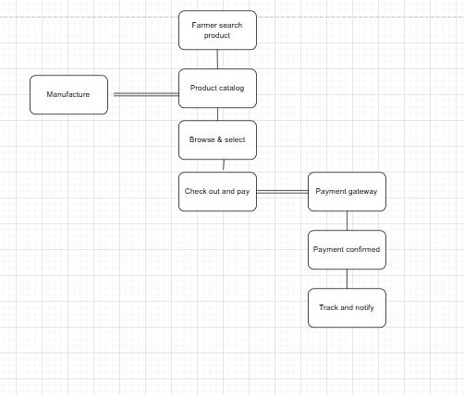

Question 8 – Handling Change Requests
A change request is a formal proposal to alter a system, product, or project. It may arise due to new business needs, government regulations, or stakeholder expectations. A Business Analyst (BA) plays a key role in handling change requests to ensure they are assessed, documented, and implemented smoothly without affecting the overall project negatively.
Steps a BA should follow to handle change requests:
- Understand and document the change request
  - Collect details from the stakeholder about what change is needed and why.
  - Clearly record it in a Change Request Document (CRD).
- Perform impact analysis
  - Evaluate how the change affects project scope, schedule, budget, resources, and risks.
  - Check if it impacts existing requirements, design, or testing.
- Prioritize the change request
  - Assign priority based on urgency, importance, and business value.
  - Discuss with stakeholders to finalize priority.
- Seek approval
  - Present the impact analysis and recommendation to the Project Sponsor / Change Control Board (CCB).
  - Get formal approval or rejection.
- Communicate the decision
  - Inform all stakeholders (developers, testers, project manager, client) about the decision.
  - Update project documents, requirements, and test cases if approved.
- Monitor and verify implementation
  - Ensure the approved change is implemented correctly.
  - Verify through testing and confirm with stakeholders.

Question 9 – Change Request vs Enhancement
- Scenario:
During the project, Ben and Kevin requested that Farmers should be able to:
- Sell their crop yields through the application (i.e., add crop yields/products and display them to the public).
- Introduce an Auction system for crop yields.

Analysis as a BA:
- The initial agreed scope of the project was only to allow Farmers to buy products (fertilizers, seeds, pesticides) from manufacturers.
- Selling crop yields and adding an Auction feature was not part of the original requirements.
- This request changes the scope of the project by introducing new functionality, workflows, database changes, and additional UI screens.

Conclusion:
👉 This is a Change Request, not just a small enhancement.
- Reason: An enhancement usually means improving or extending existing functionality (e.g., improving the search filter, adding one more payment option).
- But here, it is a major new feature outside the initial scope (farmer-to-customer sales + auction system).
- Therefore, it must be treated as a Change Request, requiring impact analysis on budget, timeline, resources, and approval from stakeholders.

Question 10 – Estimations
The project has an estimated duration of 18 months with the following team members:
Project Manager (1), Senior Java Developer (1), Java Developers (4), Network Admin (1), DB Admin (1), Testers (2), and Business Analyst (1).
Each resource works approximately 40 hours per week. Over 18 months (~78 weeks), one resource contributes about 3,120 hours. With 11 team members, the total capacity is around 34,320 manhours. Below is the distribution of these hours across project phases.
Phase / Activity | % Effort | Manhours (Approx.) | Responsible Roles
Requirement Gathering & Analysis | 10% | 3,400 | BA, PM
Design (UI/UX, DB, Architecture) | 15% | 5,150 | BA, Sr. Dev, DB Admin, PM
Development (Frontend, Backend) | 40% | 13,700 | Sr. Dev + 4 Java Devs
Testing (Unit, System, UAT) | 20% | 6,860 | Testers + Dev support
Deployment & Training | 5% | 1,700 | Network Admin, DB Admin, PM
Project Mgmt & Coordination | 10% | 3,400 | PM + BA
Conclusion: The total estimated effort for the Online Agriculture Products Store project is approximately 34,320 manhours, distributed across different project phases as shown above.

Question 11 – User Acceptance Testing (UAT)
Planning :
For the Online Agriculture Products Store project, a UAT plan will be created to test all key features such as farmer registration, product search, adding items to cart, placing orders, payment, and delivery tracking. Entry/exit criteria and timelines will be finalized in agreement with Mr. Henry and other stakeholders.
Designing :
UAT test cases will be designed to simulate real-world farming scenarios. For example:
- A farmer registering on the platform
- Searching for fertilizers/seeds/pesticides
- Adding products to cart and completing payment via UPI, COD, or card
- Tracking delivery status.
These cases ensure all business requirements are validated.
UAT Testers :
End users (farmers like Peter, Kevin, and Ben) and manufacturer representatives will act as UAT testers. They will execute the test cases to confirm that the system is easy to use and meets their needs.
Bug Reporting & Fixing :
If testers find issues (e.g., payment failure, slow page load, or missing product details), they will report them. The development team (Mr. Teyson, Ms. Lucie, Mr. Tucker, Mr. Bravo, and Ms. Juhi) will fix the issues, and testers (Mr. Jason and Ms. Alekya) will recheck.
Sign-Off :
Once farmers and stakeholders confirm that the application works smoothly (registration, search, buying, payments, and delivery tracking), Mr. Henry will provide final approval. After this sign-off, the product will be ready to Go Live.

Question 12 – Project Closure Document
A Project Closure Document for the Online Agriculture Products Store should include:
- UAT Sign-off confirmation
- Objectives achieved (Registration, Search, Orders, Payments, Delivery Tracking)
- Infrastructure readiness (web, mobile, cloud DB)
- Budget utilization (₹1.85 Crores of ₹2 Crores)
- Escalations & lessons learned
- Value delivered (90% success, strong CSR impact, digital adoption by farmers)
- Challenges faced (internet, digital literacy, payment integration)
This ensures the project is formally closed and provides a knowledge base for future initiatives.

S.No | Points to include | Details (for this Project) | Reference link
1 | Did the client sign off on the UAT Testing | Yes – Signed off on 15th Feb 2025 | UAT Sign-off.docx
 | Date of the signoff | 15th Feb 2025
 | Name of the resource | Mr. Henry (Client Sponsor)
2 | Objectives of the project | User-friendly platform for farmers | Business Scope.docx
2 | Objectives of the project | - Direct purchase from manufacturers | Business Scope.docx
2 | Objectives of the project | - Secure payments | Business Scope.docx
2 | Objectives of the project | - Delivery tracking achieved | Business Scope.docx
2 | Objectives of the project | - ROI expected in 12 months | Business Scope.docx
3 | Functionalities worked on | - Farmer Registration/Login | Requirement Document.docx
3 | Functionalities worked on | - Product catalog (Seeds, Fertilizers, Pesticides) | Requirement Document.docx
3 | Functionalities worked on | - Search & Filter | Requirement Document.docx
3 | Functionalities worked on | - Add to Cart & Place Order | Requirement Document.docx
3 | Functionalities worked on | - Payment (UPI, COD, Cards) | Requirement Document.docx
3 | Functionalities worked on | - Delivery Tracking | Requirement Document.docx
4 | Infrastructure | - Web + Mobile app deployed | Architecture.docx
4 | Infrastructure | - Cloud DB hosted | Architecture.docx
4 | Infrastructure | - Secure servers configured | Architecture.docx
4 | Infrastructure | - Payment Gateway integrated | Architecture.docx
5 | Funding | Approved: ₹2 Crores | Finance Breakdown.docx
5 | Funding | Used: ₹1.85 Crores | Finance Breakdown.docx
6 | Overall project information | Escalations: 40 handled successfully | Status Report.docx
6 | Overall project information | Customer Satisfaction: High (positive farmer feedback) | Status Report.docx
7 | Value to the company | Positive Impact – 90% | Final Report.docx
7 | Value to the company | - Improved CSR reputation | Final Report.docx
7 | Value to the company | - Increased farmer digital adoption | Final Report.docx
7 | Value to the company | - Strengthened relation with manufacturers | Final Report.docx
7 | Value to the company | - Future pipeline: Farmer-to-consumer marketplace, Auction system | Final Report.docx
8 | Lessons Learned | - Early stakeholder involvement reduces rework | Lessons Learned.docx
8 | Lessons Learned | - UAT with real farmers gave practical feedback | Lessons Learned.docx
8 | Lessons Learned | - Payment gateway testing critical | Lessons Learned.docx
9 | Challenges | - Poor internet in rural areas | Risk Register.docx
9 | Challenges | - Farmers’ low digital literacy | Risk Register.docx
9 | Challenges | - Integration delays with payment providers | Risk Register.docx

