Document 1: Definition of Done
Definition of done is a shared understanding within the Scrum team of what it means for work to be complete, ensuring transparency and consistent quality.
PURPOSE OF DOD
- Ensure quality and completeness of deliverables
- Avoid misunderstandings between the development team, Product Owner, and stakeholders
- Maintain transparency and build trust
- Make sure nothing is left incomplete or assumed

Code developed for additional features | - Autofill service request forms (address change, card application, name update, etc.)  - Viewing and downloading account/loan statements  - Display of credit/debit card and investment details  these features are implemented as per the agreed user stories and requirements.
All assumptions related to user stories validated | - All pre-conditions, constraints, and business rules stated in the user stories are confirmed and met before progressing to testing.
Application build is successful with no errors | - Auto fill forms, statement , customer service request successfully completed
. Unit testing | - Each functional module is covered with unit tests using tools like Testing. All test cases pass with no critical or major issues.
UAT | - The complete enhancement is deployed on the UAT server which mirrors the production setup. This ensures no environment-specific defects remain undetected.
Verified on supported browsers | - The application is tested across all browsers and devices as specified by ICICI Bank eg. Chrome
UX approved | - The UX team validates that the form autofill feature is intuitive and user-friendly. Labels, input fields, error messages, and tab flows are user-centric and consistent with bank standard
QA performed and bugs fixed | - Functionality, Negative inputs Field validations All defects identified have been fixed, re-tested, and closed.
acceptance criteria | Each user story is tested according to its Acceptance Criteria Autofill happens correctly after entering cust ID  - Loan offers are displayed based on minimum interest rate  - Statement downloads in PDF format  - All criteria are met successfully.
Product Owner review | - The Product Owner reviews the sprint output in the Sprint Review Meeting. Each feature is demonstrated, feedback is incorporated, and final approval is received.
Refactoring completed | - After ensuring functionality, the development team optimizes and cleans the codebase (e.g., removing redundant code, improving method naming, eliminating hard-coded values).
Any configuration or build changes documented | - Any changes in environment variables, form templates, authentication settings, or API endpoints are properly documented for future deployments and audits.
Support documentation updated | - The user manuals, form-filling guidelines, and support escalation flow are updated to reflect the new features. This documentation is accessible to branch staff.
documents completed | - Before merging into the release branch, all code and documentation are reviewed by at least one other team member for quality, readability, and logic.

Document 2- Product Vision
Scrum Project Name: | I-view application
Venue | ICICI Bank Branch Operations
Date: 03-July-2025 | Start time: 10:00 AM | End time: 11:30 AM | Duration:  1 Hour 30 Minutes
Client: | ICICI Bank Ltd.
Stakeholder list: | Branch Manager – ICICI , Product Manager – Retail Banking ,IT Application Owner,, Compliance Officer, Business Analyst, Relationship Managers
 | Scrum Team
Scrum Master: | Ajay Sharma
Product owner: | Neha Rao
Scrum Developer 1 | Devendra Singh (Backend)
Scrum Developer 2: | Rohan Kulkarni (Frontend)
Scrum Developer 3: | Swati Mehra (API Integration)
Scrum Developer 4: | Nikhil Joshi (QA Analyst)
Scrum Developer 5: | S Jain (UI/UX Designer)

Vision: What is your vision, your overarching goal for creating the product?
Target group:-

1) Which market segment does the product address?
- The project addresses the retail banking operations segment — specifically branch-based customer service.
2) Who are the target users and customers?
- Internal users: Bank employees such as Customer Service Officers (CSOs), Relationship Managers (RMs), and Branch Operations Staff.
- Indirect users: ICICI retail customers who benefit from improved in-branch services.

Needs:-
1) What problem does the product solve?
- Currently, bank staff must log in to multiple applications for different services
- Session timeouts and repetitive logins cause inefficiency and customer dissatisfaction.
- Manual form filling leads to human error and increased processing time.
- Physical form management is prone to audit and compliance issues.
2) Which benefit does it provide?
- Reduces time and effort required for service delivery.
- Minimizes human error with autofill features.
- Increases branch score by improving service accuracy and compliance.
- Enhances customer satisfaction through faster, more reliable service.

Product:-
1) What product is it?
- An enhanced version of the I-View application, offering centralized access to customer details, statements, card info, investment forms, and pre-filled service request forms.

2) What makes it desirable and special?
- All-in-one platform: reduces application switching.
- Autofill functionality saves time and reduces errors.
- Supports compliance and audit-readiness with digital form tracking.
- Improves TAT (Turnaround Time) and customer trust.
3) Is it feasible to develop the product?
- Yes. Since it’s an enhancement of an existing application, development is feasible using internal APIs and available infrastructure, with minimal external dependencies.

Value:-
1) How is the product going to benefit the company?
- Faster customer servicing increases satisfaction and retention.
- Higher branch productivity and employee efficiency.
- Better compliance with RBI and internal audit requirements.
2) What are the business goals?
- Digitize all in-branch customer requests.
- Improve branch score and compliance.
- Reduce form errors and manual processing time.
- Minimize dependency on physical documentation.
3) What is the business model?
- Cost optimization model: Increase operational efficiency without increasing headcount.
- Customer satisfaction-driven model: Retain and expand customer base through better service.

Document 3: User stories
1)
USER STORY 1 | TASK 2 |  | PRIORITY- HIGHEST
As a bank staff user,
I want the service request forms to autofill with customer details
so that,
I can save time and avoid manual error
BV-500 |  | CP-2
ACCEPTANCE CRITERIA

Autofill activates when customer ID is entered
All fields such as name, address, account no. populate correctly
User can manually edit fields if needed
Auto filled forms are saved in PDF format
Forms are ready for audit and review

USER STORY | TASK 3 |  | PRIORITY- HIGHEST
As a staff member,
I want to view and download a customer's account statement
so that
I can respond to physical or email statement requests.
BV -100 |  | CP-2
ACCEPTANCE CRITERIA
Staff can filter statement by date range
Statement is downloadable in PDF
Proper headers and formatting exist
Balance summary is shown correctly
Secure access (role-based)

USER STORY 3 | TASK 3 |  | PRIORITY- HIGHEST
As a bank user,
I want to view loan statements and offers
so that
I can assist customers with their loan queries and cross-sell low-interest loans.
BV -100 |  | CP-2
ACCEPTANCE CRITERIA
Current loan statement visible with EMI history
Loan offers are shown based on eligibility
Loan offers show % rate, tenure, and approval conditions
Download option for the loan statement

USER STORY 4 | TASK 3 |  | PRIORITY- MEDIUM
As a user,
I want to see debit/credit card information for a customer
so that
I can answer card-related queries.
BV -5 |  | CP-2
ACCEPTANCE CRITERIA
Card type (debit/credit) displayed
Masked card numbers shown
Status: Active/Inactive/Fraud Blocked
Limit and last transaction date visible

USER STORY 5 | TASK 4 |  | PRIORITY- Low
As a user,
I want to access pre-filled investment forms
so that
I can quickly initiate investment service requests.
BV -5 |  | CP-2
ACCEPTANCE CRITERIA
Forms auto-filled with cust ID, PAN, address
Correct form appears as per investment type
Download and print options available
Submitted forms logged for audit

USER STORY 6 | TASK 4 |  | PRIORITY- High
As a staff user,
I want to log in once and access all necessary services within I-View without switching applications,
so that
I can save time.
BV -500 |  | CP-4
ACCEPTANCE CRITERIA
User logs in once and accesses multiple modules
No repeated credential prompts during session
Role-based restrictions enforced
Session timeout warning is displayed

USER STORY 7 | TASK 2 |  | PRIORITY- High
As a bank manager,
I want access to customer data to be controlled based on user role
so that,
data privacy is maintained and compliance is ensured.

BV -100 |  | CP-4
ACCEPTANCE CRITERIA
Only authorized users can see sensitive fields
Unauthorized users receive access denied message
Access logs are maintained
RBAC (Role-Based Access Control) policy documented

USER STORY 8 | TASK 2 |  | PRIORITY- High
As a bank manager,
I want access to customers investment data
so that ,
I can pitch the product according to the customer profile

BV -1000 |  | CP-4
ACCEPTANCE CRITERIA
Bank manager can see the details of customer
It will improve the bank business
It will build the customer trust on bank
Help to generate the revenue
Staff can get the incentives

USER STORY 9 | TASK 2 |  | PRIORITY- High
As a bank customer
I want online access of basic services
so that
change the details online

BV -100 |  | CP-4
ACCEPTANCE CRITERIA
Customer can do the basic change in account
Net banking thorough change can be done
It will help to reduce the physical work
Customer need not to come bank
It will help in audit

USER STORY 10 | TASK 2 |  | PRIORITY- High
As a As a bank officer,
I want to access a customer's account summary
so that
I can provide accurate answers during customer interactions.

BV -100 |  | CP-4
ACCEPTANCE CRITERIA
Suggest the investments
Loans
Fixed deposits
Improve the relationship

USER STORY 11 | TASK 2 |  | PRIORITY- High
As a bank employee,
I want to view the customer profile using their Customer ID,
So that
I can access all relevant personal and contact information.
BV -200 |  | CP-4
ACCEPTANCE CRITERIA
The system shall allow input of Customer ID to fetch profile.
The profile must display name, DOB, contact number, email, address, and KYC status.
Error message must appear if invalid ID is entered.

USER STORY 12 | TASK 2 |  | PRIORITY- High
As a relationship manager,
I want to view all linked accounts in one summary view,
So that
I can assist the customer effectively.

BV -200 |  | CP-4
ACCEPTANCE CRITERIA
he system shall list savings, loan, credit card, and FD accounts.
Each account must show balance, status, and account number.
Summary view must load within 3 seconds.
USER STORY 13 | TASK 2 |  | PRIORITY- High
As a service executive
I want to access the customer's loan details (EMI, interest, tenure),
So that
I can help them with queries and statements.
BV -200 |  | CP-4
ACCEPTANCE CRITERIA
Loan information should include loan type, amount, tenure, EMI, and repayment schedule.
System shall allow filtering by loan type.
Loan statement must be downloadable in PDF format.

USER STORY 14 | TASK 2 |  | PRIORITY- medium
As a customer support executive,
I want to view credit card limits, dues, and transaction history,
So that,
I can support customers on billing and payment issues.
BV -200 |  | CP-4
ACCEPTANCE CRITERIA
Card info must show card number (masked), credit limit, due amount, payment due date.
Last 10 transactions should be visible.
The system shall alert if the card is blocked or inactive.

USER STORY 15 | TASK 2 |  | PRIORITY- medium
As a bank employee,
want to view recent transactions for any account,
So that,
I can verify debits/credits for the customer.
BV -100 |  | CP-2
ACCEPTANCE CRITERIA
System shall allow date-wise filtering of transactions.
It must display transaction date, description, amount, and balance.
A minimum of last 6 months’ data must be accessible.

USER STORY 16 | TASK 2 |  | PRIORITY- medium
As a KYC verifier,
I want to view uploaded documents like PAN, Aadhaar, Address proof,
So that,
I can complete verification quickly.
BV 100 |  | CP-2
ACCEPTANCE CRITERIA
Each document must be clearly labelled and viewable in PDF/JPG format.
System must show upload timestamp and status (verified/pending).
Incomplete or missing documents must be flagged.

USER STORY 17 | TASK 2 |  | PRIORITY- medium
As a loan officer,
I want to review the customer’s submitted collateral and lien documents,
So that,
I can assess risk and validate application status.
BV -100 |  | CP-2
ACCEPTANCE CRITERIA
Collateral type, valuation, and document upload status should be visible.
Scanned copies should be downloadable with access control.
Only authorized roles should be able to view/download the documents.

USER STORY 18 | TASK 2 |  | PRIORITY- medium
As an audit manager,,
want to track which employees accessed which customer profiles and when,
So that,
I can ensure customer data is secure and handled responsibly.
BV -100 |  | CP-2
ACCEPTANCE CRITERIA
System must log user ID, access timestamp, and customer ID accessed.
Logs should be tamper-proof and exportable.
Access history must be retained for at least 6 months.

USER STORY 19 | TASK 2 |  | PRIORITY- medium
As a regular I-View user,
I want the system to load quickly and stay stable
So that,
I can work without interruption during peak hours.
BV -50 |  | CP-2
ACCEPTANCE CRITERIA
Home dashboard must load within 2 seconds under normal load.
System uptime must be ≥ 99.5% monthly.
Access history must be retained for at least 6 months.
Graceful error message must appear if the system is down.

USER STORY 20 | TASK 2 |  | PRIORITY- medium
As a branch executive,
I want to print or email account statements directly from the system,
So that,
I can serve customers promptly without third-party tools.
BV -50 |  | CP-2
ACCEPTANCE CRITERIA
Statement should be generated in PDF and printable.
Email should auto-fill the customer’s registered email.
Option to select time range for statement (e.g., last month, custom dates).

Document 4: Agile PO Experience:-
The Product Owner in the I-View enhancement project played a crucial role in ensuring that the application evolved based on market needs, user feedback, and organizational goals. Given the critical nature of banking systems, the PO continuously collaborated with stakeholders, developers, and business analysts to deliver features that improved system performance, customer data access, and document handling.
- Market Analysis :-
- Conducted analysis to assess the current state of I-View against competitor systems in the banking sector.
- Identified a strong need to improve the response time, data accessibility, and statement/document management in internal banking applications.
- Studied customer service pain points and delays faced by employees in serving customers.
- Benchmarked against similar internal tools used by competing banks (e.g., HDFC, Axis).
- Confirmed the market demand for faster access to customer records, loan info, and statements to improve branch productivity and customer satisfaction.
- Enterprise Analysis:-
- Performed a business feasibility analysis to understand the return on investment of enhancing I-View.
- Worked with internal stakeholders like branch managers and operations heads to justify the system upgrade.
- Identified that the current system’s delays impacted customer handling time.
- Justified enhancement through improved speed, document availability, and reduction in manual dependency, thereby reducing turnaround time and operational costs.
- Product Vision and Roadmap:-
- Real-time customer profile viewing
- Instant statement download/emailing
- KYC document integration
- Loan and card details view
- System performance tuning

- Managing Product Features:-
- Collected and prioritized feature requests from stakeholders (branch staff, relationship managers, support desk).
- Balanced technical feasibility with business value and customer impact.
- Used techniques like MoSCoW and Weighted Shortest Job First (WSJF) to prioritize backlog items.
- High-priority features:
- Single-click customer data access
- Instant statement printing
- View recent transactions

- Medium-priority features:
- Document uploads & scans
- Collateral verification

- Low-priority
- AI-based customer suggestion tools
- Managing Product Backlog :-
- Maintained and continuously refined the product backlog.
- Coordinated with the BA to convert business needs into epics and user stories.
- Regularly reviewed and reprioritized items based on sprint progress, dependencies, and new stakeholder inputs.
- Managing Overall Iteration Progress:-
- Participated in Sprint Planning, Daily Scrums, Sprint Reviews, and Sprint Retrospectives.
- Tracked velocity and sprint burndown charts.
- Reprioritized features or stories as needed based on team capacity or changing stakeholder priorities.
- Conducted Sprint Review meetings with BAs and developers to assess progress.
- Approved or rejected features based on acceptance criteria.
- Collaborated in retrospectives to understand challenges (e.g., dependency delays, data availability) and ensure improvement in the next sprint.

- Sprint Meetings Involved:-

- Sprint planning meeting:-

- Purpose: To plan the work to be done in the upcoming sprint.
- Who attends: Product Owner, Scrum Master, and Development Team
Activities:
- Select items from the product backlog to include in the sprint backlog.
- Define the sprint goal.
- Break down user stories into tasks and estimate effort.
- Daily stand-up meeting:-
- Purpose: To inspect progress and synchronize the team.
- Duration: 15 minutes.
- Who attends: Development Team (Scrum Master and Product Owner can join).
- Typical Questions Discussed:
- What did I do yesterday?
- What will I do today?
- Are there any blockers or impediments?
4) Sprint retrospective meeting:-
- Purpose: To reflect on the sprint and identify areas of improvement.
- who attends: Scrum Team.
Activities:
- Discuss what went well.
- Identify what didn’t go well.
- Plan actionable steps for improvement in the next sprint.
3 question will ask at the end of the project
1 )what went well in the sprint?
2) what not went well in the sprint?
3) what are the required area for improvement in the next sprint?
- Sprint review meeting:-
- Purpose: This can be done at the end of the project where team will give the demo of a completed stories to product owner and get it clear
- Who attends: Scrum Team and stakeholder
- Activities:
    - Present completed product increment.
    - Collect feedback from stakeholders.
    - Discuss what to do next.

- backlog refinement :-
- Purpose: To keep the product backlog clean, updated, and ready for sprint planning.
- Who attends: Product Owner and Development Team (Scrum Master can assist).
- Activities:
    - Prioritize backlog items.
    - Break down large stories.
    - Add details and estimates.

- What is included in a User Story?

- Story No.:- Unique identifier for the user story
- Tasks:- Technical or functional activities required to complete the story
- Priority:- MoSCoW or P1/P2/P3 – based on business value and urgency
- Acceptance Criteria:- List of expected outcomes that must be met for the story to be marked “done
- Business Value:- Score (1–10 or 1–100) that indicates business importance
- CP:- Based on story points
In Scrum, the Product Owner (PO) acts as a central communication bridge between various parts of the organization:
- Business Stakeholders:
  - Includes branch managers, customer support teams, loan officers, operations heads, and compliance teams.
  - The PO regularly gathers feedback, pain points, and change requests from these users.
  - For I-View, stakeholders needed faster access to customer details, printed loan statements, and fewer downtimes.
- Scrum Team (Developers, Scrum Master, BA):
  - The PO conveys business needs as user stories to the Scrum team.
  - Ensures that development work aligns with stakeholder expectations.
  - Participates in daily stand-ups, sprint planning, and sprint review meetings.

Product Owner:-
The Product Owner in the I-View Project served as the voice of the customer and business, owning the vision and ensuring continuous value delivery through well-managed and prioritized user stories.
Without this role, the project risks misalignment, misunderstood requirements, or features that don’t serve real business needs — especially critical in high-impact domains like banking.

User Story ID | User Story | Tasks | Priority | BV | CP | Sprint
US-101 | As a bank employee, I want to view the customer profile using Customer ID so that I can retrieve information quickly. | - UI for input field- Backend integration- Display data in profile section | Must Have | 9 | 3 | Sprint 1
US-102 | As a loan officer, I want to download the customer's loan statement so that I can provide it when requested. | - Create loan summary layout- Generate PDF- Add download button | Must Have | 8 | 5 | Sprint 2
US-103 | As a branch staff, I want to email account statements directly so that I can serve customers faster. | - Email integration- Validate email address- Statement template creation | Should Have | 7 | 3 | Sprint 2
US-104 | As a bank employee, I want to view last 6 months’ transaction history so that I can resolve queries. | - Transaction history API- Filter by date- Display grid format | Must Have | 8 | 4 | Sprint 1
US-105 | As a KYC verifier, I want to access uploaded customer documents so that I can verify identity without delays. | - Document access logic- PDF viewer- Show upload status | Should Have | 6 | 3 | Sprint 3
US-106 | As a system admin, I want to track employee access logs so that I can monitor data security. | - Activity logging service- Admin view page- Filter by date/user | Could Have | 5 | 5 | Sprint 3
US-107 | As a service executive, I want to auto-fill customer email from records so that statement mailing is quicker. | - Retrieve email API- Pre-fill in email module- Error handling | Could Have | 4 | 2 | Sprint 3
Document 5: Product and sprint backlog and product and sprint burn down charts

Sprint backlog:
User Story ID | User Story | Tasks | Owner | Status | Estimated Effort (Story Points)
US-102 | As a loan officer, I want to download the customer's loan statement so that I can provide it when requested. | - Loan data fetch API- PDF generation logic- UI for download button | Dev ADev BDev C | In Progress | 5
US-103 | As a branch staff, I want to email account statements directly so that I can serve customers faster. | - Configure email server- Statement email template- Send email function | Dev ADev BDev C | Not Started | 3
US-107 | As a service executive, I want to auto-fill customer email from records so that statement mailing is quicker. | - Fetch email from DB- Pre-fill in form- Validation and error handling | Dev B | Not Started | 2

Product burn down chart
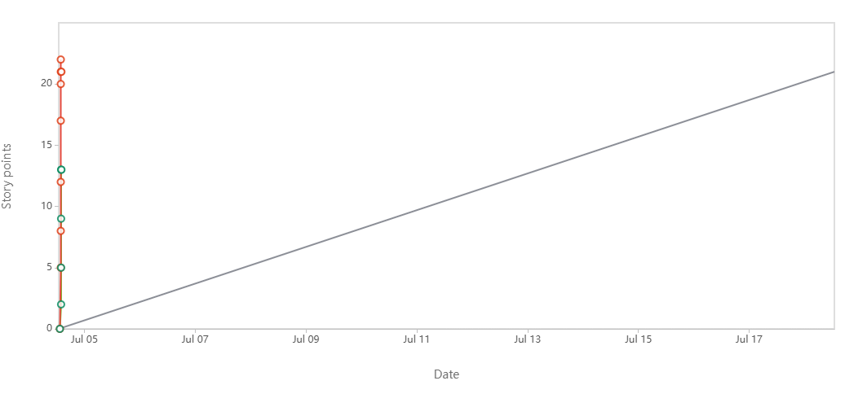

Sprint burn down chart:
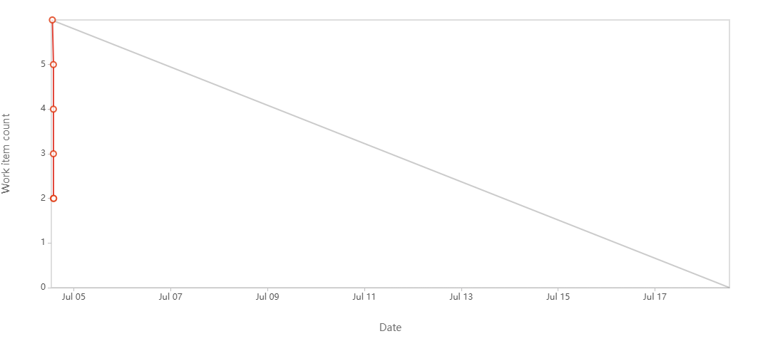

Document 6: Sprint meetings
Sprint planning meeting:
Date | 05-Jul-25
Time | 10:00 AM – 11:30 AM
Location | ICICI Bank, Mumbai
Prepared By | shruti parashar
Attendees | shruti parashar,mayank paliwal,sharaddha mule,divya,
Agenda Topics
Topic | Presenter | Time allotted
welcome and Objective of the Sprint | shruti parashar | 10 min
Sprint Goal Definition(i-view implementation) | Scrum Team | 20 min
no of user stories | mayakk paliwal | 10 min
Review of Product Backlog & Priorities | sharddha ,divya | 20 min
Sprint Backlog Finalization | scrum team | 10min
Q&A and Open Discussion | All | 10 min
observer
other resources | project sponsor, stakeholder, tools, 3rd party web sites

Sprint review meeting:-
Date | 05-Jul-25
Time | 12.00 PM –1.00pm
Location | ICICI Bank, Mumbai
Prepared By | shruti parashar
Attendees | shruti parashar,mayank paliwal,sharaddha mule,divya,
Sprint status | Things to demo | Quick updates | What’s next
Enhancing the Customer Summary View | Customer Summary View now displays updated field | All user stories approved by QA | Integrating Credit Card Information module
Adding Loan Account Integration | Loan Details Tab showing EMI, tenure, outstanding balance | Minor bug are there in date section | basic detail registration like address phone number
Implementing Statement Download (PDF) functionality | Transaction History redesigned with filters and color-coded debits/credits | filters reaming for apply | Improving Search Functionality
UI improvements for Transaction History module | PDF Statement Generation for Savings Accounts (30 days preview) | approved by user | Preparing for UAT session with branch users

Meeting Type 3: Sprint retrospective meeting

Date | 10-Jul-25
Time | 2.00 PM –3.00pm
Location | ICICI Bank, Mumbai
Prepared By | shruti parashar
Attendees | shruti parashar,mayank paliwal,sharaddha mule,divya,
Agenda | What went well | What didn’t go well | Questions | Reference
 | Successfully implemented new features like:  • Account statement generation  • Loan statement display  • Card details view  • Autofill for service request forms | Faced delays due to API dependencies from core systems (Loan & Credit Card modules) | we collaborate earlier with Core IT team to resolve backend delays? | Sprint Board: Jira – I-View_Enhancement_Sprint2
 | - Enhanced customer data visibility in one place, reducing toggling between multiple applications | Session timeout issues remained unresolved, affecting continuous use | Is it feasible to increase session duration for branch users? | Stories completed: US102 (Customer Summary),
 | improved UI flow made it easier for staff to find customer information during interaction | Some staff reported limited access due to role-based restrictions which hindered full testing | How do we ensure uniform access for testing without breaching security policies? | pain points from branch shared during stakeholder workshop on 28 June 2025
 | Team collaboration was strong with regular updates on Jira and productive daily stand-ups | Minor bugs in the autofill forms due to missing mapping with backend fields | Can we roll out training to users to understand the enhanced I-View functionalities? | pain points from branch shared during stakeholder workshop on 28 June 2025

Meeting Type 4: Daily Stand-up meeting: Week “June” (from 01-06-2025 to 07-06-2025)

Question | Name/Role | Monday | Tuesday | Wednesday | Thursday | Friday | Saturday | Sunday
What did you do yesterday? |  | 1.  Reviewed legacy code  2.  Analysed customer data  3.  Updated UI components | 1.  Fixed minor bugs  2.  Worked on API integration  3.  Attended planning session | 1.  Discussed test cases  2.  Wrote unit tests  3.  Code reviewed pull requests | 1.  Refactored dashboard code  2.  Created mock data  3.  Participated in scrum | 1.  Completed sprint tasks  2.  Documented module  2.  Bug retesting | - | -
  ShrutiD1
  MayankD2
  YuvanshD3
What will you do today? |  | 1.  Start unit testing  2.  Work on frontend validations  3.  Refactor login module | 1.  Continue integration  2.  Update documentation  3.  Code UI enhancements | 1.  Prepare test scripts  2.  Backlog grooming  3.  Optimize database queries | 1.  Coordinate with QA  2.  Deploy code to UAT  3.  Review design updates | 1.  Sprint review meeting  2.  Submit final module  3.  Code clean-up | - | -
  ShrutiD1
  MayankD2
  YuvanshD3
What (if any) is blocking your progress? |  | 1.  None  2.  Awaiting data from BA  3.  Pending merge request | 1.  API response delay  2.  None  3.  No blockers | 1.  access issue  2.  Clarification on flow  3.  None | 1.  None  2.  Login bug unresolved  3.  None | 1.  Need review approval  2.  None  3.  None | -
  ShrutiD1
  MayankD2
  YuvanshD3

