Document 1- Business case document template
Client:- Bank of Cyprus
Prepared By:- Roopshree S
Date:- 30 June 2025

➢ Why is this project initiated?
This project is initiated to modernize and streamline the customer onboarding, account opening, and signature processes which are currently fragmented, manual, and compliance heavy. The initiative aligns with the bank’s strategic goal of digital transformation, enhancing customer experience, reducing operational risk and ensuring regulatory compliance.
➢ What are the current problems?
- Manual data entry and form filling lead to frequent errors and delays.
- Physical signature collection is inefficient and hard to audit.
- Disjointed systems require customers to repeat steps across channels.
- Onboarding time is high, causing customer dissatisfaction.
- Compliance issues due to lack of integration with KYC systems.
- No real-time progress tracking or audit trail.
➢ With this project how many problems could be solved?
- 80-90% reduction in manual paperwork.
- 50% improvement in the turnaround time for onboarding.
- 100% digital signature integration into the workflow.
- Real time KYC checks integrated into the workflow.
- Seamless customer journey across the web and mobile platforms.
- Centralized dashboard for progress tracking and audit.
➢ What are the resources required?
Human Resources:
- Architect - Antu Singh
- Project Manager - Biren Shah
- Developer - Jitendra Navghire, Kavita Kamble, Bhausaheb Kasal, Piyu Sharma
- Tester - Sanskar Nema, Pravin Kote, Neha Shinde, Anand Joshi
Technical Resources:
- New onboarding platform.
- Infrastructure or cloud hosting.
- Integration with core banking, CRM, KYC system.
➢ How much organizational change is required to adopt this technology?
Moderate-to-high change required:
- Existing staff will need training in using new systems.
- Frontline teams must adapt to digital form processing and e-signatures.
- Compliance and legal teams must validate and adapt to new digital audit workflows.
- Change management and communication plans are essential for adoption success.
➢ Time frame to recover ROI?
- Estimated ROI Recovery: 12-18 months post go-live.
- Improved operational cost .
- Increased staff productivity.
- Lower risk of compliance violations and penalties.
➢ How to identify Stakeholders?
RACI matrix:
- R – Responsible (executes the task)
- A – Accountable (owns the outcome)
- C – Consulted (provides input)
- I – Informed (kept in the loop)

Activity | BA (Roopshree) | Architect (Antu Singh) | PM (Biren Shah) | Developer (Jitendra, Kavita, Bhausaheb, Piyu, Neha) | Tester (Sanskar, Pravin, Anand)
Requirements gathering | A/R | C | C | I | I
System design & architecture | R | A | C | C | I
Solution configuration/development | C | C | C | A/R | I
Integration with external systems | C | A | C | R | I
Test planning & case design | R | C | R | C | A/R
UAT | A/R | C | R | C | A/R
Deployment & Go-Live Support | C | A | A | R | R
Documentation & Handover | A/R | R | A | R | C
Post-Go-Live Support & Feedback | R | C | A | R | R

Document 2: BA Strategy
BA Approach
Client:- Bank of Cyprus
Prepared By:- Roopshree S
Date:- 30 June 2025

- Elicitation Techniques to Apply
- Stakeholder interviews – To capture expectations from department heads, compliance and operations.
- Workshop – Joint session with IT, operations and customer support for process mapping.
- Document analysis – Review of current forms, legacy system documentation and compliance reports.
- Surveys & questionnaires – From end users
- Prototyping – To validate design and usability of new onboarding screens.
- Stakeholder Analysis & RACI Preparation
Stakeholder Analysis:
- Identify key stakeholders across business, technology, compliance, legal and customer service functions.
- Classify stakeholders using the Power-Interest Grid to determine their influence and engagement level.
- Maintain a stakeholder register capturing their roles, expectations, communication preferences and approval responsibilities.
RACI Matrix:
- A RACI (Responsible, Accountable, Consulted, Informed) matrix helps define ownership and participation across project activities.
Activity | BA | PM | IT | Compliance
Requirements gathering | A/R | C | I | C
Solution design review | R | C | A | C
UAT planning & execution | A | R | C | C
Documentation & handover | A/R | C | R | C

- Key Documents to Prepare
- Business Requirements Document (BRD)
- Functional Requirements Specification (FRS)
- Non-functional Requirements Document (NFR)
- Process Flow Diagram
- RACI Matrix
- Test Cases for UAT
- Change Request
- Client Project Acceptance Form.
- Sign-Off Process for Document
- Share draft documents via email or document repository.
- Conduct a review meeting with stakeholders.
- Apply version control &comments resolution.
- To get formal approval through eSignature or email confirmation.
- Maintain sign-off logs in the Project Repository.
- Client Approval Process
- Present requirements and design in in structured review meeting.
- Record meeting Minutes of Meeting (MOM).
- Use approval matrix for multi-level sign-off.

- Communication Channels to Establish
- Daily/weekly stand ups – with development & QA team.
- Steering committee meetings – with client stakeholders.
- Email updates – for progress reports and risks.
- Tools used – MS Teams for calls, confluence/Jira for tracking
- Change Request Handling Process
- Maintain CR in a standard Change Request Form.
- Perform Impact Analysis like cost, timeline, scope.
- Get approval from client + PMO
- Update BRD/FRS and maintain version history.
- Track CRs in a change log.
- Project Progress Updates
- Weekly status reports covering:
- Completed task
- Upcoming milestones
- Risk and issues
- Pending approvals
- Use of Progress Dashboards or RAID logs.
- Escalation matrix for delays or roadblocks.
- Summary presentations in Steering Committee meetings.
- UAT Sign-Off Process
- Conduct UAT kickoff with defined scope &test cases.
- Monitor execution and defect resolution.
- Capture evidence like screenshots.
- Maintain UAT Sign-Off tracker.
- Get formal acceptance via client project acceptance form.

Document 3- Functional Specifications
Functional Specification Document
Field | Details
Project Name | Customer onboarding, account opening & signature digitization
Customer Name | Bank of Cyprus
Project Version | V1.0
Project Sponsor | Christos Nicolaou
Project Manager | Biren Shah
Project Initiation Date | 1-July-2025

Functional Requirement Specification
Req ID | Req Name | Req Description | Priority
FR0001 | Login | User should be able to securely log in using credentials with multi-factor authentication. | 10
FR0002 | New customer onboarding | The system should allow a new customer to complete onboarding through guided steps | 10
FR0003 | eKYC integration | System should fetch and validate customer identity via national eKYC API. | 9
FR0004 | Document upload | Users must be able to upload identity, address proof and signature digitally. | 9
FR0005 | Account type selection | Customers should be able to choose from multiple account types (saving, current, etc.) | 8
FR0006 | Digital signature capture | Customers must be able to digitally sign documents using OTP-based verification. | 10
FR0007 | Application status tracker | Users should be able to view the status of their onboarding application in real-time. | 8
FR0008 | Internal approval workflow | The system must route customer application through KYC, compliance and approval flows. | 9
FR0009 | Notification & alert | Automated email/SMS alerts should be sent at each key onboarding milestone. | 7
FR0010 | Dashboard for branch user | Branch staff should be able to access a dashboard to view pending onboarding cases. | 8

Document 4- Requirement Traceability Matrix
Requirement Traceability Matrix:
Req ID | Req Name | Req Description | Design | D1 | T1 | D2 | T2 | UAT
FR0001 | Login | Users should be able to securely log in using credentials with multi-factor authentication. | yes | Pending | No | Yes | Yes | Yes
FR0002 | New customer onboarding | The system should allow a new customer to complete onboarding through guided steps | Yes | Yes | Yes | Yes | Yes | Yes
FR0003 | eKYC integration | System should fetch and validate customer identity via national eKYC API. | Yes | Yes | Yes | Yes | Yes | Yes
FR0004 | Document upload | Users must be able to upload identity, address proof and signature digitally. | Yes | Yes | Yes | Yes | Yes | Yes
FR0005 | Account type selection | Customers should be able to choose from multiple account types (saving, current, etc.) | Yes | Pending | No | Yes | Yes | Yes
FR0006 | Digital signature capture | Customers must be able to digitally sign documents using OTP-based verification. | Yes | Yes | Yes | Yes | Yes | Yes
FR0007 | Application status tracker | Users should be able to view the status of their onboarding application in real-time. | Yes | Yes | Yes | Yes | yes | Yes
FR0008 | Internal approval workflow | The system must route customer application through KYC, compliance and approval flows. | Yes | Yes | Yes | Yes | Yes | Yes
FR0009 | Notification & alert | Automated email/SMS alerts should be sent at each key onboarding milestone. | Yes | Yes | Yes | Yes | Yes | Yes
FR0010 | Dashboard for branch user | Branch staff should be able to access a dashboard to view pending onboarding cases. | Yes | Yes | Yes | Yes | Yes | Yes

Document 5- BRD Template

Business Requirements Document (BRD)
Project Name: Bank of Cyprus
Project ID: BOC-ONB-2025
Version ID: v1.0
Author: Roopshree Shelke, Business Analyst

Contents
1. Document Revisions
2. Approvals
3. RASCI Chart for This Document
4. Introduction
4.1. Business Goals
4.2. Business Objectives
4.3. Business Rules
4.4. Background
4.5. Project Objective
4.6. Project Scope
4.6.1. In Scope Functionality
4.6.2. Out Scope Functionality
5. Assumptions
6. Constraints
7. Risks
8. Business Process Overview
8.1. Legacy System (AS-IS)
8.2. Proposed Recommendations (TO-BE)
9. Business Requirements
10. Appendices
10.1. List of Acronyms
10.2. Glossary of Terms
10.3. Related Documents

1. Document Revisions
Date | Version | Author | Document Change
01-Jul-2025 | 1.0 | Roopshree Shelke | Initial Draft Created

2. Approvals
Name | Designation | Signature | Date
George Christou | Project Sponsor
Biren Shah | Project Manager
Antu Singh | Solution Architect

3. RASCI Chart for This Document
The RACI chart identifies the people who need to be contacted whenever changes are made to this document. RACI stands for responsible, accountable, consulted, and informed. These are the main codes that appear in a RACI chart, used here to describe the roles played by team members and stakeholders in the production of the BRD. They are adapted from charts used to assign roles and responsibilities during a project. RACI can be made for IT side as mentioned above, apart from that it can also be made for Client side.

Codes used in RASCI Document
R | Responsible | Responsible for creating this document
A | Accountable | Accountable for accuracy of this document
S | Support | Provides supporting services in the production of this document
C | Consulted | Provides input such as interview.
I | Informed | Must be informed of any change

RACI Chart
Name | Position | R | A | S | C | I
Roopshree S | BA | Y |  | Y | Y | Y
Biren Shah | PM |  | Y |  | Y | Y
Antu Singh | Architect |  |  | Y | Y | Y
Jitendra N | Developer | Y |  |  |  | Y
Sanskar N | QA tester | Y |  |  |  | Y

4. Introduction

4.1. Business Goals
To modernize the customer onboarding, account opening, and signature process by implementing a digital, secure and regulatory-compatible system.

4.2. Business Objectives
- Reduce onboarding TAT by 50%.
- Ensure 100% KYC compliance.
- Enable paperless onboarding and digital signature capture.
- Improve branch efficiency with dashboard and automation.

4.3. Business Rules
- Customers must complete eKYC before account creation.
- Mandatory fields must be filled before submission.
- Only authorized users can approve onboarding steps.

4.4. Background
Currently the onboarding process is manual, slow and error prone. The proposed solution aims to address inefficiencies and align with digital transformation goals.

4.5. Project Objective
The primary objective of this project is to design and implement a secure, user-friendly, and digitally integrated system for customer onboarding, account opening, and signature capture for the Bank of Cyprus. The solution aims to streamline the onboarding process by replacing manual steps with automated workflows, ensuring compliance with regulatory standards (e.g., eKYC), and enhancing customer experience.
This product will allow new customers to complete their onboarding journey online including identity verification, document submission, account selection, and digital signature while enabling internal teams to process applications efficiently through approval workflows and dashboards.
The system will integrate with external services such as national eKYC APIs, OTP-based signature platforms, and internal compliance systems to ensure seamless data exchange and regulatory alignment.
This objective directly supports the bank’s broader business goals of improving operational efficiency, accelerating customer acquisition, and reducing turnaround time for account activation.

4.6. Project Scope
This project involves the development and deployment of a digital solution to streamline the customer onboarding process, account opening, and electronic signature capture for the Bank of Cyprus. The scope includes creating a secure web-based interface for customers, integrating with external verification systems, and enabling internal teams to track and approve onboarding applications through structured workflow.

4.6.1 In Scope Functionality
The following functionalities will be delivered as part of the current project:
- Customer self-registration portal for initiating onboarding.
- Integration with national eKYC API for identify verification.
- Secure document upload functionality.
- Account type selection and form auto-population.
- Digital signature capture using OTP-based verification
- Real-time application status tracking for users.
- Internal dashboard for branch and compliance staff to process application.
- Role-based access control for security and auditability.
- Email and SMS notifications at each onboarding stage.
- Logging and audit trails for compliance review.

4.6.2 Out Scope Functionality
The following items are not included in the scope of the current project:
- Loan application or processing features.
- Credit score integration or evaluation logic.
- Core banking system upgrades or changes.
- CRM enhancement or customer marketing journey.

5. Assumption
The following assumptions have been considered while defining the requirements and scope of this project:
- All required APIs for eKYC, OTP verification, and document validation will be available and accessible during development and testing phases.
- Stakeholders and subject matter experts will be available for timely requirement clarification and feedback.
- Users (customers and staff) will have access to a stable internet connection to complete onboarding and approval tasks.
- The integration with existing internal systems (e.g., compliance module, document management system) will be supported by relevant technical teams.
- Security and compliance policies currently in place at the Bank of Cyprus will remain applicable throughout the project lifecycle.
- User training and change management support will be provided by the business or training team before go-live.
- The project team will have the necessary infrastructure, tools, and access rights to carry out development, testing, and deployment activities

6. Constraints
The following constraints have been identified for the successful execution of the project:
- Fixed Budget: The project must be completed within the allocated budget, limiting scope changes and additional resource onboarding.
- Timeline Restrictions: Project delivery is time-bound, with all phases (design, development, testing, deployment) to be completed within a defined 3-month window.
- Regulatory Compliance: The system must adhere strictly to banking and data privacy regulations, which may limit design flexibility.
- Technology Stack: The solution must integrate with existing legacy systems and adhere to the bank’s approved technology stack.
- Third-Party Dependencies: Timely availability and response from third-party services (e.g., eKYC provider, OTP gateway) are essential and may impact the schedule.
- Infrastructure Availability: Hosting and deployment environments must be provided by the IT infrastructure team within agreed timelines.
- User Availability: Availability of business users and testers for UAT (User Acceptance Testing) within the scheduled period is crucial.

7. Risk
This section outlines potential risks that may impact project success. Each risk includes its likelihood, impact and a mitigation strategy whether to avoid, mitigate, transfer, or accept the risk.
Risk | Likelihood | Impact | Strategy
Third-party API delays | Medium | High | Mitigate
Limited user/tester availability | High | Medium | Mitigate
Regulatory changes to mid-project | Low | High | Transfer
Lack of digital signature expertise | Medium | Medium | Mitigate
Resistance to new process | High | Medium | Mitigate
Data migration issues | Medium | High | Mitigate
Scope creep | High | High | Avoid
Infrastructure setup delays | Medium | High | Avoid

Technological Risk
This section identifies risks arising from the adoption or integration of new technologies that the project depends on. These include potential issues such as incompatibility with existing systems, untested third-party APIs (eKYC, OTP services), or delays in infrastructure provisioning. Such risks may lead to project delays or technical failures if not proactively addressed.

Skills Risk
This section highlights the potential unavailability of team members with the necessary technical or domain expertise required to deliver key components of the solution. Risks include dependency on niche skills like digital signature integration, unfamiliar tools, or insufficient training among development or support staff, which may impact quality or timelines.

Political Risk
This section outlines external and internal political influences that could affect project progress or direction. These include changes in leadership, shifts in organizational priorities, inter-departmental conflicts, or delays in stakeholder decisions any of which could lead to funding cuts, reprioritization, or even project discontinuation.

Business Risk
This section addresses potential consequences to the business if the project is delayed or terminated. Risks include missed regulatory deadlines, loss of competitive advantage, increased customer attrition due to poor onboarding experience, and failure to align with the bank’s digital transformation goals.

Requirement Risk
This section identifies the possibility of incomplete, unclear, or incorrect requirements being gathered during the discovery phase. Specific risks include ambiguity in compliance-related features, undocumented legacy workflows, or misinterpretation of user expectations each of which could lead to rework, scope creep, or customer dissatisfaction.

Other Risk
This section captures any additional risks not categorized above. These may include natural disasters, cybersecurity threats, budget overruns, vendor withdrawal, or dependency on external events (e.g., regulatory policy rollouts). Though indirect, these risks can still impact the project’s timeline, budget, or scope.

8. Business Process Overview
This section outlines the complete end-to-end flow of the customer onboarding process, beginning with the customers first interaction with the bank to the successful creation of an account. It details how tasks are performed at each stage capturing customer information, verifying identity, approving request and completing the account setup. The overview also compares the current process with the proposed solution to highlight improvements in efficiency, automation and compliance.

8.1. Legacy System (AS-IS)
In the existing system the customer onboarding process is largely manual, and paper based. Customers visit branches physically , fill out forms and submit photocopies of documents. Branch employees manually verify the information and route forms to different departments for approval. This results in a slow, error-prone and disconnected process often requiring multiple follow-ups and in-person interactions.
Customer Visit Manual Form Filling Physical Document Collection Manual KYC Verification Physical Signature Capture Paper-based Approval Account Creation
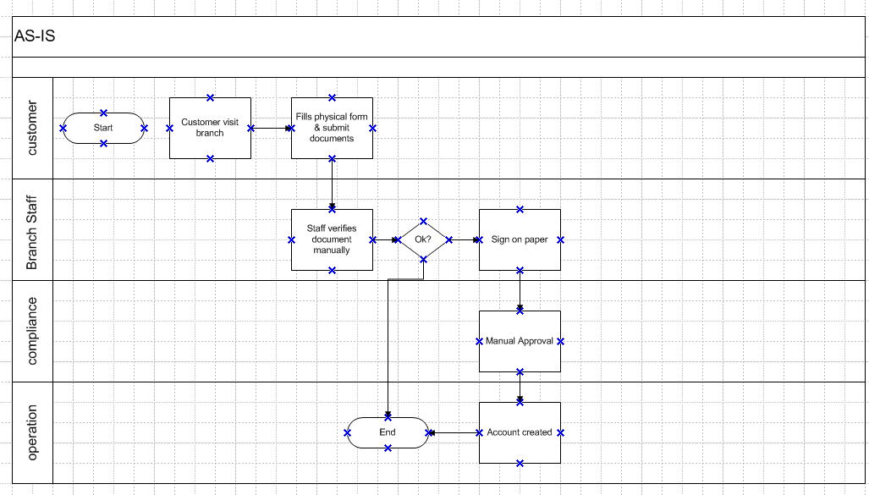

8.2. Proposed Recommendations (TO-BE)
The proposed solution replaces manual steps with a fully digital, integrated onboarding platform. Customers will initiate onboarding via a secure web portal, complete eKYC via national APIs, upload digital documents, and provide electronic signatures. The system will auto-route the application for approval and provide real-time updates to both customers and internal staff via dashboards and alerts.
Customer Portal Access Digital Form Submission eKYC API Verification Online Document Upload OTP-based eSignature System-driven Approval Workflow Instant Account Creation & Notification
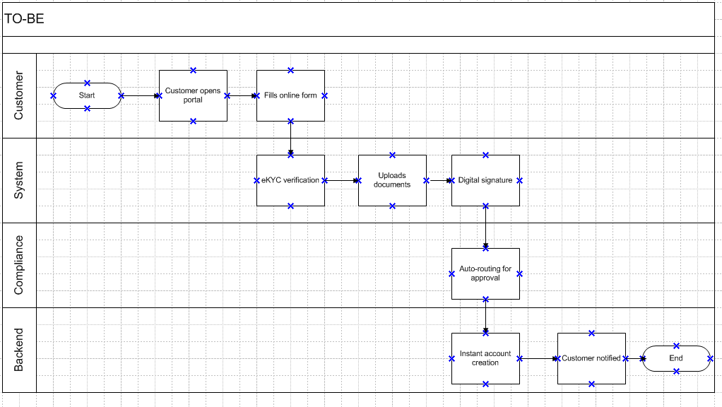

9. Business Requirements
This section outlines the specific business requirements gathered from key stakeholders, structured to ensure clarity, traceability, and alignment with project goals. Requirements are categorized by functional areas (e.g., onboarding, verification, approvals) and tagged with priority levels (High, Medium, Low) to help guide development and implementation sequences.
Each requirement supports the project’s strategic objectives and enhances the digital onboarding experience, ensuring compliance, efficiency, and customer satisfaction. Where applicable, requirements are cross-referenced with use cases and supporting documentation to provide a complete understanding of their context and expected behavior.
The requirements listed here will be tracked through a Requirements Traceability Matrix (RTM) to ensure they are addressed during design, development, testing, and deployment.

10. Appendices

10.1. List of Acronyms
- eKYC – Electronic Know Your Customer
- UAT – User Acceptance Testing
- BRD – Business Requirement Document.

10.2 Glossary of Terms
- Onboarding – The process of registering a new customer.
- eSignature – Digitally authenticated user signature.
- Dashboard – User interface for viewing system status.

10.3 Related Documents
- Functional specification document.
- Project plan
- RACI matrix
- UAT plan

