Document 6- Please prepare a use case diagram, activity diagram and a use case specification document.

USE case diagram

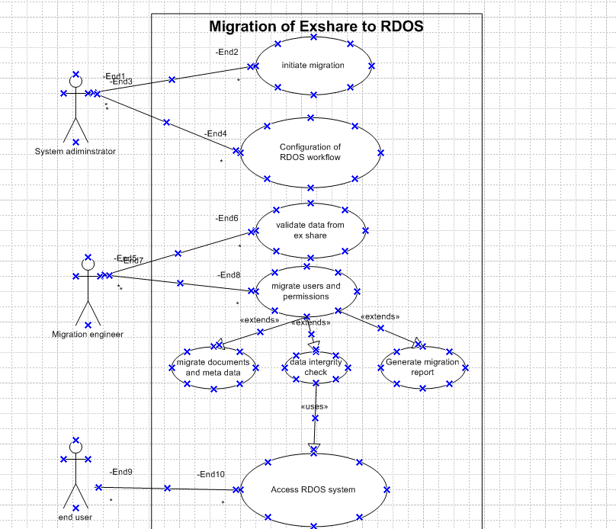

Activity diagram

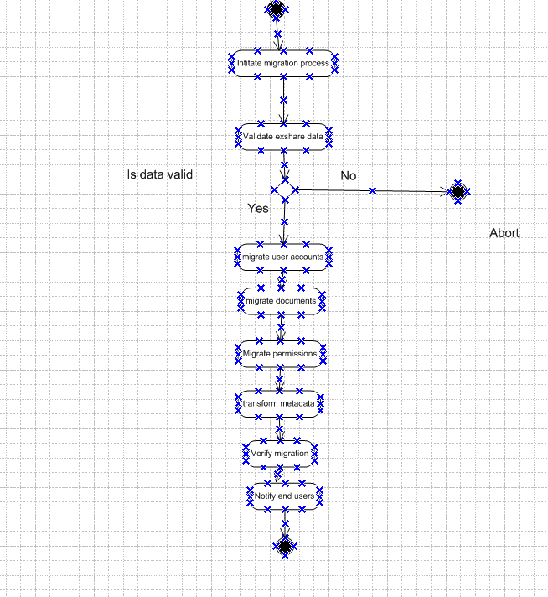

Use case specification document.
1. Use Case Name
Migration from Exshare to RDOS

2. Use Case Description
This use case describes the migration of data from the legacy system (Exshare) to the new system (RDOS). It includes extracting user data, validating it, transforming it to match the RDOS schema, and importing it into the RDOS system while preserving roles and credentials.

3. Actors
- Primary Actor: Migration Tool
- Secondary Actor: Admin

4. Basic Flow
- Admin initiates the migration process.
- Migration tool connects to Exshare database.
- Tool retrieves user data (user ID, name, email, roles, status).
- Data is validated for completeness and correctness.
- Valid data is transformed to RDOS-compatible schema.
- Tool creates users in RDOS with appropriate roles.
- Migration status is logged for each record.
- A summary report is generated.

5. Alternate Flow
5a. Skipped Inactive Users
- Step 4a: If a user account is marked as inactive in Exshare, it is skipped.
- Step 4b: The skipped record is logged with a note “Inactive – Not Migrated.”

6. Exceptional Flows
6a. Database Connection Failure
- If connection to Exshare or RDOS fails, log the error and halt the process.
6b. Data Validation Error
- If mandatory fields are missing or invalid, mark the user as "Error in Migration" and continue with others.
6c. Role Mapping Failure
- If a user role in Exshare has no equivalent in RDOS, assign default role “Viewer” and flag for admin review.

7. Preconditions
- Admin is authenticated and authorized to perform migration.
- Exshare and RDOS systems are accessible.
- Role mapping configuration file is prepared.

8. Post-conditions
- All valid user accounts are available in RDOS.
- Migration log and report are stored.
- Errors are logged for later resolution.

9. Assumptions
- User schemas in Exshare and RDOS are logically mappable.
- The system is under maintenance mode to prevent live updates.
- All role IDs used in Exshare have corresponding mappings in RDOS.

10. Constraints
- Migration must be completed within the maintenance window.
- No partial account data should be migrated.
- Passwords may need rehashing due to encryption differences.

11. Dependencies
- Role Mapping Table between Exshare and RDOS.
- Validated Exshare user database.
- Admin login and authorization.
- Network connectivity between systems.

12. Inputs and Outputs
- Inputs:
  - User records from Exshare
  - Role mapping configuration
- Outputs:
  - User records in RDOS
  - Migration log
  - Summary report

13. Business Rules
- Every user must have a unique email ID.
- Each user must belong to at least one role.
- Roles must comply with RDOS access policy.
- Users marked as “inactive” in Exshare should not be migrated.

14. Miscellaneous Information
- Migration should ideally be tested in a staging environment before production.
- A notification may be sent to migrated users after verification.

