- Use Case Document?

- Activity Diagram?

- Log in Activity Diagram

- Registration for Log in.

- Payment Gateway.

- Search button

- Payment done

- Use Case Specifications.

- System: Quickinsure
Prepared For: Anand Shrikhande
Prepared By: Gaurav Wakil
Date: 19/05/2021

Use Case: Registration
Description | Allows a new user/agent to create an account in Quickinsure by submitting mobile number, KYC, education certificate, and setting password.
Actors | Primary: New User / Agent; Secondary: Database, KYC Verification System
Basic Flow | 1. User selects “Register”. 2. Enters mobile number → OTP verification. 3. Uploads KYC documents. 4. Uploads education certificate. 5. Sets password. 6. System validates and confirms registration.
Alt Flow | If mobile number already exists → prompt to login.
Exception | Invalid number, invalid docs, password not per policy.
Preconditions | User has valid mobile number, documents ready.
Postconditions | Account created in DB.
Assumptions | User has internet, OTP service available.
Constraints | Unique mobile number, password security policy.
Dependencies | OTP service, DB, KYC service.
Inputs Outputs | Inputs: mobile, KYC, cert, pwd; Outputs: success message.
Business Rules | KYC mandatory, one account per mobile.
Misc | Data encrypted.

Use Case: Login
Description | Authenticate registered users using ID and password.
Actors | Primary: Registered User/Agent; Secondary: Database
Basic Flow | User enters ID + password → system verifies → dashboard opens.
Alt Flow | Forgot password → password reset.
Exception | Invalid ID/pwd, account locked.
Preconditions | User registered.
Postconditions | Session created.
Assumptions | DB connection active.
Constraints | 3 wrong attempts lock account.
Dependencies | DB, authentication service.
Inputs Outputs | Input: ID, pwd; Output: dashboard access.
Business Rules | Only valid users access.
Misc | Session timeout after inactivity.

Use Case: Search Vehicle / Policy
Description | Search existing vehicle details either by vehicle number or manually.
Actors | Primary: Agent/User; Secondary: Database
Basic Flow | 1. User enters vehicle number. 2. System fetches details. 3. If unavailable → manual entry option.
Alt Flow | Manual search (engine, model, etc.)
Exception | Invalid number format, DB error.
Preconditions | User logged in.
Postconditions | Vehicle details retrieved.
Assumptions | Vehicle DB updated.
Constraints | Search limited to registered vehicles.
Dependencies | Vehicle DB.
Inputs Outputs | Input: vehicle no/manual fields; Output: details.
Business Rules | Must validate vehicle no format.
Misc | Search logs maintained.

Use Case: Quote & Add-ons
Description | Generate premium quote and allow selection of add-ons.
Actors | Primary: User/Agent; Secondary: Insurance DB, API Management
Basic Flow | User selects vehicle → system generates quote → add-ons displayed → user selects.
Alt Flow | No add-ons selected → proceed with base premium.
Exception | API not responding → fallback pricing.
Preconditions | Vehicle details available.
Postconditions | Quote generated with/without add-ons.
Assumptions | Premium rules updated.
Constraints | Certain add-ons depend on vehicle type.
Dependencies | Insurance pricing API.
Inputs Outputs | Input: vehicle details, add-on selection; Output: premium quote.
Business Rules | Add-on eligibility based on vehicle/age.
Misc | Quote valid for 24 hrs.

Use Case: Issuance Form
Description | Collect customer details (Name, Email, Address) before policy issuance.
Actors | Primary: User; Secondary: Database
Basic Flow | User fills form → system validates → save in DB.
Alt Flow | Auto-fill if user already exists.
Exception | Invalid email/address.
Preconditions | Quote finalized.
Postconditions | Issuance form stored.
Assumptions | User provides correct info.
Constraints | Mandatory fields.
Dependencies | Customer DB.
Inputs Outputs | Input: Name, Email, Address; Output: confirmation.
Business Rules | Email must be unique per policy.
Misc | Verification mail sent.

Use Case: Payment
Description | Accept payment via UPI, Card, Net Banking, or Internet Banking.
Actors | Primary: User; Secondary: Payment Gateway
Basic Flow | 1. User selects “Pay Now”. 2. Chooses method (UPI/Card/Net banking). 3. Redirect to payment gateway. 4. Payment processed.
Alt Flow | Retry if payment fails.
Exception | Transaction timeout, insufficient balance.
Preconditions | Issuance form completed.
Postconditions | Payment successful → policy issued.
Assumptions | Payment gateway available.
Constraints | PCI DSS compliance.
Dependencies | Payment gateway API.
Inputs Outputs | Input: payment credentials; Output: success/failure.
Business Rules | Payment must succeed before policy issue.
Misc | Refund rules apply.

Use Case: Payment Confirmation
Description | Notify user via SMS and Email after payment success.
Actors | Primary: System; Secondary: SMS Gateway, Email Server
Basic Flow | Payment confirmed → system triggers SMS + Email → user receives acknowledgement.
Alt Flow | If email fails, retry; if SMS fails, fallback to email only.
Exception | Both channels fail → escalation.
Preconditions | Payment success.
Postconditions | Notification delivered.
Assumptions | SMS/Email service active.
Constraints | Notifications sent instantly.
Dependencies | SMS/Email gateways.
Inputs Outputs | Input: transaction details; Output: message sent.
Business Rules | Every transaction must be acknowledged.
Misc | Logs kept for audit.

- Screens and Pages?

- Log in

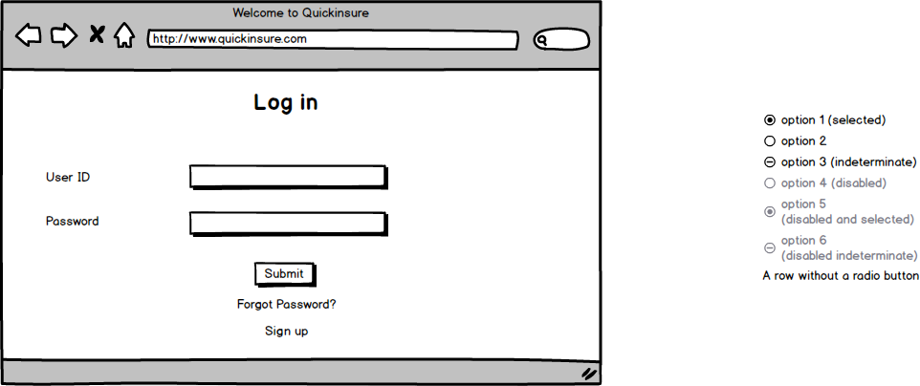

- Home Page

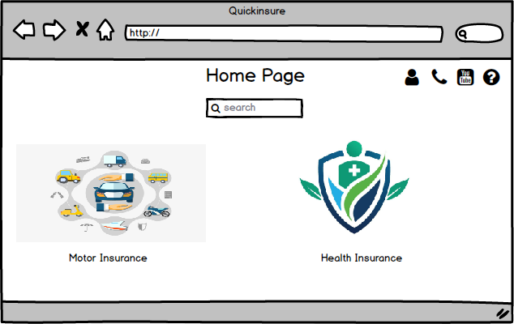

- Quotation

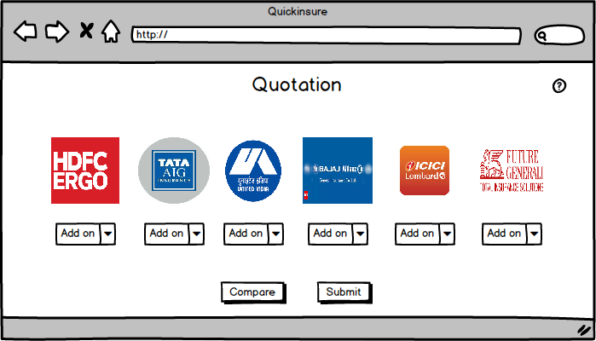

- Issuance form

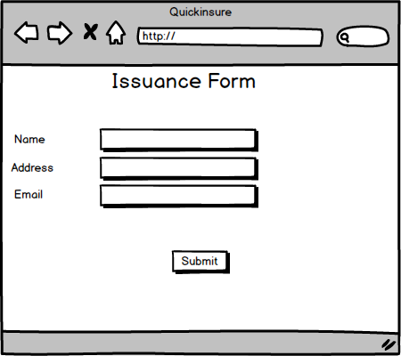

- Payment gateway

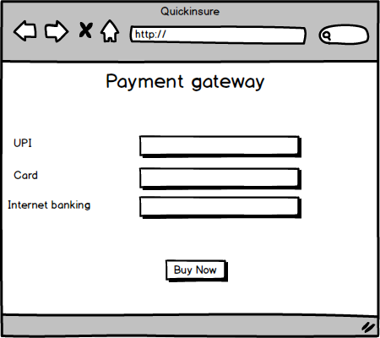

- Document 8- Tools: Visio and Balsamiq?

- During the project, I used Microsoft Visio to create use case diagrams and activity diagrams, which helped me clearly represent the system’s functional requirements and the flow of activities within different processes. Visio’s diagramming features made it easier to visualize relationships between actors and the system, as well as break down complex workflows into understandable steps. Alongside this, I used Balsamiq to design wireframes, which allowed me to quickly sketch and present the user interface layout. Balsamiq’s simple, drag-and-drop components made it easy to experiment with different designs and collect feedback before moving to detailed prototypes. Together, these tools supported both the analytical and design aspects of the project effectively.

- Ba experience?

Requirement Gathering
- Conducted stakeholder interviews, JAD sessions, and brainstorming workshops to collect detailed requirements.
- Applied MoSCoW prioritization to categorize Must-Have, Should-Have, Could-Have requirements.
- Documented requirements in BRD and Functional Specification Document (FSD).
- Ensured requirements were validated using FURPS technique (Functionality, Usability, Reliability, Performance, Supportability).
- Created Use Case Diagrams and Wireframes (Visio, Balsamiq) to visualize workflows.

Analysis Phase
- Analyzed requirements for feasibility and alignment with business goals.
- Identified gaps and dependencies, such as integration with payment gateways and external APIs (e.g., mParivahan for vehicle data).
- Developed Requirement Traceability Matrix (RTM) to map business requirements to functional & test cases.
- Worked closely with SMEs and technical architects to finalize scope.

Design Phase
- Supported solution architects in preparing system design documents.
- Ensured business requirements were translated correctly into HLD (High-Level Design) and LLD (Low-Level Design).
- Verified that in-scope functionalities (Mobile App, LMS, HRMS) were fully covered.
- Reviewed UI/UX mockups and ensured compliance with business rules and policies.

Development Phase
- Acted as a liaison between development team and client, clarifying requirements whenever ambiguities arose.
- Ensured that developers had access to finalized FSDs and data mapping documents.
- Monitored progress to confirm alignment with the waterfall plan.
- Managed change requests and updated RTM accordingly.

Testing Phase
- Coordinated with QA team to create test scenarios and test cases aligned with requirements.
- Conducted System Integration Testing (SIT) support by validating API integrations (Payment Gateway, Vehicle Data Fetch).
- Facilitated User Acceptance Testing (UAT) by preparing UAT scenarios, scripts, and checklists.
- Ensured defect triage meetings were conducted and requirements gaps were resolved.

Deployment Phase
- Verified deployment readiness by ensuring all BRD and FSD requirements were met.
- Participated in Go-Live preparation meetings with developers, testers, and client stakeholders.
- Assisted in preparing user training documents, FAQs, and release notes.
- Ensured smooth handover from project team to client operations and support team.

