Capstone Project 1 Part 3

Prepared by Mayur Mange
Batch 12th April, 2025

Question 1 – Functional Requirements

Identify minimum 20 functional requirements

What is a Functional Requirement ?

Functional Requirements define the specific behaviors, functions, or operations of a system. They describe what the system should do, outlining the necessary tasks, actions, or activities it must perform to achieve its objectives.

What is a Non Functional Requirement ?
NFR will provide the qualities and attributed of a system, focusing on how the system performs rather than specific behaviors or functions.

Req ID | Req Name | Req Description | Priority
FR0001 | Farmer Registration | Farmers Should be able to register with the application | 8
FR0002 | Farmer Login | Farmers should log in using their registered credentials. | 9
FR0003 | Farmer search for Product | Farmers should be able to search for available products in fertilizers, seeds, pesticides | 8
FR0004 | Manufacturer Registration | Manufacturers should be able to sign up and create profiles
FR0005 | Manufacturer Login | Manufacturers should be able to log in to the system. | 8
FR0006 | Upload Products | Manufacturers should upload product details (name, price, type, etc.). | 9
FR0007 | Admin Approval of Products | Admin should approve/reject uploaded products. | 8
FR0008 | Product Catalogue Browsing | Farmers should be able to view products by category (Fertilizers/Seeds/etc). | 9
FR0009 | Add to Cart | Farmers should add products to the shopping cart. | 8
FR0010 | Save for Later | Farmers can save products to a buy-later list. | 6
FR0011 | Place Order | Farmers should be able to place orders from the cart. | 10
FR0012 | Apply Discount/Offer Code | Farmers should apply discount/offer codes during checkout. | 6
FR0013 | Payment Gateway Integration | System should support UPI, Credit/Debit Card, and COD options. | 10
FR0014 | Order Confirmation Email | System should send confirmation email after order placement. | 9
FR0015 | Delivery Tracking | Farmers should track order delivery status. | 8
FR0016 | View Order History | Farmers should view their past orders. | 7
FR0017 | Admin Login | Admin should be able to log in securely. | 7
FR0018 | Admin User Management | Admin should block/unblock or manage user access. | 8
FR0019 | Manufacturer View Orders | Manufacturers should view orders received for their products. | 7
FR0020 | Logout Functionality | All users should be able to securely log out. | 7
 |  | Non Functional Requirement
NFR001 | Page Loading Time | Each Page should load within 2 seconds | 9
NFR002 | System Performance | The System should support multiple users without crashing | 9
NFR003 | Usability | App Interface should be easy to navigate for first time users | 10
NFR004 | Data Security | All Sensitive data must be stored Securely | 10
NFR005 | Availability | System should be available most of the time, (excluding scheduled maintenance) | 8
NFR006 | Compatible | It should run on all major browsers and Android mobile device | 8
NFR007 | Scalable | System should be able to handle growing number of users and products | 8
NFR008 | compliance | It should comply with IT and ecommerce Laws and rules | 9
NFR009 | maintenance | It should easily maintain for future updates | 7
NFR010 | backup | It should do Daily Backups and Recovery in case of data loss | 9

Question 2–Minimum 5 page designs

Make wireframes and prototypes

Answer : What are wire frames?

Wireframes are simple, visual representations (like sketches) of a web or mobile page. They show layout, structure, and content placement but not colors, images, or final design. Wireframe is a raw visual representation of the website or app design. It is like a blueprint
Wire framing helps the stake holders to explain their requirements efficiently of the system. A mockup design is an improved version of the Wireframe and it shows how the future system will look like.
Business Analysts use wireframes to:
Discuss user interface (UI) expectations
Visualize how users will navigate
Share requirements clearly with developers and designers

What is a Prototypes ?
A prototype is a working model of the final system that can be clicked and interacted with. It helps:
Stakeholders understand system behavior
Developers visualize workflow
Testers validate scenarios
Prototypes are more detailed than wireframes and are often used for feedback before development begins.
These wireframes help the entire project team and client understand how each screen will work, making it easier to build the right solution.

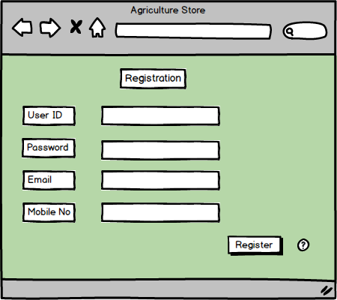

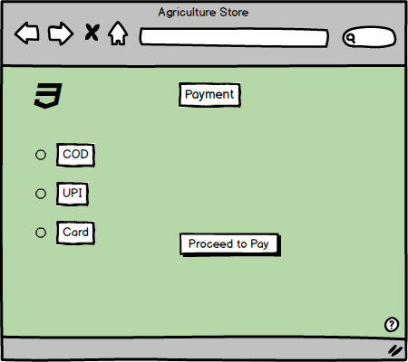

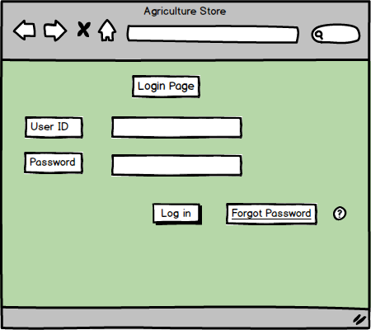

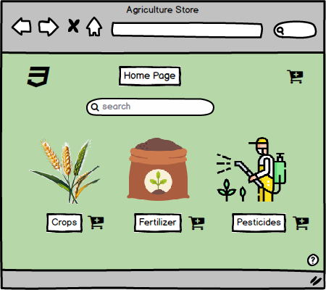

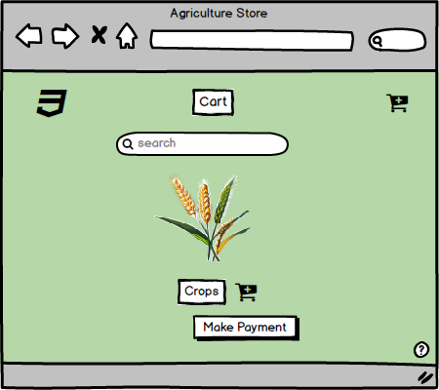

Question 3 – Tools (Visio, Balsamiq)
Make a note of the Tools, which you are using for above concepts.
What are Tools of a BA?

Answer : In this project we have used various tools like Balsamiq , Ms Visio, tool to create wireframes and prototypes. As a BA one of the key responsibility is to clearly visualize the application flow and user experience to ensure that the project meets all the stakeholders
Requirements.

Balsamiq – It is a popular lightweight wire framing tool known for its simplicity and sped, enabling designers to quickly sketch out user interface and iterate on design ideas, its hand – drawn style helps emphasis structure and layout over fine details, encouraging teams collaboration and rapid ideation. Balsamiq’s drag and drop interface, pre built UI Components, and real time collaboration features make it easy to create and modify wireframes, while its low fidelity design keeps the focus on functionality. However, its basic interactivity and limited features may not suffice for complex projects requiring high fidelity mock-ups.

Axure RP – It’s a Robust tool designed for professionals needing to create detailed and interactive prototypes. It excels in complex projects with features like conditional logic, dynamic content, and advanced interactions, axure rp’s comprehensive environment supports wireframes, flowcharts, mockups, and specifications, offering extensive, widget library, adaptive views, and html export options. While it provides precision and advanced functionalities, it has a steeper learning curve and higher cost, making it more suitable for professional designers and large Scale projects.

Microsoft Visio. – It is a versatile diagramming tool used for creating various diagrams, including wireframes, flowcharts, and network Diagram, while not exclusively for wire framing, its extensive shape libraries and integration with Microsoft office tools make it a popular Choice for designing user interfaces and planning information architecture. Visio’s drag and drop interface, custom shape and data linking Capabilities enhance productivity, but its complexity and lack of specialized wire framing features can be a drawback for users seeking basic functionalities. Despite its higher cost, it produced professional quality diagrams and integrated seamlessly with other MS Applications.

Question 4 – RTM
A business analyst’s key responsibilities are to keep track of the requirements and make sure that no requirement is missed
Mr. Henry and peter have approached you regarding the current status of the project. How will you tackle this situation? Prepare RTM

Answer:
What is RTM?
It is a Document to track the requirements throughout the project lifecycle, ensuring that they are met and that no requirements are overlooked. All the requirement that are gathered will be documented and presented in Requirement Traceability Matrix so that it can be tracked accordingly, weather they are meeting the testing and development phases. It is a document that maps and tracks user requirements throughout the project lifecycle. It helps ensure that: All requirements are implemented, no requirement is missed, every requirement is tested and verified.
D1 – Development Phase 1 : Initial Coding or development of the requirement begins, focusing on core functionality.
T1 – Testing Phase 1 Unit Testing : Individual Components or modules are tested to ensure they meet specifications.
D2 – Development Phase 2 : Enhancements or fixed based on unit testing are applied, extending the functionality further.
T2 – Testing Phase 2 – Component Testing : Testing interactions between components or modules to ensure seamless integration.
D3 – Development phase 3 – Final refinements and fixed after component testing, ensures the requirement is complete.
T3 – Testing Phase 3 – system testing : End to end testing of the entire system to ensured it meets business requirements.
D4 – Development Phase 4 – Final development or fixes for issue found during system testing before UAT
T4 – Testing Phase 4 – UAT Preparation : Final validation before presenting to end user for acceptance.
UAT – User Acceptance Testing : End users validate the functionality and usability of the system against business needs.
C : Complete
IP : in Progress
IC : Incomplete

Req ID | Req name | Design | D1 | T1 | D2 | T2 | D3 | T3 | D4 | T4 | UAT
FR0001 | Farmer Registration | C | IP | IP | IP | IP | IC | IC | IC | IC | IC
FR0002 | Farmer Login | C | C | C | IP | IP | IC | IC | IC | IC | IC
FR0003 | Farmer search for Product | C | C | C | IP | IP | IC | IC | IC | IC | IC
FR0004 | Manufacturer Registration | C | C | C | IP | IP | IC | IC | IC | IC | IC
FR0005 | Manufacturer Login | C | C | C | IP | IP | IC | IC | IC | IC | IC
FR0006 | Upload Products | C | C | C | IP | IP | IC | IC | IC | IC | IC
FR0007 | Admin Approval of Products | C | C | C | C | C | IP | IP | IC | IC | IC
FR0008 | Product Catalogue Browsing | C | C | C | IP | IP | IC | IC | IC | IC | IC
FR0009 | Add to Cart | C | C | C | IP | IP | IC | IC | IC | IC | IC
FR0010 | Save for Later | C | C | C | IP | IP | IC | IC | IC | IC | IC
FR0011 | Place Order | C | C | C | C | C | IP | IP | IC | IC | IC
FR0012 | Apply Discount/Offer Code | C | C | C | IP | IP | IC | IC | IC | IC | IC
FR0013 | Payment Gateway Integration | C | C | C | IP | IP | IC | IC | IC | IC | IC
FR0014 | Order Confirmation Email | C | C | C | C | C | IP | IP | IC | IC | IC
FR0015 | Delivery Tracking | C | C | C | C | C | IP | IP | IC | IC | IC
FR0016 | View Order History | C | C | C | C | C | IP | IP | IC | IC | IC
FR0017 | Admin Login | C | C | C | C | C | IP | IP | IC | IC | IC
FR0018 | Admin User Management | C | C | C | C | C | IP | IP | IC | IC | IC
FR0019 | Manufacturer View Orders | C | C | C | C | C | IP | IP | IC | IC | IC
FR0020 | Logout Functionality | C | C | C | IP | IP | IC | IC | IC | IC | IC
 | NFR
NFR001 | Page Loading Time | C | C | C | IP | IP | IC | IC | IC | IC | IC
NFR002 | System Performance | C | C | C | IP | IP | IC | IC | IC | IC | IC
NFR003 | Usability | C | C | C | IP | IP | IC | IC | IC | IC | IC
NFR004 | Data Security | C | C | C | IP | IP | IC | IC | IC | IC | IC
NFR005 | Availability | C | C | C | IP | IP | IC | IC | IC | IC | IC
NFR006 | Compatible | C | C | C | IP | IP | IC | IC | IC | IC | IC
NFR007 | Scalable | C | C | C | C | C | IP | IP | IC | IC | IC
NFR008 | compliance | C | C | C | C | C | IP | IP | IC | IC | IC
NFR009 | maintenance | C | C | C | C | C | IP | IP | IC | IC | IC
NFR010 | backup | C | C | C | C | C | IP | IP | IC | IC | IC

Question 5 – 10 Test Case Documents

What is Test Case Document?
It is a detailed description of a test that is performed on a software application
It is a detailed outline used by testers to ensure that a software application or system is working as expected.
It is like a guide book for the testers.

Test Case Id | TC001 |  | Test Case Name |  | Customer Registration Form
Project Id | PRj001 |  | Project Name |  | Online Agriculture Product store.
PM ID | PM001 |  | PM Name |  | Mr Vandanam
Test Strategy ID | TS001 |  | Tester ID |  | T001
Test Plan ID | TP001 |  | Tester Name |  | Mr Jason
Test Schedule Id | TSC001 |  | Date of Test |  | To be Scheduled
Scenario | Verify that a user can register successfully
Link to that page | Customer Registration Page
 | Set 1 | Set 2 |  | Set 3 | Set 4 | Set 5
Input Data | Email Id | Email Id 2 |  | Email Id 3 | Email Id 4 | Email Id 5
 | Password | Password 2 |  | Password 3 | Password 4 | Password 5
Expected Behavior | User is able to register successfully on the online agriculture product store
Actual Behavior | To be tested
Comments | NA
Result Pass/Fail | Pass/Fail

Test Case Id | TC002 |  | Test Case Name |  | Customer Logion Page
Project Id | PRj001 |  | Project Name |  | Online Agriculture Product store.
PM ID | PM001 |  | PM Name |  | Mr Vandanam
Test Strategy ID | TS001 |  | Tester ID |  | T002
Test Plan ID | TP001 |  | Tester Name |  | Ms Alekya
Test Schedule Id | TSC002 |  | Date of Test |  | To be Scheduled
Scenario | Login with Valid Credentials
Link to that page | /Login
 | Set 1 | Set 2 |  | Set 3 | Set 4 | Set 5
Input Data | Email Id | Email Id 2 |  | Email Id 3 | Email Id 4 | Email Id 5
 | Password | Password |  | Password 3 | Password 4 | Password 5
Expected Behavior | User is able to Login successfully and redirected to home page
Actual Behavior | To be tested
Comments | NA
Result Pass/Fail | Pass

Test Case Id | TC003 |  | Test Case Name |  | Manufacturer upload product
Project Id | PRj001 |  | Project Name |  | Online Agriculture Product store.
PM ID | PM001 |  | PM Name |  | Mr Vandanam
Test Strategy ID | TS001 |  | Tester ID |  | T002
Test Plan ID | TP001 |  | Tester Name |  | Ms Alekya
Test Schedule Id | TSC003 |  | Date of Test |  | To be Scheduled
Scenario | Upload new product as manufacturer
Link to that page | /upload product
 | Set 1 | Set 2 |  | Set 3 | Set 4 | Set 5
Input Data | Product Name | Product Name 2 |  | Product Name 3 | Product Name 4 | Product Name 5
 | Product Price | Product Price 2 |  | Product Name 3 | Product Name 4 | Product Name 5
Expected Behavior | User is able to upload product, product gets saved and goes for admin approval
Actual Behavior | To be tested
Comments | NA
Result Pass/Fail | Pass

Test Case Id | TC004 |  | Test Case Name |  | Admin Approves product
Project Id | PRj001 |  | Project Name |  | Online Agriculture Product store.
PM ID | PM001 |  | PM Name |  | Mr Vandanam
Test Strategy ID | TS001 |  | Tester ID |  | T002
Test Plan ID | TP001 |  | Tester Name |  | Ms Alekya
Test Schedule Id | TSC004 |  | Date of Test |  | To be Scheduled
Scenario | Approve Pending Product
Link to that page | /Admin/Products
 | Set 1 | Set 2 |  | Set 3 | Set 4 | Set 5
Input Data | Product ID | Product ID 2 |  | Product ID 3 | Product ID 4 | Product ID 5
 | Product Price | Product Price 2 |  | Product Price 3 | Product price 4 | Product Price 5
Expected Behavior | Product Status updates as active
Actual Behavior | To be tested
Comments | NA
Result Pass/Fail | Pass

Test Case Id | TC005 |  | Test Case Name |  | Search Products
Project Id | PRj001 |  | Project Name |  | Online Agriculture Product store.
PM ID | PM001 |  | PM Name |  | Mr Vandanam
Test Strategy ID | TS001 |  | Tester ID |  | T002
Test Plan ID | TP001 |  | Tester Name |  | Ms Alekya
Test Schedule Id | TSC005 |  | Date of Test |  | To be Scheduled
Scenario | Search for products using keywords
Link to that page | /Search
 | Set 1 | Set 2 |  | Set 3 | Set 4 | Set 5
Input Data | Search term | Search terms |  | Search Terms
 | Seeds | fertilizers |  | Pesticides
Expected Behavior | Search Result shows matching keywords
Actual Behavior | same
Comments | NA
Result Pass/Fail | Pass

Test Case Id | TC006 |  | Test Case Name |  | Add Product to cart
Project Id | PRj001 |  | Project Name |  | Online Agriculture Product store.
PM ID | PM001 |  | PM Name |  | Mr Vandanam
Test Strategy ID | TS001 |  | Tester ID |  | T002
Test Plan ID | TP001 |  | Tester Name |  | Ms Alekya
Test Schedule Id | TSC006 |  | Date of Test |  | To be Scheduled
Scenario | Add Item to cart from catalogue
Link to that page | /Catalogue
 | Set 1 | Set 2 |  | Set 3 | Set 4 | Set 5
Input Data | Product ID 1 | Product ID 2 |  | Product ID 3 | Product ID 4 | Product ID 5
 | Product Qty 1 | Product Qty 2 |  | Product Qty 3 | Product Qty 4 | Product Qty 5
Expected Behavior | Product Added to cart successfully
Actual Behavior | same
Comments | NA
Result Pass/Fail | Pass

Test Case Id | TC007 |  | Test Case Name |  | Apply Discount code
Project Id | PRj001 |  | Project Name |  | Online Agriculture Product store.
PM ID | PM001 |  | PM Name |  | Mr Vandanam
Test Strategy ID | TS001 |  | Tester ID |  | T002
Test Plan ID | TP001 |  | Tester Name |  | Ms Alekya
Test Schedule Id | TSC007 |  | Date of Test |  | To be Scheduled
Scenario | Apply Valid Discount Code
Link to that page | /Checkout
 | Set 1 | Set 2 |  | Set 3 | Set 4 | Set 5
Input Data | Coupon Code
 | Save 10
Expected Behavior | Discount code applied and total reduced
Actual Behavior | same
Comments | NA
Result Pass/Fail | Pass

Test Case Id | TC008 |  | Test Case Name |  | UPI Payment
Project Id | PRj001 |  | Project Name |  | Online Agriculture Product store.
PM ID | PM001 |  | PM Name |  | Mr Vandanam
Test Strategy ID | TS001 |  | Tester ID |  | T002
Test Plan ID | TP001 |  | Tester Name |  | Ms Alekya
Test Schedule Id | TSC008 |  | Date of Test |  | To be Scheduled
Scenario | Complete payment using UPI
Link to that page | /Payment
 | Set 1 | Set 2 |  | Set 3 | Set 4 | Set 5
Input Data | UPI Id
 | abc@upi
Expected Behavior | Payment confirmation and order placed
Actual Behavior | Same
Comments | NA
Result Pass/Fail | Pass

Test Case Id | TC009 |  | Test Case Name |  | Order Confirmation Mail
Project Id | PRj001 |  | Project Name |  | Online Agriculture Product store.
PM ID | PM001 |  | PM Name |  | Mr Vandanam
Test Strategy ID | TS001 |  | Tester ID |  | T002
Test Plan ID | TP001 |  | Tester Name |  | Ms Alekya
Test Schedule Id | TSC009 |  | Date of Test |  | To be Scheduled
Scenario | Verify email sent after order placement
Link to that page | /order confirmation
 | Set 1 | Set 2 |  | Set 3 | Set 4 | Set 5
Input Data | Order ID
 | OI0001
Expected Behavior | Email received with summary
Actual Behavior | Same
Comments | NA
Result Pass/Fail | Pass

Test Case Id | TC010 |  | Test Case Name |  | Track Order
Project Id | PRj001 |  | Project Name |  | Online Agriculture Product store.
PM ID | PM001 |  | PM Name |  | Mr Vandanam
Test Strategy ID | TS001 |  | Tester ID |  | T002
Test Plan ID | TP001 |  | Tester Name |  | Ms Alekya
Test Schedule Id | TSC010 |  | Date of Test |  | To be Scheduled
Scenario | Track placed order using Order ID
Link to that page | /Track Order
 | Set 1 | Set 2 |  | Set 3 | Set 4 | Set 5
Input Data | Order ID
 | OI0001
Expected Behavior | Current tracking status is visible
Actual Behavior | same
Comments | NA
Result Pass/Fail | Pass
Question 6 – DB Design

After the requirements are thoroughly explained to the entire project team by business analyst, the Database architects have decided to do the database design and also to represent the in-flow and out-flow of data. Draw database schema and ER diagram

Answer :
DB Schema is a blue Print that outlines the structure of a database, including its tables fields, relationships, constraints, and other characteristics
A Database Design is a visual representation of the structure of a database. It shows how data is stored, how different tables (entities) relate to each other, and how the data flows through those relationships.
It helps:
Understand the database design
Identify primary and foreign keys
Define relationships (One-to-One, One-to-Many)
Assist developers and database administrators in implementation

An Entity Relationship Diagram is a visual representation of the relationships between entities in a database. It depicts the entities, such as tables, attributes, properties or fields, and relationships between them.

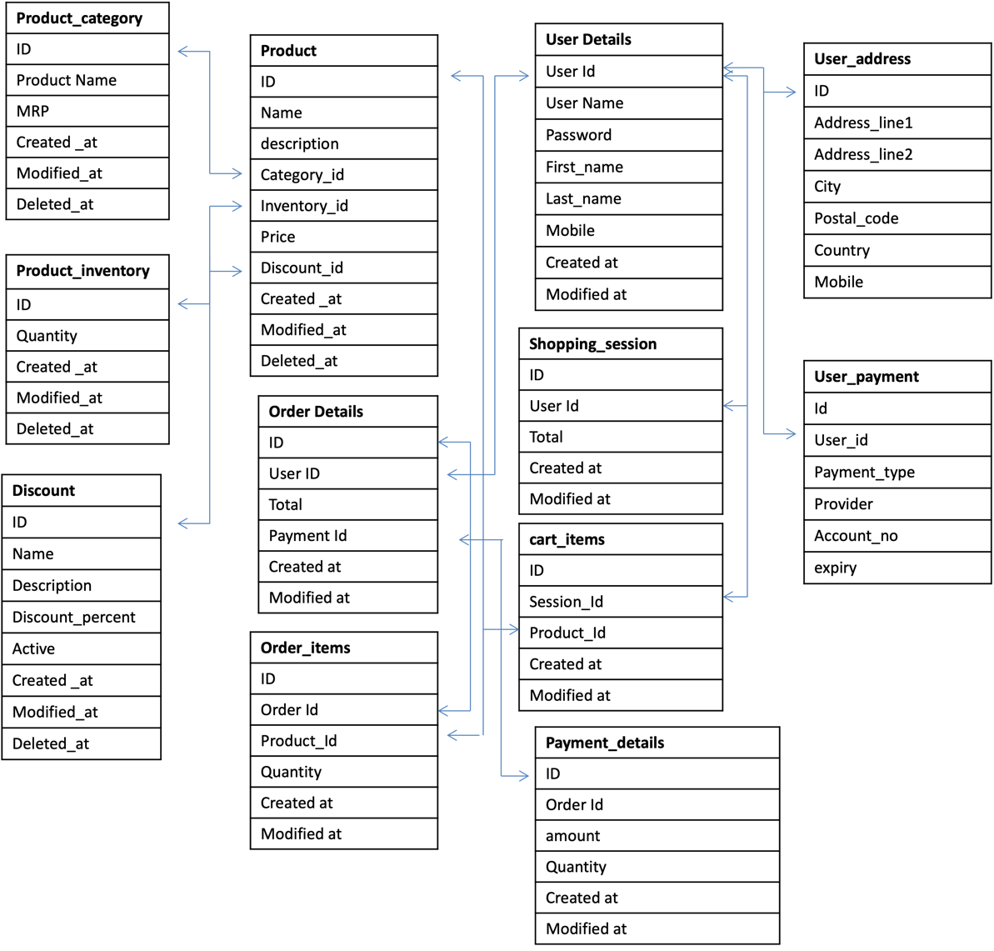
Question 7 – Data Flow Diagram
What is a data flow diagram? Draw a data flow diagram to represent the in-flow and out-flow of data when a Farmer is placing an order for the product

Answer :
A Data Flow Diagram is a visual representation that shows how data flows through a system, from input to output, and between processes, data stores and external entities
It shows where does the data come from, what happens to the data, where does the data go. It helps analysts and designers understand the flow of data within a system, identify potential bottlenecks or Inefficiencies, and communicate system requirements to stakeholders.
DFD helps the Business Analyst to under how data enters, moves and exits the system, it helps in identifying the gaps or redundant steps in process, it helps in visualizing the flow of data, it simplify communication with non technical stakeholders.
External Entities – External sources or destinations of data (Farmer)
Process : The Operations or activities performed on the data (search, Place order, process payment and track
Data Store : Where data is stored within the system (Product catalog, order database, payment, delivery tracking
Data Flows : The Movement of Data between entities, processes and data stores.

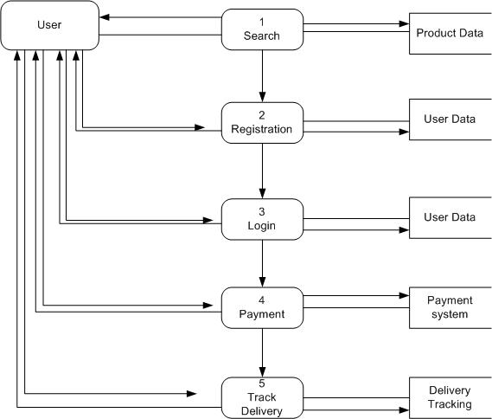

Question 8 – Change Request
Due to change in the Government Taxation structure. we should change the Tax structure
How do you handle change requests in a project?

Answer : As the Project Progresses through time. Its inevitable that some things will change that affect the project and so your requirements may also change, as requirements are inherent to change, requirements need to be managed throughout their life, people change their mind, preference, trend etc over time, so as the businesses change and markets also change accordingly.
BA always will be prepared for the change requests and their management. A structured and systematic approach is necessary to deal with change requests in a project, especially if they are related to something like a change in the government taxation structure, this ensures that the change is appropriately evaluated, communicated and implemented without negatively affecting the projects budget timeline or scope.
A Change request is a formal proposal to alter or modify a system, product or project.
- Understand the scope of Change request and Document the change request. – The first step is to understand what is being requested, in our case due to government taxation structure, we have to understand what needs to be changed? Why change? And who has raised the request, prepare the change request form with all the details, change description, date, request by, reason for change, priority, Affected Modules.
- Do the Impact analysis – Project Scope, Schedule, Budget, Resources and Risks – Work with project manager and technical team to assess, Project scope, will this affect other featured or user flow? Will any existing business rules will need revision, will the development and testing need extra time? Will there be any delay? Will it need additional budget? Is the current team sufficient to handle change? Will it require help from other domain experts? Is there any risk in terms of customers experience or legal compliance
- Prioritize change requests based on its urgency, importance, impact on project : Based on Urgency Importance and impact, it is a high priority as it is a government mandate, security issue and legal compliance, (Must). Medium priority – Business Improvement, user experience, (Should) Low Priority – Enhancement, Designs changes (Could)
- Seek approval from the project sponsor for the change request. Present the impact analysis and revised plan to the sponsor, show how this change will affect scope cost and delivery, get written approval or sign off before initiating the work.
- Communicate the change request and its potential impacts to all relevant stakeholders, including the project team. – After approval inform all affected team members – Developers for technical changes, Testers – to prepare new test cases, project manager – to revise timelines, client – to expect and review changes in UAT. Use Email and Project management tools or internal meeting to clearly communicate the details.
This process ensures that the change request is handled professionally, with minimum disruption and maximum alignment.

Question 9 – Change Request Vs an Enhancement

As the project is in process, Ben and Kevin have contacted you. The reason is to inform you that they want the Farmers to sell their crop yields through this application i.e. Farmers should be able to add their crop yields or products and display to general public and should be able to sell them. They also want to introduce Auction system for their Crop yields. As a BA, what will be your response?
Is this a change request or an enhancement???

Answer: Change Request is a modification to an existing requirement. Where as Enhancement is a new feature or an additional functionality. A Change Request is a formal proposal to modify existing functionality or existing approved requirements in the ongoing project.
This typically happens: When there's a mistake or oversight in the original requirements, Due to external influences like government policy changes, legal updates, or system limitations, When something needs to be corrected, extended, or optimized within the current system scope. In Our Project Let’s say the GST (tax) rate changes from 12% to 18%, and the government mandates that invoices must display this clearly. This is a Change Request, because: Tax calculation is already part of the existing system.
You are modifying the logic of an existing feature.
It was part of the original project scope and is now being altered.
An Enhancement is the request to introduce new features or add extra functionality that was not part of the original agreed project scope. Enhancements often: Come as new ideas or value additions from users or stakeholders, Aim to extend the usability or offerings of the product, Add additional work, cost, and time, Might lead to a new phase or version of the product. Ben and Kevin now want to add a crop-selling feature for farmers and introduce an auction module. This is an Enhancement, because:
It was never discussed or included in the original project plan.
The original system was a B2C platform — manufacturers to farmers. Adding a selling system means a shift toward a C2C or farmer-to-public model.
It involves new pages, logic, user roles, database changes, and possibly new compliance/legal issues.
Ben and Kevin requested that farmers should be able to sell their crop yields through the application, there should be an auction system for crop yeilds, This is not a change to existing requirement, but a new business need that introduces a new module and flow (crop listing, auction bidding, user-side shopping). Therefore, this qualifies as an Enhancement to the current system.”
As it was not part of the original agreed upon scope, it adds new functionality, turning the app into a 2 way market place, Buy as well as sell.
It will impact multiple areas in terms of system, UI Design for seller, Database – Crop Listing Tables, Work flow – Auctions, payments and notifications
As a BA I will Present this as an Enhancement Request,
Discuss with the client and committee (Mr. Henry, Mr. Dooku, Mr. Pandu)
Do an Impact Analysis (budget, timeline, resources)
Prepare a proposal to extend or phase this feature in a future release.

Question 10 – Estimations
Come up with estimations – How many Manhours required
Asnwer :
Estimation is the process of predicting the time, effort, and resources required to complete a project or a specific task. It helps in planning, budgeting, scheduling, and allocating resources efficiently.
Estimation is generally done in man-hours, days, or weeks and is critical for project success.
Man-Hour Estimation : Project Time Line 18 Months Approx 78 Weeks
Team Roles and Estimated Allocation:
The Roles and Team
Business Analyst - 1
PM – 1
Senior Java Developer -1
Java developers – 4
Network admin 0 1
DB Admin – 1
Testers – 2
Total Estimated Man hours is 5600 hours

Role | Person(s) | Estimated Man-Hours | Justification / Work Scope
Business Analyst | Mayur | 650 hrs | Requirement gathering, analysis, use cases, wireframes, RTM, stakeholder meetings, support UAT
Project Manager | Mr. Vandanam | 450 hrs | Planning, monitoring, risk mgmt., coordination, client updates, approvals
Senior Java Dev | Ms. Juhi | 700 hrs | Architecture, code reviews, complex module development
Java Developers | Teyson, Lucie, Tucker, Bravo (4 Devs) | 4 x 600 = 2400 hrs | Module development: login, product catalog, cart, order, search, payment, delivery, auction
Network Admin | Mr. Mike | 150 hrs | Server setup, domain, security, API integrations
DB Admin | Mr. John | 200 hrs | Schema design, normalization, ERD, data setup, backup/restore support
Testers | Mr. Jason, Ms. Alekya | 2 x 300 = 600 hrs | Test cases, test execution, logging bugs, retesting, UAT testing
UI/UX Design | (Handled by devs/BA) | 150 hrs | Wireframes, screen flows, basic UI designs
Buffer | All roles | 400 hrs | For change requests (e.g., tax structure), enhancements (e.g., auction), delays

Question 11 – UAT
Project has finally completed all the stages i.e., design, development, testing etc. Now, it is the role of a business analyst to contact the client for testing of the final product and have to successfully complete it. How are you going to handle this situation? And once it is done, what will be the process to close the project? Explain UAT Acceptance process
Answer : The UAT User Acceptance Test Process involved the client and other key stakeholders verifying that the product works according to the requirements and business needs. The process generally follows this stages.
1. UAT Planning : Identifying key stakeholders, including farmers, suppliers business owners for UAT Participation., Review Business requirements, ensuring critical functionalities like product search, payment methods, and delivery tracking are included. Develop a UAT Plan with defined scope, test cases and timelines, and set up a staging environment for testing.
2. Designing (Prepare the product for UAT) : Align the products UI with clients and end user expectations, ensuring ease of use for rural and tech savvy users alike. Conduct a walkthrough of key features like browsing categories, adding product to cart, and order tacking with stakeholders, prepare test cases and realistic datasets for accurate testing scenarios.
3. Client conducts UAT : End user execute test cases to validate functionality, such as searching for fertilizers, placing orders and making payments, the BA monitors progress, collects feedback on missing features or usability issues, and logs them for resolution. Identify and address any concerns during testing, ensuring the system meets expectations for functionality and performance.
4. Bug Fixing : Prioritize and resolve critical issues like payment gateway failures, incorrect pricing, or slow loading times.
Facilitate retesting of fixed functionalities, ensuring all bugs are resolved and no new ones are introduced, maintain regular updates with stakeholders on progress and time lines for final delivery
5. Signoff and final client review : Conduct a final review to confirm all requirements such as delivery tracking and product catalogue functionalities are met, obtain UAT Signoff form from the client, signifying that the system is ready for deployment.
Document feedback, summarize lessons learned, and transition to post launch support for ongoing maintenance.
By Following a structured approach to UAT planning, designing, testing, bug fixing and Sign Off, Organizations can ensure that the final product meets user expectations, minimizes the risk of post deployment issues, and maximizes user satisfaction.

Question 12 – Project Closure Document - Explain Project closure document
Answer : A Project Closure document, also known as a project closure report, is a formal document that summarizes the key outcomes,
Lessons learned, and final details of a completed Project.
It serves as a comprehensive record of the projects accomplishments, challenges, and overall performance, providing valuable insights
for stakeholders and future projects
Points to be Included in Project closure document are
1. Project Overview – Introduction to the project, including its objective scope and key stakeholders, Overview of the Project lifecycle,
Including major milestones and phases.
2. Achievements – Highlights key successes and deliverables achieved during the project lifecycle. Quantitative outcomes, such as cost
Savings, improved efficiency, or increased revenue. Recognition of the team contributions and innovations that added value.
3. Lessons Learned – Insights into what worked well and contributed to the projects success. Identification of areas for improvement in
Processes, tools or communication. Recommendations for future projects based on challenges faced and solutions implemented.
4. Quality Assurance – Overview of testing and validation activities to ensure deliverables met quality standards. Summary of defects or
Issues resolved and their impact on project outcomes. Final assessment of adherence to quality benchmarks and client satisfaction.
5. Resource Utilization – Analysis of resource allocation and usage, eg human, financial and technical resource. Identification of over Utilized or under utilized resources and their impact on the project. Recommendations for optimizing resource planning in future projects
6. Risk Management – Summary of risks identified at the beginning of the project and their mitigation plans, evaluation of how effectively
Risks were managed during the project. New risks encountered and lessons for better risk management in future projects.
7. Challenges – Key obstacles faced during the project and their impact on timelines or deliverables, strategies or actions taken to address
Challenges and minimize disruptions, evaluation of unresolved challenges and their implications for future efforts.
The Project Closure document serves as a formal record of the projects completion and provided valuable insights and documents for
Future reference, ensuring that the projects outcomes are captured and disseminated appropriately.

S No | Points to include | Details | Reference Link
1 | Did the client signed off on the UAT Testing  Date of the Sign Off :  Name of the Resource | 14/07/2025  Business Analyst | Business Scope Document.docx
2 | Objectives of the Project  User Friendliness  Customer Satisfaction  More categories | Achieved  ROI in 6 Months  Achieved
3 | Functionalities worked on  Secure Payment Processing  Categories | Achieved  Achieved
4 | Infrastructure  Software Installed  Laptop Purchased | Achieved  Achieved
5 | Funding  Amount Approved  Amount Used | 1 Crore  95 Lakhs | Finance Breakdown.docx
6 | Overall Project Information  Escalations  Customer Satisfaction | 50  High
7 | Value to the company  Positive/Negative | Positive 90 %  Company has gained an edge over competitors  Increased Clients  Trained Employees  New Project in Pipeline

