AGILE DOCUMENTS
Document 1: Definition of Done Document
2- Product Vision Document
3: User stories Document
4: Agile PO Experience
Document5: Product and sprint backlog and product and sprint burndown charts
Document 6: Sprint meetings

Document 1: Definition of Done
Purpose: To ensure that each user story related to the digital email updation process meets all functional, technical, and quality standards before being marked as complete.
Checklist for DOD
1.Development Completion
- Code for digital email updation module developed and unit tested.
- Two-factor authentication (OTP) integrated and verified.
- API integration between CRM and CBS(Core Banking System) completed and tested for real-time updates.
- Error handling and validation for invalid or duplicate requests implemented.
2.Testinng & Quality Assurance
- All acceptance criteria from the user story are met.
- End-to-end testing completed in UAT environment with successful CBS update confirmation.
- Negative scenarios (invalid OTP, duplicate email, invalid customer) tested and passed.
- UI validated for accessibility and browser/device compatibility.
- No open defects of severity “High” or “Critical”
3. Customer Communication
- SMS and Email acknowledgment templates configured and triggered automatically post successful update.
- Reference number generated and visible to customer and branch in CRM.
4. Compliance & Audit
- Audit trail captured for each email updation transaction.
- KYC and data privacy requirements verified as per regulatory norms.
- Digital consent stored and retrievable for audit purposes.
5.Documentation & Deployment
- MIS dashboard for branch and regional tracking configured.
- Deployment checklist completed and signed off by Product Owner.
- User manuals and process guides updated.
- Training material shared with branch and CPU users.
6. Business Validation
- Transaction tested live in pilot branches with real CBS sync.
- Customer acknowledgment verified via SMS/Email.
- Average TAT validated (1 day)
- Feedback captured post -pilot for NPS measurement.
Final Acceptance Criteria
The feature is consider Done when:
- The digital updation journey is functional end-to-end(CRMCBSCustomer)
- Customer receives acknowledgment instantly.
- Data accuracy confirmed by CBS validation.
- MIS dashboard reflects successful entries.
- Product Owner provides final sign-off.
Document 2- Product Vision
Scrum Project Name: | CRM Digital Email Id Updation --WOW Journey
Venue: | Head Office Mumbai
Date: 1 Oct 2025 | Start time: 11:00 am | End time: 06:00 pm | Duration: 6 Month
Client: | In-house
Stakeholder list: | Business Head--Liability Operations
 | IT Team--CRM and CBS Integration
 | Information Security Officer
 | Regional Operation Manager
 | Branch Managers
Scrum Team
Scrum Master:
Product Owner: | Vibha Prasad
Scrum Developer 1 | CRM Backend Developer
Scrum Developer 2 | UI/UX Developer
Scrum Developer 3 | CBS Integration Engineer
Scrum Developer 4 | QA & Testing Engineer
Scrum Developer 5 | MIS & Reporting Analyst

Product Vision: To create a seamless, secure and fully digital workflow for customer email ID updation with CRM, ensuring real-time synchronization with CBS, eliminating manual intervention, and enhancing customer experience through instant acknowledgment and fraud-free processing.

Target Group | Needs | Product | Value
Retail banking customers and branch staff | Need a faster, digital, and secure way to update customer email IDs without paper forms or physical signature | CRM WOW Journey-Digital Email ID Updation Module | Reduces processing time, prevents fraud, and boosts customer satisfaction
Target users: Bank Customer, branch operations, and CPU | Removes delays caused by physical form dispatch to CPU | Enables real-time update of customer email IDs through secure 2FA authentication | Enhances operational efficiency and customer trust.
Market Segment: Banking and BFSI | Compliance with digital KYC and audit trail requirements | Integrated with CBS for real-time data flow, ensuring zero duplication or mismatch | Saves cost by eliminating paper, logistics, and manual workload.
 |  |  | Supports organizational digital transformation and NPS improvement goals
Business Benefits
- Customer Delight: Instant acknowledgement via SMS/Email with ref. no.
- Paperless Processing: Fully digital workflow reduces physical documentation.
- Operational Efficiency: Faster turnaround time (TAT reduced to 1 day)
- Fraud Elimination: No forged signatures or manual tampering possible.
- Regulatory Compliance: End-to-end audit trail for every email ID update.

Document 3: User stories

User story No: 1 | Tasks: Form design, validation rules, backend integration | Priority: High
Value statement: As a customer, I want to update my registered email Id online so that I can receive all communication digitally and avoid visiting the branch.
BV:500 | CP:2
Acceptance criteria: User can access secure “Email ID update “form through CRM Mandatory fields validated (CID, mobile no., OTP)
Success message displayed after submission
Data securely stored and sent to CBS

User storyNo:2 | Tasks: OTP trigger, verification service, timeout logic | Priority: High
Value Statement: AS a customer, I want to authenticate using OTP so that my identity is verified securely before updating my Email.
BV:500 | CP:3
Acceptance criteria: OTP is sent to register mobile no.
OTP expires in 5 min Incorrect
OTP prompts error message.
Correct OTP allows proceeding to update form.

User storyNo:3 | Tasks: Dashboard Creation | Priority: High
Value Statement: As a CRM User, want to view pending email update request so that I can verify and approve them efficiently.
BV:500 | CP:5
Acceptance criteria: Pending requests appear in CRM
Filter by date, region, and branch work correctly.
Approvals auto-log timestamp and user ID.

User storyNo:4 | Tasks: API design, CBS testing, mapping | Priority: High
Value Statement: As a product owner, I want to integrate CRM with CBS so that updates reflect in real time.
BV:500 | CP:8
Acceptance criteria: Email update reflects instantly in CBS
Error logged if CBS unavailable.
Sync verified by reconciliation report.

User storyNo:5 | Tasks: | Priority: Medium
Value Statement: As a Customer, I want to receive an acknowledgement SMSs after my email update so that I know my request was successful.
BV:100 | CP:3
Acceptance criteria: SMS sent after successful update.
Template includes reference number.
Message delivery confirmed in logs.

User storyNo:6 | Tasks: Audit trail setup, timestamp logs | Priority:Low
Value Statement: As a CRM user, I want to track status history of each request so that I can check its stage and action owner.
BV:50 | CP:8
Acceptance criteria: Each stage (InitiatedVerifiedUpdateClosed) Visible
Status auto-update after each system event.

User storyNo:7 | Tasks: Encryption at rest and transit | Priority: High
Value Statement: As a compliance officer, I want all customer data encrypted so that sensitive information remains protected.
BV:500 | CP:8
Acceptance criteria: Data encrypted using AES-256
No plaintext visible in logs or API payloads
Compliance audit passes security tests.

User storyNo:8 | Tasks: UI display, backend fetch | Priority: Medium
Value Statement: As a customer, I want to view my update email confirmation on the CRM acknowledgment screen so that I can confirm accuracy.
BV:200 | CP:5
Acceptance criteria: Update Email shows on final screen
Data matches CBS record
Option to print acknowledgment visible.

User storyNo:9 | Tasks: Report template, export function | Priority: Medium
Value Statement: As a product owner, I want to generate MIS reports so that management can monitor daily progress.
BV:100 | CP:8
Acceptance criteria: Report shows total requests, completed, pending, failed.
Exportable in Excel and PDF format.

User storyNo:10 | Tasks: Dashboard | Priority: Medium
Value Statement: As a CRM user, I want to view branch-wise performance metrics so that I can track SLA adherence.
BV:100 | CP:5
Acceptance criteria: SLA Status auto-calculated
Colour -coded (Green/Red) performance indicators.

User storyNo:11 | Tasks: Role setup, user mapping, testing | Priority: High
Value Statement: As a system admin, I want role-based access control so that only authorized users can approve changes.
BV:500 | CP:8
Acceptance criteria: Maker-checker roles enforced.
Unauthorized access blocked with error.

User storyNo:12 | Tasks: Log creation, filters | Priority: Medium
Value Statement: As a QA tester, I want error logs for failed requests so that I can troubleshoot easily.
BV:100 | CP:3
Acceptance criteria: Logs capture request ID, error message, timestamp.
Logs retrievable by date range.

User storyNo:13 | Tasks: Auto reconciliation | Priority: High
Value Statement: As a business head, I want consolidated CBS-CRM reconciliation so that I can ensure data accuracy.
BV:500 | CP:13
Acceptance criteria: Reconciliation file auto-generated daily.
Discrepancies flagged and notified to admin.

User storyNo:14 | Tasks: Email trigger | Priority: Medium
Value Statement: As a customer, I want to receive an email notification once my request is approved so that I have official confirmation.
BV:50 | CP:3
Acceptance criteria: Email sent successfully with timestamp.
Message template approved by compliance.

User storyNo:15 | Tasks: Audit table, data retention logic | Priority: Medium
Value Statement: As a PO, I want to maintain audit compliance logs so that regulatory checks are easier.
BV:100 | CP:5
Acceptance criteria: Audit data retained for 7 years
Downloadable for compliance audit

User storyNo:16 | Tasks: Reference ID generation | Priority: High
Value Statement: As a customer, I want to see reference number after submission so that I can track my request later.
BV:200 | CP:5
Acceptance criteria: Unique reference ID generation
ID used for future tracking or support queries.

User storyNo:17 | Tasks: Search filter, indexing | Priority: Medium
Value Statement: As a CRM user, I want search functionality for email update requests so that I can locate records quickly.
BV:50 | CP:3
Acceptance criteria: Search by C.ID, branch, date
Results return with 3 seconds

User storyNo:18 | Tasks: Input Validation | Priority: Medium
Value Statement: As a customer, I want to get an error message if my email format is invalid so that I can correct it immediately.
BV:100 | CP:1
Acceptance criteria: Invalid format(missing@,.com) triggers error.
Only valid format accepted.

User storyNo:19 | Tasks: Timestamp logging | Priority: Medium
Value Statement: As s system, I want to log time of each CBS update so that performance metrics can be analysed.
BV:100 | CP:8
Acceptance criteria: Time taken for each update recorded.
Average time displayed in dashboard.

User storyNo:20 | Tasks: Cancel button, session management | Priority: Low
Value Statement: As a customer, I want to be able to cancel my request before final submission so that I have control.
BV:20 | CP:2
Acceptance criteria: Cancel returns user to dashboard
No data saved if not submitted.

User storyNo:21 | Tasks: Scheduled report, mailer setup | Priority: Medium
Value Statement: As a PO, I want performance reports weekly so that I can monitor project progress.
BV:100 | CP:3
Acceptance criteria: Report auto-emailed every Monday
Includes sprint velocity and completion %

User storyNo:22 | Tasks: Language pack, UI translation | Priority: Low
Value Statement: As a customer, I want multilingual support so that I can use the service in my preferred language
BV:20 | CP:5
Acceptance criteria: English & Hindi version functional.
Language switch persists across pages.

User storyNo:23 | Tasks: KPI Charts creation | Priority: High
Value Statement: As a business owner, I want dashboard for KPIs so that decision-making is data-driven.
BV:200 | CP:8
Acceptance criteria: KPI dashboard updated daily.
Drill-down available by region and product.

User storyNo:24 | Tasks: Alert setup, escalation logic | Priority: Medium
Value Statement: As a support team member, I want alters for failed CBS updates so that issues are resolved quickly.
BV:100 | CP:8
Acceptance criteria: Alerts generated for any failed CBS sync.
Email sent to support mailbox immediately.

User storyNo:25 | Tasks: Analytics script, dashboard integration | Priority: Medium
Value Statement: As a PO, I want user activity analytics so that I can measure adoption of the new digital feature.
BV:200 | CP:8
Acceptance criteria: Metrics track number of requests, time spent, drop rate.
Analytics visible on admin dashboard.

Document 4: Agile PO Experience
As a PO for the Digital Email ID Updation in CRM WOW journey project, my primary role was to ensure alignment between business goal, customer experience, and technology delivery. I collaborated closely with the Scrum team, business stakeholders IT to deliver a seamless digital process for email updation in the CRM platform.
Key Responsibilities and Contributions
1.Market & Enterprise Analysis
- Conducted an analysis of the existing manual process of email updation at branches.
- Identified key challenges such as customer inconvenience, fraud risk (forged signatures), and high turnaround time (TAT).
- Studied best practices in digital onboarding and CRM workflows to ensure alignment with the bank’s digital transformation goals.
2. Product Vision and Roadmap
- Defined the product vision: “To enable a secure, paperless, real-time digital journey for customer email updation in CRM.
- Created a roadmap for phased implementation of WOW journeys across service requests, with Email Id updation.
- Set measurable success parameters----80% digital adoption within 6 months and 20% NPS improvement in 3 months.
3.Managing Product Features
- Defined core features including two-factor authentication (OTP), customer acknowledgment (SMS/Email), CBS integration for real-time update, and MIS tracking dashboard.
- Prioritized features in the product backlog based on business value, regulatory importance, and technical dependencies.
- Balanced stakeholder expectation by aligning IT feasibility with branch operational efficiency.
4.Managing Product Backlog
- Created detailed user stories in collaboration with the Business Analyst and Scrum Master.
- Defined acceptance criteria for each story, ensuring they must security, compliance, and customer experience requirements.
- Conduct backlog refinement sessions before sprint to reprioritize based on progress and feedback.

5.Managing Sprint Progress
- Participated actively in Sprint Planning, Daily Scrum, Sprint Review, and Sprint Retrospective meetings.
- Ensured sprint goals aligned with the overall roadmap.
- Reviewed sprint deliverables and validated them against the Definition of Done (DOD)
- Collected feedback from pilot branch users and incorporated it into upcoming sprints for continuous improvement.
6.Collaboration and Communication
- Worked as the liaison between business stakeholder (operations, compliance, and customer service teams) and the Scrum team.
- Ensured timely communication on project progress, risk updates, and CBS dependency management.
- Facilitated change management and user training during rollout.
❖ From this project I have learned how to handle sprint meetings such as
➢ Sprint planning meeting: At the start of each sprint, I conducted a Sprint Planning Meetings with the Scrum Master and development team.
- The goal was to decide which user stories from the product backlog would be delivered in the sprint, based on business value and team capacity.
- Defined the Sprint Goal---e.g Enable OTP authentication and real-time CBS integration for digital email updation.
- Clarified scope, dependencies (especially CBS interface), and acceptance criteria for each story.
- Ensured that the team understood the business impact and customer value behind every backlog item.

➢ Daily scrum meeting: Joined the daily 15- minute Scrum stand-up to monitor progress.
- Ensured the team was aligned with sprint goals and resolved blockers (like CRM-CBS connection delays)
- Discussed what was completed yesterday, what will be done today, and any blockers.
- Helped prioritize quick decision to keep development on track.
➢ Sprint review meeting: At the end of each sprint, I reviewed the deliverables against the Definition of Done and acceptance criteria.
- Demonstrated working features such as the digital email updation workflow and SMS/email acknowledgment system to stakeholders.
- Collect feedback from operations and compliance teams to plan next improvements.
➢ Sprint retrospective meeting: Conducted with Scrum Master and team to analyse what went well and what could be improved.
- Discussed challenges such as dependency delays from CBS or testing bottlenecks.
- Agreed on actions points----e.g. improving early integration testing or revisiting sprint timelines.
➢ Backlog refinement meeting: Regularly reviewed and prioritized the product backlog.
- Collaborated with Business Analyst to break down epics into smaller user stories.
- Updated priority and value based on customer needs and business impact.
❖ Also, as a PO, I ensured every user story was clear, valuable, and testable.
Each story included:
➢ Story no.: US001
➢ Tasks: Create digital form, enable OTP authentication, integrate CRM with CBS
➢ Priority: High (due to regulatory and fraud-prevention needs)
➢ Acceptance criteria: Successful real-time email update in CBS, acknowledgment via SMS/Email, reference number generated
➢ BV & CP value: Enhance digital adoption and customer satisfaction CP: Medium—due to CBS dependency and security validation.
Role of PO: Acted as the bridge between business and technology teams.
- Ensured that the product vision (Secured digital, paperless customer service) was maintained throughout development.
- Collaborated with the scrum team to refine requirements, clarify doubts, and confirm priorities.
- Communicate updates and progress to senior stakeholders and ensured alignment with branch transformation goals.
Document 5: Product and sprint backlog and product and sprint burndown charts
Product Backlog: The Product Backlog is a master list of everything that needs to be developed in the product. Its helps to achieve the product vision.
User Story ID | User story | Tasks | Priority | BV | CP | Sprint
1 | Customer initiates Email ID update request | 3 | High | 500 | 2 | S-1
2 | Validate customer using registered mobile OTP | 3 | High | 500 | 3 | S-1
3 | Fetch customer details from CBS | 1 | High | 500 | 5 | S-1
4 | Integrate CRM with CBS | 3 | High | 500 | 5 | S-1
5 | Receive an acknowledgement SMSs | 2 | Medium | 100 | 3 | S-1
6 | MIS dashboard for email update Success/failure | 2 | High | 200 | 8 | S-1
7 | Allow entry of new email ID and re-confirm | 2 | Medium | 200 | 2 | S-1
8 | data encrypted | 1 | High | 500 | 5 | S-1
9 | role-based access control | 3 | High | 500 | 3 | S-1
10 | Generate daily CBS-CRM reconciliation report | 2 | Medium | 200 | 8 | S-1
11 | alters for failed CBS updates | 2 | Medium | 100 | 8 | S-2
12 | dashboard for KPIs so that decision-making is data-driven | 1 | High | 200 | 8 | S-2
13 | multilingual support | 2 | Low | 20 | 5 | S-2
14 | reports weekly to monitor project progress. | 2 | Medium | 100 | 3 | S-2
15 | be able to cancel my request before final submission | 2 | Low | 20 | 2 | S-2
16 | an error message if my email format is invalid | 2 | Medium | 100 | 1 | S-2
17 | reference number after submission to track | 1 | Medium | 100 | 3 | S-2
18 | audit compliance logs so that regulatory checks are easier | 2 | Medium | 100 | 5 | S-2
19 | email notification once my request is approved | 1 | Medium | 50 | 2 | S-2
20 | error logs for failed requests so that I can troubleshoot easily | 2 | Medium | 100 | 3 | S-2
21 | view branch-wise performance metrics | 1 | Medium | 100 | 3 | S-3
22 | MIS reports so that management can monitor daily progress. | 2 | Medium | 200 | 8 | S-3
23 | track status history of each request | 2 | Low | 50 | 8 | S-3
24 | Retry logic for failed | 2 | Medium | 100 | 5 | S-3
25 | Backup and archival of old email data | 2 | High | 500 | 8 | S-3

Sprint Backlog: The Sprint Backlog is a subset of the Product Backlog---it contains the items that the Scrum Team commits to completing during the current Sprint (typically 2-4 weeks)
User story ID | User story | Tasks | Owner | Status | Estimated Effort
1 | Customer initiates Email ID update request | 3 | D-1 | Completed | 2
2 | Validate customer using registered mobile OTP | 3 | D-1 | Completed | 3
3 | Fetch customer details from CBS | 1 | D-1 | Completed | 5
4 | Integrate CRM with CBS | 3 | D-1 | Completed | 5
5 | Receive an acknowledgement SMSs | 2 | D-2 | Completed | 3
6 | MIS dashborad for Email update Success/failur | 2 | D-2 | Completed | 8
7 | Allow entry of new email ID and re-confirm | 2 | D-1 | Completed | 2
8 | data encrypted | 1 | D-1 | Completed | 5
9 | role-based access control | 3 | D-1 | Completed | 3
10 | Genrate daily CBS-CRM reconcilitation report | 2 | D-1 | Completed | 8
11 | alters for failed CBS updates | 2 | D-1 | Completed | 8
12 | dashboard for KPIs so that decision-making is data-driven | 1 | D-3 | Completed | 8
13 | multilingual support | 2 | D-3 | Completed | 5
14 | reports weekly to monitor project progress. | 2 | D-3 | Completed | 3
15 | be able to cancel my request before final submission | 2 | D-1 | Completed | 2
16 | an error message if my email format is invalid | 2 | D-2 | Completed | 2
17 | reference number after submission to track | 1 | D-1 | Completed | 3
18 | audit compliance logs so that regulatory checks are easier | 2 | D-2 | Completed | 5
19 | email notification once my request is approved | 1 | D-1 | Completed | 2
20 | error logs for failed requests so that I can troubleshoot easily | 2 | D-2 | Completed | 3
21 | view branch-wise performance metrics | 1 | D-3 | Completed | 3
22 | MIS reports so that management can monitor daily progress. | 2 | D-2 | Completed | 8
23 | track status history of each request | 2 | D-1 | Completed | 8
24 | Retry logic for failed | 2 | D-2 | Completed | 5
25 | Backup and archival of old email data | 2 | D-3 | Completed | 8

Product burndown Charts: The product burndown chart is the chart that is plotted with the story points of all the user stories on the y-axis and the sprint numbers on the x-axis. Its provides the product backlog visualization of completed requirements over time
Sprint | Planned Story Points | Completed Story Points | Remaining Story Points
Start Before Sprint 1 | - | - | 25
Sprint 1 | 10 | 10 | 15
Sprint 2 | 10 | 10 | 5
Sprint 3 | 5 | 5 | 0

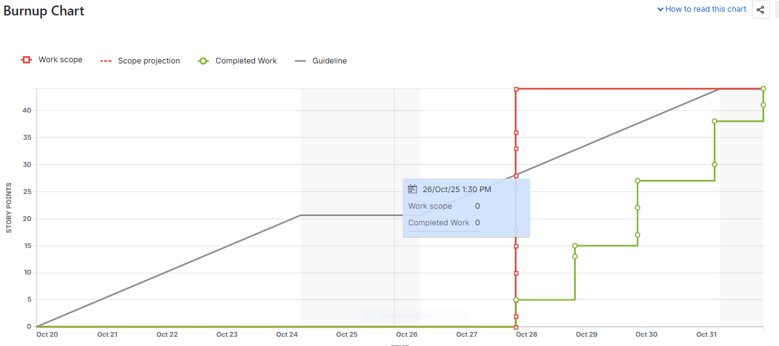

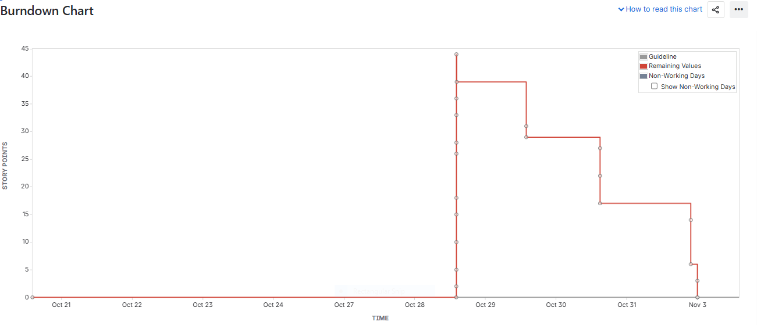

Document 6: Sprint meetings
Meeting Type 1: Sprint Planning meeting
Date | 02-Oct-25
Time | 10:00am-11:30am
Location | Digital Transformation Room/MS Teams
Prepared By | Vibha Prasad
Attendees | PO, Scrum Master, Development Team, (CRM Backend, CBS Integration, QA, MIS)
Agenda Topics
Topic | Presenter | Time allotted
Overview of Sprint Goal | Product Owner | 10 mins
User Story Review & Prioritization | Scrum Master | 15 mins
Estimation of Effort (Story Points) | Dev Team | 25 mins
Task Breakdown & Assignment | Scrum Master | 20 mins
CBS Dependency & Integration Plan | CBS Engineer | 15 mins
Risk Identification & Mitigation Plan | QA Lead | 10 mins
Final Sprint Commitment | Scrum Team | 5 mins

Other Information
Observers: IT Security Officer, Operations Head
Resources Sandbox, CBS Test Environment, Sprint Board in JIRA
Special Notes: Ensure CBS dependency approval before Day 3 of Sprint; perform mock testing before pushing to UAT
Meeting Type 2: Sprint review meeting
Date | 10-Oct-25
Time | 3:00 PM-4:00PM
Location | Digital Transformation Room/MS Teams
Prepared By | Vibha Prasad
Attendees | PO,Scrum Master,Development Team,Bussiness Stakeholders

Sprint status | Things to demo | Quick updates | What’s next
Sprint successfully completed; all 6 user stories delivered and tested | Live demo of email ID updation journey --customer validation via OTP,CRM to CBS sync. | Minor issue identified in SMS trigger for inactive customers (to handle in next sprint) | Deploy to UAT environment, plan for next sprint on mobile CRM enhancement.

Meeting Type 3: Sprint retrospective meeting
Date | 11-Oct-25
Time | 3:00 PM-3:45PM
Location | Digital Transformation Room/MS Teams
Prepared By | Vibha Prasad
Attendees | PO, Scrum Master, Development Team, Business Stakeholders,QA,CBS

Agenda | What went well | What didn't go well | Questions | Reference
 | Team collaboration improved significantly; daily stand-ups were consistent | CBS dependency approval took longer than expected, delaying integration testing. | How can we ensure CBS approval is received in the first two days of the sprint? | Action item: Align CBS dependency pre-approval in sprint backlog.
 | Test coverage for CRM-CBS sync achieved 95% | Minor delays in SMS trigger module deployment. | Should we plan partial deployment testing for low-risk modules? | Discuss with Product Owner in Sprint 2 Planning.
 | Communication with stakeholders was clear and documented | Need better documentation for API error logs. | Can we automate CBS-CRM error reporting? | To explore in next sprint improvement.

Meeting Type 4: Daily Stand-up meeting
Question | Name/Role | Monday | Tuesday | Wednesday | Thusday | Friday
What did you do yesterday | Dev 1 | Completed CRM-CBS API mapping | Worked on OTP validation module | Fixed API bug in test enviroment | Deployed on UAT | Supported QA testing
 | Dev 2 | Updated UI from validation | Integrated CBS error handling | Code review | Supported deployment | Created test report
 | Dev 3 | Designed MIS dashboard | Validated CBS data sync | Updated documentation | Closed Jira tickets | Prepared demo
What will you do today ? | Dev 1 | Test customer data push | Validate CBS reponse | Finalize logs | Verify SMS triggers | Demo setup
 | Dev 2 | Complete UI testing | Log CBS responses | QA testing | Verify OTP resend | Sprint review demo
 | Dev 3 | Review QA feedback | MIS fine-tuning | Prepare release note | Validate data flow | Attend sprint review
What (if any) is blocking your progress? | Dev 1 | CBS dependency approval pending | None | None | None | None
 | Dev 2 | API key authentication issue | Resolved | None | None | None
 | Dev 3 | Awaiting MIS test data | Resolved | None | None | None

