COEPD – CAPSTONE 5
Case Study 1 (Q1-Q6 → 12 Marks) A customer can make a payment either by Card or by Wallet or by Cash or by Net banking.

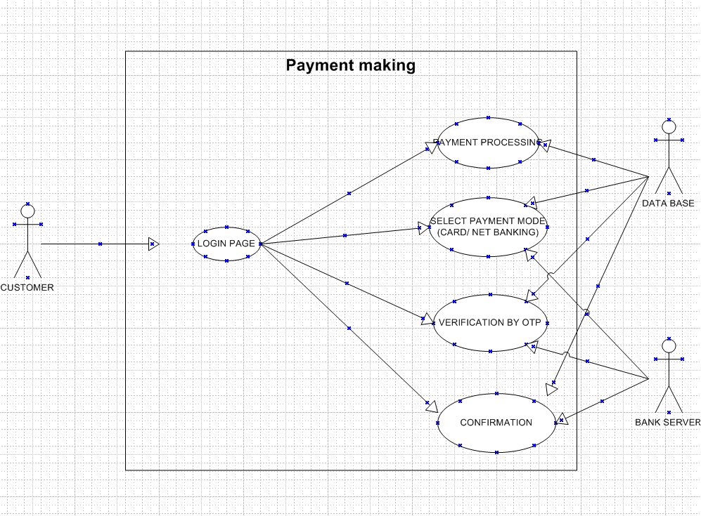

Q2. Derive Boundary Classes, Controller classes, Entity Classes. - 2 Answer :
Boundary Classes :
The Boundary class is a class that is the boundary of the system and other system or user ( which is actor in the use case diagram ).

The followings are the feature of the Boundary class.
- This class is more easy to be changed than the Entity and Control class.
- The attribute of this class and screen layout are defined at the basic design.
- In a class diagram , there are cases that the stereotype (<<boundary>>) is added.
- In a class diagram , there are cases that is shown by the following icon.


Controller classes :
The followings are the feature of the Control class.
- This class has a few attribute.
- In a class diagram , there are cases that the stereotype (<<control>>) is added.
- This class is a class to achieves use cases in the Use case diagram.
- In a class diagram , there are cases that is shown by the following icon.


Entity Classes :
The Entity class is a class that has data.
The "E" of the ER diagram means "Entity" too, if you know the ER diagram, you easily understand.

The followings are the feature of the Entity class.
- There are many cases that this objects of this class are perpetuated ¹ in the DB.
- The extraction of the class is like ER diagram ².
- This class is related to the DOA (Data-oriented approach) ².
- The module cohesion of this class is high ³, and is not easy to be changed.
- In a class diagram , there are cases that the stereotype (<<entity>>) is added.
- In a class diagram , there are cases that is shown by the following icon.


Q3. Place these classes on a three tier Architecture. - 2 Marks

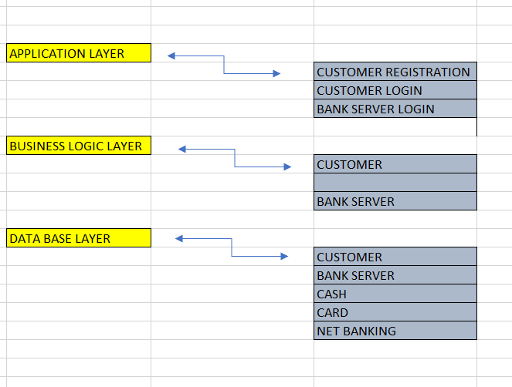

Q4. Explain Domain Model for Customer making payment through Net Banking - 2 Marks

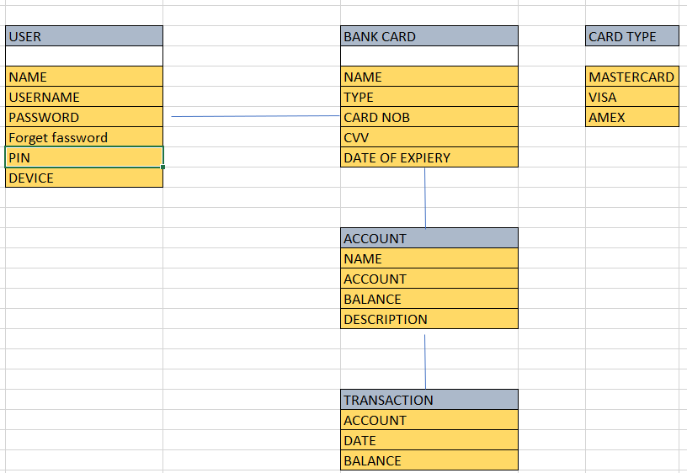
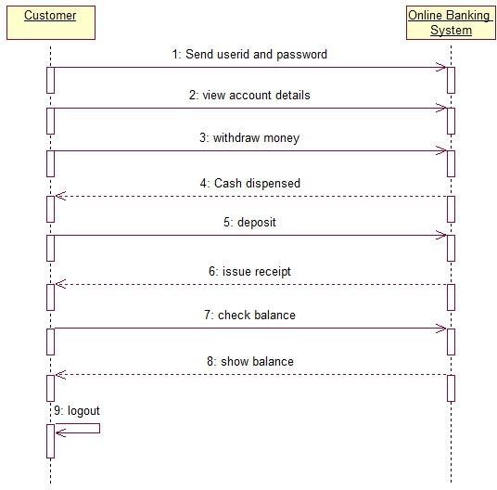
Q5. Draw a sequence diagram for payment done by Customer Net Banking - 2 Marks

Q6. Explain Conceptual Model for this Case - 2 Marks
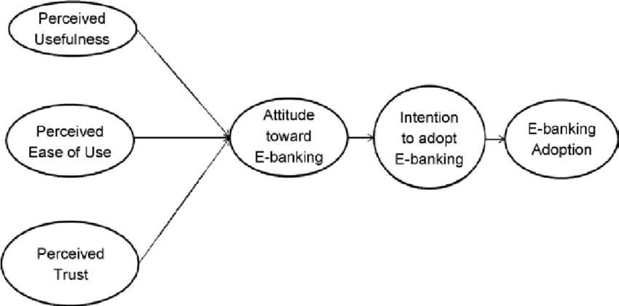

Q7. What is MVC architecture? Explain MVC rules to derive classes from use case diagram and guidelines to place classes in 3-tier architecture - 4 Marks
Ans :
The Model-View-Controller (MVC) is a well-known design pattern in the web development field. It is way to organize our code. It specifies that a program or application shall consist of data model, presentation information and control information. The MVC pattern needs all these components to be separated as different objects.

- Model: It represents the business layer of application. It is an object to carry the data that can also contain the logic to update controller if data is changed.
- View: It represents the presentation layer of application. It is used to visualize the data that the model contains.
- Controller: It works on both the model and view. It is used to manage the flow of application, i.e. data flow in the model object and to update the view whenever data is changed.

Advantages of MVC Architecture

The advantages of MVC architecture are as follows:

- MVC has the feature of scalability that in turn helps the growth of application.
- The components are easy to maintain because there is less dependency.
- A model can be reused by multiple views that provides reusability of code.
- The developers can work with the three layers (Model, View, and Controller) simultaneously.
- Using MVC, the application becomes more understandable.
- Using MVC, each layer is maintained separately therefore we do not require to deal with massive code.
- The extending and testing of application is easier.

Three-tier architecture, which separates applications into three logical and physical computing tiers, is the predominant software architecture for traditional client-server applications.

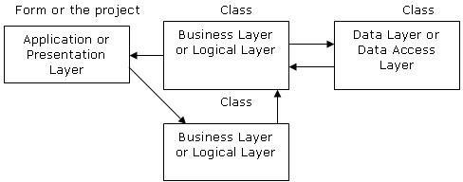

Q8. Explain BA contributions in project (Waterfall Model – all Stages)
– 4marks Ans:
A waterfall model is very old and traditional model in IT industries. It is a progressive implementation of the projects which is divided into different phrases of SDLC.
The business analyst will verify the product is delivered as per the requirements and it is meeting the business need. Maintenance: Once the implementation is done the team has to give support by installing patches, handling change requests, etc.

Stages in Waterfall Model.

- Requirement Gathering and Analysis
- Designing
- Coding
- Testing
- Deployment
- Maintenance

Requirement Gathering and Analysis:

This is the initial stage of the project where is an involvement of the BA. BA is responsible for preparing BRD document (Bussiness Requirement Document )

Artifacts: Functional Specification document. Bussiness Requirement Document.

Designing:

In this phase the artitect will start designing the system based on the bussiness analyst inputs and requirement documents. The BA helps him to clear the doubts about the requirements.
Artifacts: Design Documents and UML diagrams get ready in this phase.

Coding :
This phase is quite lengthy as the core development starts in this phase. Developer start product development based on the requirement document prepared by the BA. Developer may ask questions to BA regarding the requirement and he needs to answer the questions as and when required.

Artifacts: Code

Testing :
After coding, the testing phase will start, In this phase BA helps the testing team to understand the requirements so that they will build proper functional test cases. BA has to review whether the test cases covering the whole functionality.

Artifacts: Test Cases and test results.

Deployment:
Once the code is developed and tested,It is ready to deploy in the production environment. The BA will verify the product is delivered as per the requirements and it is meeting the business needs.

Artifacts: Implementation Review document.

Maintenance:
Once the implementation is done the team has to give support by instaling patches, Handling change requests, Etc.

A BA is the personwho knows every nook and corner of the project. So every change request has to be reviewed by him and based on his inputs and reports the team will respond.

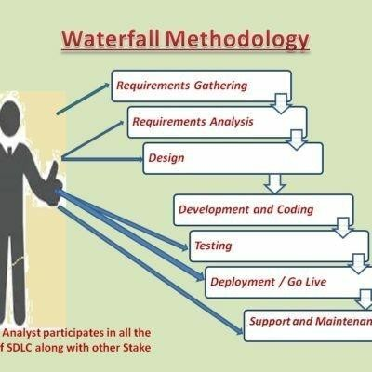
Artifacts: User Satisfaction review and change request review.

Q9. What is conflict management? Explain using Thomas – Kilmann technique – 3Marks

Ans:

In the 1970s, researchers Kenneth Thomas and Ralph Kilmann developed a model for conflict resolution. It was called the Thomas-Kilmann model after them. Under this model, the term ‘conflict’ is described as the condition in which people’s concerns can’t be compared with the others. If two or more people or groups care about things that are contradictory to each other, then the outcome is conflict.

This model describes the two core dimensions while choosing a mode of conduct in a situation of conflict: ‘assertiveness’ and ‘cooperativeness’. Assertiveness is the extent to which you try to solve and resolve for your preferred outcomes. Think of this as the factor on the Y-Axis of a graph. On the other hand, Cooperativeness is the level to which you try to resolve the other party’s problems. This is the factor on the X-Axis of the graph.

Thomas-Kilmann’s Five Modes For Handling Conflicts

From the correlation of these two and the scale of implementation, Thomas-Kilmann gave us the following five modes for handling the presented conflicts:

- Competing

Competing, the first Thomas-Kilmann conflict mode is assertive and non- cooperative. It refers to addressing only one’s own concerns at the cost of the concerns of the other. It is a power-oriented mode—one uses whatever power dynamic seems appropriate to get a favorable outcome for oneself. An individual’s ability to debate, their position in the hierarchy, or their financial power matters the most. Competing is defensive—it strictly means standing up for your individual beliefs and simply trying to win.

- Accommodating

According to the Thomas-Kilmann model, the Accommodating mode is both accepting and cooperative. It is the opposite of competing. While accommodating, the individual in question neglects their own problems or beliefs to address the problems of the other party. The element of self- sacrifice is highlighted in this mode. Accommodating typically involves selfless understanding, generosity, or charity. At times, accommodating

would require you to follow the other person’s orders when you would not
like to do so, or submit to the other’s perspective or decisions.

- Avoiding

In the Thomas-Kilmann model, avoiding is both unassertive and uncooperative. The individual wants to neither address their own problems nor the problems of others. This ultimately means that they do not want to engage in the conflict at all. Avoiding might be seen at times as a diplomatic move involving bypassing or ignoring the issue. It could also involve putting off the issue until the time is favorable, or simply stepping back from an uncomfortable or hazardous situation.

- Collaborating

Collaborating, the most beneficial outcome in the Thomas-Kilmann conflict model. is both assertive and cooperative. This mode is the complete opposite of avoiding. Collaborating includes a voluntary effort to work alongside the opposition to find a perfect solution that wholly addresses the collective problem. Collaborating involves deep-diving into an issue to locate the critical demands of the concerned individuals or parties.
Collaborating between two or more people might take the form of a quest to understand the ‘why’ of the disagreement. It involves striving to look for creative answers to interpersonal issues and enriching yourself from the other person’s insights.

- Compromising

The last outcome in the Thomas-Kilmann conflict model falls on the average point on both the assertiveness and cooperativeness scales. The goal here is to find a mutually acceptable and robust solution that, in some ways, satisfies both the individuals. It comes midway between competing and accommodating. It addresses an issue more directly than avoiding but falls short of investigating it with as much depth and rigor as collaborating. In certain situations, compromising might involve seeking middle-ground solutions, providing concessions, or looking for a quick solution that provides some way forward from the impasse.

The Thomas-Kilmann Model is based on two dimensions: assertiveness and empathy. There are 5 conflict resolution strategies: Compete, Avoid, Accommodate, Collaborate and Compromise. Each strategy has its benefits and disadvantages. Choose the appropriate one according to the situation.

Q10. List down the reasons for project failure – 3 Marks Ans:

Poor planning
Although sometimes overlooked in importance, lack of planning can make a project fail.
Having a successful project depends on properly defining in detail the scope, the time frame, and each member’s role. This way, you’ll have a route laid out to follow.

Inconsistently defined resources
Let’s be clear: planning shouldn’t be limited to agendas, meetings, and responsibilities. It should also include human, intellectual, financial, or structural resources. If these are not consistently determined, deadlines can’t be met, which can jeopardize the project’s conclusion.

Unclear objectives
objectives should be clearly defined, so as time goes by, you’ll know if you’re doing what’s right or not. Remember that choosing measurable goals helps you better visualize your progress and helps you see how close you are to achieving your results.

Lack of detail control
Monitoring is essential for successful projects, even knowing the details of many projects simultaneously can be very challenging.
As a result, it’s important to know how your project is going, if it is on schedule and if the budget is under control. This way, if there are any divergences from the initial plan, you can still correct them.

Lack of transparency
It’s essential that everyone involved in the projects have complete project visibility so that it doesn’t fail – not only the project manager, but other team members too.
This includes clear communication, good document management, and transparency about tasks’ status, all of which can be achieved with centralized, all-digital files.

Lack of communication
Communication is the key to good project management. Without the right tools and processes to allow interaction among team members and the

project manager from the beginning, efficient communication can seldom be achieved.

Change of direction
Among the ways projects fail, a very common one is scope creep. This concept refers to changes requested when the project has already started which had not been planned before. This is very common when projects are not appropriately documented and defined beforehand.

Unrealistic expectations
When you want to do something fast, with a limited budget, and a reduced team, it can really make your project fail. You should be realistic when it comes to your teams’ capabilities, deadlines, and the resources available – only then can you obtain the results you want.

Lack of monitoring
Providing a schedule to the team is not enough for a project to be successful.
You should also make sure everything goes as planned. This means
having frequent progress checks or meetings, as well as making adaptations, when necessary, is essential.

Unrealistic due dates
Planning co Unrealistic due datesmplex tasks for short due dates is definitely one of the causes for project failure. It is vitally important to carefully consider how long each project phase will take, in addition to extra time for unexpected events. This is the only way to develop a quality project.

Poorly assigned roles
When each team member receives their responsibilities clearly, they will know what, when, and how to perform their activities without someone needing to constantly ask for it.

Q11. List the Challenges faced in projects for BA – 3 Marks Ans.
A BA is responsible for multiple tasks at the same time. From handling the projects, maintaining client relationships, interacting with stakeholders, and managing project deadlines, Business Analysts got a lot on their plate. Read below to find out the challenges faced by business analysts and a possible solution to them

Lack Of Domain Knowledge

A Business Analyst needs to collaborate with the business users to understand the requirements. Domain knowledge plays a vital role in having a clear and complete understanding of the requirements.

It is challenging for Business Analysts to be assigned to a wide variety of projects as learning new domains needs time and energy.

Possible solution: Whenever you are assigned a new project, sit with the responsible person and understand the project requirements. Take notes whenever necessary and understand them thoroughly. It is challenging to learn new domains sometimes, but you must make mistakes.
Hence, go on a loop until you make a very bit of your knowledge count on your fingertips. It will help you while implementing and processing the outcome of the project.

Lack of Up To Date Process
The success of a project does not happen overnight. First, much effort and mental exhaustion are poured in to bring results.
Following this, the lion’s share is the up-to-date process of maintaining and evolving the project. The biggest challenge is the lack of up-to-date techniques and documentation. In most cases, the Project Documentation is incomplete, which hampers productivity.

Possible solution: Testing a system is the most remarkable technique to learn about an existing project. It may seem odd, but it has been used for a long time. To further understand the flow, request a demo from a staff member or SME. Afterward, conduct extensive testing.

Changing Business Needs or Requirements
Business stakeholders frequently request revisions to requirements even after they have been finalized and approved, as experienced by Business Analysts.

It might happen more once, even for the exact requirement, making it one of the most frequent issues. These adjustments could have an impact on the Business Analysis effort as well as the total project effort, cost, and schedule.

Possible solution: A change in the implementation cycle might impact the delivery process even if there are approaches that, like Agile, accept change. Business Analysts and other essential stakeholders must therefore determine how the difference may be

implemented in the best way.

Inadequate Stakeholder Involvement

One of the essential success criteria for every project is stakeholder involvement. You might encounter any of the following as a Business Analyst:
Lack of crucial stakeholders:If this occurs, there will be multiple problems since they will not be up to date on discussions about the most recent requirements. Either they won’t be able to express their ideas, or they will subsequently propose revisions.

Stakeholders’ Lack of Cooperation: Occasionally, you may encounter one or more stakeholders who are unwilling to cooperate. It could cause delays, sign-off problems, and even approval problems.

Possible solution: Business analysts may record the requirement discussions, particularly significant decisions made, and distribute them to all stakeholders in the meeting minutes. Before the scheduled requirements sessions, they may ask everyone who wasn’t present to review the points. This will reduce the likelihood of miscommunication and reopening requirements items that have already been closed.

Unrealistic Timelines
As a Business Analyst, you may find yourself in a problematic situation where timelines might be the concern. In that case, pressure is created, which might hamper your work. In that case, understand how to tackle such a situation while maintaining the quality of the work.

Possible solution:Sales Team may be forced to accept a difficult situation for tactical reasons. As a Business Analyst, you cannot change the terms of the agreement, but you can evaluate its effects and inform management of the probable costs and losses. You have the option of starting over. Unrealistic Expectations from stakeholders are widespread. It’s crucial to manage these

expectations balanced without permanently damaging the relationships.

Technical Skills
When it comes to Business Analysts, it’s a myth that they don’t require technical skills. On the contrary, most of them are champions in coding, know how to maintain business processes, and have a knack for technically undertaking the requirements.
Moreover, Business Analysts are involved in every step of the product development cycle; hence, they must understand the technical and functional side of the business as well.

Possible solution: Working with multiple clients, customers, and stakeholders is not easy. It requires a lot of skills to put in to bring the best results. Therefore, develop your skills over time. Whenever you are available, read, take courses and understand the technicality of the Project and the business. This will help you in developing better Project documents and will help in multiple ways.

Professionalism
Business analysts are one of the most underappreciated, underpaid, and ignored members of the IT world. They frequently serve as the binding agent between a project’s technical and business aspects. They are the one who contributes to the development of the project plan and who supports the project from beginning to end. They will collaborate with developers to ensure the project is constructed
following the most current standards and satisfies the business’
expectations.

Managing Communication
When you communicate effectively, you aid developers in understanding the needs, limits, and requirements of the business.You contribute to the development of solutions that benefit the client as well as the company. You guarantee the work is completed on schedule and to the required standards. But communicating the point is difficult. It involves a variety of abilities and trade secrets.

Possible solution:Soft skills are part of better work opportunities and personality. Try to communicate your views clearly and confidently to your team so they can understand them easily. It will help incur the communication gap between the team. While

intersecting with the stakeholders, try to break the idea into pointers and explain the leads to them.

Conflict with Users
Sometimes, you might find yourself in a situation where you cannot understand the user’s complaint. It happens during the product release stage and might come as rude feedback. Even conflict between stakeholders and business analysts may arise when a team suggests a new strategy pertinent to the existing business process.

Mindset
Business analysts must be prepared to deal with various difficulties throughout their work, from limitations of the technologies they employ to pushback from stakeholders and other team members.
But how one approaches their task can significantly alter if they are ready for the most typical obstacles.

Q12. Write about Document Naming Standards – 2 Marks Ans:

Keep file names short, but meaningful.
Correct - /…/Orientation/20181105SchdlVlntrs.pdf Incorrect - The_schedule_and_volunteers_for_Orientation_Nov_18.pdf

Avoid unnecessary repetition and redundancy in file names and folder names/file paths.
Correct - /…/Doe/Events/KidsNSibs/20181105BnceHsRsrvtn.pdf
Incorrect - /
…/Doe/Events/KidsNSibs/20181105KidsNSibsBounceHouseReservati
on.pdf

  - The most preferred is title case (FileName). Less preferable are, no separation (filename), underscores (file_name), dashes (file- name), or spaces (File Name).
Correct/Preferred – PSYCSyllabus.docx
Incorrect/Not Preferred – PSYC_syllabus.docx, psych syllabus.docx

When including a number, use leading zeros to ensure files sort properly, i.e., “001, 002…101” instead of “1, 2… 101”.

Correct – (In alphanumeric sort order) ) Image01.jpg, Image02.jpg, Image03.jpg, Image10.jpg, Image11.jpg, Image20.jpg
Incorrect – (In alphanumeric sort order) image1.jpg, image10.jpg, image11.jpg,

Date format should be YYYYMMDD (or YYMMDD) so years of files sort in chronological order.
Correct - 2018FAPSYC100SmithTest01V02.docx, 2018FAPSYC100SmithSyllabusV03.docx
Incorrect - test psychology smith Fall 18.docx, smith psych 100 syllabus Fall 2018.docx

When including a personal name in a file name give the family name first followed by the initials.
Correct - DoeJL20180421.jpg Incorrect -John-L-Doe20180421.jpg

Avoid using common words such as “draft” or “letter” at the start of file names.Avoid using common words such as “draft” or “letter” at the start of file names.
Correct – SyllabusV02Draft.docx, SyllabusV03Final.docx, TestV01Draft.docx, TestV04Final.docx
Incorrect - DraftSyllabusV02.docx, DraftTestV01.docx, FinalSyllabusV03.docx, FinalTestV04.docx

Order the elements in a file name in the most appropriate way to retrieve the record.
Correct -
/…/PlanningCttee/ 20040630Agenda.rtf 20040630Minutes.rtf 20050120Agenda.rtf 20050120Minutes.rtf
/…/Events/ GardenParty20040630.rtf ProcurementAward20040905.rtf WeddingDinner20030304.rtf
Incorrect -
/…/SausageCttee/ Agenda1Feb2005.rtf Agenda20Jan2005.rtf Minutes1Feb2005.rtf Minutes20Jan2005.rtf

/…/Events/ 20030304WeddingDinner.rtf 20040630GardenParty.rtf 20040905ProcurementAward.rtf

The file names of records relating to recurring events should include the date and a description of the event, except where the inclusion of either of these elements would be incompatible with rule 2.
Correct - KidsNSibs20181012.docx, KidsNSibs20191016.pdf, Orientation20180810.pptx
Incorrect – SibsWeekend.docx, WeekendWithTheKids.docx, 20180810.pptx

  - The file names of correspondence should include the name of the correspondent, an indication of the subject, the date of the correspondence and whether it is incoming or outgoing correspondence, except where the inclusion of any of these elements would be incompatible with rule 2.
Correct – /…/Returns/DoeJL20180815rcvd.txt
Incorrect – LetterFromJohnDoeReReturnAug18.txt

  - The version number of a record should be indicated in its file name by the inclusion of ‘V’ followed by the version number and, where applicable, ‘Draft’.
Correct – SyllabusV02Draft.docx, SyllabusV03Final.docx, TestV01Draft.docx, TestV04Final.docx
Incorrect - DraftSyllabusV02.docx, DraftTestV01.docx, FinalSyllabusV03.docx, FinalTestV04.docx

  - Avoid using special characters, i.e., ~ ! @ # $ % ^ & * ( ) ` ; < >
? , [ ] { } ‘ “
Correct - GardenParty20040630.rtf
Incorrect – “Picnic & Garden Party, June 30, 2004”.pdf

Q13. What are the Do’s and Don’ts of a Business analyst – 3 Marks

Ans.
- Every problem of Client has uniqueness, so talk to the client with a plain mind with no assumptions from your previous experience.

- Never come to any conclusion before listening or understanding all the aspect of requirement from client, if you have a slight amount of doubt about any demand or change it’s always preferable to clear it with the client, subject matter expert, or with your team member.

- You can take inputs from experienced people about any requirement and for that conducting meeting with them is not the only way, you can have coffee with them, have a walk, meet them sometime in between or end of the day; you can use your own creative ideas to interact with them.

- Listen very carefully and completely to the client as well as to the end user and then ask question, don’t interrupt them in between, sometimes the solution are itself hidden in the problem.

- Always remember to use best of your time, it’s not always compulsory or beneficial to attend the entire meeting, try to prioritise them, and always have a prior discussion with your project manager and sponsor before conducting a meeting.

- Maximum try to extract solution from client itself.

- Don’t be washed away by add on functionalities; just make sure to
prioritize them.

- Always try to build a repo with your senior, colleague and your team, Take care not to break confidentiality, earn their trust.

- Make sure that you have gathered all the requirements from the stakeholder for your project , missing out any information can results to unwanted redo the work as well as delay projects and increase cost.

- It’s better to ensure the activities of your analysis plans are synchronizing with the project manager schedule time to avoid any delay in project deliverables.

- Sometimes non functional requirements of client are not feasible because of budget or time constraint, so it’s always better to liaison with your PM to find out what is out of scope so that all will be in the same page and avoid misunderstanding.

- In a project, PM aim is to minimize new requirement to add in project scope, so as a BA we need to understand this and help to minimize the scope creep.

- As a BA understand the root cause of the problem, to facilitate
the solution don’t jump into the conclusion.

- Prepare your mind to work through challenging situation to negotiate and facilitate the project to complete on time.

Q14. Write the difference between packages and sub- systems – 2Marks

Ans:

Packages
A Packages is a grouping and organizing element in which other elements reside, which must be uniquely named. In the UML, packages are used in a manner similar to the way directories and folders in an operating system group and organize files. For example, the project management system may be decomposed into a collection of classes organized into packages as follows:

Sub-Systems :
Recall that a system is an organized collection of elements that may be recursively decomposed into smaller subsystems and eventually into non decomposable primitive elements. For example, the project management system may be decomposed into the following:
A user interface subsystem responsible for providing a user interface through which users may interact with the system
A business processing subsystem responsible for implementing business functionality
A data subsystem responsible for implementing data storage functionality.

While a package simply groups elements, a subsystem groups elements that together provide services such that other elements may access only those services and none of the elements themselves. A subsystem is shown as a package marked with the subsystem keyword.

Q15. What is camel-casing and explain where it will be used- 2 Marks

Ans.

Camelcase is a naming convention for writing file or object names using compounded or joined words with at least of those words beginning in a capital letter.

Camelcase is used in programming language to name different files and functions without violating the naming laws of the underlying language.
Camelcase is also known as medial capitals and Pascal case.
The term camelcase is derived from its appearance, which can resemble a camel's back. It is used in many programming language that doesn't allow spaces in file names. Camelcase enables the creation of names that are more unique and have more meaning for the developer.
For example, file names Bigball, BigBall and bigBall can be read much more easily than bigball
CamelCase is a way to separate the words in a phrase by making the first letter of each word capitalized and not using spaces. It is commonly used in web URLs, programming and computer naming conventions.

Q16. Illustrate Development server and what are the accesses does business analyst has? -3 Marks
Ans:
A development server is a type of server that is designed to facilitate the development and testing of programs, websites, software or applications for software programmers. It provides a run-time environment, as well as all hardware/software utilities that are essential to program debugging and development.
A development server is the core tier in a software development environment, where software developers test code directly. It is comprised of the essential hardware, software and other components used to deploy and test the software under development, including bulk storage, development platform tools and utilities, network access and a high-end processor. Upon testing completion, the application is moved either to a staging server or production/live server.
Busniess Analyst has the visualizing access in development server. BA has the access to all the functional servers and not to the technical servers.

Q17. What is Data Mapping 2 Marks
Ans:
Data mapping is the process of matching fields from one database to another. It's the first step to facilitate data migration, data integration, and other data management tasks.

Data mapping bridges the differences between two systems, or data models, so that when data is moved from a source, it is accurate and usable at the destination.
Data mapping has been a common business function for some time, but as the amount of data and sources increase, the process of data mapping has become more complex, requiring automated tools to make it feasible for large data sets.
Data mapping is an essential part of many data management processes. If not properly mapped, data may become corrupted as it moves to its destination. Quality in data mapping is key in getting the most out of your data in data migrations, integrations, transformations, and in populating a data warehouse.
Data mapping is an essential part of ensuring that in the process of moving data from a source to a destination, data accuracy is maintained. Good data mapping ensures good data quality in the data warehouse.

Q18. What is API. Explain how you would use API integration in the case of your application Date format is dd-mm-yyyy and it is accepting some data from Other Application from US whose Date Format is mm-dd-yyyy 3 Marks
Ans:
An API, is Application Programming Interface, is a software-to- software interface. APIs provide a secure and standardized way for applications to work with each other and deliver the information or functionality requested without user intervention.
An API, or application programming interface, is a set of defined rules that enable different applications to communicate with each other. It acts as an intermediary layer that processes data transfers between systems, letting companies open their application data and functionality to external third-party developers, business partners, and internal departments within their companies.

