Question 1 – Functional Requirements - 15 Marks
Identify minimum 20 functional requirements Example : Functional requirement: When an order is fulfilled, the local printer shall print a packing slip. Non-Functional Requirement: Packing slips shall be printed on both sides of 4”x 6” white paper, the standard size for packing slips used by local printers.
Req ID | Req Name | Req Description | Priority
FR001 | Farmer Registration | Farmers should be able to register with the application | 2
FR002 | Farmer Search for Products | Farmers should be able to search for available products in fertilizers, seeds, pesticides | 1
FR003 | Shopping Cart | Allow farmers to add product to cart and review | 7
FR004 | Payment Processing | Provide secure payment processing options to customers | 7
FR005 | Order Management | Allow farmers to view their order history and track the status | 6
FR006 | Search | Implement a search bar to allow customers to find products | 5
FR007 | Product reviews and ratings | Allow customers to leave reviews and ratings for products they have purchased to help other customers make informed decisions | 4
FR008 | Wishlist | Allow customers to save products they are interested in | 3
FR009 | Shipping & Delivery | Provide customers with shipping options and estimated delivery | 5
FR010 | Return & Refund Policy | Outline the return and refund policy for customers to ensure a positive customer experience and minimize customer complaints | 5
FR011 | Availability of product | If the product is out of stock or sold out, it will be mentioned below the product. The inventory updates will be integrated at the backend | 8
FR012 | Search Products | After selecting a particular product category, customers will further be able to filter products based on different attributes like price, new, etc. | 9
FR013 | Availability of product | If the product is out of stock or sold out, it will be mentioned below the product. The inventory updates will be integrated at the backend | 8
FR014 | New Deals and Festive offers | Banners of all deals and offers will be showcased on homepage, so that user can view all products on click that deal or offer | 10
FR015 | Company logo and name | Users will be able to view the company logo and name | 8
FR016 | Search | When the word typed matches the keyword in backend, the system will give suggestions to users so they enter their search query into the search box | 8
FR017 | Buy now | When user clicks on “Buy now”, the customer will be redirected to the checkout page | 9
FR018 | Product Comparison | Farmers can view multiple products and compare them to their liking | 7
FR019 | Product Delivery | Farmers should get real-time notifications on their order progress | 6
FR020 | Product return | Farmers should be able to initiate return of product if it is of bad quality or broke while shipping | 7

Non Functional requirements:
Req ID | Req Name | Requirement Description | Priority
NFR001 | Page Loading Time | Each Page should load within 2 seconds time | 10
NFR002 | Technical Supported System | Application can be used on any OS (Android/IOS) | 1
NFR003 | Time Limit for OTP | OTP time limit should be given maximum of 5 minutes for Login and Registration process | 2
NFR004 | Logout System | If the page is not accessed for more than 5 minutes, the page should log out automatically | 6
NFR005 | Stock Availability | Stock availability should be updated on a real-time basis | 3
NFR006 | SMS & Mail Confirmation | Automated Email and SMS notification should be sent to Users | 4
NFR007 | Backup | All data should get backup automatically | 5
NFR008 | Connectivity | System should be connected with Internet | 8
NFR009 | Stock Alerts | Seller should receive Stock alert notifications when Stock is reduced, every week | 6
NFR010 | Net Banking | Bank account should be active in nature for smooth payment process | 8
NFR011 | Check Stock | Once the Product is sold, the stock of the product should be reduced | 7
NFR012 | Email Address | Email Address should be active to receive Email notifications | 5
NFR013 | Taxation System | All products should be included with additional Tax | 8
NFR014 | Password | User should receive Password change alert every 30 days | 4
NFR015 | Payment Receipt | Generation of payment details on whitepaper receipt of 4” × 6” | 5

Question 2:

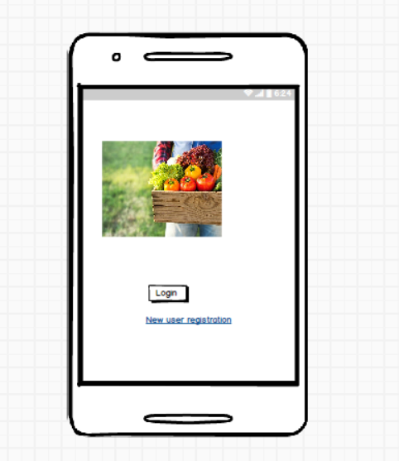
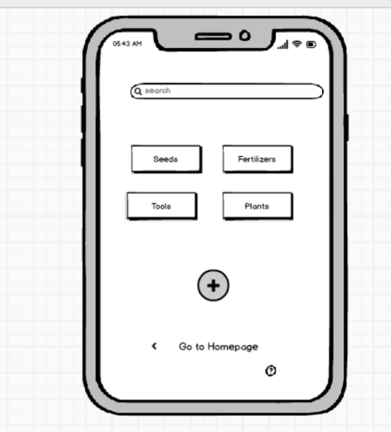

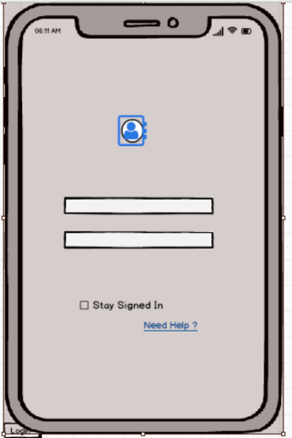

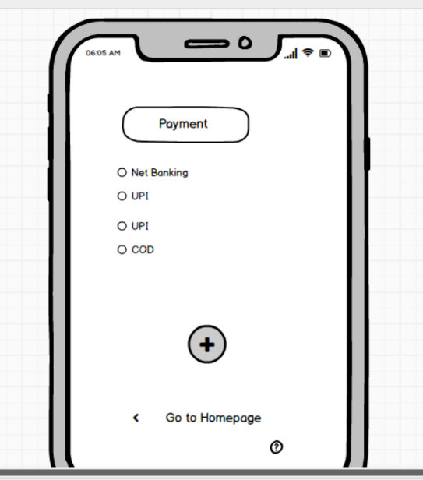
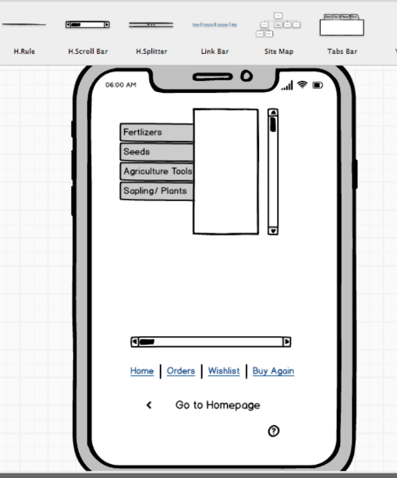

Question 3: Make a note of the Tools, which you are using for above concepts.

Balsamiq
Balsamiq Mockups is an effective tool for presenting the software requirements in the form of wireframes. This helps the software development team to visualize how the software project will look like in the very early stages of development. Balsamiq is a low-fidelity wireframing tool that allows users to create digital sketches of their ideas or concepts for an application or website.
The wireframes created using Balsamiq have a hand drawn style, it allows us to picture ideas and concepts through simple drag and drop interface.
Strength: Super fast & easy for requirements workshops with stakeholders.
It is a user interface design tool that can be used to generate wireframes, also known as mockups or low-fidelity prototypes.

. Microsoft Visio (BA perspective)
- Main Use for BA:
  - Drawing process flows, data flow diagrams (DFD), ER diagrams, use case diagrams, org charts, workflow maps.
Why BAs use it: Communicates business processes, system logic, and data relationships clearly to both business & technical teams.
  - Standardized diagramming (BPMN, UML).
  - Strength: Best for structured, technical, and process documentation.
Axure RP (BA perspective)
- Main Use for BA:
  - Creating high-fidelity, interactive prototypes that simulate how the system will behave.
- Why BAs use it:
- Can define conditional logic, data interactions, dynamic navigation.
  - Stakeholders can “click through” the prototype → feels like a real application.
  - Reduces miscommunication in requirements.

Question 4 – RTM - A business analyst’s key responsibilities are to keep track of the requirements and make sure that no requirement is missed.
Mr. Henry and peter have approached you regarding the current status of the project. How will you tackle this situation?

Prepare RTM:
Req ID | Req Name | Req Description |  | Design | D1 | D2 |  | T1 | T2 | T3 | UAT
FR001 | Website layout | Defines the overall structure, design, and navigation of the website. |  | completed | completed | completed | completed |  |  |  | completed
FR002 | Signup/Login option | Allows users to create accounts and securely log in to the system. |  | completed | completed | completed
FR003 | Search option | Enables users to search for products quickly using keywords or filters. |  | completed | completed | completed |  | completed
FR004 | Product catalogue | Displays available products with details such as name, price, and description. |  | completed | completed | completed
FR005 | Home page | Shows featured products, offers & navigation bars |  | completed | completed | completed |  | completed | completed | completed | completed
FR006 | Cart | Lets customers add products, update qty & proceed to checkout |  | completed | completed | ????
FR007 | EMI options | Provides installment methods for flexible transactions |  | completed | completed | completed |  | completed | completed | completed | completed
FR008 | Create a Wishlist |  | completed |  | completed | completed |  | completed |  |  | completed
FR009 | Saved payment option |  |  | completed | completed | completed |  | completed | completed | completed | complete
FR011 | Availability of Product | Show if a product is in stock or out of stock with real-time inventory updates. | completed | completed | completed | completed | completed | completed
FR012 | Search Products | Allow users to search products by name, category, or keyword. | completed | completed | completed | completed | completed | completed
FR013 | Availability of Product | Display product quantity and availability before checkout. | completed | completed | completed | completed | completed | completed
FR014 | New Deals and Festive Offers | Provide customers with seasonal offers, discounts, and promotional deals. | completed | completed | completed | completed | completed | completed

Req ID | Req Name | Req Description | Priority | Design | D1 | D2 | T1 | T2 | UAT
NF001 | Page Loading Time | Each page should load within 2 seconds. | High | completed | completed | completed | completed | completed | completed
NFR002 | WCAG 2.1 | The system must meet Web Content Accessibility Guidelines (WCAG 2.1). | High | completed | completed | completed | completed | completed | completed
NFR003 | Bill Printing | Bill should be printed on both sides of the page when order is dispatched. | High | completed | completed | completed | completed | completed | completed

Design → The requirement has been designed (UI, architecture, workflows, etc.).
- D1 (Development Phase 1) → First development cycle or initial coding completed.
- D2 (Development Phase 2) → Enhancements, fixes, or second phase of coding completed.
- T1 (Testing Phase 1 / Unit Testing) → First level of testing (basic validation of developed functionality).
- T2 (Testing Phase 2 / System Testing) → End-to-end testing of the system as a whole.
- T3 (Testing Phase 3 / Integration Testing) → Checking integration with other modules/systems.
- UAT (User Acceptance Testing) → Final validation by business users or clients to ensure the system meets requirements.
- D1, D2 = Development cycles
- T1, T2, T3 = Different testing cycles (unit, system, integration)
- UAT = Final acceptance testing by users
Question 5
Prepare 10 Test Case Documents
Test Case ID | TC001 | Test Case Name | Online Agriculture Product Store
Project ID | OAA | Project Name | Online Agriculture Product Store
PM ID | - | PM Name | Mr Vandanam

Test Strategy ID | - | Tester ID | -
Test Plan ID | - | Tester Name | Mr Jason
Test Schedule ID | - | Date of Test | 01-Oct-23
Scenario | To authenticate a successful user login on Gmail.com
Link to that page | -
Input Data | Name, Contact number, Email ID
Expected Behaviour | Once username and password are entered, the web page redirects to the user’s inbox, displaying and highlighting new emails at the top.
Actual Behaviour | As expected
Comments | NA
Result (Pass/Fail) | Pass

Test Case 1 – User Login Authentication
- Objective: Verify that a user can successfully log in with valid credentials.
- Input: Name, contact number, email ID.
- Expected Result: After entering username and password, the user is redirected to their Gmail inbox where new emails are highlighted.
- Actual Result: System behaved as expected.
- Status: Pass

Test Case 2
Test Case ID | TC002 | Test Case Name | Seller Product Creation
Project ID | OAA | Project Name | Online Agriculture Product Store
PM ID | - | PM Name | Mr Vandanam

Test Strategy ID | - | Tester ID | -
Test Plan ID | - | Tester Name | Miss Alekya
Test Schedule ID | - | Date of Test | 02-Oct-23
Scenario | Seller Product Creation
Link to that page | -
Input Data | Product ID, Product pictures, Product prices
Expected Behaviour | Authenticated sellers can access authorized product creation panels under authorized categories
Actual Behaviour | As expected
Comments | NA
Result (Pass/Fail) | Pass

Test Case 2 – Seller Product Creation
- Objective: Verify that an authenticated seller can create a product entry.
- Input: Product ID, product pictures, product prices.
- Expected Result: Seller should be able to access authorized product creation panels under defined categories.
- Actual Result: System behaved as expected.

Test Case 3
Test Case ID | TC003 | Test Case Name | Filter Results
Project ID | OAA | Project Name | Online Agriculture Product Store
PM ID | - | PM Name | Mr Vandanam

Test Strategy ID | - | Tester ID | -
Test Plan ID | - | Tester Name | Mr Jason
Test Schedule ID | - | Date of Test | 03-Oct-23
Scenario | Filter Results
Link to that page | -
Input Data | Product key names, product alternative names
Expected Behaviour | The user should be able to see results with default search criteria when at least one of the filter parameters isn’t mandatory
Actual Behaviour | As expected
Comments | NA
Result (Pass/Fail) | Pass

Test Case 4
Test Case ID | TC004 | Test Case Name | Product Details
Project ID | OAA | Project Name | Online Agriculture Product Store
PM ID | - | PM Name | Mr Vandanam

Test Strategy ID | - | Tester ID | -
Test Plan ID | - | Tester Name | Miss Alekya
Test Schedule ID | - | Date of Test | 04-Oct-23
Scenario | Product Details
Link to that page | -
Input Data | Product colour alternatives, product quantity, product quality
Expected Behaviour | Test that all the product details are displayed correctly and that no empty/invalid details are displayed
Actual Behaviour | As expected
Comments | NA
Result (Pass/Fail) | Pass

Test case 5
Test Case ID | TC005 | Test Case Name | Shopping Cart
Project ID | OAA | Project Name | Online Agriculture Product Store
PM ID | - | PM Name | Mr Vandanam

Test Strategy ID | - | Tester ID | -
Test Plan ID | - | Tester Name | Mr Jason
Test Schedule ID | - | Date of Test | 05-Oct-23
Scenario | Shopping Cart
Link to that page | -
Input Data | Item price, Item quantity
Expected Behaviour | Test that all added items have at least a quantity, price, and delete option associated with it
Actual Behaviour | As expected
Comments | NA
Result (Pass/Fail) | Pass

Test Case 6
Test Case ID | TC006 | Test Case Name | Checkout Page
Project ID | OAA | Project Name | Online Agriculture Product Store
PM ID | - | PM Name | Mr Vandanam

Test Strategy ID | - | Tester ID | -
Test Plan ID | - | Tester Name | Mr Jason
Test Schedule ID | - | Date of Test | 06-Oct-23
Scenario | Checkout Page
Link to that page | -
Input Data | Item price, coupon details, price breakup
Expected Behaviour | User should be shown the total amount with the necessary breakup as applicable.
Actual Behaviour | As expected
Comments | NA
Result (Pass/Fail) | Pass

Test Case 7

Test Case ID | TC007 | Test Case Name | Payment Page
Project ID | OAA | Project Name | Online Agriculture Product Store
PM ID | - | PM Name | Mr Vandanam

Test Strategy ID | - | Tester ID | -
Test Plan ID | - | Tester Name | Miss Alekya
Test Schedule ID | - | Date of Test | 07-Oct-23
Scenario | Payment Page
Link to that page | -
Input Data | Saved payment method, card numbers, UPI, Customer ID of net banking
Expected Behaviour | For returning customers, they should be redirected to log in for checkout
Actual Behaviour | As expected
Comments | NA
Result (Pass/Fail) | Pass

Test Case 8
Test Case ID | TC008 | Test Case Name | Session Log Out
Project ID | OAA | Project Name | Online Agriculture Product Store
PM ID | - | PM Name | Mr Vandanam

Test Strategy ID | - | Tester ID | -
Test Plan ID | - | Tester Name | Mr Jason
Test Schedule ID | - | Date of Test | 08-Oct-23
Scenario | Session log out if page left idle for more than 10 minutes
Link to that page | -
Input Data | Timer for page loading
Expected Behaviour | Maintain a session for each user and test verify the session times out after a while
Actual Behaviour | As expected
Comments | NA
Result (Pass/Fail) | Pass
Test Case 9
Test Case ID | TC009 | Test Case Name | Shipping and Delivery
Project ID | OAA | Project Name | Online Agriculture Product Store
PM ID | - | PM Name | Mr Vandanam

Test Strategy ID | - | Tester ID | -
Test Plan ID | - | Tester Name | Miss Alekya
Test Schedule ID | - | Date of Test | 09-Oct-23
Scenario | Shipping and Delivery
Link to that page | -
Input Data | Area postal code, dates, shipping costs
Expected Behaviour | Test the accurate calculation of shipping costs based on the chosen shipping method and destination. Verify that shipping costs are displayed clearly to the user during checkout.
Actual Behaviour | As expected
Comments | NA
Result (Pass/Fail) | Pass

Test Case 9 (Shipping & Delivery): Verified accurate calculation of shipping costs based on postal code, method, and destination. Costs were displayed clearly at checkout.
Result: Pass

Test Case 10
Test Case ID | TC010 | Test Case Name | App Installation/Uninstallation
Project ID | OAA | Project Name | Online Agriculture Product Store
PM ID | - | PM Name | Mr Vandanam

Test Strategy ID | - | Tester ID | -
Test Plan ID | - | Tester Name | Mr Jason
Test Schedule ID | - | Date of Test | 10-Oct-23
Scenario | App installation/uninstallation
Link to that page | -
Input Data | Device details, auto fill up, contact number
Expected Behaviour | The application is installed and works correctly / The application is uninstalled. The app’s icon isn’t displayed on the device’s OS.
Actual Behaviour | As expected
Comments | NA
Result (Pass/Fail) | Pass

Question 6 – DB Design
After the requirements are thoroughly explained to the entire project team by business analyst, the Database architects have decided to do the database design and also to represent the in-flow and out-flow of data.
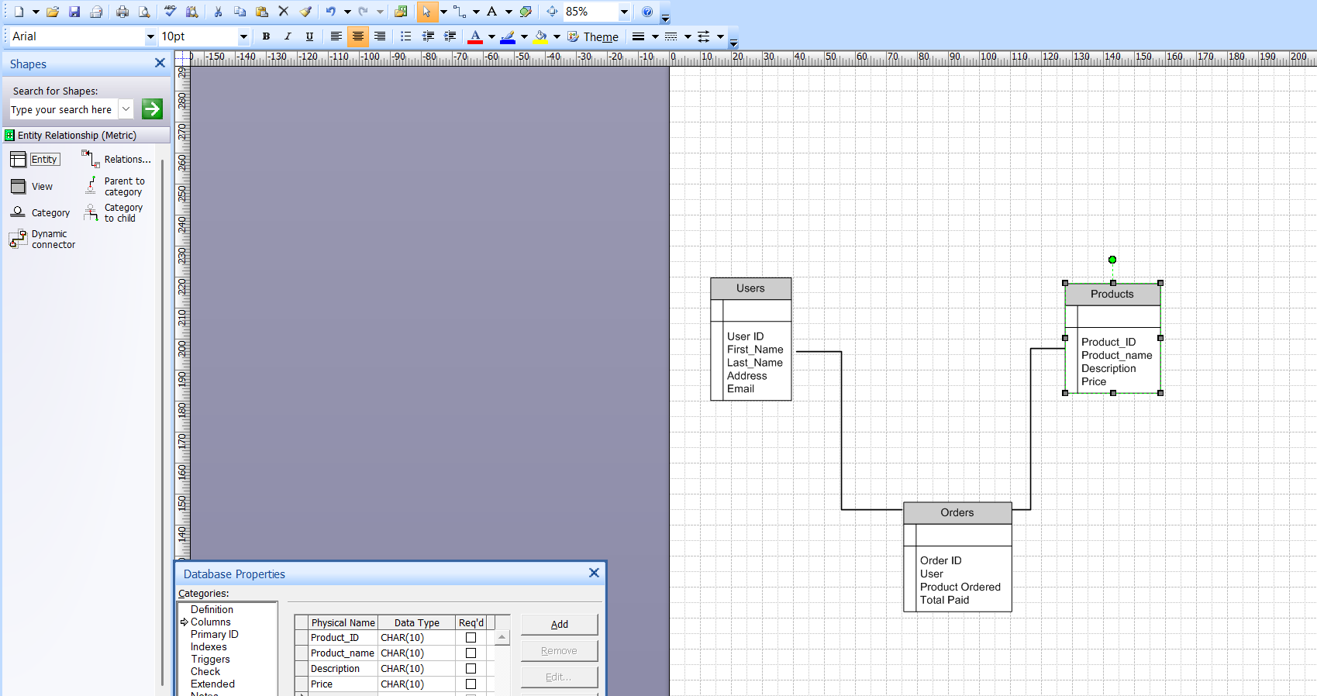
Draw database schema and ER diagram

Entity Relationship Diagram (ER Diagram)

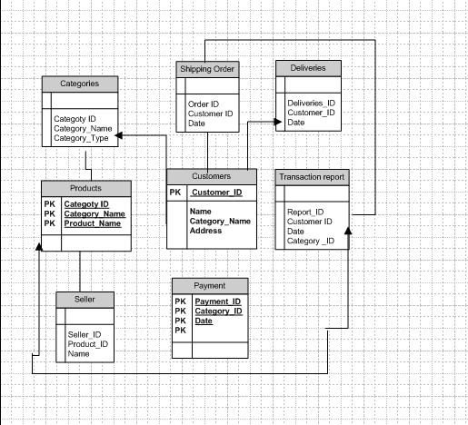

Question 7:
Inflow / Outflow Representation
1. External Entity
- Farmer (User) starts the process by requesting a product.
2. Process: "Place Order"
- Receives input: farmer details + product request.
- Produces output: order confirmation + payment details.
3. Data Stores
- Users DB → provides User_ID & details.
- Products DB → provides Product_ID, description, price.
- Orders DB → stores Order_ID, User_ID, Product_ID, Total_Paid.
4. Flow of Data
- Order Info: User sends order information to Place Order process.
- Product Query: Place Order requests data about the product from Products.
- Product Details: Products send product details to Place Order.
- Save Order: Place Order records the transaction in Orders data store.
- Confirmation: Place Order sends confirmation/status back to User.
A data flow diagram (DFD) maps out the flow of information for any process or system. It uses defined symbols like rectangles, circles, and arrows plus short test labels to show data inputs, outputs, storage points and the routes between each destination.
Customer (external entity)
Browses and selects items.
Adds product to the Shopping Cart.
Processes (circles):
Add product to cart → Sends item to cart.
Checkout → Takes product details for payment.
Collect Payments → Handles billing and sends payment info to Card/COD/Netbanking system.
Order Issue → Sends shipping request to Inventory and ensures product delivery.
Data Stores ( rectangles):
Shopping Cart (stores added items).
Card/COD/Netbanking (payment methods).
Inventory (manages stock for shipping).
Data Flows (arrows):
Show how information like product details, payment info, and shipping requests move between processes, stores, and the customer.
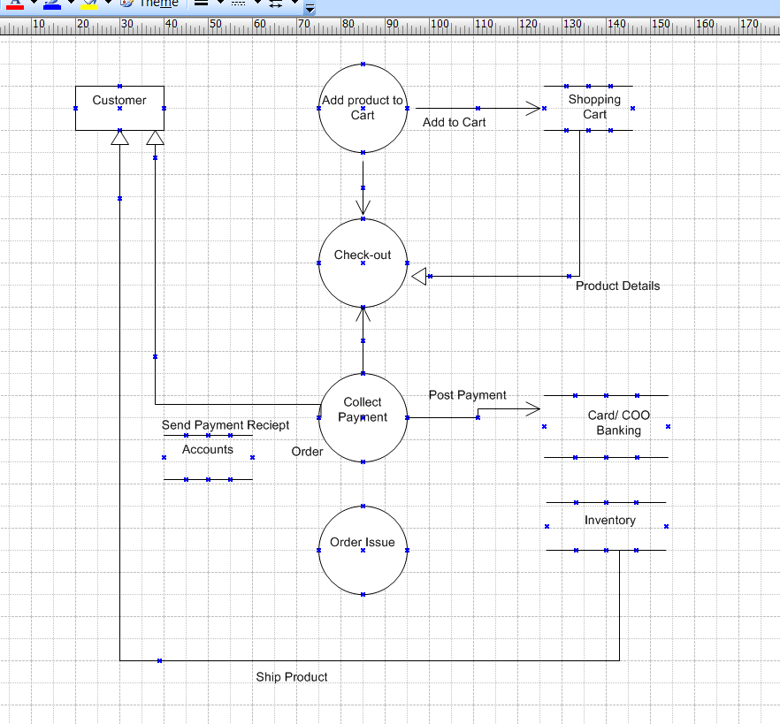

Question 8: Change Request – 10
Due to change in the Government Taxation structure . we should change the Tax structure How do you handle change requests in a project?

Ans :Change requests are when a stakeholder, either a client or an internal team or department, requests a change to the processes or deliverables that had already been decided upon in the project scope.
However, in this scenario, this change request has come up due to change in the Govt. Taxation structure. As a BA, I would analyze the request and clarify the stakeholders exactly what the request is asking us to do in the Online Agriculture Product Store. In a normal scenario, as a BA, I would first do the Feasibility Test, to check, how feasible it is to change the current ongoing project with the new change request.
However, in this case, Feasibility study is not required, as it’s a Govt structure which needs to be updated and followed. Therefore, I will follow the below steps to change the project as per the client’s requirements.
- Document the Change request.
- Look for any Supporting materials to help in adding this Change.
- Need to assess, whether the Change is an Inside or Outside scope. As its an outside scope, the Budget and time will get impacted.
- BA and PM should ensure whether the change is a minor or a major change. Policy changes by Govt is a major change request and we need to ensure that the change should be done according to the Govt. instruction.
- Fill the Change request Form and get the approval from the Project Manager.
- We must also ensure that our team understands the priority of this change request.
- Further on discussion for approval needs to be done with Change control Board, and once approval taken, project deliverables needs to be updated.
Question 9
Change Request Vs an Enhancement
As the project is in process, Ben and Kevin have contacted you. The reason is to inform you that they want the Farmers to sell their crop yields through this application i.e. Farmers should be able to add their crop yields or products and display to general public and should be able to sell them. They also want to introduce Auction system for their Crop yields. As a BA, what will be your response? Is this a change request or an enhancement???
Ans:
1.Understand the Request: Understand the nature of the request and the reason behind it. Is the request asking for a modification to an existing feature or a new feature altogether?
2.Analyze the Impact: Analyze the impact of the request on the project. Will the request require significant changes to the project's scope, timeline, or budget?
3.Evaluate the Priority of the request.
Is the request critical to the project's success, or can it be deferred to a later phase?
4. Determine the Type: Based on the above analysis, determine whether the request is a change request or an enhancement.
A change request is a formal proposal for an alteration to some product or system. In project management, a change request often arises when the client wants an addition or alteration to the agreed-upon deliverables for a project. Such a change may involve an additional feature or customization or an extension of service, among other things.
An enhancement project is one in which new capabilities are added to an existing system. Enhancement projects might also involve correcting defects, adding new reports, and modifying functionality to comply with revised business rules or needs.
So, this is an enhancement in the project.
By following the above-mentioned points
The request from Ben and Kevin is an Enhancement request, as they want to add another feature in the Online store, which will also help the Farmers to sell the yields directly in the online store, apart from buying products. Hence my response would a positive response to them.
Therefore as a BA, I should analyze the request and provide a project plan, requirement, design, an testing plans for this request. I must prepare an enhancement request form and decide how much manpower and manhours required for this enhancement request.
Question 10:
Come up with estimations – How many Manhours required
Manhours Required = Total hours working per day x Total number of members x Total numbers of days worked over the specific period.
Time period provided = 18 months = 547 days = 78 weeks (Including Weekends and Public Holidays)
Assumption: team = 12 members (listed/derived from your doc). Each full-time person = 3,120 hrs (78 weeks × 40 hrs).
Per-person calculation
78 weeks X 40 hours/ week = 3,120 Hours/ per person
Role-wise manhours (headcount × 3,120 hrs)
- Java Team (5 people) → 5 × 3,120 = 15,600 hrs
- Project Manager (1) → 3,120 hrs
- Network Admin (1) → 3,120 hrs
- DB Admin (1) → 3,120 hrs
- Testers (2) → 2 × 3,120 = 6,240 hrs
- Business Analyst (1) → 3,120 hrs
- Support / Other (1) → 3,120 hrs
Sum is equal to 37,440 Hours.
Type of Resource | Months | No of Resources
BA | 3 | 1
Project Management | 1 | 1
Senior Developer | 2.5 | 4
Java Team | 2.5 | 2
Database Team | 2 | 2
Tester | 4 | 2
Question 11: UAT – 6 Marks
Project has finally completed all the stages i.e., design, development, testing etc. Now, it is the role of a business analyst to contact the client for testing of the final product and have to successfully complete it. How are you going to handle this situation? And once it is done, what will be the process to close the project? Explain UAT Acceptance process
Ans:
To address the situation, below steps can be followed:
1. Get ready, for User Acceptance Testing (UAT); Before reaching out to the client, we need to make sure that the product is fully prepared for UAT. This helps ensure that all requirements have been met, conducting testing of the product and resolving any defects.
2. Reach out to the Client: Once the product is ready for UAT, it’s time to get in touch with the client to arrange a time for testing. Provide them with all the information such as the plan, test cases, and any relevant documentation.
3. Conduct User Acceptance Testing: During UAT it will be essential to collaborate with the client as they test the product against their requirements. Working together to identify and resolve any issues that arise.
4. Obtain Approval: Once UAT is successfully completed, obtain approval, from the client confirming their acceptance of the product. This approval has to be documented in a UAT Client Project Acceptance Form.
5. Wrap up the Project; With client acceptance of the product secured it’s time to wrap up all project activities systematically. Delivering the product or service and formally closing out all project-related tasks are components of this phase.
We have the option to utilize a project completion document, for the purpose of summarizing the outcomes of the project encompassing the deliverables insights gained throughout the process and overall achievement of the project. It is important to acquire approval, from the client or stakeholders affirming their acceptance of the deliverables and acknowledging that the project has reached its conclusion.

Question 12: Explain Project Closure Document
Ans: Project closure is a formal written assessment of a project. The purpose of the project closure document is to formally close a project and authorize the handoff. It is a crucial document that helps to ensure that all project stakeholders are aware of the project’s completion and that all necessary steps have been taken to close the project.
The document typically includes the following information:
- Project Overview: A brief summary of the project, including its objectives, scope, and constraints.
- Project Deliverables: A list of the final deliverables produced by the project.
- Lessons Learned: A summary of the lessons learned during the project, including what worked well and what could be improved in future projects.
- Project Success: An assessment of the project’s overall success, including whether it met its objectives, stayed within budget, and was completed on time.
- Project Sign-Off: A formal sign-off from the client or stakeholders indicating that they accept the final deliverables and that the project is complete.
To create a project closure document, you would need to follow the steps below:
Gather Information: Collect all the necessary information about the project, including the final deliverables, the lessons learned, and the project's overall success.
Create the Document: document creation is required to summarize the project's results. One can use a template for the same.
Review and Approve: Review the document with the project team and stakeholders to ensure that all necessary information is included and that everyone agrees with the document's contents.
Sign-Off: Obtain formal sign-off from the client or stakeholders indicating that they accept the final deliverables and that the project is complete
Sample of Project Closure Document
Project Name: Online agriculture Product Store
Project No: ABCD Project Manager : Mr. Vandanam
Date: xx/09/xxxx
Handover: Change reque st document and approval of change request document.
Reason for closure: Is it being closed because all project objects and deliverables are met.

