Online Agriculture Products Store

Mr. Henry, after being successful as a businessman and has become one of the wealthiest persons in the city. Now, Mr. Henry wants to help others to fulfill their dreams. One day, Mr. Henry went to meet his childhood friends Peter, Kevin and Ben. They live in a remote village and do farming. Mr. Henry asked his friends if they are facing any difficulties in their day-to-day work.
Peter told Mr. Henry that he is facing difficulties in procuring fertilizers which are very important for farm. Kevin said that he is also facing the same problem in-case of buying seeds for farming certain crops. Ben raised his concern on lack of pesticides which could help in greatly reducing pests in crops.
After listening to all his friends’ problems, Mr. Henry thought that this is a crucial problem faced not only by his friends but also by so many other farmers. So, Mr. Henry decided to make an online agriculture product store to facilitate remote area farmers to buy agriculture products. Through this Online Web / mobile Application, Farmers and Companies (Fertilizers, seeds and pesticides manufacturing Companies) can communicate directly with each other.

The main purpose to build this online store is to facilitate farmers to buy seeds, pesticides, and fertilizers from anywhere through internet connectivity. Since new users are involved, Application should be user friendly.
This new application should be able to accept the product (fertilizers, seeds, pesticides) details from the manufacturers and should be able to display them to the Farmers. Farmers will browse through these products and select the products what they need and request to buy them and deliver them to farmers location.

Mr. Henry has given this project through his Company SOONY. In SOONY Company, Mr Pandu is Financial Head and Mr Dooku is Project Coordinator. Mr. Henry , Mr Pandu , and Mr Dooku formed
one Committee and gave this project to APT IT SOLUTIONS company for Budget 2 Crores INR and
18 months Duration under CSR initiative. Peter, Kevin and Ben are helping the Committee and can
be considered as Stakeholders share requirements for the Project.
Mr Karthik is the Delivery Head in APT IT SOLUTIONS company and he reached out to Mr Henry through his connects and Bagged this project. APT IT SOLUTIONS company have Talent pool Available for this Project. Mr Vandanam is project Manager, Ms. Juhi is Senior Java Developer, Mr Teyson, Ms Lucie, Mr Tucker, Mr Bravo are Java Developers. Network Admin is Mr Mike and DB Admin is John. Mr Jason and Ms Alekya are the Tester. And you joined this team as a BA.

Question 10 – Use Case Diagram - 10 Marks
Draw use case diagram

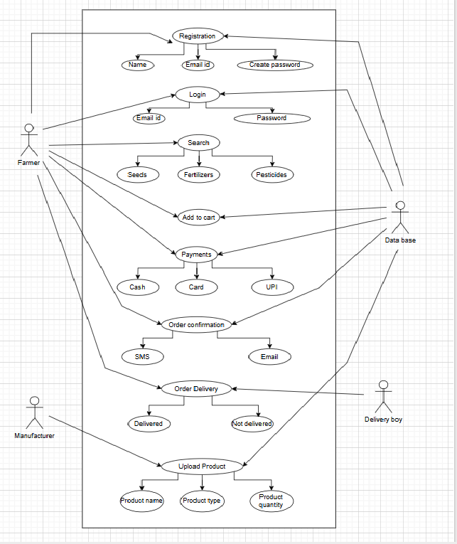Question 11 – (minimum 5) Use Case Specs - 15 Marks
Prepare use case specs for all use cases

Use Case ID | UC01
Use Case Name | Farmer Registration/Login
Created By | SK
Date created | 15-Aug
Last updated | 16-Aug
Actor(s) | Farmer
Description | Allows a farmer to register or log in to the system.
Preconditions | The farmer has a device with internet access.
Post conditions | Farmer is registered or logged in successfully.
Normal Flow | 1. Farmer opens the app.  2. Chooses to register or log in.  3. Enters credentials or registration details.  4. System verifies details.  5. On success, farmer is redirected to the dashboard.
Alternate Flow | 3a. Invalid credentials → Show error, retry.  3b. Registration with missing data → Prompt to fill mandatory fields.
Frequency of use | High
Assumptions | It is assumed that the user has internet connectivity

Use Case ID | UC02
Use Case Name | Browse and Search Products
Created By | SK
Date created | 15-Aug
Last updated | 16-Aug
Actor(s) | Farmer
Description | Farmer searches or browses available seeds, fertilizers, and pesticides.
Preconditions | Farmer is logged in.
Post conditions | Product list is displayed as per search or filters.
Normal Flow | 1. Farmer logs in.  2. Selects product category (seeds/fertilizers/pesticides).  3. Enters search keyword or filters by brand/type.  4. System displays matching products.  5. Farmer can view details of selected product.
Alternate Flow | 3a. No products found → Show “no results” message.  4a. System error → Retry or show error message.
Frequency of use | High
Assumptions | It is assumed that the user is logged in

Use Case ID | UC03
Use Case Name | Place Order
Created By | SK
Date created | 15-Aug
Last updated | 16-Aug
Actor(s) | Farmer
Description | Allows a farmer to place an order for one or more products.
Preconditions | Farmer is logged in and has selected product(s).
Post conditions | Order is placed and confirmation is sent.
Normal Flow | 1. Farmer adds product(s) to cart.  2. Proceeds to checkout.  3. Enters delivery address and payment option.  4. System processes payment (online or COD).  5. Order confirmation is displayed and sent via SMS/email.
Alternate Flow | 3a. Incomplete address → Prompt to complete.  4a. Payment failure → Retry or change payment mode.
Frequency of use | High
Assumptions | It is assumed that the user is logged in

Use Case ID | UC04
Use Case Name | Add/Manage Product (Manufacturer)
Created By | SK
Date created | 15-Aug
Last updated | 16-Aug
Actor(s) | Manufacturer
Description | Manufacturer adds or updates product details to be shown in the app.
Preconditions | Manufacturer is registered and logged in.
Post conditions | Product is visible to farmers.
Normal Flow | 1. Manufacturer logs in.  2. Selects “Add Product.”  3. Enters product details (name, category, price, stock, description).  4. Submits form.  5. System saves and displays the product to farmers.
Alternate Flow | 3a. Missing required fields → Show validation error.  4a. Duplicate product entry → Alert manufacturer.
Frequency of use | High
Assumptions | It is assumed that the user is logged in

Use Case ID | UC05
Use Case Name | Admin Approve Manufacturer
Created By | SK
Date created | 15-Aug
Last updated | 16-Aug
Actor(s) | Admin
Description | Admin reviews and approves manufacturer accounts.
Preconditions | Manufacturer has submitted registration.
Post conditions | Manufacturer gains access to product management features.
Normal Flow | 1. Admin logs in.  2. Opens "Pending Manufacturer Approvals".  3. Reviews manufacturer details and documents.  4. Approves or rejects request.  5. System updates manufacturer status and notifies them.
Alternate Flow | 3a. Documents not verified → Admin rejects with reason.  5a. Notification fails → Retry or show in-app message.
Frequency of use | High
Assumptions | It is assumed that the user is logged in

Question 12 – (minimum 5) Activity Diagrams - 15 Marks
Activity diagrams

Answer 12
1. User Registration & Login Activity Diagram

2. Product Search Activity Diagram

3. Add to Cart / Buy Later Activity Diagram

4. Order Placement & Payment Activity Diagram

5. Order Confirmation Activity Diagram

