COEPD – Prep Exam 3 –Part 1/2
1. Use Case diagram: A Use Case Diagram is a high level diagram and mother of all diagram. It is a type of Unified Modeling Language (UML) diagram that visually represents the interactions between actors (users or external systems) and a system to achieve specific goals.
The main focus of this diagram is on how external interfaces interacts with the proposed IT System.
Use Case Diagram is a graphical/visual representation of the interactions between users (actors) and a system. It illustrates the various ways in which users interact with a system to achieve specific goals or tasks.

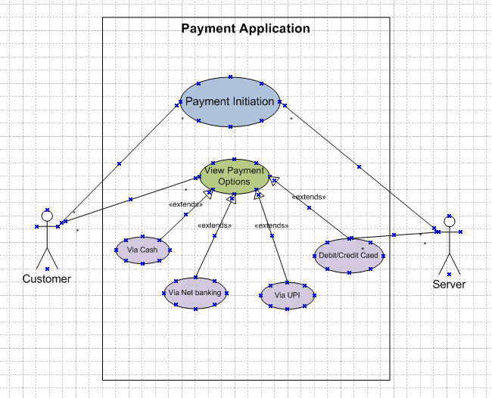
2.
A. Boundary Classes
- Act as the interface between the system and external entities (users, devices, or other systems).
- Used to handle interaction between system and external actors.
- Example- A LoginForm class that takes user credentials and passes them to the authentication system.
B. Controller Classes
- Acts as an intermediaries between boundary and entity class. Manage the flow of data between Boundary Classes and Entity Classes.
- Example: A Payment Controller class that processes transactions between a customer and the payment gateway.
C. Entity Classes
- Represent the core data and business logic of the application.
- Maintain attributes and behaviours related to core business functionality.
- Example: A Customer class that stores customer details like name, email, and purchase history.
3.Three Tier architecture:
The 3-Tier Architecture is one of the most popular and effective architectural models in the design and development of modern database-driven applications. It is widely used in Database Management Systems (DBMS) for organizing and managing complex data interactions across various layers of an application.
In DBMS, the 3-tier architecture is a client-server architecture that separates the user interface, application processing, and data management into three distinct tiers or layers.
Presentation Tier (User Interface Layer)-
- Card Payment Boundary
- PaymentMethod Selection Boundary
Application Tier (Business Logic Layer)
- Payment Controller
- Wallet Controller
Data Management Tier (Database Layer)
- Customer(Entity Class)
- Payment(Entity Class)
4.Domain Model for Customer making payment through Net Banking –
A Domain Model is a conceptual representation of the key entities, attributes, and relationships within a specific domain (business or system). It serves as a blueprint for understanding how different elements interact without diving into implementation details.

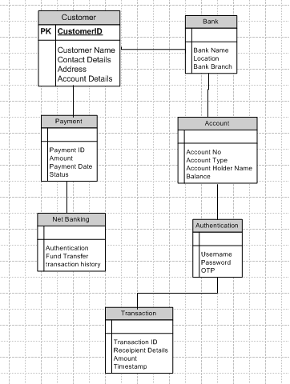

5.Sequence Diagram: A Sequence Diagram is used primarily to show the interactions between classes in the sequential order in which those interaction occurs. A sequential diagram can map a scenario described by a use case in step by step detail how classes collaborate to achieve your application’s goal.
It is a type of UML (Unified Modeling Language) diagram that visually represents how objects interact in a system over time. It shows the flow of messages between different components to accomplish a process.
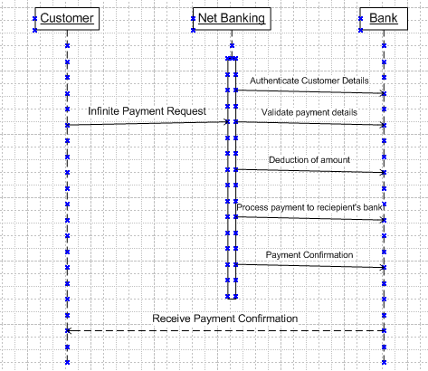

6.Conceptual Model: A Conceptual Model is a high-level representation of a system, focusing on its key concepts and their relationships without getting into technical or implementation details. It helps in understanding the structure of a domain and is often used in early phases of system design.
Key Elements of a Conceptual Model:
1️. Entities – Core objects or concepts in the system (e.g., Customer, Product, Order).
2. Attributes – Characteristics or properties of each entity (e.g., Customer has a name, email, phone number)
3. Relationships – Connections between entities (e.g., A Customer places Orders, an Order contains Products).
4. Constraints & Rules – Business logic governing the interactions (e.g., An Order must have at least one Product).
5. Processes – High-level workflows that describe how entities interact (e.g., Order Processing, Payment Verification).
6. Abstraction – Represents the system at a high level, avoiding implementation details like database schemas or programming structures.

7.MVC Architecture (Model-View-Controller) is a widely used design pattern for developing software applications, especially web applications. It helps in separating concerns, improving maintainability, and making applications more scalable.
View – Displays the user interface.
Example: A Profile Page displaying user details.
Model – Represents the data and business logic.
Example: A User model stores user data like name and email.
Controller – Manages user requests and communication between Model and View.
Example: A UserController handling login requests.
Model-View-Controller (MVC) rules in identifying classes:
  - Combination of one actor and an use case results to one boundary class.
  - Combination of two actors and an use case results to two boundary class.
  - Combination of three actors and an use case results to three boundary
Note: Only one primary actor is to be considered in one use case.

  - Use case will result in controller class.
  - Each actor will result in entity class.
In Model-View-Controller (MVC) architecture, classes are derived from Use Case Diagrams following structured rules.
guidelines to place identified MVC classes in 3-tier architecture:
  - Place all entity classes in DB layer.
  - Place primary actor associated boundary class in application layer
  - Place controller class in application layer
  - If governing body influence or reusability is there with any of remaining boundary class, place them in business logic layer else place them in application layer.
Each MVC class is placed within the appropriate layer in the Three-Tier Architecture:
Presentation Layer (UI)
- Contains: View classes (front-end UI)
- Example Classes: OrderSummaryPage, CheckoutPage

Application Layer (Business Logic)
- Contains: Controller classes (business logic & workflow)
- Example Classes: OrderController, PaymentController

Data Layer (Database)
- Contains: Model classes (data management)
- Example Classes: OrderEntity, CustomerEntity
8.BA contributions in project (Waterfall Model – all Stages)
Stage | Activities | Artifacts & Resources
Pre-Project | Conduct enterprise analysis, feasibility study, define business needs, identify stakeholders which helps in preparing a business case, project scope and understanding the risks involved. | SWOT, GAP Analysis, Market Research, Root cause analysis, Feasibility report, business case, stakeholder list
Planning | Develop project plan, define objectives, allocate resources | Project plan, Stakeholder analysis, Gantt chart, risk assessment report
Project Initiation | Set up governance structure, define roles, facilitate kickoff meetings | Kickoff agenda, governance structure, RACI matrix
Requirements Gathering | Elicit requirements via interviews, workshops, surveys, analyze needs. Prepare BRD and make protype for client understanding. | Requirements document, interview notes, workshop outputs
Requirements Analysis | Validate and prioritize requirements, create use case diagrams, sign off in SRS document and prepare RTM | UML Diagrams, Use case diagrams, process flowcharts, validation report
Design | BA communicates client on the design and. BA Create functional specifications, wireframes, prototype with the design team for helping the client understand the final product. | System design document, wireframes, prototype feedback
Development/Coding | BA provide JAD sessions support developers by clarifying requirements, track changes | Change request log, requirement clarification documents
Testing | BA or testing team prepares test cases from the use cases. Develop test scenarios, support UAT, track defects and resolutions. Updates RTM and takes sign off on UAT. | Test cases, UAT plan, defect log
UAT (User Acceptance Testing) | Forwards RTM to client or PM to be attached to the project closure document. Facilitate UAT, gather end-user feedback, ensure issues are addressed | UAT feedback report, issue resolution log

9.Conflict Management management is the practice of being able to identify and handle conflicts sensibly, fairly, and efÏciently. It is the process of dealing with disagreements arising from, for example, diverging opinions, objectives, and needs.
It is the process of identifying, addressing, and resolving disagreements in a way that minimizes negative impacts while fostering positive relationships. It is crucial in workplaces, organizations, and personal interactions to ensure smooth collaboration and productivity.
Thomas-Kilmann Conflict Management Model
The Thomas-Kilmann Conflict Mode Instrument (TKI) is one of the most widely used frameworks for managing conflict.
X Axis-Cooperative, Y-Axis-Assertiveness
It categorizes conflict resolution styles into five modes, based on two dimensions:
- Assertiveness – The degree to which an individual pushes their own needs.
- Cooperativeness – The extent to which an individual accommodates others' needs.
5 Steps to Conflict management:
- Identifying the conflict
- Discuss the detail
- Agree with the root problem
- Check for every possible solution for the conflict.
- Negotiate the solution to avoid future conflicts.
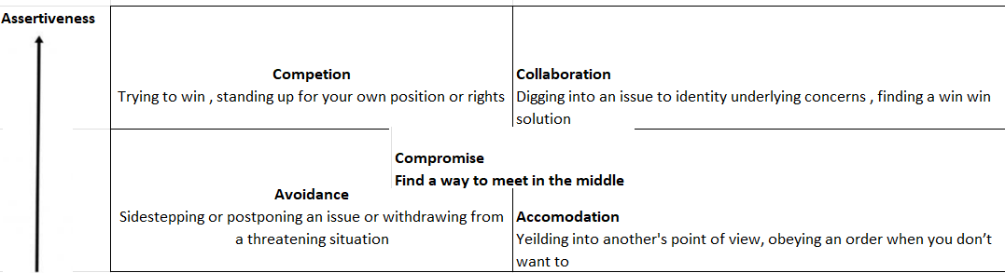
1.Competing:
We have high assertiveness and low empathy. We use competing as a conflict resolution strategy
whenever we resort to being aggressive. In addition, we also get uncooperative with the opponent.
The first strategy for dealing with conflict is competing. This strategy works well when you are in a
commanding position and have limited time and resources to resolve the conflict.
2. Avoiding
We see low assertiveness and low empathy. That means you neither asset your position nor do you
consider or emphasize the other party's point of view.
The second strategy for dealing with conflict involves avoiding it.
People use this conflict management strategy when they know that they don't have any authority over
the other person. Instead, they avoid confrontation by ignoring or avoiding the conflict entirely.
3. Accommodating
We find low assertiveness and high empathy.
Accommodating is a third strategy for dealing with conflict.
The idea behind this approach is to make concessions. For example, if one person makes a request, you
agree to do what the first person requested instead of arguing about the matter.
It's an effective way to manage conflict when you lack power
4. Collaboration
We see high assertiveness and high empathy.
When you collaborate, you take a moderate approach to solving problems. You attempt to balance
power between yourself and another person. You also try to find common ground and work together
towards achieving a shared goal.
It's an ideal choice if both parties are committed to reaching a mutual agreement. The goal here is to
reach an agreement with each other. It also needs two people who trust each other and value working
together
5. Compromising
which is compromising. This is the middle of the assertiveness and empathy scales.
If you compromise, you take the middle road between opposing views. This means agreeing to specific terms and giving up on certain other items. And since you're trying to resolve a disagreement, it's important that you show flexibility

10. The reasons for project failure:
1. Improper Requirement Gathering- Inadequate research and unclear business needs lead to misaligned solutions.
2️. Continuous Change in Requirements (Scope Creep): Constant modifications without proper documentation disrupt project timelines and increase costs.
3️. Lack of User Involvement: Failure to engage stakeholders and gather feedback results in a system that doesn't meet actual user needs.
4️. Lack of Executive Support: Weak sponsorship from leadership reduces funding, decision-making speed, and overall priority.
5️. unrealistic Expectations: Overambitious goals, tight deadlines, and impractical budgets make project success unlikely.
6️. Improper Planning: Poor project scheduling, resource allocation, and risk assessment lead to delays and inefficiencies.
7️. Poor Communication & Stakeholder Engagement: Misunderstandings between teams cause delays and conflicting objectives.
8️. Technical Challenges & Lack of Testing: Faulty software design or insufficient testing leads to defects, system crashes, and costly fixes.

11.Challenges Faced in Projects for BA
1. Lack of Training
- Insufficient domain knowledge and business understanding can lead to ineffective analysis.
- Regular upskilling and workshops are necessary for BA efficiency.
2️.Obtaining Sign-off on Requirements
- Stakeholders may delay approval due to unclear or changing expectations.
- Ensuring comprehensive requirement documentation and stakeholder engagement helps secure timely sign-offs.
3️. Change Management – with Respect to Cost and Timelines
- Unplanned requirement changes impact budgets and project schedules.
- Effective change control processes ensure smooth adaptation with minimal disruption.
4️. Coordination Between Developers and Testers
- Miscommunication between development and testing teams causes defects or delays.
- Clear documentation and frequent collaboration resolve misunderstandings.
5️. Conducting Meetings
- Meetings may lack structure, leading to ineffective discussions and wasted time.
- Agendas, action items, and follow-ups improve meeting efficiency.

6️. Making Sure Status Reporting is Effective
- Poor reporting can lead to misalignment and missed deadlines.
- Regular status updates with key metrics ensure project transparency.
7️. Driving Clients for UAT Completion
- Clients may delay testing due to lack of availability or unclear expectations.
- Setting deadlines and providing clear testing guidelines encourage timely UAT completion.
8️. People Management (Coordinating with Different People and Teams)
- Managing multiple stakeholders with varying priorities can be challenging.
- Strong interpersonal skills and proactive communication improve coordination.
9️. Overall Making Sure Project Health is in Good Shape and Delivered as Per Timelines Without Issues
- Unexpected risks, delays, or misalignment can affect project success.
- Continuous monitoring, risk assessment, and stakeholder engagement help maintain project health.
12.Document Naming Standards
All documents should follow a structured naming standards/format like:
[ProjectID][DocumentType]V[x]D[y].ext
Where:
- ProjectID → Identifies the relevant project.
- DocumentType → Specifies the type of document (e.g., Business Requirements Document (BRD), Technical Specifications, etc.).
- V[x] → Version number of the document (x represents the version).
- D[y] → Denotes a specific draft or iteration within the version.
- .ext → File extension (e.g., .docx, .pdf, .xls).
Examples:
- PQ786BRDV1D2.docx → Project PQ786, Business Requirements Document, Version 1, Draft 2.
- PQ786BRD1.2.docx → Project PQ786, Business Requirements Document, Version 1.2.
13.Dos and Don’ts as a Business Analyst

Sl No. | Do's | Don’t's
1 | Consult an SME for clarification in requirement. Always seek expert opinions when in doubt about requirements. | Never say NO to a Client
2 | Go the client with plain mind with no assumptions. Listen carefully and completely before asking queries. Avoid interruptions. | There is no word as “BY DEFAULT”
3 | Extract Possible Solutions from the Client First. Guide the conversation to let clients reveal their needs, rather than jumping to solutions based on past experience. | Never imagine anything in terms of GUI
4 | Concentrate on the important requirements | Don't interrupt the client when he is giving you the problem
5 | Question the existence of existence/Question everything | Never try to give solution to the client straight away with your previos experiences and assumptions

14.
Aspect | Packages | Sub-Systems
Definition | A package is a way to organize related components, like grouping similar functionalities together. | A subsystem is a complete functional unit that performs a specific business operation within the system.
Purpose | Helps in structuring documents, models, or software components for clarity and easy navigation. | Represents a larger section of the system that works independently or interacts with other subsystems.
Scope | Limited to categorization and doesn’t function separately. | Acts as a functional module that contributes to the overall system.
Dependency | Packages group elements, but they rely on other packages for full functionality. | Subsystems can be independent or connected to other subsystems, but they offer complete business functions.
Example | In an HR system: A Payroll Package can include salary calculations, tax deductions, and payslips. | In an HR system: A Payroll Subsystem handles everything related to payments, including salaries, bonuses, taxes, and reports.

15.Camel-casing is a naming convention used in documentation, process flows, and system design to ensure consistency in naming variables, objects, and key elements within a project.
- It is commonly used in system requirements, database structures, APIs, and user interface components.
- It is used for naming variables, functions and identifiers.
- Camel-casing is a naming convention in programming where multiple words are combined without spaces, and each word (except the first in some cases) starts with a capital letter. This improves readability in code and avoids special characters that may cause errors.
Eg-CamelCase: camelCaseExample
In Camelcasing, the first words start with a lower case letter and each subsequent word begins with an uppercase letter
Types of Camel-Casing
1️. Lower Camel Case (camelCase) – First word starts in lowercase, subsequent words start in uppercase. Example: customerName, orderStatus, validateUserInput
2️. Upper Camel Case (PascalCase) – Each word starts in uppercase, including the first word.
Example: CustomerName, OrderStatus, ValidateUserInput
How Business Analysts Use Camel-Casing?
Requirement Documentation – Naming business terms in a structured format (customerName, orderAmount).
Process Flow Diagrams – Labeling elements consistently (OrderProcessing, PaymentVerification).
Database Schema Definition – Ensuring logical field names (productID, transactionDate).
APIs & System Integration – Standardizing data exchanges (invoiceNumber, userEmail).
User Interface (UI) Elements – Naming input fields (searchBox, loginButton).

16. Development Server Overview
A Development Server refers to a dedicated environment that is used during the software development process.
It is an environment where software applications are built, tested, and modified before moving to production. It allows developers, testers, and Business Analysts to collaborate on system enhancements without affecting live operations.
A BA typically has limited access compared to developers but plays a crucial role in reviewing and validating features. Here’s what a BA can usually access:

Access Type | BA Role in Development Server
Requirement Validation | Verify implemented business rules against requirements.
Test Data Management | Provide sample input data for functional testing.
User Interface (UI) Review | Validate screen layouts, workflows, and navigation.
Bug & Defect Tracking | Report and track defects, ensuring resolution before UAT.
Documentation & Logs | Review system logs and project documentation for analysis.
APIs & Integration Checks | Validate API responses related to business processes.
Limited Database Access | Read-only access to verify data integrity in test environments.

17.Data Mapping:
Data Mapping is the process of connecting data from one source to another.
It is like creating a guide or map that shows how data in one place corresponds to data in another place.
This is especially important when you’re moving data between different systems or databases to ensure that the data stays consistent and accurate.
Data mapping is the process of matching fields from one database to another for data migration, integration, transformation, and warehousing. It's the first step to facilitate data migration, data integration, and other data management tasks.
Data mapping is an essential part of many data management processes. If not properly mapped, data may become corrupted as it moves to its destination.

18.API
An API or Application Programming Interface, is a set of rules and tools that allows different software application to communicate with each other. It is like a bridge that connects two systems and lets them share data or services.
It defines the methods and data formats that application can use to request and exchange information.,
An API (Application Programming Interface) is a set of rules and protocols that allows different software applications to communicate with each other. APIs enable the integration of data, services, and functionalities from various applications, making it easier for developers to build complex systems without starting from scratch.
An API is a set of rules that allow different software applications to communicate with each other. Think of it like a bridge that connects two systems and lets them share data or services.
EG-
API example usage is the "log in with Facebook/Twitter/Google/GitHub" capability seen on many websites.
Restaurants interact with databases pertaining to restaurants through a restaurant Application Program Interface (API)
Google Maps APIs to pull customized location data, send directions, and analyze all types of location data

