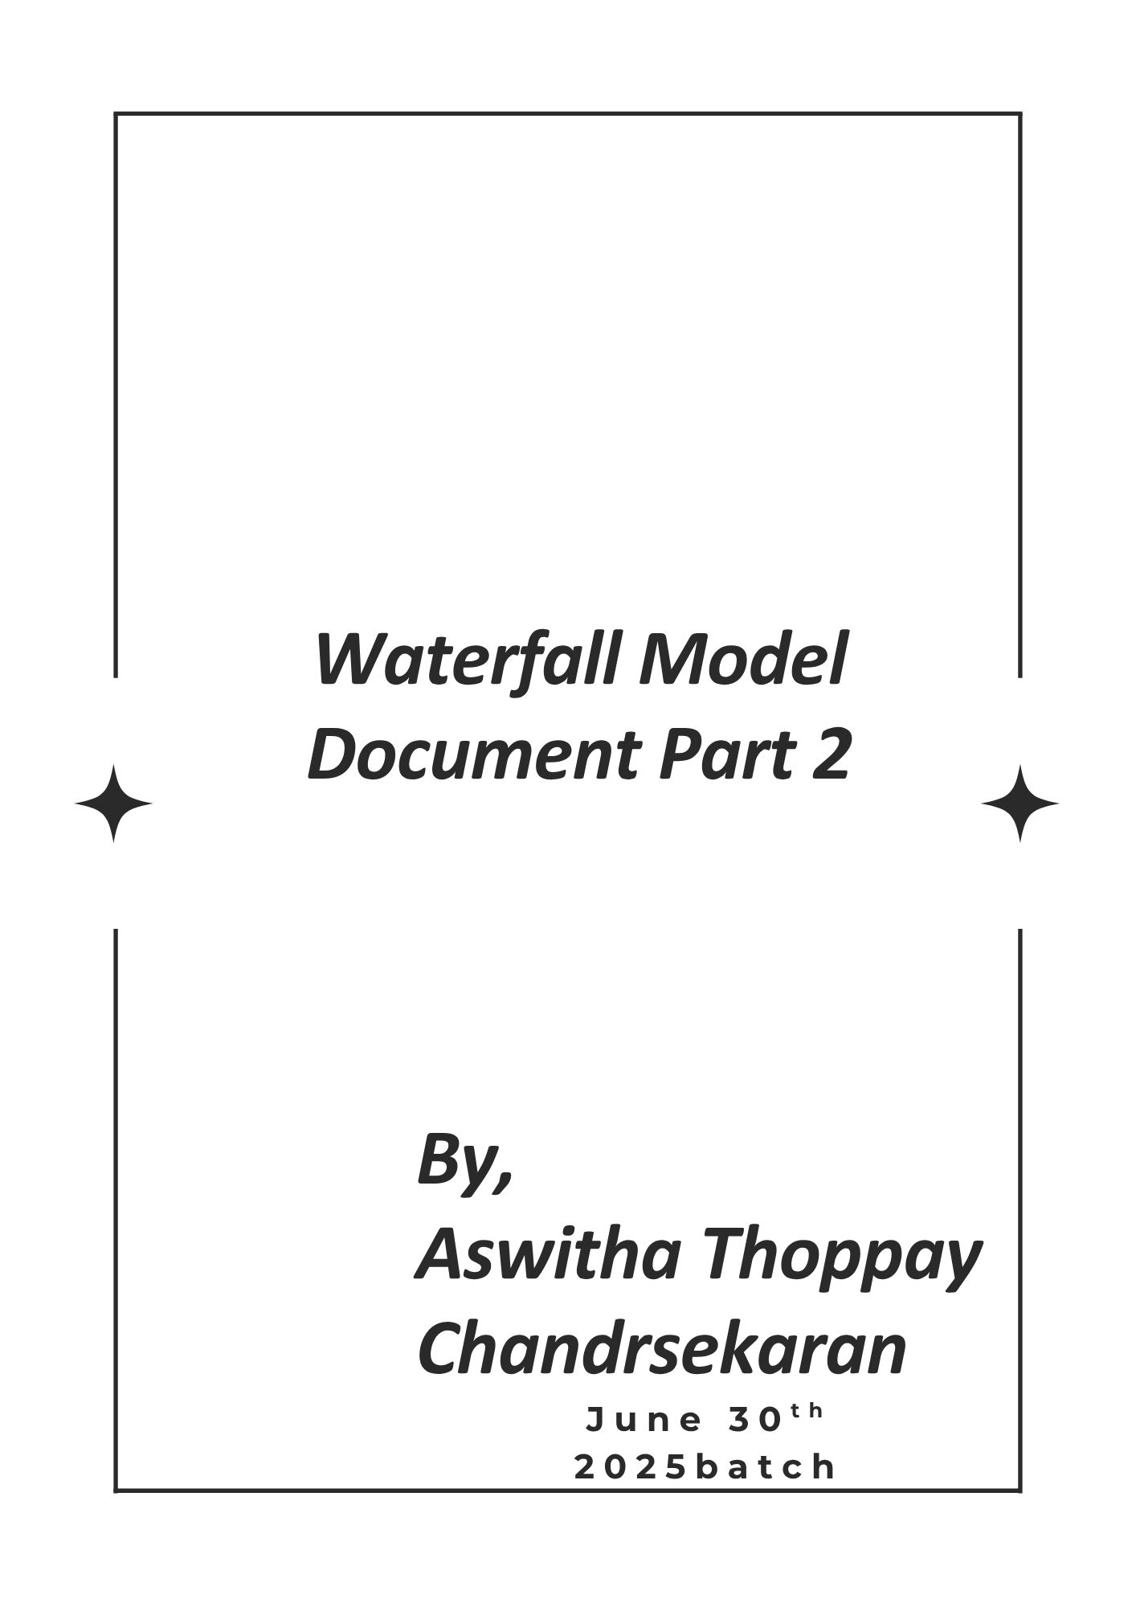

Document 6- Please prepare a use case diagram, activity diagram and a use case specification document.

  - Use case Name
  - Use case Description
  - Actors Primary Actors Secondary actors
  - Basic Flow
  - ALTERNATE FLOW
  - Exceptional flows
  - Pre- Conditions
  - post-conditions
  - Assumptions
  - Constraints
  - Dependencies
  - Inputs and Outputs
  - Business Rules 14.Miscellaneous Information

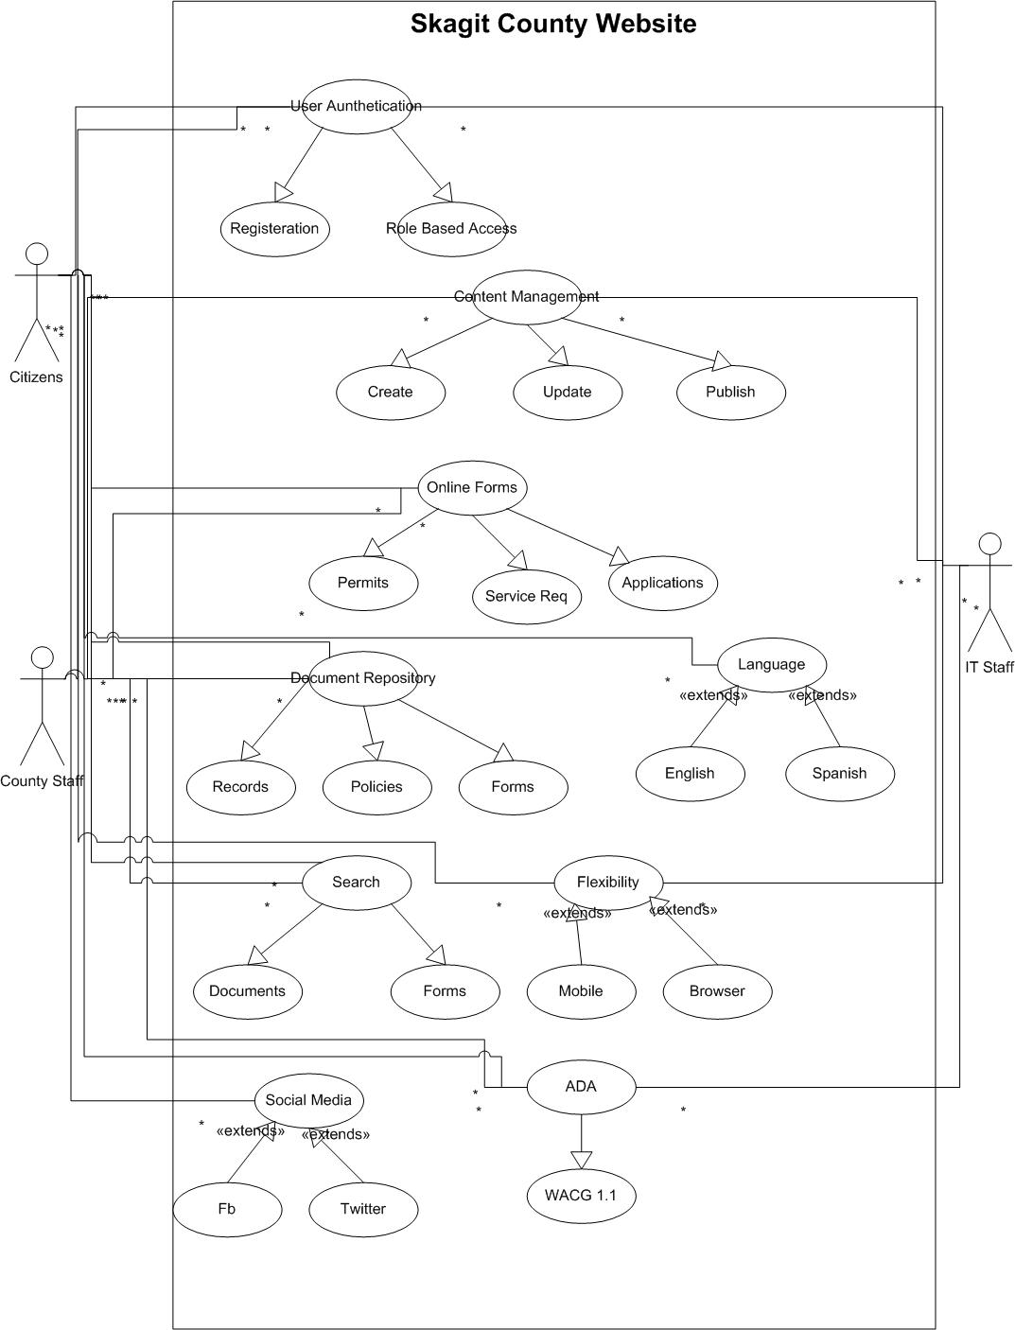
Figure 1-Skagit County Use Case Diagram
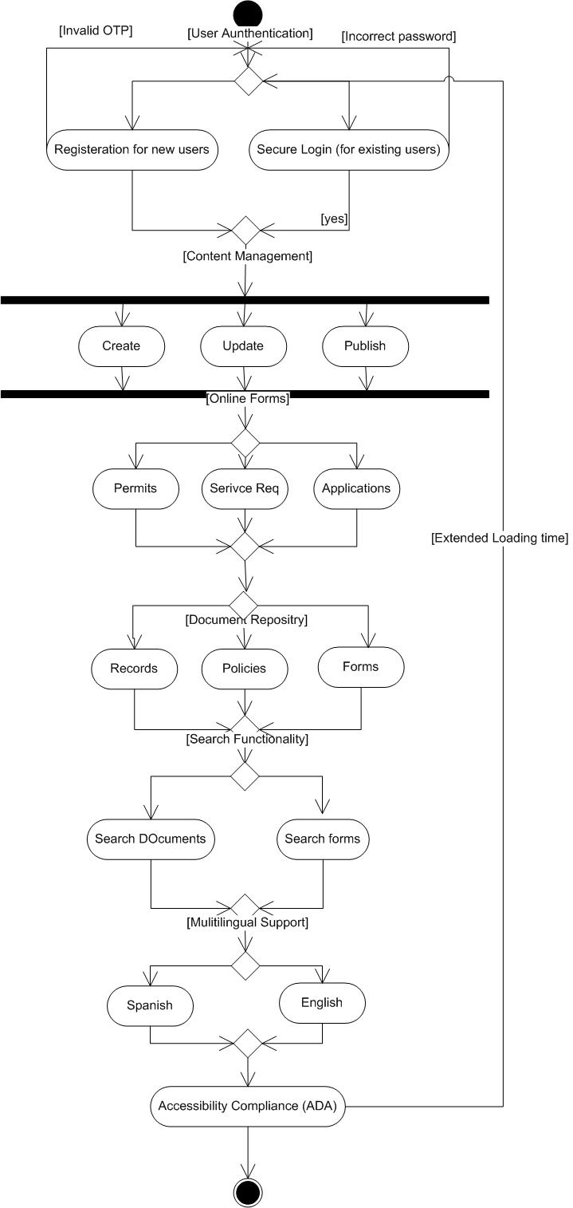
Figure 2-Skagit County Activity Diagram

Use case ID | UC001
Use case Name | User Authentication
Created by | Aswitha Last updated by 14 Oct 2025
Date created | 14 Oct 2025 Last revision Date 14 Oct 2025
Actor | Primary Actors: Citizens, County Staff  Secondary Actor: IT Department (ensures identity management, security policies)
Description | This use case describes how citizens and county staff securely log in to the Skagit County website with role-based access (Admin, Editor, User). It ensures only authorized users can access restricted services while citizens can self-register and log in for online services.
Pre conditions | - User must have an active internet connection.  - Citizens must have registered (if not, they must complete the registration first).  - County staff roles (Admin, Editor) must be pre-assigned in the CMS.
Post conditions | - User gains secure access with permissions appropriate to their role.  - System logs authentication attempt in the audit trail.
Normal flow /Basic flow | - User navigates to the website login page.  - User selects either Register (new user) or Login (existing user).  - System validates credentials (username, password, or multi-factor authentication).  - If valid, user is authenticated and granted role-based access (Admin, Editor, or User).  - User proceeds to use assigned website features.
Alternative flow | A1: Forgot Password Flow  - User selects “Forgot Password.”  - System sends a password reset link or OTP via email/SMS.  - User resets credentials and logs in.
Exceptions | - Invalid login credentials entered → system shows error and allows retry.  - Account locked after 5 failed attempts → requires reset by IT or email verification.  - Network/system error during login → system displays maintenance/error page.
Frequency of use | High
Assumptions | - Citizens will mostly use self-service login.  - Staff roles are predefined by the County IT Department.  - MFA (multi-factor authentication) may be introduced in later phases.
Constraints | - Must comply with government security standards and ADA/WCAG accessibility.  - Authentication must occur within 3 seconds under normal load.  - Password complexity rules enforced (minimum 8 characters, mixed type).
Dependencies | - Depends on user registration process for new citizens.  - Depends on integration with CMS user role management.  - Depends on AWS GovCloud security and authentication services.
Inputs and Outputs | - Inputs: Username, Password, MFA token (optional).  - Outputs: Success message, dashboard access, or error message.
Business Rules | - Users must authenticate before accessing restricted content.  - Each role (Admin, Editor, User) is mapped to specific website permissions.  - All login attempts must be logged for auditing purposes.
Miscellaneous Information | - Accessibility features must allow screen readers and keyboard navigation on login pages.  - Login page branding must align with Skagit County visual guidelines.  - Future integration possible with Single Sign-On (SSO) for staff.

Document 7- Screens and pages
Please follow the following steps to create the mock-ups
    - Kindly use balsamic or Axure.
    - Always start with a home page of an application.
    - Take a feature and follow it to the end

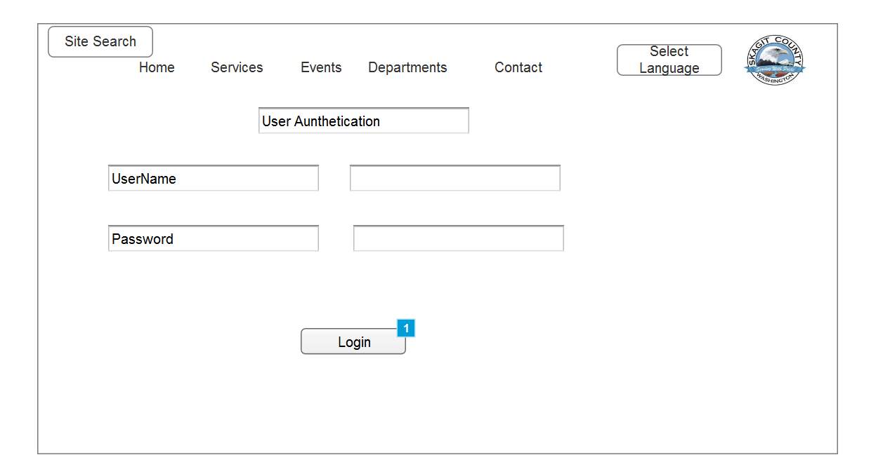
Figure 3-user Authentication

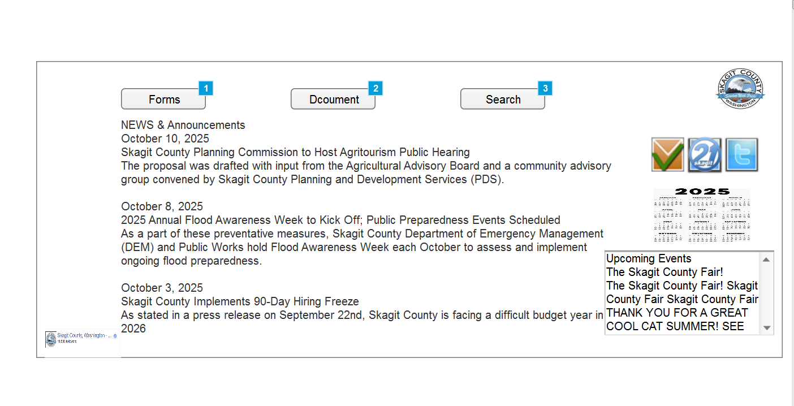
Figure 4 Website
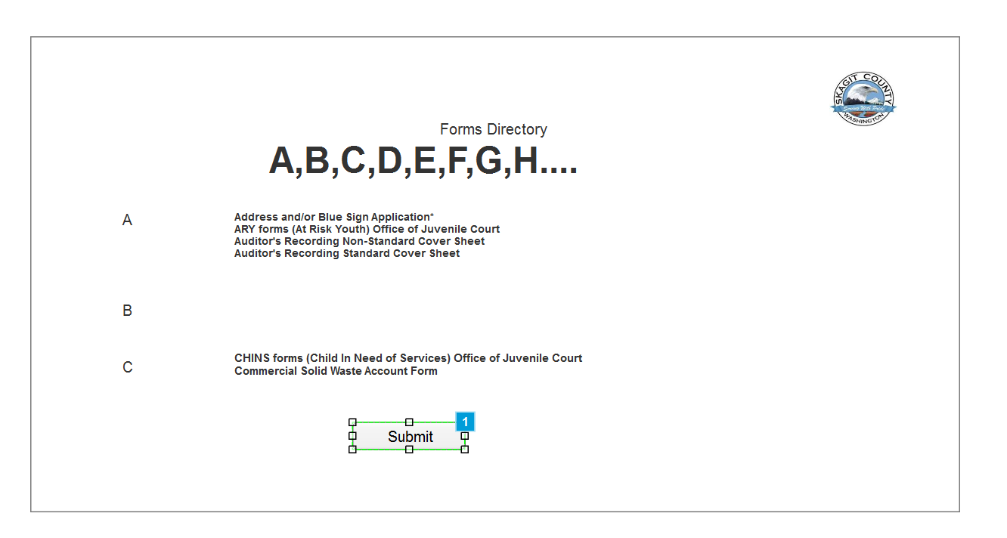
Figure 5Forms Directory

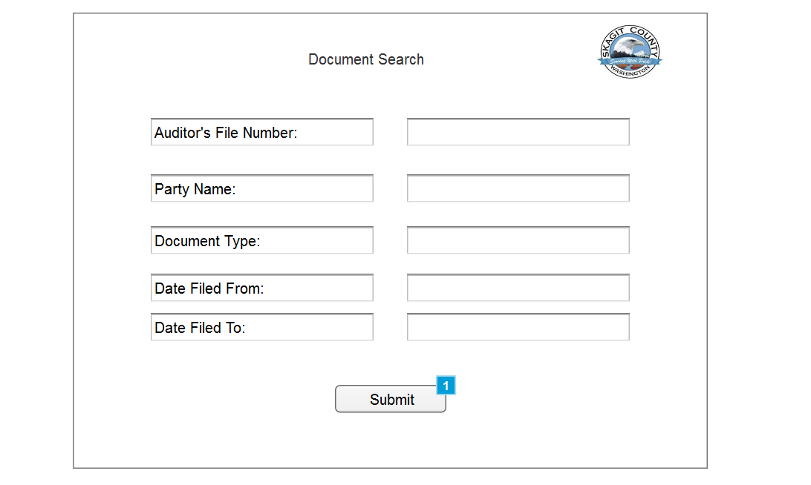
Figure 6-Document Search
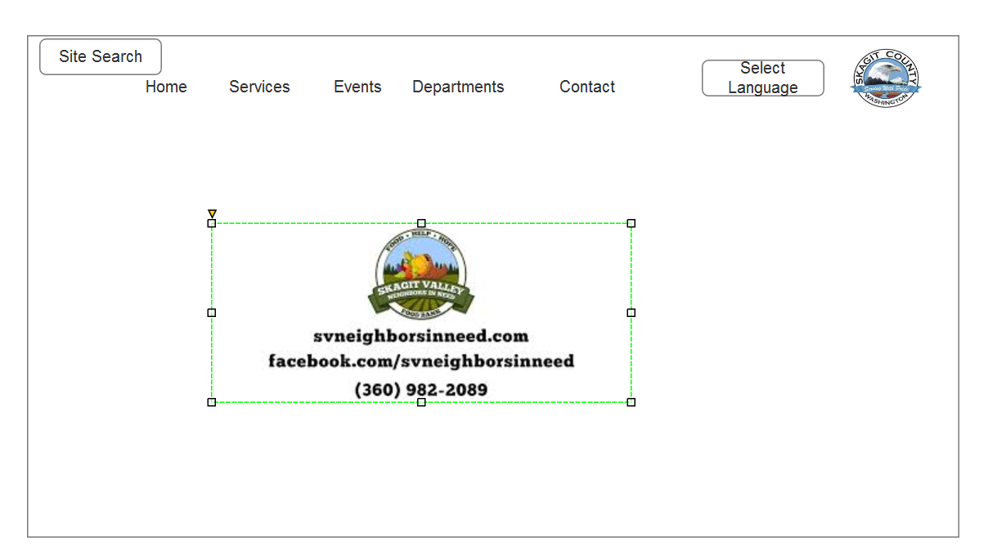
Figure 7Thank you

Document 8- Tools-Visio and Axure
Write a paragraph on your experience using Visio and Axure for the project.

Experience Using Visio and Axure for Skagit County Project
For the Skagit County Website project, I used Visio primarily for creating structured diagrams such as use case diagrams, activity diagrams. Visio provided predefined UML templates that helped me clearly represent user authentication flows, content management processes, and accessibility compliance. This ensured the diagrams aligned with industry-standard notations and were easy for stakeholders to understand. The drag-and-drop features and layering capability allowed me to manage complexity while maintaining readability.
On the other hand, Axure was used for building interactive mock-ups and wireframes of the County website. Starting from the home page, I built step-by-step screens covering the login page, search functionality, form submission, and logout process. Axure’s ability to add interactions made the mock-ups more realistic, allowing stakeholders to visualize how citizens and staff would navigate through the system. It also allowed me to test layouts for accessibility and responsiveness across devices, ensuring the design met WCAG 2.1 AA standards.
The combination of Visio and Axure brought strong value to this project: Visio provided clear documentation of requirements and processes (use cases, activity diagrams), while Axure demonstrated how those requirements translate into user-facing screens and interactions. Together, these tools supported both technical clarity and user experience validation, making them essential in bridging the gap between business analysis and design for the Skagit County project.

Document 9- BA experience

My experience as BA in following phases:

Requirement gathering:
- For this enhancement project, I focused on eliciting requirements from stakeholders rather than starting from scratch.
- I used techniques such as interviews with County staff and leadership, workshops, prototyping in Axure, and observation of citizen service requests to identify gaps in the current AS-IS system.
- For example, staff heavily relied on IT for routine content updates, and citizens struggled to find forms. I documented these as high-priority requirements. I also used document analysis of the existing website and policies to confirm compliance needs.
- By combining these techniques, I ensured requirements were clear, complete, and free from duplication.

Requirement Analysis:
- I performed a gap analysis between the AS-IS state (outdated CMS, poor navigation, lack of ADA compliance) and the TO-BE state (modern, mobile-responsive, self-service platform).
- I translated business needs into UML use case diagrams, activity diagrams, and workflows for clarity. These diagrams were shared with the team; when disagreements arose, I facilitated discussions to refine them.
- I prepared both the Business Requirement Document (BRD) to ensure alignment between County goals and technical delivery.
- Design:
- As a BA, I also created prototypes using Axure to show how the CMS, login, search, and online forms would work in the redesigned site. This helped the development team clearly understand functional flows.
- I also reviewed design documents with the Technical Architect and UX/UI team, ensuring WCAG 2.1 AA accessibility, usability, and security requirements were embedded at the design stage.

Development:
- I facilitated Joint Application Development (JAD) sessions with County IT and developers to clarify requirements and answer queries during coding. For example, when staff workflows (content publishing and form approvals) required clarification, I worked with department heads to finalize the business logic.
- I ensured a positive collaboration environment by addressing conflicts or misunderstandings one-on-one with stakeholders. My role also included aligning development with compliance expectations (e.g., accessibility, security, data handling).

Testing:
- I worked with QA to prepare test cases from use cases and validate both positive and negative flows (e.g., successful login vs failed login attempts). I ensured accessibility testing was conducted across multiple devices and browsers.
- I gathered test data from the County for scenarios like permits and service requests. I tracked test results against the RTM and helped prepare the County staff for UAT sessions, ensuring test scripts reflected real-world citizen scenarios.

Deployment:
- Before closure, I provided the County with the updated RTM, linking it to final sign-off. I helped prepare end-user manuals and organized training sessions for staff to ensure they could manage the CMS independently without IT dependency.
- I ensured attendance and engagement in these sessions, explaining how the new system streamlined content updates, citizen service requests, and compliance management.

