Capstone Project- 2

Q.1) Write Agile Manifesto
Ans. 4 Core Values
- Individuals and interactions over processes and tools- Focus on collaboration and teamwork rather than just rigid tools.
- Working software over comprehensive documentation- Deliver functional increments (like your Scrum Foods features) rather than heavy paperwork.
- Customer collaboration over contract negotiation- Work closely with stakeholders (Business Owner, Customer, Restaurant, etc.) instead of just sticking to predefined contracts.
- Responding to change over following a plan- Adapt to changing requirements (like new delivery options or payment features) instead of rigidly following initial plans.
12 Principles of Agile Manifesto
- Customer satisfaction through early & continuous delivery.
- Welcome changing requirements, even late in development.
- Deliver working software frequently.
- Business people & developers work together daily.
- Build projects around motivated individuals.
- Use face-to-face communication as the best form of conveying information.
- Working software is the primary measure of progress.
- Maintain a sustainable development pace.
- Continuous attention to technical excellence & good design.
- Simplicity—maximize the work not done.
- Self-organizing teams deliver best results.
- Regularly reflect and adjust for effectiveness.

Q.2) User Stories- Acceptance Criteria-BV-CP
Ans. User Stories- A user story is a brief statement that explains a software feature from the user's point of view, focusing on what they need and why.
Acceptance Criteria- Acceptance Criteria are a set of conditions or requirements that a product or feature must meet in order to be accepted by the user, customer, or stakeholders. They define how the user story should work and what must be true for it to be considered complete and functioning as expected.

Scrum Foods – User Stories (40 Total)
User Story No: 1 | Tasks: 2 | Priority: Highest
Delivery Boy

Register in Scrum Foods to deliver orders
BV: 500 | CP: 02
Acceptance Criteria

Registration screen with fields (Name, Password, Nation ID, Mobile, Email, Address), Register button, success notification

User Story No: 2 | Tasks: 2 | Priority: Highest
Restaurant Owner

View orders to see list of orders
BV: 500 | CP: 02
Acceptance Criteria

View orders tab, display in tabular format

User Story No: 3 | Tasks: 2 | Priority: Highest
Customer

Add address for order delivery
BV: 500 | CP: 02
Acceptance Criteria

Textbox for address, validation for 5km radius

User Story No: 4 | Tasks: 2 | Priority: Highest
Customer

Select payment mode
BV: 500 | CP: 03
Acceptance Criteria

Display modes, radio buttons, payment button, only 1 mode allowed

User Story No: 5 | Tasks: 2 | Priority: Highest
Admin

View restaurants for approval
BV: 500 | CP: 02
Acceptance Criteria

List of restaurants, verify details, approve/reject buttons, notification

User Story No: 6 | Tasks: 2 | Priority: Highest
Customer

View price of menu items
BV: 50 | CP: 01
Acceptance Criteria

Display price beside each menu item

User Story No: 7 | Tasks: 2 | Priority: Highest
Customer

View delivery boy contact details
BV: 50 | CP: 01
Acceptance Criteria

Show delivery boy name, number, picture in tracking field

User Story No: 8 | Tasks: 2 | Priority: Highest
Restaurant Owner

Provide time slots for customers
BV: 100 | CP: 02
Acceptance Criteria

Add “from” & “to” time in dashboard, submit, update confirmation

User Story No: 9 | Tasks: 2 | Priority: Highest
Business Owner

View restaurant revenue report
BV: 200 | CP: 03
Acceptance Criteria

Select reports, filters by date & region, generate, export Excel

User Story No: 10 | Tasks: 2 | Priority: Highest
Regional Admin

Manage regional restaurants performance
BV: 200 | CP: 03
Acceptance Criteria

Select date range, generate report (ID, Name, Revenue), export Excel

User Story No: 11 | Tasks: 2 | Priority: Highest
Admin

View regional revenue reports
BV: 100 | CP: 03
Acceptance Criteria

Dropdown for region, tabular performance view, download Excel/PDF

User Story No: 12 | Tasks: 2 | Priority: Highest
Customer

Chat with Regional Admin for refund
BV: 200 | CP: 02
Acceptance Criteria

Text fields, Order ID displayed, description, submit, Issue ID generated, success message

User Story No: 13 | Tasks: 2 | Priority: Highest
Customer

Track food order in real time
BV: | CP: 05
Acceptance Criteria

Map view, order status updates (Accepted, Prepared, Out for Delivery, Delivered)

User Story No: 14 | Tasks: 2 | Priority: Highest
Customer

Cancel food order
BV: 500 | CP: 03
Acceptance Criteria

Cancel button, confirmation popup, refund rules applied

User Story No: 15 | Tasks: 2 | Priority: Highest
Customer

Give feedback & rating
BV: 200 | CP: 02
Acceptance Criteria

Rating scale (1–5), comment box, submit

User Story No: 16 | Tasks: 2 | Priority: Highest
Delivery Boy

Update delivery status
BV: 500 | CP: 02
Acceptance Criteria

Status options (Picked up, On the way, Delivered), updates visible to customer

User Story No: 17 | Tasks: 2 | Priority: Highest
Restaurant Owner

Update menu items
BV: 500 | CP: 03
Acceptance Criteria

Add/Edit/Delete dishes, price field, save button

User Story No: 18 | Tasks: 2 | Priority: Highest
Restaurant Owner

View feedback from customers
BV: 200 | CP: 02
Acceptance Criteria

List feedback & ratings linked to orders

User Story No: 19 | Tasks: 2 | Priority: Highest
Delivery Boy

View assigned orders
BV: 500 | CP: 02
Acceptance Criteria

Order list with pickup address, customer address, estimated time

User Story No: 20 | Tasks: 2 | Priority: Highest
Admin

Approve/reject delivery boy registration
BV: 500 | CP: 02
Acceptance Criteria

List delivery boys, verify documents, approve/reject button

User Story No: 21 | Tasks: 2 | Priority: Highest
Business Owner

Update payments to restaurants
BV: 200 | CP: 02
Acceptance Criteria

Select restaurant, enter amount, update record, confirmation message

User Story No: 22 | Tasks: 2 | Priority: Highest
Business Owner

Update payments to delivery boys
BV: 200 | CP: 02
Acceptance Criteria

Select delivery boy, enter payment, update record, confirmation message

User Story No: 23 | Tasks: 2 | Priority: Highest
Customer

View restaurant profile
BV: 100 | CP: 02
Acceptance Criteria

Show restaurant name, address, license details, rating

User Story No: 24 | Tasks: 2 | Priority: Highest
Regional Admin

Handle refund requests
BV: 200 | CP: 03
Acceptance Criteria

View refund request, approve/reject, update customer & restaurant

User Story No: 25 | Tasks: 2 | Priority: Highest
Admin

Resolve customer issues
BV: 200 | CP: 02
Acceptance Criteria

View issue tickets, mark resolved, notify customer

User Story No: 26 | Tasks: 2 | Priority: Highest
Delivery Boy

Raise issue with admin
BV: 100 | CP: 02
Acceptance Criteria

Submit issue form with details, issue ID generated

User Story No: 27 | Tasks: 2 | Priority: Highest
Customer

Filter restaurants by cuisine
BV: 200 | CP: 03
Acceptance Criteria

Cuisine dropdown (Indian, Chinese, Italian, etc.), filter results

User Story No: 28 | Tasks: 2 | Priority: Highest
Customer

Filter restaurants by rating
BV: 200 | CP: 02
Acceptance Criteria

Select rating (4★+, 3★+), update results

User Story No: 29 | Tasks: 2 | Priority: Highest
Customer

View estimated delivery time
BV: 200 | CP: 02
Acceptance Criteria

Display expected delivery time before confirming order

User Story No: 30 | Tasks: 2 | Priority: Highest
Restaurant Owner

Verify delivery boy
BV: 200 | CP: 02
Acceptance Criteria

Access list of delivery boys, approve/reject verification

User Story No: 31 | Tasks: 2 | Priority: Highest
Regional Admin

Manage regional delivery boys
BV: 200 | CP: 03
Acceptance Criteria

Add, block, or verify delivery boys under region

User Story No: 32 | Tasks: 2 | Priority: Highest
Admin

Manage regional admins
BV: 200 | CP: 03
Acceptance Criteria

Add, edit, remove regional admins

User Story No: 33 | Tasks: 2 | Priority: Highest
Customer

View order history
BV: 100 | CP: 02
Acceptance Criteria

List past orders with details (date, items, price, rating)

User Story No: 34 | Tasks: 2 | Priority: Highest
Customer

Re-order from history
BV: 100 | CP: 02
Acceptance Criteria

“Reorder” button, adds items from past order to cart

User Story No: 35 | Tasks: 2 | Priority: Highest
Restaurant Owner

View revenue reports
BV: 200 | CP: 03
Acceptance Criteria

Select date range, display daily/monthly revenue

User Story No: 36 | Tasks: 2 | Priority: Highest
Delivery Boy

View revenue reports
BV: 100 | CP: 02
Acceptance Criteria

Show completed orders, earnings breakdown, export option

User Story No: 37 | Tasks: 2 | Priority: Highest
Customer

Apply discount coupons
BV: 200 | CP: 03
Acceptance Criteria

Coupon textbox, validation, discount applied

User Story No: 38 | Tasks: 2 | Priority: Highest
Customer

View popular dishes
BV: 100 | CP: 02
Acceptance Criteria

Highlight trending dishes based on orders

User Story No: 39 | Tasks: 2 | Priority: Highest
Admin

Approve/reject restaurant menu changes
BV: 200 | CP: 02
Acceptance Criteria

View requested menu updates, approve/reject

User Story No: 40 | Tasks: 2 | Priority: Highest
Business Owner

Generate business performance dashboard
BV: 1000 | CP: 05
Acceptance Criteria

Display revenue trends, orders by region, best restaurants

Q.3) What is epic? Write 2 epics
Ans. An Epic is a large body of work that can be broken down into multiple User Stories. An Epic usually represents a high-level feature or initiative that delivers significant business value. Epics are too big to complete in a single sprint, they are decomposed into smaller user stories.
Example – 2 Epics for Scrum Foods
Epic 1: Customer Order Management
Description:
As a Customer, I want to place, track, and manage my food orders so that I can get timely delivery and manage my preferences.
Business Value (BV): 500 (very high, since it’s core to the business)
Complexity Points (CP): 8 (high – multiple features: place order, payment, cancel, track, feedback)
Breaks into User Stories:
- Place food order (menu selection, add to cart)
- Select payment mode
- Track order in real time
- Cancel order
- Give feedback & rating
- View order history & reorder

Epic 2: Restaurant Management System
Description:
As a Restaurant Owner, I want to register, manage menu items, view orders, and analyze performance so that I can effectively run my restaurant on Scrum Foods.
Business Value (BV): 800 (important for smooth supply & variety of food)
Complexity Points (CP): 7 (medium-high – involves multiple integrations)
Breaks into User Stories (examples):
- Register restaurant & get approved by Admin
- Update menu items & pricing
- Provide delivery time slots
- View customer feedback
- Generate restaurant revenue reports

Q.4) What is difference between BV and CP
Ans. BV – Business Value
It means Importance of the feature (User Story) to the business / customer. Stakeholders, Product Owner, or Clients decides it.
It is estimated using Scrum Currency Notes (₹500, ₹200, ₹100, ₹50, ₹20, ₹10). Purpose is to helps in prioritization, Higher BV = Feature is more important to business.
Example: “Customer should be able to pay online” → BV = 1000 (very critical). “Customer can change profile picture” → BV = 50 (less critical).
CP – Complexity Points (Story Points)
It means the effort / complexity / time required to develop the feature. Scrum Developers (the technical team) decides it. It is estimated using Poker Cards (1, 2, 3, 5, 8, 13, 20, 40, 100). Purpose is to helps in sprint planning & capacity estimation Higher CP = More effort required.
Example: “Implement payment gateway integration” → CP = 8 (complex).
“Display delivery boy’s phone number” → CP = 1 (simple).

Q,5) Explain about Sprint
Ans. A Sprint is a fixed time-box in Scrum Framework during which the Scrum Team works to deliver a potentially shippable product increment.
It is the heart of Scrum where ideas are turned into value.
- Sprint = 2- 4 weeks of development work.
- Daily Scrum = 15-30 min stand-up every day inside the Sprint.

Q.6) Explain product Backlog and Sprint Backlog
Ans. Product Backlog
- It is a master list of everything that might be needed in the product.
- Contains all features, enhancements, bug fixes, technical work, research items etc.
- It is owned by the Product Owner.
- It is dynamic – items can be added, removed, or reprioritized anytime.
- Items are written as User Stories (with acceptance criteria).
- It reflects the long-term vision and overall scope of the product.
Sprint Backlog
- It is a subset of the Product Backlog.
- It contains only those items (user stories) that the team commits to complete in the current Sprint.
- It is owned by the Development Team.
- It is fixed during the Sprint (changes are rare, unless agreed by the team).
- It provides a short-term plan (just for the Sprint).

Q.7) What is impediments log? write 2 impediments
Ans. An Impediments Log is a register (list) maintained by the Scrum Master (or sometimes by the team) to track all obstacles, blockers, or challenges that prevent the Scrum Team from making progress during a sprint.
- It ensures visibility of issues.
- Helps the Scrum Master prioritize and resolve impediments quickly.
- Supports continuous improvement in later sprints

Example of 2 Impediments:
- Unavailability of Testing Environment
  - The QA team cannot test completed user stories because the staging server is down.
  - Impact: Delays in moving tasks from WIP to Done.
- Dependency on Third-Party API
  - Development is blocked because an external vendor has not yet provided access to the required API.
  - Impact: User story completion is delayed, affecting sprint velocity.

  - Ensure environment readiness before sprint starts.
  - Track external dependencies in impediments log early and follow up faster.

Q.8) Explain Velocity of the team
Ans. Velocity of the Team in Scrum
Velocity is a measure of the amount of work completed by the Scrum Team in a sprint, usually expressed in Complexity Points (CP) (or Story Points).
It is calculated by summing up the Complexity Points of all fully completed user stories divided by number of the sprints.

Example with Sprint 1
- Sprint Backlog selected: 10 User Stories
- Total CP planned: 20 CP
- Completed (Done): All 20 CP
Velocity of Team = 20 CP

Q.9) Draw Sprint Burn Charts n Product Burn Down Charts
Ans.

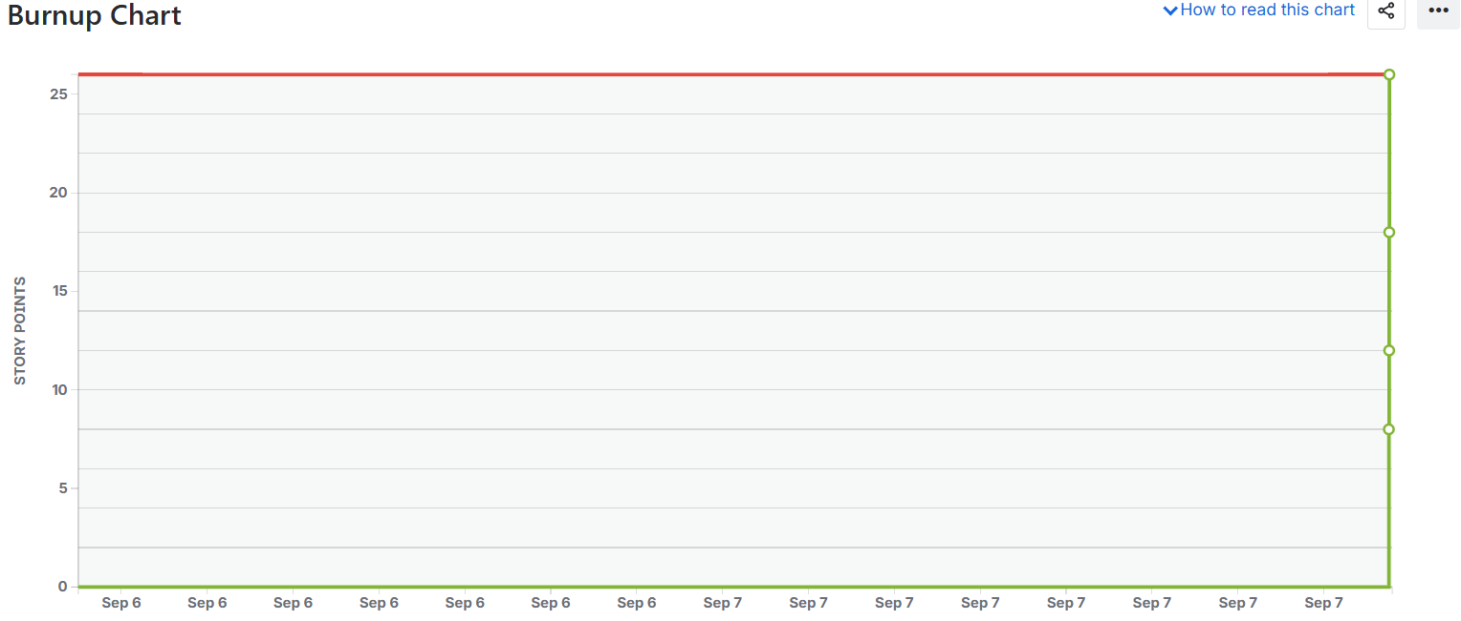

SPRINT-2

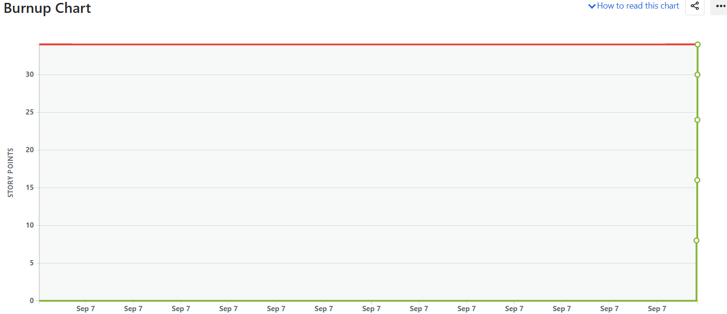

Q.10) Explain about Product Grooming
Ans. Product Grooming is a regular activity in Scrum where the Product Owner and Scrum Team review items in the Product Backlog to ensure they are well defined, properly prioritized, Estimated (in Complexity Points), Ready to be picked up in upcoming sprints.

Objectives of Product Grooming
- Clarify Requirements- Ensure every Product Backlog Item (PBI) has clear acceptance criteria and is understandable by the team.
- Prioritize Work- Arrange backlog items based on business value, client needs, and dependencies.
- Break Down Large Items- Split large epics or stories into smaller, more manageable user stories.
- Estimate Effort- Assign Complexity Points (CP) using estimation techniques like Planning Poker.
- Prepare for Sprint Planning- Only ready user stories (well defined, estimated, and prioritized) will move to the Sprint Backlog.

Product Insights for Improvement (used during Grooming)

During Sprint Reviews and feedback sessions, the team and stakeholders may generate insights such as:
- Features that need enhancement
- Usability improvements
- Performance bottlenecks
- Missing functionality requested by clients
These insights are logged as new PBIs or changes to existing PBIs, which are then refined during Product Grooming.

Q.11) Explain the roles of Scrum Master and Product Owner
Ans.
1. Scrum Master
- Acts as a servant leader for the Scrum Team.
- Ensures that Scrum principles, rules, and practices are followed.
- Removes impediments that block the team’s progress.
- Facilitates Scrum events (Daily Scrums, Sprint Review, Sprint Retrospective).
- Coaches the team and organization in Agile mindset.
- Shields the team from external distractions.
In Sprint 1:
- The Scrum Master helped track impediments (e.g., testing environment unavailability, API delays).
- Facilitated Daily Scrums and ensured smooth communication.
- Supported the team in following the agreed sprint plan.

2. Product Owner
- Represents the voice of the customer/stakeholders.
- Owns and manages the Product Backlog.
- Ensures backlog items are clear, prioritized, and aligned with business value.
- Decides what to build (the team decides how to build it).
- Engages with stakeholders to gather feedback and refine requirements.
- Accepts or rejects completed user stories.
In Sprint 1 (You acted as Product Owner):
- Selected 10 user stories (MVP) for the sprint backlog.
- Communicated client expectations and clarified requirements.
- Prioritized features that deliver maximum business value.
- Participated in Sprint Review with stakeholders to capture product insights for future improvement.

Q.12) Explain all Meetings Conducted in Scrum Project
Ans. 1. Sprint Planning Meeting
- When: At the start of every sprint.
- Participants: Product Owner, Scrum Master, Scrum Developers.
- Purpose:
  - Decide what work will be done in the sprint (select backlog items).
  - Define Sprint Goal.
  - Break down stories into tasks and estimate effort.
- Outcome: Sprint Backlog (set of PBIs + tasks to deliver in the sprint).

2. Daily Scrum (Stand-up Meeting)
- When: Every day, max 15 minutes.
- Participants: Scrum Developers (Scrum Master and Product Owner may attend but only as observers if needed).
- Purpose: Inspect progress toward the sprint goal and adjust the plan for the next 24 hours.
- Typical 3 Questions:
  - What did I work on yesterday?
  - What will I work on today?
  - Are there any impediments?

3. Sprint Review Meeting
- When: At the end of the sprint (before retrospective).
- Participants: Scrum Team (Scrum Master, Product Owner, Developers) + Stakeholders (Client, Users, Reviewers).
- Purpose:
  - Demonstrate the Product Increment to stakeholders.
  - Discuss what was completed and what was not.
  - Gather feedback and insights for improvement.
- Outcome: Adjustments to the Product Backlog based on feedback.

4. Sprint Retrospective Meeting
- When: After the Sprint Review, at the very end of the sprint.
- Participants: Scrum Team only (Scrum Master, Product Owner, Developers).
- Purpose:
  - Reflect on the process (not the product).
  - Identify what went well, what went wrong, and how to improve.
  - Decide on action items for improvement in the next sprint.
- Outcome: Continuous improvement and stronger teamwork.

Q.13) Explain Sprint Size and Scrum Size
Ans. Sprint Size
- Meaning: Refers to the duration/length of a Sprint.
- Typical Range:
  - 1 to 4 weeks (most common = 2 weeks).
- Decided by: The Scrum Team in agreement with the Product Owner and Scrum Master.
- Should be:
  - Consistent across the project (e.g., always 2 weeks, not changing each time).
  - Short enough to adapt quickly, but long enough to deliver a meaningful increment.
Example: If your team chooses a 2-week Sprint size, every sprint will be 10 working days.

Scrum Size
- Meaning: Refers to the size of the Scrum Team.
- According to Scrum Guide (by Ken Schwaber & Jeff Sutherland):
  - Recommended 3 to 9 Developers (excluding Product Owner and Scrum Master).
  - With PO + SM included, total team size usually 9 to 12 people.
- Why limited?
  - Small enough to remain agile and communicate effectively.
  - Large enough to deliver significant increments each sprint.
Example: A Scrum Team might include:
- 1 Scrum Master
- 1 Product Owner
- 6 Developers (Frontend, Backend, QA, Designer, etc.)
Total Scrum Size = 8

Q.14) Explain DOR and DOD
Ans. 1. Definition of Ready (DOR)
A checklist of conditions that a User Story / Product Backlog Item (PBI) must meet before the team can commit it into a Sprint.
Purpose:
- Ensures backlog items are well-prepared.
- Avoids confusion during sprint execution.

2. Definition of Done (DOD)
A shared understanding of what it means for work to be completed and releasable at the end of a Sprint.
Purpose:
- Ensures quality and completeness.
- Prevents partial/incomplete work being marked as done.

Q.15) Explain Prioritization Techniques and MVP
Ans. Prioritization Techniques in Agile / Scrum
The Product Backlog usually has many items, the Product Owner uses prioritization techniques to decide what to build first (highest business value).
Here are the common ones:
1. MoSCoW Method
- Must Have – essential, non-negotiable.
- Should Have – important but not vital.
- Could Have – nice to have.
- Won’t Have (this time) – not in scope for now.
2. Kano Model
- Basic Needs – must be there (otherwise product fails).
- Performance Needs – the more you add, the more customers are satisfied.
- Excitement Needs – unexpected features that delight users.
3. WSJF (Weighted Shortest Job First)
- Formula: WSJF = Business Value / Job Size
- Items that deliver high value quickly are prioritized.
4. Value vs Effort Matrix
- Plot items on a 2x2 grid (High Value/Low Effort → do first).
5. RICE Scoring
- Reach × Impact × Confidence ÷ Effort
- Prioritize items with maximum reach, high impact, strong confidence, and low effort.

MVP (Minimum Viable Product)
The smallest usable version of the product that delivers core features and provides value to the customer, while allowing feedback for improvement.
Purpose:
- Launch quickly with essential features.
- Gather real customer feedback early.
- Avoid wasting time on unnecessary features.
- Reduce risk and validate assumptions.
Example:
- A ride-sharing app MVP might include:
  - User registration
  - Book a ride
  - Payment system

Q.16) Difference between Business Analyst n Product Owner
Ans. Business Analyst (BA)
- Primary Focus: Requirements Gathering & Analysis
- Works as a bridge between business stakeholders and the development team.
- Usually exists in traditional (Waterfall/Hybrid) projects, but can also support Agile teams.
- Focuses on documenting requirements, process flows, gap analysis, and acceptance criteria.
Key Responsibilities:
- Elicit requirements from stakeholders.
- Analyze and document business processes.
- Create functional specifications, use cases, or user stories.
- Ensure the team understands business rules.
- Sometimes supports Product Owner in backlog refinement.

Product Owner (PO)
- Primary Focus: Product Vision & Backlog Management
- Official Scrum role (defined in Scrum Guide).
- Represents the voice of the customer.
- Decides what features to build and in what order (prioritization).
- Accountable for maximizing the value delivered by the product.
Key Responsibilities:
- Define and communicate the Product Vision.
- Own and manage the Product Backlog.
- Prioritize backlog items (using MoSCoW, WSJF, RICE, etc.).
- Accept/reject completed user stories based on DoD.
- Engage with stakeholders and gather feedback during Sprint Reviews.

Q.17) Prepare a sample Resume of 3yrs exp Product Owner
Ans.

Name: Ruchita Pawar
Phone: +91-9960568024
Email: pruchitas11@gmail.com
Location: Pune, India
LinkedIn: linkedin.com/in/ruchitapawar

Professional Summary
Results-driven Product Owner with 3 years of experience in Agile/Scrum environments. Skilled in managing product backlogs, defining product vision, and collaborating with cross-functional teams to deliver high-value increments. Adept at stakeholder management, and translating business needs into actionable user stories. Strong focus on delivering Minimum Viable Products (MVPs), improving team velocity, and ensuring customer satisfaction.

Key Skills
- Agile & Scrum Methodologies
- Product Backlog Management
- Sprint Planning & Prioritization
- User Stories & Acceptance Criteria
- Stakeholder Engagement & Communication
- Sprint Review
- JIRA, Balsamiq, Microsoft office Visio 2007
- Business Value
- Product Grooming & Refinement
- Data-Driven Decision Making

Professional Experience
Product Owner | ABC Technologies, Pune
(Nov 2024 – 2025)

- Owned and maintained the Product Backlog with 150+ user stories, ensuring alignment with business goals.
- Partnered with stakeholders to define product vision, strategy, and roadmap.
- Facilitated Sprint Planning, Reviews with cross-functional teams (Scrum Master, Developers, Testers).
- Applied prioritization techniques (MoSCoW) to maximize product value delivery.
- Collaborated with UX/UI designers and developers to enhance user experience based on customer feedback.
- Defined and enforced Definition of Ready (DoR) & Definition of Done (DoD) standards.
- Assisted Product Owner in refining and prioritizing backlog items.
- Documented user stories, acceptance criteria, and process flows to support development.
- Conducted requirement workshops with clients and translated them into technical specifications.
- Supported UAT (User Acceptance Testing) by preparing test cases aligned with business requirements.
- Coordinated with developers and testers to ensure smooth sprint execution.

Power BI Developer | Copeland India Private Limited, Pune
(Sept 2022 – Oct 2024)

- Developed & maintained IP & Innovation Dashboards using Power BI, providing actionable insights for business & IP counsels.
- Managed & Updated key IP data & reporting tools to ensure accuracy & efficiency decision making processes.
- Proven ability to design and implement scalable data models.
- Communication & Collaboration: Strong interpersonal skills to work effectively with both technical and non-technical stakeholders.
- Very good communication skills, able to discuss the requirements effectively with internal teams.
- Continuous learning while building professional connections through networking events and team collaborations.

Education
- MSc Physics– Pune University (2022- 2024)
- BSc Physics – Pune University (2019- 2022)

Certifications
- Certified Business Analyst Professional- IIBA (COEPD)

