BRD

Project Name: Centralized Inventory & Delivery Optimization System
Client: Ice-Cream & Milk Products by MilkyWay
Prepared By: Janhavi Borhade – Business Analyst
Version: 1.0
Date: 11-Aug-2025

- Document Revisions

Version | Date | Author | Description of Change
1 | 11-Aug-25 | Janhavi Borhade | Initial draft for client review

- RACI Chart for This Document

Activity | BA | PM | Dev Team | QA Team | Client SME | IT Ops
Requirement Gathering | R | S | I | I | C | I
BRD Preparation | R | A | I | I | C | I
Solution Design | C | S | R | I | C | I
Development | I | S | R | I | I | C
Testing & UAT | S | S | S | R | C | I
Deployment | I | S | C | I | I | R

4.1. Business Goals
- Ensure accurate real-time inventory tracking across all plants & warehouses.
- Reduce product wastage due to expiry.
- Achieve faster delivery times with optimized routing.
- Enable data-driven decision-making via analytics dashboards.
4.2. Business Objectives
- Centralize inventory data from multiple sites.
- Automate delivery route planning using location & traffic data.
- Improve customer satisfaction by reducing delivery delays.
- Provide warehouse managers with predictive replenishment alerts.
4.3. Business Rules
- Perishable products must be dispatched based on First Expiry First Out (FEFO).
- Orders cannot be assigned to warehouses with stock levels below safety thresholds.
- Delivery vehicles must comply with cold chain requirements.
4.4. Background
Currently, stock is tracked manually using spreadsheets at each warehouse.
Delivery assignments are done manually without considering real-time location data, leading to delays and inefficient logistics.
4.5. Project Objective
Develop a web-based and mobile-enabled platform to integrate inventory management with automated delivery scheduling.
4.6. Project Scope
4.6.1. In Scope Functionality
- Real-time inventory tracking
- Order management system
- Route optimization engine
- Role-based dashboards
- Reports & analytics
4.6.2. Out Scope Functionality
- Payment processing
- Manufacturing process automation

5. Assumptions
- All warehouses have stable internet connections.
- GPS-enabled vehicles or delivery partner API is available.
- Accurate initial master data will be provided by the client.

6. Constraints
- Perishable nature of products limits storage time.
- Seasonal demand fluctuations may impact delivery scheduling.
- Integration dependent on third-party mapping APIs.

7. Risks
Technological Risks
- API downtime from map service provider.
Skills Risks
- Limited in-house technical expertise for advanced route optimization.
Political Risks
- Regional regulations on cold storage transport.
Business Risks
- Loss of sales if inventory system fails.
Requirements Risks
- Scope creep due to evolving delivery requirements.
Other Risks
- User adoption resistance.

8. Business Process Overview
8.1. Legacy System (AS-IS)
- Inventory tracked manually in spreadsheets.
- Delivery planning done by phone calls and manual route mapping.
- No centralized visibility across warehouses.
8.2. Proposed Recommendations (TO-BE)
- Automated stock updates in centralized system.
- AI-driven delivery route optimization.
- Integrated dashboard for warehouse, sales, and logistics teams.

AS IS: Legacy System To BE: Proposed recommendations

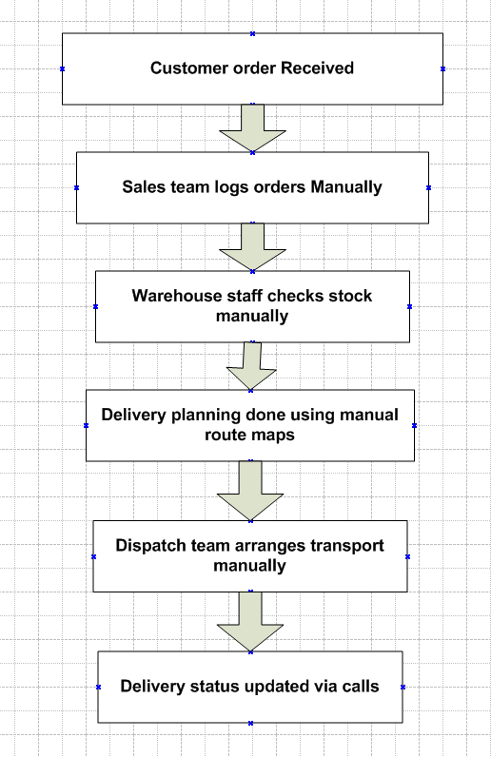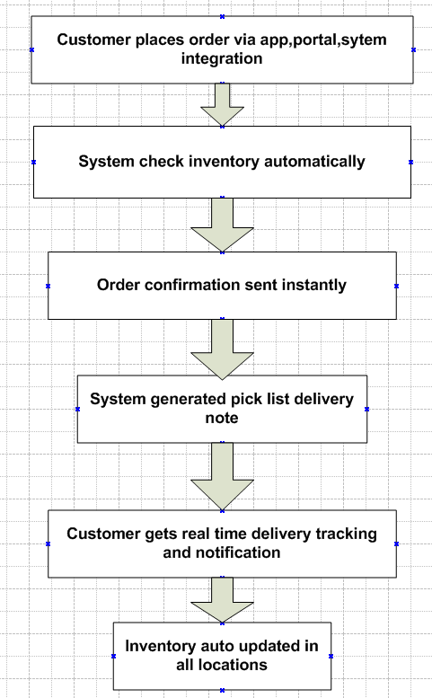
9. Business Requirements

Req ID | Requirement
REQ-001 | Real-time stock level tracking across all warehouses
REQ-002 | Batch tracking with expiry date alerts
REQ-003 | Customer order placement & tracking
REQ-004 | Route optimization considering location & traffic
REQ-005 | Reports for stock, wastage, and delivery performance

10. Appendices
10.1. List of Acronyms
- BRD – Business Requirements Document
- UAT – User Acceptance Testing
- FEFO – First Expiry First Out
10.2. Glossary of Terms
- Route Optimization – Algorithmic calculation of the shortest delivery path.
- Batch Tracking – Monitoring products based on manufacturing batch.
10.3. Related Documents
- AS-IS & TO-BE Process Flows
- Requirement Traceability Matrix (RTM)

11. Process flow diagram :

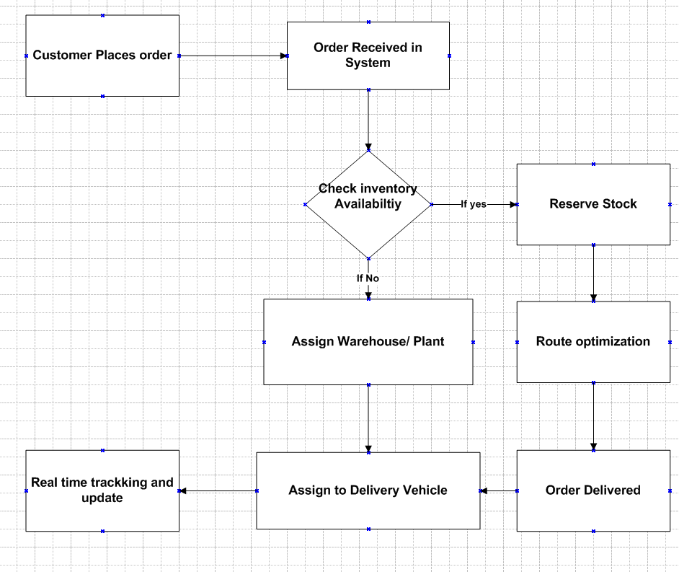

Assignment 2

1. Introduction Letter to Client
Subject: Introduction as Business Analyst – Project Initiation for Online Store Platform
Dear Mr. M.S.Deshmukh,
I hope this message finds you well.
My name is Janhavi Borhade, and I will be serving as the Business Analyst for FreshCart Retail Pvt. Ltd.’s new Online Store Platform project. My primary role will be to work closely with you and your team to understand the business needs, capture requirements, and translate them into clear and actionable specifications for our development and QA teams.
Over the coming days, I will initiate the business understanding phase, during which we will:
- Conduct stakeholder interviews.
- Analyse existing processes and systems (if applicable).
- Define and document business requirements in a structured format.
- Align on project goals, scope, and success criteria.
My aim is to ensure that the final solution aligns perfectly with your business objectives, addresses current challenges, and delivers measurable value.
I look forward to collaborating with you and your team to make this project a success. Please feel free to reach out to me at any time for discussions or clarifications.
Best Regards,
Janhavi Borhade
Business Analyst
borhade.janhavi@atos.com | 9028175182

2. Brief BRD & SRS – Online Store for FreshCart Retail Pvt. Ltd.
BRD – Online Store
Project: Online Store for FreshCart Retail Pvt. Ltd.
Prepared By: Business Analyst – Janhavi Borhade
Date: 15.08.2025

1. Document Revisions
0.1 | 31-07-2025 | Initial Draft | Janhavi Borhade | Project Lead
1 | 16-08-2025 | Approved Final Document | Janhavi Borhade | Client/PM

2. Approvals
Role | Name | Signature | Date
Client Sponsor | Mr. Ravi Mehta |  | 16-08-2025
Project Manager | Ms. Nisha Kulkarni |  | 16-08-2025
Business Analyst | Janhavi Borhade |  | 16-08-2025

- RACI Chart for This Document
Codes Used:
- R – Responsible
- A – Accountable
- S – Supportive
- C – Consulted
- I – Informed

Task | Client | BA | Dev Team | QA | PM
Requirements Gathering | C | R | I | I | A
Documentation | I | R | S | S | A
Design Validation | C | R | A | S | I
Development | I | C | R | I | A
Testing | I | C | S | R | A
Final Approval & Sign-off | A | C | I | I | R

4. Introduction
FreshCart Retail Pvt. Ltd. is a retail company specializing in fresh groceries, dairy, and organic products. To expand its reach and improve customer satisfaction, the company is planning to launch an Online Store that will enable customers to browse, shop, and get doorstep delivery of products efficiently.
4.1 Business Goals
- Expand market presence via digital commerce.
- Provide seamless online shopping experience.
- Enable efficient delivery and customer satisfaction.
- Centralize inventory & order management.
4.2 Business Objectives
- Launch an e-commerce platform accessible via web & mobile.
- Real-time synchronization of inventory with warehouses.
- Integration with secure payment gateways.
- Enable order tracking and notifications.
4.3 Business Rules
- Customers must register before making purchases.
- Orders above ₹500 qualify for free delivery.
- Payments accepted via Credit/Debit Cards, UPI, NetBanking, Wallets.
- Cancellations allowed before dispatch only.
4.4 Background
FreshCart currently operates only through offline retail outlets. With growing demand for online shopping, the company wants to implement an online store to stay competitive.
4.5 Project Objective
To design and implement a user-friendly, scalable, and secure online platform that manages products, orders, payments, and deliveries in real-time.
4.6 Project Scope
4.6.1 In-Scope Functionality
- User Registration & Login
- Product Browsing, Search & Filter
- Shopping Cart & Wishlist
- Secure Payments Integration
- Order Tracking & Delivery Updates
- Admin Dashboard for Sales, Products, and Inventory
4.6.2 Out-of-Scope Functionality
- International deliveries
- Third-party marketplace integrations
- Loyalty points/reward system (Phase 2 feature)

5. Assumptions
- Customers have internet-enabled devices.
- Inventory data from warehouses is accurate.
- Payment gateways will support required transaction load.

6. Constraints
- Budget and timeline restricted to 6 months.
- Limited in-house technical expertise.
- Must comply with data protection & payment security standards.

7. Risks
Technological Risks – Integration issues with payment gateway, scalability under high traffic.
Skills Risks – Limited expertise in e-commerce implementation.
Political Risks – New government regulations around e-commerce or data privacy.
Business Risks – Customer resistance due to delivery delays or app usability.
Requirements Risks – Changes in product categories, delivery models mid-project.
Other Risks – Dependency on third-party logistics for last-mile delivery.

8. Business Process Overview
8.1 Legacy System (AS-IS)
- All sales happen via physical stores.
- Inventory managed manually at each outlet.
- No centralized visibility.
8.2 Proposed Recommendations (TO-BE)
- Centralized e-commerce system.
- Automated stock updates & dashboards.
- AI-driven delivery route optimization.
- Seamless customer ordering experience.

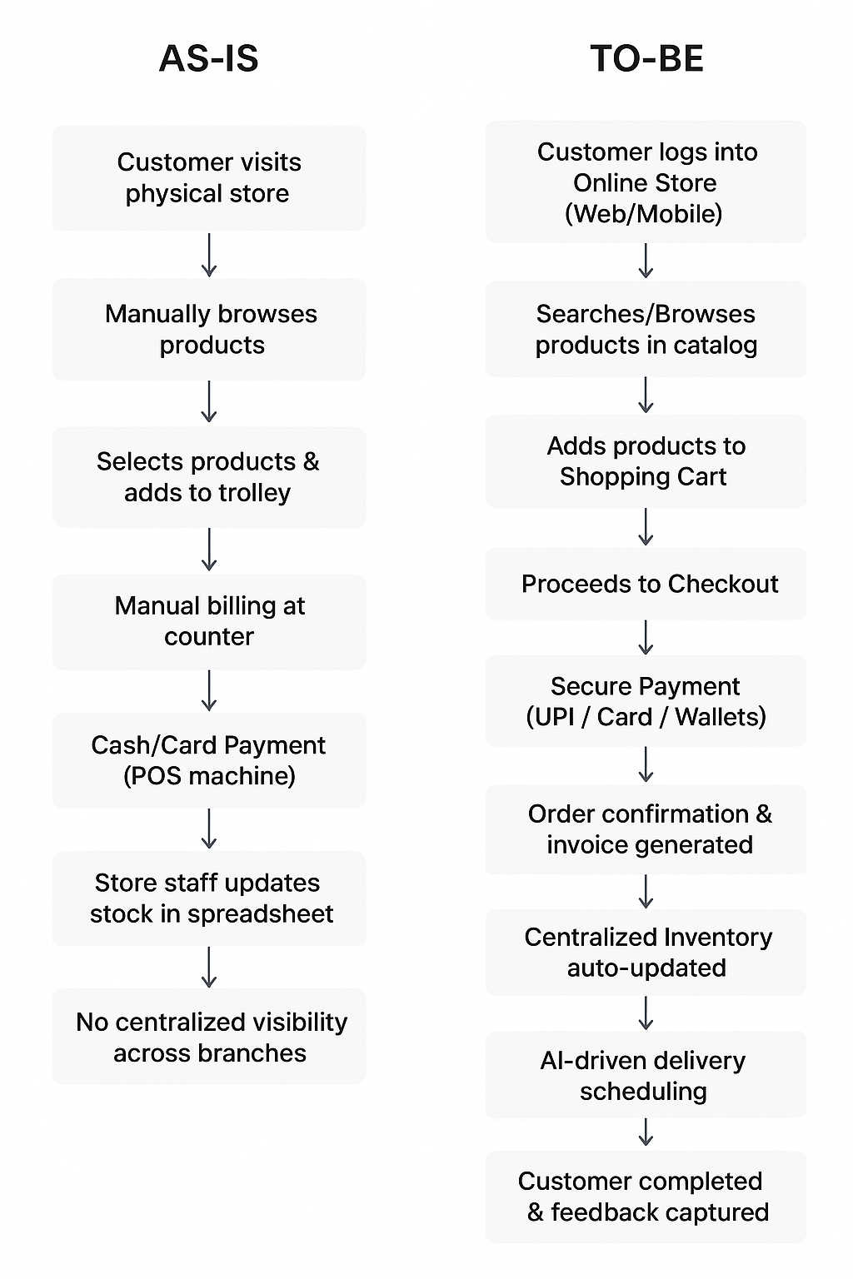

9. Business Requirements
- Customers must be able to register/login securely.
- Customers can browse and search products easily.
- Shopping cart & checkout should be intuitive.
- Secure multi-payment options must be available.
- Customers can track orders in real-time.
- Admin users can manage inventory, orders, and reports centrally.

10. Appendices
10.1 List of Acronyms
- BA – Business Analyst
- PM – Project Manager
- UI – User Interface
- DB – Database
10.2 Glossary of Terms
- E-commerce: Online system for buying/selling goods.
- Inventory: Stock of goods available for sale.
- Payment Gateway: Service to process online payments.
10.3 Related Documents
- Project Charter
- High-Level System Architecture Diagram
- Functional Requirement Documents (FRD)

SRS – Online Store
1. Introduction
1.1 Purpose
The purpose of this document is to define the functional and non-functional requirements for the FreshCart Online Store. The system aims to enable customers to browse, purchase, and get deliveries of grocery and fresh products online, while ensuring accurate inventory tracking and smooth operations.
1.2 Scope
- Online platform for browsing and purchasing grocery and fresh products.
- Centralized inventory management across multiple warehouses.
- Secure payment gateway integration.
- AI-driven delivery route optimization.
- Customer self-service portal with order tracking and feedback.
1.3 Definitions, Acronyms, and Abbreviations
- UI – User Interface
- DBMS – Database Management System
- SKU – Stock Keeping Unit
- OTP – One-Time Password
1.4 References
- BRD for FreshCart Online Store (Version 1.0).
- Industry standards for e-commerce security (PCI-DSS, GDPR).

2. Overall Description
2.1 Product Perspective
The online store will replace the manual in-store shopping process with a centralized e-commerce platform accessible via web and mobile.
2.2 Product Functions
- Customer registration & login.
- Product catalogue browsing & search.
- Cart management & checkout.
- Payment gateway integration.
- Inventory auto-update on order placement.
- Order confirmation, invoice generation.
- Delivery scheduling & real-time tracking.
2.3 User Classes & Characteristics
- Customer: End-users purchasing products.
- Admin: Manages inventory, products, and user accounts.
- Delivery Staff: Access to assigned delivery routes & orders.
- Support Staff: Handles order issues, refunds, and escalations.
2.4 Constraints
- System must support 24x7 availability.
- Must comply with data privacy and payment security standards.
- Mobile-friendly responsive UI.
2.5 Assumptions & Dependencies
- Customers will have internet access.
- Payment gateways (UPI, Wallet, Credit/Debit Card) will be integrated via third-party APIs.
- Delivery is dependent on logistics partner availability.

3. Specific Requirements
3.1 Functional Requirements
- User Management
  - Customers can register/login using email, mobile, or social login.
  - Password reset using OTP/email verification.
- Product Management
  - Admin can add/update/delete products with details (SKU, price, category, stock).
  - Customers can view/search/filter products.
- Shopping Cart & Checkout
  - Customers can add/remove/update items in cart.
  - Checkout with multiple payment options.
- Order Management
  - System generates unique Order ID for each purchase.
  - Order confirmation sent via email/SMS.
  - Customers can track order status in real-time.
- Inventory Management
  - Stock automatically updated upon order placement.
  - Low-stock alerts for admin.
- Delivery Management
  - AI-driven route optimization for delivery staff.
  - Delivery status updated (Out for delivery → Delivered).
- Customer Support
  - Ticketing system for complaints/refunds.
  - Order history and re-order option.

3.2 Non-Functional Requirements
- Performance: System should handle 10,000 concurrent users.
- Security: Data encryption, OTP authentication, secure payment compliance.
- Scalability: Support future addition of new warehouses & delivery zones.
- Usability: Simple, intuitive UI for web & mobile.
- Reliability: 99.9% uptime.

4. System Models
- ERD (Entity Relationship Diagram) connecting Customer, Product, Order, Payment, Inventory.
- Use Case Diagrams for Customer (shopping), Admin (inventory), and Delivery Staff.

3. ERD – Support Ticket / Ticketing Life Cycle
Entities & Attributes:
- User
  - User_ID (PK)
  - Name
  - Email
  - Phone
- Ticket
  - Ticket_ID (PK)
  - User_ID (FK)
  - Category_ID (FK)
  - Priority_ID (FK)
  - Status_ID (FK)
  - Subject
  - Description
  - Created_Date
  - Closed_Date
- Category
  - Category_ID (PK)
  - Category_Name (Order Issue, Payment Issue, Product Query, Technical Issue)
- Priority
  - Priority_ID (PK)
  - Priority_Level (Low, Medium, High, Urgent)
- Status
  - Status_ID (PK)
  - Status_Name (Open, In Progress, Resolved, Closed)
- Agent
  - Agent_ID (PK)
  - Name
  - Email
- Ticket_History
  - History_ID (PK)
  - Ticket_ID (FK)
  - Updated_By (User_ID / Agent_ID)
  - Old_Status
  - New_Status
  - Update_Date
Relationships:
- A User can create many Tickets.
- A Ticket belongs to one Category, has one Priority, and has one Status at a time.
- A Ticket is assigned to one Agent.
- A Ticket can have many Ticket_History records.

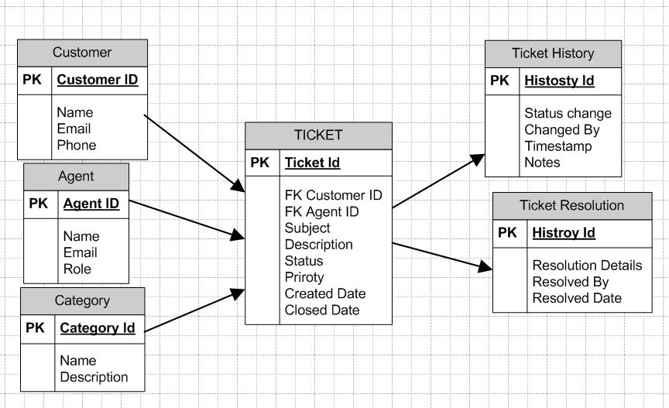

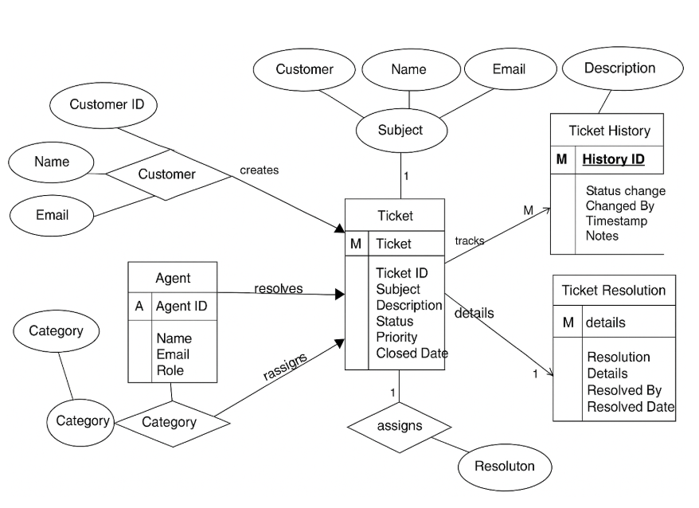

4.User story of shopping from ecommerce

User Story ID | As a (Role) | I want to (Goal) | So that (Benefit) | BV | CP | Acceptance Criteria
US001 | Customer | Register and create an account | I can securely log in and shop | 500 | 3 | • User can register using email/phone  • Unique username/email must be enforced  • System must encrypt passwords
US002 | Customer | Login to the store | I can access my account securely | 500 | 2 | • Login requires correct credentials  • Incorrect attempts show error  • Supports forgot password flow
US003 | Customer | Manage my profile details | I can update personal information easily | 500 | 3 | • User can edit name, phone, email  • Profile updates reflected instantly  • Validation on mandatory fields
US004 | Customer | Reset password | I can recover my account securely | 500 | 2 | • Password reset via OTP/email  • Expiry time for reset link  • New password must follow policy
US005 | Customer | Logout securely | I can protect my account from misuse | 200 | 1 | • Logout option visible on all pages  • Session terminated after logout  • Redirects to homepage
US006 | Customer | Browse products by categories | I can easily find items I need | 500 | 3 | • Categories displayed on homepage  • Clicking category shows products  • Pagination/infinite scroll supported
US007 | Customer | Search for products using keywords | I can quickly locate desired items | 200 | 5 | • Search box accepts keywords  • Results must match product name/description  • Autocomplete suggestions appear
US008 | Customer | Apply filters (price, brand, rating) | I can refine my search results | 200 | 5 | • Filters available on product listing  • Multiple filters can be applied  • Results refresh dynamically
US009 | Customer | View product details | I can understand product before buying | 500 | 2 | • Details include description, price, stock, reviews  • Product images and zoom option  • Availability status shown
US010 | Customer | View product reviews/ratings | I can make informed purchase decisions | 500 | 3 | • Customers can leave reviews  • Average rating displayed  • Reviews sorted by date/relevance
US011 | Customer | Add products to cart | I can purchase multiple items together | 500 | 3 | • 'Add to Cart' button visible  • Cart icon updates count  • Items remain until removed/checkout
US012 | Customer | Update quantity in cart | I can adjust order before checkout | 500 | 2 | • Quantity can be increased/decreased  • Cart total updates automatically  • Cannot exceed stock
US013 | Customer | Remove products from cart | I can manage my cart easily | 500 | 2 | • Remove button on each item  • Cart total updates instantly  • Undo option available
US014 | Customer | Proceed to checkout | I can place my order | 500 | 3 | • Checkout page shows summary, address, payment  • System validates all fields  • Delivery charges shown
US015 | Customer | Save multiple shipping addresses | I can reuse them later | 500 | 3 | • Multiple addresses can be saved  • User can set default address  • Editable anytime
US016 | Customer | Make secure payments | I can complete purchase confidently | 500 | 5 | • Payment options include card, UPI, wallet  • Transactions are encrypted  • Success/failure status shown
US017 | Customer | Save payment methods | I can checkout faster next time | 500 | 5 | • Users can save card/UPI  • Data stored securely  • Option to delete saved methods
US018 | Customer | Apply coupons/discount codes | I can save money | 200 | 5 | • Coupon field validates format/expiry  • Discount applied instantly  • Invalid coupons show error
US019 | Customer | Use gift cards | I can pay using preloaded balance | 200 | 5 | • Gift card code validation  • Balance deduction tracked  • Partial payment supported
US020 | Customer | Receive invoice/receipt | I can keep purchase records | 500 | 2 | • Invoice auto-generated  • PDF available for download  • Sent to email
US021 | Customer | Track order status | I know when my product will arrive | 500 | 3 | • Order history available  • Statuses: Processing, Shipped, Delivered  • Estimated delivery shown
US022 | Customer | Cancel order before shipping | I can change my decision | 500 | 3 | • Cancel option before shipment  • Refund initiated automatically  • User notified
US023 | Customer | Return/exchange products | I can handle wrong/damaged items | 500 | 5 | • Return request form  • Status updates on return  • Refund/exchange processed
US024 | Customer | Get delivery notifications | I can stay updated | 500 | 2 | • SMS/email notifications  • Push notification on mobile app  • Updates on major status changes
US025 | Customer | Rate & review delivered products | I can share feedback | 200 | 3 | • Option appears after delivery  • Star rating system  • Review moderation enabled
US026 | Admin | Add/edit/delete products | I can keep catalog updated | 500 | 5 | • Admin dashboard to manage products  • Mandatory fields validated  • Updates reflected instantly
US027 | Admin | Manage inventory stock | I can ensure product availability | 500 | 5 | • Low-stock alerts  • Auto stock update on purchase  • Centralized view across warehouses
US028 | Admin | View sales analytics | I can track performance | 500 | 5 | • Reports on sales, revenue, trends  • Filters by date/category  • Export option available
US029 | Admin | Manage user accounts | I can handle customers securely | 500 | 5 | • View/edit/deactivate accounts  • Reset customer passwords  • Role-based access control
US030 | Admin | Manage discount campaigns | I can attract more customers | 200 | 5 | • Create/edit campaigns  • Apply on categories/products  • Start and end dates mandatory
US031 | Customer | Choose delivery time slot | I can receive products conveniently | 500 | 5 | • Multiple slot options  • Slot availability validated  • Confirmation before checkout
US032 | Customer | Chat with support team | I can resolve issues quickly | 500 | 3 | • Live chat option in app/website  • Ticket auto-created for unresolved queries  • Chat history saved
US033 | Customer | Reorder past purchases | I can buy frequently ordered items faster | 500 | 3 | • Reorder option in order history  • Cart pre-filled with same items  • User can modify before checkout
US034 | Customer | Subscribe for recurring deliveries | I don’t run out of essentials | 500 | 5 | • User sets frequency (weekly/monthly)  • Auto-order triggered  • Cancellation option anytime
US035 | Customer | Compare products | I can make better decisions | 200 | 3 | • Comparison view available  • Attributes displayed side-by-side  • Limit on max comparison items
US036 | Admin | Assign delivery agents | I can manage order distribution | 500 | 5 | • Admin can assign manually/auto  • Agent receives notification  • Tracking integrated
US037 | Admin | Manage support tickets | I can resolve queries efficiently | 200 | 5 | • Admin can view all tickets  • Ticket includes priority/status  • Customer notified when resolved
US038 | Admin | View abandoned carts | I can re-engage customers | 200 | 5 | • Report on abandoned carts  • Email reminders triggered  • Conversion rate tracked
US039 | Admin | Enable promotional banners | I can highlight offers | 100 | 3 | • Banner upload option  • Schedule start/end dates  • Visible on homepage/category pages
US040 | Admin | Generate customer behaviour reports | I can improve sales strategy | 500 | 5 | • Track browsing history  • Heatmaps on most-viewed products  • Export to Excel/PDF

