Agile Model Deliverables Documents

Document 1- Definition of Done
Question 1: As Per Agile Extension to the BABOK® Guide v2, Definition of Done is a technique where the team agrees on, and prominently displays, a list of criteria which must be met before a backlog item is considered done.
That is the team has to create a well-defined, unambiguous, measurable, agreed-upon, and shared Definition of Done between all team members.
The best form of Definition of Done representation is a checklist of activities that has to demonstrate the agreed value and quality of a user story. So, this checklist should include:
- acceptance criteria (to satisfy customer requirements for a product)
- quality criteria (to satisfy quality requirements for a product)
Definition of Done may be defined for different levels of project work. For example, in Agile / Scrum framework these levels of work could be user story, sprint, and release.
Checklist for DOD:
- Produced code for presumed functionalities
- Assumptions of User Story met
- Project builds without errors
- Unit tests written and passing
- Project deployed on the test environment identical to production platform
- Tests on devices/browsers listed in the project assumptions passed
- Feature ok-ed by UX designer
- QA performed & issues resolved
- Feature is tested against acceptance criteria
- Feature ok-ed by Product Owner
- Refactoring completed
- Any configuration or build changes documented
- Documentation updated
- Peer Code Review performed

Answer: The Definition of Done ensures that all project deliverables—whether at the user story, sprint, or release level—are complete, high-quality, and ready for production. It provides a shared checklist across the team, reducing ambiguity and ensuring consistency in delivery across digital platforms, supply chain processes, and compliance requirements.
User Story Level DoD
Each user story (e.g., a customer-facing feature, procurement workflow, or integration point) is considered Done when the following criteria are fulfilled:
- Acceptance criteria are fully implemented and validated
- Feature functionality is developed, committed, and integrated with the latest build
- Business rules and localization requirements (e.g., currency, language, tax rules) are implemented
- Code is peer-reviewed and meets coding standards
- Unit tests are written with minimum 80% coverage and all tests pass
- The feature is tested on required browsers/devices (as per device matrix)
- QA has executed test cases and validated that the story passes all functional tests
- UX review and validation completed (if applicable)
- Any associated error handling or edge cases implemented and tested
- The feature is approved by the Product Owner
- Technical documentation (e.g., API usage, config values) is updated

Sprint Level DoD
A sprint is considered Done when the following conditions are met:
- All committed user stories in the sprint meet their individual DoD
- All changes are successfully integrated and the sprint build passes without errors
- Code is deployed to a test/staging environment that mirrors production
- Integration testing (e.g., between payment gateway, ERP, or logistics APIs) is completed
- Non-functional requirements such as performance, responsiveness, and accessibility are tested (where applicable)
- The Sprint Review is conducted and stakeholders have validated the sprint increment
- Sprint Retrospective is held, with team feedback and improvement actions documented
- All open bugs and critical defects from the sprint are resolved or deferred with stakeholder approval

Release Level DoD
A release (e.g., deployment of the new website, mobile app, or operational readiness for order processing) is considered Done when:
- All features planned for the release meet their sprint and story-level DoD
- Full end-to-end system testing is completed (covering digital ordering to fulfilment)
- Data privacy, security, and food compliance checks (e.g., labelling, shelf-life rules) are passed
- Go-to-market workflows such as logistics, payments, and customer service flows are validated
- Regulatory approvals and certifications required for the country (e.g., FSSAI-equivalent) are obtained
- Technical and user documentation (for internal users, support teams) is finalized
- Production deployment scripts and rollback plans are tested and verified
- Release notes and knowledge transfer sessions are delivered
- Product Owner and key stakeholders formally sign off
- Post-Go-Live monitoring tools are in place and team is ready for support and stabilization sprint

Acceptance Criteria: Defined by the Product Owner or Business Analyst to ensure the feature/story delivers business value and meets end-user expectations
- Product Availability
- All existing SKUs are available on the new country’s app/website with accurate pricing, ingredients, nutritional info, and packaging details.
- Localized Experience
- The digital interface supports the local language, currency, and regional units of measure.
- Legal and tax regulations (e.g., VAT, digital tax) are accurately applied during checkout.
- Functional Integration
- Order flow integrates end-to-end with payment gateways, inventory system, and local logistics partners.
- Users can place, track, and cancel orders successfully.
- User Journey Completion
- Key user journeys (e.g., registration, product search, checkout, support request) complete without errors.
- Edge cases like invalid address, payment failure, and out-of-stock items are handled gracefully.
- Compliance Alignment
- Labels, allergen info, expiry dates, and country-of-origin data meet the local food regulatory body’s standards.
- Customer data is captured and stored per data protection laws (e.g., GDPR equivalent).
- Stakeholder Approval
- Feature is reviewed and accepted by Product Owner and relevant business stakeholders before closure.

Quality Criteria: Defined and enforced by the QA team and technical leads to ensure robustness, performance, and maintainability of deliverables.
- Code Quality & Maintainability
- Code is modular, readable, and follows project coding standards.
- All critical logic is covered by unit tests with at least 80% code coverage.
- Peer code review is completed and comments addressed.
- Cross-Platform Compatibility
- App and website are fully functional and visually consistent across the supported browsers (Chrome, Safari, Firefox) and mobile devices (iOS & Android).
- Performance Benchmarks
- Page load time is under 3 seconds on standard 4G mobile network.
- Backend APIs respond in < 500ms for standard queries under nominal load.
- Security Assurance
- All sensitive data (e.g., payment details, personal info) is transmitted and stored securely using encryption (HTTPS, AES).
- No hardcoded credentials or exposed endpoints.
- Bug-Free Criteria
- No critical or major defects open at the time of deployment.
- All known minor issues are documented, with mitigation or resolution planned.
- Documentation & Traceability
- All user stories, test cases, configs, and technical specs are updated in the knowledge repository.
- Version control tags are correctly applied to each release.
- Test Coverage
- Functional, integration, regression, and user acceptance testing completed.
- All test cases pass and results are documented with evidence/screenshots where required.

Document 2- Product Vision
Question 2:
Scrum Project Name
Venue
Date | Start Time | End Time | Duration
Client
Stakeholder List
Scrum Team
Scrum Master
Product Owner
Scrum Developer 1
Scrum Developer 2
Scrum Developer 3
Scrum Developer 4
Vision: What is your vision, your overarching goal for creating the product?
Target Group  Which market segment does the product address?  Who are the target users and customers? | Needs  What problem does the product solve?  Which benefit does it provide? | Product  What product is it?  What makes it desirable and special?  Is it feasible to develop the product? | Value  How is the product going to benefit the company?  What are the business goals?  What is the business model?

Answer:
Scrum Project Name: Cargill Expansion – Digital & Operational Rollout
Venue: Company HQ (Hybrid with virtual Scrum ceremonies)
Date: July 10, 2024
Start Time: 10:00 AM
End Time: 12:00 PM
Duration: 2 hours
Client: Cargill Industry Company (Global HQ)
Stakeholder List: Chief Product Officer, Regional Business Development Manager, Head of Supply Chain, Marketing Director (New Markets), Legal & Compliance Lead, IT Operations Manager
Scrum Team:
Role | Name
Scrum Master | Priya Sharma
Product Owner | Rahul Verma
Scrum Developer 1 | Ayesha Singh
Scrum Developer 2 | Arjun Mehta
Scrum Developer 3 | Sneha Reddy
Scrum Developer 4 | Kartik Iyer

Vision: To successfully expand the company's established food product portfolio into new international markets by building a digitally-driven, locally-integrated business model that aligns with regional consumer preferences, regulatory requirements, and operational capabilities.
The goal is to deliver a localized, high-quality customer experience through the launch of a fully functional country-specific website and mobile app, supported by a local procurement and supply chain ecosystem, while maintaining the company’s global standards of quality, trust, and sustainability.
This vision supports the company’s broader objective of becoming a globally accessible, regionally rooted food brand by enabling agile entry into new markets, minimizing launch time, and driving long-term customer loyalty through operational excellence and cultural relevance.
Target Group:
Which market segment does the product address?
- Urban, health-conscious individuals aged 20–45
- Digitally active B2C consumers in the new country
- Customers seeking affordable, nutritious packaged food options
Who are the target users and customers?
- Mobile-first users browsing food products
- E-commerce shoppers looking for local sourcing
- Repeat customers of existing product lines in new regions
Needs:
What problem does the product solve?
- Lack of access to trusted international food brands in the local market
- Limited digital availability of healthy packaged food through native platforms
Which benefit does it provide?
- Regionally tailored e-commerce experience
- Locally sourced, globally trusted food products
- Convenience, transparency, and quick delivery
Product:
What product is it?
- A localized e-commerce website and mobile app integrated with supply chain, payments, and delivery systems
- Operational model for local procurement and fulfilment
What makes it desirable and special?
- Combines global brand trust with local sourcing and delivery
- Customized content, language, and payment options for local relevance
Is it feasible to develop the product?
- Yes, using Agile development with cross-functional teams and proven tech stacks (React, Node.js, AWS, etc.)
Value:
How is the product going to benefit the company?
- Establishes the company’s presence in a new high-potential market
- Diversifies revenue streams and scales global operations
What are the business goals?
- Achieve 15% market penetration within the first year
- Build a repeat customer base and enhance brand visibility
- Lower sourcing and fulfilment costs through regional supply chain
What is the business model?
- B2C direct sales through mobile/web platform
- Subscription and loyalty rewards model
- Regional procurement and in-market production to reduce costs

Document 3- User stories
Question 3:
User Story No | Tasks | Priority
Value statement
As a user…. I want to……. So that I can….
BV | CP
Acceptance Criteria

Answer: In Agile development, a User Story is a short, simple, and user-focused description of a feature or functionality. It helps the development team understand what the user needs, why they need it, and what value it provides—without prescribing how to build it.

User Story ID: US001
Tasks:4
Priority:1
Value Statement: As a first-time customer, I want to browse food products in my local language and currency, so that I feel comfortable and confident making a purchase.
BV: 500
CP:5
Acceptance Criteria:
- Customer installs the application and registers.
- Home screen displays categories and food options.
- Customer selects a food category, explores the menu, and adds items to the cart.
- Proceeds to checkout and confirms the order.
- If the item is unavailable, alternative suggestions are provided.
- Notifications on promotions and discounts appear during checkout.
- In case of network issues, an appropriate error message appears.

User Story ID: US002
Tasks:3
Priority:1
Value Statement: As a customer, I want to pay using local payment methods (UPI, mobile wallets, cards), so that I can complete transactions securely and conveniently.
BV: 200
CP:4
Acceptance Criteria:
- Payment screen displays local payment options dynamically based on region.
- Transactions are encrypted and processed securely.
- Successful payments show order confirmation with order ID and estimated delivery time.
- Failed payments return meaningful error messages with retry options.
- Transaction logs are stored in user order history.

User Story ID: US003
Tasks:5
Priority:2
Value Statement: As a customer, I want to receive real-time delivery updates, so that I know exactly when my order will arrive.
BV: 100
CP:3
Acceptance Criteria:
- Customer receives a push notification when the order is confirmed.
- GPS tracking is enabled once the order is dispatched.
- Delivery status (e.g., "Out for Delivery", "Delivered") is shown on the order detail screen.
- Customers receive SMS or app notifications for delays.
- System auto-closes order once delivery is confirmed.

User Story ID: US004
Tasks:4
Priority:2
Value Statement: As a product manager, I want to localize all app content based on regional language preferences, so that users feel culturally connected and supported.
BV: 200
CP:4
Acceptance Criteria:
- Application detects region/language on first install or prompts for selection.
- All screens display content (menus, buttons, labels) in selected language.
- Content matches translations defined in the localization dictionary.
- Users can change language settings later from the profile screen.
- LTR (Left-to-right) language support is included where needed.

User Story ID: US005
Tasks:6
Priority:1
Value Statement: As an operations team member, I want to onboard and manage local vendors via an admin panel, so that supply chain readiness is ensured before launch.
BV: 100
CP:6
Acceptance Criteria:
- Admin user logs into the vendor management dashboard.
- New vendor onboarding form includes business license, contact, and material type.
- Vendor records are stored and visible in a searchable list.
- Admin can approve, reject, or deactivate vendors.
- Vendor profile shows material types, delivery zones, and status history.
- Notifications are sent to vendors upon status change.

Document 4- Agile PO Experience
Question 4: The Product Owner has a vision of the product keeping the domain/industry experience and the market need.
- Following are the responsibilities of PO in a project
- Market Analysis
- Analysis of market need/demand
- Availability of similar products in the market
- Enterprise Analysis
- Due diligence on the market opportunity
- Product Vision and Roadmap
- Product vision keeping the need analysis in mind
- Product roadmap with high-level features and timeline
- Managing Product Features
- Managing stakeholder expectations and prioritizing needs
- Prioritization of the epics, stories, and features based on criticality and ROI involved
- Managing Product Backlog
- Prioritization of user stories
- Reprioritization based on stakeholders' needs
- Epics planning
- Managing Overall Iteration Progress
- Sprint progress review
- Reprioritization of sprints and epics if needed
- Sprint retrospectives with Business Analyst
- From this project I have learned how to handle sprint meetings such as
- Sprint planning meeting
- Daily scrum meeting
- Sprint review meeting
- Sprint retrospective meeting
- Backlog refinement meeting
- Also, User stories creation and what things will be included in user stories such as
- Story no
- Tasks
- Priority
- Acceptance criteria
- BV & CP value
- In Scrum, a product owner serves as the liaison between multiple areas of an organization. This person communicates with business stakeholders and collaborates closely with Scrum teams to keep all areas of the business informed on a project's development.
- The product owner develops a vision of a product's function and operation, which in turn allows this Scrum team member to define product features and break those features into product backlog items.

Answer:

Document 5: Product and sprint backlog and product and sprint burndown charts
Question 5:
Product Backlog
User Story ID | User Story | Tasks | Priority | BV | CP | Sprint

Sprint Backlog
User Story ID | User Story | Tasks | Owner | Status | Estimated Effort

Product Burndown
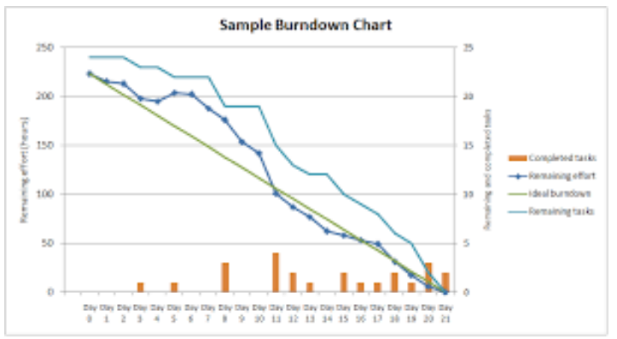
Sprint Burndown
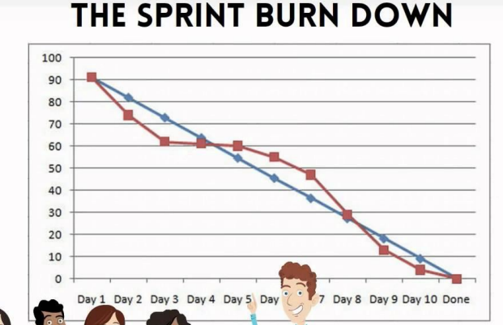

Document 6: Sprint meetings
Question 6:
Meeting Type 1: Sprint Planning meeting
Date
Time
Location
Prepared by
Attendees

Agenda Topics
Topic | Presenter | Time Allotted

Other Information
Observers
Resources
Special Notes

Meeting Type 2: Sprint review meeting
Date
Time
Location
Prepared by
Attendees

Sprint Status | Things to Demo | Quick Updates | What’s next

Meeting Type 3: Sprint retrospective meeting
Date
Time
Location
Prepared by
Attendees

Agenda | What went well | What didn’t go well | Questions | Reference

Meeting Type 4: Daily Stand-up meeting
Question | Name/Role | Week “X” (from dd-mm-yyyy to dd-mm-yyyy)
Question | Name/Role | Mon | Tues | Wed | Thurs | Fri | Sat | Sun
What did you do yesterday?
  Developer 1
  Developer 2
  Developer 3
What will you do today?
  Developer 1
  Developer 2
  Developer 3
What (if any) is blocking your progress?
  Developer 1
  Developer 2
  Developer 3

