A customer can make a payment either by Card or by Wallet or by Cash or by Net banking. Q1. Draw a Use Case Diagram -
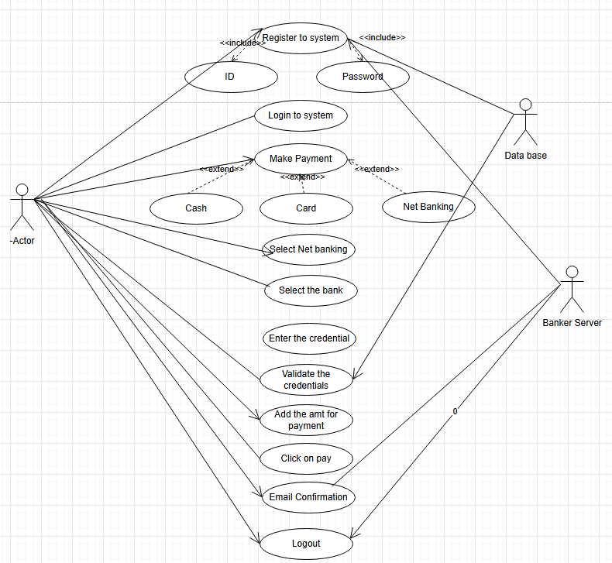

Q-2 Derive Boundary Classes, Controller classes, Entity Classes.
1. Entity Classes
These represent core business objects with data and behavior, independent of the user interface.
Entity Class | Attributes | Description
Customer | customerId, name, contactInfo | Stores customer profile
Payment | paymentId, amount, paymentMethod, status, timestamp | Abstract parent class or interface for different payment types
CardPayment | cardNumber, cardHolder, expiryDate | Extends Payment; stores card info
WalletPayment | walletProvider, walletId | Extends Payment; stores wallet info
CashPayment | paymentConfirmationCode | Used for COD scenarios
NetBankingPayment | bankName, transactionId | Online banking transaction details
Order | orderId, items, totalAmount, paymentStatus | Represents the placed order

2. Boundary Classes
These interact directly with users or external systems (UIs, APIs).
Entity Class | Attributes | Description
Customer | customerId, name, contactInfo | Stores customer profile
Payment | paymentId, amount, paymentMethod, status, timestamp | Abstract parent class or interface for different payment types
CardPayment | cardNumber, cardHolder, expiryDate | Extends Payment; stores card info
WalletPayment | walletProvider, walletId | Extends Payment; stores wallet info
CashPayment | paymentConfirmationCode | Used for COD scenarios
NetBankingPayment | bankName, transactionId | Online banking transaction details
Order | orderId, items, totalAmount, paymentStatus | Represents the placed order

3. Controller Classes
These handle logic and coordination between boundary and entity classes.
Controller Class | Responsibility
PaymentController | Orchestrates the payment process: validates method, delegates to specific handlers
OrderController | Places the order, links it to payment status
CardPaymentHandler, WalletPaymentHandler, etc. | Specialized logic per payment type
PaymentValidator | Ensures inputs are valid and complete based on method selected

Q3. Place these classes on a three tier Architecture.
Three-Tier Architecture, which organizes an application into three logical layers: Presentation, Business Logic, and Data Access. This separation enhances maintainability, scalability, and clarity.
3 Tier | Components
1. Application Layer | Customer Registration  Customer Login  Bank server login
2. Business Logic Tier  Primary actors associated with  Boundary class) | Customer  Bank Server
3. Data base Layer (All the entity  classes)- All actors | Customer  Bank server  Cash  Card  NetBanking

Q4. Explain Domain Model for Customer making payment through Net Banking

Domain model is similar to the entity relationship model. The tables are connected to each
other. In the below diagram, the customer table is connected to bank table, which is why
the customer is able to make payment.
Customer table is also connected to payment table, because he should make the payment. Now the payment is done by net banking, so payment table is connected to net banking table.The account is in the bank, so the account table is connected to the bank table.
The authentication table is connected to both net banking table and bank table, because authencation is to be performed there.
Also, the authentication table is connected to transaction table, because authentication will be done while transaction.

Difference between ER diagram and domain model-
ER Model – do not have attributes inside the box
Domain Model- do have attributes mentioned inside the box
ER Model – it is a data modelling technique used in database design to represent table
Domain Model- it is a conceptual model that represents real world entities.
ER Model – focuses on relationships required for storing and retrieving the data
Domain Model- It focuses on capturing the behaviour of application
ER Model –primarily used in database design
Domain Model-used throughout the software development lifecycle
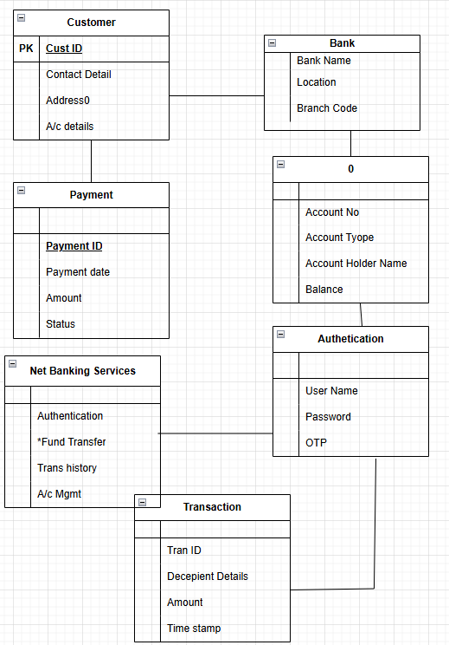

Q5. Draw a sequence diagram for payment done by Customer Net Banking

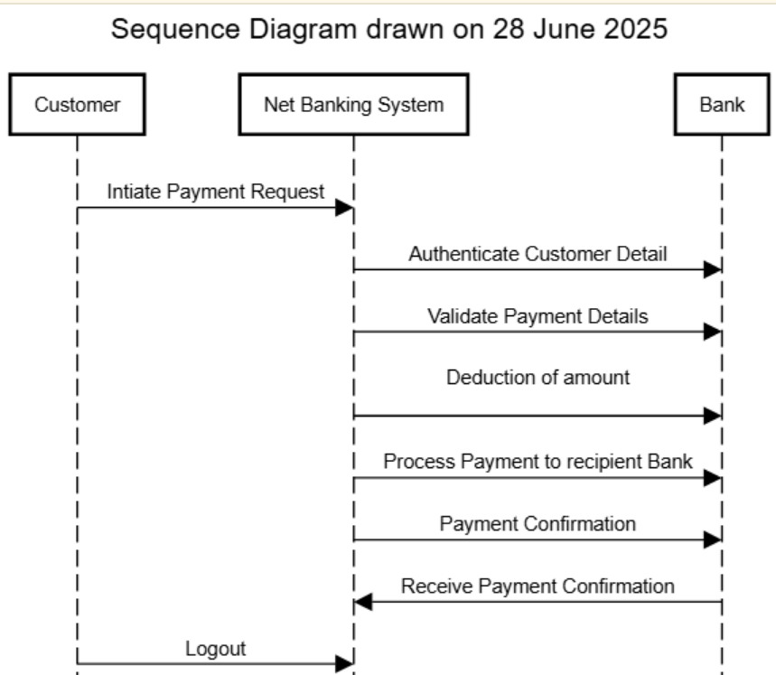

Q6. Explain Conceptual Model for this Case

The conceptual model helps in understanding the key concepts, their relationships, and the
overall structure of the net banking payment system.
It serves as a foundation for designing the database schema, defining the application
architecture, and implementing the necessary functionalities within the system

The relationships between these entities can be described as follows:
1.Customer: This node represents the customers or users of net banking services.
2.Service awareness: Customers should be aware of the available net banking services
and their features.
3.Privacy of data: The importance/significance of this node is to protect the privacy and
confidentiality of customer data in the context of net banking.
4.Technology awareness: The significance of this node is that customers should be aware
and comfortable with the underlying technology used in net banking services.
5.Trust & Support: This node indicates that the bank provides such good services that it will
help to enhance the customer’s trust.
6.Bank: This node represents a service provider responsible for offering net banking
services.
7.Online information: This aspect highlights the importance of providing accurate and up-
to-date online information about net banking services to customers.
8.Security & Privacy: The bank should adapt the security policies which will help the
customers to keep their data related to their transaction secure and private.
9.Infrastructure: This component suggests that the underlying technological infrastructure,
including hardware and software systems, plays important role in enabling net banking
services.
10.Policies: This node represents the various policies and regulations that govern the
implementation and operation of net banking services, ensuring compliance and customer
protection

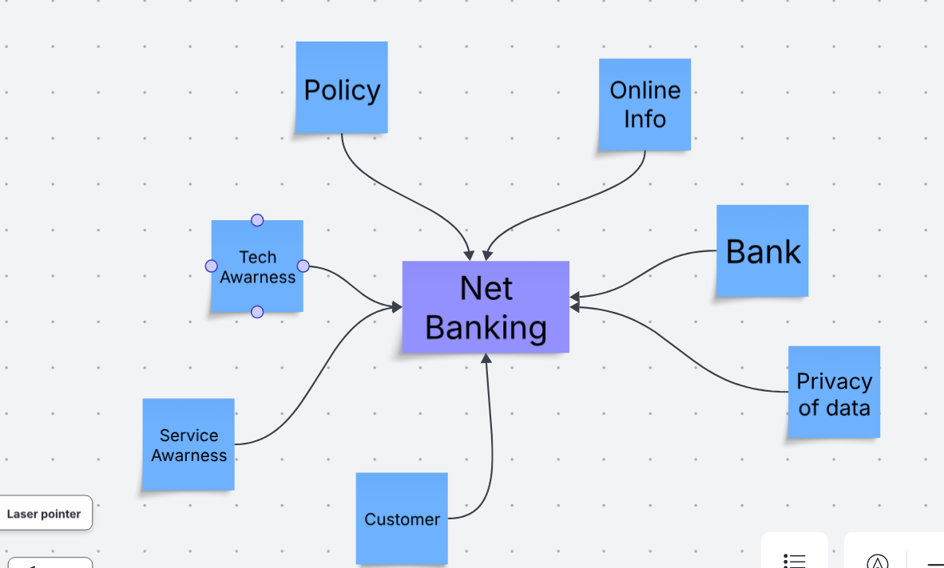

Q7. What is MVC architecture? Explain MVC rules to derive classes from use case diagram and guidelines to place classes in 3-tier architecture

MVC is a design pattern where, the application is divided into 3 logical parts-
Model, View and Controller.
Each of these parts will have specific responsibility.
Model-
The Model represents the data and the business logic of the application. Model is
responsible for multiple tasks like managing the application's data, performing
data validation, implementing business rules, and handling data access operations. Model
does not depend on how the data is presented or how the user interacts with the application
The model class is known about all the data that is needed to be displayed. This layer
corresponds to the data-related logic that the user works with. It represents the data that is
being transferred between View and Controller. It can add or retrieve the data from the
database
It responds to the controller’s request because the controller cannot interact with
the database by itself.
The model interacts with the database and give the requested data. All the model classes
are nothing but the entities. Model classes are represented as entity class.
View-
The View is responsible -for presenting the data to the user for handling the user interface.
The View can be a web page, a desktop application window, or any other form of user
interface. It receives input from the user and passes it to the Controller for processing.
It represents the presentation of the application. View refers to the model.
It takes the data from the Model and renders it in a way that is suitable for the user's display
or interaction.
For rendering the data, it uses query method. View does not depend upon application logic.
View class are represented as boundary class.

Controller-
The Controller acts as an intermediary between the Model and the View. It receives input
from the user (via the View), processes the input by invoking the appropriate methods in the
Model, and then updates the View with the new data or state.
The Controller handles user interactions, interprets user input, and translates it into
instructions for the Model or the View. It coordinates the flow of data between the Model and
the View, ensuring that they remain separated and independent of each other.

Whenever the user requests for anything, that request first goes to the controller. Controller
works on the users request.
Takes input from the user/ client. It interacts with the model and view. Controller class
represents as use case. Controller acts as a mediator between model and database
Controller cannot directly get the data from the database. So, controller interacts with the
model.

Advantages of MVC-

MVC has the feature of scalability, which in turn helps the growth of application. The
components are easy to maintain. A model can be used by multiple views that provide
reusability of code. By using MVC, the application becomes more manageable. As all the
three layers are different and independent, they are maintained separately
Rules to derive the classes from use case diagram-
1.
•Combination of one actor and one use case results in one boundary class.
•Combination of two actor and one use case results in two boundary class.
•Combination of three actor and one use case results in three boundary class.
2. Use case will result in controller class.
3. Each actor will result in one entity class.

Consider the example of Online shopping application with the following use case:

Model Classes-Customer, Payment, Net Banking, Card, Cash

View Classes-Login View, Payment Option View, Net Banking View, Bank Selecton View,
Credentials View, Payment Amount View, Payment Confirmation View, Logout View

Controller Classes-Login Controller, Payment Option Controller, Net Banking Controller,
Bank Selection Controller, Credentials Controller, Payment Amount Controller, Payment
Confirmation Controller, Logout Controller

Guidelines to place classes in 3-tier architecture-

Presentation Layer-This layer is nothing but a user interface. View is inside this layer
Tier architecture: - has 3 layers
oApplication layer
oBusiness logic layer
oData base layer

Data flowing from the 3 layers explains the 3-tier architecture where the information is
passed. Here in elicitation techniques 3 tier architecture works as a medium where as a BA
we get to know the information shared by the requester will it fit in application layer, business
logic layer or data base layer.

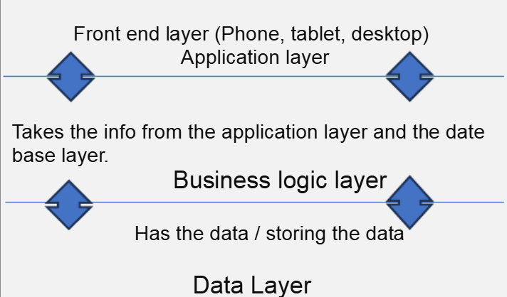

Q8. Explain BA contributions in project (Waterfall Model – all Stages)
Ans.

Waterfall model is useful in the situation where the project requirements are well defined and
the project goals are clear.
•Waterfall model follows sequential approach.
•In this model each phase is completed entirely and then only moved to the next
phase.
•Waterfall model relies on documentation to ensure that the project is well defined and
project team is working toward clear goals.
•Ones that particular phase has been completed and ones we move to the next
phase, we cannot go back to the previous phase to make changes.
•This model is stable for the projects when the requirements are clear

Requirements Gathering-
First, the stakeholders are identified. In this phase, all the requirements are gathered from
the stakeholder.BA and Project Manager participates in this phase. After completing this
phase, BRD will be generated.
Requirements Analysis-The requirements are analysed to understand the scope of
the project. Analysing means the BA will check all the requirements, if he founds convincing
requirements then the BA will talk to the concerned stakeholder to clear it, remove the
ambiguous requirements

BA will prepare functional requirement. The document which contains the
functional requirements is called (FRS).[Functional Requirement Specifications]
Technical team will prepare non-functional requirement. The document which contains the
non-functional requirements is called (SSD). [Supplementary Support Document ]BA will
combine FRS and SSD to form SRS.[ Software Requirement Specifications]BA will prepare
RTM by referring SRS

Design-
After the requirements are cleared, Design phase starts. This has a detailed design
document that outlines the software architecture, user interface, and system components’,
ADD and solution document will be generated here. [High-level Design Doc.]
BA Collaborate with designers, architects, and developers to translate requirements into
system design.BA Ensure that the design aligns with the documented requirements and
addresses stakeholder needs.

Development-
The Development phase include implementation. It involves coding the software based on
the design specifications. Programmers or developer are involved in this phase. Here BA
acts as a mediator between the development team and the stakeholders.BA clarifies the
requirements, check if the development is going on right track or not.BA also participates in
scrum meetings.

Testing-
In the testing phase, the software is tested as a whole to ensure that it meets the
requirements and is free from defects. Testers are involved in this phase
Test documents are generated here.BA works with the testing team to ensure that the
solution meets the requirements.BA facilitate UAT.BA helps the users to know the
functionality of the system and also helps them to use the system

Deployment-Once the software has been tested and approved, it is deployed to the production environment.BA ensures that there is smooth transition from development phase to the production phase.Implementation- This is the final stage of waterfall model. It involves running the code for the very first time inproduction phase. Release manager handles this phase.BA will Update documentation and requirements specifications to reflect changes in the system over timeMaintenance-Running the code for second time in the production phase is called maintenance. This is done by support team.

Q9. What is conflict management? Explain using Thomas – Kilmann technique

Conflicts can occur due to various reasons, such as differences in goals, values,
personalities, resources, or communication breakdowns.
Conflict is an inevitable part of any workplace. So it is important to resolve it to promote
learning and growth.
Conflict management is nothing but the process of identifying and addressing conflicts in a
healthy and constructive manner. It consists of strategies and techniques aimed at resolving disputes, disagreements, or differing perspectives among individuals or groups

By identifying the conflicts efficiently, it will in turn be helpful to reduce negative impact and increase positive impact.
It is a process or skill to find creative ways to handle the disagreement. Thomas – Kilmann
approach is widely used to recognize the approaches for conflict management

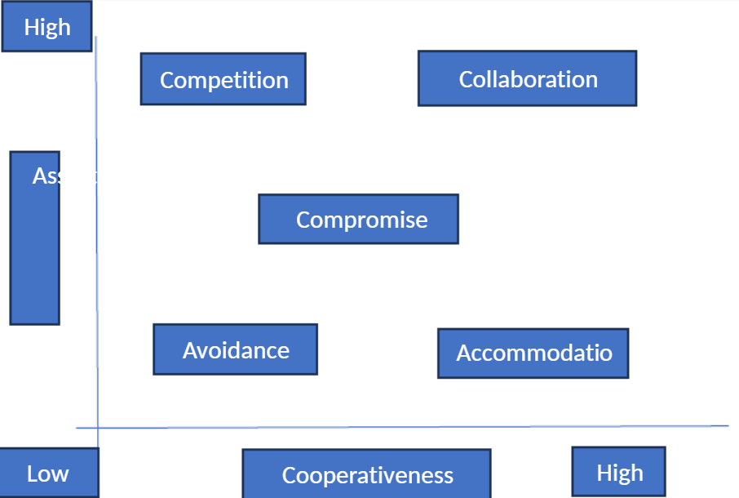

Y axis- assertiveness
X axis- co-cooperativeness
High Assertiveness and High Cooperativeness
– Collaboration- means working together to find solution
High Assertiveness and Low Cooperativeness
– Competition- means defensive, that is standing for your individual beliefs and
trying to win.

Low Assertiveness and High Cooperativeness
– Accommodation- stakeholder will prioritize their needs over others.
Low Assertiveness and Low Cooperativeness
– Avoidance- means ignoring the conflict Assertiveness- the extent to which the
person attempts to satisfy his own concerns.
Cooperativeness- the extent to which the person attempts to satisfy the other
persons concerns.

Q10. List down the reasons for project failure

Top Reasons for Project Failure

1.Unclear or Incomplete Requirements
- Inadequate stakeholder input
- Evolving needs not captured upfront (especially risky in Waterfall)
- Misinterpretation or vague documentation

2. Poor Planning and Estimation
- Unrealistic timelines or resource allocations
- Lack of buffer for risk or scope change
- Ignoring complexity points or business value during estimation

3. Lack of Stakeholder Engagement
- Absentee product owners or disengaged sponsors
- Stakeholder feedback not looped into development

4. Ineffective Communication
- Silos between business, development, and QA
- Conflicting priorities or assumptions not surfaced early
- Incomplete handovers during phase transitions

5. Scope Creep
- Continuous addition of features without adjusting schedule or budget
- No formal change control in place

6. Inadequate Risk Management
- Ignoring technical, market, or operational risks
- No mitigation or contingency planning

7. Team Issues
- Lack of clarity in roles/responsibilities
- Low morale, poor collaboration, or high turnover
- Inexperience or skill gaps not addressed

8. Poor Quality Assurance
- Late testing cycle (e.g., only during final stage in Waterfall)
- Incomplete test cases or misaligned validation criteria

9. Insufficient User Involvement or Training
- End users not involved in requirement validation or UAT
- Poor adoption due to lack of training or change resistance

10.Technology Challenges
- Choosing the wrong tech stack for business needs
- Integration issues, performance bottlenecks, or scalability limitations

11. Weak Project Governance
- No defined escalation path or decision-making authority
- Lack of status reporting or KPI tracking

Q11. List the Challenges faced in projects for BA

Lack of training
•Obtaining sign-off on the requirement
•Change management
•Co-ordination between developers and testers
•Conducting meetings.
•Making sure status report is effective
•Driving clients for UAT completion
•Making sure that the project is going on right track and delivered as per the timelines without
any issues
•Gathering clear and unambiguous requirements can be challenging
•Unable to understand what stakeholder is trying to convey
•Scope creep- change in requirement or scope of the project during the project lifecycle can
lead to scope creep
•Managing the stakeholder with conflicting interest can be a difficult task for BA
•BA may face difficulties in understanding the requirements if the domain is not familiar to him
•Poor communication between stakeholder and BA can affect the process of gathering the
information
•Technical complexity

Q12. Write about Document Naming Standards

Sure thing, KapilKaran! Here's a clear and structured overview of **Document Naming Standards**—an essential but often underappreciated cornerstone of efficient collaboration and version control in any project, whether Agile, Waterfall, or hybrid.

---

## 📄 What Are Document Naming Standards?

Component | Example | Description
Project/Module Name | ScrumFoods, HRMS | Identifies what the doc relates to
Document Type | SRS, BRD, TestCases | Specifies purpose
Feature/Section | PaymentFlow, Login | Helps with modularity
Version | v1.0, v2.3 | Tracks iterations
Date | 2025-06-28 | Helps sort chronologically
Author/Team Optional | KapilK, QAteam | Attribution if needed

📝 **Example Format:**
```
ScrumFoods_BRD_PaymentFlow_v1.2_2025-06-28.docx
```
Q13. What are the Do’s and Don’ts of a Business analyst

Never say “NO” to the client.
•There is no word called as “BY DEFAULT”
•Never imagine anything in terms of GUI
•Question everything in the world
•Go to the client with plain mind that is with no assumptions
•Listen to the client very carefully and after he is done, then ask questions
•Don’t interrupt the client.
•Never try to give solutions to the client right away.
•Try to concentrate only on important and required things.
•Be like a lotus in mud- if a client comes with a fancy requirement, then talk to the
project manager first.
•Requirement hurried-project buried.
•Never criticize the stakeholder. Always appreciate the stakeholder even for small
efforts.

Q14. Write the difference between packages and sub-systems
Packages- it is a group of classes or use cases that are used to organize model elements.
Packages can be nested within other packages.These are used as containers to organize elements. It is very useful to represent system architecture

Subsystems- it is logical grouping of related components.
It is collection of classes, packages, libraries and other sub systems that work together to
deliver a specific set of functionalities

Q15. What is camel-casing and explain where it will be used
Camel-casing refers to the naming convention of variable, parameters or properties.
Here, multiple words are combined together.
In camel-casing, the starting letter of first word starts with small letter and other words first letter starts
with capital letters.
Ex- firstName, lastName
In BA, camel-casing is used in requirements documentation.
In requirement documentation, BA often use camel-casing to name the entities like use case,
features, user stories like validateCustomerDetails, calculateInterestRate, etc
Business rules, which should be satisfied by the system use camel-casing
While documenting business process or work flows, camel-casing can be used to individual in steps.
This will help maintain consistency in the document.
The database tables name also uses camel-casing.
Requirement naming- camel casing is used in requirement document also, to name the functional andnon-functional requirements.
By using camel casing in the documents, it helps to maintain consistency in the entire document and also increases readability

Q16. Illustrate Development server and what are the accesses does business analyst has?

A development server refers to a dedicated environment that is used during
the software development process it provides platform for the developers and the testers to build, test, develop and debug the application.

The accesses a BA has are-

Read Only- BA’s may be granted with the read only access to the development server.
This will allow them to view the user interface of the application, navigate through the features and also, they will be able to observe the behaviour of the application.
Limited Access-Depending upon the project needs, the BA’s will be granted limited access to the specific modules in the application.
Limited Configuration Access- Means BA have the authority to make changes in certain areas of application where they have the access.

Q17. What is Data Mapping

Data Mapping is the process of matching data fields from one source to corresponding fields in another—a foundational step in data integration, migration, transformation, and warehousing.

The main purpose of data mapping is-
Data integration-
While combining the data from different sources, it ensures that the data is properly
matched.
Data Migration-
While migrating the data from legacy system(source) to the new system(destination), the
data elements are mapped accurately into the new system.
Required techniques are applied to covert the data into the format that is required by the
new system

Data Transformation-
Data transformation means converting the data from one format to other. In data mapping,
data transformation plays very important role which ensures that the data of legacy
system(source) is mapped correctly to the data in new system (destination

Q18. What is API. Explain how you would use API integration in the case of your application Date format is dd-mm-yyyy and it is accepting some data from Other Application from US whose Date Format is mm-dd-yyyy

API stands for Application Programming Interface
It is a software intermediary that allows the two applications to communicate with each other.It is the set of rules, protocols and tools that define how different software applicati on should interact with each other.

API allows sharing of only necessary information and keeps the internal system details
hidden, which helps the system security.

For the above scenario, Establish API communication- set up API communication between
your application and other application to exchange data.

Data formatting- While sending the data from one application to other, convert the date
format from dd-mm-yyyy to mm-dd-yyyy.

While receiving the data from other application, parse the data and extract the date, month
and year and re-arrange them accordingly. Perform Data Validation and ensure that
the converted date remains in a valid format

Capstone PREP-3
Q4. Explain Domain Model for Customer making payment through Net Banking
Ans. Domain model is similar to the entity relationship model. The tables are connected to each
other. In the below diagram, the customer table is connected to bank table, which is why
the customer is able to make payment.
Customer table is also connected to payment table, because he should make the payment. Now the
payment is done by net banking, so payment table is connected to net banking table.
The account is in the bank, so the account table is connected to the bank table. The authentication
table is connected to both net banking table and bank table, because authencation is to be performed
there.
Also, the authentication table is connected to transaction table, because authentication will be done
while transaction.
Difference between ER diagram and domain model-
ER Model – do not have attributes inside the box Domain Model- do have attributes mentioned inside
the box
ER Model – it is a data modelling technique used in database design to represent table
Domain Model- it is a conceptual model that represents real world entities.
ER Model – focuses on relationships required for storing and retrieving the data
Domain Model- It focuses on capturing the behaviour of application
ER Model –primarily used in database design
Domain Model-used throughout the software development lifecycle

BANK
Bank
Name
Location Branch
Code
CUSTOMER
Custome
r ID
Customer
Name
Contact
details
Address Account
Number

