Waterfall Project2 – Part -2/2

Document 6- Please prepare a use case diagram, activity diagram and a use case specification document:-

Use Case Diagram
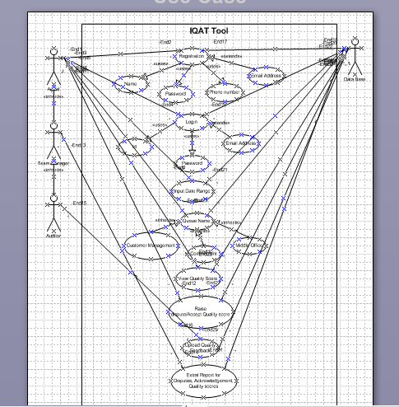

Activity Diagram

Process flow for Agent access:-
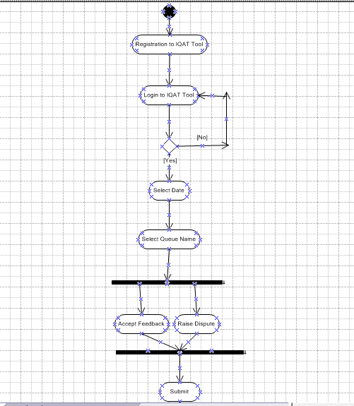

Process flow for Team Manager/Auditor:-
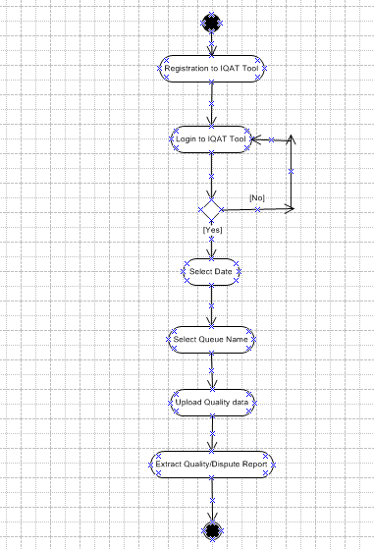

Use Case Specification Document

Use Case Name:- Login
Use case Description:- Allows users to log in to the IQAT Tool.
Actors Primary Actors Secondary actors:-
Primary Actors: Agents, Team Manager & Quality/Auditor
Secondary Actor:- Data Base

Basic Flow:-

1. User navigates to the login page.
2. User enters username and password.
3. System validates credentials.
4. System displays the Quality scores/dashboard upon successful login.

Alternate Flow:- Invalid credentials:

1. System displays an error message.
2. User retries login or resets password.

Exceptional Flows:- System downtime:

1. User is unable to log in.
2. System displays maintenance message.

Pre-Conditions:-

1. User must be registered in the system.
2. System must be online.

Post-Conditions:-

1. User is logged in and directed to the dashboard.

Assumptions:-
1. Users should have valid credentials.
2. Users should have internet connect

Constraints:-

1. High load times during peak hours.

Dependencies:-

1. User database authentication service.

Inputs and Outputs:-

1. Inputs: Username, password
2. Outputs: Dashboard, error messages

Business Rules:-

1. Passwords must meet security requirements.
2. Account lockout after multiple failed attempts.

Miscellaneous Information:-

Ensure password reset functionality is available.

Use Case Name:- Upload Quality data

Use Case Description:- Allow Quality/Auditor to upload Quality scores

Actors Primary Actors Secondary actors:-
1. Primary Actors: Agents, Team Manager & Quality/Auditor
2. Secondary Actor:- Data Base

Basic Flow:-

1. Auditor will login to IQAT tool
2. Auditor will select the date of audit done
3. Auditor will fill up the Quality form
4. Auditor will upload the Quality scores

Alternate Flow:- Uploading Quality form

1. System displays an error message.
2. Auditor corrects and resubmits the Quality form in the correct format

Exceptional Flows:- Database error:

1. System displays an error message.
2. Auditor uploads the Quality form again with Quality scores

Pre-Conditions:-

1. Auditor must be logged in to the system
2. User should have Quality data to be uploaded

Post-Conditions:-

1. Quality form is successfully submitted on IQAT tool

Assumptions:-

1. Auditors should have the correct scores to update
2. Auditors should have internet connection

Constraints:-

1. High load times during peak hours.

Dependencies:-

1. Database service

Inputs and Outputs:-

1. Inputs: Update Quality scores and upload the form
2. Output: Successfully uploaded, error message

Business Rules:-

1. Quality form should be checked before uploading
2. Quality form should be uploaded as per format defined and agreed
3. The access for uploading and submitting the quality form is supposed to be given only to the Auditor

Miscellaneous Information:-

1. Ensure Quality format is user-friendly

Use Case Name:- View Quality data

Use Case Description:- Retrieve Quality scores/Agent acknowledgement/Dispute data/Quality dashboards

Actors Primary Actors Secondary actors:-
1.Primary Actors: Agents, Team Manager & Quality/Auditor
2.Secondary Actor:- Data Base

Basic Flow:-

1. Team Manager/Auditor will login to IQAT tool
2. Team Manager/Auditor will select the date for which the report is required
3. Team Manager/ Auditor will select the report type needed and extract the data

Alternate Flow:- No report available

1. System displays a message that no data is available for the for the selected term

Exceptional Flows:- Database error

1. System displays an error message
2. Team Manager/ Auditor retries later

Pre-Conditions:-

1. Report should be available on IQAT tool to be extracted
2. User should have access to extract the report

Post-Conditions:-

1. Report is extracted for the queue that is requested

Assumptions:-

1. Users should have valid credentials.
2. Users should have internet connect

Constraints:-

1. Report generation performance

Dependencies:-

1. Database service

Inputs and Outputs:-

1. Inputs: Select date and queue name
2. Output: Successfully retrieved, error message

Business Rules:-

1. Report should be extracted only in excel format
2. Report should be password protected
3. The access for extracting the report is supposed to be given only to the Auditor/Team Manager

Miscellaneous Information:-

1. Ensure data is pulled in a manner which is easily readable by the members

Document 7- Screens and pages:-

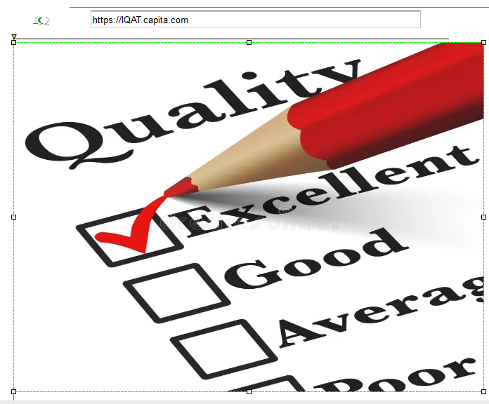

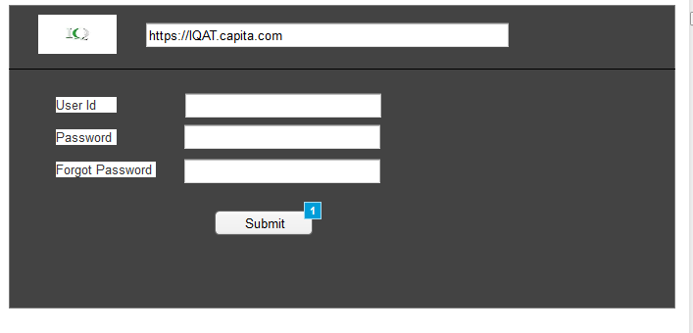

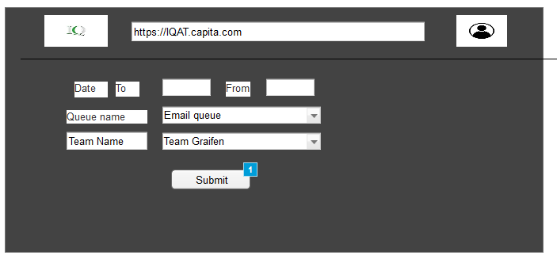

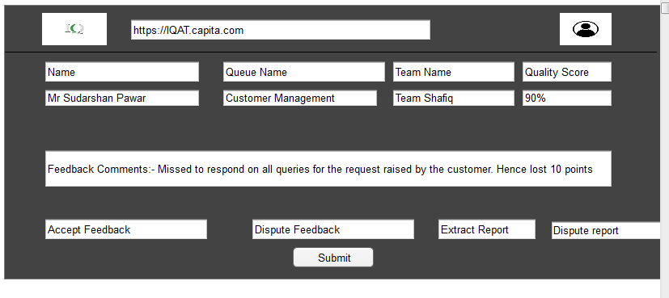

Document 8- Tools-Visio and Axure:-

Write a paragraph on your experience using Visio and Axure for the project:-

Ms Visio was very useful as it helped to prepare a detailed system interaction with the Actors. It also helped in preparing process flow chart which would be very easy for the Developers to understand what the client requirement is. This facilitated clear communication and planning throughout all the stages of the project.
Axure gave a real feel to the business heads as to how the application would look like. It allowed to understand how a User would use the application in live environment. As a BA if the business heads had any changes that they wanted it was easy to communicate and know their requirement.
Both the tools were really efficient and productive in fulfilling business needs.

Document 9- BA experience

My experience as BA in following phases:-

Requirement gathering:-

1. In this project, I leveraged my expertise as a Business Analyst to gather comprehensive requirements by using MOSCOW technique for IQAT portal.
2. Through a combination of stakeholder interviews, workshops, and surveys, I meticulously documented the needs and expectations of Agent, Auditors, Team Manager & Higher Management.
3. I validated the requirements using FURPS technique.
4. Utilizing elicitation techniques such as use case analysis and process mapping, I ensured a thorough understanding of the functional and non-functional requirements.
5. My experience in requirement gathering helped create a detailed and precise requirements document, which served as a solid foundation for the successful development and implementation of the IQAT portal.
6. Prototyping is used to give more specific requirement.

Requirement Analysis:-

1. In this project, I utilized my skills as a Business Analyst to perform a thorough requirements analysis for the IQAT portal.
2. I started by organizing and categorizing the gathered requirements, ensuring clarity and removing any ambiguities.
3. Using detailed analysis techniques, I identified and consolidated duplicate requirements, ensuring a streamlined and coherent set of needs.
4. I shared diagrams with the team for feedback. The team suggestions were incorporated and made necessary modifications.
5. I conducted regular validation sessions with stakeholders to confirm the accuracy and completeness of the requirements.
6. By developing and sharing prototypes, I facilitated stakeholder engagement , refining the requirements to align perfectly with user expectations. This meticulous approach ensured a solid foundation for the project's successful implementation.

Design:-

1. From use case and activity diagrams, I took help of Testing team to prepare test cases
2. Clear communication to the stakeholder was given all the time via email, MS Teams, MOMs on design and solution documents.
3. With help from Testing team, we wrote negative test cases to understand the Alternative and Exceptional flow of the system.
4. Got positive test cases as well to implement the activity at each of the stage.
5. RTM document was updated to ensure we capture the status of each of the requirements and accordingly decide on further plan of action.

Development:-

1. Organized JAD session where I was able to get all the stakeholders, developers and testers on one platform to define project requirements and designs.
2. Managed to address all the queries for development team that were raised with regards to the portal design.
3. During JAD session we had Auditors and few tenured agents who were not ready to capture to the new way of working. This was because the team had been following the existing feedback process for more than 6 years and they were very comfortable with it. As a team they were not aware that the existing process was not at all benefiting the business and it was also creating knowledge gap. Explained the benefits to the members of what things can ease for themselves if we implement this portal and most important it would help the business to frequently meet Quality targets and improve CSAT. This always had a chance to get more business from the clients.
4. Referred diagrams to the development team to help code the unit.
5. Frequently had meeting conducted with technical team and the stakeholders to understand their challenges. Discussed about what solutions that could be implemented which not only helped the individual but all the other members in the team. Members who were on leave or not available for any reason, we got the session recorded on MS Teams, so that once they resumed, they could listen to the recording and be updated or aligned with what was discussed in team huddle.

Testing:

1. Connected with Testing team to create test cases.
2. Prioritized test cases basis risk and criticality.
3. Implemented test automation for repetitive and time-consuming tests.
4. Establishing clear communication channels between development and testing teams.
5. Updated test case document and shared with stakeholders for sign offs where the test was successfully completed.
6. Shared test document with developers where there was bug identified so they could fix the issue.

Deployment:

1. Attached the RTM (Requirement Traceability Matrix) sheet to project closure document when sending the details to the stakeholders.
2. Reviewed all training documents & SOPs and shared the same with the stakeholders.
3. Planned for training sessions for all Agents, Auditors and Team Managers on how to use the new IQAT portal. Invites were sent for MS Teams call basis their availability and ensured 100% participation.
4. Post deployment, provided support for any queries or to resolve any technical glitch

