Q1. Identify minimum 20 functional requirements
Req ID | Requirement Name | Functional Requirement Description
FR001 | User Registration – Farmers | System shall allow Farmers to register using email ID and password.
FR002 | User Registration – Manufacturers | System shall allow Manufacturers to register and create product listings.
FR003 | User Login | System shall authenticate users (Farmers/Manufacturers/Admin) using their login credentials.
FR004 | Password Reset | System shall provide password reset through email verification.
FR005 | View Product Catalog | Farmers shall be able to browse fertilizers, seeds, and pesticides.
FR006 | Product Search | System shall allow Farmers to search products using keywords, type, brand, and category.
FR007 | Product Filter | Farmers shall filter products by price, category, rating, manufacturer, etc.
FR008 | Add to Cart | System shall allow Farmers to add selected products to the cart for purchase.
FR009 | Buy Later / Wishlist | Farmers shall add products to wishlist list.
FR010 | Add New Product (Manufaturer) | Manufacturers shall upload product details (name, price, description, stock).
FR011 | Update Product (Manufaturer) | Manufacturers shall edit/update their existing product details.
FR012 | Delete Product (Manufaturer) | Manufacturers shall remove their products from the catalog.
FR013 | Place Order | Farmers shall place orders for products in the cart.
FR014 | Payment - COD | System shall support Cash-on-Delivery.
FR015 | Payment - Credit/Debit Card | System shall support online card payments.
FR016 | Payment - UPI | System shall support UPI payment options.
FR017 | Order Confirmation Email | System shall send email confirmation after successful order placement.
FR018 | Delivery Tracking | Farmers shall view the current status and movement of their order.
FR019 | Order History | Farmers shall be able to view previous orders and their details.
FR020 | Admin Management | Admin shall manage users, products, and overall platform settings.

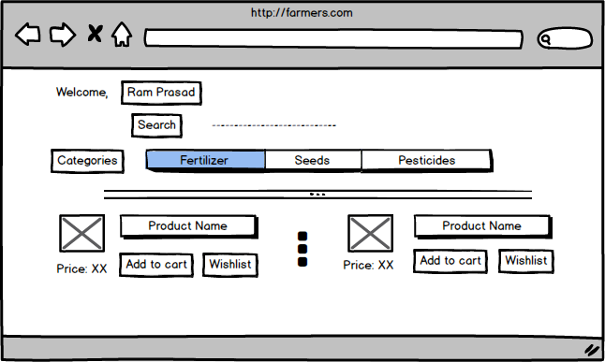
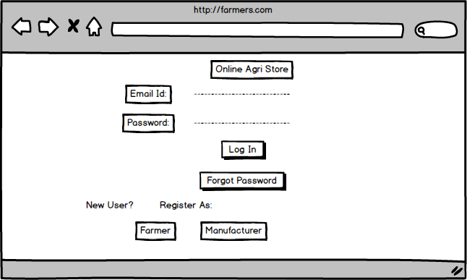
Q2. Make wireframe and prototypes

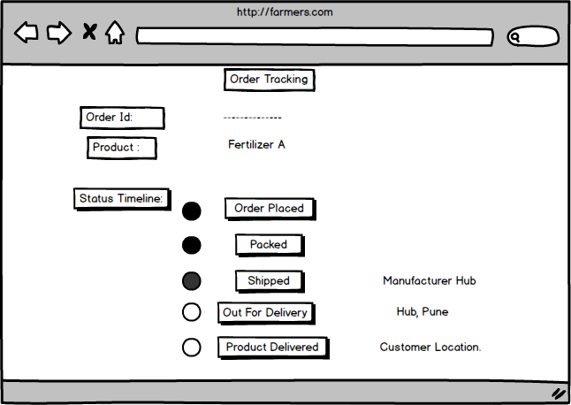
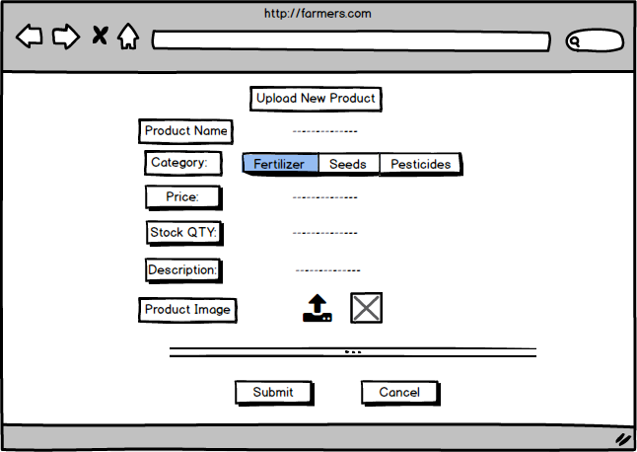
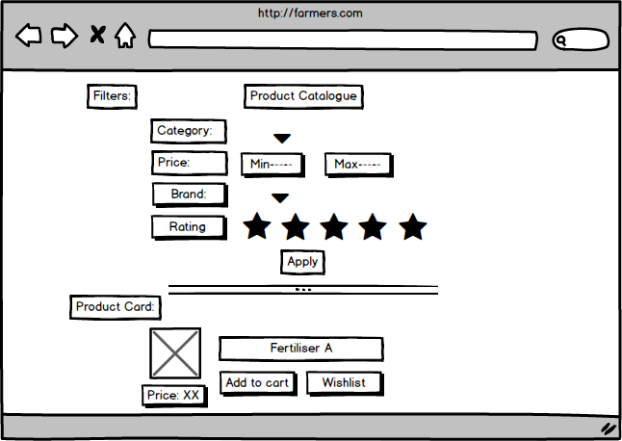

Q.3 Make a note of the Tools, which you are using for above concepts.
Microsoft Visio, Balsamiq, Excel, Word.

Q.4 A business analyst’s key responsibilities are to keep track of the requirements and make sure that no requirement is missed. Mr. Henry and peter have approached you regarding the current status of the project. How will you tackle this situation?
Req ID | Requirement Name | Description | Design (D1) | Dev (T1) | Test (T2) | UAT
FR001 | Farmer Registration | Farmers shall register using email & password | ✔ | ✔ | ✔ | Pending
FR002 | Product Search | Farmers shall search fertilizers, seeds, pesticides | ✔ | ✔ | ✔ | Pending
FR003 | User Login | Secure authentication for all users | ✔ | ✔ | ✔ | Pending
FR004 | Password Reset | Password reset via email verification | ✔ | ✔ | ✔ | Pending
FR005 | View Product Catalog | Farmers browse fertilizers, seeds, pesticides | ✔ | ✔ | ✔ | Pending
FR006 | Product Filter | Filter products by price, brand, category | ✔ | ✔ | In Progress | Pending
FR007 | Add to Cart | Farmers add items to cart | ✔ | In Progress | Pending | Pending
FR008 | Wishlist | Farmers save products for later | ✔ | In Progress | Pending | Pending
FR009 | Place Order | Farmers place an order | ✔ | In Progress | Pending | Pending
FR010 | Payment – COD | Cash-on-Delivery support | ✔ | Not Started | Pending | Pending
FR011 | Payment – Cards | Debit/Credit card support | ✔ | Not Started | Pending | Pending
FR012 | Payment – UPI | UPI payment integration | ✔ | Not Started | Pending | Pending
FR013 | Order Confirmation Email | Confirmation email after order | ✔ | In Progress | Pending | Pending
FR014 | Order Tracking | Track order shipment & delivery | ✔ | In Progress | Pending | Pending
FR015 | Order History | View previous orders | ✔ | ✔ | ✔ | Pending
FR016 | Product Upload (Manufacturer) | Manufacturer uploads products | ✔ | ✔ | ✔ | Pending
FR017 | Edit Product | Manufacturer updates product details | ✔ | ✔ | ✔ | Pending
FR018 | Delete Product | Manufacturer deletes products | ✔ | ✔ | ✔ | Pending
FR019 | Admin Management | Admin manages users & products | ✔ | In Progress | Pending | Pending
NFR001 | Page Load Time | Each page ≤ 2 seconds load time | ✔ | In Progress | Pending | –
NFR002 | WCAG 2.1 Accessibility | UI accessible as per WCAG 2.1 | ✔ | In Progress | Pending | –

Q5. Prepare 10 Test Case Documents

1. Test Case: Farmer Registration
Test case ID | FR_001 | Test case Name | Farmer Registration
Project ID | OAPS_001 | Project Name | Online Agriculture Products Store
PM ID | PM_001 | PM Name | Mr. Vandanam
Test strategy ID | TS_001 | Tester ID | QA_01
Test plan ID | TP_001 | Tester Name | [cite_start]
Test schedule ID | SCH_001 | Date of Test | 18-Nov-2025
Scenario | Verify New Farmer Registration
Link to that page: | /register
 | Set 1 (Valid Data) | Set 2 (Invalid Data) | Set 3
Input Data | Email: farmer@test.com  Pass: Farm123$  Confirm Pass: Farm123$ | Email: farmer@test.com  Pass: 123  Confirm Pass: 123
Expected behaviour | System accepts details; Account created; Redirect to Login. | System displays error: "Password too weak" or "Invalid format".
Actual behaviour | As Expected | As Expected
Comments | Verified DB entry created. | Error message verified.
Result (Pass/Fail) | Pass | Pass

2. Test Case: Farmer Login
Test case ID | FR_002 | Test case Name | Farmer Login
Project ID | OAPS_001 | Project Name | Online Agriculture Products Store
PM ID | PM_001 | PM Name | Mr. Vandanam
Test strategy ID | TS_001 | Tester ID | QA_02
Test plan ID | TP_001 | Tester Name | [cite_start]
Test schedule ID | SCH_001 | Date of Test | 18-Nov-2025
Scenario | Verify Farmer Login Functionality
Link to that page: | /login
 | Set 1 (Valid) | Set 2 (Invalid) | Set 3
Input Data | Email: peter@test.com  Pass: Peter123 | Email: peter@test.com  Pass: WrongPass
Expected behaviour | User successfully logged in; Dashboard displayed. | System displays error: "Invalid Credentials".
Actual behaviour | As Expected | As Expected
Comments | Redirected in <2 secs.
Result (Pass/Fail) | Pass | Pass

3. Test Case: Product Search
Test case ID | FR_003 | Test case Name | Product Search
Project ID | OAPS_001 | Project Name | Online Agriculture Products Store
PM ID | PM_001 | PM Name | Mr. Vandanam
Test strategy ID | TS_001 | Tester ID | QA_01
Test plan ID | TP_001 | Tester Name
Test schedule ID | SCH_001 | Date of Test | 19-Nov-2025
Scenario | Search for product in Catalog
Link to that page: | /search
 | Set 1 (Seeds) | Set 2 (Pesticides) | Set 3
Input Data | Keyword: "Tomato Seeds"  Filter: Seeds | Keyword: "Pesticide"  Filter: All
Expected behaviour | List displays only Tomato Seed products. | List displays available pesticides.
Actual behaviour | As Expected | As Expected
Comments | Search results accurate.
Result (Pass/Fail) | Pass | Pass

4. Test Case: Manufacturer Upload
Test case ID | MN_001 | Test case Name | Manufacturer Product Upload
Project ID | OAPS_001 | Project Name | Online Agriculture Products Store
PM ID | PM_001 | PM Name | Mr. Vandanam
Test strategy ID | TS_001 | Tester ID | QA_01
Test plan ID | TP_001 | Tester Name
Test schedule ID | SCH_001 | Date of Test | 19-Nov-2025
Scenario | Upload new product details
Link to that page: | /manufacturer/add-product
 | Set 1 | Set 2 | Set 3
Input Data | Name: Urea 50kg  Type: Fertilizer  Price: $20  Image: urea.jpg | Name: Cotton Seeds  Type: Seeds  Price: $50  Image: seed.jpg
Expected behaviour | Product saved; Visible in Catalog. | Product saved; Visible in Catalog.
Actual behaviour | As Expected | As Expected
Comments | Upload time < 2 sec.
Result (Pass/Fail) | Pass | Pass

5. Test Case: Browse Catalog
Test case ID | FR_004 | Test case Name | Browse Catalog
Project ID | OAPS_001 | Project Name | Online Agriculture Products Store
PM ID | PM_001 | PM Name | Mr. Vandanam
Test strategy ID | TS_001 | Tester ID | QA_02
Test plan ID | TP_001 | Tester Name
Test schedule ID | SCH_001 | Date of Test | 20-Nov-2025
Scenario | Browse and View Product Details
Link to that page: | /products
 | Set 1 | Set 2 | Set 3
Input Data | Action: Click "Fertilizers" category.  Action: Select "Urea". | Action: Click "Seeds" category.  Action: Select "Tomato".
Expected behaviour | Category filters; Product Detail page opens with Price/Desc. | Category filters; Product Detail page opens.
Actual behaviour | As Expected | As Expected
Comments | Images loaded correctly.
Result (Pass/Fail) | Pass | Pass

6. Test Case: Add to Buy-Later
Test case ID | FR_005 | Test case Name | Add to Buy-Later (Wishlist)
Project ID | OAPS_001 | Project Name | Online Agriculture Products Store
PM ID | PM_001 | PM Name | Mr. Vandanam
Test strategy ID | TS_001 | Tester ID | QA_02
Test plan ID | TP_001 | Tester Name
Test schedule ID | SCH_001 | Date of Test | 20-Nov-2025
Scenario | Add product to Wishlist
Link to that page: | /product-detail
 | Set 1 | Set 2 | Set 3
Input Data | Product: Pesticide X  Action: Click "Add to Buy-Later" | Product: Seeds Y  Action: Click "Add to Buy-Later"
Expected behaviour | Item added to "My Buy-Later List"; Confirmation msg shown. | Item added to "My Buy-Later List".
Actual behaviour | As Expected | As Expected
Comments
Result (Pass/Fail) | Pass | Pass

7. Test Case: COD Payment
Test case ID | PY_001 | Test case Name | Cash on Delivery Payment
Project ID | OAPS_001 | Project Name | Online Agriculture Products Store
PM ID | PM_001 | PM Name | Mr. Vandanam
Test strategy ID | TS_001 | Tester ID | QA_01
Test plan ID | TP_001 | Tester Name
Test schedule ID | SCH_001 | Date of Test | 21-Nov-2025
Scenario | Checkout using COD
Link to that page: | /checkout
 | Set 1 | Set 2 | Set 3
Input Data | Cart Total: $100  Payment Mode: Cash on Delivery | Cart Total: $500  Payment Mode: Cash on Delivery
Expected behaviour | Order Placed; Status "Pending Payment"; Success Page shown. | Order Placed; Status "Pending Payment".
Actual behaviour | As Expected | As Expected
Comments | Verified in Admin panel.
Result (Pass/Fail) | Pass | Pass

8. Test Case: Online Payment
Test case ID | PY_002 | Test case Name | Online Payment (Card/UPI)
Project ID | OAPS_001 | Project Name | Online Agriculture Products Store
PM ID | PM_001 | PM Name | Mr. Vandanam
Test strategy ID | TS_001 | Tester ID | QA_01
Test plan ID | TP_001 | Tester Name
Test schedule ID | SCH_001 | Date of Test | 21-Nov-2025
Scenario | Checkout using Credit Card/UPI
Link to that page: | /checkout
 | Set 1 (Credit Card) | Set 2 (UPI) | Set 3
Input Data | Mode: Credit Card  Card: 4111-xxxx-xxxx-1111  CVV: 123 | Mode: UPI  UPI ID: farmer@upi  Pin: 123456
Expected behaviour | Payment Processed; Order Placed; Status "Confirmed". | Payment Processed; Order Placed.
Actual behaviour | As Expected | As Expected
Comments | Gateway response OK.
Result (Pass/Fail) | Pass | Pass

9. Test Case: Order Confirmation Email
Test case ID | NT_001 | Test case Name | Email Confirmation
Project ID | OAPS_001 | Project Name | Online Agriculture Products Store
PM ID | PM_001 | PM Name | Mr. Vandanam
Test strategy ID | TS_001 | Tester ID | QA_02
Test plan ID | TP_001 | Tester Name
Test schedule ID | SCH_001 | Date of Test | 22-Nov-2025
Scenario | Verify Email Receipt
Link to that page: | /email-client
 | Set 1 | Set 2 | Set 3
Input Data | Trigger: Order #999 Placed  Action: Check Email Inbox
Expected behaviour | Email received from AgriStore; Contains Order #999 details.
Actual behaviour | As Expected
Comments | Email arrived in < 1 min.
Result (Pass/Fail) | Pass

10. Test Case: Delivery Tracking
Test case ID | TR_001 | Test case Name | Delivery Tracking
Project ID | OAPS_001 | Project Name | Online Agriculture Products Store
PM ID | PM_001 | PM Name | Mr. Vandanam
Test strategy ID | TS_001 | Tester ID | QA_02
Test plan ID | TP_001 | Tester Name
Test schedule ID | SCH_001 | Date of Test | 22-Nov-2025
Scenario | Track Order Location
Link to that page: | /track-order
 | Set 1 | Set 2 | Set 3
Input Data | Order ID: #12345  Status: Dispatched  Action: Click "Track"
Expected behaviour | Map/Timeline displays current location and status "In Transit".
Actual behaviour | As Expected
Comments
Result (Pass/Fail) | Pass

Q6. After the requirements are thoroughly explained to the entire project team by business analyst, the Database architects have decided to do the database design and also to represent the in-flow and out-flow of data. Draw database schema and ER diagram.

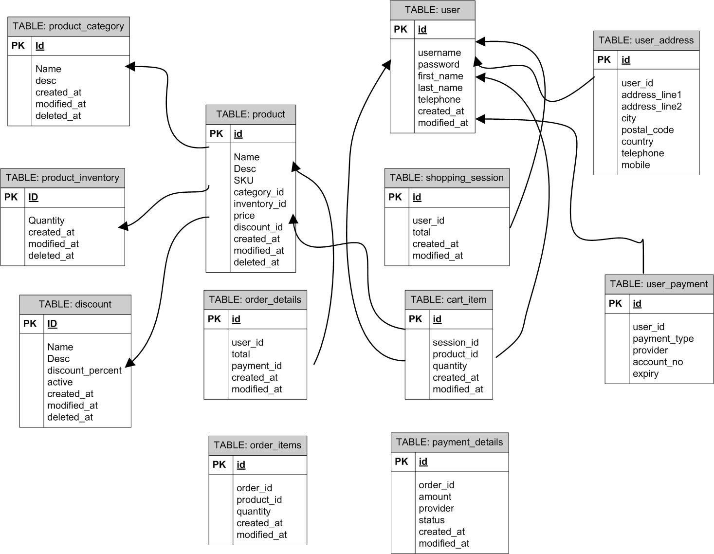

Q7. What is a data flow diagram? Draw a data flow diagram to represent the in-flow and out-flow of data when a Farmer is placing an order for the product.

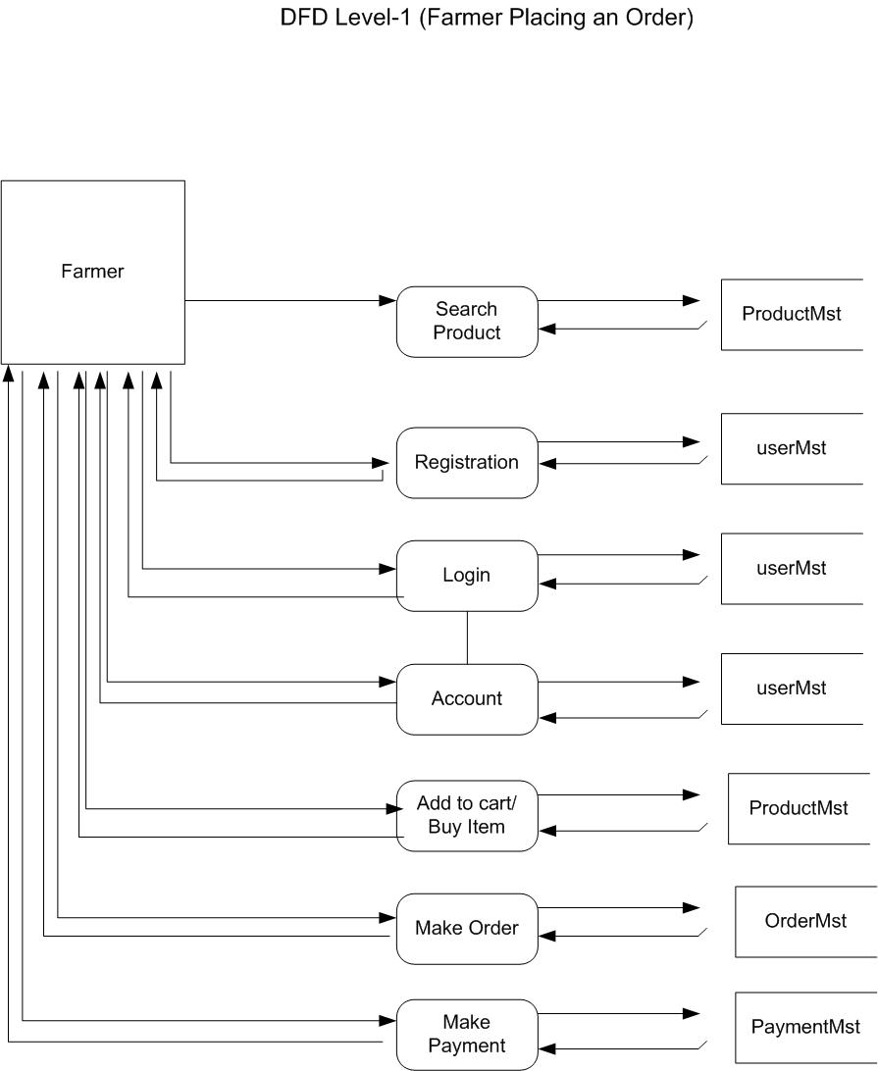

Q8. Due to change in the Government Taxation structure . we should change the Tax structure How do you handle change requests in a project?
A change request is a formal proposal to alter a system, product, or project.
- Understand the scope of the change request and document it – In this case, the government has introduced a new taxation structure, so the tax calculation logic in pricing, invoice, and checkout needs modification.
- Do the impact analysis – Assess how the new tax rules affect the project scope, schedule, budget, affected modules (pricing engine, checkout, invoice, reports), resources required, and risks related to compliance.
- Prioritize the change request based on its urgency and importance – Since it is a government-mandated compliance requirement, it is treated as a high-priority change.
- Seek approval from the project sponsor and key stakeholders – Present the impact analysis, effort estimation, and timeline, and obtain approval before making any updates.
- Communicate the approved change request and potential impacts to all relevant stakeholders including development, testing, and deployment teams, and update BRD, SRS, RTM, and test cases accordingly.

Question 9 – Change Request Vs an Enhancement
As the project is in process, Ben and Kevin have contacted you. The reason is to inform you that
they want the Farmers to sell their crop yields through this application i.e. Farmers should be able
to add their crop yields or products and display to general public and should be able to sell them.
They also want to introduce Auction system for their Crop yields. As a BA, what will be your
response? Is this a change request or an enhancement???

As per the currently approved project scope, the application supports farmers to search and purchase products only.
The ability for farmers to sell their crop yields and the introduction of an auction system are not part of the existing requirements.
These are new functionalities that introduce additional business processes, data flows, UI screens, and integrations.
Therefore, this request will be categorized as a Scope Enhancement (not a Change Request).
A separate Enhancement Request will be raised, followed by detailed impact analysis, cost estimation, timeline update, and stakeholder approval.

Q10. Come up with estimations – How many Manhours required
As per the estimation, the total effort required for this enhancement is approximately 430–450 manhours.
Hence, this will fall under a Small Project / Small Enhancement (as it is below 500 hours).
As trained resources are already available in the existing project team, no additional training or new resources are required.
As the structure, architecture, and modules of the current application already exist (product listing, login, checkout), no new infrastructure or environment setup is required.
Only additional development, testing, BA documentation, and UI/UX work are needed to support the new Selling and Auction features.

Q11. Project has finally completed all the stages i.e., design, development, testing etc. Now, it is the role of a business analyst to contact the client for testing of the final product and have to successfully complete it. How are you going to handle this situation? And once it is done, what will be the process to close the project? Explain UAT Acceptance process
Planning:
In this step, blueprints are prepared to implement UAT testing for all the features that need to be tested. The BA defines the scope, entry criteria, exit criteria, timelines, and minimum standards required for accepting the UAT results.
Designing:
Here, the UAT test cases and scenarios are designed based on real-world usage. All possible business flows are covered so that the end users can validate the software thoroughly.
UAT Testers:
A UAT testing team consists of selected end users who understand the business process. They should be aware of the test cases, expected behaviour, and must verify whether the delivered system meets their requirements.
Bug Fixing:
Whatever bugs, mismatches, or issues are identified during UAT testing should be logged and sent to the development team. The team works on resolving them and ensures that the software becomes stable and error-free.
Sign Off:
After all the bugs are resolved and the system works as expected, the UAT team provides acceptance of the final product. In this phase, all stakeholders agree that the software is ready for Go-Live, and the formal UAT Sign-Off document is signed.

Q12. Explain Project closure document
- A project closure document is a formal report summarizing the final outcomes, achievements, lessons learned, and performance of the completed Online Agriculture Product Store Project.
- It records the overall accomplishments, challenges faced, and key insights that will help stakeholders and future projects.
Project Overview
This project aimed to build an online platform where Farmers can search and buy products, and Manufacturers can upload and sell their products. The development followed the V-Model with phases RG, RA, Design, D1–D4 & T1–T4, and UAT. Key stakeholders included Farmers, Manufacturers, Admin, PM, BA, Developers, and Testers.
Achievements
- All core modules (Registration, Product Search, Product Listing, Cart, Checkout, Payment Gateway, Order Tracking) were delivered.
- System successfully passed all ST, IT, and UAT cycles.
- Performance improved to meet expected load and speed.
- Final product deployed successfully in the client environment.
Lessons Learned
- Early involvement of SMEs reduces requirement conflicts.
- Change request impact analysis must be done immediately to avoid delays.
- Clear communication between BA, PM, and client helps faster approvals.
- Proper documentation ensures smooth development across V-Model phases.
Quality Assurance
- All requirements were mapped with test cases.
- Bugs from T1–T4 and UAT were fixed within timelines.
- No major defects remained at the time of go-live.
- System met all functional and non-functional acceptance criteria.
Resource Utilization
- BA and PM actively supported all phases of V-Model.
- Java Developers, Testers, DB Admin, and NW Admin were used efficiently as per Gantt chart.
- No additional training or external resource requirement.
Risk Management
- Requirements changes (Taxation rules, Farmer Crop Selling feature) were assessed and controlled.
- Third-party API risks for payment and tracking were mitigated.
- Data inconsistencies were handled using validation and verification measures.
Challenges
- Change in Government taxation rules caused rework.
- UAT delays due to Farmer and Manufacturer availability.
- Integration issues with payment gateway and delivery partner API.

