Document 6- Please prepare a use case diagram, activity diagram and a use case specification document.
- Use case Document.
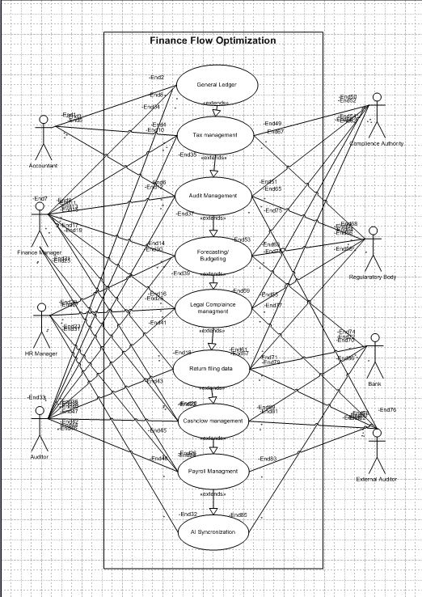

2. Activity Diagram
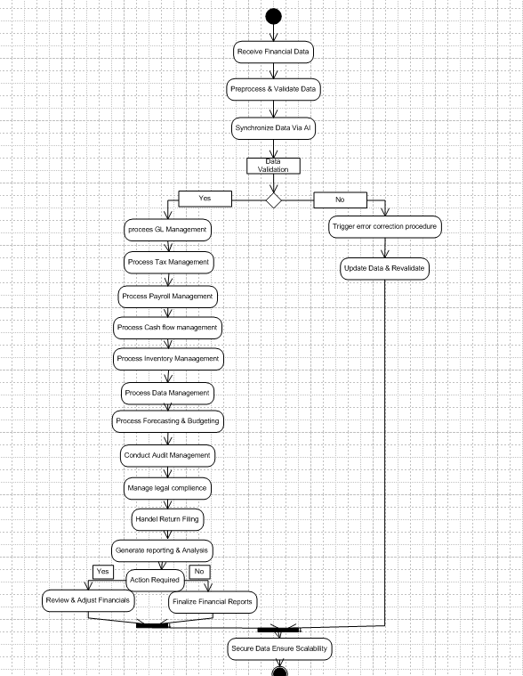

Use Case Specification Document

1. Use Case: General Ledger Management
Criteria | Details
Use Case Name | General Ledger Management
Use Case Description | Provides a centralized, real-time system for recording, updating, and auditing journal entries with AI-assisted validation and error detection.
Actors (Primary, Secondary) | Primary: Accountant, Finance Manager Secondary: Internal Auditor
Basic Flow | 1. Authenticated user selects the module. 2. System displays balances and recent transactions. 3. User enters or adjusts journal entries. 4. AI validates entries. 5. System records transactions.
Alternate Flow | If the AI detects discrepancies, it suggests corrections before final submission.
Exceptional Flows | If a data synchronization error or connectivity loss occurs, an error message is triggered and the transaction is queued for manual review.
Pre-Conditions | User is authenticated and the chart of accounts is established.
Post-Conditions | Ledger reflects validated transactions with audit trails; success/error logs are generated.
Assumptions | Historical data is accurate and available; data model conforms to accounting standards.
Constraints | Dependent on network connectivity and server performance impacting real-time updates.
Dependencies | Data Management module and AI validation engine integration must be operational.
Inputs and Outputs | Inputs: Journal entries, adjustment requests. Outputs: Updated ledger entries, validation statuses, and audit logs.
Business Rules | Every journal entry must be balanced, and validation must occur before posting.
Miscellaneous Information | Audit trails support internal reviews and external audits, ensuring compliance.

2. Use Case: Tax Management
Criteria | Details
Use Case Name | Tax Management
Use Case Description | Aggregates financial data to automatically calculate tax liabilities, ensuring compliance with updated tax rules and reducing manual errors.
Actors (Primary, Secondary) | Primary: Tax Manager, Accountant Secondary: System Administrator (for tax rule updates)
Basic Flow | 1. User navigates to the Tax Management module. 2. System aggregates relevant financial data. 3. AI calculates tax liabilities using predefined rules and historical patterns. 4. A tax summary is presented. 5. User confirms and schedules filing.
Alternate Flow | If missing or inconsistent data is detected, the AI flags the issue and offers a manual override option.
Exceptional Flows | Any aggregation errors or outdated tax rules trigger an alert for immediate manual intervention.
Pre-Conditions | All relevant financial transactions are recorded and updated tax rules are loaded in the system.
Post-Conditions | Validated tax computations are stored; a tax summary report is generated and adjustments logged for audit.
Assumptions | Tax laws remain stable during the cycle and the required financial data is complete.
Constraints | Must comply with jurisdiction-specific tax rules and filing deadlines; timely updates to tax rules are essential.
Dependencies | General Ledger and Data Management modules; external regulatory feeds for tax rule updates.
Inputs and Outputs | Inputs: Financial transactions and deduction criteria, current tax rules. Outputs: Calculated tax liability, tax summary report, filing schedule.
Business Rules | Tax computations must meet all regulatory requirements; no returns should be filed with validation errors.
Miscellaneous Information | Supports scheduled electronic filing along with audit-readiness reports for smoother annual operations.

3. Use Case: Audit Management
Criteria | Details
Use Case Name | Audit Management
Use Case Description | Automates the auditing process by cross-checking transactions and using AI to detect anomalies, enhancing compliance tracing and accountability.
Actors (Primary, Secondary) | Primary: Internal Auditor, Compliance Officer Secondary: Finance Manager (for follow-up actions)
Basic Flow | 1. Auditor initiates an audit in the module. 2. System collects transaction data from all modules. 3. AI performs cross-checks to identify discrepancies. 4. Detailed audit logs and anomaly reports are generated.
Alternate Flow | Auditors can drill down into flagged transactions to investigate unusual patterns.
Exceptional Flows | Severe discrepancies trigger escalation, data is locked for further investigation, and alerts are sent to the compliance team.
Pre-Conditions | All financial data across modules is current and synchronized; auditing parameters are pre-configured.
Post-Conditions | A comprehensive audit report is generated and maintained; audit trails are preserved for regulatory review.
Assumptions | AI algorithms are calibrated on historical data; data integrity is maintained across systems.
Constraints | Large data volumes may increase processing time; detailed analysis may require extra system resources.
Dependencies | Relies on synchronized outputs from the General Ledger, Tax, and Data Management modules.
Inputs and Outputs | Inputs: Complete transaction logs and historical data. Outputs: Audit reports, flagged anomalies, exception summaries.
Business Rules | Audit logs must remain immutable following validation and comply with data retention policies.
Miscellaneous Information | Secure storage of audit logs is essential, and access is restricted to authorized personnel only.

4. Use Case: Forecasting and Budgeting
Criteria | Details
Use Case Name | Forecasting and Budgeting
Use Case Description | Generates forward-looking financial forecasts and budgets by applying AI predictive analytics on historical data to support strategic planning.
Actors (Primary, Secondary) | Primary: Finance Manager, CFO Secondary: Business Analyst
Basic Flow | 1. User selects the Forecasting and Budgeting module. 2. System aggregates historical financial data. 3. AI applies predictive algorithms to forecast revenues, expenses, and cash flows. 4. Visual reports are generated. 5. User finalizes the budget.
Alternate Flow | When assumptions change, the AI recalculates forecasts in real time.
Exceptional Flows | If historical data discrepancies are found, the system alerts for manual review before finalizing forecasts.
Pre-Conditions | Historical financial data is available across connected modules; external data sources (if used) are updated.
Post-Conditions | A dynamic forecasting model and approved budget report are generated and stored for ongoing monitoring.
Assumptions | Historical data reliably predicts future trends; AI models are tuned for the organization’s context.
Constraints | Forecast accuracy is tied to input data quality; economic shifts may require model recalibration.
Dependencies | Dependent on aggregated data from the General Ledger, Tax, and Cash Flow modules.
Inputs and Outputs | Inputs: Historical data, forecasting parameters, and assumptions. Outputs: Forecast reports, visual dashboards, and budget documentation.
Business Rules | Forecasts must adhere to internal policies; budget adjustments require managerial approval.
Miscellaneous Information | Supports “what-if” analyses to evaluate different business scenarios.

5. Use Case: Legal Compliance Management
Criteria | Details
Use Case Name | Legal Compliance Management
Use Case Description | Ensures that all financial transactions conform to current legal and regulatory standards through continuous AI-driven monitoring and validation.
Actors (Primary, Secondary) | Primary: Compliance Officer, Legal Advisor Secondary: IT Administrator (for system and rule updates)
Basic Flow | 1. User accesses the Legal Compliance module. 2. System retrieves current legal guidelines. 3. AI checks financial transactions across modules. 4. Deviations are flagged and detailed reports are generated.
Alternate Flow | Periodic automated re-checks occur when regulatory rules are updated.
Exceptional Flows | If external legal updates fail, the system defaults to manual review and notifies the compliance officer.
Pre-Conditions | Latest legal and regulatory rules must be loaded; all transaction data is current.
Post-Conditions | Transactions are either confirmed as compliant or flagged for remediation; compliance reports are documented.
Assumptions | Legal guidelines are accurate and integrated; transaction data is complete.
Constraints | There may be a lag between legal changes and system updates; variances exist across jurisdictions.
Dependencies | Integration with external legal information services; data from all financial modules.
Inputs and Outputs | Inputs: Transaction data and legal compliance rules. Outputs: Compliance status reports and flagged exception logs.
Business Rules | All operations must follow current legal mandates; non-compliance must trigger corrective actions.
Miscellaneous Information | The module can schedule periodic audits to ensure ongoing compliance and integrate with risk management systems.

6. Use Case: Data Management
Criteria | Details
Use Case Name | Data Management
Use Case Description | Organizes, secures, and maintains data integrity across all operational modules using AI-enabled backups and real-time consistency checks.
Actors (Primary, Secondary) | Primary: Data Manager, IT Administrator Secondary: Finance Manager (for data retrieval and analysis)
Basic Flow | 1. User accesses the Data Management module. 2. System aggregates and organizes data from various modules. 3. AI monitors data for anomalies and performs backups. 4. Role-based access is enforced. 5. Data retrieval, archiving, or purging is allowed.
Alternate Flow | If inconsistencies are detected, the AI suggests corrective actions and alerts the administrator.
Exceptional Flows | In case of a security breach or data corruption, the system triggers emergency alerts and initiates backup recovery protocols.
Pre-Conditions | A secure, centralized data repository is operational; modules are feeding data continuously.
Post-Conditions | Data is secure, consistent, and available for analytics; backup and access logs are updated.
Assumptions | Regular system backups and maintenance checks are scheduled; incoming data is timely and accurate.
Constraints | Network performance and storage capacity may impact backup processes; strict regulatory data privacy guidelines apply.
Dependencies | Integration with operational modules and up-to-date security patches; robust network infrastructure.
Inputs and Outputs | Inputs: Raw and processed data streams. Outputs: Organized data repository, backup logs, and access control reports.
Business Rules | Data must be accessed only under strict role-based permissions; backups must be performed without disrupting live operations.
Miscellaneous Information | Also supports compliance with internal data governance and external regulatory requirements.

7. Use Case: Return Filing Management
Criteria | Details
Use Case Name | Return Filing Management
Use Case Description | Automates the completion and filing of tax returns by pre-populating forms from aggregated financial data and scheduling electronic submissions.
Actors (Primary, Secondary) | Primary: Tax Manager, Accountant Secondary: System Administrator (for form configuration and updates)
Basic Flow | 1. User navigates to the Return Filing module. 2. System aggregates necessary financial and tax data. 3. AI validates the data. 4. Filing forms are auto-populated and scheduled for submission. 5. A confirmation receipt is generated.
Alternate Flow | If mismatches are found, the system prompts the user for manual review and corrections before submission.
Exceptional Flows | Incomplete or inconsistent data triggers an immediate alert and halts automated filing until corrected.
Pre-Conditions | Synchronized data from the Tax Management and General Ledger modules must be available; current regulatory filing rules are loaded.
Post-Conditions | Tax returns are filed successfully; confirmation receipts and logs are stored.
Assumptions | Financial and tax data is complete and accurate; electronic filing endpoints are operational.
Constraints | Must adhere to strict government filing deadlines and standards; dependent on timely regulatory updates.
Dependencies | Integration with Tax Management, General Ledger, and possibly external e-filing systems.
Inputs and Outputs | Inputs: Aggregated financial data, tax rules, and manual adjustments if needed. Outputs: Pre-filled filing forms, confirmation receipts, and error logs.
Business Rules | Tax returns must be validated by dual checks (AI and manual) before submission; only fully validated returns can be filed electronically.
Miscellaneous Information | May integrate directly with national tax authority systems for electronic filing.

8. Use Case: Payroll Management
Criteria | Details
Use Case Name | Payroll Management
Use Case Description | Automates employee payroll processing by calculating salaries, deductions, taxes, and generating payslips using AI-driven computations and batch processing workflows.
Actors (Primary, Secondary) | Primary: HR Manager, Payroll Administrator Secondary: IT Administrator (for integration with banking/API systems)
Basic Flow | 1. User opens the Payroll Management module. 2. System retrieves employee records, attendance, and deduction data. 3. AI calculates gross pay, deductions, tax withholdings, and net salaries. 4. Payroll is processed in batch. 5. Payslips are generated and stored.
Alternate Flow | If discrepancies occur during calculation, affected records are flagged for manual verification before processing.
Exceptional Flows | If banking/API integration fails, the system switches to manual payment processing and alerts the finance team.
Pre-Conditions | Up-to-date employee data and attendance records are available; salary structures and deduction policies are in place.
Post-Conditions | Payroll is processed accurately and on time; payslips and payroll reports are archived for audits.
Assumptions | Employee data is current and accurate; external banking/APIs are reliable.
Constraints | Employee privacy must be maintained; processing time may vary based on batch volume.
Dependencies | HR databases, attendance systems, and banking APIs for direct deposit integration.
Inputs and Outputs | Inputs: Employee details, attendance records, salary structures, deduction criteria. Outputs: Payroll sheets, payslips, and payroll summary reports.
Business Rules | Payroll calculations must adhere to labor laws and internal policies; all deductions and tax withholdings require verification.
Miscellaneous Information | Every calculation step is logged for audit traceability, ensuring transparency and accuracy.

9. Use Case: Cash Flow Management
Criteria | Details
Use Case Name | Cash Flow Management
Use Case Description | Monitors and forecasts cash inflows and outflows in real time, simulating different scenarios to ensure optimal liquidity and prompt managerial actions.
Actors (Primary, Secondary) | Primary: CFO, Finance Manager Secondary: Business Analyst
Basic Flow | 1. User accesses the Cash Flow Management module. 2. System aggregates revenue, expenditure, and liquidity data. 3. AI computes the current cash position and simulates “what-if” scenarios. 4. Real-time dashboards update with key metrics. 5. Recommendations are provided.
Alternate Flow | If projected cash shortages are detected, the system prioritizes alerts and suggests remedial actions.
Exceptional Flows | Data anomalies that affect cash flow accuracy trigger alerts and suspend automated recommendations until resolved.
Pre-Conditions | Current transactional data is reliably available; all relevant modules are synchronized.
Post-Conditions | Cash flow dashboards are updated with real-time metrics; alerts and recommendations are logged for review.
Assumptions | All inflow and outflow data are complete and timely; AI forecasting models are well calibrated.
Constraints | Real-time processing is reliant on network performance; liquidity thresholds are defined by internal policies.
Dependencies | Aggregated financial data from modules such as General Ledger and Inventory Management is required.
Inputs and Outputs | Inputs: Transaction data, liquidity parameters, historical trends. Outputs: Cash flow reports, scenario simulations, and alert summaries.
Business Rules | Maintain minimum liquidity levels; recommendations must be reviewed by designated managers before taking action.
Miscellaneous Information | The module supports ad hoc “what-if” analyses for enhanced strategic planning and risk management.

10. Use Case: Inventory Management
Criteria | Details
Use Case Name | Inventory Management
Use Case Description | Tracks stock levels, valuations, and reordering processes; synchronizes inventory data with financial records and uses AI-powered triggers for reordering.
Actors (Primary, Secondary) | Primary: Inventory Manager, Finance Manager Secondary: Purchasing Department (for replenishment orders)
Basic Flow | 1. User opens the Inventory Management module. 2. System displays current stock levels and valuation trends. 3. AI monitors inventory and triggers reorder alerts when thresholds are met. 4. Data is auto-synchronized.
Alternate Flow | If recorded inventory differs from physical counts, the system flags items and suggests a physical review.
Exceptional Flows | On detecting substantial mismatches, an investigation alert is generated and inventory adjustments are paused until resolution.
Pre-Conditions | Real-time inventory data is continuously updated; stock levels, thresholds, and reorder points are predefined.
Post-Conditions | Up-to-date inventory records are maintained; automated reorder triggers are active; discrepancies are logged for review.
Assumptions | Sales and purchase data are integrated in real time; reorder thresholds reflect historical demand patterns.
Constraints | Physical stock audits may not align with digital updates; data latency can affect monitoring accuracy.
Dependencies | Tightly coupled with Sales, Purchasing, and General Ledger modules.
Inputs and Outputs | Inputs: Inventory transactions and physical stock counts. Outputs: Updated stock records, reorder alerts, and discrepancy reports.
Business Rules | Inventory valuation must comply with accounting standards; reorder protocols are initiated only after sales forecast verification.
Miscellaneous Information | Future integration with supply chain systems may further automate purchase orders and improve efficiency.

11. Use Case: Reporting and Analysis
Criteria | Details
Use Case Name | Reporting and Analysis
Use Case Description | Consolidates data across modules to generate comprehensive reports, dashboards, and visualizations for strategic decision-making.
Actors (Primary, Secondary) | Primary: Business Analyst, Management, CFO Secondary: Data Manager
Basic Flow | 1. User selects the Reporting and Analysis module. 2. System aggregates data from various modules. 3. AI processes the data to generate custom reports and dashboards. 4. Users filter, export, and drill down into data.
Alternate Flow | If data anomalies are detected, the system annotates reports with AI-suggested recommendations for review.
Exceptional Flows | Data inconsistencies trigger alerts and pause report generation pending manual review.
Pre-Conditions | All operational modules are synchronized and validated; historical data is available for trend analysis.
Post-Conditions | A comprehensive reporting package is generated and accessible; insights are stored and logs updated.
Assumptions | Data across modules is accurate and up-to-date; AI models are calibrated to organizational metrics.
Constraints | High data volumes may delay report processing; real-time generation subject to system performance limitations.
Dependencies | Dependent on the integration of data from modules like General Ledger, Cash Flow, and Inventory Management, and support from the Data Management module.
Inputs and Outputs | Inputs: Consolidated operational data with filters and parameters. Outputs: Custom reports, interactive dashboards, and visual analytics.
Business Rules | Reporting formats must adhere to internal and regulatory standards; periodic validations of data accuracy are required.
Miscellaneous Information | Supports ad hoc queries and drill-down features to facilitate in-depth analysis.

12. Use Case: System Integration & AI Synchronization
Criteria | Details
Use Case Name | System Integration & AI Synchronization
Use Case Description | Ensures that all modules operate in tandem with continuous AI monitoring for real-time synchronization and error detection across the system.
Actors (Primary, Secondary) | Primary: IT Administrator, System Architect Secondary: Data Manager
Basic Flow | 1. Integration engine initializes module synchronization on system startup. 2. AI continuously monitors data flows for consistency. 3. Errors or anomalies are flagged and logged. 4. Automated reconciliations run periodically.
Alternate Flow | Partial module updates trigger a targeted synchronization sequence to isolate and correct inconsistencies.
Exceptional Flows | If severe integration issues occur, the affected module is isolated and the issue is escalated for manual intervention.
Pre-Conditions | All modules are deployed, operational, and connected to a centralized repository; integration framework and AI monitoring are active.
Post-Conditions | Modules remain synchronized in real time with errors resolved or flagged; integration logs are updated.
Assumptions | All modules use standardized data formats and communication protocols; network infrastructure is reliable.
Constraints | Network latency and possible downtime may affect real-time synchronization; high data volumes could delay reconciliations.
Dependencies | Dependent on the Data Management system, middleware for communication, and continuous AI monitoring tools.
Inputs and Outputs | Inputs: Real-time data streams from operational modules. Outputs: Synced data logs, integration status reports, and error alerts.
Business Rules | All data transfers must adhere to internal security protocols; integration checks are performed continuously and logged.
Miscellaneous Information | This integration foundation supports system scalability and future enhancements across the financial management software.

Document 7 - Screens and pages.
- Home Page
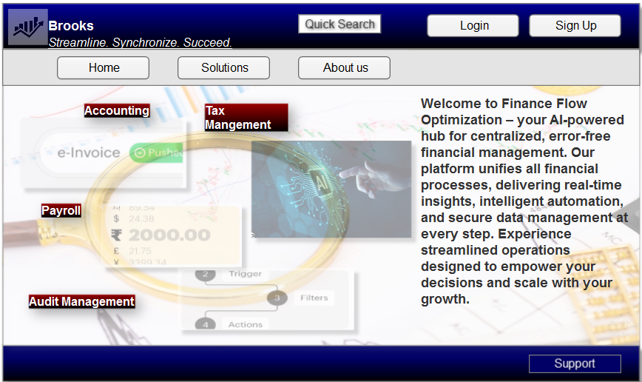

- Log In Page

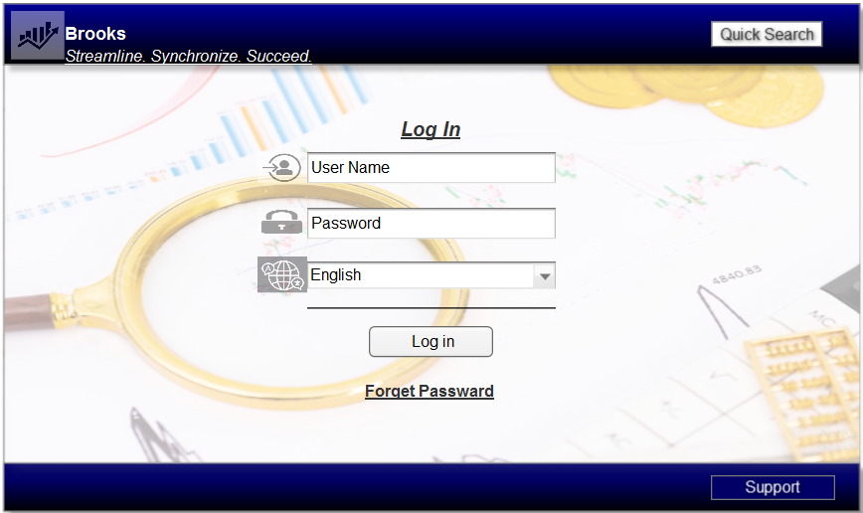

- Dashboard.
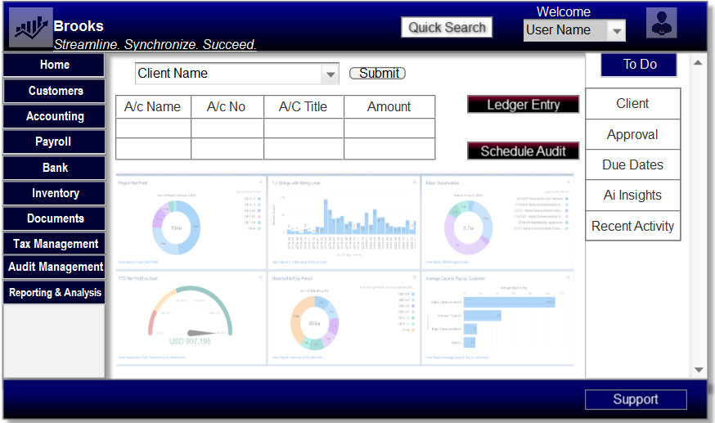

- Payroll Dashboard
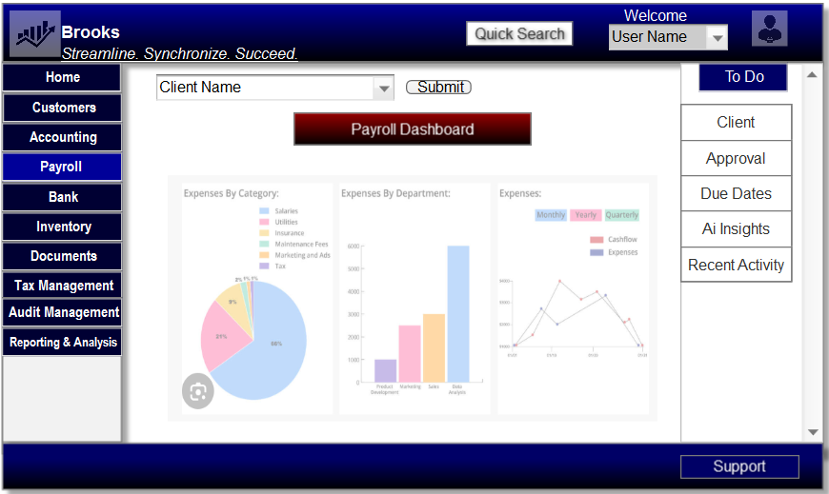

- Ai Insights
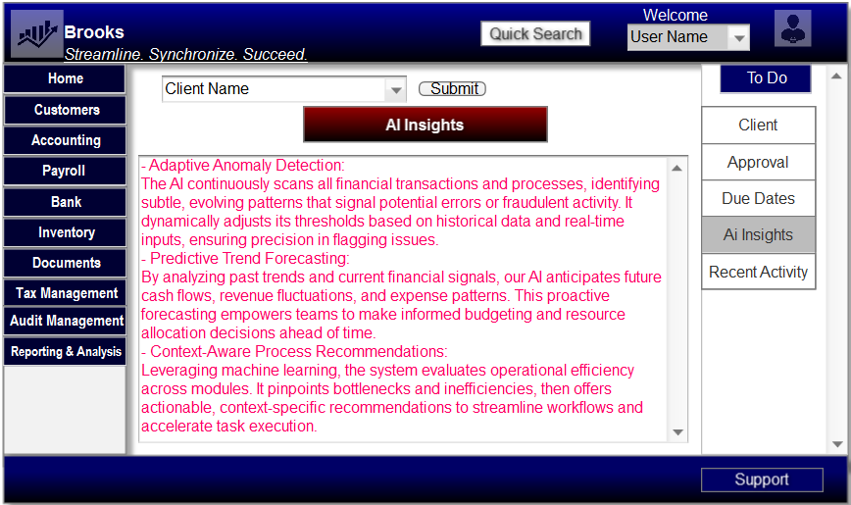

- Logout page
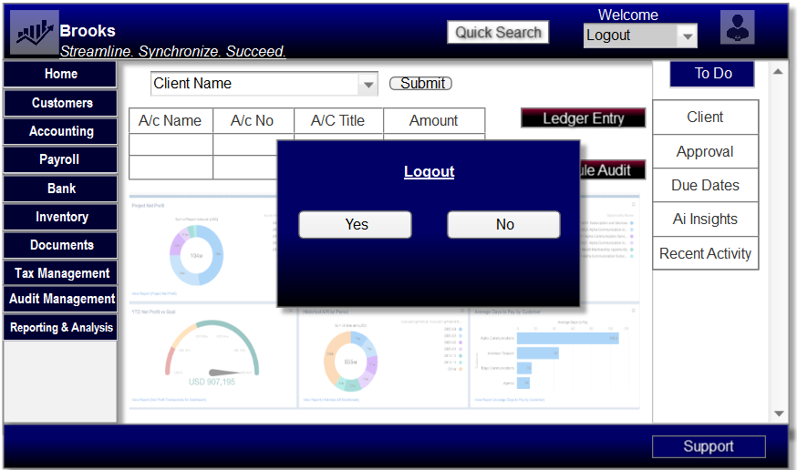

Document 8- Tools-Visio and Axure.

My experience using MS Visio and Axure on the Finance Flow Optimization project was instrumental to its success. I used MS Visio to prepare detailed activity and use-case documents that clearly mapped out the flow of processes—from general ledger and tax management to payroll and cash flow management—with each step synchronized to support our AI-enabled error-free operations. This tool enabled me to visualize complex workflows and integration points for legal compliance and data security, ensuring that all modules were aligned with industry standards. Complementing this, Axure allowed me to create high-fidelity mock-up for key user interface pages such as the home, login, logout, and various operational pages. These prototypes not only offered a realistic representation of the end product but also facilitated early stakeholder feedback, streamlining the review process within our waterfall development framework. Together, these tools significantly enhanced our documentation, communication, and project clarity, paving the way for a scalable, efficient, and secure financial management system.

Document 9- BA experience
My experience as BA in following phases:
- Requirement gathering:
.• Used MOSCOW Technique: Employed the MOSCOW method to prioritize requirements, ensuring that critical functionalities were clearly distinguished from lower-priority features.
•Managed Client Unavailability: When the client was temporarily unavailable, proactively sourced alternate points of contact to secure vital information without delaying progress.
•Validated with FURPS: Applied the FURPS technique (Functionality, Usability, Reliability, Performance, and Supportability) to validate the standards and quality of the requirements.
•Eliminated Duplicates: Identified and removed duplicate or repeated requirements swiftly to maintain a clear and concise set of specifications.
•Utilized Prototyping: Leveraged prototyping methods to create tangible representations of requirements, enabling stakeholders to gain specific insights and ensure alignment early in the process.

- Requirement Analysis:

.• UML Diagrams Creation: Developed detailed UML diagrams to visually represent system interactions, ensuring each business requirement was clearly mapped and easily understood by both stakeholders and the development team.
•Activity Diagrams for Process Flow: Crafted activity diagrams to delineate the process flows for various functionalities such as forecasting, payroll, and compliance, making complex workflows transparent and manageable.
•Team Communication and Iteration: Presented the diagrams to the team, actively incorporating feedback and modifications. This iterative approach helped resolve discrepancies and ensured that all perspectives were considered.
•Documentation of Requirements: Prepared comprehensive Business Requirements Specification (BRS) and Software Requirements Specification (SRS) documents, capturing all functional and non-functional requirements to serve as a definitive guide throughout the project lifecycle.

- Design:
• Test Case Derivation: Extracted comprehensive test cases directly from use case diagrams, ensuring every system interaction was thoroughly covered.
•Client Collaboration: Regularly communicated with the client to review design and solution documents, ensuring alignment with business needs and design feasibility.
•Comprehensive Testing Approach: Developed both positive and negative test cases to validate acceptable system behavior and to identify potential failures under adverse conditions.
•Meticulous Detailing: Ensured every test case was documented—leaving no gaps—since missing a single test case could significantly impact later stages of the project.
•Test Data Preparation: Prepared and organized detailed test data sets to support rigorous testing scenarios.
•RTM Updates: Continuously updated the Requirements Traceability Matrix (RTM) to confirm that all requirements were addressed and met throughout the design and testing phases.

- Development:
• JAD Sessions: Organized Joint Application Development (JAD) sessions to foster collaboration and ensure clear communication of requirements.
•Clarification During Coding: Actively addressed technical queries during the coding phase to resolve ambiguities and maintain continuous progress.
•Managing Team Disagreements: When team members disagreed or showed reluctance in JAD sessions, I conducted one-on-one discussions to explain how their perspectives could affect the project and to promote a healthy, cooperative environment.
•Utilizing Diagrams: Ensured that the technical team consistently referred to design diagrams when coding the Unit, maintaining alignment with the established design.
•Regular Meetings and Follow-ups: Held regular meetings with both the technical team and the client, recorded sessions for those unable to attend, and followed up with one-on-one discussions to ensure everyone stayed informed and engaged.

- Testing:
• Derived Test Cases: Created comprehensive test cases directly from use cases to ensure thorough coverage of all functional and non-functional requirements.
•High-Level Testing: Conducted high-level testing to validate the overall functionality and integration of system components.
•Coordinated Test Data: Collaborated with the client to procure the necessary test data, ensuring realistic and relevant testing scenarios.
•Updated RTM: Continuously updated the Requirements Traceability Matrix (RTM) to accurately map every requirement to its corresponding test case.
•Secured Client Sign-Off: Obtained formal sign-off from the client on testing outcomes, ensuring alignment with their expectations.
•Prepared for UAT: Strategically prepared the client for User Acceptance Testing (UAT) by providing clear instructions, expected outcomes, and support to ensure a smooth transition.

- Deployment:
• RTM Integration: Forwarded the updated Requirements Traceability Matrix (RTM) to the client, ensuring it was included in the project closure documentation.
•End-User Manuals Coordination: Collaborated with the documentation team to finalize and share comprehensive end-user manuals.
•Training Sessions Organization: Planned and organized training sessions tailored to different user groups, ensuring everyone understood the new system.
•Attendance Assurance: Followed up to confirm participation, ensuring all candidates attended the training sessions to facilitate smooth deployment.

