Waterfall Model Document Part-2

Document 6- Use case diagram—(UPDATED VERSION ---DATABASE ADMIN ADDED)

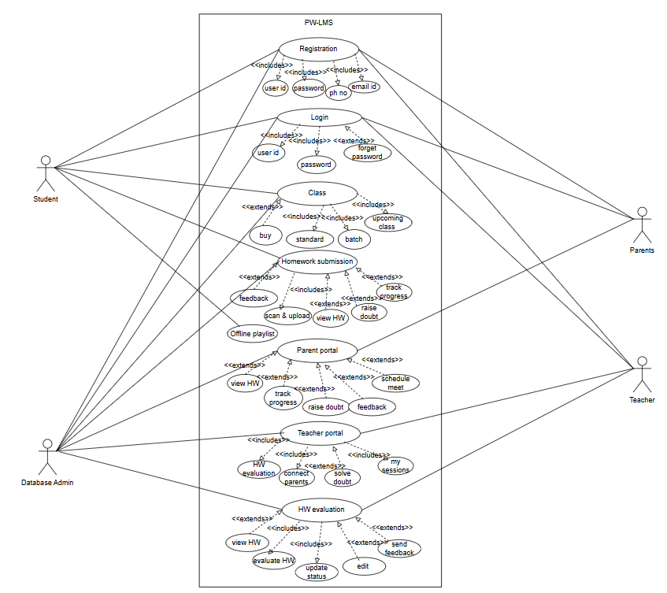

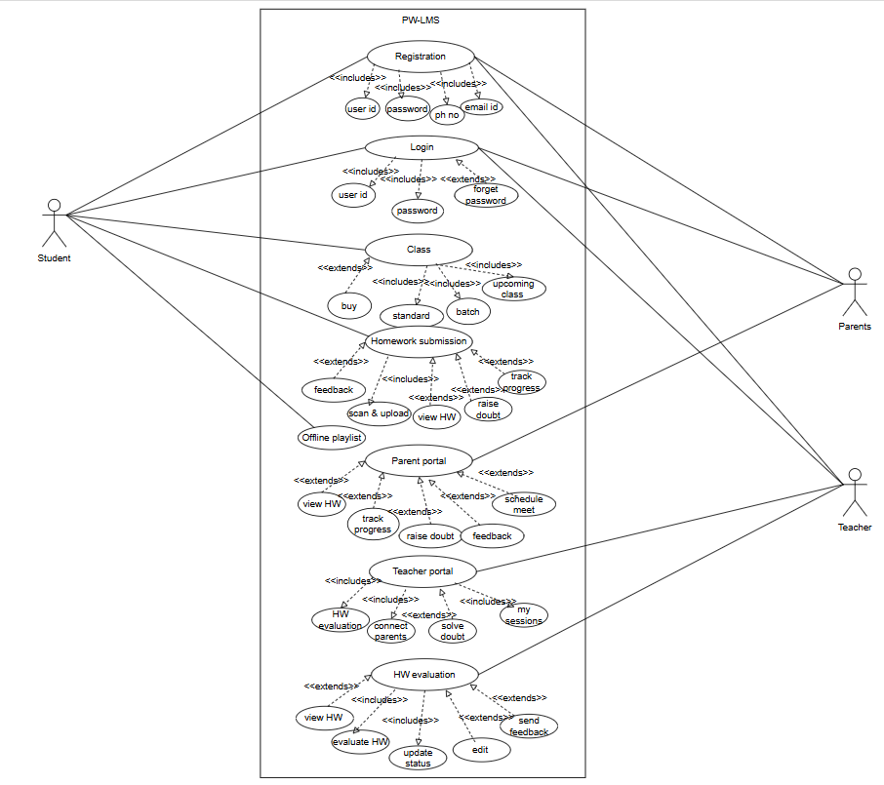
Use case diagram OLD version

Activity diagram (UPDATED VERSION)
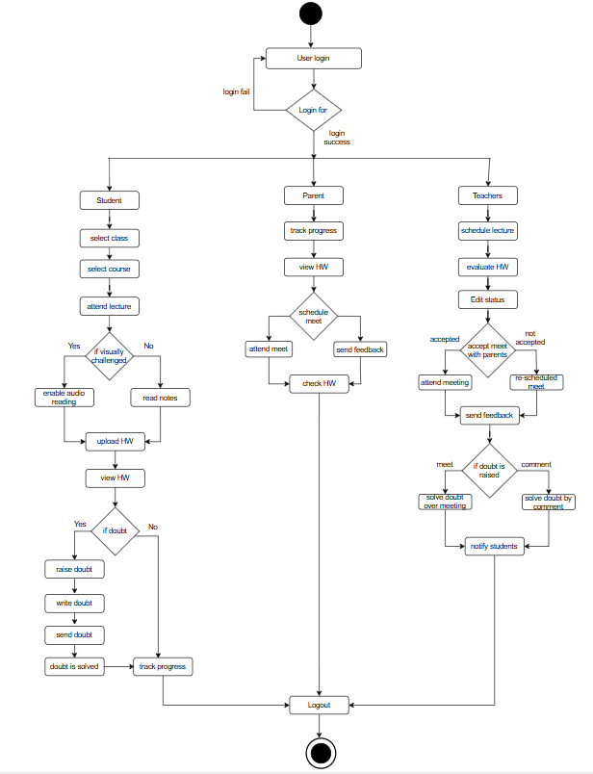

Activity Diagram_ Old Version
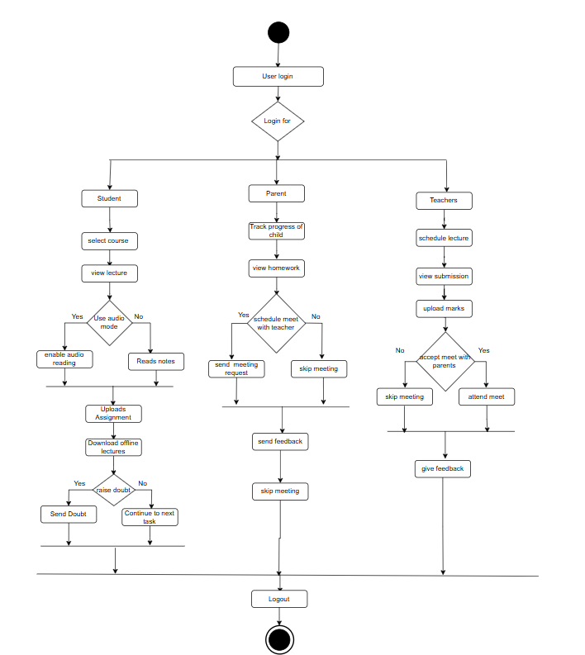

Use case specification
Use case ID | UC001
Use Case Name | Upload Assignment
Actors | Student
Description | Allows students to upload their homework
Preconditions | User is logged in.
Postconditions | Student sees a “Submitted” status
Basic Flow | - Student logs into the LMS.  - Navigates to the "Homework Submission" section.  - Selects the subject and assignment.  - Clicks on "Upload File".  - Selects and attaches the file  - Clicks "Submit".
Alternate Flow | Late submission  1. Student uploads after the deadline.  2. System marks the submission as "Late" and notifies the teacher.
Expectations | No Assignment Found, failed to upload assignment
Assumptions | Student has a stable internet connection.
Constraints | Only one submission per student per assignment is allowed unless resubmission is enabled.
Dependencies | Student must be enrolled in the batch/class for which the assignment is scheduled.
Input and output | Input-Student selects assignment and uploads a file  Output- Confirmation message shown “Assignment Submitted”
Business rules | Uploads past the deadline are flagged as "Late Submission" and highlighted for teachers.
Miscellaneous Information | Error messages must be clear and instructive

Use case ID | UC002
Use Case Name | Raise doubt
Actors | Student
Description | Allows students to raise academic doubts to teachers.
Preconditions | User is logged in and enrolled in an active course.
Postconditions | Doubt is submitted to the teacher and logged in the system
Basic Flow | - Student logs into the LMS.  - Navigates to the "Ask Doubt" section.  - Selects the subject and topic.  - Types the question or attaches an image.  - Clicks “Submit
Alternate Flow | System prompts user to select subject/topic.
Expectations | Doubt not submitted, subject not found
Assumptions | Teacher will respond within 48 hours.
Constraints | Only academic queries allowed.
Dependencies | Subject must be active and mapped to teacher.
Input and output | Input – Subject, doubt text/image  Output – Message: “Your doubt has been submitted.”
Business rules | Each doubt must be under 9000 characters if text-based.
Miscellaneous Information | System stores doubts for tracking and follow-up.

Use case ID | UC003
Use Case Name | Schedule Meeting
Actors | Parent and Teacher
Description | Enables parents and teachers to schedule one-on-one meetings
Preconditions | Both parent and teacher accounts are active.
Postconditions | Meeting request is logged and notification is sent.
Basic Flow | - Parent logs in and navigates to “Meetings”.  - Selects teacher and available slot.  - Sends meeting request.  - Teacher receives notification and confirms or reschedules.
Alternate Flow | Teacher Unavailable:  System shows alternate slots or allows rescheduling.
Expectations | Teacher did not respond, time slot conflict
Assumptions | Meeting must be scheduled at least 24 hours in advance.
Constraints | Only three meeting can be requested per week per subject.
Dependencies | Teacher's schedule must be updated in system.
Input and output | Input – Time slot, teacher name, parent comment  Output – Meeting confirmation or reschedule notice
Business rules | Rescheduling allowed only once per request.
Miscellaneous Information | Meeting link or location will be sent 1 hour before the meeting.

Use case ID | UC004
Use Case Name | Use Audio Mode
Actors | Student
Description | Enables visually challenged students to listen to study material.
Preconditions | Student has enabled accessibility settings.
Postconditions | System begins audio playback of selected content.
Basic Flow | 1 Student logs into LMS.  2 Navigates to reading section or study material.  3 Clicks on “Enable Audio Mode”.  4 System converts text to speech and begins playback.
Alternate Flow | No Audio Available:  System displays message: “Audio version not available for this content.”
Expectations | Audio loading error, system lag during playback
Assumptions | TTS (Text-to-Speech) engine is integrated and active.
Constraints | Audio available only in English in Phase 1.
Dependencies | Material must be available in text format.
Input and output | Input – Selected text/chapter  Output – Audio playback
Business rules | Feature available only to students with accessibility settings enabled.
Miscellaneous Information | Feature should support pause, resume, and playback speed controls.

Document 7- Screens and pages
Home Page
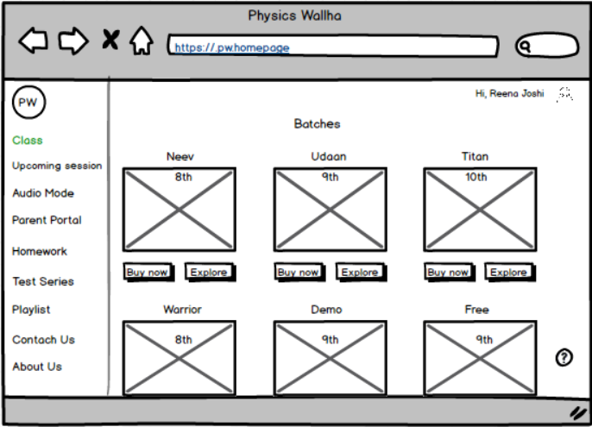

Login Page
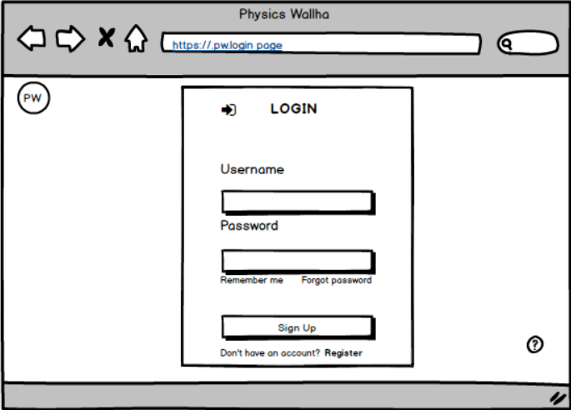

Parent Portal
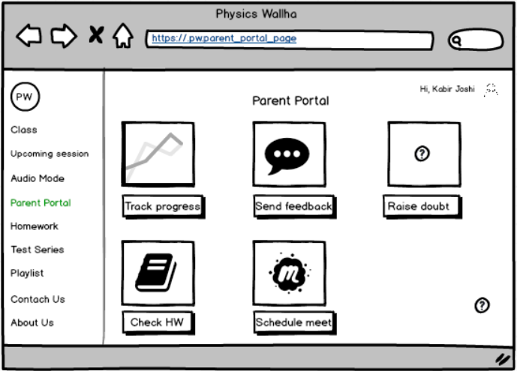

Audio Mode For Student
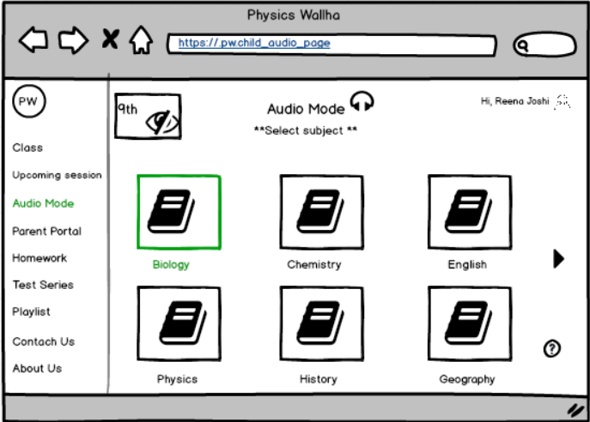

Homework Evaluation Page For Student
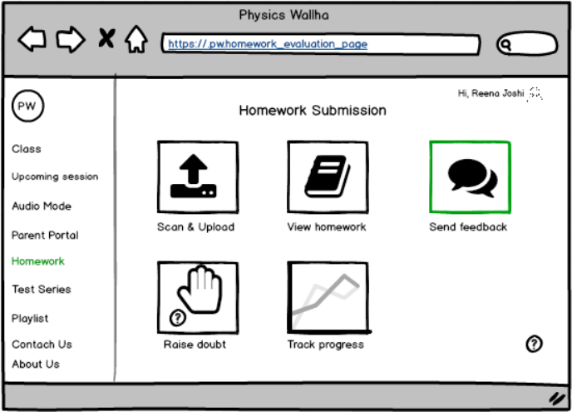

Log Out Page
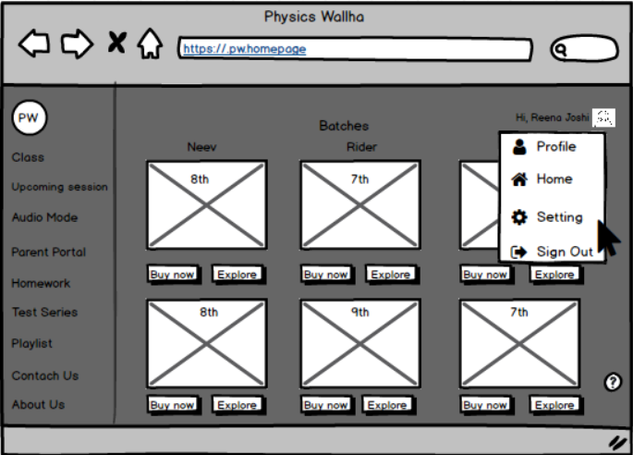

Teachers Login
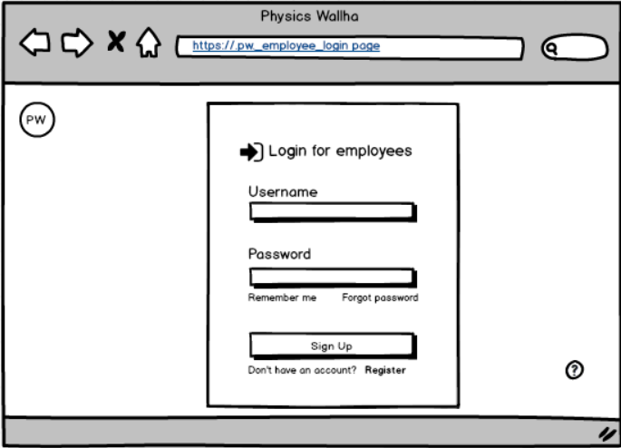

Homework evaluation page for teachers

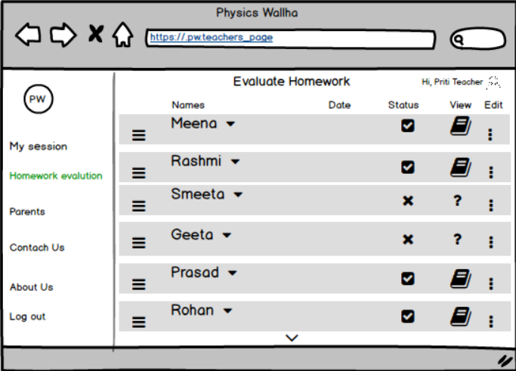

Document 8- Tools-Visio and Axure
During this project, I used Microsoft Visio to create clear and structured process flow diagrams, such as AS-IS and TO-BE workflows, which helped stakeholders easily understand how the system will change after enhancements. It made it simple to visualize each user’s journey—like how students upload assignments or how parents track progress. I also used Axure RP to design interactive wireframes for the new features, including the parent portal and audio reading interface. This helped the client see how the screens would actually look and work, making it easier to get feedback and approval. Both tools were very useful in turning ideas into clear visuals for communication and development.

Document 9- BA experience
1. Requirement Gathering:
I applied the MOSCOW prioritization technique to identify and organize requirements effectively. Since the client was occasionally unavailable during this phase, I proactively coordinated with alternate points of contact from the client side to gather missing information promptly. I validated the collected requirements using the FURPS model and ensured the removal of duplicated or repetitive items. To refine unclear inputs, I used document analysis technique, which helped stakeholders visualize their needs more clearly.
2. Requirement Analysis:
I created UML diagrams and activity diagrams to depict process flows and system interactions visually. These were shared with the team for feedback, and I made necessary adjustments based on their suggestions. Additionally, I prepared the Business Requirement Specification (BRS) and Software Requirement Specification (SRS) documents to formally capture functional and non-functional requirements.
3. Design Phase:
During the design phase, I worked closely with the QA and development teams to derive test cases from use cases — covering both positive and negative scenarios. I ensured that no test case was missed, recognizing its potential impact on development quality. I also helped in preparing relevant test data and kept the Requirements Traceability Matrix (RTM) updated to ensure all requirements were properly mapped and validated.
4. Development Phase:
used JAD sessions as a collaborative space where both business and technical teams could clarify development-related doubts, make informed decisions quickly, and ensure shared understanding. This minimized miscommunication, improved team alignment, and helped keep the development on track
5. Testing Phase:
I collaborated with the QA team to ensure high-level testing was conducted using the defined test cases. I coordinated with the client to obtain required test data, updated the RTM, and prepared the client for User Acceptance Testing (UAT). Once UAT was successfully completed, I secured formal sign-off from the client.
6. Deployment Phase:
As part of deployment activities, I shared the finalized RTM and contributed to the project closure documentation. I coordinated the creation and delivery of end-user manuals, planned and conducted training sessions, and ensured active participation from all intended users.

