Document 1 – Business case document template

- Why is this project initiated?
  - The project was initiated to digitize wealth management reporting and mutual fund transactions in DBS Bank India. Clients faced delays, manual processes and lack of accessibility. By leveraging the Digibank app, the bank aimed to provide secure, real-time and user-friendly digital access to investment reports, risk profiling and MF transactions.

- What are the current problems?
  - Manual report generation – time consuming and error prone
  - Physical dispatch of reports – delayed delivery, high logistics and printing costs
  - Limited accessibility – clients cannot access reports anytime anywhere
  - Low client engagement – static reports reduce financial insights
  - Offline risk profiling – inconsistent and paper based
  - Lengthy MF transactions – dependent on manual forms and advisors
  - Operational inefficiency – staff occupied with repetitive low value tasks
  - Compliance risks – higher chances of missing regulatory requirements due to manual handling

- With this project how many problems could be solved?
  - The project could resolve at least 7 critical problems
- Manual reporting inefficiency
- Report dispatch delays
- Limited client accessibility
- Low engagement with financial data
- Offline/inconsistent risk profiling
- Delays in MF transactions
- Operational inefficiency and compliance risks

- What are the resources required?
  - Human resources
    - Project manager, Business Analyst, Solution Architect, Developers, Testers, Operations and compliance teams
  - Technical resources
  - Information resources
  - Budget – Rs. 25 lakhs
  - Timeline – 1 year (Waterfall)

- How much organizational change is re quired to adopt this technology?
  - Medium-level organizational change –
    - Sales and operations staff – training to support clients digitally instead of manual paperwork
    - Clients – need awareness & onboarding to use Digibank for reports and MF transactions
    - Compliance – transition to automated digital monitoring and reporting
Overall, change management is manageable with proper training and client communication.

- Time frame to recover ROI
  - Investment – Rs. 25 lakhs
  - Cost savings – 30-50% reduction in operational and reporting costs annually
  - Client adoption – 70% expected in first 6 months
  - ROI recovery – within 18-24 months through savings in printing, logistics and manpower reallocation + higher client retention and engagement

- How to identify stakeholders?
  - Primary stakeholders –
    - Wealth management and HNI clients
    - Sales team (Relationship managers)
    - Operational team
    - Compliance team
  - Secondary stakeholders –
    - IT & development teams
    - Senior management & project sponsors
- Identification methods –
  - Stakeholder interviews (RMs, compliance officers, IT staff, clients)
  - Surveys/questionnaires (client preferences)
  - Workshops and brainstorming sessions
  - Document analysis (existing reports and compliance guidelines)

Document 2 – BA Strategy
Write BA approach strategy (As a BA, what are the steps that you would need to follow to complete a project – what elicitation techniques to apply, how to do stakeholder analysis RACI/ILS, what documents to write, what process to follow to sign off on the documents, how to take approvals from the client, what communication channels to establish n implement, how to handle change requests, how to update the progress of the project to the stakeholders, how to take sign off on the UAT – client project acceptance form)

- Steps to complete the project
- Initiation & Understanding
  - Understand the business case (manual report generation – digital transformation)
  - Align with project sponsor and project manager on BA role and deliverables
- Stakeholder Analysis
  - Identify key stakeholders (sales team, operations, compliance, It, clients)
  - Analyse influence and interest levels (eg. Compliance = high influence, clients = high interest)
  - Prepare RACI & ILS chart to assign clear roles.
- Requirements Elicitation
  - Apply structured elicitation techniques
  - Capture business needs for online reports, digital risk profiling and MF transactions
- Documentation
  - Write BRD, FRS, SRS, Use cases, data flow diagrams and traceability matrix
  - Validate requirements with stakeholders and update based on feedback.
- Sign-off & approvals
  - Conduct review sessions and walkthroughs of documents
  - Obtain sign off from compliance, IT and project sponsor
- Development & Testing Support
  - Support design team with clarification
  - Ensure requirements traceability through test cases
- UAT & Acceptance
  - Prepare UAT scenarios, facilitate testing with end users
  - Log defects, retest fixes and ensure readiness for go-live
  - Obtain Client Project Acceptance Sign-off
- Post-Implementation
  - Track adoption rates and client feedback
  - Support change requests and enhancements

- Elicitation techniques applied
- Stakeholder interviews – RMs, operations, compliance officers, IT staff, HNI clients
- Workshops & brainstorming – cross-functional alignment, mapping client journey
- Document analysis – physical reports, MF forms, compliance checklists
- Survey/questionnaire – client preferences – PDF vs. dashboard
- Observation – report generation team
- Prototyping/wireframes – mockups of dashboards, report formats

- Stakeholder Analysis – RACI & ILS
- RACI Matrix
  - Responsible – BA for requirements, developers for coding, testers for QA
  - Accountable – project manager, project sponsor
  - Consulted – compliance team, RMs, operations team
  - Informed – end clients, wider operations staff
- ILS (Information-Liason-Support)
  - Information – operations, compliance
  - Liason – BA, Project manager
  - Support – IT, Testing, sales team during requirements validation

- Documents to write
- BRD – digitization goals
- Functional requirement specification FRS – online reports, risk profiling, MF flows
- System requirement specification – architecture, APIs, security
- Use cases – report download, sip set up profiling flows
- Process maps (AS-IS & TO-BE) – manual to digital journey
- Traceability matrix – requirements – test case mapping
- UAT test plan & UAT acceptance form
- Document sign-off process
- BA prepares draft – circulate to stakeholders
- Conduct requirement walkthrough sessions with sales, operations, IT and Compliance
- Incorporate feedback – finalize version
- Obtain formal approval – email, digital signature or project portal approval from product owner, compliance officer and project sponsor
- Approvals from client
- Present validated requirements in client review sessions
- Demonstrate prototype/woreframes to confirm alignment
- Obtain client approval through a formal sign off form or minutes of the meeting MOM with acceptance noted.
- Communication channels
- Weekly status report – project manager, sponsor, compliance
- Steering committee meetings – monthly updates with leadership
- Daily standups with IT and dev teams – progress tracking
- Email & collaboration tools (teams, confluence, JIIRA) – documentation, discussions, issue tracking
- Client communication – quarterly review meetings and feedback surveys
- Handling change requests
- Client and sponsor raises CR through form or JIRA ticket
- BA does impact analysis of scope, cost, timeline, compliance
- Share CR analysis with Project Manager & Change Advisory Board (CAB)
- Approved CR – update BRD/FRS + Traceability Matrix
- Communicate impact to stakeholders – implement

- Updating project progress
- Use RAG status (Red, Amber, Green) in weekly dashboards
- Publish progress reports on requirements completion, defect fixes, adoption targets
- Hold demo sessions after each milestone to show progress to business users
- Keep compliance team in loop for regulatory updates

- UAT & client project acceptance
- UAT preparation
  - BA prepares UAT test plan, scenarios, test data
  - Map UAT to requirements via traceability matrix
- Execution
  - Facilitate client testers to execute scenarios in UAT environment
  - Log defects – retest after fixes
- Sign-off
  - BA prepares UAT compliance report
  - Client sponsor reviews results
  - Client project acceptance form signed – project considered delivered

Document 3 – Functional Specifications

Project Name | Wealth Management – Digital Report Generation & MF Transactions
Customer Name | DBS Bank India Limited
Project Version | V1.0
Project Sponsor | Neelkantan Shroff
Project Manager | Sachin
Project Initiation Date | 04/08/2025

Req ID | Req Name | Req Description | Priority
FR0001 | Login & Authentication | Users should be able to securely login using username, password and OTP (two factor authentication) | 10
FR0002 | Report generation | System should automatically generate investment portfolio reports (PMS, MF, Equity, Fixed Income) | 10
FR0003 | Report download | Clients should be able to view and download reports in PDF/Excel format via Digibank app | 9
FR0004 | Portfolio dashboard | A dashboard should show consolidated holdings, asset allocation and market value in real time | 9
FR0005 | Risk profiling | Clients should complete digital risk profiling questionnaires and system should assign a risk category | 8
FR0006 | Mutual fund transactions | Clients should be able to purchase, redeem and set up SIPs digitally through integrated MF APIs | 10
FR0007 | E-Locker | Clients should upload/download financial documents securely (KYC docs, investment proofs) | 7
FR0008 | Notifications & Alerts | System should send push/email/sms alerts for transactions, sip due dates and market updates | 8
FR0009 | Transaction history | Clients should be able to view past transactions, orders and execution status | 7
FR0010 | Advisor connect | Clients should be able to connect with their RM through chat, video or appointment booking | 6
FR0011 | Compliance and security | All features should comply with KYC, AML, SEBI and RBI digital security standards | 10
FR0012 | Performance tracking | Provide analytics and insights on client portfolio performance over different time horizons | 6

Document 4 – Requirement Traceability Matrix

Req ID | Req Name | Req Description | Design D1 | T1 (Unit test) | D2 (Integration) | T2 (System Test) | UAT
FR0001 | Login & Authentication | Users must be able to login securely with 2FA to access the application | Yes | Pending | No | Yes | Yes
FR0002 | Report generation | System should automatically generate investment portfolio reports | Yes | Yes | Yes | Pending | Yes
FR0003 | Report downloads | Clients should be able to view and download reports in PDF/Excel format via Digibank app | Yes | Pending | Yes | Yes | Yes
FR0004 | Portfolio dashboard | A dashboard should show consolidated holdings and asset allocation | Yes | Yes | Pending | Yes | Yes
FR0005 | Risk profiling | Clients should complete digital risk profiling and get a risk score | Yes | Yes | Yes | Pending | Yes
FR0006 | Mutual fund transactions | Clients should buy/redeem/set up sips through integrated MF platform | Yes | Pending | Yes | Yes | Yes
FR0007 | E-Locker | Clients should upload/download financial documents securely | Yes | Yes | Pending | Yes | Yes
FR0008 | Notifications & Alerts | Push/email/sms alerts for transactions, sip dates and market updates | Yes | Yes | Yes | Pending | Yes
FR0009 | Transaction history | Clients should view past transactions and order status | Yes | Pending | Yes | Yes | Yes
FR0010 | Advisor connect | Clients should connect with RMs via chat, video or appointments | Yes | Yes | Pending | Yes | Yes
FR0011 | Compliance and security | Features must comply with KYC, AML, SEBI and RBI regulations | Yes | Yes | Yes | Pending | Yes
FR0012 | Performance tracking | Provide analytics and insights on portfolio performance | Yes | Pending | Yes | Yes | Yes

Document 5 – BRD Template

BRD
Project Name - Wealth Management – Digital Report Generation & Mutual Fund Transactions
Project ID – DBS-WM-Digi-2025-01
Version ID – v1.0
Author – Nahidd Anjum

Contents
- Document Revision
- Approvals
- RASCI Chart for this document
Codes used in RASCI chart
RASCI Chart
- Introduction
  - Business Goals
  - Business Objectives
  - Business Rules
  - Background
  - Project Objective
  - Project Scope
    - In Scope functionality
    - Out Scope functionality
- Assumptions
- Constraints
- Risks
Technological Risks
Skills Risks
Political Risks
Business Risks
Requirements Risks
Other Risks
- Business process overview
  - Legacy System (AS-IS)
  - Proposed Recommendations (TO-BE)
- Business requirements
- Appendices
  - List of Acronyms
  - Glossary of Terms
  - Related documents

- Document Revisions

Date | Version Number | Document changes
04/08/2025 | 0.1 | Initial draft created by BA (Nahidd Anjum)
10/08/2025 | 0.2 | Added functional requirements (FR0001-FR0012)
18/08/2025 | 0.3 | Incorporated stakeholder feedback from sales & compliance teams
25/08/2025 | 0.4 | Final draft submitted for review
01/09/2025 | 0.5 | Approved version-Baseline BRD

- Approvals

Role | Name | Title | Signature | Date
Project Sponsor | Neelkantan Shroff | Head – Wealth Management |  | 01/09/2025
Business Owner | Senior RM (HNI Segment) | Wealth Management Division |  | 01/09/2025
Project Manager | Sachin | Project Manager |  | 01/09/2025
System Architect | Devi Menon | Solution Architect |  | 01/09/2025
Development Lead | Jaideep | Technical Lead |  | 01/09/2025
User Experience Lead | Shefali | UI/UX Lead |  | 01/09/2025
Quality Lead | Kumar Amit | QA Lead |  | 01/09/2025
Content Lead | Nahidd Anjum | Business Analyst (Author) |  | 01/09/2025

- RACI Chart – Business Requirement Document (BRD)

Name | Position/Role | (Authorize) | R | A | S | C | I
Neelkantan Shroff | Project Sponsor |  |  |  |  |  | X
Sachin | Project Manager |  |  |  |  |  | X
Nahidd Anjum | Business Analyst (Author/Content Lead)
Devi Menon | Solution Architect
Jaideep | Technical lead/ Development Lead
Shefali | User Experience (UX Lead)
Kumar Amit | Quality Lead (QA/Test Lead)
Senior RM-HNi | Business Owner (Wealth Mgt)
Compliance officer | Compliance Team
Operations Manager | Operations team lead
Clients (HNI users) | End users

- Introduction

  - Business Goals
Organizational goal – DBS Bank India aims to be the “Best Digital Bank” by providing clients with seamless, secure and real-time digital banking services.

Organizational need – currently, wealth management client rely on manual and physical report generation, offline risk profiling and lengthy mutual fund transactions. This reduces efficiency, increases operational cost and lowers customer satisfaction. The need is to digitize wealth management services through the Digibank app to improve accessibility, reduce costs and ensure compliance.
  - Business objectives

To provide an IT solution for –
- Automated wealth management reporting of PMS, MF, Equity, Fixed income and other financial transactions
- Online access and downloads of investment reports
- Digital risk profiling with structured questionnaires
- Mutual fund transactions – purchase, redemption, sip, setup and tracking
- Portfolio dashboard with consolidated holdings and insights
- Smart alerts and notifications for transactions and market updates
- E-locker for secure storage of client documents
- Advisor connect (chat, video, appointments) for client support

  - Business rules

- All transactions must comply with RBI, SEBI and AMFI regulations
- Mandatory adherence to KYC,AML policies for all new and existing clients
- System access must be restricted via two-factor authentication
- Data storage and transfer must follow DBS Bank’s internal data security policy
- Reports must be generated in standard formats (PDF, Excel) as per client preference
- Uptime of 99.5% and report download speed of <3 seconds must be ensured

  - Background

Wealth management clients of DBS Bank India faced challenges such as –
- Manual report generation – delayed, inconsistent, costly
- Physical report dispatch – time consuming and limited accessibility
- Risk profiling – offline, verbal and error probe
- Mutual fund transactions – paper-based requiring advisor coordination
To address these issues, the Wealth Management Digitalization Project was proposed under the Digibank App. The project uses a Waterfall methodology, with the expected benefits of –
- Increased client satisfaction and engagement
- Reduced operational costs – 30-50%
- Improved compliance and risk management
- Enhanced scalability for future services

  - Project objective

The objective of this project is to develop a secure, user-friendly, digital wealth management solution integrated into the Digibank app that will –
- Enable 24/7 client access to reports, risk profiling and transactions
- Ensure automation of reporting and transaction workflows
- Reduce manual intervention in operations and compliance risks
- Provide real-time alerts and decision-support analytics
- Integrate with existing banking systems and mutual fund platforms via APIs

  - Project scope
    - In Scope functionality

- Automated generation of investment portfolio reports
- Report downloads in PDF, excel formats
- Digital risk profiling questionnaire
- Online mutual fund transactions like purchase, redemption, sip setup
- Portfolio summary dashboard
- E-locker for secure document storage
- Smart alerts and notifications like push, sms, email
- Advisor connect like chat, video, appointment
- Transaction history and order tracking
- Compliance and data security integration

    - Out Scope functionality

- Mobile application development outside Digibank app
- E-learning Management System (LMS) not part of wealth management scope
- Integration with non-DBS third party apps

- Assumptions
The following assumptions were made while defining the requirements for this project –
- Clients have basic digital literacy and access to smartphones with internet
- Existing client account and transaction data is accurate and available for migration
- Existing client account and transaction data is accurate and available for migration
- Required APIs for mutual fund transactions are provided by approved MF partners
- Compliance policies KYC, AML, SEBI, RBI guidelines remain stable during the project timeline
- Users will adopt two-factor authentication (2FA) for secure login
- Project will be delivered within the allocated budget of Rs. 25 lakh and timeline of 1 year
- Operations and sales team will be available for requirement validation and UAT sessions
- Infrastructure servers and cloud storage will be provisioned and maintained by DBS IT
- Client feedback from UAT and pilot rollout will be representative of larger adoption

- Constraints – The following constraints may impact the execution of the project –

- Budget constraint – project capped at Rs. 25 lakh
- Timeline constraint – must be completed with 12 months with waterfall methodology
- Technology constraint – must integrate into existing Digibank app
- Compliance constraint – adherence to RBI, SEBI, AMFI regulations at all times
- Security constraint – end-to-end encryption, 2FA and DBS internal security standards mandatory
- Operational constraint – availability of sales, operations and compliance teams for input and testing
- Change management constraint – waterfall model limits flexibility, late requirement changes may delay timelines
- Performance constraint – uptime must be 99.5% and report download speed <3 seconds

- Risks

Risks are potential events or conditions that may impact the project’s success. They are analysed based on likelihood of occurrence, impact, cost and an appropriate mitigation strategy.

Risk handling strategies
- Avoid – Eliminate the risk
- Mitigate – Reduce probability or impact
- Transfer – Transfer ownership to another entity
- Accept – Acknowledge and prepare for consequences

Technological risks –
Risk | Likelihood | Impact | Mitigation Strategy
Integration issues with Digibank app & MF APIs | Medium | High | Early integration testing, engage API providers during design phase
System downline or performance bottlenecks | Medium | High | Load testing – ensure server redundancy, 99.5% uptime SLA
Data security breach | Low | Very high | Use encryption, 2FA, penetration testing, strict adherence to DBS security policies

Skills risks –

Risk | Likelihood | Impact | Mitigation strategy
Lack of skilled developers for API integration | Medium | Medium | Upskill existing team, bring in external consultants if needed
Limited experience in digital risk profiling design | Low | Medium | Leverage SMEs from compliance and RM teams, benchmark against industry solutions

Political risks –

Risk |  | Likelihood |  | Impact | Mitigation strategy
Change in regulatory requirements from RBI/SEBI | Medium |  | High |  |  | Continuous monitoring of regulatory updates, compliance team involvement throughout project
Global DBS policy changes (Singapore HQ mandates) | Low |  | Medium |  |  | Escalate to project sponsor, align local project timelines with HQ policy changes

Business risks –

Risk | Likelihood | Impact | Mitigation strategy
Clients resist adopting digital reports, prefer physical copies | Medium | High | Client education, onboarding sessions, hybrid support (digital + physical in early phase)
Project cancellation due to budget overruns | Low | High | Strict project governance, weekly budget reviews, early flagging of deviations

Requirement risks –

Risk | Likelihood | Impact | Mitigation strategy
Incomplete or incorrect capture of client needs | Medium | High | Multiple elicitation techniques like interviews, surveys, prototyping and validation workshops
Misinterpretation of compliance rules | Low | High | Continuous involvement of compliance officers during requirement analysis

Other risks –

Risk | Likelihood | Impact | Mitigation strategy
Delays in UAT participation from business users | Medium | Medium | Schedule UAT well in advance, secure business owner commitment
Vendor dependency for API readiness | Medium | High | Formalize SLAs with vendors, contingency planning for alternate providers
Change requests late in waterfall cycle | High | High | Strict change control process like CR form, impact analysis, CAB approval

- Business process overview

  - Legacy System (AS-IS)

Explanation –
- Clients request investment portfolio reports by visiting or contacting the branch
- Sales and operations team prepares reports manually using spreadsheets
- Reports are printed and physically dispatched to clients
- Risk profiling is done verbally and paper based during RM meetings
- MF transactions are done via physical forms, signed and submitted
- High dependency on manual effort – delays, errors, operational cost and compliance risks
AS-IS process flow –
- Client requests report
- Sales team collects data
- Operations team prepares manual report
- Print & dispatch to client
- Client reviews offline
- MF transaction requested via paper form
- Operations processes form manually
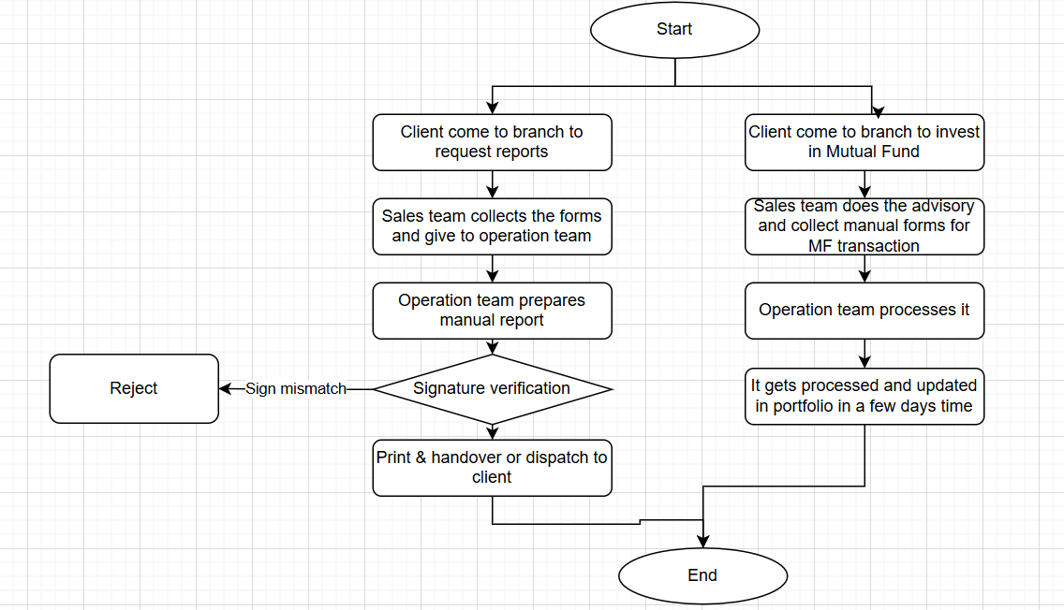

  - Proposed Recommendations (TO-BE)

Proposed solution –
- All reports available digitally via Digibank app
- Risk profiling digitized with structured online questionnaires
- MF transactions processed real-time via integrated APIs
- Portfolio dashboard for instant portfolio summary & insights
- Smart alerts for transactions, sip due dates and compliance checks
- Digital E-locker for secure document storage
- RM and advisor connect integrated digitally

TO-BE process flow –
- Client logs into Digibank app with secure login and 2FA
- Client views and downloads portfolio report
- System auto-generates reports in PDF and excel
- Client completes online risk profiling
- Client initiates MF transaction digitally
- System integrates with MF platform APIs
- Confirmation and alerts sent to client in real-time

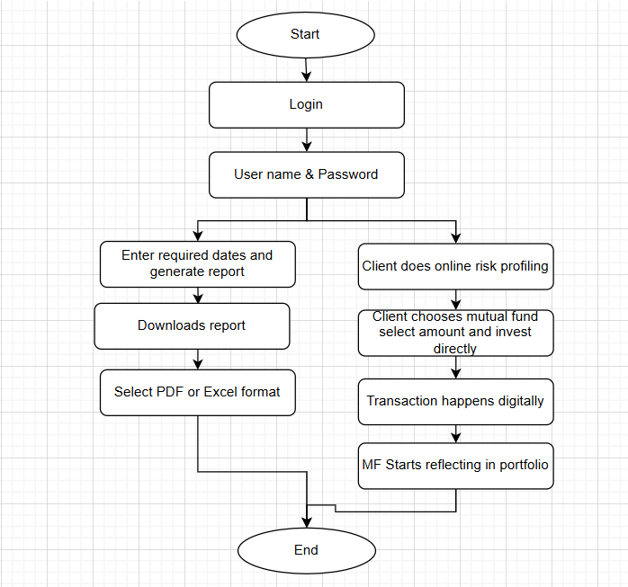

9. Business requirements
The following requirements were elicited from stakeholders. They are categorized by priority and functionality area.

Req ID | Area | Requirement Description | Priority
FR0001 | Authentication | Secure login with username, password and 2FA | High
FR0002 | Reports | Automated generation of portfolio reports like PMS, MF, Equity, Fixed income | High
FR0003 | Reports | Download reports in PDF and excel | High
FR0004 | Dashboard | Portfolio summary dashboard with asset allocation and insights | High
FR0005 | Risk Profiling | Online questionnaire with automated scoring | Medium
FR0006 | Transactions | Mutual fund purchase, redemption, sip setup with payment gateway integration | High
FR0007 | Notifications | Smart alerts for transactions, sip due dates, market updates | Medium
FR0008 | Compliance | Adherence to RBI, SEBI and AML and KYC policies | High
FR0009 | Security | End-to-end encryption and regulatory compliance | High
FR0010 | Document Management | E-locker for uploading and storing KYC and investment documents | Medium
FR0011 | Advisor connect | Chat, video, appointment with RM | Low
NFR001 | Performance | System uptime 99.5%, report download <3 seconds | High
NFR002 | Scalability | Support at least 50,000 concurrent users | Medium
NFR003 | Usability | Simple, intuitive UI with accessibility compliance | Medium

10. Appendices
10.1. List of Acronyms
- DBS – Development Bank of Singapore
- MF – Mutual Fund
- PMS – Portfolio Management Services
- RM – Relationship Manager
- KYC – Know your customer
- AML – Anti-Money laundering
- UAT – User Acceptance Testing
- API – Application Programming Interface
- BRD – Business Requirement Document
- FRS – Functional Requirement Specification
- RTM – Requirement Traceability Matrix
- SLA – Service Level Agreement
- CAB – Change Advisory Board
- SIP – Systematic Investment Plan

10.2. Glossary of Terms
- Digibank App – DBS India’s mobile application providing digital banking services
- Risk profiling – A process of assessing a client’s investment risk tolerance
- E-locker – A secure digital vault for storing client documents
- SIP – A method of investing in mutual funds at regular intervals
- Compliance – Adhering to rules and regulations of RBI, SEBI, AML, KYC

10.3. Related Documents
- Business case document
- Business analyst strategy document
- Functional specification document (FRD, FRS)
- Requirement Traceability Matrix (RTM)
- UAT test plan and client acceptance form
- Compliance and risk policy guidelines by RBI and SEBI

