Capstone Project1 – Part -3/3

Identify Business Requirements (which includes Stakeholder Requirements)
BR001 – Farmers should be able to search for available products in fertilizers, seeds, pesticides.
BR002 – Manufacturers should be able to upload and display their products in the application
BR003 – Application should be user friendly
BR004 - This new application should be able to accept the product (fertilizers, seeds, pesticides) details from the manufacturers.
BR005 – It should be able to display them to the Farmers.
BR006 - Farmers will browse through these products and select the products what they need and request to buy them and deliver them to farmers location.
BR007 – A Farmer should be able to browse through the products catalog once they visit the website and need to have a search option so that they can search for any product they need.
BR008 - If a farmer wants to buy any product or add them to buy-later list, they need to login first using their email id and password.
BR009 - If it is a new user, then they can create a new account by submitting their email ID and creating a secure password.
BR010 - Farmers needs to have an easy-to-use payment gateway which should include cash-on-delivery (COD), Credit/Debit card and UPI options so that the user’s experience should be better.
BR011 – A user gets an email confirmation regarding their order status. A delivery tracker to track the whereabouts of their order.
BR012 - He is expecting to have a login for all its users (fertilizers, seeds, pesticides manufacturers and Farmers), a product catalogue of fertilizers, seeds, pesticides, a search option to search for products, payment process, and delivery tracking.

Question No – 1 Functional and Non-functional requirements

Req ID | Req Name | Req Description | Priority
FR001 | Farmer registration | Each farmer should register with the application | 8
FR002 | Sort, filter and Search the Products | Every user should be able to search, sort and filter the products according to their requirements | 8
FR003 | Change the quantity | They should be able to increase no of products once placed on the same page | 8
FR004 | Remove the product | If required, there should be an option of removing the products from the cart | 7
FR005 | Place the order | After adding required products, they should be able to place the order | 9
FR006 | Add to cart | While checking the available products, they should have the option of adding to the cart there itself | 9
FR007 | Farmer Login | After registration farmers should be able to login to their page | 8
FR008 | Manufacturer uploads products | Manufacturer need to upload the products on the application to make it visible along with the pictures and specifications | 8
FR009 | Stock Availability | Available stock should be visible on the application | 7
FR010 | Manufacturer maintain stock | Manufacturer should maintain the stock to avoid delays | 7
FR011 | Manufacturer Registration | Manufacturer needs to be verified and registered on the application | 8
FR012 | Delivery tracking | Farmers should be able to track their order on the app | 6
FR013 | Manufacturer reporting | Dashboard for sales view to the manufacturer | 6
FR014 | Manufacturer orders listing view | Manufacturer should get notified easily when any order is placed and there should be a dashboard to check current orders | 7
FR015 | Make payment | Farmers should be able to make the payment through online options on the app (by Cash, Card or UPI) | 8
FR016 | Payment Confirmation | Farmer should receive confirmation after system receives payment | 8
FR017 | User should see the products by category | Grouping of products as per category should be done (Like Pesticides, Seeds, Fertilisers) | 8
FR018 | Selection of shipping and billing address | Farmer should have option of selecting shipping and billing address | 8
FR019 | Applying coupons and discounts | If farmers have any applicable coupons there should be an option of applying before making the payment | 6
FR020 | View orders | Farmers should be able to view all orders in order to understand their status | 6
FR021 | Return and exchange | If any damaged product is received, they should be able to return back and get the refund | 6
NFR001 | Page loading time | Page loading time should be less than 5 seconds to avoid farmer’s discomfort with the app | 8
NFR002 | Manufacturer should store goods in clean warehouse | Warehouses where stocks are maintained need to be clean | 7
NFR003 | Location services should be safe and secure | Delivery boys’ and users’ location should be secured from threats. | 8
NFR004 | Users’ data should be secure | Personal information stored in data should not be easily accessible to anyone | 8
NFR005 | Servers should be installed as per requirement | Servers needs to be installed for safety of the data and easily accessible | 8
NFR006 | Internet connectivity at users’ end | User should have good internet connectivity | 7
NFR007 | Delivery partners need to be assigned as per the areas | Delivery partners need to be assigned as per the areas a per the requirement | 7
NFR008 | Delivery partner should get hard copy of bill to submit to end customer | Delivery partner should get hard copy of bill to submit to end customer | 6
NFR009 | Multiple logins and orders should happen without lagging | Multiple logins and orders should happen without lagging | 7
NFR010 | Application should be free to install and use | Application should be free to install and use for the user on order to make it cost effective | 7

Question No 2- Wireframes and Prototypes

1.0. Add to Cart

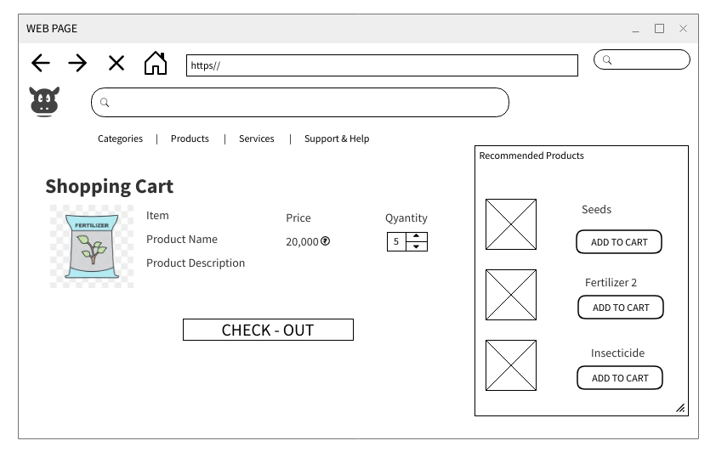

2.0. My cart

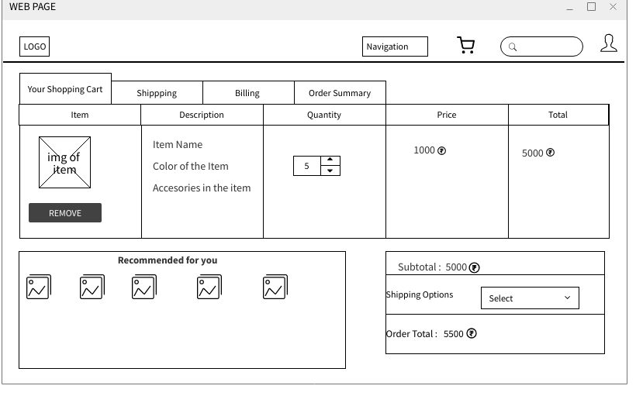
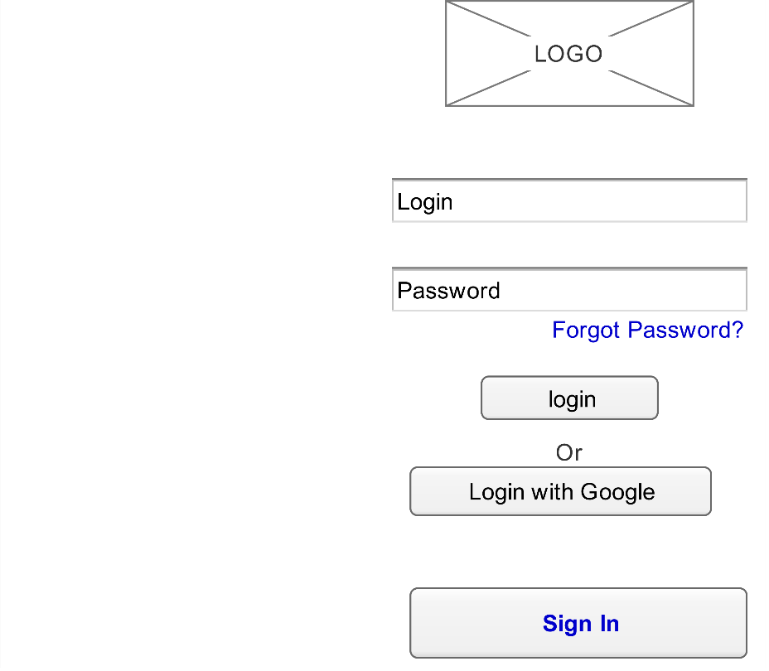

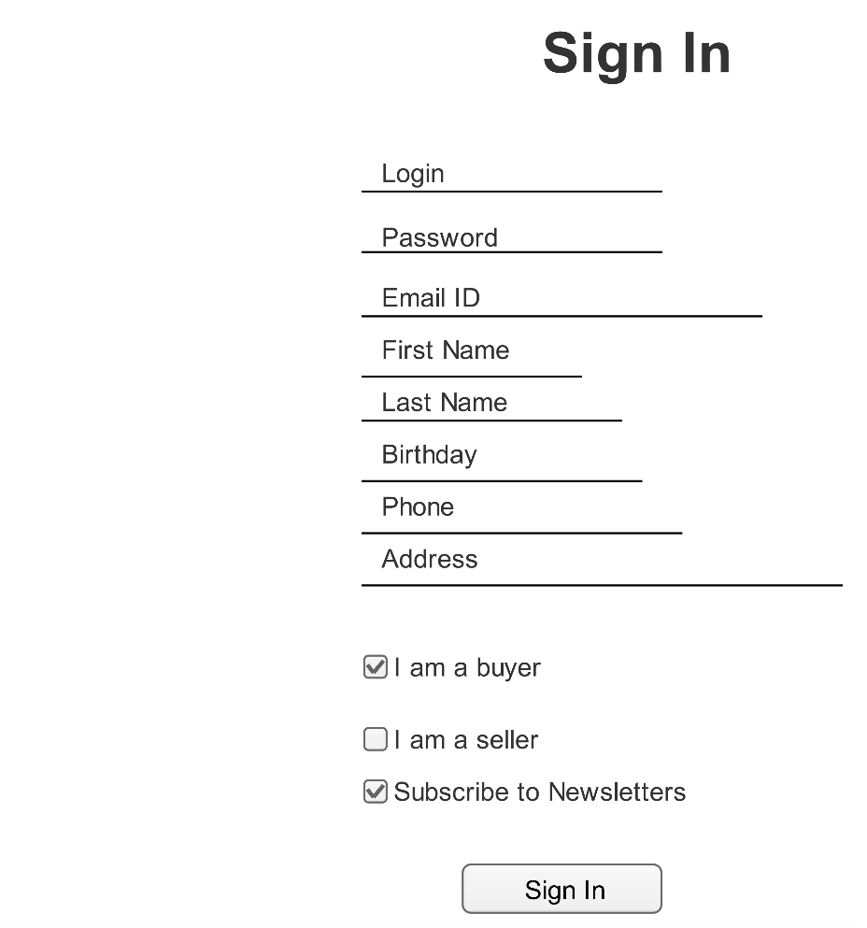
Prototypes
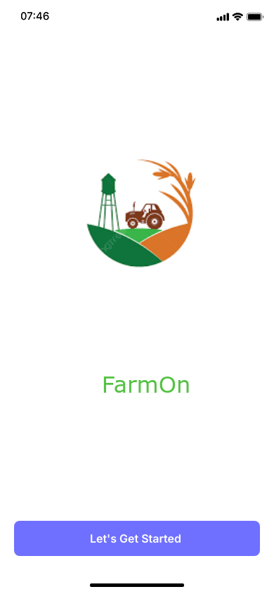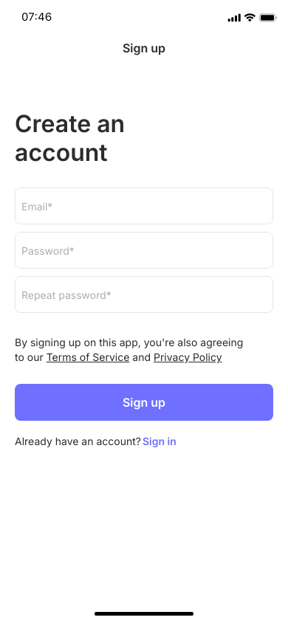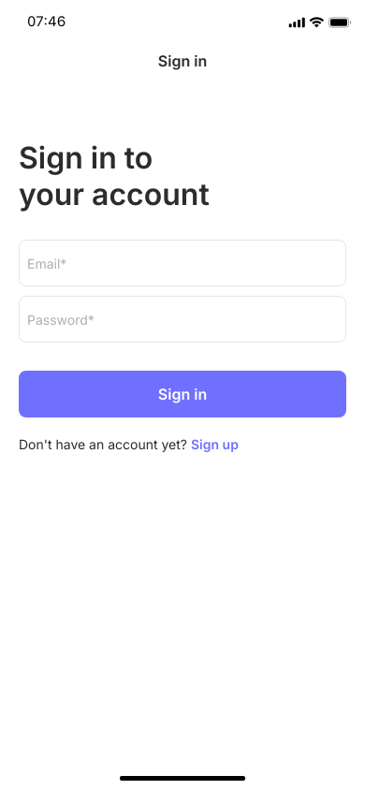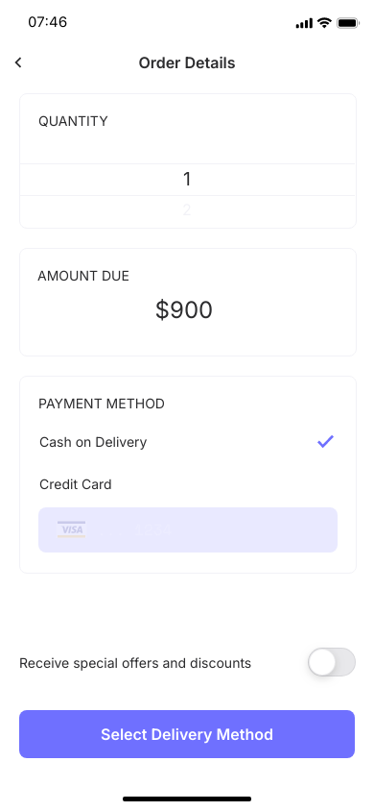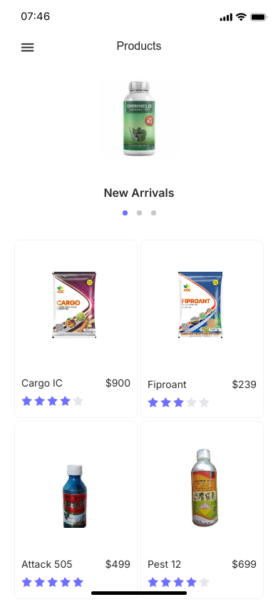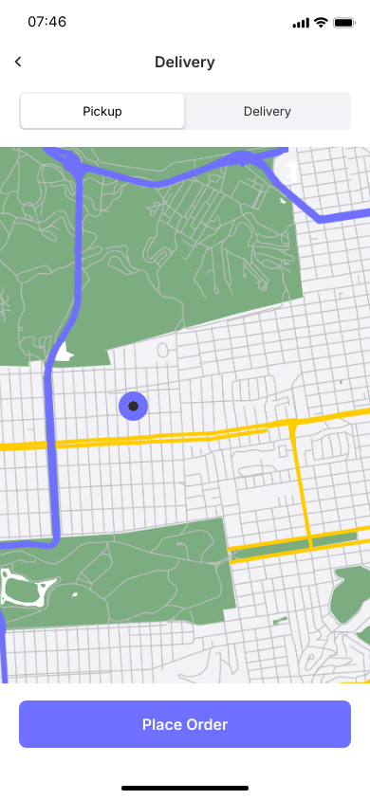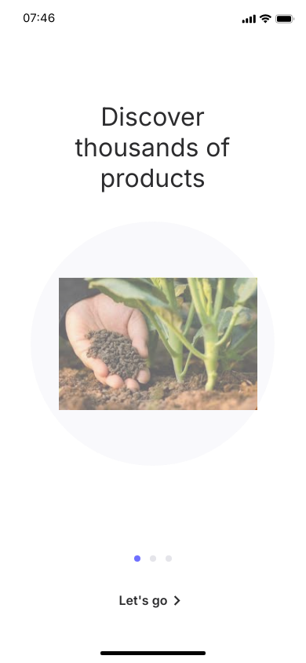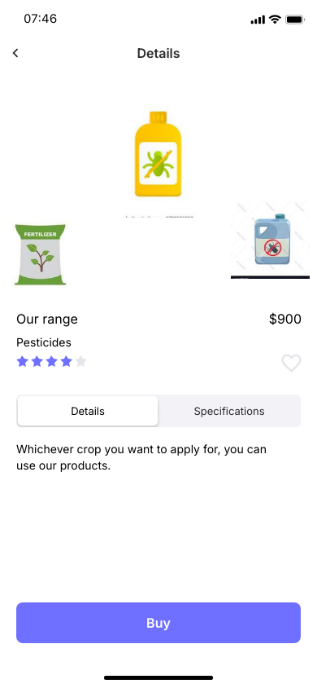
Question No 3 – Tools (Visio, Balsmiq, Axure)

Microsoft Visio:
Microsoft Visio is a diagramming and vector graphics application that is part of the Microsoft Office family. It’s primarily used to create a wide range of professional diagrams that help visualize data, processes, systems, and organizational structures.

🔹 What Microsoft Visio Is Used For
Flowcharts:
Used for mapping out processes or workflows.
Common in business process modeling (BPM) or software development.

Organizational Charts:
Shows hierarchy in a company or organization.

Network Diagrams:
Illustrates computer networks and device relationships.
Useful for IT professionals and system architects.

Floor Plans & Office Layouts:
Designs physical spaces for homes, offices, and industrial facilities.

UML Diagrams:
Supports Unified Modeling Language for software engineering.
Includes use case, class, sequence, and activity diagrams.

Database Models:
Visualizes relational database structures and relationships.

Gantt Charts & Timelines:
Useful for project planning and scheduling.
Business Process Model and Notation (BPMN)
Used in business process design and documentation.

🔹 Key Features of Microsoft Visio:
Drag-and-drop shapes from a large library of stencils.
Templates for common diagram types.
Data linking: You can connect Visio diagrams to external data sources (like Excel or SQL Server) for dynamic visuals.
Collaboration tools: Multiple users can work on diagrams and comment in real-time (especially with Visio Online).
Exporting and sharing: Diagrams can be exported to PDF, image, or shared via OneDrive or SharePoint.

Balsmiq Tool:
Balsamiq is a UI/UX wireframing tool used for creating quick and rough user interface (UI) mockups. It helps designers, developers, and stakeholders visualize the structure and layout of a website or application before development begins.

🔹 What Balsamiq Is
A low-fidelity wireframing tool that mimics the look of a sketch or whiteboard drawing.
Focuses on functionality and layout, not detailed design (like colors, fonts, or animations).
Known for its simplicity and speed, making it ideal for brainstorming and prototyping.

🔹 Where Balsamiq Is Used
UI/UX Design:
Sketching out interface screens for web or mobile apps.
Testing ideas quickly with minimal effort.

Requirements Gathering:
Helps business analysts, clients, and developers agree on functionality and layout early in the project.

Wireframes for Websites and Applications:
Create mockups for dashboards, forms, menus, navigation bars, etc.
Agile Development:
Often used in agile teams for iterative feedback and fast prototyping.
Client Communication:
Visually explains concepts to non-technical stakeholders without overwhelming them with design details.

🔹 Key Features
Drag-and-drop interface with pre-built UI components (buttons, dropdowns, text fields, etc.).
Hand-drawn style to keep focus on structure, not appearance.
Linking screens to create interactive mockups.
Works as a desktop app, web app (Balsamiq Cloud), or plugin (for tools like Confluence or Jira).
Supports collaboration and feedback through annotations and comments.

Axure Tool:
Axure RP is a professional wireframing and prototyping tool used in Business Analysis (BA) and UX/UI design to create interactive prototypes, flowcharts, wireframes, and documentation. It is especially valuable in complex or enterprise-level projects where detailed functional specifications and interactivity are important.

🔹 What Axure Is
A powerful tool for building high-fidelity, interactive prototypes.

Allows creation of clickable wireframes that simulate real software behaviour, including dynamic content, conditional logic, and data-driven interactions.

Supports diagramming, documentation, and collaboration in one platform.

🔹 How Business Analysts Use Axure
Creating Wireframes

Quickly sketch user interfaces (UIs) for web or mobile apps.

Helps stakeholders visualize screens early in the project lifecycle.

Interactive Prototypes

Add behaviors like click events, form input, conditional logic, or animations.

Simulate real user experience (UX) without coding.

Business Process Flows and Diagrams

Use flowcharts and decision trees to model business processes or workflows.

Clearly explain complex logic or decision points.

Requirements Validation

Interactive mockups allow early feedback from stakeholders.

Ensures business requirements are understood and validated before development begins.

Functional Specification

Annotate prototypes with detailed notes for developers and QA.

Export to Word or HTML for full documentation.

User Testing

Prototypes can be shared for usability testing to gather feedback on navigation, flow, and layout.

🔹 Key Features of Axure RP
Widgets library: Ready-made UI components (buttons, fields, tables, etc.).

Dynamic panels: For interactive or changing UI content.

Conditional logic: "If-Else" statements to show/hide or update elements.

Data-driven prototypes: Simulate databases or lists (like product catalogs, tables, etc.).

Team collaboration: Multiple users can work on shared projects with version control.

Export options: HTML for interactive preview, Word/PDF for static documentation.

🔹 Example BA Use Case
You're gathering requirements for an online hotel booking system:

Create wireframes for search, booking, and payment screens.

Use Axure to simulate selecting dates, filtering results, and submitting payment.

Annotate each screen with business rules (e.g., “User must enter valid credit card to proceed.”).

Share with stakeholders for validation before handoff to developers.

Question no 4 : Prepare RTM

Req ID | Req Name | Req Description | Design | Code | UT (Unit Testing) | Component Testing | System Testing | SIT | UAT
FR001 | Farmer registration | Each farmer should register with the application | complete | complete | complete | complete | complete | complete | complete
FR002 | Sort, filter and Search the Products | Every user should be able to search, sort and filter the products according to their requirements | complete | complete | complete | complete | complete | complete | complete
FR003 | Change the quantity | They should be able to increase no of products once placed on the same page | complete | complete | complete | complete | complete | complete | complete
FR004 | Remove the product | If required, there should be an option of removing the products from the cart | complete | complete | complete | complete | complete | complete | complete
FR005 | Place the order | After adding required products, they should be able to place the order | complete | complete | complete | complete | complete | complete | complete
FR006 | Add to cart | While checking the available products, they should have the option of adding to the cart there itself | complete | complete | complete | complete | complete | complete | complete
FR007 | Farmer Login | After registration farmers should be able to login to their page | complete | complete | complete | complete | complete | complete | complete
FR008 | Manufacturer uploads products | Manufacturer need to upload the products on the application to make it visible along with the pictures and specifications | complete | complete | complete | complete | complete | complete | complete
FR009 | Stock Availability | Available stock should be visible on the application | complete | complete | complete | complete | Incomplete | Incomplete | Incomplete
FR010 | Manufacturer maintain stock | Manufacturer should maintain the stock to avoid delays | complete | complete | complete | complete | Incomplete | Incomplete | Incomplete
FR011 | Manufacturer Registration | Manufacturer needs to be verified and registered on the application | complete | complete | complete | complete | Incomplete | Incomplete | Incomplete
FR012 | Delivery tracking | Farmers should be able to track their order on the app | complete | complete | complete | complete | Incomplete | Incomplete | Incomplete
FR013 | Manufacturer reporting | Dashboard for sales view to the manufacturer | complete | complete | complete | complete | Incomplete | Incomplete | Incomplete
FR014 | Manufacturer orders listing view | Manufacturer should get notified easily when any order is placed and there should be a dashboard to check current orders | complete | complete | complete | complete | Incomplete | Incomplete | Incomplete
FR015 | Make payment | Farmers should be able to make the payment through online options on the app (by Cash, Card or UPI) | complete | complete | complete | complete | Incomplete | Incomplete | Incomplete
FR016 | Payment Confirmation | Farmer should receive confirmation after system receives payment | complete | complete | complete | complete | Incomplete | Incomplete | Incomplete
FR017 | User should see the products by category | Grouping of products as per category should be done (Like Pesticides, Seeds, Fertilisers) | complete | complete | complete | complete | Incomplete | Incomplete | Incomplete
FR018 | Selection of shipping and billing address | Farmer should have option of selecting shipping and billing address | complete | complete | complete | complete | Incomplete | Incomplete | Incomplete
FR019 | Applying coupons and discounts | If farmers have any applicable coupons there should be an option of applying before making the payment | complete | complete | complete | complete | Incomplete | Incomplete | Incomplete
FR020 | View orders | Farmers should be able to view all orders in order to understand their status | complete | complete | complete | complete | Incomplete | Incomplete | Incomplete
FR021 | Return and exchange | If any damaged product is received, they should be able to return back and get the refund | complete | complete | complete | complete | Incomplete | Incomplete | Incomplete

Question No 5 – Prepare Test cases
Test Case ID | TC001 | Test case Name | Login Status
Project ID | AP001 | Project Name | Agriculture Project
Test Strategy ID | TS001 | PM Name | Vandanam
Test Plan ID | TP001 | Tester ID | Testor01
Scenario | Login of farmer | Tester Name | Jason
Link to that Page |  | Date of Test | 01/06/25
Input Data | Correct Login ID and Password | Correct login ID and wrong Password | Wrong ID and Wrong password | Correct Login ID but no password | Forgot Login ID
Expected Behaviour | Login done | Login Failed | Login Failed | Login failed | Login Failed
Actual Behaviour | Login done | Login Failed | Login Failed | Login failed | Login Failed
Comments | Show notifications | Ask to click on Forgot password | Ask to click on Forgot password | Ask to click on Forgot password | Ask to click on Forgot ID and send OTP to registered email/phone
Results | Pass | Pass | Pass | Pass | Pass

Test Case ID | TC002 | Test case Name | Sign In
Project ID | AP002 | Project Name | Agriculture Project
Test Strategy ID | TS002 | PM Name | Vandanam
Test Plan ID | TP002 | Tester ID | Testor01
Scenario | Registration of farmer | Tester Name | Jason
Link to that Page |  | Date of Test | 01/06/25
Input Data | Personal Details and ID Password | Missing Details correct ID password | Personal details and invalid password | Personal details and Invalid password | Wrong email ID
Expected Behaviour | All correct, Successful registration | Show the red cross on missing details area | Show the red cross on missing details area | Show the red cross on Invalid password area | Show the red cross on email ID part
Actual Behaviour | All correct, click on submit Successful registration | Show the red cross on missing details area Submit button wont work | Show the red cross on missing details area Submit button won’t work | Show the red cross on Invalid password area Submit button won’t work | Show the red cross on email ID part Submit button won’t work
Comments | Notify the User, Save ID and password
Results | Pass | Pass | Pass | Pass | Pass

Test Case ID | TC003 | Test case Name | Search the products
Project ID | AP003 | Project Name | Agriculture Project
Test Strategy ID | TS003 | PM Name | Vandanam
Test Plan ID | TP003 | Tester ID | Testor02
Scenario | Search the products | Tester Name | Alekya
Link to that Page |  | Date of Test | 01/06/25
Input Data | Put required product like pesticide name | Put required product like fertiliser | Put required product like seed name | Select from category, then search the product | Search by name directly
Expected Behaviour | Products are shown as per the filter | Products are shown as per the filter | Products are shown as per the filter | Products are shown as per the filter | Products are shown as per the filter
Actual Behaviour | Products are shown as per the filter | Products are shown as per the filter | Products are shown as per the filter | Products are shown as per the filter | Products are shown as per the filter
Comments
Results | Pass | Pass | Pass | Pass | Pass

Test Case ID | TC004 | Test case Name | Add to cart
Project ID | AP004 | Project Name | Agriculture Project
Test Strategy ID | TS004 | PM Name | Vandanam
Test Plan ID | TP004 | Tester ID | Testor02
Scenario | Adding products to the cart | Tester Name | Alekya
Link to that Page |  | Date of Test | 01/06/25
Input Data | Searched products selection and add to cart, add or remove quantity | Add new product to existing cart | View added products in the cart | Add products from wishlist | Move products to the wishlist from cart
Expected Behaviour | Added to cart successfully | Added to cart successfully | Cart is visible | Wishlist is visible and products are movable | Wishlist is movable and products are added in the cart
Actual Behaviour | Added to cart successfully | Added to cart successfully | Cart is visible | Wishlist is visible and products are movable | Wishlist is movable and products are added in the cart
Comments | Successful notification | Success in adding
Results | Pass | Pass | Pass | Pass | Pass

Test Case ID | TC005 | Test case Name | Make payment
Project ID | AP005 | Project Name | Agriculture Project
Test Strategy ID | TS005 | PM Name | Vandanam
Test Plan ID | TP005 | Tester ID | Testor02
Scenario | Make payment for the order | Tester Name | Alekya
Link to that Page |  | Date of Test | 01/06/25
Input Data | Select payment by Card, put card details | Select payment by UPI, put UPI details | Select payment by COD | Apply Coupons , put valid coupon code
Expected Behaviour | Payment done | Payment done | Payment created | Payment done
Actual Behaviour | Payment done | Payment done | Payment created | Payment done
Comments
Results | Pass | Pass | Pass | Pass

Test Case ID | TC006 | Test case Name | Track Order
Project ID | AP006 | Project Name | Agriculture Project
Test Strategy ID | TS006 | PM Name | Vandanam
Test Plan ID | TP006 | Tester ID | Testor02
Scenario | Track the order | Tester Name | Alekya
Link to that Page |  | Date of Test | 01/06/25
Input Data | Put order ID | Put order ID | Put order ID | Put order ID | Put order ID
Expected Behaviour | Once placed, Track the status, status is under the process | Status is packed, ready to dispatch | Status is dispatched | Status shows out for delivery | Status shows delivered; Bill summary is visible
Actual Behaviour | Once placed, Track the status, status is under the process | Status is packed, ready to dispatch | Status is dispatched | Status shows out for delivery | Status shows delivered; Bill summary is visible
Comments | Confirm Address and products | Confirm Address and products |  | confirm the contact details and address | Moved to my orders
Results | Pass | Pass | Pass | Pass | Pass

Test Case ID | TC007 | Test case Name | View my Orders
Project ID | AP007 | Project Name | Agriculture Project
Test Strategy ID | TS007 | PM Name | Vandanam
Test Plan ID | TP007 | Tester ID | Testor02
Scenario | View my orders | Tester Name | Alekya
Link to that Page |  | Date of Test | 01/06/25
Input Data | Login and click on view my orders | Login and click on view my orders | Login and click on view my orders | Login and click on view my orders | Login and click on view my orders
Expected Behaviour | Showed all past orders | Showed all past orders | Showed all past orders | Showed all past orders | Showed all past orders
Actual Behaviour | Showed all past orders | Showed all past orders | Showed all past orders | Showed all past orders | Showed all past orders
Comments | Use order ID for filtering | Use order ID for filtering | Use order ID for filtering | Use order ID for filtering | Use order ID for filtering
Results | Pass | Pass | Pass | Pass | Pass

Test Case ID | TC008 | Test case Name | Return order
Project ID | AP008 | Project Name | Agriculture Project
Test Strategy ID | TS008 | PM Name | Vandanam
Test Plan ID | TP008 | Tester ID | Testor02
Scenario | Return the product | Tester Name | Alekya
Link to that Page |  | Date of Test | 01/06/25
Input Data | Order ID and product ID | Order ID and product ID | Order ID and product ID | Order ID and product ID | Order ID and product ID
Expected Behaviour | Page giving options like refund/exchange | Page giving options like refund/exchange | Page giving options like refund/exchange | Page giving options like refund/exchange | Page giving options like refund/exchange
Actual Behaviour | Page giving options like refund/exchange | Page giving options like refund/exchange | Page giving options like refund/exchange | Page giving options like refund/exchange | Page giving options like refund/exchange
Comments
Results | Pass | Pass | Pass | Pass | Pass

Test Case ID | TC009 | Test case Name | Update Details
Project ID | AP009 | Project Name | Agriculture Project
Test Strategy ID | TS009 | PM Name | Vandanam
Test Plan ID | TP009 | Tester ID | Testor02
Scenario | Update personal details | Tester Name | Alekya
Link to that Page |  | Date of Test | 01/06/25
Input Data | Put all the information as required | Put all the information as required | Put all the information as required | Put all the information as required | Put all the information as required
Expected Behaviour | Details to be updated and considered for upcoming transactions | Details to be updated and considered for upcoming transactions | Details to be updated and considered for upcoming transactions | Details to be updated and considered for upcoming transactions | Details to be updated and considered for upcoming transactions
Actual Behaviour | Details to be updated and considered for upcoming transactions | Details to be updated and considered for upcoming transactions | Details to be updated and considered for upcoming transactions | Details to be updated and considered for upcoming transactions | Details to be updated and considered for upcoming transactions
Comments
Results | Pass | Pass | Pass | Pass | Pass

Test Case ID | TC010 | Test case Name | View my Profile
Project ID | AP010 | Project Name | Agriculture Project
Test Strategy ID | TS010 | PM Name | Vandanam
Test Plan ID | TP010 | Tester ID | Testor02
Scenario | View my Profile | Tester Name | Alekya
Link to that Page |  | Date of Test | 01/06/25
Input Data | Put ID and Password | Put ID and Password | Put ID and Password | Put ID and Password | Put ID and Password
Expected Behaviour | All personal details and order details, payment details visible on the screen | All personal details and order details, payment details visible on the screen | All personal details and order details, payment details visible on the screen | All personal details and order details, payment details visible on the screen | All personal details and order details, payment details visible on the screen
Actual Behaviour | All personal details and order details, payment details visible on the screen | All personal details and order details, payment details visible on the screen | All personal details and order details, payment details visible on the screen | All personal details and order details, payment details visible on the screen | All personal details and order details, payment details visible on the screen
Comments
Results | Pass | Pass | Pass | Pass | Pass

Question No 6
DB Diagram:
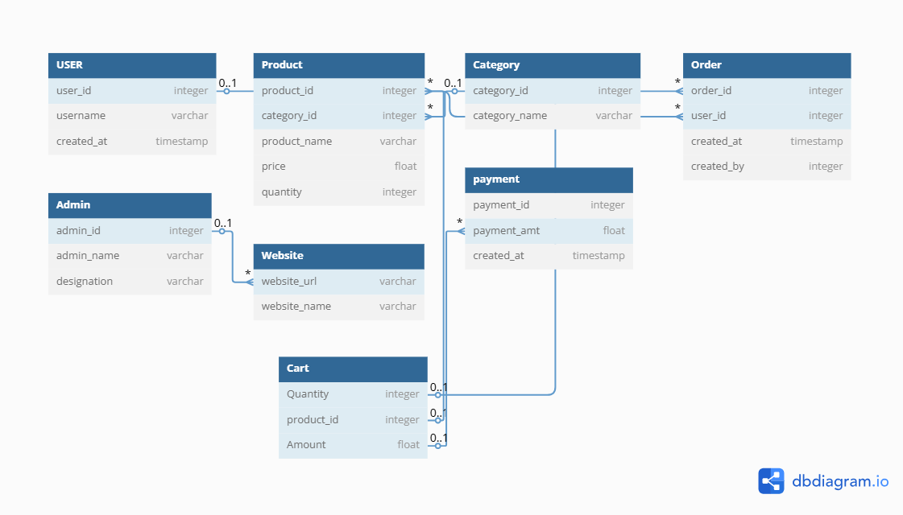
ER Diagram:

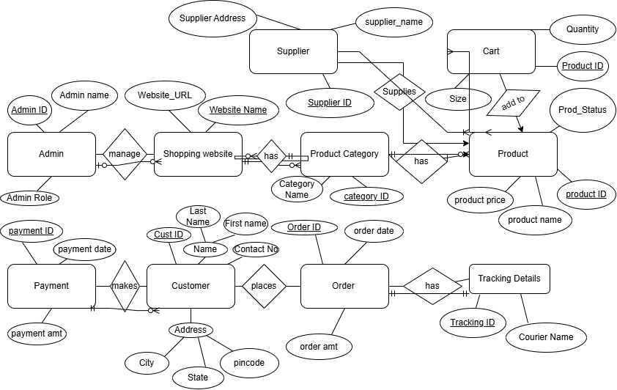
Question 7:

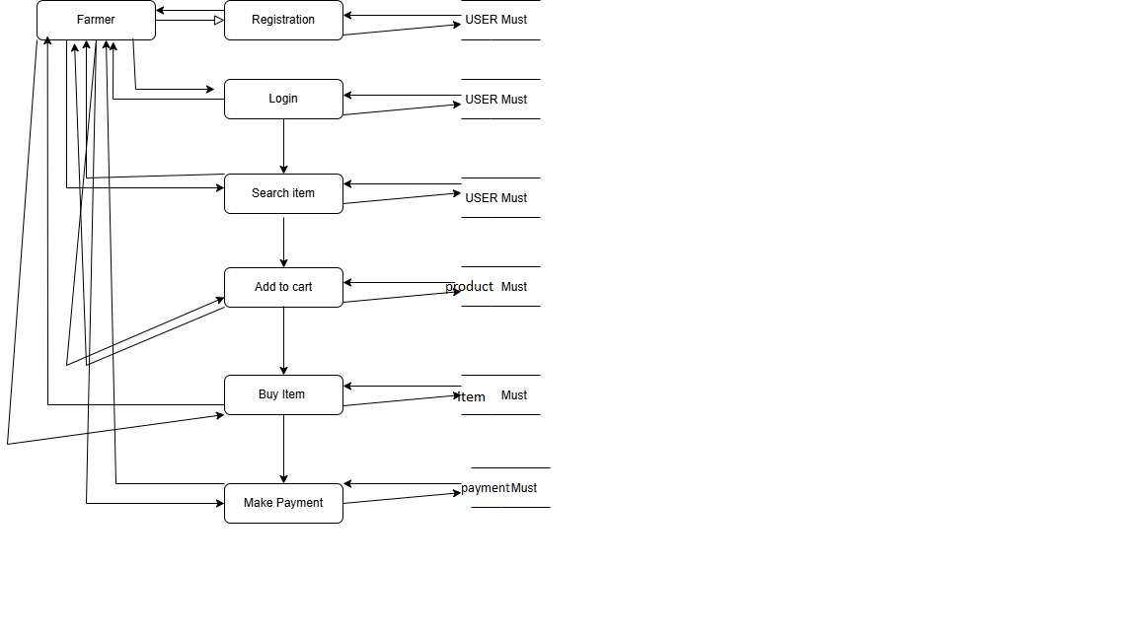

Question 8 – Change request management

1. Understand and Document the Change Request
The first step is to clearly understand what is changing and why. In this case:
- What is changing?
The existing tax structure (e.g., GST/VAT rates applied to agricultural products).
- Why is it changing?
Because of a revised government taxation policy.
This change request should be formally documented, including:
- Request originator (e.g., business analyst, compliance officer)
- Description of the change
- Business justification
- Expected outcomes
- Date of request
This documentation becomes the foundation for further evaluation.

2. Conduct Impact Analysis
Once the request is documented, a comprehensive impact analysis must be performed. This analysis should evaluate:
- Project Scope:
Will new modules or features need to be developed? Will existing modules such as billing, invoicing, or reporting be modified?
- Schedule/Timeline:
Will implementing this change delay existing milestones or deliverables?
- Budget:
Are there additional development, testing, or compliance costs involved?
- Resources:
Will the current team handle the change, or will external consultants, domain experts, or additional developers be needed?
- Risks:
What are the risks of implementing or not implementing the change?
For example:
  - Legal non-compliance
  - Data mismatches in tax reports
  - Customer dissatisfaction if incorrect tax is applied
A Change Impact Assessment Document can be created to summarize this information.

3. Prioritize the Change Request
Once the impact is known, the change must be prioritized based on:
- Urgency:
Is it a regulatory compliance issue with a fixed deadline?
- Importance:
Does this impact financial calculations or legal reporting?
- Impact on Project Goals:
Will it significantly affect quality, delivery, or user satisfaction?
In this case, since it’s a government-mandated tax change, it is likely high priority and time-sensitive.

4. Seek Approval from Project Sponsor or Change Control Board
The documented change request, along with the impact analysis, is submitted for formal approval. This is usually done by:
- The Project Sponsor
- A Change Control Board (CCB)
- Senior Management, if budget or timeline changes are significant
They will review:
- Business justification
- Risks and costs
- Impact on scope and schedule
Upon approval, the change is authorized for implementation.

5. Communicate the Change to Stakeholders
After approval, clear communication is essential to ensure everyone is aligned. This includes:
- Internal teams (development, QA, project management)
- Business users (finance, sales, procurement)
- Clients or customers, if the change affects billing or product pricing
Communication should include:
- What is changing
- Why it’s changing
- When the change will take effect
- How it will affect stakeholders
- Any required actions (e.g., updated processes or documentation)
Project documentation, such as the Project Plan, Requirements Document, and Test Plan, should also be updated accordingly.

Optional – Execution and Monitoring (Post-Approval)
Once the change is implemented:
- Ensure development and testing follow proper quality procedures.
- Deploy the change to production.
- Monitor for any issues post-implementation.
- Review with stakeholders to confirm the change is effective and complete.

Question 9 – Change request Vs Enhancement

Stakeholder Request Summary:
Ben and Kevin want to:
- Allow Farmers to list and sell their crop yields/products through the application.
- Introduce an Auction System for crop yields.

As a BA, What Is Your Response?
1. Acknowledge the Request
As a BA, you would first acknowledge the new business need raised by Ben and Kevin and thank them for bringing in a potentially valuable feature.
2. Clarify and Understand the Requirements
Before labeling it as a change or enhancement, you would:
- Set up a detailed discussion with the stakeholders.
- Ask questions such as:
  - What kind of crops/products will be listed?
  - How will the selling process work (fixed price vs auction)?
  - How do they envision the auction process (time limits, bidding rules)?
  - What kind of user roles and permissions will be needed for farmers?
  - What payment and delivery mechanisms are expected?
3. Determine Project Impact
You then assess:
- Does this feature align with the original project scope?
- What are the technical, time, and budget implications?
- Will it affect the existing architecture?

Is it a Change Request or an Enhancement?
It is a Change Request.
Here’s why:
- A change request is raised when a new requirement or a significant deviation from the originally agreed scope is proposed after the project is in progress.
- Initially, the project was about an online store for agricultural products (probably from sellers/vendors), but now the user base is being expanded to include farmers as direct sellers, and a new auction module is being proposed.
- This represents a major functional change to the system's purpose, business flow, user roles, and technical implementation.
Therefore, this is not just a small enhancement to existing features — it’s a change request requiring full impact analysis, documentation, and approval.

Question 10 - Estimations

Man hours are the required effort of the resources to complete a project. There are 3 types of projects:
Small: Up to 500 hours
Medium: Up to 1000 hours
Large: Up to 1500 hours

Analysis
As per the case study, the duration of the project is 18 months and the current team size is around 15. This will come under medium project.
As the trained resources are available, trainers are not required.
As the structure of the project is available, New and enhanced infrastructure is not required.

Question 11 –

Step 1: Initiate User Acceptance Testing (UAT)
Objective:
To allow the client/end users to verify if the system meets their business requirements and is ready for production.

Steps to Handle This Situation as a Business Analyst:

A. Prepare for UAT
- Review Business Requirements
  - Ensure all business requirements and use cases are traceable and testable.
  - Cross-check the Requirements Traceability Matrix (RTM) to verify coverage.
- Create a UAT Plan
  - Define:
    - Scope of testing
    - Test environment setup
    - Roles and responsibilities
    - Entry and exit criteria
- Prepare UAT Test Cases / Scenarios
  - Write business-focused test cases in collaboration with users.
  - Focus on real-world business workflows, not just technical validation.
- Set Up the UAT Environment
  - Ensure a stable and sanitized UAT environment that mirrors production.
- Coordinate with the Client
  - Reach out to the client, inform them the system is ready for UAT.
  - Share the UAT plan, test cases, schedule, and credentials.
  - Arrange a UAT kick-off meeting.

B. Execute UAT
- Support the Client During Testing
  - Be available to clarify any queries related to workflows or requirements.
  - Track defects or issues reported by users.
- Record Feedback and Defects
  - Use a defect-tracking tool or a shared log.
  - Coordinate with the development/testing team for quick resolution.
- Retesting and Validation
  - Ensure fixed issues are retested and closed by the client.

C. UAT Sign-Off / Acceptance
- Get Formal UAT Sign-Off
  - Once the client confirms the system meets their expectations, request them to sign the UAT Sign-Off Document or Acceptance Certificate.
- Document Any Outstanding Items
  - If any non-critical items are deferred, note them clearly for the next phase or release.

Step 2: Project Closure Process
Once UAT is completed and sign-off is received, you move to formal project closure.
Steps to Close the Project:

1. Final Review & Handover
- Ensure all deliverables (documents, code, credentials, training manuals) are handed over.
- Conduct a final client walkthrough, if needed.

2. Obtain Final Acceptance
- Get a Project Closure Sign-Off from the client.
- Confirm no open issues or unresolved tasks remain.

3. Release Resources
- Inform internal teams (development, QA) that project work is completed.
- Reallocate or release team members as per organizational process.

4. Documentation and Archival
- Archive all relevant project documents:
  - BRD, SRS, UAT Plan, RTM, Test Cases, Sign-Off documents, etc.
- Ensure proper version control and storage for future reference.

5. Conduct a Lessons Learned / Retrospective Session
- Hold a meeting with the team to document:
  - What went well
  - What could have been better
  - Recommendations for future projects

6. Celebrate and Close
- Acknowledge the team's efforts and celebrate project success.

Question 12 – Project Closure Document

1. Project Overview
The project titled “Online Agriculture Product Store” was initiated to develop a digital platform enabling customers to browse and purchase agriculture-related products online. The system aimed to offer user-friendly navigation, secure payment gateways, and real-time product availability. The project followed a structured SDLC process covering all phases including requirements gathering, design, development, testing, and deployment.

2. Achievements
- Successfully designed and developed the complete e-commerce platform for agriculture products.
- Integrated secure user registration, product listing, cart management, and payment features.
- Enabled role-based access for Admin, Customers, and Sellers.
- Developed a fully responsive UI compatible with mobile and desktop browsers.
- Conducted thorough system testing and achieved a successful User Acceptance Testing (UAT) sign-off.
- Delivered all agreed project deliverables on or before the final timeline.

3. Lessons Learned
- Early stakeholder engagement helped in clearly defining scope and priorities.
- Agile communication between teams minimized delays in clarification and decision-making.
- Change requests received during the development phase highlighted the importance of freezing scope early.
- Continuous integration and incremental testing helped detect issues earlier in the cycle.
- Documentation of user scenarios in business terms improved UAT efficiency and stakeholder satisfaction.

4. Quality Assurance
- Functional, Integration, System, and UAT testing were successfully completed.
- All critical and major defects were resolved before deployment.
- Quality metrics such as defect density, test coverage, and user feedback were monitored throughout.
- A dedicated QA team followed standard testing protocols ensuring the system met quality benchmarks.

5. Resource Utilization
- The project was executed using a balanced team of business analysts, developers, testers, UI/UX designers, and project managers.
- Resource allocation was optimized based on project phase (e.g., heavier QA involvement during testing).
- No significant unplanned resources were required; all resource plans aligned with initial estimations.
- Regular monitoring ensured efficient use of human and technical resources.

6. Risk Management
- Risks were identified and tracked using a risk log from project initiation.
- Major risks such as timeline slippage due to late change requests were mitigated by timely escalation.
- Backup and recovery plans were in place to protect project data.
- No high-impact risk materialized during the execution phase.

7. Challenges
- Mid-project change requests (e.g., adding farmer selling features and auction system) required scope reassessment.
- Minor communication delays occurred between cross-functional teams during testing.
- Aligning schedules for client UAT took additional coordination effort.
- Ensuring compliance with evolving taxation structures required updates to the existing logic mid-cycle.

Conclusion
The project was completed successfully, with all deliverables approved by the client. The learnings, challenges, and performance outcomes have been documented to improve future project planning and execution. This document formally marks the closure of the project.

