Document 6- Please prepare a use case diagram, activity diagram and a use case specification document.
Part 2/2 Evaluation Document 6- Please prepare a use case diagram, activity diagram and a use case specification document. Document 7- Screens and pages Document 8- Tools-Visio and Axure Document 9- BA experience My experience as BA in following phases: 1. Requirement gathering: 2. Requirement Analysis: 3. Design: 4. Development: 5. Testing: 6. Deployment:
Project: In-house Ticket Management System (TMS)
- Use Case Diagram
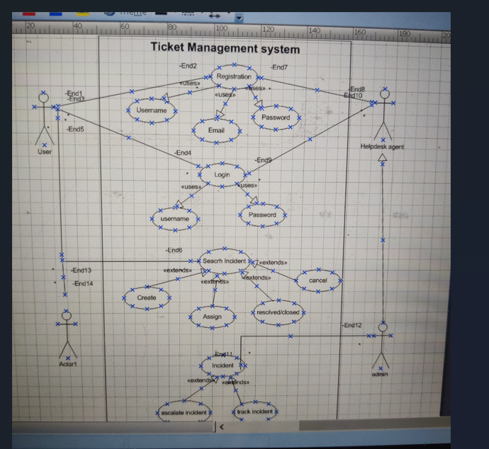

Activity diagram
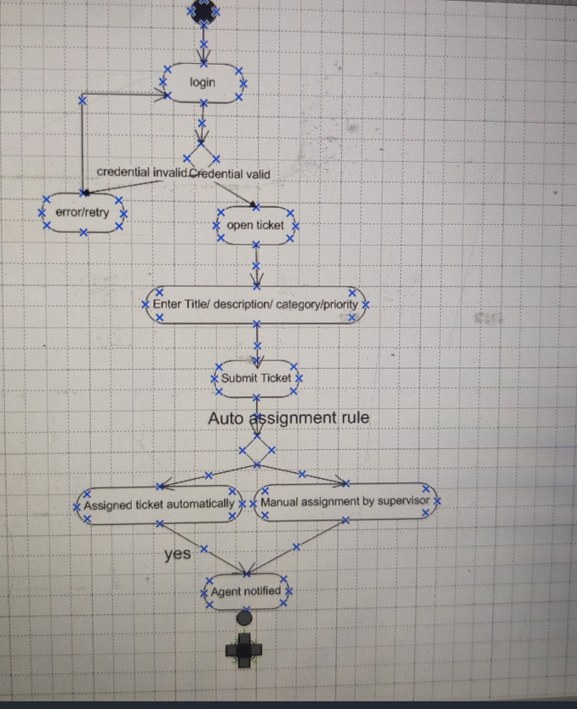

3) Use Case Specification (Template + filled example)
Follow the required fields listed in the assignment. Below is a fully filled use case for Create Ticket.
Use Case Name: Create Ticket
Use Case Description: End user creates a new support ticket describing an issue or request to be handled by the helpdesk team.
Primary Actor: EndUser (any employee)
Secondary Actors: System (notification/email), ExternalEmail (if ticket created by inbound email), HelpdeskAgent, Supervisor
Basic Flow (Main Success Scenario):
- User logs in to the TMS.
- User navigates to "Create Ticket".
- User fills Title, Description, Priority, Category, Contact info, and optionally attachments.
- User submits the ticket.
- System applies auto-assignment rules; ticket is assigned to an agent or posted for manual assignment.
- Ticket appears in agent's queue and user can view ticket status.
Alternate Flows:
- A1 — Ticket created via email: Incoming email parser creates ticket; system maps sender to user profile, extracts subject/body into Title/Description.
- A2 — Minimal fields only: If optional fields are omitted, ticket is still created with default priority = Medium.
Exceptional Flows:
- E1 — Attachment exceeds allowed size: System rejects attachment and shows error; user can retry uploading a smaller file.
- E2 — Required fields missing: System highlights fields and prevents submission.
- E3 — System unavailable: Show friendly error and provide ability to save draft locally or contact with fallback phone number.
Pre-conditions:
- User has valid credentials and is authenticated.
- System services (DB, email) are up.
Post-conditions:
- A ticket record exists in the database with correct metadata.
- User received acknowledgement.
- Ticket assigned or queued for assignment.
Assumptions:
- Users have unique employee IDs and email addresses.
- Attachment types allowed: pdf, jpg, png, docx.
Constraints:
- Max attachment size = 10 MB.
- Title max length = 200 characters.
- Priority values fixed: Low, Medium, High, Critical.
Dependencies:
- Authentication service (LDAP/SSO).
- Email server for notifications.
- User directory for mapping email to user.
Inputs and Outputs:
- Inputs: Title, Description, Priority, Category, Attachments, Contact info.
- Outputs: Ticket ID, Acknowledgement email, Notifications to agents.
Business Rules:
- Tickets with Priority = Critical must trigger SMS and an immediate escalation.
- SLA timers start at ticket creation time.
- Duplicate ticket detection: if a user opens multiple tickets for the same category within 15 mins, system prompts to update existing ticket.
Miscellaneous Information:
- Audit trail must record all changes to ticket status and owner with timestamp and actor.

4) Additional Use Cases (short list)
- View Ticket
- Assign Ticket
- Update Ticket
- Resolve Ticket
- Close Ticket
- Reopen Ticket
- Add Comment
- Search Tickets
- Generate Reports
- Manage Users (Admin)
- Configure SLA (Admin)
For each, follow the same template above when preparing your submission.

Document 7- Screens and pages

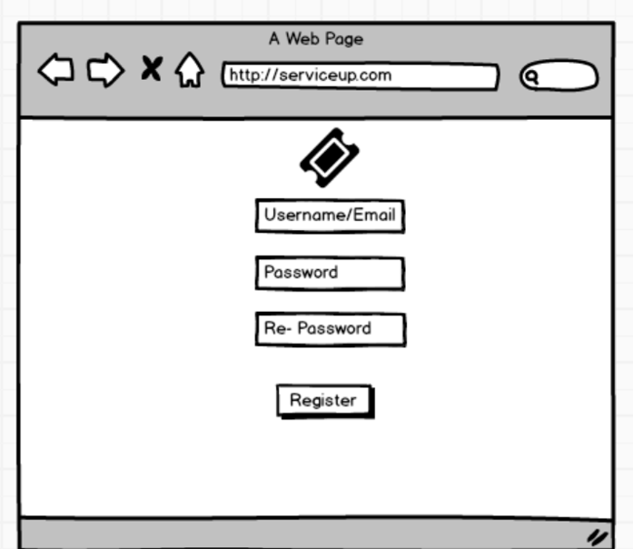
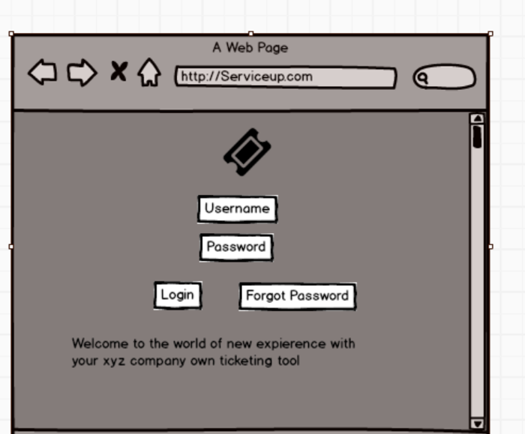
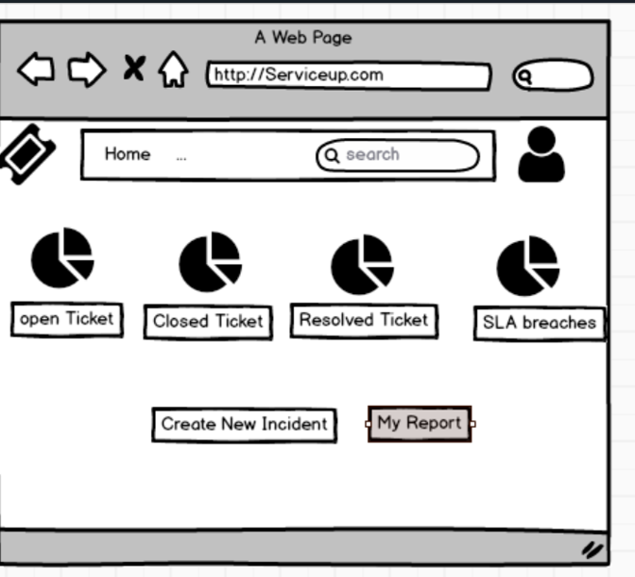
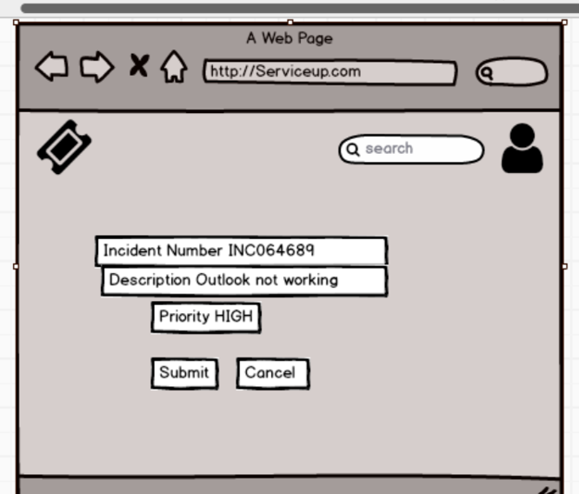
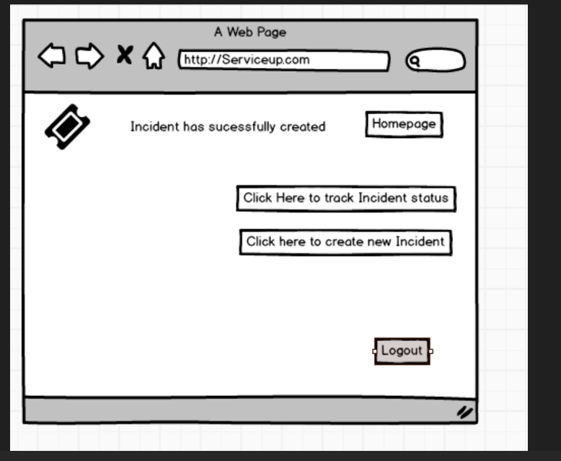
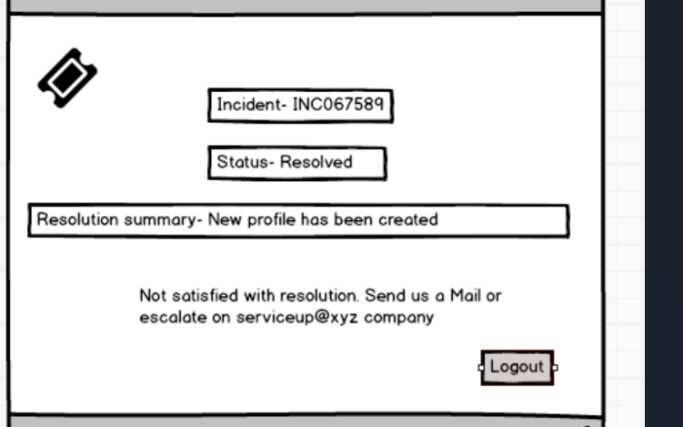
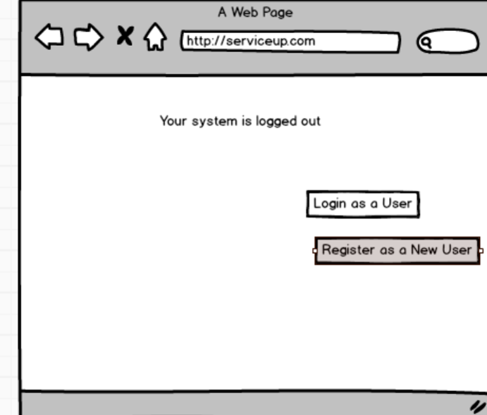

Document 8- Tools-Visio and Axure
Answer: For the Ticket Management System implementation, I used Microsoft Visio to design UML diagrams such as use case diagrams, activity diagrams, and process flows. Visio’s ready-made UML templates, connectors, and swimlanes helped me present workflows in a clear and professional manner, which made it easier for stakeholders and the development team to understand system behavior. For the user interface and screen mockups, I relied on Axure RP, as it allowed me to build interactive wireframes, link pages, and simulate end-to-end user flows like ticket creation, assignment, and resolution. This helped in gathering early feedback from stakeholders, validating requirements, and reducing misunderstandings before development. Together, Visio and Axure supported both the analytical modeling and visual prototyping needs of the project, ensuring better clarity and alignment across all phases.

Document 9- BA experience My experience as BA in following phases: 1.
Requirement gathering:
Project: Implementation — Ticket Management System (Waterfall)
- Requirement Gathering:
  - I facilitated workshops and JAD sessions with IT helpdesk teams, managers and end users to collect functional and non-functional requirements.
  - Used MoSCoW prioritization to categorize must-have vs nice-to-have features.
  - Captured detailed acceptance criteria and sample data for reporting requirements.
  - Validated and categorized requirements using FURPS to ensure they were complete and testable.
  - Handled stakeholder unavailability by identifying alternate points of contact and arranging follow-up sessions.
- Requirement Analysis:
  - Translated requirements into UML artifacts: use case diagrams, activity diagrams, class sketches and sequence diagrams to clarify interactions.
  - Created Business Requirement Specification (BRS) and Software Requirement Specification (SRS) with prioritized requirements and acceptance criteria.
  - Performed requirement de-duplication and conflict resolution with stakeholders.
  - Produced the RTM to map requirements to test cases and design elements.
- Design:
  - Coordinated with UX to create wireframes and with architects to finalize DB schema and interfaces.
  - Derived test cases from use case flows, including negative scenarios.
  - Prepared sample test data and updated RTM with test coverage.
- Development:
  - Conducted regular standups and JAD sessions to clarify requirements for developers.
  - Acted as liaison between client and technical team; tracked change requests and ensured traceability.
  - Reviewed unit test results for feature completeness and clarified acceptance criteria.
- Testing:
  - Prepared detailed test cases and participated in integration testing and regression cycles.
  - Coordinated UAT with client representatives; collected sign-off for each milestone.
  - Ensured RTM was updated and used for final sign-off and project closure.
- Deployment:
  - Assisted in release planning and coordinated with operations for deployment windows and rollback strategy.
  - Prepared end user manuals and training sessions; coordinated training attendance and feedback collection.
  - Ensured RTM and project artifacts were handed over to the client for audit and support.
Challenges faced & how I handled them:
- Stakeholder unavailability: I used recorded sessions and one-to-one follow ups.
- Duplicate requirements / scope creep: I maintained a change control log and used MoSCoW to reprioritize.
- Integration issues: Engaged early with the technical team to define interface contracts and test stubs.

