CAPSTONE PROJECT 1- PART 2

1. 4 Quarterly Audits are planned Q1, Q2, Q3, Q4 for this project . What is your
Knowledge on how these audits will happen for a BA ?
As a Business Analyst , audits play a critical role in ensuring that the requirements
Management process, documentation quality, traceability, and stakeholder alignment
Remain consistent and compliant throughout the project lifecycle. In this project, four
Quarterly audits (Q1, Q2, Q3, Q4) will be conducted to assess BA- related deliverables
And practices.
STAGE | Quarter 1- Requirement Gathering
COMPLETED | Week 1 to Week 10
CHECK LIST | BRD Template prepared and approved by Project Manager .Stakeholder identification and RACI Matrix created . Elicitation results report (BRDFOWJIPQU techniques used)  Duplicate requirement check and consolidation done .  Email communication sent - To, CC, BCC(committee + APT IT solutions team)

STAGE | Quarter 2 - Requirement Analysis Phase
COMPLETED | Week 11 to Week 18
CHECK LIST | Business process flows and Use case diagrams validated functional and Non- functional requirements.  Documented RTM(Requirement Traceability Matrix).  Prepared version control log updated for BRD & SRS .  Client review feedback captured & sign-off initiated.  Email communication - To, CC, BCC(project stakeholders + PM + BA team)

STAGE | Quarter 3 - Design & Development Phase
COMPLETED | Week 19 to Week 26
CHECK LIST | UML Diagrams (Use case Specs, Activity Diagrams, Sequence Diagrams)finalized.  UI Mock-ups & Prototypes approved by client.  Database Design and API Mapping reviewed with technical team.  Change request log maintained for any scope update stakeholder meeting minutes(MoM) documented.  Email communication - To, CC, BCC(Project Committee + APT IT Team)

STAGE | Quarter 4 - Testing & Closure Phase
COMPLETED | Week 27 - Week 34
CHECK LIST | UAT Scenarios mapped to requirements.  Defect Traceability Matrix verified .  Client Signoff on UAT and Project Acceptance Form obtained.  Change request closure & final version archived.  Lessons learned and project closure report submitted.  Email communication - To, CC, BCC(Client + Committee + APT IT Delivery Team)

2. Before the project is going to kickstart, the committee asked Mr. Karthik to submit
BA Approach Strategy ?
Before starting the project, the BA needs to create a clear and structured approach
Strategy that defines how the BA will gather requirements, analyze stakeholders, prepare documents, handle changes, communicate with the client, and take approvals and sign offs
This strategy ensures smooth communication, proper documentation, and successful
Delivery of the “ Online Agriculture Product Store” project.
1. ELICITATION TECHNIQUES TO APPLY :
Elicitation is the process of collecting information and understanding the needs of
Stakeholders. The BA uses different techniques to gather these requirements effectively.
Common elicitation techniques include :
BRAINSTORMING : To generate and discuss new ideas with stakeholders.
DOCUMENT ANALYSIS: Studying existing documents and reports for background
Information.
OBSERVATION: Observing users day to day work to understand actual needs.
INTERVIEWS: One on One discussions with key people like Mr. Henry, Peter, Kevin, Ben.
FOCUS GROUPS: Conducting group meetings to collect opinions from multiple
Stakeholders.
REVERSE ENGINEERING: Understanding current systems or processes to find
Improvements.
PROTOTYPING: Showing sample screens to validate expectations.
These techniques help ensure that the BA gathers accurate and complete requirements.
2. STAKEHOLDER ANALYSIS ( RACI/ ILS):
The BA performs stakeholder analysis to identify all the people involved in the project,
Understand their expectations, and assign proper roles and responsibilities.
RACI MATRIX helps define these roles:
R - Responsible - who completes the task.
A - Accountable - who owns the result.
C - Consulted - who provides input.
I - Informed - who should be kept updated.
The BA also applies ILS Analysis:
Influence - How much power or impact the stakeholder has.
Level of Interest - How interested they are in the project .
Support - Whether they are positive or resistant to the project.
This ensures every stakeholders voice is heard, and their expectations are managed
Correctly.
3. DOCUMENTS TO PREPARE :
The BA is responsible for creating and maintaining all Business Analysis documents
During the project. These include:
BRD ( business req doc): Describes high-level business needs.
FRD ( Functional req doc): Details the system’s functional features.
SRS ( System req specification): Converts business needs into technical terms.
Use Case Documentation : Describes how users interact with the system.
Test Case Document : Lists test scenarios for UAT.
Change Request Form : Tracks any change in requirements.
RTM(requirement traceability matrix) : Maps requirements to testing and
Implementation.
These documents are reviewed and signed off by the client before development begins.
4. PROCESS FOR DOCUMENT SIGN-OFF:
Once the BA prepares the documents, a formal sign-off process is folloed:
Submit the BRD and SRS for client review.
Conduct a review meeting to clarify doubts or suggestions.
Make updates if needed based on client feedback.
Obtain the sign-off via email or a signed copy.
Store all signed documents in the project repository for audit purpose.
This confirms that all stakeholders agree with the documented requirements before development starts.
5. CLIENT APPROVAL PROCESS:
Client approval is very important for every project phase. The ba ensures approvals are
Taken after every key deliverable:
Arrange formal meetings with the client (Mr. Henry and committee).
Present the documents and explain each section.
Address any changes or clarifications.
Take written or email approval for closure.
Maintain all approval records for traceability and audit.
6. COMMUNICATION CHANNELS TO ESTABLISH AND IMPLEMENT:
The BA sets up different channels to ensure smooth flow of information.
Weekly Meetings - To discuss progress and blockers with the team.
Bi-Weekly or Sprint Reviews: To update stakeholders on milestones.
Emails: For official communication, MOM,(minutes of meeting), & Approvals.
Monthly Reports: To share progress and performance updates.
Group Tools: Teams, Zoom, Slack for quick discussions.
7. HANDLING CHANGE REQUESTS:
Receive the change request using a change request form.
Do an impact analysis to understand how the change affects scope, time and cost.
Discuss with the PM and team.
Get approval from the client before implementing the change.
Update all affected docs ( brd, srs….)
Communicate the approved change to all stakeholders.
8. UPDATING PROJECT PROGRESS:
The BA regularly updates stakeholders on project progress to keep them informed.
Send weekly status reports to the PM and client.
Conduct monthly review meetings to discuss updates, issues, and next steps.
Maintain dashboards or trackers to visualize progress and milestones.
9. TAKING UAT & PROJECT SIGN-OFF:
Prepare uat test scenarios and ashare them with the client.
Help the client test the application features.
Record results and fix any identified issues.
Conduct the final review meeting.
Take final approval using the client project acceptance form.
Close the [project after the receiving official sign-off.

3. Explain and illustrate 3-tier architecture ?

3-tier architecture means dividing an application into three layers or parts. Each layer has
Its own specific job- this makes the system easier to manage, update, and secure.
The 3 layers:
Application layer
Business logic layer
Database layer
1. APPLICATION LAYER ( PRESENTATION LAYER):
This is the top layer that users can see and interact with.
It contains the User Interface(UI) - like buttons, pages, screens, and menus.
Users send requests through this layer(like logging in and searching product).
In our Agriculture project:
Farmers and manufacturers use this layer to view products, place orders, and make
Payments.
2. BUSINESS LOGIC LAYER ( APPLICATION LAYER/ MIDDLE LAYER):
This is the middle layer that connects the UI and the database.
It contains all the rules and logic of the application- the “brain” of the system.
It decides how data should move and what should happen when the user performs
An action.
In our Agriculture project:
When a farmer clicks “Buy Now”, this layer processes the order and sends details to the
Database.
3. DATABASE LAYER (DATABASE LAYER/ BACKEND LAYER):
This is the bottom layer of the system.
It is responsible for storing and retrieving data.
It manages all the data related to users, products, payments, and orders.
In our project:
All details about fertilizers, seeds, pesticides, farmer’s profiles, and order records are
Stored here.
Why 3- tier architecture is useful:
Makes the system secure (data is separated from interface).
Makes it easier to maintain and update.
Different teams (frontend, backend, DB) can work independently.
Improves performance and scalability when users increase.

3- TIER ARCHITECTURE - ONLINE AGRICULTURE PRODUCT STORE.
Presentation Layer (UI)
-Website / mobile App screens
-Login, search, add to cart

Database Layer (Backend)
-My SQL / Oracle Database
-Stores Product & Order data
Business Logic Layer
Application
-java/ .net code
-Order Processing, Payment Handling

4. Business Analyst should keep what points in his/her mind before he frames a
Question to ask to the stakeholder.
(5W 1H - SMART - RACI - 3 TIER Architecture - Use Cases, Use Case Specs,
Activity Diagrams, Models, Page Designs).
Before a BA starts asking questions to stakeholders, they must plan how to frame those
Questions properly. This ensures that the BA gathers clear, complete, useful information
About the project.
1. 5W1H FRAMEWORK:
What - what exactly is the problem or requirement?
Why - why is this needed or important?
Who - Who will use this feature or process?
When - When should this process happen?
Where - where will it be used (location or system)?
How - how will this work or be implemented?
Like , what problem are farmers facing ?
Why do we need online payment options?
How will the delivery tracking work?
2. SMART TECHNIQUE:
It helps in creating clear and achievable requirements and goals.
S- Specific (clearly defined)
M - Measurable (can be tracked)
A - Attainable(realistic to achieve)
R - Relevant (useful to business)
T - Time-bound (has a deadline)
Farmers should be able to place an order within 3 clicks- this is specific, measurable and
Time-bound.
3. RACI CHART:
It helps in identifying roles and responsibilities in the project. It also helps the BA know
Whom to ask questions during requirement gathering.
R (Responsible) - who will do the task. .(developer, tester).
A ( Accountable) - who owns the result.(PM).
C ( Consulted) - who gives input.( client, stakeholder).
I (Informed) - who needs updates.(sponsor, team).
If u want to know about system design, ask the developer (responsible), if u want
Approval ask the PM (accountable).
4. UML MODELS (UNIFIED MODELING LANGUAGE):
Main UML and Design Artifacts:
Use Case Diagram:
Shows how different users (actors) interact with the system.
Example: Farmer - place order - system.
Use Case Specifications:
Step by step explanation of each use case- what user does and what system responds.
Example : Farmers logs in - selects product - adds to cart - makes payment.
Activity Diagrams :
Show the flow of actions in a process - step by step from start to end.
Example: login - search product - add to cart - make payment - order confirmed.
Models:
Include diagrams like class models or sequence models to show data flow and system interaction.
Example: “order” class connected to “product” and “farmer” classes.
Page Design (wireframes / mockups):
Simple screen layouts showing how each page ( like login, product list, cart, payment) will look.
Example: sketch of a page where the farmer can search and filter products.

5. As a Business Analyst, What Elicitation techniques you are aware of ?
Elicitation techniques are different methods a BA uses to collect information &
Requirements from clients & users.
In the Online Agriculture Products Store case study, the BA need to gather details from Mr. Henry, farmers, and manufacturers about how they want the app to function- like login
Search , payment, & delivery tracking.
VARIOUS ELICITATION TECHNIQUES:

TECHNIQUE | MEANING | EXAMPLE | TYPES
Brainstorming | Group discussion to generate ideas | Mr. Henry & farmers share ideas about feature like search & delivery tracking. | No major subtypes ,can be structured (planned topics) / unstructured ( free discussion).
Document Analysis | Studying existing docs, reports/systems | BA studies existing e-commerce apps/ agricultural catalogs to understand what data is needed. | Current system docs, user manuals, previous project reports.
Reverse Engineering | Understanding an existing system by analyzing how it works. | Checking apps like “kisanmandi”/”agrostar”to identify useful features for the new app. | Types: White Box (analyze internal code/design)  Black Box: (analyzes system behavior without seeing code).
Focus Groups | Collecting feedback from a small grp of users. | A small grp of farmers and sellers discuss what challenges they face when buying/selling products. | Homogenous (same background users) - Heterogenous (mixed users).
Observation | Watching users in their environment. | BA observes how farmers currently buy seeds and fertilizers offline. | Active Observation(BA interacts) - Passive Observation (BA just watches).
Workshops | Group sessions to refine and finalize requirements. | Workshop with Mr. Henry’s team and IT developers to finalize login and catalog process. | Requirement Workshop, Design Workshop, Review Workshop.
JAD (joint application document) | Structured collaborative meetings between business & IT. | BA developers, farmers together discuss how search and order flow should work. | Traditional JAD(in person) - Virtual JAD (online tools).
Interview | One-on-one / group discussion. | BA interviews mr. henry for business goals & ben for payment preferences. | Structured (set questions) - Unstructured (open-ended) - Semi - structured.
Prototype | Creating mockups / sample screens. | BA shows a demo screen of the login / catalog to famers & collects feedback. | Low-fidelity (paper sketches) - High-fidelity (clickable UI demo).
Survey/ questionnaire | Written questions sent to many users. | Sending survey forms to farmers to know preferred payment options ( UPI,COD,…) | Open-ended (descriptive) - Closed-ended (yes/no, MCQs).
Use case specifications | Step-by-step description of how users interact with the system. | Writing “farmer searches & orders fertilizer” scenario in steps. | Basic flow(normal case) - Alternate flow (optional path) - Exception flow (error handling).

6. Which Elicitation Techniques can be used in this project and justify your selection
Of Elicitation Techniques?
The best elicitation techniques for this project are :
1. PROTOTYPING: Helps farmers and manufacturers visualize how the online store and
Product catalog will look and work.
2. USE CASE SPECIFICATIONS: Clearly defines how each user (farmer, manufacturer)
Interacts with the system, like login, product search, and order
Tracking.
3. DOCUMENT ANALYSIS: Helps review existing data or reports about agriculture
Product processes to understand needs better.
4. BRAINSTORMING: Useful for generating new ideas and gathering suggestions from
Mr. Henry, Peter, Kevin & Ben.
These techniques are chosen because they help gather clear, visual, & practical requirements from both technical and non-technical stakeholders.

7. Make suitable assumptions and identify at least 10 Business Requirements?
BR001 : Farmers should be able to search for available products in fertilizers, seeds,
And pesticides.
BR002: Manufacturers should be able to upload & display their products in the
Application.
BR003: Farmers should be able to create a new account & log in securely.
BR004: The system should allow farmers to add products to a cart or “buy later” list.
BR005: The application should have a secure payment gateway (COD, Credit/Debit card,
UPI).
BR006: Farmers should receive email confirmation after successful order placement.
BR007: The system should provide order delivery tracking for farmers.
BR008: The admin should be able to manage user accounts & product listings.
BR009: The application should support product search & filter options by category,
Brand/price.
BR010: The system should maintain a purchase history for each farmer for future reference

These requirements ensure the online agriculture store is user-friendly, secure, and meets both farmer and manufacturer needs.

8. List your Assumptions?
Here are the key assumptions for this project:
1. All users (farmers & manufacturers) have basic internet access & smart phone/computer
Knowledge.
2. Manufacturers will regularly update their product details and stock availability.
3. The payment gateway integration (COD, UPI, Credit/Debit) will be handled by a
Trusted third-party service.
4. Farmers will register using valid email IDs and mobile numbers.
5. Delivery services are available in all targeted rural and remote areas.
6. The application will support multiple languages for easy use by farmers.
7. Data security and privacy will be ensured for all users.
8. Stakeholders ( Mr. Henry, Peter, Kevin, Ben) will be available for requirement discussions
And approvals.
9. Testing and UAT will be completed within the project timeline.
10. The project budget and duration ( 2 crores INR, 18 months) will not change during
Development.
These assumptions help ensures smooth project execution and proper understanding among all stakeholders.

9. Give Priority 1 to 10 numbers ( 1 being low priority - 10 being high priority) to
These requirements after discussion with the stakeholders?
Based on stakeholder discussions and project needs, here’s the priority list for the requirements:
Req ID | Req Name | Req description | Priority(1-10)
BR001 | User search for products. | Users should be able to search for the available products. | 9
BR002 | Users browse through products. | Users should be able to browse through the available products. | 8
BR003 | Users create login. | Users should be able to create login if they are new users. | 10
BR004 | Email confirmation. | Users should get an email confirmation for their order. | 6
BR005 | Payment gateway. | All payment options (COD/Credit/Debit/UPI) should be available. | 7
BR006 | Manufacturer add products. | Manufacturers must be able to add and display products. | 8
BR007 | Add to cart option | Users must be able to add items to the cart / buy later. | 7
BR008 | Product delivery tracking | Users must be able to track their order delivery status. | 9
BR009 | Product information | Users should get detailed information about each product. | 8
BR010 | View purchase history | Users should be able to view their past orders and transaction history. | 5

10. Draw use case diagram?

This use case diagram represents the Online Agriculture Product Store system.
ACTORS: Farmers, Manufacturer, Admin, Delivery Agent, and External payment gateway.
Farmer can register, log in, browse and add products to cart, save for later, make
Payments, and track orders.
Manufacturer uploads and manages products.
Admin manages orders and monitors system operations.
Delivery Agent updates delivery details through the “Track order/Delivery Detail”
Use case.
The payment Gateway handles online transactions externally.
RELATIONSHIPS:
<<include>>: shows mandatory action (like “select payment” includes “manage
orders”).
<<extend>>: shows optional or conditional actions (like “login” extends “make
payment”).
The below diagram shows how different users interact with the system and how main
Functions like ordering, payment, and delivery are connected.

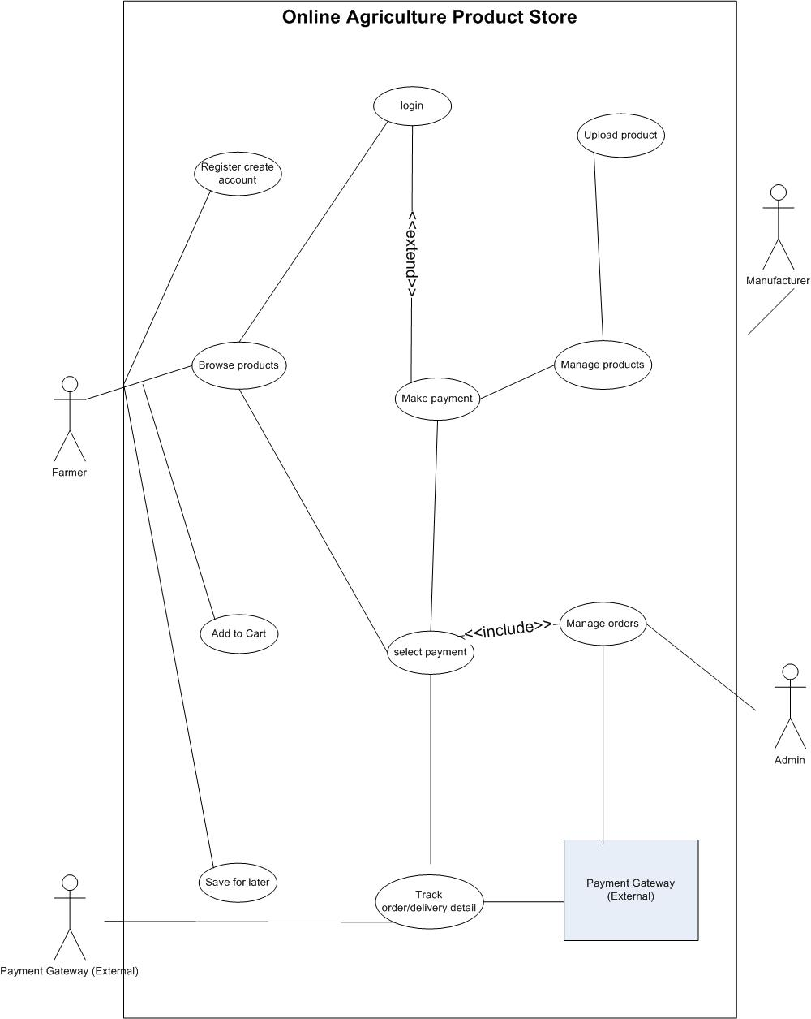

11. Prepare use case specs for all use cases?

USE CASE ID | UC001
USE CASE NAME:  DATE CREATED:  LAST UPDATED BY:  LAST REVISION DATE:  ACTOR:  DESCRIPTION:  PRECONDITION:  POSTCONDITION: | BA Team  APR 1, 2025  BA Team  APR 2, 2025  Farmer, Manufacturer  This use case describes how a new user registers in the system.  Users should not be registered in the application.  User receives confirmation of successful registration.
Main flow/ Happy Path | User clicks “register”.  System displays registration form.  User enters details and submits.  System validates data and saves.  Confirmation message sent to user.
Alternate Flow | Invalid email - system shows error.  Existing email - system shows “user already exists.”
Exceptions | Internet connectivity issue during registration.
Frequency of use:  Assumptions: | High  User has basic computer knowledge.

USE CASE ID | UC002
USE CASE:  CREATED BY:  DATE CREATED:  LAST UPDATED BY:  LAST REVISION DATE:  ACTOR:  DESCRIPTION:  PRECONDITION:  POSTCONDITION: | User login  BA Team  Apr 1, 2025  BA Team  Apr 2, 2025  Farmer, Manufacturer  Describes how user logs into the system securely.  User must be registered.  User successfully logged in.
MAIN FLOW / HAPPY PATH | User enters email and password.  System verifies credentials.  User is redirected to dashboard.
ALTERNATE FLOW | Invalid credentials - “incorrect email or password.  Forgot password - “reset password” option.
EXCEPTIONS | Internet connection lost.
FREQUENCY OF USE:  ASSUMPTIONS: | High  User remembers login details.

USE CASE ID
USE CASE NAME:  CREATED BY:  DATE CREATED :  LAST UPDATED BY:  LASDT REVISION DATE:  ACTOR:  DESCRIPTION:  PRECONDITION:  POSTCONDITION: | Product upload  BA Team  Apr 1 , 2025  BA Team  Apr 2 , 2025  Manufacturer  Allows manufacturers to upload product details.  Manufacturer is logged in.  Product appears in product list.
MAIN FLOW / HAPPY PATH | Manufacturer clicks “add product”  Enters product name, type, price, image.  System validates and saves product.  Message “product added successfully.”
ALTERNATE FLOW | Missing data - system requests all mandatory fields.
EXCEPTIONS | Server down or upload failure.
FREQUENCY:  ASSUMPTIONS: | Medium  Manufacturer is verified.

USE CASE ID: | UC004
USE CASE NAME:  CREATED BY:  DATE CREATED:  LAST UPDATED BY:  LAST REVISION DATE:  ACTOR:  DESCRIPTION:  PRECONDITION:  POSTCONDITION: | Product search  BA Team  Apr 1 2025  BA Team  Apr 2 2025  Farmer  Allows farmers to search and view products.  User is logged in.  System displays search results.
MAIN FLOW: | Farmer enters product name or filter.  System fetches results.  Farmer views product details.
ALTERNATE FLOW: | No results - “no product found.”
EXCEPTIONS: | Network error while loading results.
FREQUENCY:  ASSUMPTIONS: | High  Farmer knows product category.

USE CASE ID: | UC005
USE CASE NAME:  CREATED BY:  DATE CREATED:  LAST UPDATED BY:  LAST REVISION DATE:  ACTOR:  DESCRIPTION:  PRECONDITION:  POSTCONDITION: | Place order and payment  BA Team  Apr 1 2025  BA Team  Apr 2 2025  Farmer  Describes how a farmer buys products and makes payment.  Farmer logged in, product in stock.  Order placed and confirmation email sent.
MAIN FLOW / HAPPY PATH: | Farmer adds product to cart.  Clicks “checkout.”  Chooses payment option (UPI/COD/CARD).  Payment processed and order ID generated.
ALTERNATE FLOW: | Payment failed - system shows “try again.”
EXCEPTIONS: | Internet failure during payment.
FREQUENCY OF USE:  ASSUMPTIONS: | High  Payment gateway active.

12. Activity diagrams.

