Q1. Use Case Diagram – Customer Payment System
Description:
A customer selects a payment method (Card, Wallet, Cash, Net Banking) to complete a transaction.
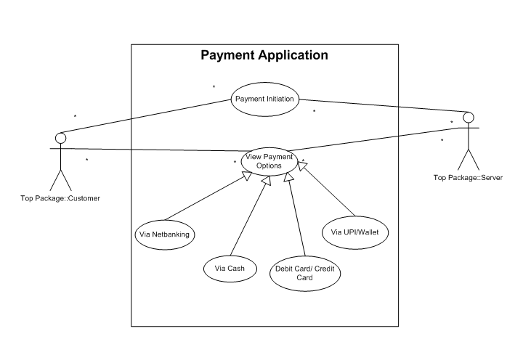

Q2. Derive Boundary, Controller and Entity Classes
- Boundary Classes: These represent the interaction between the system and external actors.
  - Payment Screen: The interface through which the customer selects and enters payment details.
  - Net Banking Login Screen: A specific screen for net banking authentication.
- Controller Classes: These acts as intermediaries between boundary and entity Classes
  - Payment Processor: The main controller that manages the overall payment process.
  - NetBanking Payment Handler: A specific controller that handles the logic for net banking payments.
- Entity Classes: These represent core data and business logic of the application within the system.
  - Customer: Stores customer information (e.g., name, customer ID).
  - Payment: Contains general payment data (e.g., payment ID, amount, timestamp, status).
  - NetBankingPayment: A specialized class inheriting from Payment that holds net banking-specific details (e.g., bank name, transaction ID).

Q3. Placement of Classes in Three-Tier Architecture
The three-tier architecture separates an application into a Presentation Tier, an Application Tier, and a Data Tier.
- Presentation Tier (User Interface):
  - Payment Screen
  - NetBanking Login Screen
  - (These are the interfaces with which the user interacts.)
- Application (Business Logic):
  - Payment Processor
  - NetBanking Payment Handler
  - (These controllers contain the core business rules and process flow for handling payments.)
- Data Tier (Database):
  - Customer
  - Payment
  - NetBanking Payment
  - (These entity classes are mapped to database tables where their data is stored and retrieved.)
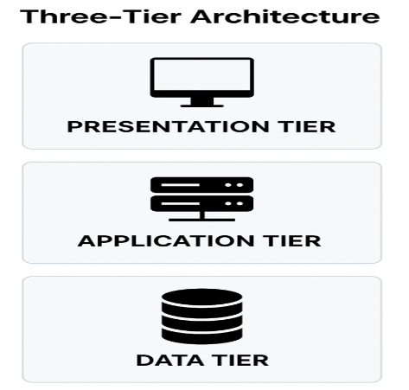

Q4. Domain Model – Net Banking Payment
Definition: It is a conceptual representation that defines the structure, relationships, and behaviours of entities within a specific problem domain
Entities: Customer, Bank Account, Payment, Transaction, Bank, Netbanking Service, Authentication
Relationships:
- Customer initiates Payment.
- Payment is processed through Bank Account.
- Bank verifies credentials and approves Transaction.
- Transaction updates Payment status and confirms to Customer.
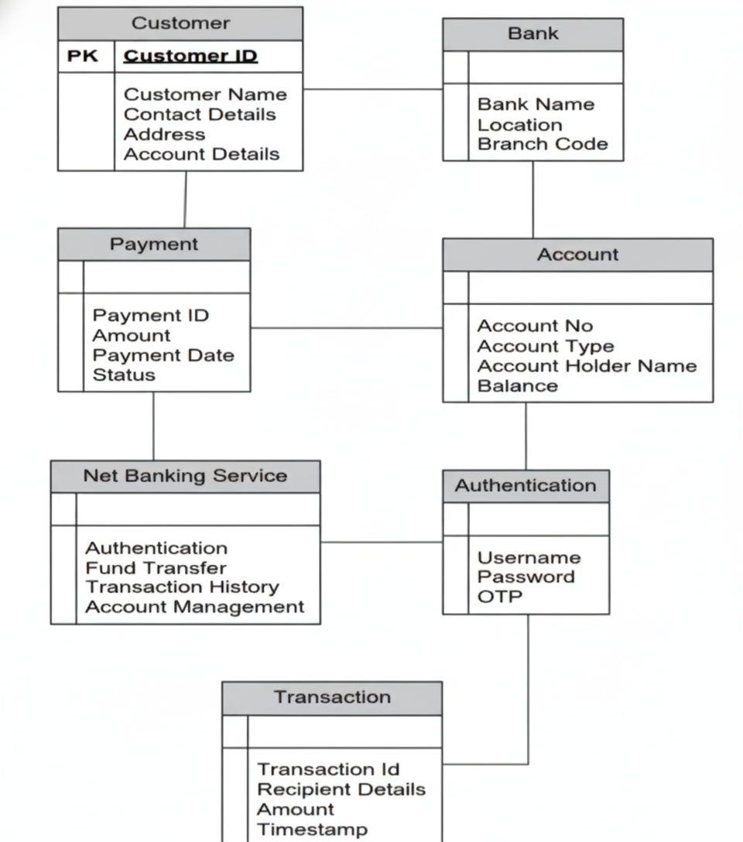

Q5. Sequence Diagram – Net Banking Payment
A sequence diagram is a type of interaction diagram used in software engineering and systems design to illustrate how processes operate with one another and in what order.
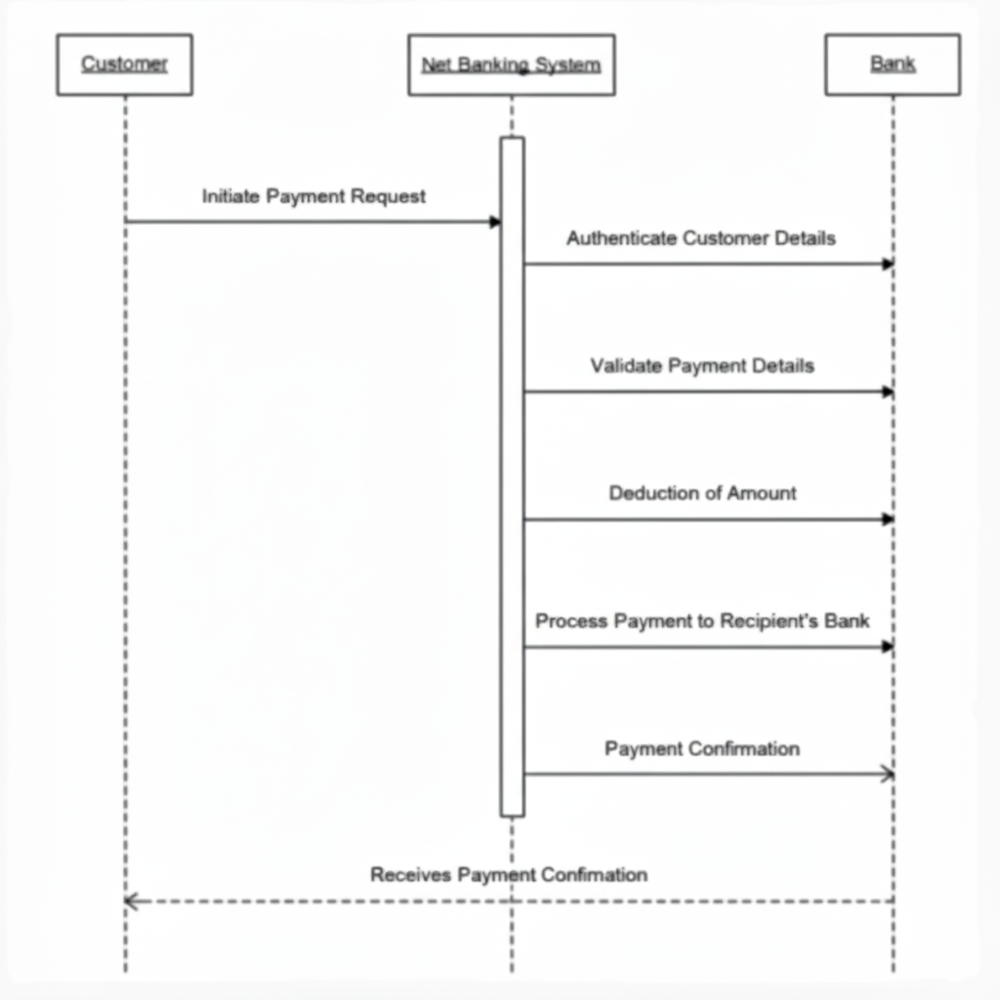

Q6. Conceptual Model – Payment System
A conceptual model is a high level representation of a system that helps in understanding, visualizing, and communication the essential aspects of a domain
It provides a clear and simplified view of the domain, making it easier to understand.
Key Elements of the conceptual Model:
- Entities- Customer, Product, Order & Payment
- Attributes – Custmer id, Name, email, phone number
- Relationships – eg. A customer places an order

Q7. MVC Architecture
Definition:
MVC (Model-View-Controller) separates an application into:
- Model: Manages data and business logic.
- View: User interface representation.
- Controller: Mediator between Model and View.

Rules for Deriving Classes from Use Case Diagram:
Class Type | MVC Role | Derivation Rule (from Use Case)
Boundary (or View Classes) | View | Derive from the interaction points between the Actor (user) and the System. Every screen, form, or UI component that the actor interacts with corresponds to a Boundary class
Controller Classes | Controller | Derive a Controller class for each major use case (or group of related use cases). This class manages the business flow and logic for that specific task
Entity Classes | Model | Derive from the key data/information that the system must track or manage. These typically represent real-world concepts or data structures involved in the use case.

3-Tier Placement Guidelines:
Class Type | 3-Tier Layer | Responsibility
Boundary (View) Classes | 1. Presentation Tier | These are placed in the client or web server layer because they manage the User Interface (UI) and capture user input.
Controller Classes | 2. Application Tier | These are placed in the Application/Business Logic server. They execute the core business rules and manage the transaction flow, which is the heart of the application.
Entity (Model) Classes | 2. Business Tier (Data Representation) &  3. Data Tier (Persistence) | The in-memory Entity objects are used in the Business Tier. The actual persistence (database) of the data they represent resides in the Data Tier (e.g., Database Server).

Q8. BA Contributions in Waterfall Model – All Stages
Waterfall Stage | BA Contributions
Requirement Gathering | Elicit, analyze, document and validate requirements with stakeholders.
System Design | Translate business needs into technical specifications and use case models.
Implementation | Support developers by clarifying requirements and handling change requests.
Testing | Prepare test scenarios, validate functional coverage, assist UAT.
Deployment | Help with training and transition to users.
Maintenance | Manage enhancement requests and monitor post-deployment performance.

Q9. Conflict Management – Thomas-Kilmann Technique
Conflict Management
- Conflict management is the process of resolving conflicts or disagreements between individuals or groups in a constructive manner.
Thomas-Kilmann Technique
- The Thomas-Kilmann technique is a widely used tool for assessing conflict resolution styles and guiding individuals in selecting appropriate strategies to manage conflicts.
5 Steps of Conflict Management
- Identify the conflict.
- Discuss the details.
- Agree with the root problem.
- Check for every possible solution for the conflict.
- Negotiate the solution to avoid future conflicts

Q10. Reasons for Project Failure
Here is a list of common reasons for project failure:
- Poor Planning
- Unclear Objectives and Requirements
- Inadequate Risk Management
- Poor Communication
- Scope Creep (Uncontrolled changes or continuous growth in a project's scope)
- Lack of Stakeholder Engagement
- Resource Constraints (e.g., lack of budget, personnel, or time)
- Technical Challenges

Q11. Challenges Faced by Business Analysts
Here is a list of common challenges faced by a Business Analyst (BA) in projects:
- Unclear or Changing Requirements
- Managing Stakeholder Expectations
- Scope Creep and Scope Management
- Time and Resource Constraints
- Quality Assurance and Testing
- Documentation and Knowledge Management
- Technology Constraints and Complexity

Q12. Document Naming Standards
- A document numbering standard is a systematic approach to assigning unique identifiers to various documents created and used throughout the development process.
Example
Suppose we have a project with the ID "PROJ123," and we're working with a Requirements Specification Document.
- Project ID: PROJ123
- Document Type: REQ
- Version: 1.0
- Date: 2025-11-03 (Date format YYYY-MM-DD)
The final document identifier could be:
PROJ123-REQ-1.0-2025-11-03

Q13. Do’s and Don’ts of a Business Analyst
Sr. No. | DO'S | DON'TS
1 | Consult an SME for clarifications in requirements. | Never say NO to the client.
2 | Go to the client with a plain mind with no assumptions. Listen carefully and completely until the client is done, and then you can ask queries. | There is no word as "By default" (everything must be confirmed).
3 | Try to extract maximum leads to the solution from the client himself. | Never imagine anything in terms of GUI (Graphical User Interface) too early.
4 | Concentrate on the important requirements. | Don't interrupt the client when he is giving you the problem.
5 | Question the existence of existence/ Question everything. | Never try to give solutions to the client straight away with your previous experience and assumptions.

Q14. Difference between Packages and Sub-systems
Term | Definition | Example Application Context
Packages | A collection of components (like classes) that are not reusable in nature. | Application development companies work on Packages (solutions specific to a single client/need).
Sub-systems | A collection of components (like classes) that are reusable in nature. | Product development companies work on Sub-systems (components designed to be sold or integrated widely).

Q15. Camel-Casing and Usage
Camel casing is a naming convention where multi-word identifiers are written without spaces and each word begins with a capital letter (except the first).
Examples:
customerName, orderAmount, paymentStatus
Usage: Variable names, method names, attribute definitions in code and UML models.

Q16. Development Server and BA Access
A Development Server is an environment where new features are developed and tested before production.
BA Access Rights:
- Read-only access to application modules for validation.
- Access to test data and reports for requirement verification.
- Cannot modify code or configurations but can raise change requests.

Q17. Data Mapping
Definition:
Matching fields between two data sources to ensure accurate integration or migration. Data mapping is the process of connecting data from one source to another.
It's like creating a guide or map that shows how data in one place corresponds to data in another place.
This is especially important when you're moving data between different systems or databases to ensure that the data stays consistent and accurate.
Purpose: Maintains data integrity during transfer between systems.

Q18. API and Integration Example (10 Marks)
Definition:
An API (Application Programming Interface) enables two applications to communicate and exchange data.
Scenario:
Our system uses dd-mm-yyyy format while the US source system uses mm-dd-yyyy.
Solution Steps:
- API middleware converts incoming date format to local standard.
- Validation logic ensures data consistency and type matching.
- Transformation rules maintain uniformity for reporting.
Benefits: Accuracy, seamless integration, reduced manual errors.

