Capstone Project 01 Part – 03

Question 01 – Functional Requirement.
20 Functional Requirements
Answer:
Functional Requirements:
Req. ID | Req. Name | Req. Description | Priority
FR001 | User Registration | Farmer should be able to register with basic details | 8
FR002 | User Login | Register user/farmer should be login with email & password | 9
FR003 | Product Search | User should be able to search for the available product | 7
FR004 | Product Filter | User can filter products by category, price & rating | 6
FR005 | Product Details | User should be able to view product details like name, image, price, description and rating/reviews | 5
FR006 | Add to cart | User should be able to add the product to the cart | 7
FR007 | View cart | User should be able to view cart item, quantity and total price | 6
FR008 | Edit cart | User should be update quantity and remove from the cart or also transfer to the wishlist for future reference. | 7
FR009 | Add to wishlist | User should be to add products to the wishlist for future reference | 5
FR010 | Place holder | User should be able to confirm order and place order from the cart | 7
FR011 | Make Payment | User should be able to make payment via UPI, card, wallet and COD | 9
FR012 | Order Confirmation | Confirmation message and order ID should be shown after payment also send a message on register email ID and Mob. No. | 8
FR013 | Order Tracking | User should be able to track their order status like. Shipped, intransit, delivered | 8
FR014 | Invoice generation | System should auto generate invoice after successfully order and send user register email | 7
FR015 | Notification system | User should receive SMS/emails alerts for order status and any updates | 9
FR016 | Contact/support page | User should be able to ask any product related queries and report any app related delays and errors. | 7
FR017 | Product update | Manufacturer should be able to list/add products | 9
FR018 | Admin login | Admin should be login in to manage users and products | 7
FR019 | Order management | Admin can view and update order status | 6
FR020 | User management | Admin should be able to view all register users and block/unblock them | 7

Non Functional Requirement:
Req. ID | Req. Name | Req. Description | Priority
NFR001 | Usability | The user interface should be simple and easy to use for farmers and customer | 9
NFR002 | Performance | Website/application pages should load within 3 seconds under normal internet connection | 9
NFR003 | Security | All user data must be stored securely and protected from unauthorized access | 10
NFR004 | WCAG 2.1 | The system must meet Web Content Accessibility Guidelines 2.1 | 7
NFR005 | Availability | The platform should be available 24/7 | 8
NFR006 | Response time | The application should be respond to user inputs within 2-3 seconds | 8
NFR007 | Portability | The system should work on all modern browser and devices | 6
NFR008 | Responsiveness | The website should work well on desktop, tablet and mobile devices | 8
NFR009 | Maintainability | The application should be easy to update and maintain by the development team | 7
NFR010 | Load Capacity | The server must handle 500 orders per hour | 8
NFR011 | Language support | The application must support English and local languages | 9
NFR012 | Backup and recovery | Daily data backups must be taken and easy recovery should be possible | 6
NFR013 | Scalability | The system must handle growing traffic and product listing without issues | 7
NFR014 | Reliability | The app must process 95% of orders without errors | 7
NFR015 | Network Resilience | The application must function with intermittent internet | 8
NFR016 | Use documentation | Basic user instruction and help documentation should be available | 7
NFR017 | Legal compliance | The system must comply with e-commerce and data protection laws | 8
NFR018 | Report generation | Admin dashboard must allow downloading reports like sales and customer data | 6
NFR019 | Data integrity | Product data must be consistent across all platforms | 7
NFR020 | Clear error messaging | The system should guide users with helpful error messages if actions fail. | 6

Question 03 – Minimum 5 page design
Make wireframe and prototypes
Answer:
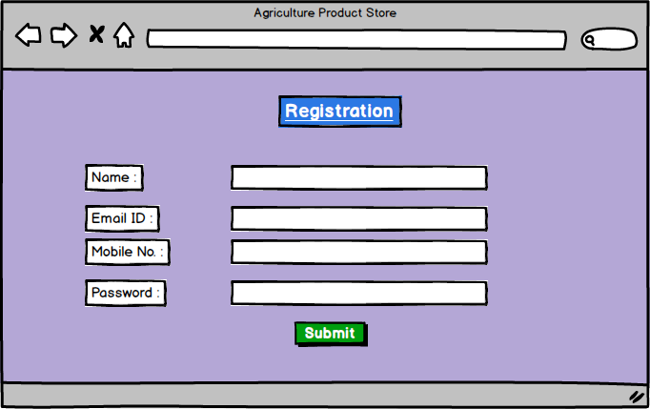

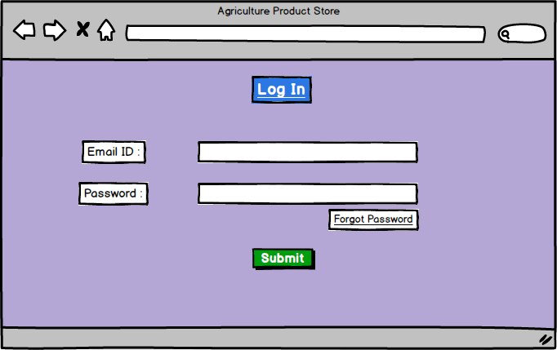
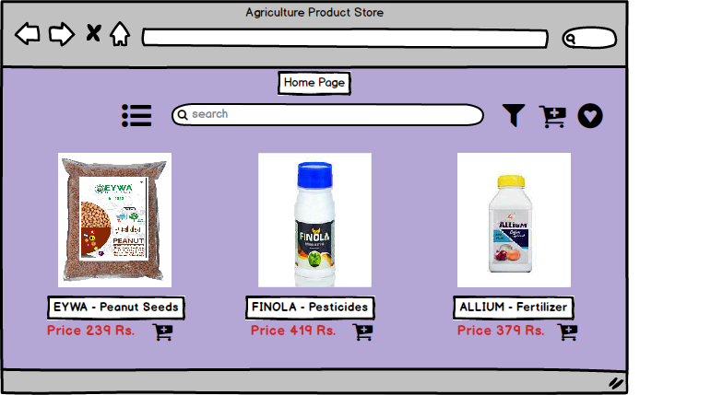
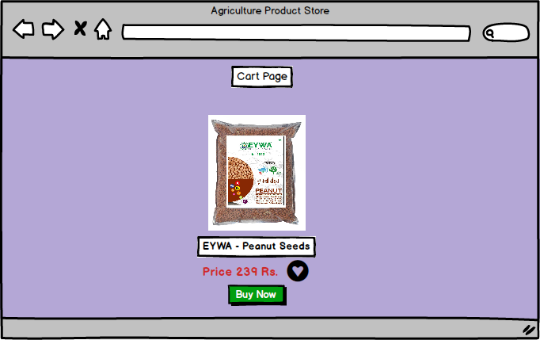
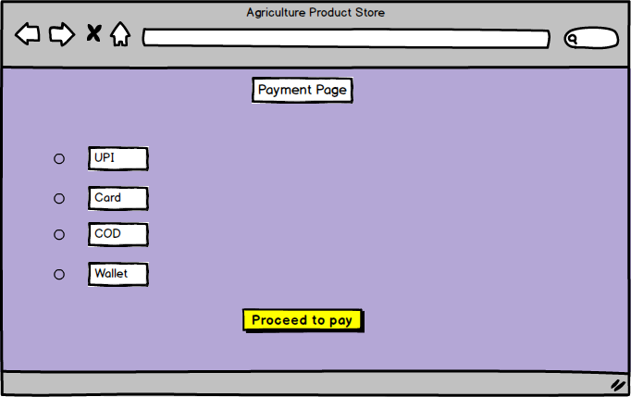

Question 03 – Tools (Visio, Balsamiq)
Make a note of the Tools, which you are using for above concepts.

Answer:

MS Visio: Microsoft Visio is a diagraming and vector graphics tool developed by Microsoft. It is mainly used to create to visual diagrams, such as UML diagrams, use case diagrams, flowchart diagrams etc.
As a Business Analyst, MS Visio is very helpful in visually representing the system design, processes and flows. It allows you to draw clean and professional diagrams that make it easier to explain complex ideas to stakeholders, developers or clients.

In this project, I have prepared two diagrams in MS Visio.
Use Case Diagram (UCD): A use case is a UML element that describes a sequence interaction between actor and the system to achieve a specific goal. In Visio use cases appear as ovals linked to actor symbols, modeling functional requirements and guiding both development and testing.

Activity Diagram: An Activity diagram shows the step by step flow of a process or system functionality. In MS Visio, it is created using shapes like action boxes, decision and connectors to represent the sequence of tasks, decision and parallel flows. It helps visualize how the process works from start to end.

Balsamiq: Balsamiq is a wireframing tool used to create simple, quick and user interface mockups. It helps business analyst to sketch how a website or application will look before actual development starts.
In Balsamiq, wireframes can be linked to each other, allowing us to explain the screen flow clearly to both developers and the statkeholder. The main goal of balmasiq is to focus on structure and functionality, not design.
It offers a drag and drop interface with ready-made elements like text box, search box, button, icons, etc.
These allow you visualize screens, layout ideas, and user flows easily.
It helps for how the screen will work to developers and stakeholders

Question 04 – RTM
A business analyst’s key responsibilities are to keep track of the requirements and make sure that no requirement is missed.
Mr. Henry and peter have approached you regarding the current status of the project. How will you tackle this situation?
Answer:

Req. ID | Req. Name | Req. Description | Category | Sub Category | Design | Code | UT | CT | ST | SIT | UAT
FR001 | User registration | Farmer should be able to register with basic details | User management | Registration
FR002 | User login | Register user/farmer should be login with email & password | User management | Authentication
FR003 | Product Search | User should be able to search for the available product | Product management | Search
FR004 | Product Filter | User can filter products by category, price & rating | Product management | Filter
FR005 | Product Details | User should be able to view product details like name, image, price, description and rating/reviews | Product management | View product details
FR006 | Add to cart | User should be able to add the product to the cart | Order management | Add to cart
FR007 | View cart | User should be able to view cart item, quantity and total price | Order management | View cart
FR008 | Edit cart | User should be update quantity and remove from the cart or also transfer to the wishlist for future reference. | Order management | Cart modification
FR009 | Add to wishlist | User should be to add products to the wishlist for future reference | Order management | Wishlist
FR010 | Place holder | User should be able to confirm order and place order from the cart | Order management | Order placement
FR011 | Make Payment | User should be able to make payment via UPI, card, wallet and COD | Payment system | Order payment
FR012 | Order Confirmation | Confirmation message and order ID should be shown after payment also send a message on register email ID and Mob. No. | Order management | Confirmation
FR013 | Order Tracking | User should be able to track their order status like. Shipped, intransit, delivered | Order management | Tracking
FR014 | Invoice generation | System should auto generate invoice after successfully order and send user register email | Order management | Invoice/ Bill receipt
FR015 | Notification system | User should receive SMS/emails alerts for order status and any updates | Communication | Alerts/notification
FR016 | Contact/support page | User should be able to ask any product related queries and report any app related delays and errors. | Communication | Customer support
FR017 | Product upload | Manufacturer should be able to list/add products | Admin functionality | Upload products
FR018 | Admin login | Admin should be login in to manage users and products | Admin functionality | Manage product inventory
FR019 | Order management | Admin can view and update order status | Admin functionality | View and manage orders
FR020 | User management | Admin should be able to view all register users and block/unblock them | Admin functionality | Manage users
NFR001 | Usability | The user interface should be simple and easy to use for farmers and customer | User experience | Ease of use
NFR002 | Performance | Website/application pages should load within 3 seconds under normal internet connection | System performance | Speed
NFR003 | Security | All user data must be stored securely and protected from unauthorized access | Data security | Data protection
NFR004 | WCAG 2.1 | The system must meet Web Content Accessibility Guidelines 2.1 | Accessibility | Web compliance
NFR005 | Availability | The platform should be available 24/7 | System availability | 24/7 Access
NFR006 | Response time | The application should be respond to user inputs within 2-3 seconds | System performance | Load speed
NFR007 | Portability | The system should work on all modern browser and devices | Platform compatibility | Cross browser support
NFR008 | Responsiveness | The website should work well on desktop, tablet and mobile devices | Platform compatibility | Multi device support
NFR009 | Maintainability | The application should be easy to update and maintain by the development team | System maintenance | Easy to update
NFR010 | Load Capacity | The server must handle 500 orders per hour | System capacity | Concurrent user support
NFR011 | Language support | The application must support English and local languages | Localization | English + local language
NFR012 | Backup and recovery | Daily data backups must be taken and easy recovery should be possible | Data recovery | Auto backup
NFR013 | Scalability | The system must handle growing traffic and product listing without issues | System scalability | Handling growth
NFR014 | Reliability | The app must process 95% of orders without errors | System reliability | Error free processing
NFR015 | Network Resilience | The application must function with intermittent internet | Connectivity | Stable network handling
NFR016 | Use documentation | Basic user instruction and help documentation should be available | Help & support | User instructions
NFR017 | Legal compliance | The system must comply with e-commerce and data protection laws | Legal requirement | E-commerce/data protection compliance
NFR018 | Report generation | Admin dashboard must allow downloading reports like sales and customer data | Reporting | Dashboard and reports
NFR019 | Data integrity | Product data must be consistent across all platforms | Data management | Consistent data
NFR020 | Clear error messaging | The system should guide users with helpful error messages if actions fail. | User experience | Guidance via message

Question 05 – 10 Test case documents.
Prepare 10 Test Case Documents

Answer:

Test Case ID | TC001 | Test case Name | User Registration
Project ID | AGR01 | Project Name | Online Agriculture Product Store
PM ID | PM023 | PM Name | Mr. Vandanam
Test Strategy ID | STR001 | Tester ID | T001
Test Plan ID | TP001 | Tester Name | Mr. Jason
Test Schedule ID | TS002 | Date of Test | 22/05/2025
Scenario | New user should be able to register using valid information
Link to that page | Registration page
Input Data | Set 1  Name: Shubham  Email ID: Shubham12@gmail.com  Password: Shubha@2  Mobile No.: 254745865 | Set 2  Name: Tanvi  Email ID: Tanvi123@yahoo.com  Password: Dance#55  Mobile No.: 157466985 | Set 3  Name: Pratik  Email ID: Pratikmule@hotmail.com  Password: Mule$3  Mobile No.: 3658974585 | Set 4  Name: Payal  Email ID: Payal@outlook.com  Password: Payal#1368  Mobile No.: 847569585 | Set 5  Name: Rohit  Email ID: Rohil40@gmail.com  Password: Rohil@11  Mobile No.: 69574588
Expected behavior | User should be successfully registered and redirect to the login page | User should be successfully registered and redirect to the login page | User should be successfully registered and redirect to the login page | User should be successfully registered and redirect to the login page | User should be successfully registered and redirect to the login page
Actual Behavior | Confirmation email sent and user ID created in database. | Confirmation email sent and user ID created in database. | Password is incorrect please enter valid password with 1 Capital letter 1 small letter 1 special character and numbers with Min. 8 to Max. 12 character | Confirmation email sent and user ID created in database. | Confirmation email sent and user ID created in database.
Comments | Success message | Success message | Password incorrect | Success message | Success message
Result (Pass/Fail) | Pass | Pass | Fail | Pass | Pass

Test Case ID | TC002 | Test case Name | Product Search
Project ID | AGR01 | Project Name | Online Agriculture Product Store
PM ID | PM023 | PM Name | Mr. Vandanam
Test Strategy ID | STR002 | Tester ID | T002
Test Plan ID | TP002 | Tester Name | Ms. Alekya
Test Schedule ID | TS003 | Date of Test | 29/05/2025
Scenario | User Logs into the system using valid credentials.
Link to that page | Login page
Input Data | Set 1  Email ID: Shubham12@gmail.com  Password: Shubha2 | Set 2  Email ID: Tanvi123@yahoo.com  Password: Dance#55 | Set 3  Email ID: Pratikmule@hotmail.com  Password: mule$3656958fghr | Set 4  Email ID: Payal@outlook.com  Password: Payal#1368 | Set 5  Email ID: Rohil40@gmail.com  Password: Rohil@11
Expected behavior | User should be logged in and redirected to the home page | User should be logged in and redirected to the home page | User should be logged in and redirected to the home page | User should be logged in and redirected to the home page | User should be logged in and redirected to the home page
Actual Behavior | Error message display: Invalid User ID and Password | User should be logged in and home page displayed. | Error message display: Invalid User ID and Password | User should be logged in and home page displayed. | User should be logged in and home page displayed.
Comments | Functionality is working as expected for incorrect login attempts. | Login functionality working as expected | Functionality is working as expected for incorrect login attempts. | Login functionality working as expected | Login functionality working as expected
Result (Pass/Fail) | Fail | Pass | Fail | Pass | Pass

Test Case ID | TC003 | Test case Name | Product Search
Project ID | AGR01 | Project Name | Online Agriculture Product Store
PM ID | PM023 | PM Name | Mr. Vandanam
Test Strategy ID | STR002 | Tester ID | T002
Test Plan ID | TP002 | Tester Name | Ms. Alekya
Test Schedule ID | TS004 | Date of Test | 05/06/2025
Scenario | User searches for a product using the searching bar
Link to that page | Product search
Input Data | Set 1  Tomato seeds | Set 2  Fertilizers under 500 Rs. | Set 3  Pesticides fast action 250ml | Set 4  Natural pesticides herbal | Set 5  Cotton seeds 1 kg
Expected behavior | Search result should display 15 matching products related to the keywords with product name, image, price. | Search result should display 15 matching products related to the keywords with product name, image, price. | Search result should display 15 matching products related to the keywords with product name, image, price. | Search result should display 15 matching products related to the keywords with product name, image, price. | Search result should display 15 matching products related to the keywords with product name, image, price.
Actual Behavior | Search results showing matching products. | Search results showing matching products. | Search results showing matching products. | Search results showing matching products. | Search results showing matching products.
Comments | Search function is working correctly for all tested keywords. | Search function is working correctly for all tested keywords. | Search function is working correctly for all tested keywords. | Search function is working correctly for all tested keywords. | Search function is working correctly for all tested keywords.
Result (Pass/Fail) | Pass | Pass | Pass | Pass | Pass

Test Case ID | TC004 | Test case Name | Product Filter
Project ID | AGR01 | Project Name | Online Agriculture Product Store
PM ID | PM023 | PM Name | Mr. Vandanam
Test Strategy ID | STR002 | Tester ID | T002
Test Plan ID | TP002 | Tester Name | Mr. Jason
Test Schedule ID | TS005 | Date of Test | 11/06/2025
Scenario | Filter product using categories like seeds, pesticides and fertilizers
Link to that page | Product listing page
Input Data | Set 1  Seed  Price range: 100 – 500Rs  Rating: 4+ | Set 2  Pesticides  Price range: 200-1000Rs  Rating: 3+  Discount %: Above 40% | Set 3  Fertilizers  Price range: 50-300Rs  Rating: any  Brand Name: Dalod, Greeny | Set 4  Seeds  Brand Name: EYWA, Lonis, TARA  Discounts%: 10-20% | Set 5  Pesticides  Price range: 500-1500Rs  Rating: 4+
Expected behavior | Filtered products should match the selected filter criteria. | Filtered products should match the selected filter criteria. | Filtered products should match the selected filter criteria. | Filtered products should match the selected filter criteria. | Filtered products should match the selected filter criteria.
Actual Behavior | The product list was displayed correctly based on selected category. | The product list was displayed correctly based on selected category. | The product list was displayed correctly based on selected category. | The product list was displayed correctly based on selected category. | The product list was displayed correctly based on selected category.
Comments | Product data is correctly fetched from the database and matches user input filters. | Product data is correctly fetched from the database and matches user input filters. | Product data is correctly fetched from the database and matches user input filters. | Product data is correctly fetched from the database and matches user input filters. | Product data is correctly fetched from the database and matches user input filters.
Result (Pass/Fail) | Pass | Pass | Pass | Pass | Pass

Test Case ID | TC005 | Test case Name | Add to Cart
Project ID | AGR01 | Project Name | Online Agriculture Product Store
PM ID | PM023 | PM Name | Mr. Vandanam
Test Strategy ID | STR002 | Tester ID | T001
Test Plan ID | TP002 | Tester Name | Mr. Jason
Test Schedule ID | TS007 | Date of Test | 25/06/2025
Scenario | User select product and add to the cart
Link to that page | Cart page
Input Data | Set 1  Add Wheat seeds (Qty.01) to cart | Set 2  Add pesticides Loras (Qty.03) | Set 3  Add Fertilizer Greeny (Qty.02) | Set 4  Add Peanut seeds (Qty. 20) | Set 5  Add to Pesticides(Qty.03)
Expected behavior | Selected product with correct quantity should be added to cart and visible in cart list. | Selected product with correct quantity should be added to cart and visible in cart list. | Selected product with correct quantity should be added to cart and visible in cart list. | Selected product with correct quantity should be added to cart and visible in cart list. | Selected product with correct quantity should be added to cart and visible in cart list.
Actual Behavior | Product was successfully added to cart and displayed with correct details. | Product was successfully added to cart and displayed with correct details. | Product was successfully added to cart and displayed with correct details. | Product was successfully added to cart and displayed with correct details. | Product was successfully added to cart and displayed with correct details.
Comments | Add to cart feature working smoothly for all product types and quantities. | Add to cart feature working smoothly for all product types and quantities. | Add to cart feature working smoothly for all product types and quantities. | Add to cart feature working smoothly for all product types and quantities. | Add to cart feature working smoothly for all product types and quantities.
Result (Pass/Fail) | Pass | Pass | Pass | Pass | Pass

Test Case ID | TC006 | Test case Name | Edit Cart
Project ID | AGR01 | Project Name | Online Agriculture Product Store
PM ID | PM023 | PM Name | Mr. Vandanam
Test Strategy ID | STR002 | Tester ID | T002
Test Plan ID | TP004 | Tester Name | Ms. Alekya
Test Schedule ID | TS009 | Date of Test | 30/06/2025
Scenario | User edits quantity or removes product from the cart
Link to that page | Cart page
Input Data | Set 1  Edit wheat seed (Qty From 01 to 03) | Set 2  Remove pesticides Loras from cart | Set 3  Remove Fertilizer Greeny (Qty.0) | Set 4  Update Peanut seeds (Qty.10) | Set 5  Edit to Pesticides with blank input
Expected behavior | Cart should update quantities or remove product as per user action. | Cart should update quantities or remove product as per user action. | Cart should update quantities or remove product as per user action. | Cart should update quantities or remove product as per user action. | Cart should update quantities or remove product as per user action.
Actual Behavior | Cart updated successfully for valid entries. | Cart updated successfully for valid entries. | Error displayed for invalid inputs | Cart updated successfully for valid entries. | Error displayed for invalid inputs
Comments | System correctly handled both valid and invalid cart edits with appropriate messages. | System correctly handled both valid and invalid cart edits with appropriate messages. | System correctly handled both valid and invalid cart edits with appropriate messages. | System correctly handled both valid and invalid cart edits with appropriate messages. | System correctly handled both valid and invalid cart edits with appropriate messages.
Result (Pass/Fail) | Pass | Pass | Fail | Pass | Fail

Test Case ID | TC007 | Test case Name | Make Payment
Project ID | AGR01 | Project Name | Online Agriculture Product Store
PM ID | PM023 | PM Name | Mr. Vandanam
Test Strategy ID | STR002 | Tester ID | T001
Test Plan ID | TP006 | Tester Name | Mr. Jason
Test Schedule ID | TS011 | Date of Test | 09/07/2025
Scenario | User completes the payment for the order
Link to that page | Cart page - Payment page
Input Data | Set 1  Pay with Debit card | Set 2  Pay with UPI valid ID | Set 3  Pay with net banking | Set 4  Try payment with expired debit card | Set 5  Pay with wallet balance
Expected behavior | Payment should be processed and confirmation displayed. | Payment should be processed and confirmation displayed. | Payment should be processed and confirmation displayed. | Payment should be processed and confirmation displayed. | Payment should be processed and confirmation displayed.
Actual Behavior | Payment succeeded for all valid modes | Payment succeeded for all valid modes | Payment succeeded for all valid modes | Expired card showed error message | Payment succeeded for all valid modes
Comments | Payment system is working fine. | Payment system is working fine. | Payment system is working fine. | Error handling for failed transactions is also appropriate. | Payment system is working fine.
Result (Pass/Fail) | Pass | Pass | Pass | Fail | Pass

Test Case ID | TC008 | Test case Name | Order Track
Project ID | AGR01 | Project Name | Online Agriculture Product Store
PM ID | PM023 | PM Name | Mr. Vandanam
Test Strategy ID | STR002 | Tester ID | T002
Test Plan ID | TP008 | Tester Name | Ms. Alekya
Test Schedule ID | TS012 | Date of Test | 17/07/2025
Scenario | User checks the status of their order from the order history page
Link to that page | Order History – Track Order
Input Data | Set 1  Order ID valid – Status shows 'Shipped' | Set 2  Order ID valid – Status shows 'Out for Delivery' | Set 3  Order ID valid – Status shows 'Delivered' | Set 4  Order ID invalid | Set 5  Order ID valid – Status shows 'Processing'
Expected behavior | System should display the correct order status based on the order ID. | System should display the correct order status based on the order ID. | System should display the correct order status based on the order ID. | System should display the correct order status based on the order ID. | System should display the correct order status based on the order ID.
Actual Behavior | System showed correct statuses for valid orders. | System showed correct statuses for valid orders. | System showed correct statuses for valid orders. | Error displayed for invalid ID | System showed correct statuses for valid orders.
Comments | Order tracking feature is working as expected with proper validations. | Order tracking feature is working as expected with proper validations. | Order tracking feature is working as expected with proper validations. | Order tracking feature is working as expected with proper validations. | Order tracking feature is working as expected with proper validations.
Result (Pass/Fail) | Pass | Pass | Pass | Fail | Pass

Test Case ID | TC009 | Test case Name |  | Product Update
Project ID | AGR01 | Project Name |  | Online Agriculture Product Store
PM ID | PM023 | PM Name |  | Mr. Vandanam
Test Strategy ID | STR002 | Tester ID |  | T001
Test Plan ID | TP009 | Tester Name |  | Mr. Jason
Test Schedule ID | TS014 | Date of Test |  | 28/07/2025
Scenario | Update Product details by manufacturer
Link to that page | Product update page
Input Data | Set 1  Change product name ‘Peanut seed’ to ‘Super Peanut seed’ | Set 2  Update price from 500-550 Rs | Set 3  Add 100 units in stock |  | Set 4  Leave blank product name | Set 5  Enter negative price -200 Rs.
Expected behavior | System should update product correctly or show validation error | System should update product correctly or show validation error | System should update product correctly or show validation error |  | System should update product correctly or show validation error | System should update product correctly or show validation error
Actual Behavior | Name Updated | Price Updated | Stock Updated |  | “Product name required” error | “Invalid price” error
Comments | Working Fine | Working Fine | Working Fine |  | failed due to validation errors | failed due to validation errors
Result (Pass/Fail) | Pass | Pass | Pass |  | Fail | Fail

Test Case ID | TC010 | Test case Name |  | Performance Test
Project ID | AGR01 | Project Name |  | Online Agriculture Product Store
PM ID | PM023 | PM Name |  | Mr. Vandanam
Test Strategy ID | STR002 | Tester ID |  | T002
Test Plan ID | TP010 | Tester Name |  | Ms. Alekya
Test Schedule ID | TS016 | Date of Test |  | 12/08/2025
Scenario | Verify that the page loads within 3 seconds under normal internet conditions
Link to that page | Product Listing page
Input Data | Set 1  Load Product page with 20 products (Normal internet) | Set 2  Load product page with images on 3G connection | Set 3  Load product page with filters applied |  | Set 4  Load page on mobile browser | Set 5  Load page with high traffic simulation
Expected behavior |  | Page should load within 3 seconds in all scenarios | Page should load within 3 seconds in all scenarios |  | Page should load within 3 seconds in all scenarios | Page should load within 3 seconds in all scenarios
  Page should load within 3 seconds in all scenarios
Actual Behavior | Page loaded in under 2.5 seconds | Page loaded in under 2.5 seconds | Page loaded in under 2.5 seconds |  | Loaded in 3.1s | Loaded in 4.5s
Comments | recommend image optimization and caching | recommend image optimization and caching | recommend image optimization and caching |  | exceeded expected time limit | exceeded expected time limit
Result (Pass/Fail) | Pass | Pass | Pass |  | Fail | Fail

Question 06 – DB Design
After the requirements are thoroughly explained to the entire project team by business analyst, the Database architects have decided to do the database design and also to represent the in-flow and out-flow of data. Draw database schema and ER diagram.

DB Scheme:
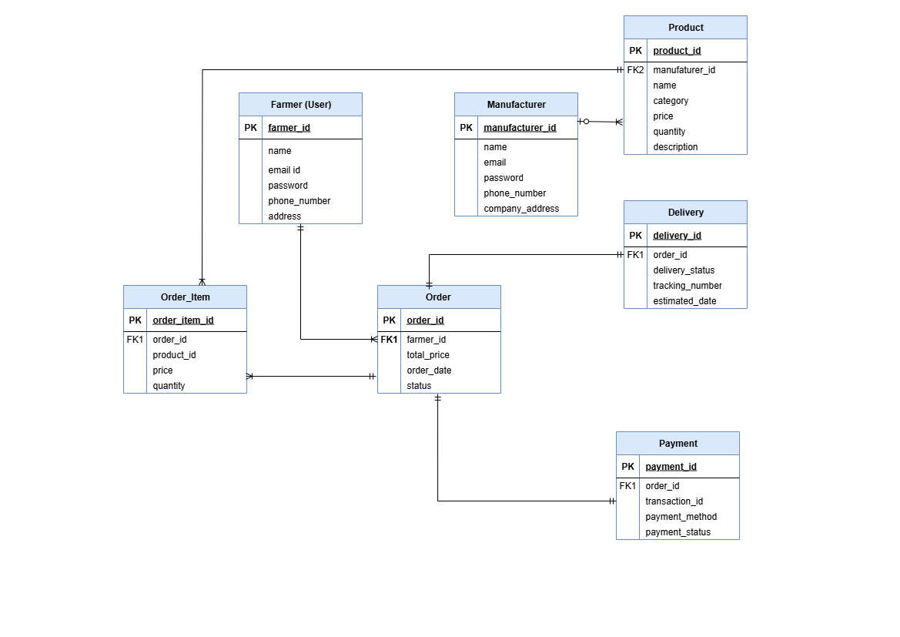

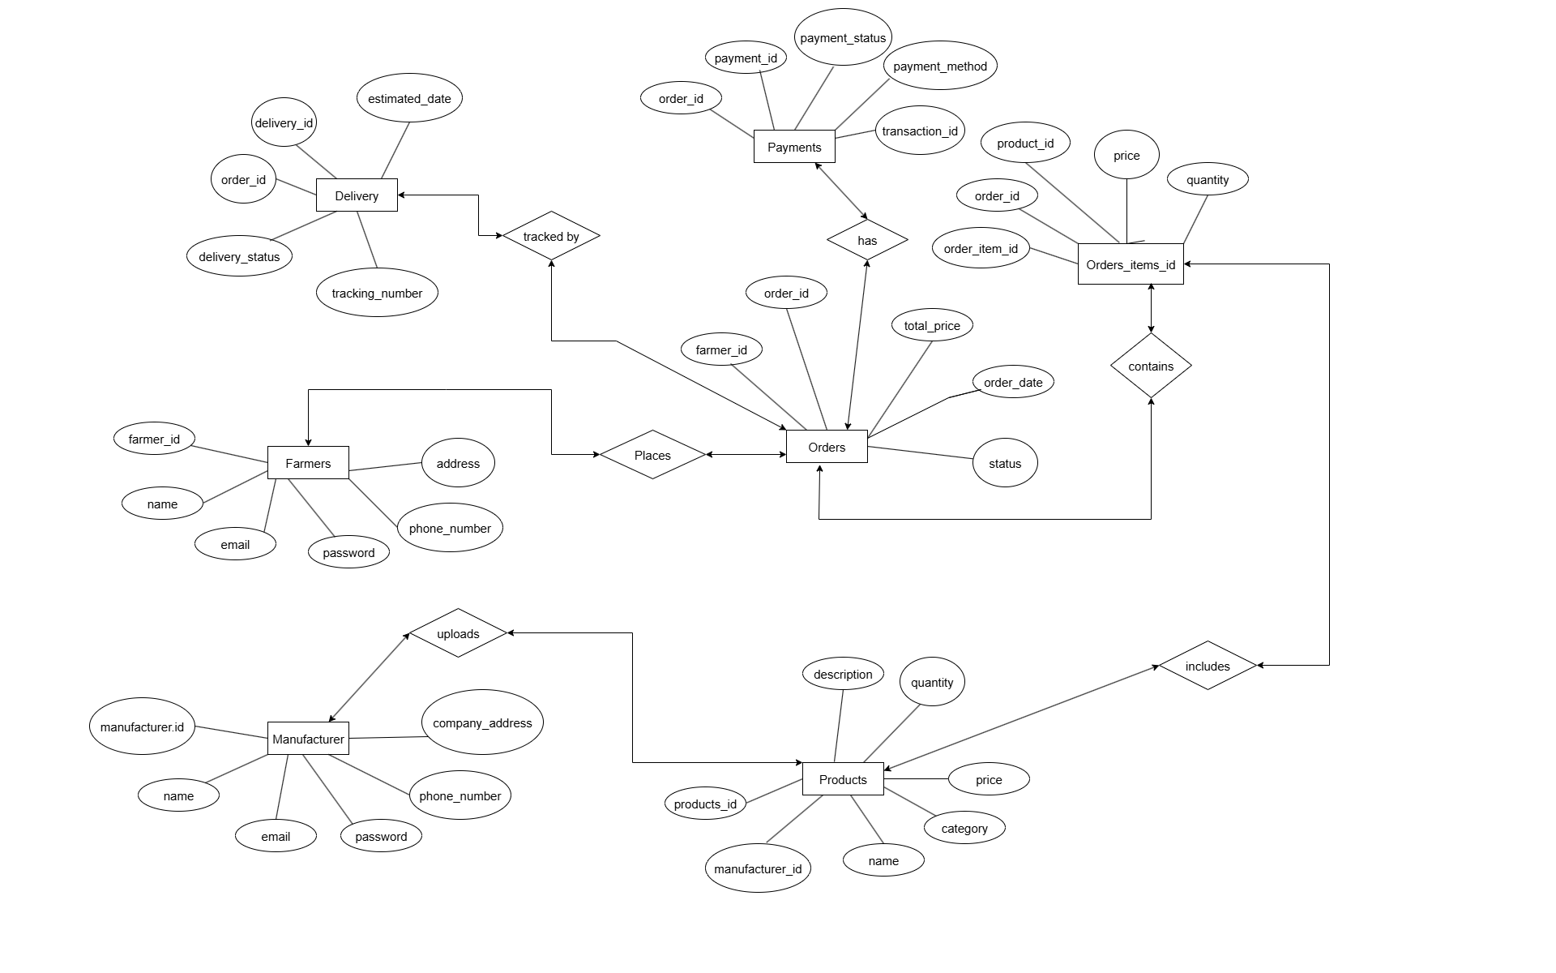
ER Diagram:

Question 07 – Data flow diagram
What is a data flow diagram? Draw a data flow diagram to represent the in-flow and out-flow of data when a Farmer is placing an order for the product

Answer:

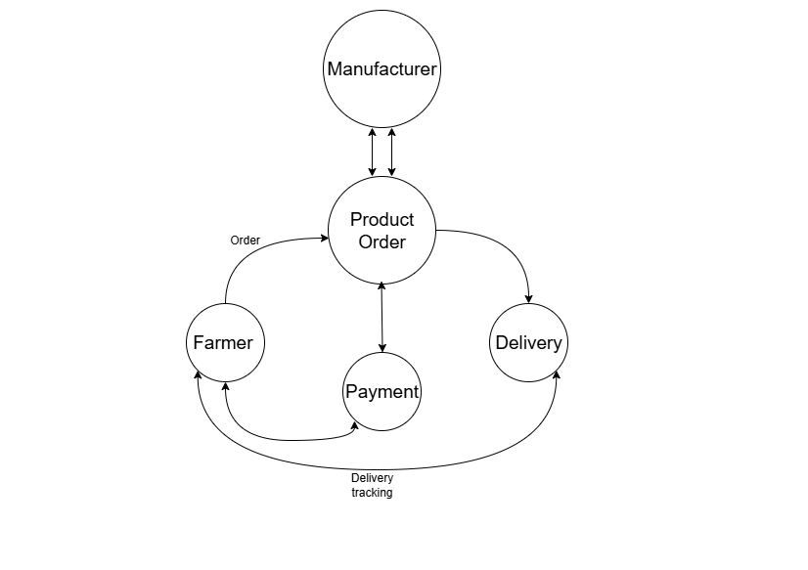
A Data Flow Diagram (DFD) is a graphical tool used to represent the flow of data in a system. It shows how input data is transformed into output data through a series of processes. DFD helps understand the system’s functionality, data movement, and storage points.

Question 08 – Change request.
Due to change in the Government Taxation structure. we should change the Tax structure How do you handle change requests in a project?
Answer:
- Understand and Document the Request
First, we clearly understand the scope of the change (i.e., update in tax structure) and document it properly in a Change Request Form.
- Conduct Impact Analysis
We evaluate how the change will affect the existing system in terms of project scope, timeline, cost, resources, and risks. Modules like invoice generation and payment calculations are closely assessed.
- Prioritize the Change Request
The change is prioritized based on its urgency and criticality. In this case, since it involves government policy, it is treated as high priority.
- Seek Approval from Project Sponsor
The change request is then submitted to the project sponsor or client for approval along with the impact analysis report and revised effort estimation.
- Communicate with Stakeholders
Once approved, the change and its implications are communicated to all stakeholders including developers, testers, and business users to ensure alignment during implementation.
This structured approach helps in managing change requests smoothly without impacting the overall project quality and timeline.

Question 09 – Change request Vs an enhancement
As the project is in process, Ben and Kevin have contacted you. The reason is to inform you that they want the Farmers to sell their crop yields through this application i.e. Farmers should be able to add their crop yields or products and display to general public and should be able to sell them. They also want to introduce Auction system for their Crop yields. As a BA, what will be your response? Is this a change request or an enhancement???
Answer:
Change Request: refers to any modification made to the existing scope, functionality, or requirements of a project that was already approved. It is generally raised when:
- There is a change in business rules, government policies, or compliance requirements.
- The client wants to modify existing features or correct issues.
- Example: Changing the tax calculation method due to a government update.
Enhancement: on the other hand, means adding new features or functionalities to improve or extend the system beyond its original scope. It usually:
- Improves user experience or system performance.
- Adds value by introducing new capabilities.
- Example: Adding an auction feature or enabling farmers to sell crops directly from the app.
This is an enhancement
In this case, adding the auction feature and enabling farmers to sell their crop yields is considered an enhancement because it introduces new functionalities that were not part of the original project scope.
This request will be treated as an enhancement since it adds new features to the system. I will document the requirements clearly and collaborate with the development team to assess the feasibility, potential benefits, risks, and cost implications. Based on the impact analysis, I will then make informed recommendations and present them to the client for review and approval.

Question 10 – Estimations
Come up with estimations – How many Man-hours required

Answer: Man hours are the required effort of the resources to complete a project. There are 3 types of project.

- Small: Upto 500 hours
- Medium: Upto 1000 hours
- Large: Upto 1500 hours

Analysis:

As per the given case study, the duration of the project is 18 months, and the current team size is approximately 11 members. Based on this information, the project fits under the Medium project category, which requires up to 1000 man-hours.

Supporting Analysis:
- Since the resources are trained and available, no additional time or man-hours are required for training.
- The existing infrastructure is sufficient, so no additional setup or delays are expected.
- The project scope and team structure suggest that the work distribution will be efficient and well-managed.
Question 11 – UAT
Project has finally completed all the stages i.e., design, development, testing etc. Now, it is the roleof a business analyst to contact the client for testing of the final product and have to successfully complete it. How are you going to handle this situation? And once it is done, what will be the process to close the project? Explain UAT Acceptance process

Answer:

1. Planning
In this step, blueprints and test objectives are created. It involves identifying which features need to be tested, who will perform the testing (UAT testers), and defining the minimum acceptance criteria. Proper planning ensures a smooth UAT execution.

2. Designing
Here, the BA and QA team prepare test cases that simulate real-world scenarios. These test cases are focused on ensuring that all software functionalities are validated from the user’s perspective in a production-like environment.

3. UAT Testers
A group of end users is selected to perform UAT. These testers should be familiar with the system’s purpose and have a clear understanding of how the functionalities are expected to work. Their role is crucial in validating the usability and functionality.

4. Bug Fixing
If any bugs or issues are identified during UAT, they are reported to the development team. The development team then works to resolve these issues quickly to ensure the software becomes stable and error-free.

5. Sign-Off
After all bugs are fixed and the application meets all criteria, the testers give final approval. A formal UAT sign-off document is prepared and signed by stakeholders. This confirms that the product is ready to Go Live and the project can be moved to closure.
Question 12 – Project closure document
Answer:
A project closure document, also called a project closure report, is a formal document that outlines the conclusion of a project. It summarizes the key outcomes, lessons learned, and final project details. This document ensures all stakeholders have a clear understanding of what was accomplished and how the project performed.
It also acts as a comprehensive record of the project’s achievements, challenges, and the overall performance, providing insights for future projects.

Points to Include in the Project Closure Document:
- Project Overview – Summary of the project, goals, and scope.
- Achievements – Key deliverables and accomplishments.
- Lessons Learned – Insights gained and improvements for future work.
- Quality Assurance – Summary of testing, reviews, and quality checks.
- Resource Utilization – Overview of how human and technical resources were used.
- Risk Management – Risks identified and how they were handled.
- Challenges – Major issues faced and their resolutions.

Sr. No. | Points to include | Details | Reference link
1 | Did the client sign off on the UAT Testing
 | Date of the signoff | 28th July 2025
 | Name of the resource | Mr. Chetan Ambadkar
2 | Objectives of the project
 | User friendliness | Simple UI for farmers and customers
 | Customer satisfaction | ROI expected within 6 months
 | More categories | Seeds, Fertilizers, Pesticides – Achieved
3 | Functionalities worked on
 | Secure payment processing | Achieved (Supports UPI, Card, COD)
 | Categories | Filtered by Products sorted by type, price, rating
4 | Infrastructure
 | Software installed | Achieved
 | Laptop purchased | Achieved
5 | Funding
 | Amount approved | Rs. 2 Crore
 | Amount used | Rs. 1.80 Crore
6 | Overall project information
 | Escalations | 50
 | Customer satisfaction | Positive feedback from farmers and end-users
7 | Value to the money
 | Positive/Negative | Positive 95%  First Agri E-store in region  Attracted large farmer base  Trained internal user for support  High potential for future modules like Auction & Live Chat

