Question 1:

Identify minimum 20 functional requirements
Functional requirement.
Non-Functional Requirement.

Answer:
Functional requirements:

Functional requirements define what the system should do.The specific features, actions, and behaviors. Based on the case study of the Online Agriculture Product Store, here are 15 functional requirements:

FR001 – Farmer Registration
Farmers should be able to register with the application using email and password.

FR002 – Manufacturer Registration
Manufacturers should be able to create accounts and register their company details.

FR003 – User Login
Both Farmers and Manufacturers should be able to log in securely using their credentials.

FR004 – Password Reset
Users should be able to reset their password via email verification.

FR005 – Product Upload by Manufacturers
Manufacturers should be able to upload product details (fertilizers, seeds, pesticides).

FR006 – Product Catalog Browsing
Farmers should be able to browse all available products in a categorized manner.

FR007 – Product Search
Farmers should be able to search for products using keywords, filters, or categories.

FR008 – Product Details View
Farmers should be able to view detailed product descriptions, price, and manufacturer info.

FR009 – Add to Cart
Farmers should be able to add products to the cart for purchase.

FR010 – Buy Now / Place Order
Farmers should be able to place orders for selected products.

FR011 – Payment Gateway Integration
The system should support payments via COD, Credit/Debit Card, and UPI.

FR012 – Order Confirmation & Email Notification
System should send email confirmation with order details after successful purchase.

FR013 – Delivery Tracking
Farmers should be able to track the delivery status of their orders.

FR014 – Order History
Farmers should be able to view their past orders and invoices.

FR015 – Admin Panel
Admin should be able to monitor, approve/reject products, and manage users.

Non functional requirements:

Non-Functional Requirements define how the system should perform — the quality attributes, standards, and constraints

NFR001 – Performance
Each page should load within 2 seconds under normal load.

NFR002 – Scalability
The system should support at least 10,000 concurrent users.

NFR003 – Security
All sensitive data (passwords, payments) must be encrypted (SSL/TLS, AES-256).

NFR004 – Availability
The system should be available 99.9% of the time (excluding planned maintenance).

NFR005 – Usability
The application UI should follow WCAG 2.1 accessibility guidelines.

NFR006 – Compatibility
The application should work on major browsers (Chrome, Firefox, Safari, Edge) and mobile devices.

NFR007 – Maintainability
Code should follow modular structure with documentation for easy maintenance.

NFR008 – Reliability
The system should handle unexpected failures gracefully and recover without data loss.

NFR009 – Data Backup & Recovery
The system should automatically back up data daily and support recovery within 2 hours.

NFR010 – Audit & Logging
The system should maintain logs of all user activities and transactions for at least 1 year.

Question 2:

Make 5 wireframes.

Answer:

Wireframes are basic visual layouts of a web or mobile application that show the structure, placement of elements, and navigation flow without any design details.

They help visualize “what goes where” — such as buttons, menus, forms, and images.

Usually created in tools like Balsamiq or Visio, wireframes focus on functionality, not color or graphics.

Purpose: To communicate page layout and user flow early in the design process.

Homepage
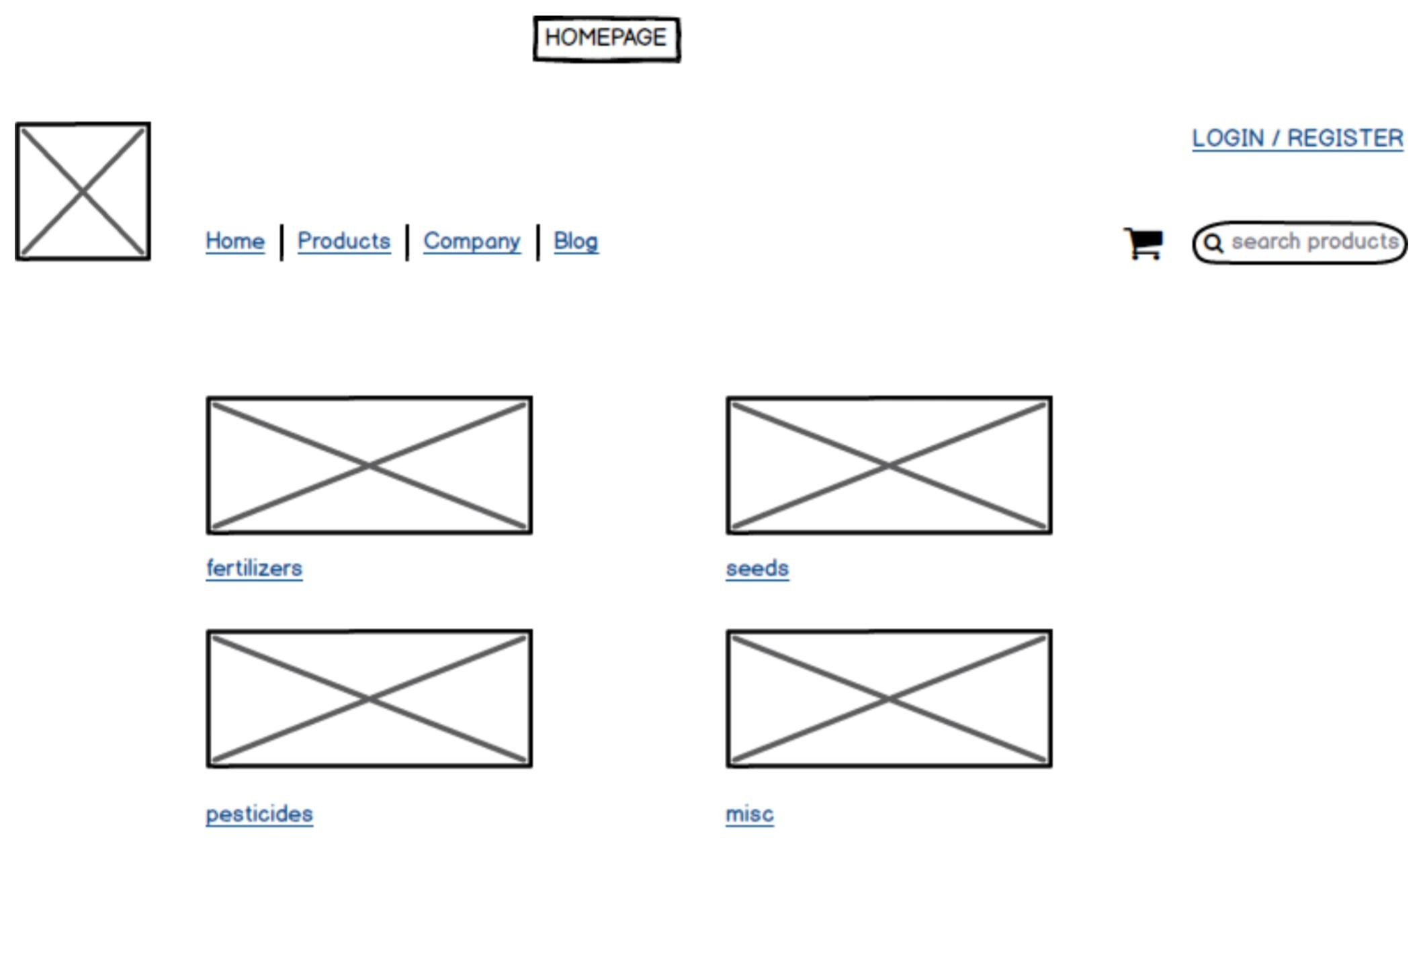

Registration
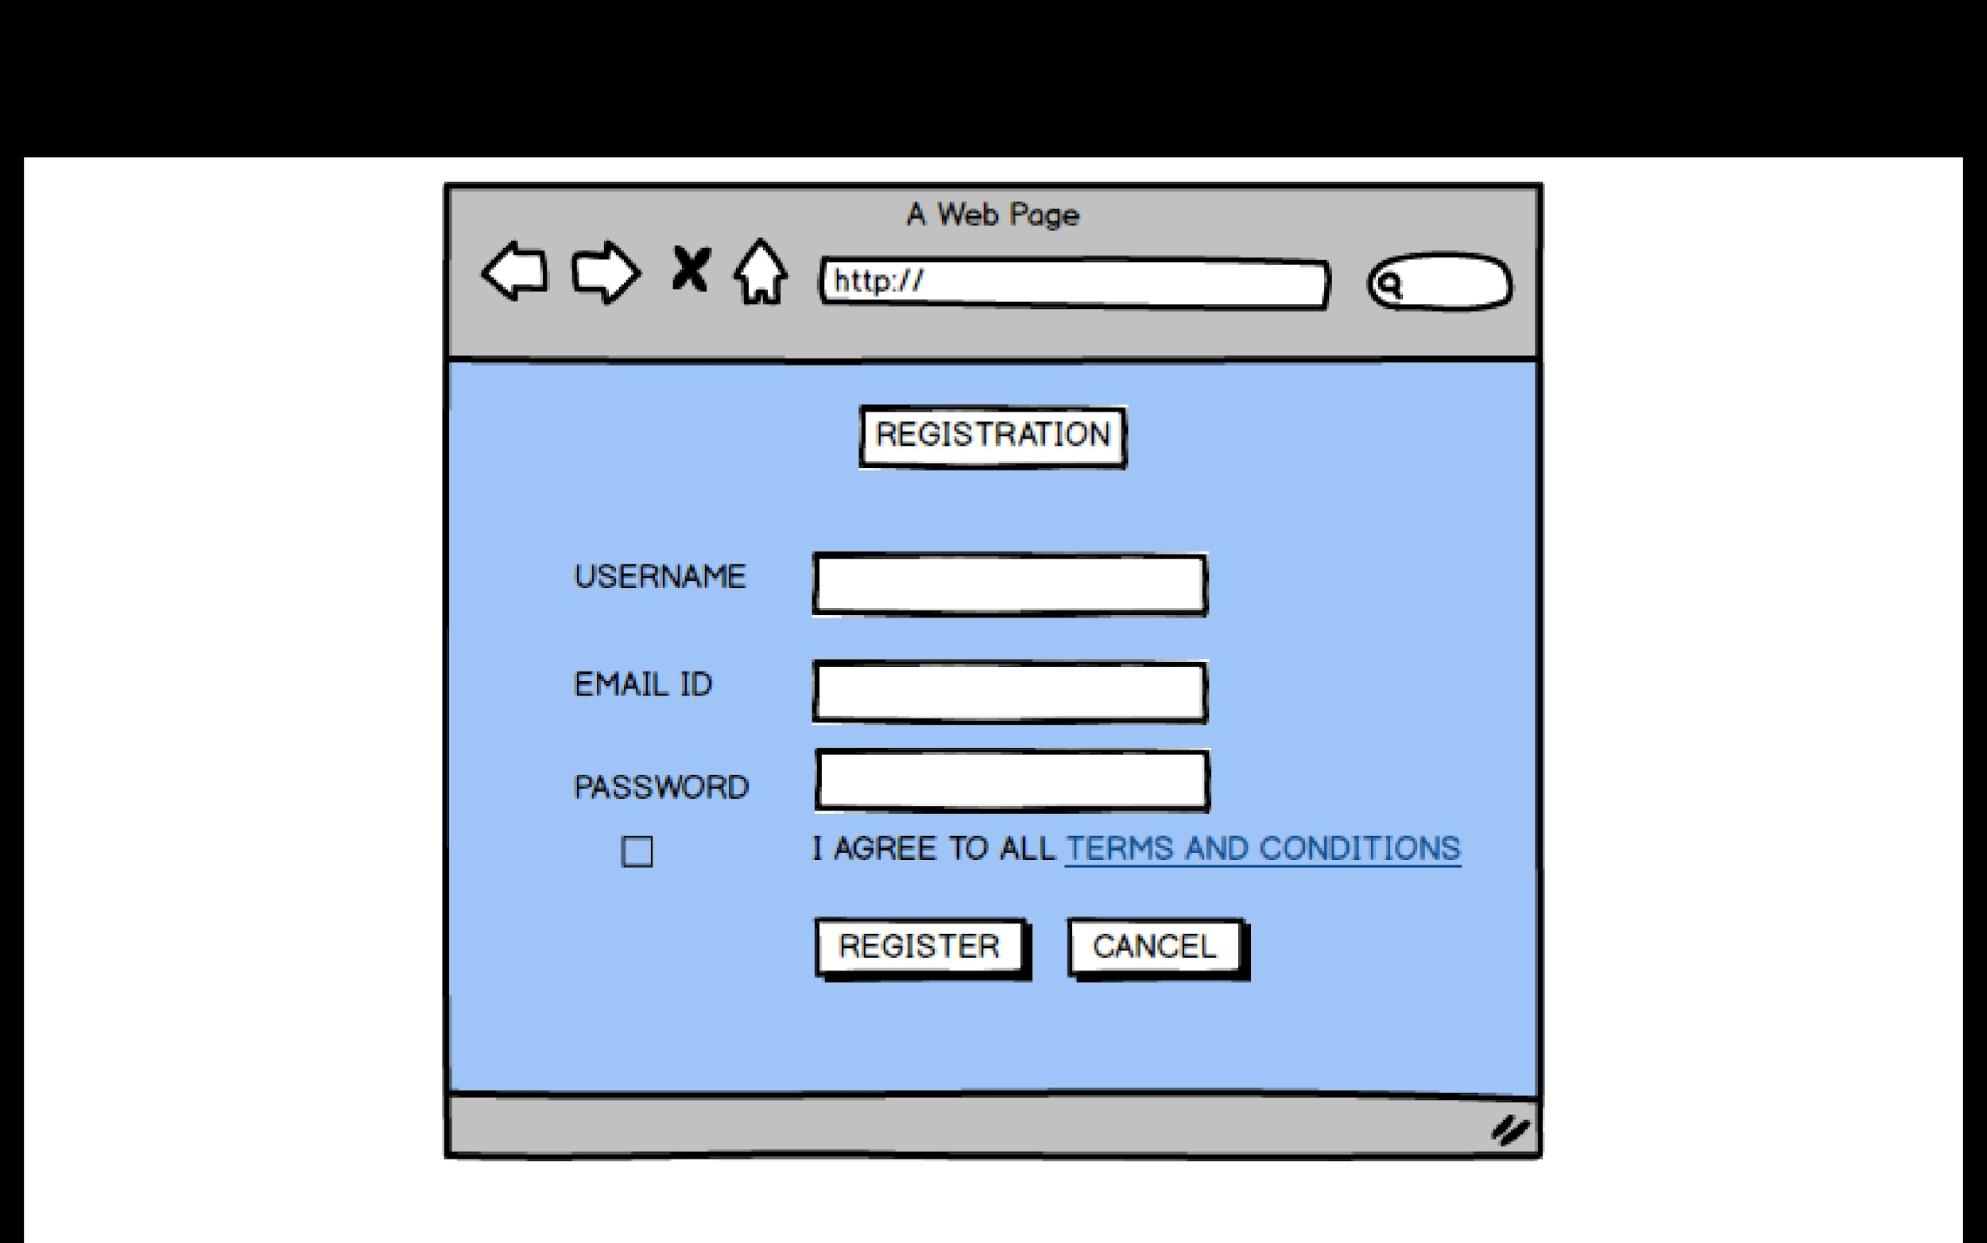

Login
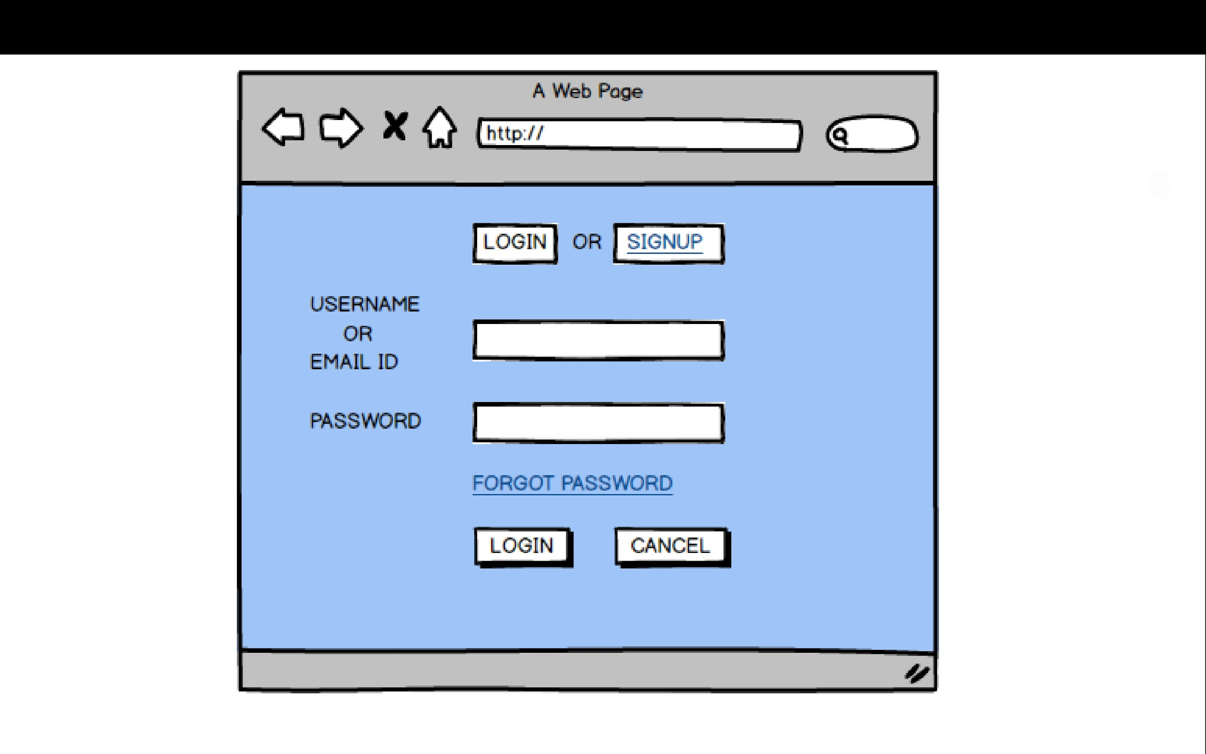
Product view
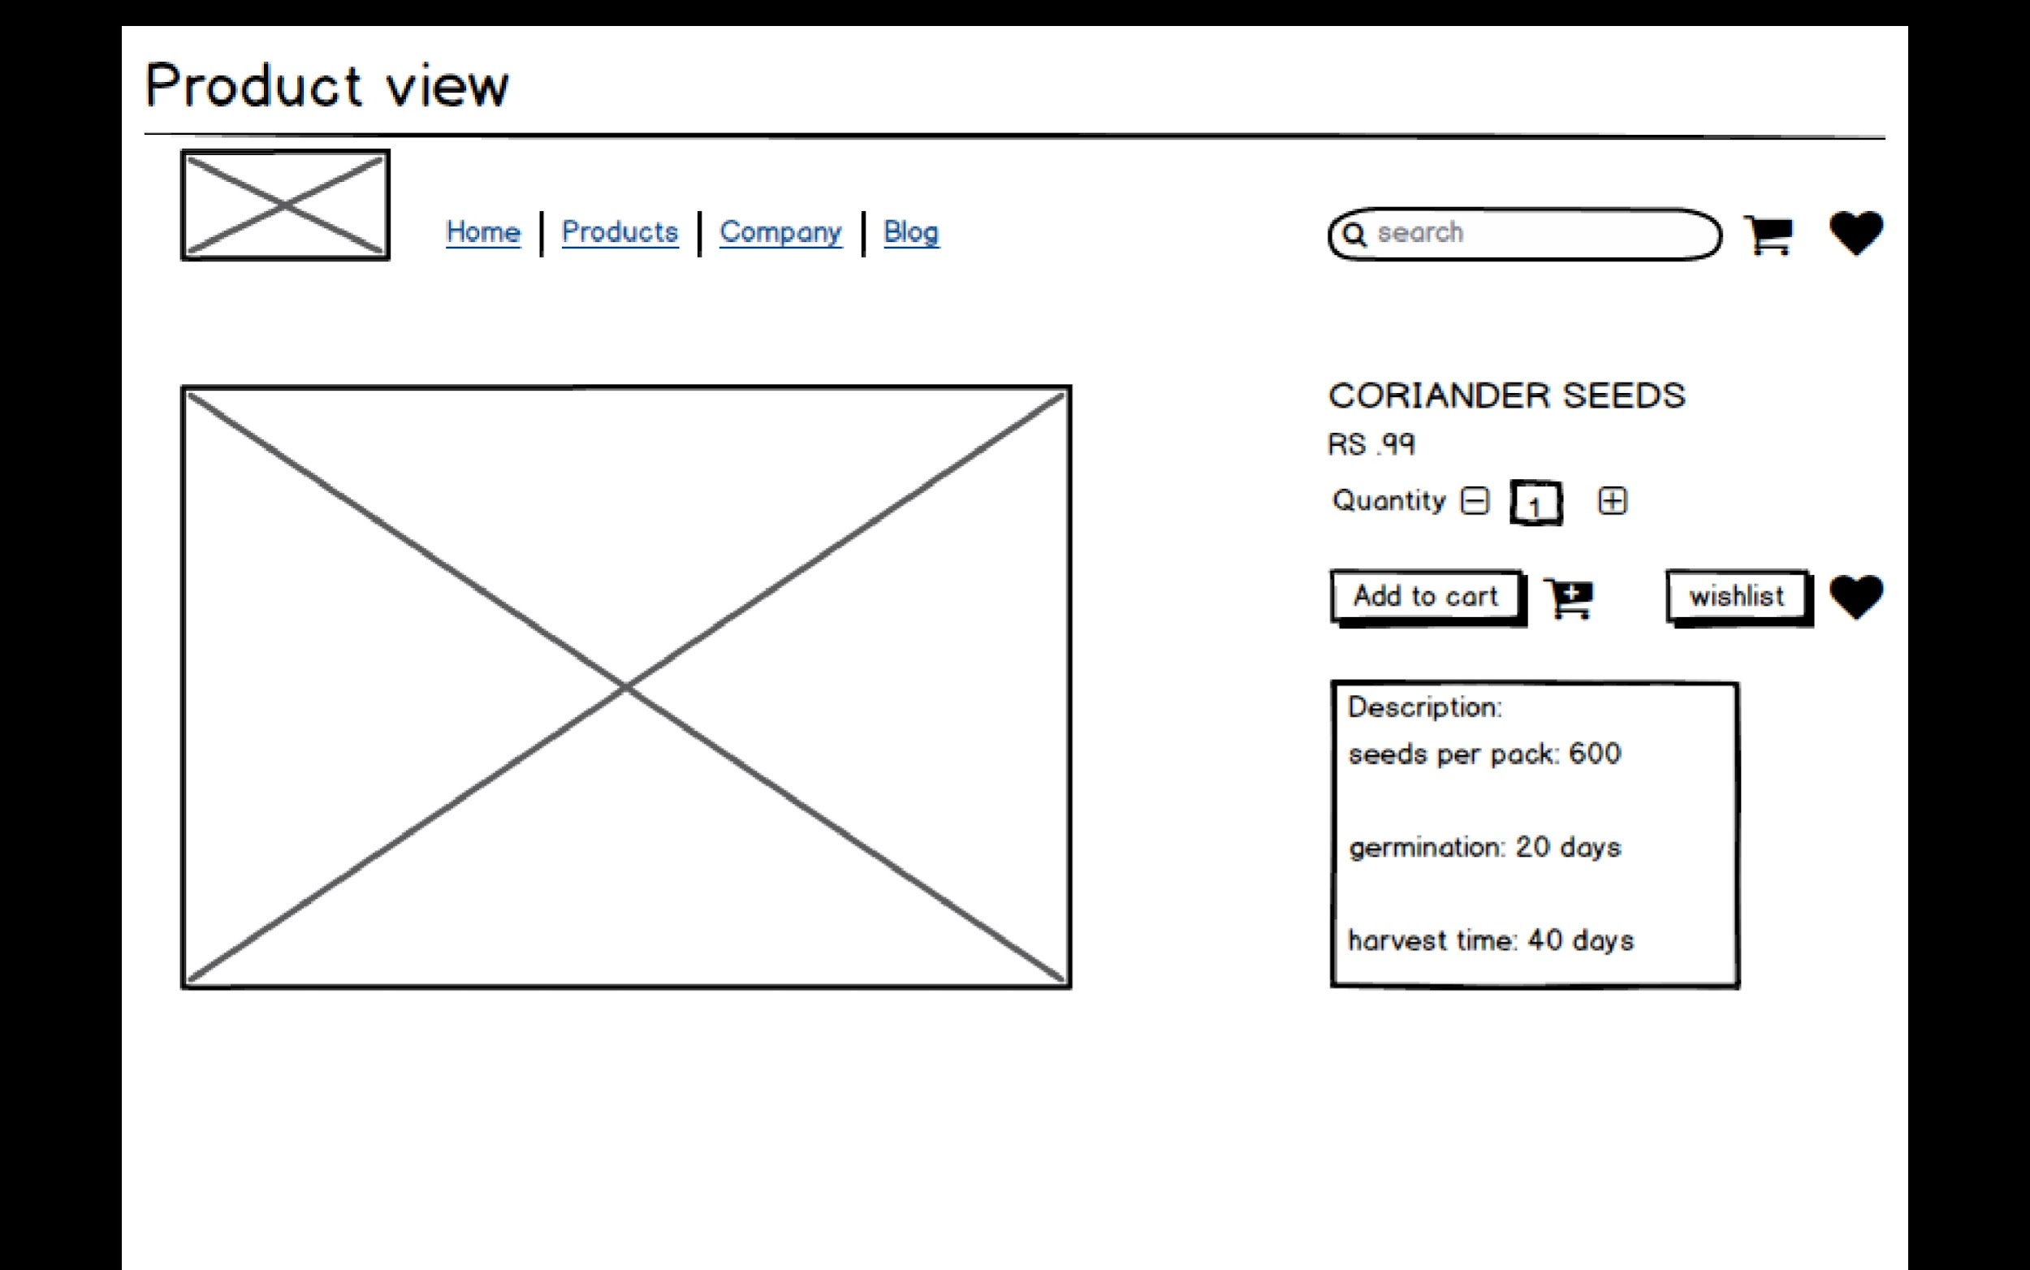

Order page
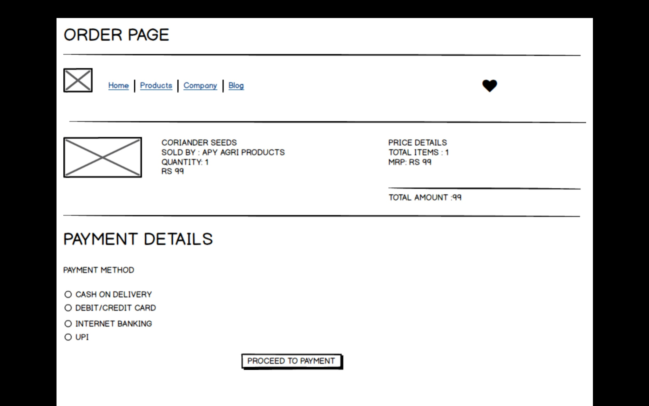

Question : 3

Make a note of the Tools, which you are using for the above concepts.
Microsoft visio
Balsamiq
Axure

Answer:

1. Microsoft Visio

Purpose: A diagramming and visualization tool by Microsoft used to represent systems, workflows, and organizational structures.

Key Features:

Rich library of templates and stencils for UML, flowcharts, DFDs, ER diagrams, and network diagrams.

Integration with Microsoft Office (Word, Excel, PowerPoint).

Supports collaboration and cloud-based sharing via OneDrive/SharePoint.

Use for Business Analysts:

Create Use Case Diagrams, Activity Diagrams, and Process Flows.

Represent system architecture and data flow to ensure clarity with stakeholders.

Provides professional visuals for documentation and presentations.

Benefit in Project: Helps communicate functional flows and system interactions clearly to both technical and non-technical teams.

2. Balsamiq

Purpose: A lightweight wireframing tool for creating low-fidelity prototypes of web and mobile applications.

Key Features:

Drag-and-drop interface with ready UI elements like buttons, input fields, and dropdowns.

Sketch-style design that keeps focus on functionality, not final look.

Supports collaboration via real-time sharing and comments.

Use for Business Analysts:

Quickly design mockups of user interfaces.

Gather early feedback from stakeholders without heavy design effort.

Validate requirements and discover usability issues early in the SDLC.

Benefit in Project: Saves time by providing a visual understanding of requirements and aligns all stakeholders before costly development begins.

3. Axure

Purpose: A professional prototyping tool for creating high-fidelity, interactive prototypes.

Key Features:

Supports clickable prototypes with conditional logic, animations, and dynamic content.

Advanced documentation support for requirement notes, flows, and annotations.

Cloud collaboration for team projects.

Use for Business Analysts:

Create interactive wireframes that simulate real application behavior.

Demonstrate end-to-end workflows for complex systems.

Provide detailed prototypes for developers and testers, reducing ambiguities.

Benefit in Project: Offers stakeholders a realistic view of the system before development, helping validate both functional and non-functional requirements.

Question 4:

Prepare RTM

Answer:

RTM (Requirements Traceability Matrix) is a document used to track and map requirements through the project lifecycle.

It ensures that all requirements are implemented and tested.

It links Business Requirements → Functional Requirements → Design → Development → Testing (Unit, Integration, System, UAT).

Helps stakeholders and BA to check project status anytime.

Avoids missed or untested requirements.

RTM:
Req ID | Req Name | Req Description | Design | Code | UT (Unit Testing) | CT (Component Testing) | SIT (System Testing) | UAT (User Acceptance Testing)
FR001 | Farmer Registration | Farmers register with email/password | Complete | Complete | Complete | Complete | Complete | Incomplete
FR002 | Manufacturer Registration | Manufacturers register company details | Complete | Complete | Complete | Complete | Incomplete | Incomplete
FR003 | User Login | Secure login for Farmers & Manufacturers | Complete | Complete | Complete | Complete | Incomplete | Incomplete
FR004 | Password Reset | Reset password via email link | Complete | Complete | Complete | Incomplete | Incomplete | Incomplete
FR005 | Product Upload | Manufacturers upload products | Complete | Complete | Complete | Complete | Incomplete | Incomplete
FR006 | Product Catalog | Farmers browse products | Complete | Complete | Complete | Incomplete | Incomplete | Incomplete
FR007 | Product Search | Farmers search products with filters | Complete | Complete | Complete | Incomplete | Incomplete | Incomplete
FR008 | Product Details | View product description, price, info | Complete | Complete | Complete | Complete | Incomplete | Incomplete
FR009 | Add to Cart | Add products to shopping cart | Complete | Complete | Complete | Incomplete | Incomplete | Complete
FR010 | Buy Now / Place Order | Place order for products | Complete | Complete | Complete | Incomplete | Incomplete | Incomplete
FR011 | Payment Gateway | Support COD, UPI, Cards | Complete | Complete | Complete | Complete | Incomplete | Incomplete
FR012 | Order Confirmation | Email confirmation after purchase | Complete | Complete | Complete | Incomplete | Incomplete | Incomplete
FR013 | Delivery Tracking | Track delivery status | Complete | Complete | Complete | Incomplete | Incomplete | Incomplete
FR014 | Order History | View past orders and invoices | Complete | Complete | Complete | Incomplete | Incomplete | Incomplete
FR015 | Admin Panel | Admin manages users & products | Complete | Complete | Complete | Incomplete | Incomplete | Incomplete

Question 5:

Prepare 10 Test Case Documents

Answer:
A Test Case Document is a detailed file that defines how a specific feature or function of an application should be tested.

It includes information like Test Case ID, scenario, input data, expected result, actual result, and status (Pass/Fail).

Purpose: To ensure every requirement is verified through testing, maintain consistency, and track whether the system works as intended.

Test Case 1 – Farmer Registration
Field | Details
Test Case ID | TC001
Test Case Name | Farmer Registration
Project ID | P001
Project Name | Online Agriculture Product Store
PM ID | PM001
PM Name | Mr. Vandanam
Test Strategy ID | TS001
Test Plan ID | TP001
Tester ID | T001
Tester Name | Jason
Date of Test | 02-10-2025
Scenario | Register a new farmer user
Link to Page | Registration Page
Input Data | Name = “Ravi”, Email = “ravi@mail.com”, Password = “Ravi@123”, Mobile = 98765432
Expected Behaviour | System should create a new farmer account and send confirmation email
Actual Behaviour | Account created successfully, confirmation email received
Result (Pass/Fail) | Pass
Comments | –

Test Case 2 – Manufacturer Registration
Field | Details
Test Case ID | TC002
Test Case Name | Manufacturer Registration
Project ID | P001
Project Name | Online Agriculture Product Store
PM ID | PM001
PM Name | Mr. Vandanam
Test Strategy ID | TS001
Test Plan ID | TP001
Tester ID | T002
Tester Name | Alekya
Date of Test | 02-10-2025
Scenario | Register a new manufacturer
Link to Page | Manufacturer Registration Page
Input Data | Company Name = “AgroTech”, Email = “info@agrotech.com”, GST No = “29ABCDE1234F1Z5”
Expected Behaviour | Manufacturer account created successfully
Actual Behaviour | As expected
Result (Pass/Fail) | Pass
Comments | –

Test Case 3 – Login with Valid Credentials
Field | Details
Test Case ID | TC003
Test Case Name | Login with Valid Credentials
Project ID | P001
Project Name | Online Agriculture Product Store
PM ID | PM001
PM Name | Mr. Vandanam
Test Strategy ID | TS001
Test Plan ID | TP001
Tester ID | T001
Tester Name | Jason
Date of Test | 03-10-2025
Scenario | Login as a valid farmer
Link to Page | Login Page
Input Data | Email = “ravi@mail.com”, Password = “Ravi@123”
Expected Behaviour | Farmer successfully logs in and redirected to dashboard
Actual Behaviour | As expected
Result (Pass/Fail) | Pass
Comments | –

Test Case 4 – Login with Invalid Credentials
Field | Details
Test Case ID | TC004
Test Case Name | Login with Invalid Credentials
Project ID | P001
Project Name | Online Agriculture Product Store
PM ID | PM001
PM Name | Mr. Vandanam
Test Strategy ID | TS001
Test Plan ID | TP001
Tester ID | T002
Tester Name | Alekya
Date of Test | 03-10-2025
Scenario | Login with incorrect password
Link to Page | Login Page
Input Data | Email = “ravi@mail.com”, Password = “wrongpass”
Expected Behaviour | System should show “Invalid Credentials” message
Actual Behaviour | As expected
Result (Pass/Fail) | Pass
Comments | –

Test Case 5 – Search Product
Field | Details
Test Case ID | TC005
Test Case Name | Product Search
Project ID | P001
Project Name | Online Agriculture Product Store
PM ID | PM001
PM Name | Mr. Vandanam
Test Strategy ID | TS001
Test Plan ID | TP001
Tester ID | T001
Tester Name | Jason
Date of Test | 04-10-2025
Scenario | Search for “Pesticide”
Link to Page | Product Search Page
Input Data | Keyword = “Pesticide”
Expected Behaviour | List of pesticide products should be displayed
Actual Behaviour | As expected
Result (Pass/Fail) | Pass
Comments | –

Test Case 6 – View Product Details
Field | Details
Test Case ID | TC006
Test Case Name | View Product Details
Project ID | P001
Project Name | Online Agriculture Product Store
PM ID | PM001
PM Name | Mr. Vandanam
Test Plan ID | TP001
Tester ID | T002
Tester Name | Alekya
Date of Test | 04-10-2025
Scenario | View a fertilizer product
Link to Page | Product Details Page
Input Data | Product ID = 102
Expected Behaviour | Product details (price, manufacturer, description) displayed
Actual Behaviour | As expected
Result (Pass/Fail) | Pass
Comments | –

Test Case 7 – Add Product to Cart
Field | Details
Test Case ID | TC007
Test Case Name | Add Product to Cart
Project ID | P001
Project Name | Online Agriculture Product Store
PM ID | PM001
PM Name | Mr. Vandanam
Test Plan ID | TP001
Test Schedule ID | TSch001
Tester ID | T001
Tester Name | Jason
Date of Test | 05-10-2025
Scenario | Add fertilizer to cart
Link to Page | Product Catalog Page
Input Data | Product ID = 105
Expected Behaviour | Product should be added to cart and cart count updated
Actual Behaviour | As expected
Result (Pass/Fail) | Pass
Comments | –

Test Case 8 – Place an Order
Field | Details
Test Case ID | TC008
Test Case Name | Place Order
Project ID | P001
Project Name | Online Agriculture Product Store
PM ID | PM001
PM Name | Mr. Vandanam
Test Strategy ID | TS001
Test Plan ID | TP001
Tester ID | T002
Tester Name | Alekya
Date of Test | 05-10-2025
Scenario | Place an order for products
Link to Page | Checkout Page
Input Data | Cart with 2 products, Payment = COD
Expected Behaviour | Order placed successfully, confirmation email sent
Actual Behaviour | As expected
Result (Pass/Fail) | Pass
Comments | –

Test Case 9 – Payment via UPI
Field | Details
Test Case ID | TC009
Test Case Name | Payment via UPI
Project ID | P001
Project Name | Online Agriculture Product Store
PM ID | PM001
PM Name | Mr. Vandanam
Test Strategy ID | TS001
Test Plan ID | TP001
Tester ID | T001
Tester Name | Jason
Date of Test | 06-10-2025
Scenario | Pay for order using UPI
Link to Page | Payment Gateway
Input Data | UPI ID = “farmer@upi”
Expected Behaviour | Payment should be successful and receipt generated
Actual Behaviour | As expected
Result (Pass/Fail) | Pass
Comments | –

Test Case 10 – Delivery Tracking
Field | Details
Test Case ID | TC010
Test Case Name | Delivery Tracking
Project ID | P001
Project Name | Online Agriculture Product Store
PM ID | PM001
PM Name | Mr. Vandanam
Test Strategy ID | TS001
Test Plan ID | TP001
Tester ID | T002
Tester Name | Alekya
Date of Test | 06-10-2025
Scenario | Track the delivery of an order
Link to Page | Order Tracking Page
Input Data | Order ID = 5001
Expected Behaviour | System should show real-time delivery status
Actual Behaviour | As expected
Result (Pass/Fail) | Pass
Comments | –

Question 6:
After the requirements are thoroughly explained to the entire project team by a business analyst, theDatabase architects have decided to do the database design and also to represent the in-flow and out-flow of data.
Draw database schema and ER diagram

Answer:

Database Schema
- A Database Schema is the blueprint or structure of a database.
- It defines how data is organized into tables, along with fields, data types, primary keys, foreign keys, and relationships between tables.
- It represents the logical design of the database that developers and DBAs use to store and manage data efficiently.

ER Diagram (Entity Relationship Diagram)
- An ER Diagram visually represents the entities (tables), their attributes (fields), and relationships (one-to-one, one-to-many, many-to-many) between them.
- It helps Business Analysts and Developers understand data flow and relationships before creating the actual database.
- Symbols used: Rectangles for entities, ovals for attributes, diamonds for relationships.

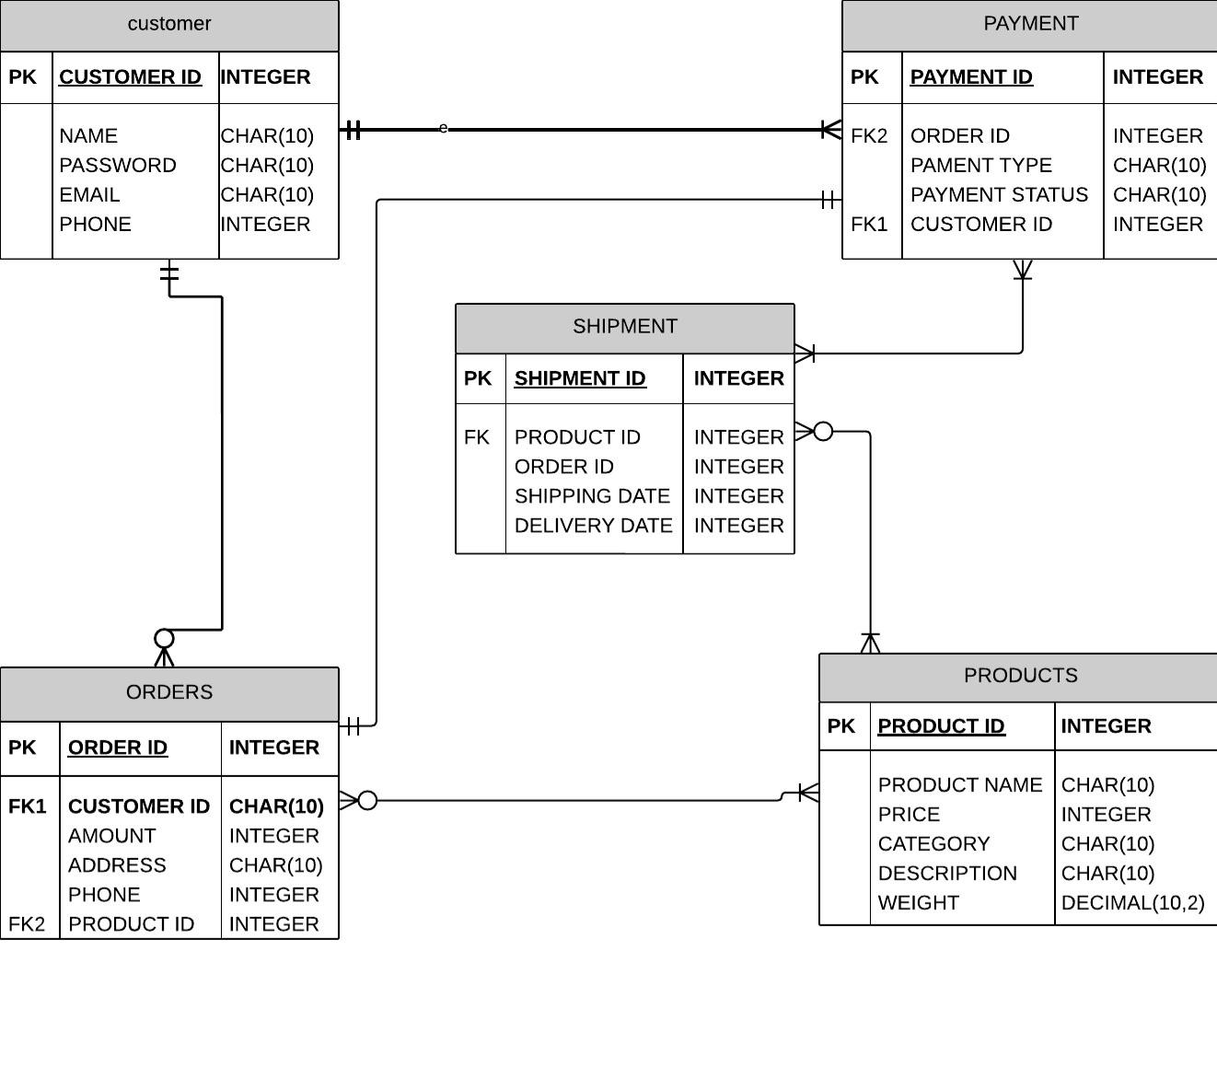

Question 7:

Draw a dataflow diagram

Answer:

Data Flow Diagram (DFD)

A Data Flow Diagram is a visual representation that shows how data moves through a system from input to processing and then to output.

It illustrates the flow of information between processes, data stores, and external entities.

Common symbols:

Circles/Ovals → Processes
Arrows → Data flow
Rectangles → External entities (like users or systems)
Open-ended rectangles → Data stores

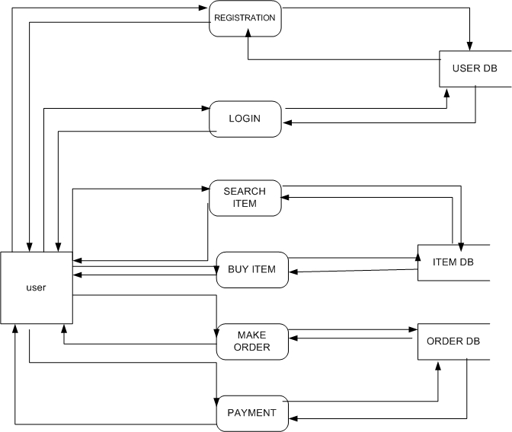

Question 8:

Due to change in the Government Taxation structure . we should change the Tax structure
How do you handle change requests in a project?

Answer:

Definition: A Change Request (CR) is a formal proposal to alter the agreed scope, design, or behavior of the system. For a regulation-driven tax change, the change is usually mandatory and must be processed quickly while maintaining traceability, testing, and auditability.

Steps to Handle a Change Request (CR Process)

1. Raise & Log CR

A stakeholder (Finance, Legal, Client, or Internal team) raises a formal Change Request.

It is logged in the Change Management system with a unique CR ID, title, and description.

2. Initial Assessment / Triage

The Project Manager and BA assess whether it is urgent, regulatory, or optional.

Classify it as Normal or Emergency.

3. Impact Analysis

The BA coordinates with Developers, Testers, DB Admins, and Architects.

Identify affected requirements, modules, data, test cases, timelines, and risks.

Prepare an Impact Analysis Document.

4. Effort Estimation & Scheduling

The technical team estimates cost, effort (in man-days), and proposes a delivery timeline.

PM updates the project plan accordingly.

5. Approval from Change Control Board (CCB)

The CR, with impact and estimates, is presented to the Change Control Board (stakeholders + PM).

For urgent changes (like government tax updates), an Emergency CAB (ECAB) may approve quickly.

6. Design & Planning

The solution architect and developers create a technical design, database migration scripts, rollback plan, and update requirement documents.

Testers prepare updated test plans and test cases.

7. Implementation & Unit Testing

Developers implement the change and test it in isolation.

Defects are fixed immediately before moving to higher testing levels.

8. System / Integration Testing

QA team validates the change along with regression testing to ensure no other functionality is broken.

9. User Acceptance Testing (UAT)

The business stakeholders (e.g., Finance/Legal for tax changes) test and confirm that the change meets their requirements.

10. Deployment & Rollback Plan

The approved change is deployed into production in a controlled release window.

A rollback plan is kept ready to restore the system in case of issues.

11. Post-Implementation Review & Closure

The BA and PM review the change with stakeholders.

Lessons learned are documented, requirements traceability is updated, and the CR is formally closed.

Handling the Taxation Change Request as a BA

As a Business Analyst, my role is to ensure the new government taxation structure is correctly captured, analyzed, and implemented without impacting existing system stability. I would handle this Change Request as follows:

1. Requirement Elicitation & Documentation

Collect details of the new taxation rules (GST/VAT slabs, rates, exemptions) from Finance, Legal, and Government notifications.

Document the change in a Change Request Form (CR-ID) with clear description, priority, and rationale.

2. Impact Analysis

Identify which modules are affected:

Pricing Engine (calculations of product cost).

Invoice/Receipt Generation (display new tax rates).

Database tables (tax codes, percentage values).

Reports (sales reports, tax summaries).

Payment Gateway & ERP integration.

Assess downstream impact on customers and financial compliance.

Prepare an Impact Analysis Document.

3. Update Requirements & Traceability

Convert the taxation rule changes into Functional Requirements (FRs).

Update the RTM to ensure each new tax requirement is mapped to design, test cases, and UAT.

4. Estimation & Planning

Coordinate with Dev & QA teams for effort estimation (man-hours, cost, timeline).

Present schedule and cost implications to the Project Manager and CAB for approval.

5. Stakeholder Communication

Communicate with stakeholders (Mr. Henry, Finance Head Pandu, Project Coordinator Dooku) about scope, effort, risks, and timelines.

Set expectations regarding delivery before the government deadline.

6. Design & Development

Ensure the technical team updates the tax configuration logic in a modular way (configurable rates, no hardcoding).

Involve DB Admin to update tax code tables.

7. Testing & Validation

Support QA team in preparing new test cases for tax calculation, invoices, and reports.

Ensure regression testing so that old functionality (discounts, payment) isn’t broken.

Conduct UAT with Finance/Legal stakeholders to validate accuracy.

8. Deployment & Rollback

Coordinate deployment with Release Manager.

Ensure a rollback plan is in place if incorrect tax rates cause issues.

9. Documentation & Training

Update requirement documents, RTM, and user manuals.

Provide quick training to support team and customer service on how new tax is applied.

10. Closure

Once stakeholders sign-off, formally close the CR and archive documents for audit and compliance purposes.

Question 9:

As the project is in process, Ben and Kevin have contacted you. The reason is to inform you that they want the Farmers to sell their crop yields through this application i.e. Farmers should be able to add their crop yields or products and display them to the general public and should be able to sell them.They also want to introduce an auction system for their crop yields. As a BA, what will be your response?
Is this a change request or an enhancement?

Answer:

Change Request
A Change Request (CR) is a formal proposal to modify the existing agreed scope, functionality, or deliverables of a project. It typically arises due to regulatory updates, technical limitations, business process changes, or client feedback after requirements are frozen. CRs do not usually add brand-new features; instead, they alter, correct, or improve what was already planned. For example, updating the tax calculation method due to new government policies is a change request. CRs often affect timelines, cost, and require re-validation of requirements, design, and testing activities. They are processed via a Change Control Board (CCB) for approval.

Enhancement
An Enhancement refers to adding new functionalities or features that were not part of the original scope but can improve the product’s value, usability, or efficiency. Enhancements are often identified by stakeholders as future needs or opportunities to expand the product’s capabilities. Unlike a CR, enhancements do not fix existing issues; instead, they extend the system beyond its baseline. For example, adding an auction system for farmers in the agriculture portal is an enhancement, as it introduces a new business model. Enhancements are usually planned in future releases or versions, based on business priority and available resources.

Key Differences – Change Request vs Enhancement
Aspect | Change Request | Enhancement
Definition | Modification to existing requirements or scope | Introduction of new features beyond original scope
Purpose | To correct, comply, or adapt to change | To expand, upgrade, or add new value
Impact | Alters current system behavior | Adds additional functionalities
Examples | Updating tax rules, fixing login workflow | Adding auction system, introducing crop selling feature
Timeline | Typically urgent and must align with compliance/business needs | Planned in future releases or new phases
Process | Managed via change control process (CCB) | Managed as new business requirements / enhancements backlog

The request from Ben and Kevin to enable farmers to sell their crop yields and introduce an auction system is an Enhancement, not a Change Request. This is because it introduces new functionalities beyond the original project scope, rather than modifying existing features. As a BA, I would document the request, conduct impact analysis, and present it to stakeholders for approval as part of a future release or extended phase of the project.

Question 10:
What “estimation” means
Answer:
Estimation converts the agreed scope into an amount of effort (man-hours) needed to deliver that scope. Good estimates are explicit about assumptions, use a repeatable method, and include contingency for risks.
Common estimation techniques:
Bottom-up (recommended here) — break the system into tasks, estimate each task, then sum. Best for accuracy when requirements are known.
Top-down / Analogous — use past projects to estimate. Fast but less accurate.
Parametric — use metrics (e.g., hours per use-case or function point). Good when you have historical productivity numbers.
Three-point (PERT) — uses Optimistic, Most-Likely, Pessimistic to produce a risk-adjusted estimate
Story points / velocity (Agile) — estimate relative size; convert to hours using team velocity.

Team Members (APT IT SOLUTIONS)
- Project Manager – Mr. Vandanam
- Senior Java Developer – Ms. Juhi
- Java Developers – Mr. Teyson, Ms. Lucie, Mr. Tucker, Mr. Bravo (4 members)
- Network Admin – Mr. Mike
- DB Admin – Mr. John
- Testers – Mr. Jason & Ms. Alekya (2 members)
- Business Analyst (Me)

Step 1 – Assumptions
- 18 months project lifecycle = 18 × 22 days × 8 hrs = 3,168 hours per person.
- Total man-hours = 3,168 × 11 = 34,848 hours capacity (if fully utilized).
- Assume 80% productive utilization = 27,878 hours.
- Allocate effort across phases of SDLC: Requirement, Design, Development, Testing, Deployment, Support.

Step 2 – Phase-wise Allocation (example distribution)
Phase | % of Total | Hours | Team Focus
Requirements & Analysis | 10% | 2,788 h | BA, PM, Stakeholder workshops
Design (UI, DB, Architecture) | 15% | 4,182 h | BA, PM, Senior Dev, DB Admin, Net Admin
Development (Coding) | 40% | 11,151 h | Senior Dev + 4 Devs
Testing (QA, bug fixing) | 20% | 5,576 h | Testers + Devs support
Deployment & Integration | 10% | 2,788 h | DB Admin, Net Admin, PM, Devs
Support & Documentation | 5% | 1,393 h | BA, PM, Testers
Total = 27,878 hours (utilized from 34,848 available).

Step 3 – Role-wise Allocation (simplified)
Role | Members | Hours (18 months)
Project Manager | 1 | 2,400 h (oversight, planning, risk mgmt)
Business Analyst (You) | 1 | 2,200 h (requirements, RTM, UAT, liaison)
Senior Java Developer | 1 | 3,200 h (complex modules, mentoring)
Java Developers | 4 | 8,800 h (main coding workload)
Testers | 2 | 4,800 h (QA cycles + UAT support)
DB Admin | 1 | 1,800 h (schema, optimization, data security)
Network Admin | 1 | 1,500 h (infra setup, deployment, monitoring)
Total allocated ≈ 24,700 h (core work) + 3,178 h contingency = 27,878 h.

Step 4 – Timeline Fit (18 months)
- Months 1–3: Requirements + High-Level Design (BA, PM, Senior Dev, DB/Net Admins).
- Months 4–12: Development in sprints (Devs + Senior Dev, BA support).
- Months 10–15: Testing in parallel, integration, bug fixing.
- Months 16–18: UAT, Deployment, Knowledge transfer, Support.

Question 11:

What is UAT?
Answer:
User Acceptance Testing (UAT) is the final stage of software testing where business users and stakeholders validate whether the developed system meets the agreed requirements and supports real-world business processes. Unlike system testing (which verifies technical correctness), UAT confirms that the application is fit for purpose and ready to go live.

UAT Process with Phases

1. Planning
- Define the scope of UAT (modules, workflows to be tested).
- Identify entry criteria (system testing complete, no critical defects).
- Prepare a UAT plan with timelines, responsibilities, and resources.
- BA ensures traceability by mapping requirements (RTM) to test cases.

2. Designing
- Business Analyst and stakeholders prepare UAT test scenarios and test cases based on business requirements.
- Create test data that simulates real-world usage.
- Ensure test cases cover end-to-end workflows (e.g., farmer registering, product search, order placement, payment, delivery tracking).

3. UAT Testers
- Select actual end-users, SMEs, or business representatives as testers.
- Train testers on how to execute test cases and log results.
- Provide access to a stable UAT environment that mirrors production.
- BA facilitates execution and tracks progress.

4. Bug Fixing
- Testers log defects if expected results differ from actual results.
- BA analyzes issues with the technical team.
- Developers fix defects; testers re-test to confirm closure.
- Priority is given to critical business-blocking bugs.

5. Sign-off
- Once all test cases are executed and critical defects are resolved, stakeholders validate the product.
- Formal sign-off documents are prepared and signed by business users.
- This sign-off confirms that the system is ready for production deployment.

BA’s Role in UAT
- Coordinate planning and design of UAT.
- Prepare test cases and acceptance criteria.
- Support testers during execution.
- Facilitate defect tracking and resolution.
- Collect sign-off to move the project to deployment.

Question 12:
What is a Project Closure Document?

A Project Closure Document (also known as a Project Closure Report or Final Sign-off Document) is the formal record that confirms the project has been completed, delivered, and accepted by the client. It marks the official end of the project lifecycle.

It captures key information such as: objectives achieved, deliverables handed over, acceptance confirmation, lessons learned, pending issues (if any), and release of project resources. This ensures transparency, accountability, and a smooth transition to business operations or support teams.

Purpose of Project Closure Document:

To formally hand over the completed project to the client or operations team.

To confirm that all deliverables meet the business requirements and acceptance criteria.

To record lessons learned for future projects.

To close contracts with vendors and release project resources.

To provide official sign-off from the client and management.

Contents of a Project Closure Document

1. Project Overview
This section provides a summary of the project, including its objectives, scope, stakeholders, timeline, and budget. It explains why the project was initiated and whether it delivered against the original business case. The overview sets the context for closure by describing the purpose and expected outcomes.

2. Deliverables
Lists all the final deliverables that were committed in the requirements phase. It documents whether each deliverable was completed, tested, and accepted by the client. This ensures that nothing is left incomplete. For example: functional application modules, user manuals, database design, and training sessions.

3. Achievements
Highlights the key accomplishments of the project team. This could include meeting deadlines, staying within budget, achieving stakeholder satisfaction, implementing innovative features, or overcoming challenges. Achievements showcase the project’s value and help recognize team efforts.

4. Lessons Learned
Captures knowledge gained throughout the project lifecycle. This includes both positive outcomes (what worked well) and negative experiences (what could have been better). For example: effective communication strategies, scope management challenges, or technical improvements. Documenting lessons ensures future projects benefit from this experience.

5. Quality Assurance
Summarizes how the quality of the product was ensured. This includes testing outcomes (System Testing, UAT results), compliance with standards (e.g., WCAG, performance benchmarks), and defect metrics. It ensures that the project adhered to defined quality processes and delivered a reliable system.

6. Resource Utilization
Details how human and technical resources were used throughout the project. It includes workload distribution among team members, efficiency of resource allocation, and whether resources were over- or under-utilized. This helps in evaluating resource planning for future projects.

7. Risk Management
Describes the risks identified during the project and how they were managed. It covers mitigation strategies, contingency plans, and unresolved risks that may affect future operations. For example: third-party integration delays, regulatory changes, or budget risks. This section shows how the team handled uncertainties.

8. Challenges
Documents the major obstacles faced during the project, such as scope creep, technical issues, stakeholder conflicts, or timeline pressures. It also describes how the team overcame these challenges. This section demonstrates adaptability and provides insights for preventing similar issues in future projects.

