NAME: Janya Sree
BATCH:15th May 2025

Online Agriculture Products Store

Question 1 – BPM
Ans:
GOAL: To create an online website / mobile application. Which facilitates the farmers to buy Fertilizers, seeds and pesticides from anywhere with internet connectivity and farmers and manufactures can communicate easily.
INPUTS: Products (fertilizers, seeds, pesticides), manufacture details, customer data.
RESOURSES: Application platform, farmers, delivery, support team, products, product details.
OUTPUTS: Application which contains the products and product details, directions to use, reviews, payment gateway, customer support.
ACTIVITIES: Login or registration, ordering, product lists, payment modes, delivery, order tracking, feedback/rating.
VALUE CREATED TO THE END CUSTOMER: It is a user friendly application to buy the products to farmers. While farmers get their products at doorstep, Quality assurance provided, variety of products.

Question 2 – SWOT Analysis
ANS:
SWOT Analysis is a model used to understand the influencing factors (strengths, weaknesses, opportunities, threats) that can impact a project or an organization.
Strengths: good budget of 2cr, direct communication between farmers and manufacturers, different payment options, fast delivery, direct access to quality products.
Weaknesses: Farmers could face the issue due to no internet connectivity, if the product is out of stock, payments declined due to technical issues.
Opportunities: developing the products according to the needs of the customer, expanding the market through digital marketing, profits.
Threats: Competitors, unable to deliver the product due to the economic conditions (weather), lack of internet access, fake products, delay in delivery, change in customer preferences.

Question 3 – What Is Feasibility Study
ANS:
Feasibility is an analysis which help to answer the essential question, “should we proceed with the proposed project or idea?”
We can analyse the possibility of doing a project within some constraints like Technology, Budget, and Time.
Budget - 2Cr
Time Period - 18months.
Technology - JAVA
Hardware Requirements - Database servers, Networking, Storage devices.
Software Requirements - Payment Gateways, Java application, Security Application.
Trained Resources -
Project Manager – Mr. Vandanam
Java Developers – Ms. Juhi (Sr. Developer), Mr. Teyson, Ms. Lucie, Mr. Tucker & Mr. Bravo.
Total no. of Java Developers is 5.
Network Admin – Mr. Mike
DB Admin – Mr. John
Testers – Mr. Jason & Ms. Alekya
Total no. of Testers is 2
BA – Self
Total no. of Trained Resources in this project is 11.
Calculating Cost of Estimation of the total budget of the project:
Cost of estimation for Hardware = 30Lacs
Cost of estimation for Software = 50Lacs
Therefore, total cost of estimation on Technology = 80lacs.
Resources:
Product manager - 1Lac per month, Project timeframe given is 18 months so, 1lac *18months = 18Lacs.
SR. Developer is 50000 per month. So, 50000*18m = 9lacs.
Developers is 25000 per month. Total no. of Developers is 4, so 4*18*25000 = 18lacs.
Network Admin is 30000 per month. So, 30000*18m = 5,40,000.
DB Admin is 25000 per month. So, 25000*18m = 4,50,000
Testers is 40000 per month. Total no. of testers is 2. So, 2*18*40000 = 14,40,000.
Business Analyst is 75000 per month. So, 75000*18m = 13,50,000.
Total Cost of Estimation of Trained Resources = 82,80,000.
Therefore, Total Estimated Cost of Budget for the Project = 1,62,80,000.
Cost of Budget given is 2crores for this Agricultural project. So, Total Revenue saved for the project for any future enhancement is 37,20,000.
- By considering these points in feasibility study, Mr. Karthik will be able to assess the viability and potential success of an online agriculture store in the Java technology domain.

Question 4 – Gap Analysis
ANS: Mr. Karthik must submit the GAP Analysis which emphasizes the contrast between the current state and the desired state to convince Mr. Henry to initiate this project.
Current State (As-Is):
- Creating an online application for farmers.
- Difficulties in procuring the fertilizers.
- Less number of shops available in the market.
- No proper guidance on new products in the market.
- Unavailability of stock in offline stores.
Desired State (To–Be):
- farmers to buy the products through the online website with the help of internet connectivity.
- There will be no travel expenses, since the products will be delivered to farmers’ doorstep.
- Low costs compared to offline stores.
- Time saving
- Wide range of products of the best quality.

Question 5 – Risk Analysis
Ans:
BA Risks:
- Change in requirements
- Requirement gathering
- A new idea may be introduced during the requirement phase
- not aware about the project domain
Project/Process Risks:
- poor internet quality
- lack of storage
- payment issues
- lack of awareness leads to failure
- delay in deliveries

QUESTION 6 – STAKEHOLDER ANALYSIS (RACI Matrix)
ANS:
RACI – Responsible, accountable, consulted, informed.
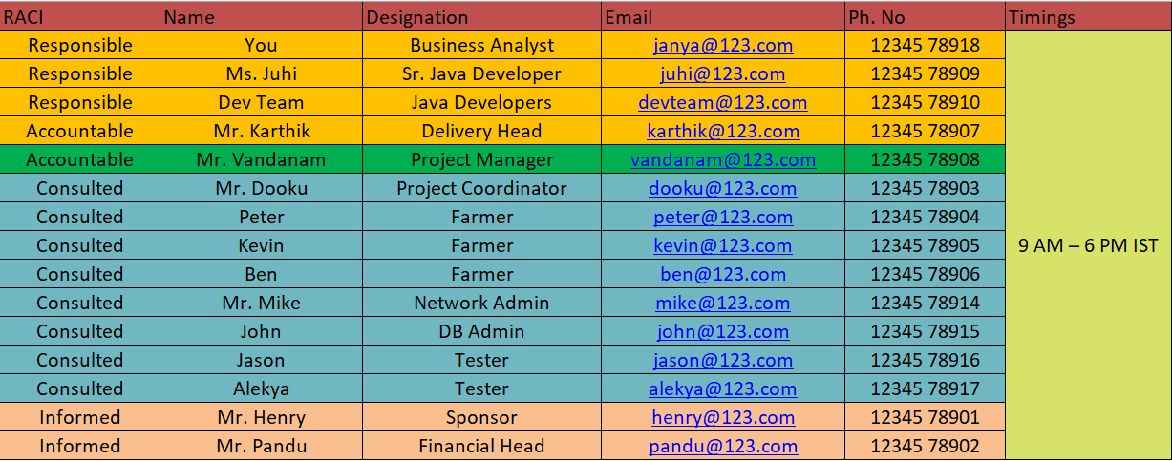

Question 7 – Business Case Document
Ans:
Karthik must prepare a business case document to show our purpose of the project. For this we need to answer the above questions.
- Why is this project initiated?
Mr. Henry initiated this project to address the difficulties faced by farmers in the village for purchasing seeds, pesticides, and fertilizers.

- What are the current problems?
There are difficulties faced by the farmers to get the fertilizers and other products for the farming due to unavailability of the products in offline store. Framers must travel to the store to confirm whether the product is available or not?

- With this project how many problems can be solved?
This project can solve many problems for farmers. They can buy seeds, pesticides, and fertilizers easily through the online app without traveling anywhere, which saves money and time. The products are low-cost and good quality. Farmers also get doorstep delivery and proper instructions directly from the manufacturers.

- What are the resources required?
Funds, developers, manufacturers, Internet connectivity, security, support team, delivery vendors, customers.

- How much Organizational changes required to adopt this technology?
Some organisational changes required to adopt this technology such as website development team, marketing, providing information to the consumers.

- What is the time frame to recover ROI?
Time frame of 2 to 3 years, as we can expect maximum no. of farmers & manufacturing companies will participate in online agricultural store.

- How to identify stakeholders?
Stakeholders can be identified by determining who is interested, affected or has impact on this project. This includes internal groups like team members and managers and external groups such as customers and suppliers.

Question 8 – Four SDLC Methodologies
Ans:
Sequential: It is a classic life cycle model and referred as a linear – sequential life cycle model. In this model, each phase must be completed entirely before the next phase begins. After completing each phase, it is reviewed if the project is in the correct path or not and decide whether to continue the project or not.
Stages:
- Requirement gathering
- Requirement analysis
- Design
- Development - coding
- Testing
- UAT
- Configuration management
- Deployment and implementation
Iterative (RUP):
In this model the project is delivered in modules with some frequency. We track the defects at early stages, this avoids the downward flow of the defects.
Phases:
- Inception: what will be built
- Elaboration: design needed to deliver
- Construction: implementation of full functional system
- Transition: delivery, defect correction

Evolutionary:
The spiral model is a risk-driven process model generator for software projects. The spiral model has four phases
Phases:
- Planning
- Risk analysis
- Engineering
- Evaluation
Agile:
Agile is implemented where the project is to be delivered faster, no documentation required. Can handle the change requests. Agile requires close collaboration between the development team and the stakeholders ensures faster and more efficient software delivery.

Question 9 – Waterfall Rup Spiral and Scrum Models
Ans:
Waterfall:
In the waterfall model each face should be completed before the next phase begins. After completing each phase, it is reviewed if the project is in the correct path or not and decide whether to continue the project or not. It is also referred as linear – sequential life cycle model.
RUP:
It is an iterative model developed by IBM. It mainly focuses on the risk analysis. In this model it is described what is to be produced and how goals are to be achieved.
Spiral:
The spiral model emphases risk analysis. There will be a high amount of risk analysis, and it is good for the large project. Consists of repeated cycles (spirals) with four activities: Planning, Risk Analysis, Engineering, Evaluation.
Scrum models:
The scrum model can be implemented either at the beginning of the project pr when the project is declining stage.
- As a BA, the V model SDLC methodology will be best for this project. This is a small project, and a small project and V model works well for small projects. In this V model, the testing is done in each phase and review the process so we will know that the project is going on correct path or not.

Question 10 – Waterfall Vs V-Model
Ans:
The difference between Waterfall Model and V – Model are as below:
Waterfall model | V - Model
Cost is very low | V – Model is expensive
Guarantee of success is low | Guarantee of success is high
It moves in linear way | Does not move in linear way
Waterfall model is rigid | V – Model is flexible
Testing starts after the development stage | Testing starts from initial stage

Question 11 – Justify Your Choice
Ans:
As a BA, I would like to choose V model for this project since it is a small project. If we have testing phase associated with each development phase, it becomes easy to
identify problems in project to run development process smoothly. With this V-model we can satisfy our clients as well as the end users’ needs with the delivery of valuable software and the desired results.

Question 12 – Gantt Chart
Ans:

Resources | Week 1–10 | Week 11–20 | Week 21–29 | Week 30–46 | Week 47–55 | Week 56–65 | Week 66–78
Project Manager | 1
Business Analyst | 1
Java Developer |  |  | 5
Testers |  |  | 2
DB admin |  | 2
Network admin |  | 1 admin

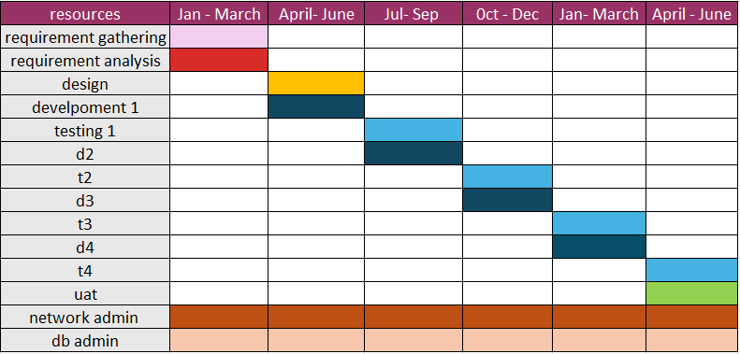

Question 13 – Fixed Bid Vs Billing
Ans:
Fixed bid:
The client will be fixing the budget and timeline before the initiation of the project. A fixed-bid project is one where the service provider agrees to complete a set of tasks for a fixed price. The scope, deliverables, and timeline are decided in advance, and any extra costs or delays are the responsibility of the service provider.
Billing projects:
In this model, the client will pay per resource per hour for work done by the team. This model is preferred for long term projects. In this model, Resources & timelines are flexible and can be adjusted if needed. Budget is estimated based on the requirements and process. The changes in project are acceptable in this model.

Question 14 – Prepare timesheets of a BA in various stages of SDLC
Ans:
