Waterfall Model Documents

Waterfall Project2 – Part -2/2 – 100 Marks - Pass 60 % Instructions to follow:
- Copy paste (either image, diagram or text) is not entertained. If done, the document will not be
evaluated.
- After submission of the answers of this exam, you should be prepared to attend viva and justify your answers in the exams. If in Viva, participant is NOT justifying the answers, Viva will be repeated until Candidates justify 60% correctness.
- Mentor calls are scheduled only if the participant have submitted their task at least for one time. (should apply their knowledge in this task first)
- For attempting the exams participant should be thorough on the topics using their references.
- Please format the document properly (Always have a question no., question and answer).
- Have a consistent format (Font name: Arial/ Calibri -Font size 12, Font Color: Black).
- Answers should be elaborated in detail (not as per the allotted marks).
- Please focus on learning and applying the knowledge as this knowledge will be helpful in contributing at your BA job.
- In the evaluation, students must answer all questions and should be able to justify at least 60% content and correctness of each answer.

Part 2/2 Evaluation
Document 6- Please prepare a use case diagram, activity diagram and a use case specification document.
Document 7- Screens and pages Document 8- Tools-Visio and Axure Document 9- BA experience
My experience as BA in following phases:
- Requirement gathering:
- Requirement Analysis:
- Design:
- Development:
- Testing:
- Deployment:

Document 6- Please prepare a use case diagram, activity diagram and a use case specification document.

  - Use case Name
  - Use case Description
  - Actors Primary Actors Secondary actors
  - Basic Flow
  - ALTERNATE FLOW
  - Exceptional flows
  - Pre- Conditions
  - post-conditions
  - Assumptions
  - Constraints
  - Dependencies
  - Inputs and Outputs
  - Business Rules
14. Miscellaneous Information

Ans:
Use Case Specification Document: Submit Credit Application

Activity Diagram

1. Use Case Name
Submit Credit Application

2. Use Case Description
This use case describes how a Relationship Manager (RM) submits a credit application for a commercial client in the CM Simpli system. The application is then reviewed by Credit Officers for approval.

3. Actors
- Primary Actor:
  - Relationship Manager (RM)
- Secondary Actors:
  - Credit Analyst
  - Credit Officer
  - System Admin

4. Basic Flow (Main Success Scenario)
- RM logs into CM Simpli system
- RM navigates to “New Credit Application” section
- RM fills in client information and credit requirements
- RM attaches necessary documents (e.g., financials, ID, KYC)
- RM submits the application
- System validates required fields
- System routes the application to the Credit Officer
- Confirmation message is shown to RM

5. Alternate Flows
5A – Save as Draft:
- RM can choose to save the application as a draft instead of submitting.
5B – Missing Information:
- If any mandatory fields are missing, the system prompts the RM to complete them before submission.

6. Exceptional Flows
6A – System Timeout:
- If session times out due to inactivity, RM is logged out, and data is lost unless saved as draft.
6B – Document Upload Error:
- If a document fails to upload, system notifies user and prompts retry.

7. Pre-Conditions
- RM is authenticated and logged into the system
- Client profile exists or is created before application
- RM has necessary access rights

8. Post-Conditions
- Credit application is successfully submitted and queued for review
- RM receives application reference number
- Audit trail is updated

9. Assumptions
- All actors have valid roles and permissions
- System is available and responsive
- Client KYC is already validated

10. Constraints
- File upload limit: 10MB per document
- Only PDF and DOCX files allowed
- Application form must be submitted within 48 hours of creation

11. Dependencies
- Client data service integration
- Document storage service
- Role-based access control (RBAC)
- Credit approval workflow

12. Inputs and Outputs
- Inputs:
  - Client data, loan details, financial documents
- Outputs:
  - Application reference number, submission confirmation, audit log

13. Business Rules
- Application cannot be submitted without mandatory financial documents
- Each credit application must be associated with a valid client ID
- Only RMs with role “Credit Submitter” can submit applications

14. Miscellaneous Information
- Application submission timestamps are stored in UTC
- Email notification sent to Credit Officer upon submission
- Data encrypted in transit and at rest

Document 7- Screens and pages
Please follow the following steps to create the mock-ups
    - Kindly use balsamic or Axure.
    - Always start with a home page of an application.
    - Take a feature and follow it to the end
      - Eg: Home page of SCRUM Foods
      - Select Login- Create a login page
      - Let’s assume, you want to search a restaurant
      - Search page- Type the restaurant name and select the dish
      - Add to cart page
      - Payment page
      - Logout page

Ans:
Images
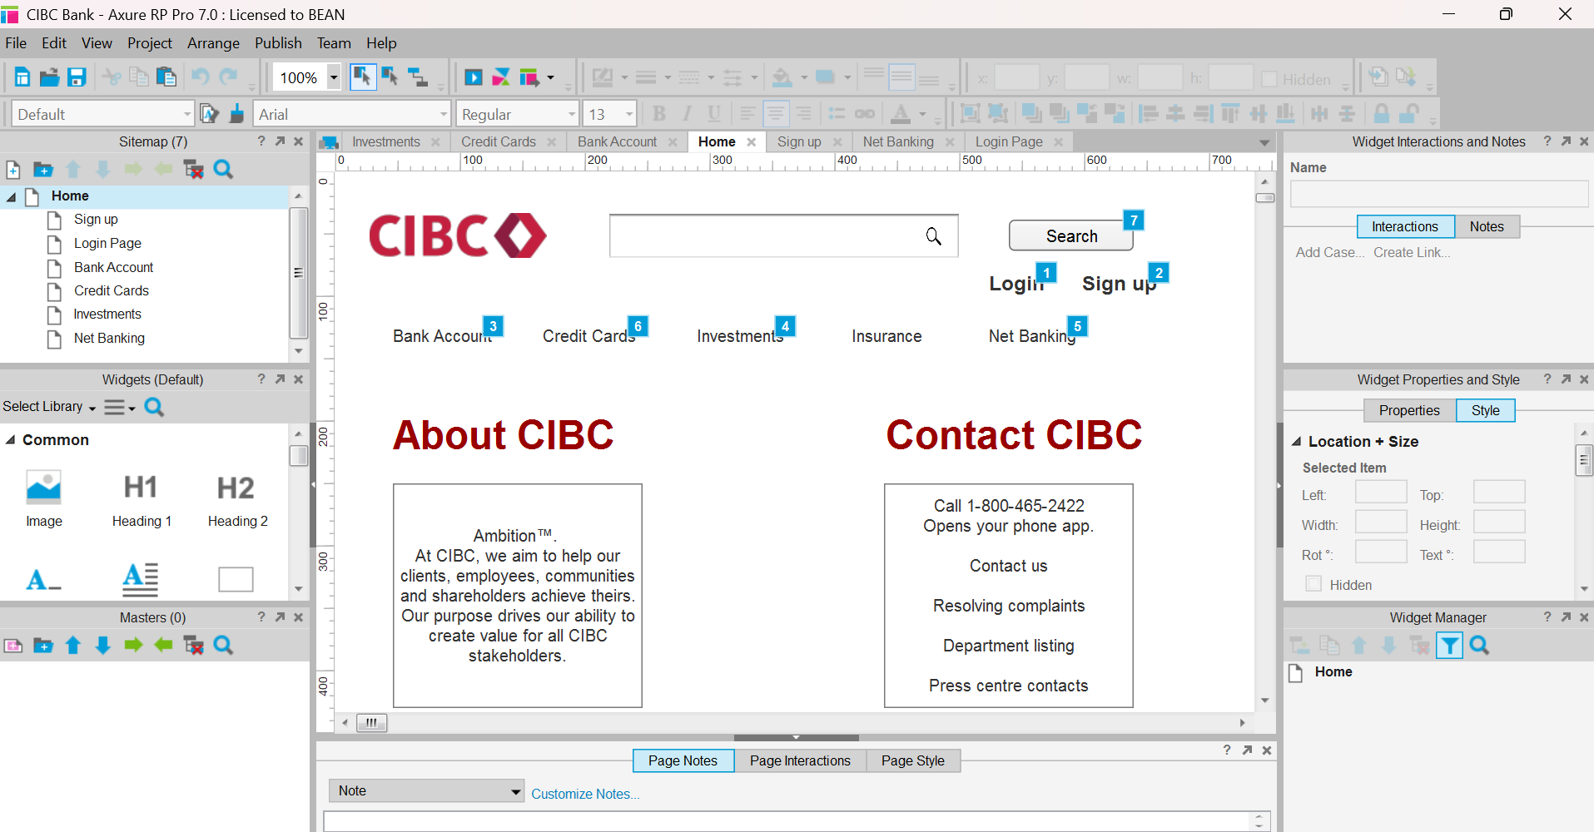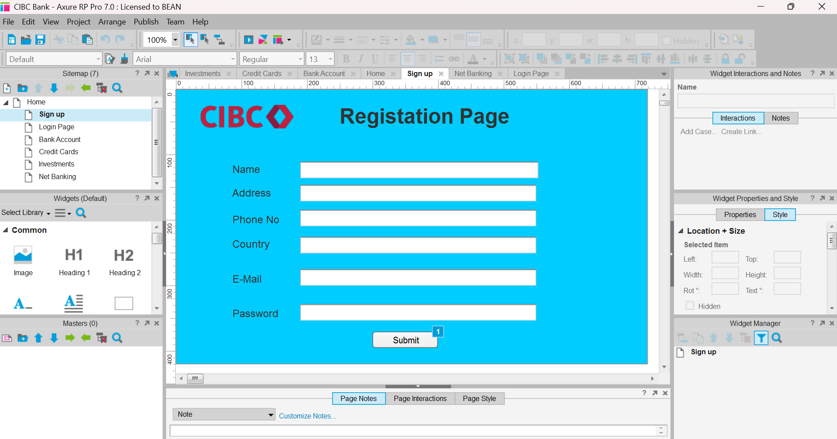

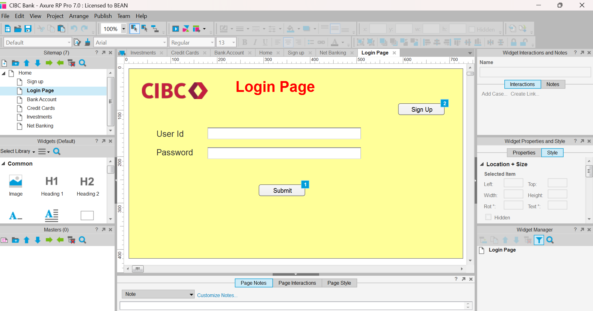

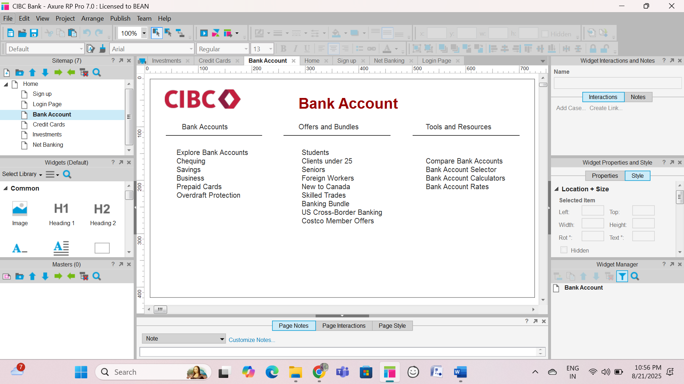

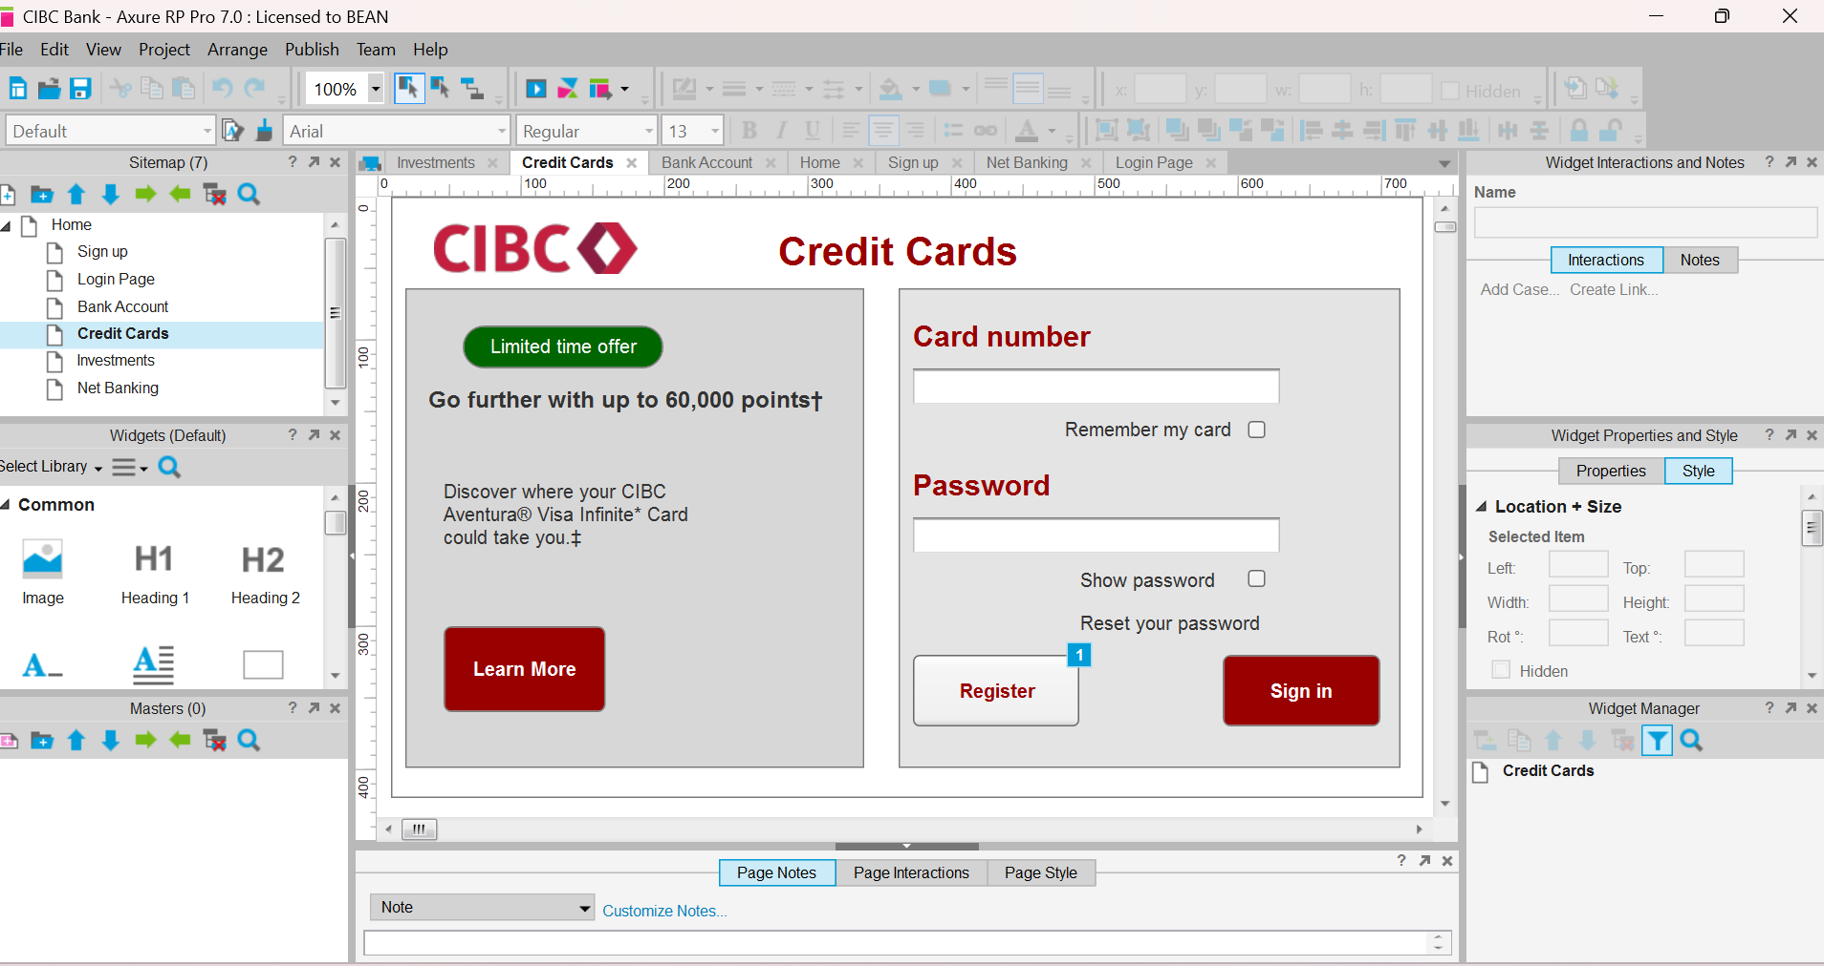

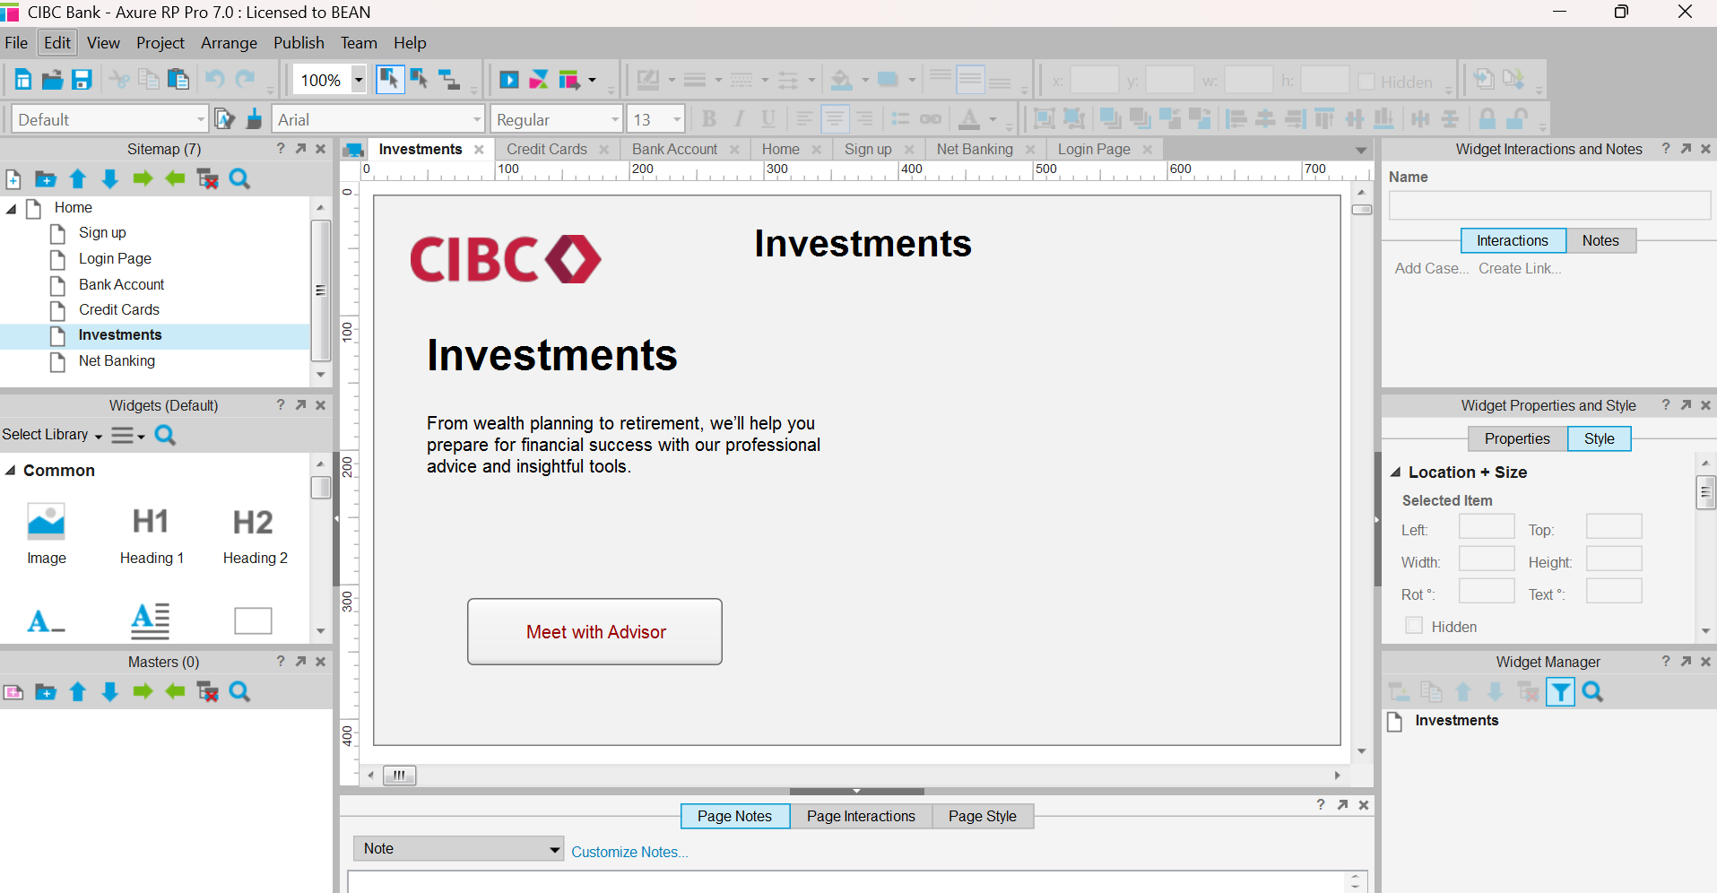

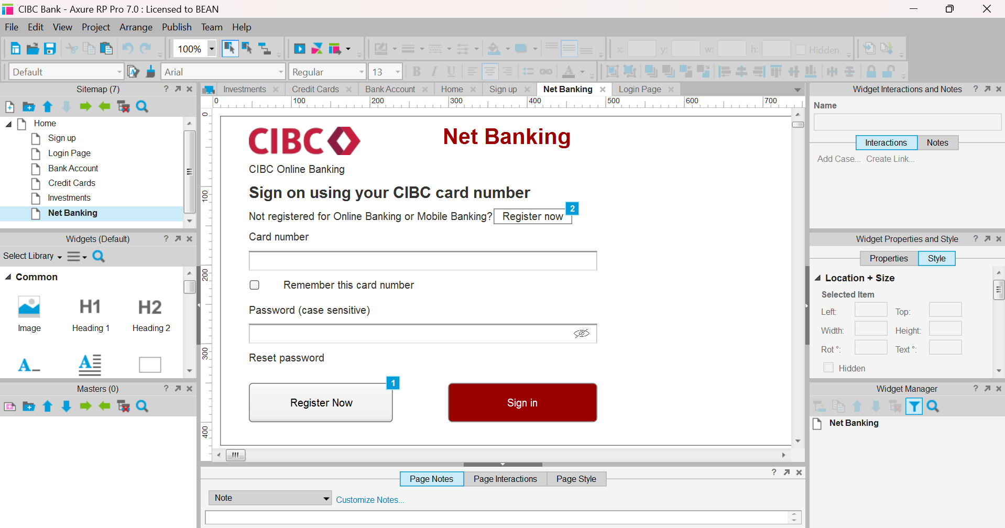Tool to Use
- Create all mock-ups using Axure RP.
Start with the Home Page
- Begin by designing the Home Page of the application.
- Include navigation to all main features.

Design the Following Core Screens (in order):
- Login Page – For registered users to access the application.
- Sign-Up Page – For new users to create an account.
- Bank Account Page – Show account details, balances, and transactions.
- Credit Cards Page – Show card details, statements, and payment options.
- Investment Page – Display portfolio details, charts, and investment tools.
- Net Banking Page – Provide fund transfers, bill payments, and online services.

Login Page – Specification
Purpose:
To allow registered users to securely log in and access their accounts.
Page Elements:
- Header Section
  - Application logo
  - Page title: "Login"
- Login Form
  - Username / Email field (text box)
    - Placeholder: “Enter Username or Email”
    - Validation: Required
  - Password field (password box)
    - Placeholder: “Enter Password”
    - Validation: Required, masked input

  - Login Button (primary action button)
    - Label: “Login”
  - Remember Me (checkbox)
  - Forgot Password (link to password reset page)
- Additional Links
  - “Don’t have an account? Sign Up” (link to Sign-Up page)
- Footer
  - Copyright notice
  - Links to Terms & Privacy Policy

Sign-Up Page – Specification
Purpose:
To allow new users to create an account in the application.
Page Elements:
- Header Section
  - Application logo
  - Page title: "Sign Up"
- Registration Form
  - Full Name (text box)
    - Placeholder: “Enter your full name”
    - Validation: Required
  - Email Address (text box)
    - Placeholder: “Enter your email”
    - Validation: Required, must be in valid email format
  - Mobile Number (text box)
    - Placeholder: “Enter your mobile number”
    - Validation: Required, numeric only
  - Password (password box)
    - Placeholder: “Create a password”
    - Validation: Required, min 8 characters, includes letters and numbers
  - Confirm Password (password box)
    - Placeholder: “Re-enter your password”
    - Validation: Must match the password field

Bank Account Page – Specification
Purpose:
To display the user’s bank account details, balances, and recent transactions, and to provide quick access to account actions.
Page Elements:
- Header Section
  - Application logo
  - Page title: "Bank Account"
  - Navigation menu (links to: Home, Credit Cards, Investment, Net Banking, Logout)
- Account Summary Panel
  - Account Holder Name (text label)
  - Account Number (masked: e.g., XXXX XXXX 1234)
  - Account Type (e.g., Savings, Current)
  - Available Balance (highlighted text)
  - Last Updated (timestamp)

Document 8- Tools-Visio and Axure
Write a paragraph on your experience using Visio and Axure for the project.
Ans:
During the project, I actively utilized Microsoft Visio and Axure RP to support various stages of business analysis and design. Using Visio, I created clear and structured process flow diagrams, data flow diagrams (DFDs), and swim lane diagrams to visualize complex business workflows and system interactions. This helped stakeholders easily understand the current and proposed processes. In Axure, I developed interactive wireframes and high-fidelity prototypes to represent the application's UI and functionality. This was particularly useful during stakeholder reviews and user acceptance sessions, as it allowed for early feedback and iterative refinement. Both tools significantly enhanced communication among cross-functional teams and ensured alignment between business requirements and technical implementation.

Document 9- BA experience

My experience as BA in following phases:
- Requirement gathering:
  - To gather requirements, we used MOSCOW technique.
  - Client is not available for some period of time during this phase. So as a BA i need to source out point of contacts from his side and get the information ASAP.
  - I validate the requirements using FURPS technique
  - There are many requirements which are duplicated or repeated. We need to remove them immediately
  - Prototyping is used to give more specific requirements

Requirement Analysis:
  - We need to draw UML diagrams to visually describe the requirements
  - Activity diagrams also used to describe the process flow
  - Communicate the diagrams to team. Some team members might not agree with them and might make changes. As a BA we need to consider the points and make modifications
  - Prepare BRS and SRS

Design:
  - From the use case diagrams, we prepare test cases
  - Communicate with client on design and solution documents
  - Write negative test cases as well along with positive test cases.
  - Do not miss a single test case. It might have huge impact on project development in later stages
  - Prepare test data for testing
  - Update RTM. This is just as we need to make sure that all the requirements are met

Development:
  - Organized JAD sessions
  - Clarifying queries of tech team during coding
  - There might be some team members who doesn't agree with the concept or who doesn’t cooperate during JAD sessions. As a BA i handle the situation gently and had one on one discussion with them. Explained how their actions are going to affect the project. Setup healthy environment within the team.
  - Referred diagrams to code the Unit
  - Conduct regular meetings with technical team and client which is challenging. Some team members might not be available for the meeting. Recording the session and providing that to missed one and having one to one discussion later with that missed person is all i need to do

Testing:
  - Prepare test cases from use cases
  - Perform high level testing
  - Test data is requested by BA from client
  - Updated RTM
  - Take signoff from client
  - Prepare client for UAT

Deployment:
  - Forwarded RTM to client which should be attached to project closure document
  - Coordinates to complete and share end user manuals
  - Plans and organizes training sessions
  - Make sure all the candidates attend the meeting

