COEPD – Prep Exam 3 –Part 2/2

Q1. What is the difference between Brainstorming and JAD Sessions?
Ansswer -
Point | Brainstorming | JAD (Joint Application Development) Sessions
Definition | A group creativity technique used to generate a large number of ideas or solutions to a problem. | A structured workshop involving stakeholders, business users, and IT team to gather requirements and design solutions.
Purpose | To encourage free flow of ideas and innovative solutions. | To gather detailed requirements and make collective decisions.
Participants | Generally involves team members, subject matter experts, or stakeholders – often smaller groups. | Includes stakeholders, business analysts, developers, testers, and end-users.
Structure | Informal, unstructured, free-flow discussion. | Formal, structured, facilitator-led sessions with clear agenda.
Output | List of potential ideas, options, or solutions. | Documented business requirements, system design decisions, and consensus.
When Used | Early stages of requirement elicitation or problem-solving. | When detailed requirements and alignment between business & IT are needed.

Q 2. Why Document Analysis is one of the compulsory technique we use in a Project? Justify – 3 Marks
- Answer - Document Analysis helps to study existing documents like policy papers, user manuals, reports, process flows, and previous project documents.
- It saves time by providing background knowledge and helps understand current processes, rules, and pain areas.
- It ensures no important detail is missed and gives a strong base for requirement gathering and validation.
Justification:
Without document analysis, there is a risk of incomplete requirements, missing compliance rules, and misunderstanding of business processes. That’s why it is a compulsory technique in projects.

Q3. In Which Context we will use Reverse Engineering?
- Answer - Reverse Engineering is used when there is an existing system but proper documentation is missing or outdated.
- It helps to understand system functionality, workflows, data structures, and business rules.
- Useful in cases like system migration, upgrading legacy applications, or analyzing competitor’s product.
- It is also applied when we need to re-build, enhance, or integrate an old system with new technology.
Context:
Reverse Engineering is mainly used in legacy systems where documentation is not available, but the system is still working and business depends on it.
Q4. What is the difference between Brainstorming and Focus Groups?
Answer - Brainstorming:
- A technique used to generate a wide range of creative ideas and solutions.
- Participants are encouraged to think freely without criticism.
- Focus is on quantity of ideas first, quality is analyzed later.
- Typically used in the early stage of requirement elicitation.
Focus Groups:
- A structured discussion with selected stakeholders or users.
- A moderator guides the session to collect opinions, expectations, and feedback.
- Focus is on exploring perspectives, needs, and experiences.
- Used to validate requirements and understand user expectations.

Q5. Observation Technique – Explain both Active and Passive approaches
Answer- Observation Technique:
It is a requirement elicitation technique where the Business Analyst directly observes stakeholders’ day-to-day activities to understand processes, workflows, and challenges.
1. Active Observation (Participatory):
- The BA actively participates in the process while observing.
- Example: A BA joins the sales team and performs some activities to understand the sales workflow.
- Advantage: Provides deeper insights into challenges and exceptions.
2. Passive Observation (Non-Participatory):
- The BA silently observes the stakeholders without interfering in their work.
- Example: Watching how a cashier handles customer billing in a store.
- Advantage: Less disruptive, captures the real way tasks are performed.

Q6. How do you conduct the Requirements Workshop-
Answer - Conducting a Requirements Workshop:
- Plan & Prepare: Identify objectives, participants, agenda, and resources.
- Facilitate the Workshop: Engage stakeholders, encourage participation, use techniques (brainstorming, discussions, models).
- Document & Validate: Capture requirements, resolve conflicts, and get confirmation from stakeholders.
Q7. In which context, Interview Technique can be conducted by a BA ? How may approaches are there in conducting Interviews? (Structured – Unstructured) Explain them. Explain the difference between Open Ended Questions and Closed ended Questions –
Answer - Interview Technique – Context:
- A BA conducts interviews to gather detailed information directly from stakeholders.
- Useful when requirements are not documented, or when clarification is needed on specific processes.
Approaches of Interviews:
- Structured Interview:
  - Predefined set of questions.
  - Formal and consistent.
  - Example: Asking each user the same set of requirement-related questions.
- Unstructured Interview:
  - Open conversation with no fixed format.
  - More flexible, exploratory in nature.
  - Example: Casual discussion to understand user needs.
Difference between Question Types:
- Open-Ended Questions:
  - Allow detailed, descriptive answers.
  - Example: “What challenges do you face while using the current system?”
- Closed-Ended Questions:
  - Have specific, short answers (Yes/No or choice-based).
  - Example: “Do you use the mobile app for placing order” (Yes/No or choice-based).
Q8. Questionnaire Technique – Where we will use? Give one example
Answer - Questionnaire Technique:
- A BA uses questionnaires when information needs to be collected from a large group of stakeholders in less time.
- Useful for gathering quantitative data, opinions, or feedback.
- Cost-effective and time-saving.
Where we will use Questionnaire Technique:
- When there are many stakeholders spread across different locations.
- When time is limited and BA cannot interview everyone individually.
- When we need statistical / measurable data (preferences, ratings, multiple-choice answers).
- Best used for surveys, feedback, and requirement validation.
Example:
In an Online Agriculture Products Store, a BA circulates a questionnaire to farmers asking: “Which mode do you prefer for receiving payments – Bank Transfer, UPI, or Cash on Delivery?”

Q9. How to Sort the Requirements – Where we will use? Give one example - 5 Marks
Answer - How to Sort the Requirements:
- Sorting requirements means arranging them in a systematic order based on priority, category, or dependency.
- Common techniques:
  - MoSCoW Method – Must Have, Should Have, Could Have, Won’t Have.
  - Priority-based Sorting – High, Medium, Low.
  - Grouping by Functionality – Example: Customer Module, Product Module, Payment Module.
Where we use it:
- Used during requirement analysis and prioritization phase.
- Helps stakeholders and the project team to focus on critical requirements first.
Example (Online Agriculture Products Store):
- Must Have: Farmers should be able to list their products.
- Should Have: Customers can track order delivery.
- Could Have: Discount coupons and offers.
- Won’t Have (for now): AI-based crop suggestions.

Q10. Prioritise the Requirements – –Where we will use? Give one example - 5 Marks
Answer - Prioritizing the Requirements:
- It is the process of deciding which requirements should be implemented first based on their business value, urgency, and impact.
- Techniques used: MoSCoW, 100-Dollar Method, Ranking, Kano Model.
Where we use it:
- During requirement analysis and release planning.
- Helps the BA and project team to deliver high-value features early and manage scope effectively.
Example (Online Agriculture Products Store):
- High Priority: Farmers should be able to register and list their crops online.
- Medium Priority: Customers can give ratings and reviews.
- Low Priority: System sends festival-based promotional offers.

Q11. Weekly status reporting – How we will drive? 5 Marks
Answer - A Weekly Report is a concise summary of all work done during a week, explaining how the completed activities contribute to the progress of a task or project and bring the team closer to their goals. It helps keep stakeholders and team members informed about recent work, accomplishments, priorities, and challenges for the upcoming week.
1. What have you been working on recently?
- Finalized and documented core requirements with stakeholder team (Peter, Kevin, Ben).
- Coordinated approval for UI mockups with Mr. Henry and committee.
- Worked on payment gateway integration with Ms. Juhi and developers.
- Conducted risk assessment and started usability review for mobile app.

2. What have you accomplished this week?
- Completion of requirements phase; signed off by all stakeholders.
- UI prototype approved and handed off to testing team.
- 60% backend development achieved; user registration module deployed in test.
- Identified new enhancement request: crop-sale/auction feature.

3. What are your top priorities?
- Resolve payment gateway integration issues with developer team.
- Begin impact analysis and requirement drafting for crop auction module.
- Continue development on product listing and order management features.
- Prepare environment for first round of user acceptance testing.

4. What are your challenges going into next week?
- Payment API integration is delayed due to technical obstacles.
- Adapting requirements for new crop auction feature within original timeline.
- Ensuring clear communication with remote stakeholders on feature changes.
- Managing team bandwidth for parallel development and bug fixing.

Q12. Meeting Minutes Document – prepare one Sample -5 Marks
Answer –
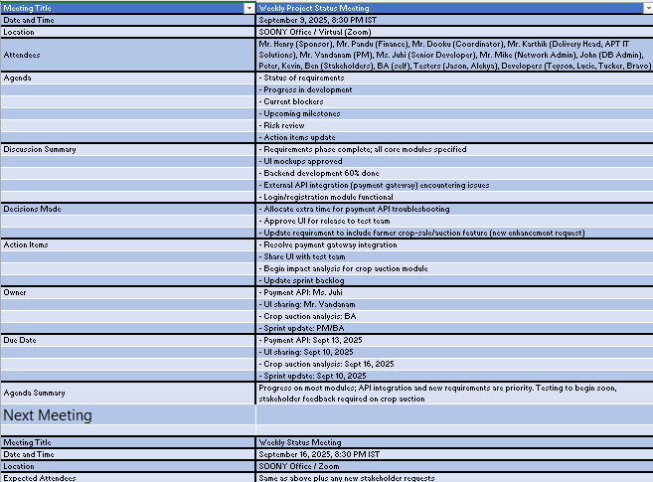
Q13. Change Tracker – Document - – prepare one Sample -4 Marks
Answer –
Date | Version Number | Document changes | Name | Title | Signature | Approved by
05-09-2025 | v1.1 | Added crop auction feature requirement | Peter | Stakeholder | [Signed] | Mr. Karthik
07-09-2025 | v1.2 | Revised UI mockups for farmer dashboard | Ms. Juhi | Sr. Developer | [Signed] | Mr. Vandanam (PM)
08-09-2025 | v1.3 | Updated payment gateway integration plan | Mr. Mike | Network Admin | [Signed] | Mr. Dooku (Coord.)
09-09-2025 | v1.4 | Incorporated bug fixes from initial UAT feedback | Jason | Tester | [Signed] | Mr. Henry (Sponsor)

Q14. Difference between Traditional Development Model and Agile Development Models – 8 Marks 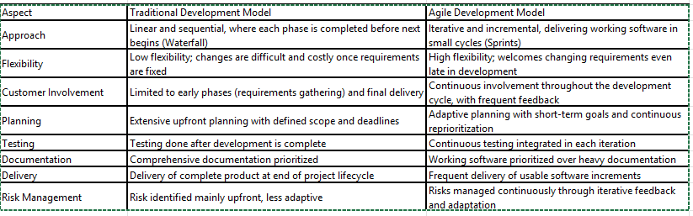
Q15. Explain Brainstorming Technique – Where to use? 5 Marks
Answer - Brainstorming is a creative problem-solving technique where team members come together to freely generate a wide range of ideas to address a specific issue or challenge. The goal is to encourage open thinking without criticism, fostering an atmosphere where innovative and diverse solutions can surface.
Key Features:
- Emphasizes quantity of ideas over immediate quality.
- No idea is judged or rejected during the session.
- Ideas are recorded for further analysis and refinement later.
- Can be done in person or virtually with diverse participants including experts, stakeholders, and team members.
Where to Use Brainstorming:
- Project Initiation: Defining project objectives, scope, and stakeholder identification.
- Planning Phase: Generating risk mitigation strategies, resource allocation ideas, scheduling alternatives.
- Problem Solving: Overcoming obstacles during execution by generating creative solutions.
- Improvement: Identifying process improvements and ways to enhance team collaboration.
- Idea Generation: When launching new features, products, or exploring enhancements.

Q16. What reports Accounts Departments will generate (minimum 5 reports) – 10 Marks

Answer - Here are five key reports that the Accounts Department in TTS Company’s Employees Loan Management System project would generate, explained for 10 marks:

Reports Accounts Department Will Generate
- Loan Approval and Disbursement Report
  - Lists all loans approved during a period with employee details, loan amounts, approval dates, and disbursement status.
  - Helps track how many loans were granted and the total loan amount disbursed.
- Loan Repayment Schedule Report
  - Displays repayment timelines for all active loans including installment amounts, due dates, and outstanding balances.
  - Assists in monitoring upcoming payments and managing employee deductions.
- Loan Rejection and Reason Report
  - Summarizes loans rejected by HR/Accounts with reasons for rejection documented for employee communication and audit.
  - Allows management to review common rejection causes and improve loan eligibility criteria.
- Salary Deduction Report
  - Details automatic salary deductions made for loan repayments for each employee, including amount deducted and payment dates.
  - Ensures accurate reconciliation of repayments and payroll processing.
- Outstanding Loan Balance Report
  - Shows current loan balances for all employees with active loans, including delayed or defaulted payments.
  - Supports risk assessment, follow-up actions, and forecasting cash flows related to employee loans.

These reports provide comprehensive visibility into the lifecycle of employee loans from approval through repayment and assist efficient loan management while supporting transparency and compliance.

Q17. What is the structure of the message/mail communicated from the HR department to the employee in case the Loan is rejected? – 5 Marks

Answer - Structure of Loan Rejection Message/Mail from HR to Employee
- Subject Line:
  - Example: "Loan Request Status – Application Rejected"
- Salutation:
  - Dear [Employee Name],
- Acknowledgment of Loan Request:
  - Thank you for submitting your loan request dated [Application Date].
- Rejection Statement:
  - We regret to inform you that your loan application has been reviewed and unfortunately cannot be approved at this time.
- Reason for Rejection:
  - The decision is based on [specific reason(s), e.g., eligibility criteria not met, insufficient documentation, credit limits exceeded, etc.].
- Optional Alternative or Next Steps:
  - You may consider reapplying after addressing [specific issues], or explore other loan options available through [partner banks/financial institutions].
- Offer of Support:
  - If you have any questions regarding this decision, please feel free to contact the HR department at [HR contact details].
- Closing:
  - We appreciate your understanding.
  - Regards,
  - [HR Manager’s Name]
  - HR Department, [Company Name]

Q18. What is the structure of the message/mail communicated from the HR department to the employee in case the Loan is approved? – 5 Marks
Answer - Structure of Loan Approval Message/Mail from HR to Employee
- Subject Line:
  - Example: "Loan Application Approved – Details and Next Steps"
- Salutation:
  - Dear [Employee Name],
- Approval Confirmation:
  - We are pleased to inform you that your loan application submitted on [Application Date] has been approved.
- Loan Details:
  - Approved loan amount: [Amount]
  - Interest rate: [Rate]%
  - Repayment term: [Number] months
  - Monthly installment/deduction amount: [Amount]
- Terms and Conditions:
  - Outline key loan terms and conditions, including repayment schedule and automatic salary deduction details.
- Acceptance Request:
  - Please review the attached loan agreement and confirm your acceptance by signing and returning it by [Due Date].
  - Contact HR if you have any questions or require clarifications.
- Closing:
  - Congratulations and thank you for your continued contributions to [Company Name].
  - Regards,
  - [HR Manager’s Name]
  - HR Department, [Company Name]

Q19. Design a sample report on the Loans applications Received by the accounts department – 8 Marks
Answer - 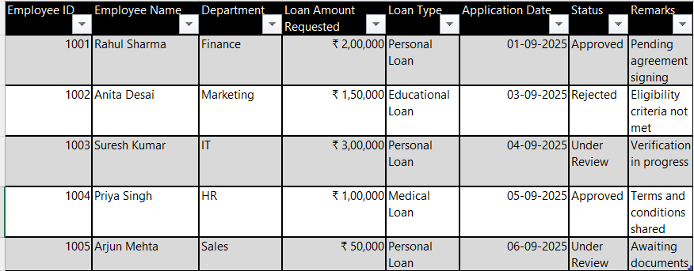

Summary:
- Total applications received this month: 5
- Approved: 2
- Rejected: 1
- Under Review: 2

Q20. Which reporting Tools we will use for generating reports. – 5 Marks
Answer - Reporting Tools for Generating Reports
- Microsoft Power BI
  - A powerful business intelligence tool for creating interactive and visually appealing dashboards and reports.
  - Supports data integration from multiple sources and offers real-time analytics.
- Tableau
  - Widely used data visualization platform that enables easy creation of detailed, customizable reports.
  - Good for drilling down into loan data trends and employee loan status visualization.
- Crystal Reports
  - Popular for enterprise report generation with rich formatting outputs, ideal for formal loan approval/rejection letters and financial statements.
- SQL Server Reporting Services (SSRS)
  - Generates reports directly from SQL databases with complex query support, useful for up-to-date loan applications and repayment status reports.
- Excel with Pivot Tables and Power Query
  - Flexible and accessible tool for ad-hoc reporting, data sorting, and filtering.
  - Suitable for smaller-scale data analysis and quick loan report generation.

