AGILE DELIVERABLES

Documented by V Niharika
Date : 15-09-2025

Agile Documents –

Document 1: Definition of Done

Definition of Done (DoD) for the Human Machine Interface (HMI)
For an HMI Agile project, a feature is considered done when the designed interface is fully implemented, tested for functionality, usability, performance, and accessibility, integrated with backend/embedded systems without defects, documented properly, and accepted by the Product Owner as a potentially shippable product increment.
Checklist for DoD:
Code & Development
- Code implemented, peer-reviewed, and merged to main branch.
- Code follows naming conventions and coding standards.
- Unit tests written with ≥ 80% coverage.
Functionality
- Tagging options (Single, Multiple, No Stow) implemented and functional.
- Feedback/dislike option for poor-quality media is working.
- Dashboards/reports for supervisors are updated and accessible.
Testing
- Unit testing passed.
- Integration testing passed.
- UAT (User Acceptance Testing) completed with stakeholders.
- No critical/high defects remain open.
Performance & Quality
- Video/image clarity meets agreed standards.
- System performance improved (e.g., video loads 30–40% faster).
- Load testing completed for large video files.
Documentation
- User stories updated with acceptance criteria.
- Technical documentation updated.
- User training material prepared (for associates).
Deployment & Compliance
- Code deployed in staging/production environment via CI/CD.
- Security checks completed and privacy compliance verified.
- Feature demoed in sprint review to product owner/stakeholders.
Definition of Ready:
It is a set of clear criteria that a user story must meet before the development team can start working on it in a sprint. It ensures the story is well-defined, understood, estimated, prioritized, and free of major blockers, so the team can confidently commit to delivering it.

Clear User Story – Written in the format “As a … I want … so that …” and easily understood by all team members.
Acceptance Criteria Defined – Testable and measurable conditions for success are documented.
Dependencies Identified – Any external inputs (e.g., videos/pictures from fulfillment center, compliance datasets) are available or planned.
Data Availability Confirmed – Sample videos/pictures for testing are provided.
Effort Estimated – Story points assigned by the development team.
Priority Set – Product Owner has prioritized the story in the backlog.
Non-Functional Needs Considered – Clarity, video quality standards, performance, and audit logging requirements are captured.

Document 2- Product Vision
Scrum Project | Human Machine Interface
Venue: | Online – Microsoft Teams
Date: | 16-September-2025
Start time: | 10:00 AM
End time: | 12:00 PM
Duration: | 2 Hours
Client: | Amazon Fulfillment Centre – Operations & Quality Team
Stakeholder list: | Associates (End Users)  Supervisors / Managers  Product Managers  QA/Compliance Team  Development Team
Scrum Role | Name
Scrum Master: | Vinod
Product Owner: | Niharika
Scrum Developer 1: | Madhuri (Frontend – ReactJS)
Scrum Developer 2: | Abhinaya (Backend – Node.js/Java)
Scrum Developer 3: | Vardhan (AI/ML – Python)
Scrum Developer 4: | Sara (UI/UX Designer
Scrum Developer 5: | Arun (QA Engineer)

Vision
To deliver a smart and reliable Human Machine Interface (HMI) tool that empowers associates, supervisors, and fulfilment centre teams with accurate tagging, high-quality video verification, real-time dashboards, and continuous improvements through Agile, ensuring efficiency, transparency, and compliance in product placement.”
Target Group | Needs / Pain Points | Product / Solution | Value / Benefit
End Users / Operators | Easy-to-use interface, minimal errors, quick navigation | Intuitive HMI screens & controls | Increased efficiency, reduced errors, improved satisfaction
Managers / Supervisors | Real-time monitoring, performance insights | Dashboards and reporting features | Better decision-making and process visibility
IT / Maintenance Team | Seamless integration, maintainable system | Well-documented HMI with backend integration | Reduced maintenance effort, reliable system operation
Business Stakeholders | Timely delivery, measurable ROI | Agile-developed, tested HMI product | Faster deployment, higher ROI, stakeholder confidence

Document 3 UserStories

User Stories – Human Machine Interface ( HMI)

User story No: US-01 | Tasks: Integrate fulfillment center API, display media, functional testing | Priority: High
Value statement:
As an associate, I want to view videos/pictures from the fulfillment center so that I can check product stowing.
BV: 500 | CP: 8 | Acceptance criteria:  Videos and pictures load without errors  Media linked to the correct bin/job ID  Playback smooth with no lag

User story No: US-02 | Tasks: Build tagging UI, connect database, store tagging result | Priority: High
Value statement:
As an associate, I want to tag a bin as Single Product, Multiple Products, or No Stow so that I can mark
BV: 500 | CP: 8 | Acceptance criteria:  Tagging options (Single/Multiple/No Stow) visible  Tagging data saved in DB  Saved tags retrievable in reports

User story No: US-03 | Tasks: Add dislike button, capture feedback, store in DB, generate reports | Priority: Medium
Value statement: As an associate, I want to dislike poor-quality videos/pictures so that future versions improve.
BV: 200 | CP: 5 | Acceptance criteria: Dislike option visible on media  Dislike stored with user ID and media ID  Dislike reports visible to supervisors

User story No: US-04 | Tasks Design report dashboard, build charts, add export function | Priority: Medium
Value statement:
As a supervisor, I want to see reports of tagging results so that I can track accuracy and errors.
BV: 200 | CP: 5 | Acceptance criteria:  Reports display aggregated tagging data  Supervisor can filter by associate/date/bin  Reports exportable in PDF/Excel

User story No: US-05 | Tasks: Implement version control, migration process, testing | Priority: High
Value statement:
As a system admin, I want version management so that I can roll out updates every 6–12 months with improved media quality.
BV: 500 | CP: 8 | Acceptance criteria:  New version deployed successfully  Previous data intact  Version change logged in system

User story No: US-06 | Tasks Create language packs, apply translations, UI testing | Priority: Low
Value statement: As an associate, I want the portal in my preferred language so that I can easily understand instructions.
BV: 50 | CP: 2 | Acceptance criteria:  Videos and pictures load without errors  Media linked to the correct bin/job ID  Playback smooth with no lag

User story No: US-07 | Tasks: Train AI model, integrate AI predictions, validation testing | Priority: Medium
Value statement:
As an associate, I want the system to highlight suspected stow errors using AI so that I can review faster.
BV: 200 | CP: 5 | Acceptance criteria AI highlights stow errors automatically  Accuracy ≥ 80% in test cases  Associate can override AI suggestion

User story No: US-08 | Tasks: Add report filters, update DB queries, test filtering | Priority: Medium
Value statement:
As a manager, I want to filter reports by error type so that I can focus on specific issues.
BV: 200 | CP: 5 | Acceptance criteria:  Reports filterable by error type  Filters apply instantly without refresh  Filtered results downloadable

User story No: US-09 | Tasks Implement logging, create audit trail reports, export functionality | Priority: High
Value statement:
As an IT admin, I want audit trails of tagging actions so that I can ensure compliance.
BV: 500 | CP: 8 | Acceptance criteria:  Each action logged with user ID, timestamp  Audit logs exportable Immutable trail maintained

User story No: US-10 | Tasks: Add tooltips, content entry, UI testing | Priority: Low
Value statement: As an associate, I want tooltips/help text on tagging options so that I can understand them quickly.
BV: 50 | CP: 2 | Acceptance criteria:  Tooltip appears on hover  Tooltip content is correct  Tooltips available for all tagging options

User story No: US-11 | Tasks: Configure notification rules, implement push/email alerts, testing | Priority: Medium
Value statement:
As a supervisor, I want notifications when poor-quality videos are flagged so that I can escalate them.
BV: 500 | CP: 8 | Acceptance criteria:  Notifications sent instantly when flagged  Only relevant supervisors receive alerts  Notification logged in system

User story No: US-12 | Tasks: Translate report templates, implement language selector | Priority: Low
Value statement:
As a stakeholder, I want multilingual reports so that global teams can use them..
BV: 50 | CP: 2 | Acceptance criteria:  Reports generated in multiple languages  Correct language displayed for chosen option

User story No: US-13 | Tasks: Add pause/replay controls, test playback | Priority: High
Value statement:
As an associate, I want to pause/replay videos so that I can verify stow actions accurately..
BV: 500 | CP: 8 | Acceptance criteria:  Pause button works instantly  Replay starts from beginning  Controls work on all devices

User story No: US-14 | Tasks: Define KPIs, create metrics dashboard, integrate data sources | Priority: Medium
Value statement:
As a manager, I want KPIs for accuracy rates so that I can measure associate performance..
BV: 200 | CP: 5 | Acceptance criteria:  KPI dashboard displays daily/weekly accuracy  Data updated in real time  Export option available

User story No: US-15 | Tasks: Implement login system, configure roles, security testing | Priority: High
Value statement:
As an IT admin, I want secure login and role-based access so that only authorized users access data.
BV: 500 | CP: 8 | Acceptance criteria:  Users log in with valid credentials  Roles restrict access correctly  Unauthorized access blocked

User story No: US-16 | Tasks: Build responsive design, test on mobile devices | Priority: Medium
Value statement:
As an associate, I want mobile access to the HMI portal so that I can review stows on handheld devices.
BV: 200 | CP: 5 | Acceptance criteria:  Portal loads on mobile browser  UI responsive to screen size  Full functionality available on mobil

User story No: US-17 | Tasks: Enable download option, handle file formats, testing | Priority: Low
Value statement:
As a supervisor, I want to download flagged images/videos so that I can review offline.
BV: 50 | CP: 2 | Acceptance criteria:  Files download successfully  Correct file format maintained  Download history logged

User story No: US-18 | Tasks: Automate weekly report generation, email integration | Priority: Medium
Value statement:
As a manager, I want weekly summary reports so that I can track overall performance..
BV: 200 | CP: 5 | Acceptance criteria:  Report auto-generated weekly  Report emailed to managers  Data matches actual system metrics

User story No: US-19 | Tasks: Create training mode, load sample videos, test tagging | Priority: Medium
Value statement:
As an associate, I want a training mode with sample videos so that I can practice tagging.
BV: 200 | CP: 5 | Acceptance criteria:  Training mode accessible separately  Mock tasks available for practice  Results not included in live reports

User story No: US-20 | Tasks: Capture feedback, link backlog system, store results | Priority: High
Value statement:
As a product owner, I want a backlog of feedback items from associates so that future releases address real issues.
BV: 500 | CP: 8 | Acceptance criteria:  Feedback form available for associates  Feedback stored with metadata  Backlog auto-updated with new items.

Document 4: Agile PO Experience
As the Product Owner, my responsibilities in the Content Integrity Initiative (SRT Project):

Responsibilities:
- Acted as the primary point of contact for stakeholders, gathering requirements for the HMI system and translating them into actionable user stories.
- Prioritized and managed the product backlog to ensure high-value HMI features were delivered each sprint.
- Defined user stories with clear acceptance criteria, ensuring usability, performance, and accessibility standards were met.
- Collaborated with the Scrum team during sprint planning, daily stand-ups, sprint reviews, and retrospectives to ensure smooth Agile delivery.
- Conducted demos and feedback sessions with stakeholders, refining features based on user input and business needs.
- Ensured integration with backend/embedded systems while maintaining a seamless user experience.
- Monitored progress to ensure the delivery of potentially shippable increments aligned with the project vision.

Lessons Learned:
- Stakeholder Collaboration is Key
  - Early and continuous engagement with stakeholders helped clarify requirements and reduced rework.
- Clear Acceptance Criteria Prevents Ambiguity
  - Writing precise user stories with well-defined acceptance criteria improved testing and delivery quality.
- Prioritization Drives Value
  - Focusing on high-value features first ensured that the most critical HMI functionalities were delivered on time.
- Regular Demos Enhance Feedback
  - Sprint reviews and live demos enabled timely feedback, resulting in a more user-friendly interface.
- Integration Challenges Must Be Anticipated
  - Early coordination with backend/embedded teams prevented integration bottlenecks later in the project.
- Testing Early Saves Effort
  - Incorporating unit, usability, and accessibility testing in early sprints reduced defects in later stages.
- Documentation Supports Maintenance
  - Keeping design, technical, and user documentation updated ensured easier onboarding and system maintenance.
- Team Communication Improves Efficiency
  - Daily stand-ups, retrospectives, and open communication helped in quick issue resolution and smoother sprints.

Document 5: Product and sprint backlog and product and sprint burndown charts

Product Backlog

User Story ID | User Story | Tasks | Priority | BV | CP | Sprint
US0001 | As an associate, I want to view videos/pictures from the fulfillment center so that I can check product stowing. | Integrate APIs, Display media, Test | High | 500 | 8 | Sprint 1
US0002 | As an associate, I want to tag a bin as Single Product, Multiple Products, or No Stow so that I can mark placement accuracy. | UI buttons, DB updates, Validation | High | 500 | 8 | Sprint 1
US0003 | As an associate, I want to mark poor-quality videos/pictures with dislike so that they can be improved in the next version. | Like/Dislike option, Store feedback | Medium | 200 | 5 | Sprint 1
US0004 | As a supervisor, I want to see reports of tagging results so that I can track accuracy and errors. | Dashboard, Charts, Export option | Medium | 200 | 2 | Sprint 2
US0005 | As a system admin, I want version management so that I can roll out updates every 6–12 months with improved quality. | Versioning module, Migration, Testing | High | 500 | 8 | Sprint 1
US0006 | As an associate, I want the portal in my preferred language so that I can easily understand instructions. | Language pack, Localization | Low | 100 | 2 | Sprint 2
US0007 | As an associate, I want the system to highlight suspected stow errors using AI so that I can review them faster. | AI integration, Training, Testing | Medium | 200 | 3 | Sprint 3
US0008 | As a manager, I want to filter reports by error type so that I can focus on specific issues. | Add filters, Query DB, Update dashboard | Medium | 200 | 3 | Sprint 3
US0009 | As IT admin, I want audit trails of tagging actions so that I can ensure compliance and accountability. | Log actions, Create audit reports | High | 500 | 8 | Sprint 2
US0010 | As an associate, I want tooltips/help text on tagging options so that I can understand them quickly. | Add tooltips, Update UI | Low | 50 | 1 | Sprint 5
US0011 | As a supervisor, I want notifications when poor-quality videos are flagged so that I can escalate them. | Notification engine, Rules setup | Medium | 200 | 3 | Sprint 4
US0012 | As a stakeholder, I want multilingual reports so that global teams can use them. | Report localization, Language switch | Low | 100 | 2 | Sprint 4
US0013 | As an associate, I want to pause/replay videos so that I can verify stow actions accurately. | Video controls, UI testing | High | 500 | 5 | Sprint 5
US0014 | As a manager, I want KPIs for accuracy rates so that I can measure associate performance. | Define KPIs, Build metrics dashboard | Medium | 200 | 3 | Sprint 5
US0015 | As IT admin, I want secure login and role-based access so that only authorized users access data. | Authentication, Role mapping, Security tests | High | 500 | 8 | Sprint 3
US0016 | As an associate, I want mobile access to the HMI portal so that I can review stows on handheld devices. | Mobile UI, Responsive design | Medium | 200 | 3 | Sprint 5
US0017 | As a supervisor, I want to download flagged images/videos so that I can review them offline. | Download option, File handling, Testing | Low | 100 | 1 | Sprint 4
US0018 | As a manager, I want weekly summary reports so that I can track overall performance. | Auto-generate reports, Email delivery | Medium | 200 | 2 | Sprint 5
US0019 | As an associate, I want a training mode with sample videos so that I can practice tagging. | Training module, Mock videos, Validation | Medium | 200 | 3 | Sprint 2
US0020 | As a product owner, I want a backlog of feedback items from associates so that future releases address real issues. | Feedback capture, Backlog integration | High | 500 | 8 | Sprint 4

Sprint Backlog
User Story ID | User Story | Tasks | Owner | Status | Estimated Effort
US-01 | As an associate, I want to view videos/pictures from the fulfillment center so that I can check product stowing. | Integrate API, Display media, Testing | Dev Team | In Progress | 16 hrs
US-02 | As an associate, I want to tag a bin as Single/Multiple/No Stow so that I can mark placement accuracy. | Build tagging UI, Connect DB, Save tags | Dev Team | To Do | 12 hrs
US-03 | As an associate, I want to dislike poor-quality videos/pictures so that future versions improve. | Add dislike button, Save feedback, Reports | Dev Team | To Do | 10 hrs
US-04 | As a supervisor, I want to see reports of tagging results so that I can track accuracy and errors. | Build dashboard, Add filters, Export option | BI Team | To Do | 17 hrs
US-05 | As a system admin, I want version management so that I can roll out updates every 6–12 months. | Versioning module, Migration, Testing | DevOps | To Do | 9 hrs

Burnup chart

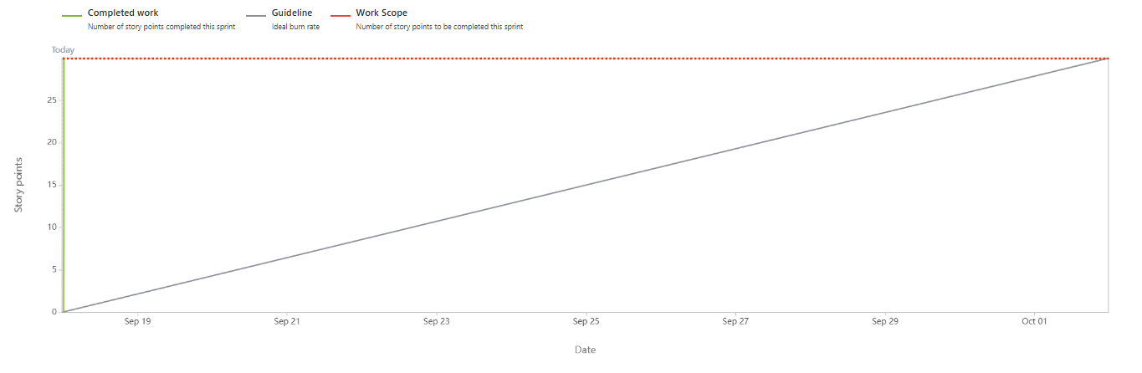

Burndown chart

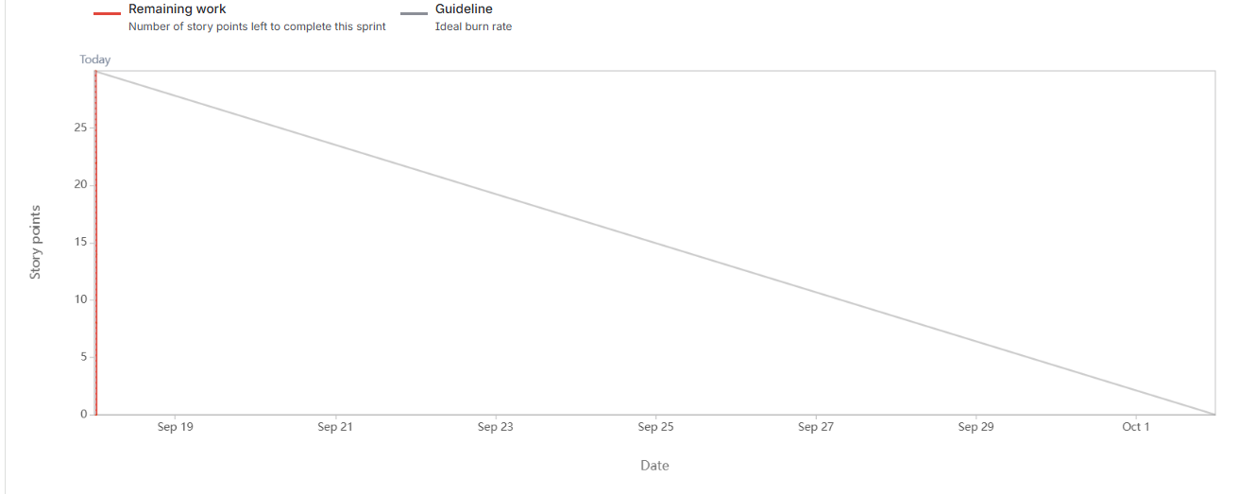

Document 6: Sprint meetings
Meeting Type 1: Sprint Planning meeting
Date | 01-July-2025
Time | 9:00 AM – 11:00 AM
Location | Online (Teams)
Prepared By | Scrum Master
Attendees | Product Owner, Scrum Master, Dev Team

Agenda Topics
Topic | Presenter | Time allotted
Discuss Sprint 1 scope | Product OWNER | 2 weeks
Story estimation & BV/CP assignment | BA | 45mins

Other Information
Observers | Stakeholders
Resources | JIIRA board , Backlog
Special Notes | Focus on Human Machine Interface features

Meeting Type 2: Sprint review meeting

Date | 10-July-2025
Time | 4:00 PM
Location | Teams
Prepared By | Scrum Master
Attendees | PO , BA , QA, SM, MANAGER

Sprint status | Things to demo | Quick updates | What’s next
100% HMI Portal base UI & Backend API completed  Video & Picture integration from Amazon Fulfillment Center functional. | Tagging workflow with live video/picture feed  Dislike feature for poor-quality media | Feedback loop tested with sample videos from fulfillment center.  Audit logs for tagging actions completed | Add version management functionality for 6–12 month updates.  Prepare metadata validation for future (quality checks, tagging consistency)

Meeting Type 3: Sprint retrospective meeting
Date | 23-Sep-2025
Time | 10:00 AM – 11:00 AM
Location | Online (MS Teams)
Prepared By | Scrum Master / BA
Attendees | Scrum Team (PO, SM, Dev, QA)

Agenda | What went well | What didn’t go  well | Questions | Reference
Sprint Goal Review |  | Dashboard filters not delivered fully in sprint |  | Sprint Goal Document
  Review
  Tagging options (Single, Multiple, No Stow) completed and tested with sample videos
  Should dashboard reporting be split into smaller user stories?
Collaboration | Dev & Fulfillment Center team worked closely to get sample videos | Few associates missed daily stand-ups | How to improve engagement in daily scrums? | Jira
Technical Setup | Dislike feature for poor-quality videos integrated successfully | Video quality validation rules not fully configured | Should video clarity rules be prioritized in Sprint 2? | User Stories

Meeting Type 4: Daily Stand-up meeting

Question | Name/Role | Week “1” (from 01-07-2025 to 15-07-2025)
  Monday | Tuesday | Wednesday | Thursday | Friday | Saturday | Sunday
What did  you do  yesterday?
  Developer
  1
  Developer
  2
  Developer
  3
  Set up video feed integration with Fulfillment Center | Built tagging UI (Single/Multiple/No Stow) | Fixed bugs in tagging save logic | Prepared demo for PO | Prepared demo for PO | - | -
    Stow)
   | Implemented dislike feedback storage | Tested dislike functionality on pictures | Debugged dislike counts not updating | Completed unit tests for dislike module | - | -
    Created dislike button for poor-quality videos
   | Built initial reporting API | Integrated dashboard with sample tagging data | Tested report accuracy |  | - | -
    Designed dashboard schema
    accuracy
    QA on dashboard metrics
What will  you do  today?
  Developer
  1
  Developer
  2
  Developer
  3
  Connect tagging system with database | Enhance tagging with validation checks | Support QA for tagging module | Update tagging documentation | Demo tagging feature in Sprint Review | - | -
  Enhance dislike feature with feedback export | Add dislike option for video quality | support QA in testing dislike workflows | Document dislike module | Demo dislike feature in Sprint Review | - | -
   | Test dashboard export to CSV | Finalize dashboard UI integration | Prepare sprint review materials | Demo dashboard feature in Sprint Review | - | -
    Add filters to dashboard (by bin type)
What (if  any) is  blocking  your  progress?
  Developer
  1
  Developer
  2
  Developer
  3
  None |  | - | - | - | - | -
    Waiting for Fulfillment Center team to send additional sample videos
  Delay in getting media quality standards from compliance officer | - | - | - | - | - | -
  Need more test data for multiple/no stow cases | - | - | - | - | - | -

