Waterfall Project Part-1

Document -1 Business Case Document

Why is this project initiated?

The Online Shopping (E-Commerce Application) project is initiated to provide customers with a seamless and convenient platform to browse, purchase, and track a variety of products online. The goal is to transition traditional retail business to a digital platform, enhancing reach and operational efficiency.

What are the current problems?

- Lack of an online platform for customer orders.
- Limited geographic reach for product sales.
- Inventory mismanagement due to manual operations.
- Poor customer engagement and retention.

With this project how many problems could be solved?

- Enables 24/7 online sales.
- Reduces manual inventory management issues.
- Improves customer engagement through personalized features.
- Scalability for Growth

What are the resources required?

- Project Manager
- UI/UX Designer
- Front-end and Back-end Developers
- Database Administrator
- Testers
- Business Analyst
- Cloud infrastructure
- Payment Gateway Provider

How much organizational change is required?
- Moderate change in business operations.
- Training staff on backend order processing and inventory updates.
- Integration of logistics and customer support with digital platform.
Timeframe to recover ROI?
- Estimated ROI recovery is within 12–18 months post-launch, based on increased sales, operational cost reduction, and expanded customer base.

How to identify Stakeholders?
- Organizational charts to identify internal roles (e.g., Business Owner, IT team).
- Project charter and Business Case Document to understand project goals and scope.
- Business process documentation to identify operational teams (e.g., Customer Support, Inventory Management).
- External analysis to include third-party providers (e.g., Payment Gateway Providers, Delivery Partners).
Examples:
- Internal: Business Owner, Project Manager, Development Team, Marketing Team, IT Operations Team, Customer Support Team.
- External: End-Users (customers), Payment Gateway Providers, Delivery Partners, Regulatory Bodies.

Document - 2 BA Strategy

Steps to Complete the Project

- Review project charter and business case to understand objectives and scope.
- Identify key stakeholders and establish initial communication channels.
- Gather requirements using techniques
- Engage stakeholders to capture business, functional, and non-functional requirements.
- Analyze elicited requirements for clarity, feasibility, and completeness.
- Resolve conflicts or ambiguities through stakeholder validation.
- Create and refine deliverables (BRD, FRS, RTM)
- Ensure traceability between requirements and project objectives.
- Conduct review sessions with stakeholders to validate requirements.
- Obtain sign-offs on deliverables
- Manage change requests
- Facilitate UAT and obtain client sign-off
- Ensure all deliverables are approved and archived.
- Conduct lessons learned sessions to document insights for future projects.

Requirement Elicitation Techniques
Stakeholder Interviews: Direct conversations for explicit needs and pain points.
Workshops/Focus Groups: Collaborative sessions for consensus and clarification.
Surveys & Questionnaires: Efficiently gather input from large user bases.
Observation/Job Shadowing: Understand actual workflows and identify hidden needs.
Document Analysis: Review existing process documents, manuals, and reports.
Prototyping: Use visual aids to confirm requirements and find gaps in user journeys.

Stakeholder Analysis
Identifying stakeholders is a crucial step in the project planning process. Stakeholders can be identified through a comprehensive stakeholder analysis, which involves mapping out individuals and groups who will be affected by the project. Identifying stakeholders via organizational charts, project charter, and interviews. Creating a RACI Matrix to assign roles for each deliverable ( BRD approval, UAT testing). Validating the matrix with stakeholders during workshops or review meetings.

Documentation to Prepare
- Business Case Document: Justifies the project with business needs, benefits, and costs.
- Business Requirements Document (BRD): Defines high-level business objectives and scope.
- Functional Requirements Specification (FRS): Details functional and non-functional requirements.
- Requirement Traceability Matrix (RTM): Maps requirements to test cases for validation.
- User Acceptance Testing (UAT) Plan: Outlines test scenarios, criteria, and sign-off process.
- Risk Analysis Document: Identifies risks and mitigation strategies.
- Change Request Log: Tracks changes to scope or requirements.
- Meeting Minutes (MoMs): Documentation of discussions and agreements
Document Review & Signoff Process
Draft Creation: Document is created based on elicited requirements.
Internal Review: Reviewed by internal stakeholders (BA, PM, Tech Lead).
Stakeholder Walkthrough: Conducted with client and key business users.
Feedback Consolidation: All inputs are reviewed and resolved.
Version Control: Updated version number and changelog maintained.
Formal Approval: Shared via email with signoff or e-signature.
Client Approval Process
- Share documents with clear version history and summary.
- Set a deadline for review and schedule a walkthrough session.
- Archive signed documents in a shared repository for audit/reference.
Communication Channels
- Project Status Meetings: Weekly or biweekly meetings (remote/in-person).
- Email Updates: Summaries and action items post-meetings.
- Collaboration Platforms: Project management tools (e.g., JIRA, Confluence, MS Teams).
- Reporting: Sharing progress reports/gantt charts as per stakeholder preference.
Change Request Handling
- Require submission of formal Change Request (CR) form.
- Assess impact (scope, budget, timeline) of each CR.
- Review and approve/reject CR in meetings.
- Update documentation, communicate to all stakeholders, and rebaseline if needed
Progress Updates to Stakeholders
- Scheduled project status reports with timelines, milestones, risks, and key issues.
- Dashboard updates ( Gantt charts) for visual tracking.
UAT and Client Project Acceptance
UAT Planning: Prepare UAT Test Cases based on FRS and RTM..
Client Walkthrough: Explain testing scenarios and process.
Execution Window: Allocate 3–5 business days to test.
Defect Logging: Issues captured in JIRA or Excel Tracker.
Issue Fix & Retest: Developers address defects; testers validate fixes.
Final Report: UAT Summary Report shared with stakeholders.
Signoff: Obtain signature on UAT Signoff and Client Project Acceptance Form.

Document 3- Functional Specifications

Project Name | Online Shopping (E-Commerce Application)
Customer Name | John
Project Version | 1.0
Project Sponsor | Prashanth
Project Manager | Adharsh
Project Initiation Date | 28/07/2025

Functional Requirement Specifications

Req ID | Req Name | Req Description | Priority
FR0001 | User Login | Allow users to securely log in to their accounts | 10
FR0002 | Product Listing | Enable browsing/searching of products by categories | 10
FR0003 | Cart Management | Add/remove/update items, view cart summary | 9
FR0004 | Secure Checkout | Multi-step checkout, addresses, payment gateway integration | 10
FR0005 | Order Tracking | Users track order delivery and status | 8
FR0006 | Admin Management | Admin dashboard for managing products, orders, users | 8
FR0007 | Inventory Sync | Auto-update stock level after each purchase | 7
FR0008 | Reviews & Ratings | Product reviews and ratings by users | 6
NFR001 | Performance | The system must handle 10,000 concurrent users with a response time of under 2 seconds for all user interactions (e.g., page loads, search, checkout). | 10
NFR002 | Security | All user data (e.g., personal details, payment information) must be encrypted using SSL/TLS, and passwords must be hashed to ensure data protection. | 10
NFR003 | Scalability | The system must scale to accommodate a 50% increase in traffic during peak events (e.g., sales, holidays) without performance degradation. | 10
NFR004 | Usability | The user interface must be intuitive, with a maximum of 3 clicks to complete key actions (e.g., add to cart, checkout), and support accessibility standards (e.g., WCAG 2.1). | 9
NFR005 | Availability | The system must achieve 99.9% uptime, with scheduled maintenance windows communicated to users in advance, to ensure reliable access. | 9

Document 4- Requirement Traceability Matrix

Req ID | Req Name | Req Description | Design | D1 | T1 | D2 | T2 | UAT
FR0001 | User Login | Allow users to securely log in to their accounts | Yes | ✓ | ✓ | ✓ | ✓ | ✓
FR0002 | Product Listing | Enable browsing/searching of products by categories | Yes | ✓ | ✓ | X | ✓ | ✓
FR0003 | Cart Management | Add/remove/update items, view cart summary | Yes | ✓ | X | ✓ | ✓ | ✓
FR0004 | Secure Checkout | Multi-step checkout, addresses, payment gateway integration | Yes | ✓ | ✓ | ✓ | X | Yes
FR0005 | Order Tracking | Users track order delivery and status | X | ✓ | X | ✓ | ✓ | X
FR0006 | Admin Management | Admin dashboard for managing products, orders, users | Yes | ✓ | ✓ | ✓ | X | ✓
FR0007 | Inventory Sync | Auto-update stock level after each purchase | Yes | X | ✓ | ✓ | ✓ | ✓
FR0008 | Reviews & Ratings | Product reviews and ratings by users | Yes | ✓ | ✓ | X | ✓ | X
NFR001 | Performance | System must handle 10,000 concurrent users with <2s response time for all user interactions | Yes | ✓ | ✓ | ✓ | ✓ | ✓
NFR002 | Security | All user data encrypted using SSL/TLS, passwords hashed | Yes | ✓ | ✓ | X | ✓ | ✓
NFR003 | Scalability | System must scale to 50% more users during peak events without degradation | Yes | X | ✓ | ✓ | ✓ | ✓
NFR004 | Usability | UI must allow key actions with ≤3 clicks and support accessibility standards | Yes | ✓ | ✓ | ✓ | X | ✓
NFR005 | Availability | System must achieve 99.9% uptime, scheduled maintenance communicated in advance | Yes | ✓ | ✓ | ✓ | ✓ | X

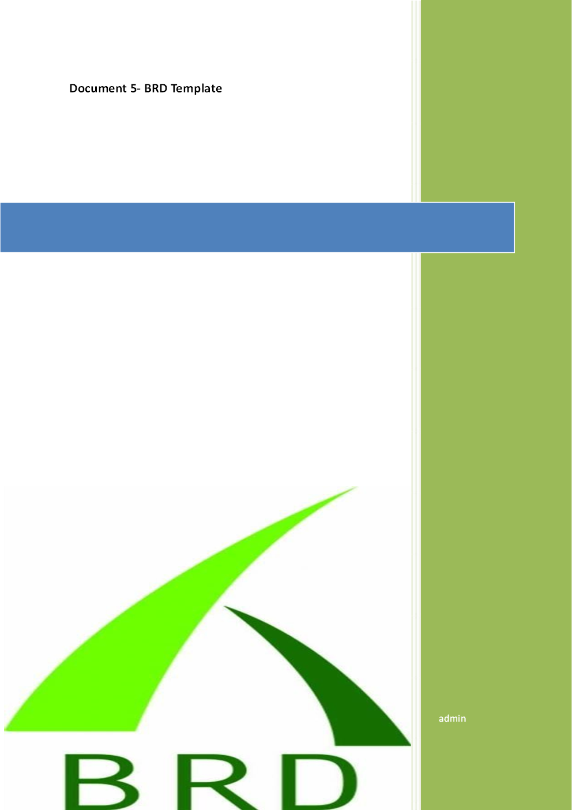
Online Shopping (E-Commerce Application)
ECOM0123
Version 1.0
Sai Krishna

Contents
1. Document Revisions.............................................................................................................8
2.Approvals...............................................................................................................................8
3. RASCI Chart for This Document............................................................................................9
Codes Used in RASCI Chart.......................................................................................................9
RASCI Chart...............................................................................................................................9
4.Introduction...........................................................................................................................9
4.1. Business Goals...................................................................................................................9
4.2. Business Objectives...........................................................................................................9
4.3. Business Rules................................................................................................................. 10
4.4. Background..................................................................................................................... 10
4.5. Project Objective.............................................................................................................10
4.6. Project Scope...................................................................................................................10
4.6.1. In Scope Functionality..............................................................................................10
4.6.2. Out Scope Functionality...........................................................................................10
5. Assumptions.........................................................................................................................10
6.Constraints............................................................................................................................10
7. Risks......................................................................................................................................10
Technological Risks..................................................................................................................10
Skills Risks.................................................................................................................................11
Political Risks............................................................................................................................11
Business Risks...........................................................................................................................11
Requirements Risks..................................................................................................................11
Other Risks...............................................................................................................................11
8. Business Process Overview..................................................................................................11
8.1. Legacy System (AS-IS)......................................................................................................11
8.2. Proposed Recommendations (TO-BE).............................................................................11
9. Business Requirements.......................................................................................................12
10. Appendices........................................................................................................................12
10.1. List of Acronyms.......................................................................................................... 12
10.2. Glossary of Terms........................................................................................................ 12
10.3. Related Documents..................................................................................................... 12

1. Document Revisions
Date | Version Number | Document Changes
23/07/2025 | 1.0 | Initial draft created with project requirements and objectives.
24/07/2025 | 1.1 | Revised based on stakeholder feedback

2. Approvals

Role | Name | Title | Signature | Date
Project Sponsor | Mr Prashanth | Project Sponsor |  | 24/07/2025
Business Owner | Mr Raghu | Business Owner |  | 24/07/2025
Project Manager | Mr Adarsh | Project Manager |  | 24/07/2025
System Architect | Ms Rachel | System Architect |  | 24/07/2025
Development Lead | Ms Monica | Development Lead |  | 24/07/2025
UX Lead | Mr Alex | User Experience Lead |  | 24/07/2025
Quality Lead | Ms Phoebe | Quality Lead |  | 24/07/2025
Content Lead | Mr Scott | Content Lead |  | 24/07/2025
3. RACI Chart for This Document

The RACI chart identifies the persons who need to be contacted whenever changes are
made to this document. RACI stands for responsible, accountable, consulted, and informed.
These are the main codes that appear in a RACI chart, used here to describe the roles played
by team members and stakeholders in the production of the BRD. They are adapted from
charts used to assign roles and responsibilities during a project. (RACI Can be made for IT
side [Project stakeholder] as mentioned above, apart from that Can also Be made for Client
side [Business Stakeholder]).
The following describes the full list of codes used in the table:
* Authorize Has ultimate signing authority for any changes to the document.
R Responsible Responsible for creating this document.
A Accountable Accountable for accuracy of this document
(for example, the project manager)
S Supports Provides supporting services in the production of this
Document
C Consulted Provides input (such as an interviewee).
I Informed Must be informed of any changes.

RACI Chart for Project Stakeholders and Business Stakeholders
Name | Position | * | R | A | S | C | I
Mr Prashanth | Project Sponsor | * |  |  |  |  | C
Mr Adarsh | Project Manager |  | R | A |  | S | I
Ms Rachel | System Architect |  |  |  | S | C | I
Ms Monica | Development Lead |  |  |  | S
Ms Phoebe | Quality Lead |  |  |  |  | C | I
Mr Alex | UX Lead |  |  |  |  | S | I
Mr Raghu | Business Owner |  |  |  |  | C | I

4. Introduction
4.1 Business Goals
- Digitize retail operations by creating a scalable, user-friendly online shopping platform.
- Enhance revenue streams by tapping into digital sales channels.
- Provide customers with a seamless and convenient shopping experience.
4.2 Business Objectives
- Deliver web and mobile platforms for product search, browsing, purchase, and order tracking.
- Automate key business operations including inventory, order management, and customer communications.
- Collect actionable data to inform marketing and promotions strategies.
4.3 Business Rules
- Only registered users may place orders.
- Payments must be authorized before order fulfillment.
- No items can be sold beyond available inventory.
- User data must comply with applicable data privacy laws.
4.4 Background
Current retail operations are limited to physical stores, resulting in restricted market reach and manual, error-prone processes. Rising digital adoption and competition necessitate building an e-commerce solution to meet customer expectations and improve business agility.

4.5 Project Objective
To develop, deploy, and support an online platform (web & mobile) for seamless product discovery, cart management, secure payment, and timely fulfillment, all integrated with backend systems for real-time inventory and order processing.

4.6 Project Scope
4.6.1 In Scope Functionality
- Customer registration, login, and account management
- Product listing & search
- Cart and order management
- Payment gateway integration
- Order tracking for customers
- Admin portal for products, orders, and users
- Inventory auto-sync
- Customer support chat and notifications
4.6.2 Out Scope Functionality
- In-store POS integration
- International shipping (Phase 1)
- Loyalty programs (Planned for further phases)
- Third-party marketplace integration
5. Assumptions
- Project stakeholders and users will be available for timely feedback.
- Required infrastructure and licenses will be arranged proactively.
- Skilled resources (developers, testers) will remain allocated throughout the project timeline.
- Supplier product data will be provided on schedule.
6. Constraints
- Fixed project budget and timelines.
- Regulatory compliance with payment and data privacy standards.
- Dependencies on third-party APIs (e.g., payment gateway).
- Limited integration with non-priority vendor systems initially.
7. Risks
Technological Risks
- Integration poses risks due to instability of third-party APIs.
- Data migration challenges from legacy systems.
- Potential cyber threats and security breaches.
Skills Risks
- Potential shortage of skilled developers/testers prolonging timelines.
- Delays due to onboarding or attrition.
Political Risks
- Regulatory changes could delay go-live.
- Policy updates on e-commerce or data privacy.
Business Risks
- Resistance to change from current staff or existing customers.
- Competitive pressures if delayed.
Requirements Risks
- Incomplete or evolving requirements leading to rework or scope creep.
- Misalignment on key functionalities due to lack of clarity.
Other Risks
- Pandemic-related or other force majeure events.
- Supply chain disruptions impacting fulfillment.

8. Business Process Overview

The business process for the Online Shopping (E-Commerce Application) project is centered around transforming a traditional, manual retail operation into a modern, digital, and fully automated e-commerce platform.

8.1 Legacy System (AS-IS)

The current AS-IS retail process is highly manual and paper-based, with all sales, inventory management, and order processing handled by staff using physical records. Customers can only purchase products in person or via phone, receiving limited information and no real-time updates on orders or stock. Management lacks centralized, real-time analytics, making business scalability, operational efficiency, and customer experience major challenges

AS-IS Process Flow Diagram:
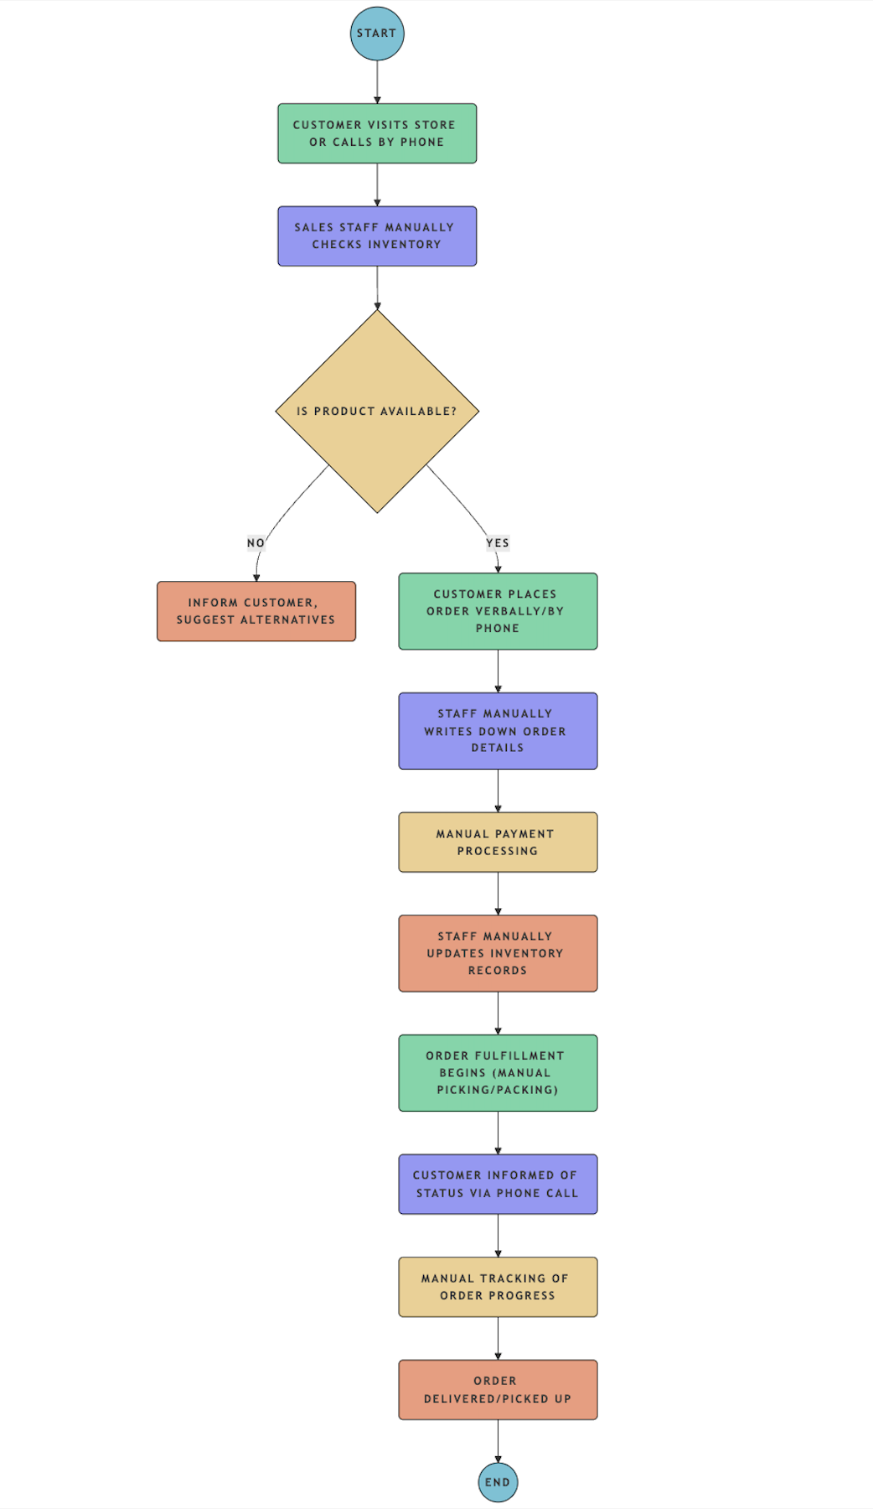

8.2 Proposed Recommendations (TO-BE)

The TO-BE process transforms the retail operation into a fully digital e-commerce platform where customers can browse products, place orders, and make secure payments online through a web or mobile app, with real-time order tracking and instant notifications. Inventory management, order processing, and payments are automated, minimizing human error while enabling efficient, scalable, and transparent operations. Admins and managers access a centralized dashboard for product, order, and user management, supported by advanced analytics and robust security throughout the platform.

TO-BE Process Flow Diagram:
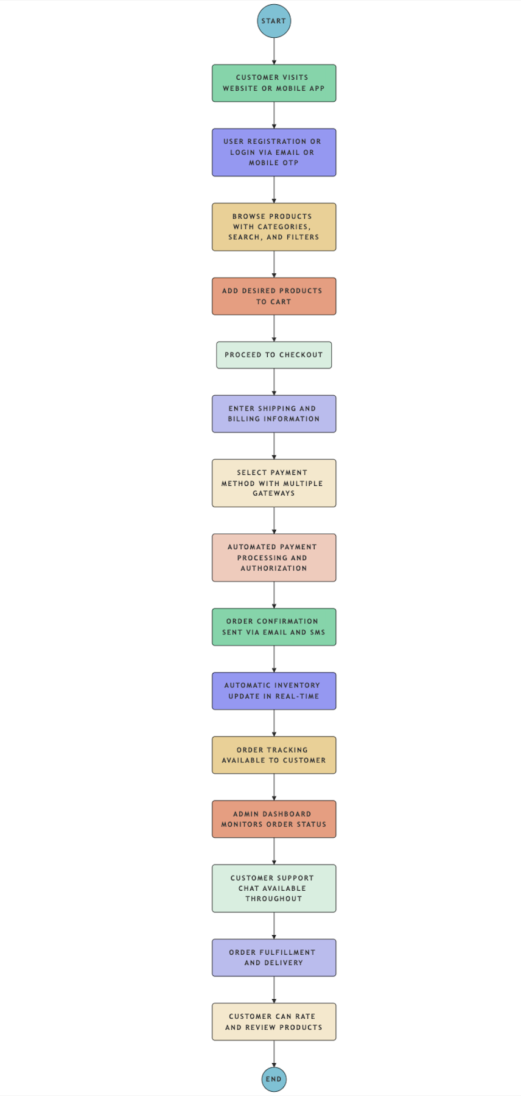

9. Business Requirements

Req ID | Req Name | Req Description | Priority
BR001 | User Registration | Users should be able to register using email or mobile number with OTP verification. | High
BR002 | User Login | Registered users must be able to log in securely using credentials. | High
BR003 | Product Browsing | Users should be able to view products categorized and searchable via filters. | High
BR004 | Shopping Cart | Users can add, update, or remove products in their shopping cart. | High
BR005 | Checkout Process | Users can enter shipping information and proceed to payment. | High
BR006 | Payment Integration | System should support multiple payment gateways (credit/debit card, UPI, wallets). | High
BR007 | Order Confirmation | Order details and confirmation should be sent via email and SMS. | High
BR008 | Order Tracking | Users must be able to track the real-time status of their orders. | Medium
BR009 | User Profile Management | Users can manage their account information and view order history. | Medium
BR010 | Admin Dashboard | Admin should manage products, users, orders, and inventory from backend. | High
BR011 | Inventory Management | Inventory should update automatically based on orders placed. | High
BR012 | Customer Support Chat | Live chat option for customer queries and issue resolution. | Medium
BR013 | Ratings and Reviews | Users can provide product reviews and rate their purchases. | Low
BR014 | Promo Code Application | Users can apply valid promo codes during checkout for discounts. | Medium

