Nurturing Process – Waterfall Deliverables – Part -1/2- V2D2 August 2024
Part 1/2 Evaluation
Document 1- Business case document template
Document 2: BA Strategy
Document 3- Functional Specifications
Document 4- Requirement Traceability Matrix
Document 5- BRD Template
Answers:
Document 1- Business case document template
Document 1 – Business Case
1. Why is this project initiated?
The iView enhancement project is initiated to improve the existing internal banking application by adding critical features such as account statement viewing and customer contact information update. This project aims to streamline bank staff operations, improve first-contact resolution rates, and enhance customer satisfaction by reducing dependence on multiple systems.
2. What are the current problems?
Currently, iView only allows users to view basic customer information such as account balance using identifiers like Customer ID, PAN, or Mobile Number. However, it lacks key functionalities such as viewing account statements and updating customer contact details, resulting in operational delays, poor customer experience, and manual overhead.
3. With this project how many problems could be solved?
This enhancement solves multiple problems:
- Enables bank staff to provide complete assistance to customers.
- Reduces customer service turnaround time.
- Eliminates manual processes and system switching.
- Improves customer satisfaction.
- Ensures data is updated securely and compliantly.
4. What are the resources required?
Human Resources: Business Analyst, UI/UX Designer, Developers, Tester and Project Manager
Technology: iView application codebase, OTP integration services, test environment
Tools: Project management tools, testing tools, development IDE
Infrastructure: Development and staging servers
5. How much organizational change is required to adopt this technology?
Minimal organizational change is required. Staff training on the new features and internal communication about the upgraded functionalities will be necessary. No major structural or technological shifts are needed.
6. Time frame to recover ROI?
ROI is expected to be recovered within 6 to 9 months through improved operational efficiency, time savings, and reduced manual tasks. However, since the benefits are operational, ROI will be measured through qualitative and performance KPIs.
7. How to identify stakeholders?
Stakeholders can be identified through stakeholder analysis methods such as interviews, document analysis, and stakeholder mapping. Key stakeholders include branch operations staff, relationship managers, IT team members, project sponsor, compliance officers, and the end customers indirectly impacted by the changes.

Document 2 BA Approach Strategy
BA Approach Strategy
As a Business Analyst for the iView enhancement project, I will follow a structured approach to ensure the project's success by gathering accurate requirements, engaging stakeholders effectively, managing scope, and ensuring deliverables align with business objectives. Below are the detailed steps of the strategy:
1. Requirement Elicitation Techniques
To gather the requirements, I will use a combination of elicitation techniques:
- Interviews: Conduct one-on-one sessions with stakeholders to understand their needs.
- Workshops: Organize group discussions with key users to brainstorm and validate requirements.
- Document Analysis: Review existing system documentation, logs, and help manuals.
- Observation: Observe current processes performed by customer service representatives.
- Questionnaires: Circulate surveys to gather feedback from a larger user base.
2. Stakeholder Analysis and RACI/ILS Matrix
I will identify stakeholders using stakeholder mapping and categorize them by influence and interest.
- Create a RACI Matrix:
- R – Responsible: Business Analyst, Developers
- A – Accountable: Project Manager
- C – Consulted: Operations Manager, Compliance Officer
- I – Informed: Senior Management, Support Teams
- I will also prepare an Influence/Interest matrix to prioritize stakeholder engagement.
3. Documents to be Prepared
As part of the Waterfall methodology, I will prepare the following deliverables:
- Business Case Document
- BA Strategy Document
- Functional Specification Document
- Requirement Traceability Matrix
- Business Requirements Document (BRD)
- UAT Test Cases and Acceptance Criteria
- Change Request Log and Meeting Minutes
4. Document Sign-Off Process
After preparing draft versions of each document:
- Share the document with stakeholders via email or shared folder.
- Conduct review meetings to walkthrough the content.
- Collect feedback and incorporate changes.
- Circulate the final version and obtain approval through email confirmation or e-signatures.
- Store signed documents in a version-controlled repository.
5. Client Approval Process
- Present finalized documents to client in a formal review meeting.
- Capture any final comments and adjust documents accordingly.
- Seek formal approval and obtain signatures on each key deliverable.
- Archive approvals securely for future reference.
6. Communication Channels
To ensure transparency and timely updates:
- Email: Official communication and document exchange.
- Project Management Tool (e.g., JIRA, Trello): Track progress and task ownership.
- Instant Messaging (e.g., Slack, Teams): Quick queries and daily standups.
- Weekly Meetings: Progress reviews with stakeholders.
- Status Reports: Weekly status update reports shared with all key parties.
7. Handling Change Requests
- Maintain a Change Request (CR) log.
- Evaluate each CR for business impact, cost, and technical feasibility.
- Present CR to Change Control Board (CCB).
- Upon approval, update impacted documents, timelines, and inform all stakeholders.
- Ensure traceability by updating the RTM and version logs.
8. Project Progress Updates
- Provide weekly or bi-weekly progress reports.
- Include completed tasks, upcoming activities, risks, blockers, and pending approvals.
- Present updates during steering committee or stakeholder meetings.
- Update dashboards in project management tools for real-time visibility.
9. UAT Sign-Off and Client Project Acceptance
- Create detailed UAT scenarios based on business requirements.
- Conduct UAT sessions with end users and document their feedback.
- Fix issues, retest, and confirm successful completion.
- Prepare a Client Project Acceptance Form.
- Obtain formal sign-off from the client to confirm the project meets expectations.
- Store signed form as proof of project closure.

Document 3- Functional Specifications
Project Information
Project Name | iView Banking Application Enhancement
Customer Name | COEPD BANK
Project Version | 1.0
Project Sponsor | Mr. Henry
Project Manager | Raju
Project Initiation Date | 12/7/2025
Functional Requirement Specifications

Req ID | Req Name | Req Description | Priority
FR0001 | Login | User should be able to login to the application securely. | High
FR0002 | Search Customer | Search customer by Customer ID, PAN, or Mobile Number. | High
FR0003 | View Account Balance | Display current balance after customer search. | High
FR0004 | View Account Statement | Allow user to select date range and view transaction history. | High
FR0005 | Download/Print Statement | Enable downloading or printing of the statement. | Medium
FR0006 | Update Mobile Number | Allow updating mobile number with OTP validation. | High
FR0007 | Update Email ID | Allow updating email address with OTP validation. | Medium
FR0008 | Update Address | Enable editing and updating of residential address. | Medium
FR0009 | Audit Logging | Maintain audit logs for all data updates for compliance and security auditing. | High

Document 4- Requirement Traceability Matrix

Req ID | Req Name | Req Description | Design (D1) | Test Case (T1) | Design (D2) | Test Case (T2) | UAT
FR0001 | Login | User must be able to login to access the application | Yes | Yes | Yes | Yes | Yes
FR0002 | Search Customer | Search customer using Customer ID, PAN, or Mobile Number | Yes | Yes | Yes | Yes | Yes
FR0003 | View Account Balance | View customer’s current account balance | Yes | Yes | Yes | Yes | Yes
FR0004 | View Account Statement | View transaction history for a selected date range | Yes | Yes | Yes | Yes | Yes
FR0005 | Download Statement | Download or print the account statement | Yes | Yes | Yes | Pending | Yes
FR0006 | Update Mobile Number | Update customer’s mobile number with OTP verification | Yes | Yes | Pending | Pending | Yes
FR0007 | Update Email ID | Update email address with OTP validation | Yes | Yes | Pending | Pending | Yes
FR0008 | Update Address | Edit and save customer’s residential address | Yes | Yes | Pending | Pending | Yes
FR0009 | Audit Logging | Keep audit logs for all data updates | Yes | Yes | Yes | Yes | Yes

Document 5- BRD Template
Project Information
Project Name : iView Banking Application Enhancement
Project ID : IVW2025-001
Version ID : 1.0
Author : Lolabhattu Surya Likhitha
1. Document Revisions
Date | Version Number | Document Changes
12/07/2025 | 0.1 | Initial Draft
13/07/2025 | 0.2 | Updated Business Objectives and scope
14/07/2025 | 0.3 | Added AS-IS and TO-BE Diagrams
14/07/2025 | 0.4 | Finalized Business Requirements and RTM
15/07/2025 | 1.0 | Approved Final Version
2. Approvals
Role | Name | Title | Signature | Date
Project Sponsor | Mr. Henry | Sponsor
Business Owner | Vijay | Operations Lead
Project Manager | Raju | PM
System Architect | Varshini | Architect
Development Lead | Vivek | Tech Lead
User Experience Lead | Praneetha | UX Lead
Quality Lead | Sai | QA Lead
3. RASCI Chart for this Document
Name | Position | R | A | S | C | I
Business Analyst | Surya Likhitha | Y |  | Y | Y
PM | Raju |  | Y |  | Y | Y
Developer | Manoj | Y |  | Y
QA Lead | Sai |  |  | Y |  | Y

4. Introduction
4.1 Business Goals
To enhance the iView system to allow bank employees to offer comprehensive customer service from a single platform, improving operational efficiency and customer experience.
4.2 Business Objectives
To provide an integrated IT solution that enhances digital transformation for education and employee management by developing:
1. Mobile Application (Android & iOS)
Purpose:
To provide users with mobile access to both learning and HR services from anywhere, improving accessibility, engagement, and productivity.
Key Functionalities:
• Secure login with OTP or email verification
• Dashboard tailored for different user roles (e.g., Student, Trainer, Employee, HR, Admin)
• Course access with video streaming, document downloads, and offline mode
• Push notifications for updates, deadlines, or messages
• Attendance tracking and leave request features
• Access to HR documents (payslips, appraisal letters, etc.)
• Integration with LMS and HRMS backend systems
2. E-Learning Management System (LMS)
Purpose:
To facilitate online education, skill development, and certification through structured content delivery, assessments, and tracking.
Key Functionalities:
• Course creation and management by trainers/admins
• Multimedia content support (videos, PDFs, slides)
• User enrollment and batch assignment
• Online assessments with automated results
• Certification generation on completion
• Performance analytics and progress tracking
• Discussion forums or Q&A support
• Integration with mobile app and HRMS for seamless experience
3. Human Resource Management System (HRMS)
Purpose:
To digitize and streamline core HR functions like employee records, payroll, leave, performance, and training.
Key Functionalities:
• Employee onboarding and profile management
• Leave and attendance management
• Payroll and payslip generation
• Performance management and feedback cycles
• HR policy document repository
• Role-based access and approval workflows
• Integration with LMS for training tracking
• Notifications for events (birthdays, holidays, reminders)
• Self-service portal for employees and mobile access
4.3 Business Rules
The following organizational policies, procedures, and regulatory guidelines will govern the operation and usage of the software systems (Mobile App, LMS, and HRMS):
User Access & Authentication
• All users must authenticate using secure credentials (email/username + password or OTP).
• Password policies must enforce complexity, expiry, and history rules (e.g., minimum 8 characters, at least one number and symbol).
• Role-based access control (RBAC) must be implemented to restrict access based on user roles (e.g., student, trainer, HR, admin).
• Session timeout must be enabled for idle sessions (e.g., auto-logout after 10 minutes of inactivity).
Data Privacy & Security
• Personal and sensitive employee/student information must be encrypted in transit and at rest.
• The system must comply with applicable data protection regulations (e.g., GDPR, IT Act 2000).
• Audit logs must be maintained for all data access, updates, and login attempts.
• Contact information updates (email, mobile number) must require OTP/email verification.
Course & Content Management (LMS)
• Only authorized trainers or admins can create, update, or delete courses and learning materials.
• Course content must be reviewed and approved before being published.
• Copyrighted or third-party content must not be uploaded without proper licensing.
• Students must complete all mandatory modules before earning certifications.
HR Policies & Workflows (HRMS)
• Leave approvals must follow the organization’s defined hierarchy and workflows.
• Attendance records must be updated daily and validated by supervisors.
• Payroll calculations must comply with statutory requirements (PF, ESI, TDS, etc.).
• Performance evaluations must be conducted bi-annually using the company’s appraisal framework.
Compliance & Legal
• All employee and student records must be maintained as per company and legal retention policies.
• The software must undergo periodic vulnerability assessments and audits.
• Employees or users violating system usage policies may face disciplinary action, including access revocation.
Usage Guidelines
• Users must not share login credentials with others.
• Mobile app usage must align with acceptable device security standards (e.g., screen lock enabled, OS updated).
• Feedback or complaints regarding courses or HR services must be submitted through the official support/helpdesk module.
4.4 Background
iView was originally built to help staff retrieve basic account details. However, it lacks features necessary to resolve most customer queries. Employees currently rely on manual processes or multiple systems, leading to delays and inefficiency.
4.5 Project Objective
To empower front-line staff by integrating additional modules into iView for statement viewing and secure contact information updates, ensuring seamless and compliant service delivery.
4.6 Project Scope
Enable bank staff to view customer account statements (with data range, export, and print options) and update contact information security within iView. Implement audit logging, OTP-based verification, and UI enhancements, with testing and post-launch support-all confined to the internal iView tool.
4.6.1 In Scope Functionality
- View account statement (date range filter)
- Download/print statement
- Update mobile number with OTP
- Update email ID with OTP
- Update customer address
- Audit logging for all updates
4.6.2 Out of Scope Functionality
- Customer self-service via internet/mobile banking
- Backend data migration
5. Assumptions
- Staff will be trained to use the enhanced system.
- OTP and email/SMS gateway integrations will be available.
- Access rights are managed via existing user roles.
6. Constraints
- Limited access based on staff roles.
- Compliance with banking regulations on customer data changes.
- OTP delivery is dependent on third-party SMS/email service availability.
7. Risks
The success of this IT solution depends on proactively identifying and managing potential risks that could impact project delivery, budget, scope, and quality. The following risk types have been analyzed and categorized for better control and mitigation.
Risk Type | Description | Strategy
Technological | OTP/email integration failure | Mitigate
Skills | Staff may need time to adapt to new features | Accept & Train
Business | Resistance to change from current manual process | Mitigate
Requirements | Misinterpretation of contact update workflow | Mitigate
Technological Risks
Risk | Likelihood | Impact | Strategy | Mitigation Plan
Integration challenges between LMS, HRMS, and Mobile App | Medium | High | Mitigate | Allocate sufficient time for system integration and API testing. Use standardized protocols and experienced integration developers.
Mobile app compatibility issues across Android and iOS devices | High | Medium | Mitigate | Use cross-platform development tools and conduct device compatibility testing.
Data breach or system vulnerability | Low | High | Avoid | Apply encryption, regular vulnerability scans, and comply with data security best practices. Conduct periodic audits.
Skills Risks
Risk | Likelihood | Impact | Strategy | Mitigation Plan
Lack of skilled developers or trainers for LMS/HRMS | Medium | Medium | Mitigate | Provide training, outsource critical roles if needed, or hire experienced consultants.
Inadequate testing team for mobile and web platforms | Medium | High | Mitigate | Hire a dedicated QA team with experience in both mobile and enterprise system testing.
Political Risks
Risk | Likelihood | Impact | Strategy | Mitigation Plan
Change in organizational leadership may affect priorities | Medium | Medium | Accept | Keep all documentation updated; ensure buy-in from multiple stakeholders.
Regulatory or compliance changes (e.g., labor laws, data protection) | Low | High | Mitigate | Regularly review legal frameworks and update systems accordingly. Consult legal experts during development.
Business Risks
Risk | Likelihood | Impact | Strategy | Mitigation Plan
Project cancellation due to budget constraints | Low | High | Transfer | Ensure project has executive sponsorship; break project into smaller deliverables for phased investment.
Low adoption rate by employees or students | Medium | High | Mitigate | Run awareness campaigns, provide training, and ensure user-friendly UI/UX design. Collect feedback early and iterate.
Requirements Risks
Risk | Likelihood | Impact | Strategy | Mitigation Plan
Misunderstanding of user needs or incomplete requirements | Medium | High | Mitigate | Conduct detailed requirement elicitation using workshops, interviews, and surveys. Validate requirements with all stakeholders.
Frequent scope changes | Medium | Medium | Mitigate | Implement a change control process and freeze baseline requirements early in the project.
Other Risks
Risk | Likelihood | Impact | Strategy | Mitigation Plan
Project delays due to resource unavailability or external dependencies | Medium | High | Mitigate | Maintain a resource backup plan, buffer timelines in the project plan.
Resistance to system change or new process adoption | High | Medium | Mitigate | Provide onboarding support, training sessions, and communicate the benefits clearly.
8. Business Process Overview
The Business Process Overview outlines how the organization currently operates key processes (AS-IS) and how those processes will be improved through the proposed system (TO-BE). It helps in identifying inefficiencies in the legacy system and demonstrating how technology will streamline operations and improve user experience.
8.1 Legacy System (AS-IS Process)
Currently, the organization uses a disconnected and partially manual process to manage employee onboarding, training, attendance tracking, and certification. These tasks are performed using a mix of spreadsheets, emails, physical forms, and standalone software applications without proper integration.
Key AS-IS Process Characteristics:
- Employee Onboarding: New employees manually fill out forms and submit documents physically or via email. HR manually enters these details into spreadsheets or a basic HR tool.
- Training Assignment: Training schedules are shared manually by trainers via email or calendar invites. There’s no structured tracking of content access or progress.
- Attendance Tracking: Attendance is taken either manually on paper or in Excel sheets. There’s no real-time validation or integration with system logins.
- Certification: Course completion certificates are either issued manually or not issued at all, due to lack of automated tracking.
- Lack of Integration: HRMS and training processes are siloed. Data needs to be entered multiple times across systems.
Challenges in the Legacy System:
- High administrative overhead and human error
- Delayed onboarding and poor visibility of progress
- No centralized monitoring of employee learning or compliance
- Disjointed employee experience with multiple touchpoints
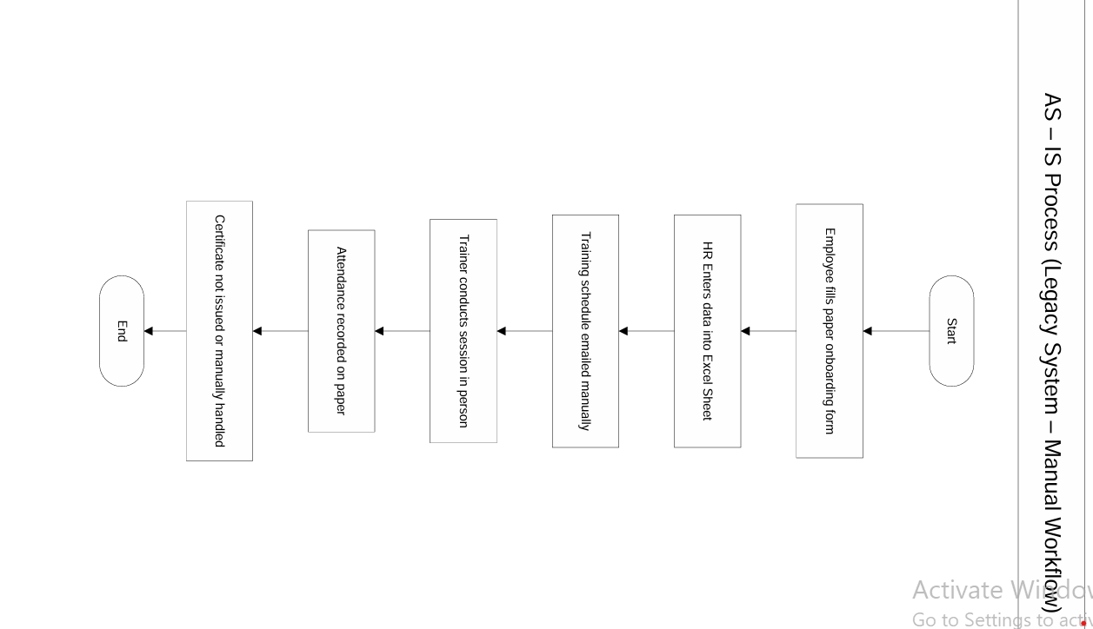
8.2 Proposed Recommendations (TO-BE Process)
The proposed system introduces a fully integrated IT platform combining a Mobile App, an LMS, and an HRMS. It aims to digitize, centralize, and automate the processes of onboarding, training, attendance tracking, and certification generation.
Key TO-BE Process Features:
- Mobile App (Android & iOS): Employees can register, access training, mark attendance, download certificates, apply for leave, and view pay slips — all in one app.
- E-Learning Management System (LMS): Structured courses, assessments, and automatic certificate generation. Real-time progress tracking.
- Human Resource Management System (HRMS): End-to-end employee lifecycle management — onboarding, performance tracking, leave and payroll management — integrated with the LMS.
How the Proposed System Resolves Legacy Issues:
Legacy Issue | TO-BE Solution
Manual data entry | Automated profile creation via self-service onboarding
Disjointed training | Centralized LMS assigns and tracks training in real-time
Paper-based attendance | Auto attendance via login tracking and mobile access
No certification process | Auto-generation of digital certificates on completion
Low visibility for HR | Dashboards with real-time performance and learning analytics
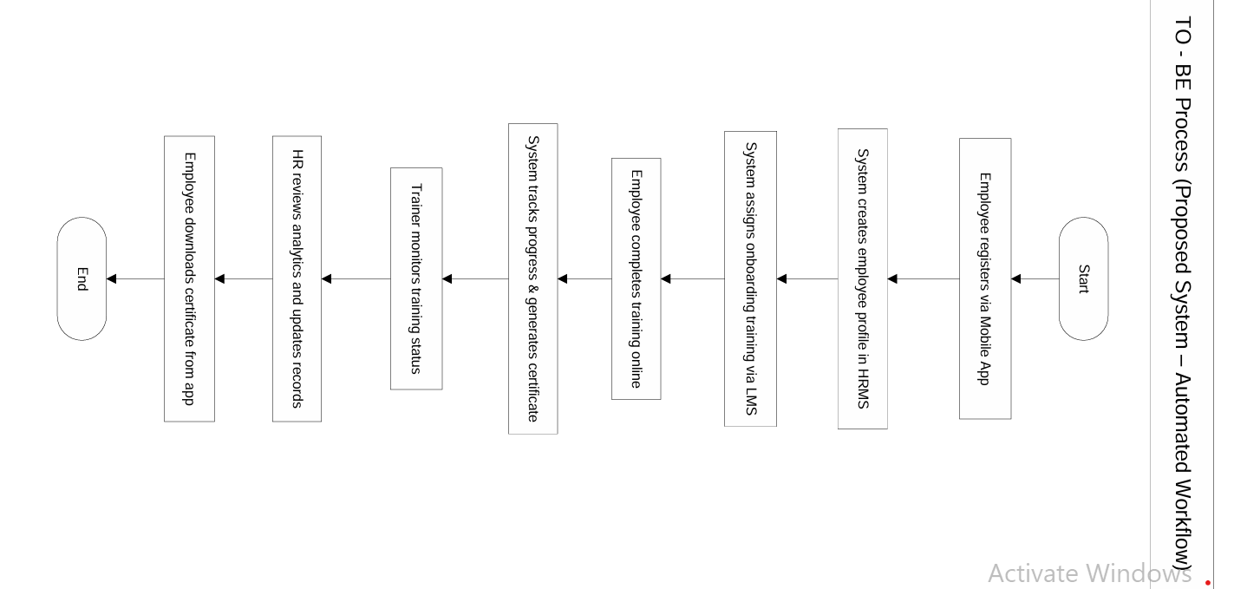
9. Business Requirements
This section captures the specific business requirements gathered from stakeholders across various functional areas of the proposed system. Requirements are organized by priority (High, Medium, Low) and functional domain for clarity and traceability. These requirements serve as the foundation for system design, development, and testing.
9.1 Functional Requirements
These are the system behaviors and operations that define what the system must do.
FR ID | Requirement Description | Functionality Area | Priority
FR-01 | User should be able to register and log in using mobile number/email with OTP | Mobile App | High
FR-02 | Employee onboarding should be initiated digitally with document upload and validation | HRMS | High
FR-03 | HR should be able to view, edit, and manage employee master data | HRMS | High
FR-04 | LMS should automatically assign onboarding training modules to new joiners | LMS | High
FR-05 | Users should be able to access courses through mobile (video, PDFs, slides) | Mobile App / LMS | High
FR-06 | The system must allow trainers to create/edit course content | LMS | Medium
FR-07 | Attendance should be auto-recorded based on course login and session access | LMS | Medium
FR-08 | Upon course completion, the system must generate certificates automatically | LMS | High
FR-09 | HR should be able to manage leave applications and approvals online | HRMS | High
FR-10 | System must generate payroll reports and payslips with statutory compliance | HRMS | High
FR-11 | Users must receive alerts/notifications (via app/email) for key events | System-wide | Medium
FR-12 | Admin should be able to manage user roles, permissions, and access levels | All Modules | High
9.2 Non-Functional Requirements
These define how the system performs rather than what it does. They focus on quality attributes like performance, security, scalability, and usability.
NFR ID | Requirement Description | Category | Priority
NFR-01 | System should be accessible on Android and iOS with 99.5% uptime | Availability | High
NFR-02 | All user data must be encrypted (at rest and in transit) | Security | High
NFR-03 | System should support at least 500 concurrent users | Scalability | Medium
NFR-04 | System response time must be ≤ 3 seconds for 95% of operations | Performance | Medium
NFR-05 | User interface must support English and 1 regional language | Usability | Medium
NFR-06 | System logs must be maintained for audit trail and traceability | Audit/Logging | High
NFR-07 | Mobile app and LMS must follow WCAG accessibility guidelines | Accessibility | Low
10. Appendices
10.1 List of Acronyms
- OTP – One-Time Password
- UAT – User Acceptance Testing
- BRD – Business Requirements Document
10.2 Glossary of Terms
- iView – Internal bank application for customer info retrieval
- Audit Log – Record of changes made to customer data
10.3 Related Documents
- Business Case Document
- BA Strategy
- Functional Specification
- Requirement Traceability Matrix

