Assumptions and identify at least 10 Business Requirements.
List your assumptions
Give Priority 1 to 10 numbers ( 1 being low priority – 10 being high priority) to these Requirements after discussions with the stakeholders

Business requirements

Req ID | Requirement Name | Req Description | Priority
BR001 | Farmers should be able to search for available products | Searching is fundamental—without it, farmers can't find needed products, defeating the purpose of the store. | 5
BR002 | Manufacturers should upload and display their products | Product availability is core to the store; without uploads, the catalog remains empty. | 9
BR003 | Secure user login and registration | Without authentication, users cannot access core features or place orders—critical for platform functionality. | 8
BR004 | Farmers can browse catalog without logging in | Enhances accessibility and ease-of-use, especially for first-time or casual users. | 3
BR005 | Login required to buy or add to buy-later list | Secure transaction and user-specific actions mandate authentication. | 9
BR006 | Buy-later (wish list) feature | Adds convenience and encourages repeat business but can be considered post-launch. | 3
BR007 | Payment gateway (COD, Credit/Debit, UPI support) | Payments are indispensable for order completion; no payment means no revenue. | 9
BR008 | Email confirmations for order status | Helpful communication feature, though in-app notifications could serve as alternative initially. | 3
BR009 | Delivery tracking functionality | Adds transparency and user satisfaction but not absolutely necessary at launch. | 5
BR010 | Order history and receipts for farmers | Helps farmers manage their orders efficiently, improving user experience. | 5

Question 1 – Functional Requirements - 15 Marks
Identify minimum 20 functional requirements
Answer 1
Functional requirements describe what a system must do. They specify the behaviours, functions, or services the system must provide in order to meet the needs of its users or stakeholders.
FR ID | FR Name | FR Description | Priority
FR0001 | Farmer Registration | The system shall allow a new Farmer user to create an account by providing email ID, secure password, full name, address, phone number and verification. | 9
FR0002 | Manufacturer Registration | The system shall allow a new Manufacturer user to create an account by providing company name, contact person, email ID, secure password, address, phone number, manufacturer licence/verification (if needed). | 8
FR0003 | User Login | The system shall allow registered users (Farmers or Manufacturers) to login using email ID and password. | 9
FR0004 | Forgot Password / Reset | The system shall allow users to reset their password via email verification if they forget it. | 8
FR0005 | Browse Product Catalogue | The system shall allow Farmers (even without login or after login) to browse products in the catalogue, filtered by category (fertilizers/seeds/pesticides). | 7
FR0006 | Search Products | The system shall allow Farmers to search for products using keywords, category filters, manufacturer filters, price range, and region of availability. | 8
FR0007 | View Product Details | The system shall allow Farmers to click a product and view full details: name, manufacturer, description, category, price, availability (in‐stock/out of stock), delivery region, images. | 8
FR0008 | Add to Cart / Wish list | The system shall allow Farmers (after login) to add a product to a “Buy Later” list or shopping cart for later purchase. | 6
FR0009 | Manage Cart / Modify Quantity | The system shall allow Farmers to view the items in their cart/buy‐later list, change quantities, remove items, update before purchase. | 6
FR0010 | Place Order / Request Purchase | The system shall allow Farmers to place an order (request purchase) by selecting items in cart, confirming delivery address, selecting payment method, and submitting. | 9
FR0011 | Payment Processing | The system shall integrate with payment gateway(s) to accept Credit/Debit card and UPI payments, and shall support Cash-on-Delivery (COD) option if selected. | 9
FR0012 | Order Confirmation Email | The system shall send an email confirmation to the Farmer once the order is placed, including order ID, items, amount, payment method, estimated delivery. | 8
FR0013 | Manufacturer Order Dashboard | The system shall provide a dashboard for Manufacturers to view orders placed for their products, with order status, delivery address, payment status, and allow them to update status (accepted, dispatched, shipped). | 8
FR0014 | Inventory Status Update | The system shall allow Manufacturers to update product inventory (in stock / out of stock), update product details (price, description, images) at any time. | 8
FR0015 | Delivery Tracking for Farmer | The system shall allow Farmers to view the current status of their order (e.g., Order Received, Dispatched, In Transit, Delivered) and optionally view map / location of delivery (if available). | 7
FR0016 | Order History & Status | The system shall allow Farmers to view their past and current orders, statuses, payment history, invoices. | 7
FR0017 | Manufacturer Product Upload | The system shall allow Manufacturers to upload new products (enter name, description, category, price, available quantity, images, region of availability) for listing in the catalog. | 8
FR0018 | Notifications / Alerts | The system shall send notifications (email and/or in-app) to Farmers and Manufacturers for key events (e.g., order confirmed, dispatched, delivered; low inventory alert for manufacturer; payment receipt for manufacturer). | 7
FR0019 | Admin/Committee Reporting | The system shall provide reporting capabilities (for the administrative/committee user) to view metrics like total orders, sales by category, geography, manufacturer performance. | 5
FR0020 | User Profile Management | The system shall allow Farmers and Manufacturers to view and update their profile information (name, contact, password, address) and manage preferences. | 6
FR0021 | Region/Delivery Availability Check | The system shall allow Farmers to see whether delivery is available to their location (village/region) for each listed product before placing the order. | 8
FR0022 | Multi-language / Localization | The system shall allow UI to be switched to regional language (for example Hindi or local state language) for Farmers’ ease of use. | 6
FR0023 | Search Refinement & Sort | The system shall allow Farmers to refine search results by price range, category, manufacturer, rating, availability, and sort results (by price, popularity, newest). | 6
FR0024 | Review & Rating of Products | The system shall allow Farmers (after delivery) to submit reviews and ratings of products purchased, which will be visible to other Farmers. | 4
FR0025 | Manufacturer Payment Settlement View | The system shall allow Manufacturers to view payment settlement status for orders completed and received. | 5

Non-functional requirements (NFRs) describe how a system must behave or the qualities it must have, rather than what it must do. They are criteria used to judge the operation of a system rather than specific behaviours.

NFR ID | NFR Name | NFR Description | Priority
NFR0101 | Page Load Time | Each page in the web/mobile application shall load and become interactive within 2 seconds for 95% of accesses under normal load. | 9
NFR0102 | Mobile Responsiveness | The mobile application (or mobile web view) shall support devices in portrait and landscape and adapt layouts for screens from 4″ to 7″ without horizontal scrolling. | 8
NFR0103 | Accessibility | The application UI shall meet WCAG 2.1 Level AA accessibility standards (e.g., for users with vision impairment). | 8
NFR0104 | Availability / Uptime | The system shall provide at least 99.5% uptime (excluding planned maintenance windows) in any 30-day period. | 8
NFR0105 | Scalability | The system architecture shall support scaling to handle up to 50,000 concurrent users (farmers + manufacturers) without performance degradation. | 8
NFR0106 | Data Backup & Recovery | The system shall perform full data backups nightly, and allow recovery of critical data within 4 hours in case of major failure. | 7
NFR0107 | Security – Data Encryption | All sensitive data (user credentials, payment info) shall be encrypted at rest and in transit using industry-standard encryption (e.g., TLS 1.2+ for transport). | 9
NFR0108 | Security – Authentication | The system shall enforce secure password policies (minimum length, complexity) and support optional two-factor authentication for manufacturers. | 7
NFR0109 | Usability – First Time Use | A farmer who has never used the system shall be able to complete registration and search for a product within 5 minutes with no formal training. | 8
NFR0110 | Response Time for Search | When the farmer submits a product search request, results shall be displayed within 1.5 seconds under normal load. | 8
NFR0111 | Maintainability – Code Standards | The system shall be built in modular components, and all code shall follow the company’s coding standards to enable future modifications and maintenance. | 7
NFR0112 | Interoperability / Compatibility | The mobile/web application shall support the latest two major versions of iOS and Android, and the latest two versions of Chrome, Firefox, Safari browsers. | 6
NFR0113 | Data Integrity | The system shall guarantee that for all orders placed, the order status transitions follow the defined sequence (e.g., Received → Dispatched → InTransit → Delivered) without data loss or corruption. | 8
NFR0114 | Auditability / Logging | The system shall log all critical user actions (login, payment processed, order status change) and retain logs for at least 12 months for audit purposes. | 6
NFR0115 | Localization / Language Support | The system shall support English and the regional language(s) of the target farming region (e.g., Hindi), with all UI text translatable. | 5
NFR0116 | Disaster Recovery | In the case of a site disaster, the system shall recover to an alternate data centre and resume service within 8 hours. | 7
NFR0117 | Network Bandwidth Efficiency | The system UI shall be optimized so that initial page load uses no more than 2 MB of data on slow mobile connections. | 6
NFR0118 | Peak Load Handling | During peak farming season (e.g., fertilizer/seed ordering in early season), the system shall handle twice the average daily order rate without errors or unacceptable delay. | 8
NFR0119 | Privacy Compliance | The system shall comply with relevant data protection laws (e.g., Indian IT Act, GDPR if applicable) including user consent for data collection and right to delete personal data. | 7
NFR0120 | Availability of Support | The system’s “Help & Support” facility shall provide at least email and chat support during business hours (8 am to 8 pm) and aim to respond to user tickets within 24 hours. | 6

Question 2–Minimum 5 page designs - 15 Marks

Make wireframe and prototypes

Answer 2

1. Registration
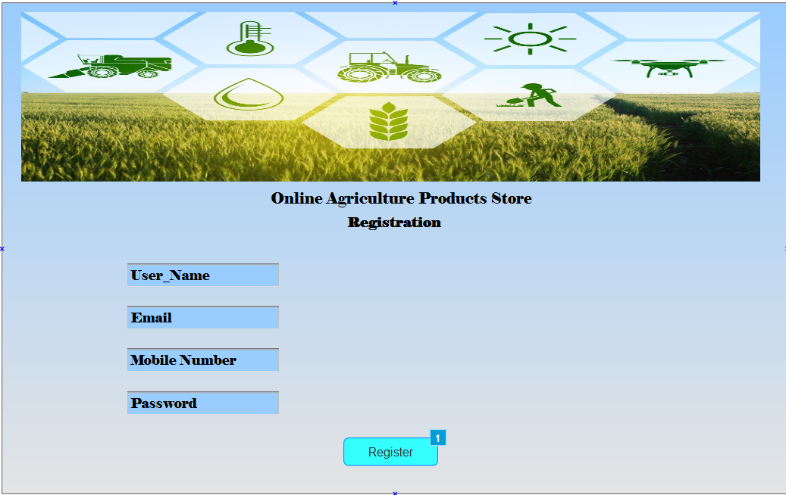

2. Login
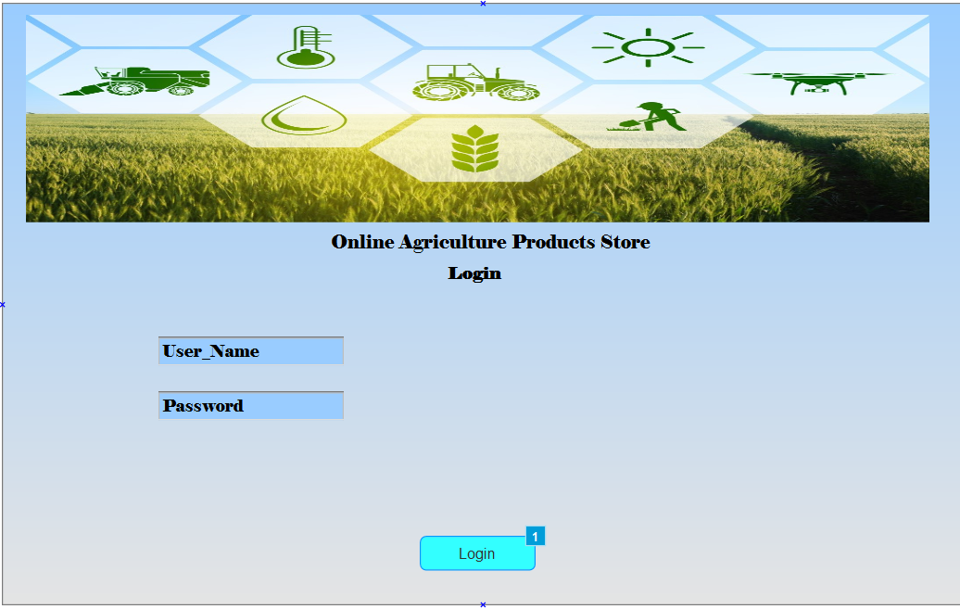

3. Product backlog
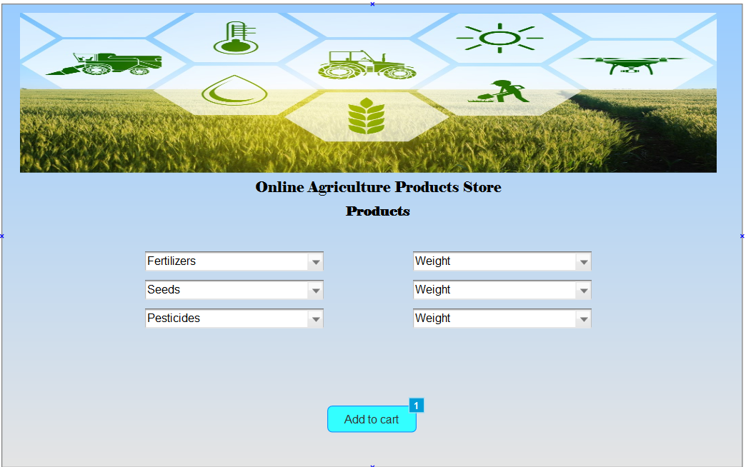

4. Add to cart
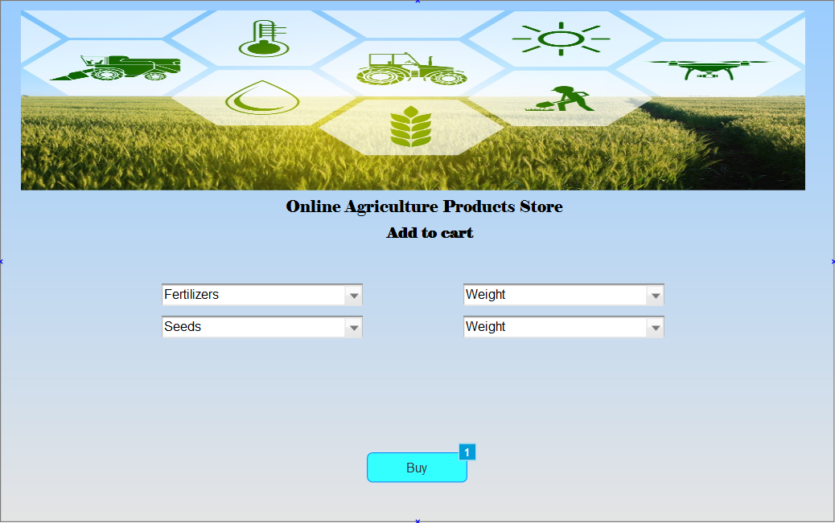

5. Payment
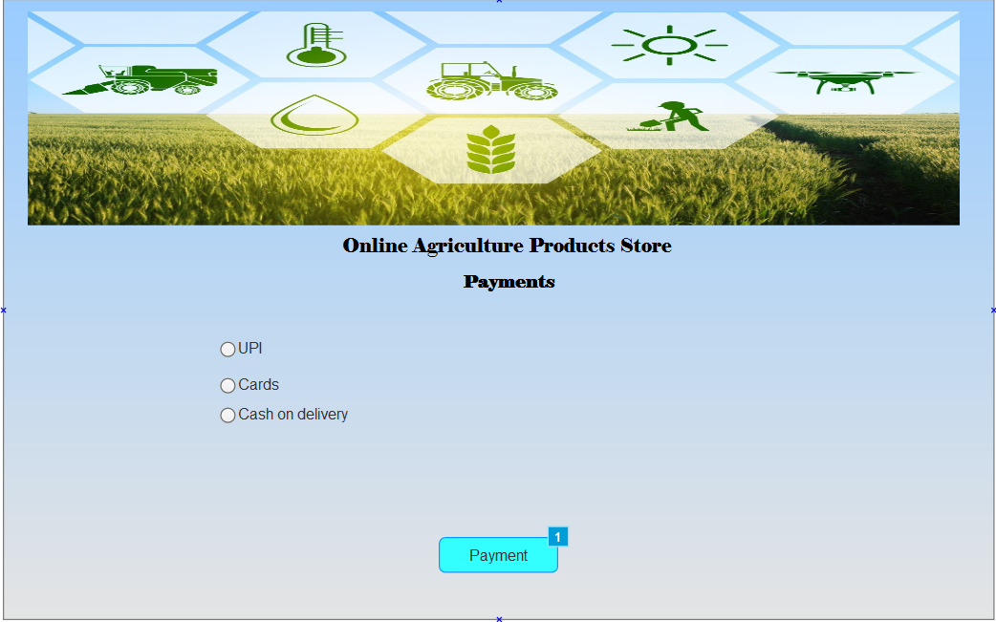

6. Payment status
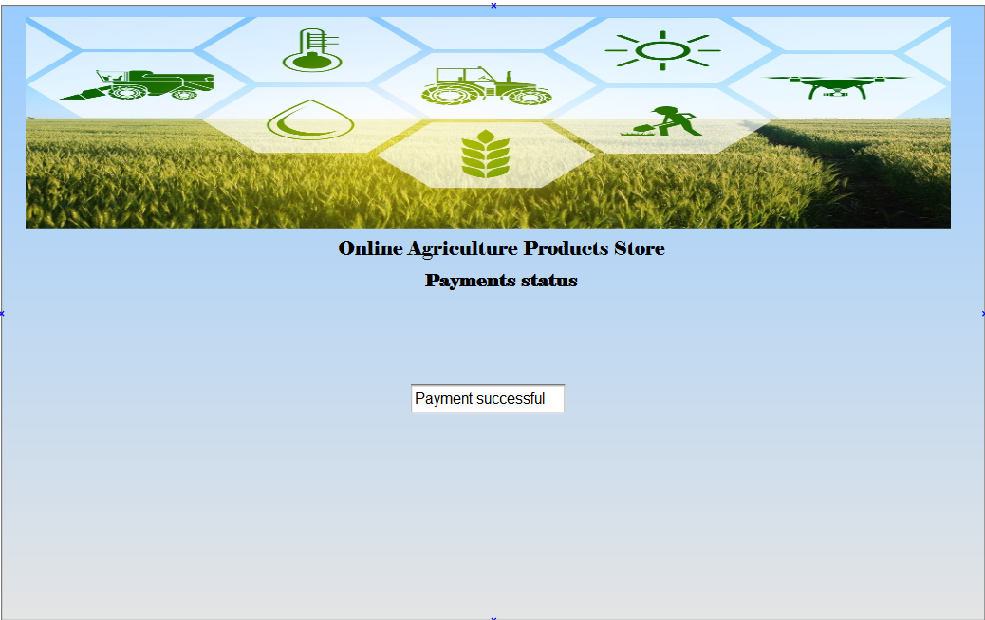

Question 3 – Tools (Visio, Balsamiq) - 15 Marks

Make a note of the Tools, which you are using for above concepts.
Answer 3
Microsoft Visio-
- Microsoft Visio is a diagramming and vector-graphics application aimed at creating flowcharts, organisational charts, process maps, software diagrams (UML), floor plans etc.
- It provides a large library of shapes, templates, connectors and supports complex diagramming tasks.
- It has rich diagramming capabilities with many templates, shapes, stencils for varied uses (flows, org charts, UML, infra diagrams).
- Integrates with Microsoft ecosystem (Office, Teams, etc).
- Suitable for both technical & business diagrams (so versatile)

Balsamiq-
- Balsamiq is a rapid wire framing /mock up tool optimized for low-fidelity interface sketches (web, mobile, desktop).
- It uses a sketch-like aesthetic (hand-drawn style) to focus attention on structure, layout and flow rather than detailed visuals.
- It is used early in the design process when you want to explore layout ideas, high-level flows, stakeholder alignment, and gather feedback quickly.
- Very easy to pick up; fast drag-and-drop, pre-built UI components for quick mock ups.
- Good for collaboration and embedding into documentation/workflow (has versions/plugins for integration with Confluence, Jira, etc.)

Axure RP-
- Axure RP is a tool for wire framing, prototyping (including high-fidelity and interactive prototypes), and specification/documentation of digital products (web, mobile apps).
- It allows you to create UI layouts, define interactions (clicks, hovers, variables/conditions), dynamic content, multiple states, etc.
- It is used when you want to create a realistic interactive prototype that simulates the final product, not just static screens.
- It is used when you need to define and communicate interactions, transitions, states (e.g., drop-downs, modals, data flows).
- Very powerful for interactions and advanced UI prototyping (conditions, variables, dynamic panels).
Question 4 – RTM - 6 Marks
A business analyst’s key responsibilities are to keep track of the requirements and make sure that no requirement is missed.
Mr. Henry and peter have approached you regarding the current status of the project. How will you tackle this situation? Prepare RTM
Answer 4
Req ID | Req Name | Req Description | Design Doc Ref | Code/ Dev Status | UT (Unit Testing) | CT (Component testing) | ST (System Testing) | SIT (System Integration Testing) | UAT (User Acceptance Testing)
FR0001 | Farmer Registration | Farmers should be able to register with the application | D1 | Complete | Complete | Complete | Complete | Complete | Incomplete
FR0002 | Search Product | Farmers should be able to search for available products in fertilizers, seeds, pesticides | D1 | Complete | Complete | Complete | Incomplete | Incomplete | Incomplete
FR0003 | Login / Account Creation | User login for farmers/manufacturers; new user account creation with email + secure password | D1 | Complete | Complete | Complete | Incomplete | Incomplete | Incomplete
FR0004 | Product Catalog Display | System should display products (fertilizers, seeds, pesticides) | D1 | Complete | Complete | Complete | Incomplete | Incomplete | Incomplete
FR0005 | Add to Buy-Later List | A farmer should be able to add a product to a “buy later” list | D2 | Pending | Pending | Pending | Pending | Pending | Not started
FR0006 | Payment Options | Payment gateway should support COD, Credit/Debit Card & UPI | D3 | Pending | Pending | Pending | Pending | Pending | Not started
FR0007 | Email Confirmation | After placing an order the user gets an email confirmation reg order status | D3 | Pending | Pending | Pending | Pending | Pending | Not started
FR0008 | Delivery Tracking | Farmers should track the whereabouts of their order delivery | D4 | Pending | Pending | Pending | Pending | Pending | Not started

Question 5 – 10 Test Case Documents - 10 Marks
Prepare 10 Test Case Documents
Test Case 1
Field | Value / Description
Test Case ID | TC_FR0001 | Test Case Name | User Registration (Farmer)
Project ID |  | Project Name
PM ID |  | PM Name
Test Strategy ID |  | Tester ID
Test Plan ID |  | Tester Name
Test Schedule ID |  | Date of Test
Scenario | Verify that a new farmer can register with valid email and password
Link to that page
Input Data | Email: farmer1@example.com Password: P@ssw0rd
Expected Behaviour | Registration succeeds; user directed to login/welcome screen; message “Registration successful, please login”
Actual Behaviour
Comments | Check email format validation, password strength, account created in database
Result (Pass/Fail)
Test Case 2

Field | Value / Description
Test Case ID | TC_FR0002 | Test Case Name | User Registration – Invalid Email
Project ID |  | Project Name
PM ID |  | PM Name
Test Strategy ID |  | Tester ID
Test Plan ID |  | Tester Name
Test Schedule ID |  | Date of Test
Scenario | Verify registration fails when user enters invalid email format
Link to that page
Input Data | Email: farmer1@example.com Password: P@ssw0rd
Expected Behaviour | System rejects registration; shows error “Enter a valid email address”; account not created
Actual Behaviour
Comments | Also test other invalid formats (missing @, missing domain)
Result (Pass/Fail)
Test Case 3
Field | Value / Description
Test Case ID | TC_FR0003 | Test Case Name | Login (Existing User)
Project ID |  | Project Name
PM ID |  | PM Name
Test Strategy ID |  | Tester ID
Test Plan ID |  | Tester Name
Test Schedule ID |  | Date of Test
Scenario | Verify that an existing user can login with correct credentials
Link to that page
Input Data | Email: farmer1@example.com Password: P@ssw0rd
Expected Behaviour | Login succeeds; user redirected to product catalogue/dashboard
Actual Behaviour
Comments | Verify session created; user role recognised
Result (Pass/Fail)
Test Case 4
Field | Value / Description
Test Case ID | TC_FR0004 | Test Case Name | Login – Incorrect Password
Project ID |  | Project Name
PM ID |  | PM Name
Test Strategy ID |  | Tester ID
Test Plan ID |  | Tester Name
Test Schedule ID |  | Date of Test
Scenario | Verify login fails with correct email but wrong password
Link to that page
Input Data | Email: farmer1@example.com Password: P@ssw0rd
Expected Behaviour | Login rejected; shows error “Invalid email or password”
Actual Behaviour
Comments | Verify no session created; user remains on login page
Result (Pass/Fail)
Test Case 5
Field | Value / Description
Test Case ID | TC_FR0005 | Test Case Name | Product Search – Valid Keyword
Project ID |  | Project Name
PM ID |  | PM Name
Test Strategy ID |  | Tester ID
Test Plan ID |  | Tester Name
Test Schedule ID |  | Date of Test
Scenario | Verify that the farmer can search for a product using a valid keyword
Link to that page
Input Data | Keyword: “Fertilizer A”
Expected Behaviour | System returns list of products matching “Fertilizer A” with details (name, price, manufacturer)
Actual Behaviour
Comments | Verify partial match, case-insensitive search, no irrelevant items
Result (Pass/Fail)
Test Case 6
Field | Value / Description
Test Case ID | TC_FR0006 | Test Case Name | Product Search – No Results
Project ID |  | Project Name
PM ID |  | PM Name
Test Strategy ID |  | Tester ID
Test Plan ID |  | Tester Name
Test Schedule ID |  | Date of Test
Scenario | Verify that search with a keyword not present returns no results
Link to that page
Input Data | Keyword: “XYZSeed”
Expected Behaviour | No products displayed; shows message “No products found for ‘XYZSeed’”
Actual Behaviour
Comments | Verify UI handles empty result gracefully
Result (Pass/Fail)
Test Case 7
Field | Value / Description
Test Case ID | TC_FR0007 | Test Case Name | Add to Cart / Buy-Later List
Project ID |  | Project Name
PM ID |  | PM Name
Test Strategy ID |  | Tester ID
Test Plan ID |  | Tester Name
Test Schedule ID |  | Date of Test
Scenario | Verify that a logged-in farmer can add a product to cart or buy-later list
Link to that page
Input Data | Product: “Seed B”
Expected Behaviour | Product appears in user’s cart/buy-later list; item count increments; confirmation shown
Actual Behaviour
Comments | Verify default quantity=1; check remove/update functionality
Result (Pass/Fail)
Test Case 8
Field | Value / Description
Test Case ID | TC_FR0008 | Test Case Name | Payment Options – COD
Project ID |  | Project Name
PM ID |  | PM Name
Test Strategy ID |  | Tester ID
Test Plan ID |  | Tester Name
Test Schedule ID |  | Date of Test
Scenario | Verify that user can select Cash On Delivery (COD) in checkout
Link to that page
Input Data | Payment method: COD
Expected Behaviour | Order placed successfully; confirmation message; order shows “Payment Mode: COD”; email sent
Actual Behaviour
Comments | Verify order status, backend payment mode recorded, email confirmation
Result (Pass/Fail)
Test Case 9
Field | Value / Description
Test Case ID | TC_FR0009 | Test Case Name | Payment Options – UPI / Card
Project ID |  | Project Name
PM ID |  | PM Name
Test Strategy ID |  | Tester ID
Test Plan ID |  | Tester Name
Test Schedule ID |  | Date of Test
Scenario | Verify user can select UPI or Credit/Debit Card payment options
Link to that page
Input Data | Card: 4111 1111 1111 1111, Expiry 12/25, CVV 123 | UPI: farmer1@upi
Expected Behaviour | Payment successful; order confirmed; payment mode displays accordingly; email sent
Actual Behaviour
Comments | Also include scenarios for invalid card/UPI
Result (Pass/Fail)
Test Case 10
Field | Value / Description
Test Case ID | TC_FR00010 | Test Case Name | Delivery Tracking – Order Status Update
Project ID |  | Project Name
PM ID |  | PM Name
Test Strategy ID |  | Tester ID
Test Plan ID |  | Tester Name
Test Schedule ID |  | Date of Test
Scenario | Verify that after placing an order, the user can track the delivery status
Link to that page
Input Data | Order ID: ORD-12345 (example)
Expected Behaviour | Order status shows current stage (“Dispatched”, “In Transit”, “Delivered”); map or timeline displayed if available
Actual Behaviour
Comments | Verify status updates over time; backend updates propagate to UI
Result (Pass/Fail)

Question 6 – DB Design – 8 Marks
After the requirements are thoroughly explained to the entire project team by business analyst, the Database architects have decided to do the database design and also to represent the in-flow and out-flow of data. Draw database schema and ER diagram

Answer 6
Database schema
Question 7 – Data Flow Diagram - 3 Marks
What is a data flow diagram? Draw a data flow diagram to represent the in-flow and out-flow of data when a Farmer is placing an order for the product

Answer 7-
A Data Flow Diagram (DFD) is a graphical representation of the flow of data through a system or process: how data enters, is transformed, stored and exits the system.
It helps analysts and designers to understand the flow of data within a system, identify potential bottlenecks or inefficiencies, and communicate system requirements to stakeholders.

Question 8 – Change Request - 10 Marks
Due to change in the Government Taxation structure . we should change the Tax structure How do you handle change requests in a project?

Answer 8
A change request is a formal proposal to alter a system, product, or project.

1. Understand the scope of change request and document the change request
2. Do the impact analysis - project scope, schedule, budget, resources, and risks
3. Prioritize change requests based on its urgency, importance, impact on project
4. Seek approval from the project sponsor for the change request.
5. Communicate the change request and its potential impacts to all relevant stakeholders, including the project team.

Question 9 – Change Request V/s an Enhancement - 5 Marks

As the project is in process, Ben and Kevin have contacted you. The reason is to inform you that they want the Farmers to sell their crop yields through this application i.e. Farmers should be able to add their crop yields or products and display to general public and should be able to sell them. They also want to introduce Auction system for their Crop yields. As a BA, what will be your response?
Is this a change request or an enhancement???

Answer 9
In this case, adding the feature for farmers so that they can sell their crop yields to the application would be considered an enhancement as it involves adding new features to the system.
As a Business Analyst, you should document the requirements and work with the development team to determine the feasibility and impact of the new features. You should also consider the potential benefits, risks, and costs associated with the enhancements before making any recommendations to the client.
Peter, Kevin & Ben (stakeholders) request that Farmers should also be able to sell their crop yields and also introduce an Auction system for crop yields.
- This was not part of the original scope/specification.
- It introduces a new workflow (farmer as seller, listing yields, managing auctions) which significantly changes how the system works.
- It will impact multiple processes (product catalog now includes yields, new user roles, new payment/listing/auction modules, new deliverables).
- It likely impacts scope, cost, schedule, maybe architecture and data model.
Thus:
- This is more than a small tweak or minor enhancement of existing functionality.
- It is a new major piece of functionality beyond what was originally planned.

Question 10 – Estimations - 6 Marks

Come up with estimations – How many Man hours required
Answer 10
Estimation for the online agriculture-product store project
Budget - ₹2 Crores Duration -18 months

Assumptions
- Three types of users: manufacturers (fertilizers/seeds/pesticides), farmers (buyers), admin/committee.
- Features: user registration/login, product catalog management (by manufacturers), product browsing/search (by farmers), buy-later list, ordering, payment gateway (COD + card/debit + UPI), order confirmation email, delivery tracking.
- Back-end + database + UI + integration + QA + deployment + documentation.
- Medium complexity takes 800-1,200 hours.

Estimation by phase (in man-hours)
Phase | Estimated hours
Requirements & Analysis (BA, Stakeholders, documentation) | 125
Design (UI/UX, architecture, DB design) | 100
Development – Backend (APIs, database, business logic) | 225
Development – Frontend (web + mobile UI) | 200
Integration (payment gateway, delivery-tracking service, email notifications) | 75
Testing / QA (unit, integration, user-acceptance) | 100
Deployment, Training & Go-Live support | 50
Project Management, Meetings, Reporting | 75
Contingency (about ~15% for unknowns, risk) | 100
Total | ≈ 1100 man-hours

Analysis:

- As per the case study, the duration of the project is 18 months. This will come under medium project.
- As the trained resources are available, trainers are not required..
- As the structure of the project is available, New and enhanced infrastructure is not required.

Question 11 – UAT – 6 Marks

Project has finally completed all the stages i.e., design, development, testing etc. Now, it is the role of a business analyst to contact the client for testing of the final product and have to successfully complete it. How are you going to handle this situation? And once it is done, what will be the process to close the project?
Explain UAT Acceptance process

Answer 11

Planning: In this step, Blue Prints are made to implement UAT testing for every feature that needs to test and minimum standards for accepting the test.
Designing: Here the Test cases are designed to hide all the possibilities of software packages in a real world environment.
UAT Testers: A Testing team consists of a end users that meet the criteria for implementing testing They should know the test cases to run and understand the functionalities.
Bug Fixing: Whatever Bugs are found in the UAT Testing, the development team should work on them and make it software error free.
Sign Off: After removing all the bugs, the testing team indicates acceptance of the completion of the bugs. In this phase, all the stakeholders come to a conclusion that the software is ready to GO LIVE and sign it off.

Question 12 – Project Closure Document - 6 Marks

Explain Project closure document

Answer 12

- A project closure document, also known as a project closure report in a formal document that summarizes the key outcomes, lessons learned, and final details of a completed project.
- It serves as a comprehensive record of the project's accomplishments, challenges, and overall performance, providing valuable insights for stakeholders and future projects.
Points to be included in the Project closure document are
- Project Overview
- Achievements
- Lessons Learned
- Quality Assurance
- Resource Utilization
- Risk Management
- Challenges

S.No | Points to include | Details | Reference link
1 | Did the client signed off on the UAT Testing
 | Date of the signoff: | 11th April 2024
 | Name of the resource: | Mr Shubham
2 | Objectives of the project
 | User friendliness | Achieved
 | Customer satisfaction | ROI in 6 months
 | More categories | Achieved
3 | Functionalities worked on
 | Secure payment processing | Achieved.
 | Categories | Achieved
4 | Infrastructure
 | Software’s Installed | Achieved
 | Laptops purchased | Achieved
5 | Funding
 | Amount approved | Rs.2 crore
 | Amount used | Rs. 1 crore 90 Lakhs
6 | Overall project Information
 | Escalations | 50
 | Customer satisfaction | High
7 | Value to the company
 | Positive/Negative | Positive-90%
 | Positive/Negative | Company has gained an edge over the competitors
 | Positive/Negative | Increased clients
 | Positive/Negative | Trained employees
 | Positive/Negative | New project in pipeline

